**Investigational examination on heat transfer and fluid flow phenomena of curve formed spoke through gaps on the plate”**

**Imran Ansari1, Dr.Nitin Dubey2**

1Scholar, Mechanical Engineering (PCST), Bhopal, MP, India

2Dr.Nitin Dubey , Mechanical Engineering (PCST), Bhopal, MP, India

**ABSTRACT**

A simple solar air heater has a low value of heat transfer coefficient. It is because of low interaction between absorber plate and the flowing air. In the turbulent flow near the absorber plate surface, a laminar sub layer forms, that is less efficient for the heat transfer and hence act as an insulating medium. So due to this reason we create artificial roughness on the underside of the absorber plate to break the laminar sub layer. Artificial roughness disturbs the laminar sub layerand makes it turbulent, which results in increase in the heat transfer rate. Thermo-hydraulic performance of solar air heater duct can be improved through enhancing the heat transfer. Hence artificial roughness is an effective technique to enhance the value of heat transfer of fluid flow. Experiments were performed to obtain maximum increase in Nusselt number and friction factor in forced convection flow of air in rectangular duct of solar air heater with Arc type rib roughness on the absorber plate. Various parameters are considered according to operating condition. The experiment encompassed with Reynolds number in the range of 2000-12000, relative roughness height (e/Dh) of 0.045,relative roughness pitch (P/e) is 10, angle of attack is 300, roughness height (e) is 2mm, number of gaps(Ng) are 1,2,3,4,5 with heat flux of 900 w/m2. Result is further compared with those of smooth duct under similar flow condition to determine heat transfer coefficient and friction factor.

**Keywords:** Nusselt number, Reynolds number ,Heat flux, friction factor, roughness, solar energy

1. **INTRODUCTION**

The Energy can be defined as capacity for doing work. It is important pillar to sustain life and development as well. There is various type of energy available on the earth which drives the machine. Now days as the population increasing rapidly the demand of energy also increases continuously [1].Due to continuous rise in demand of energy causes decrease in availability of fossil fuels on the earth. As the use of fossil fuel increases the environmental problem also arises. Growing concern about cost of energy and environmental problems has forced the scientific community to focus on alternate energy source or to develop alternate energy source. Therefore, it is desired to develop self-sustaining quantity of energy which is not having significant impact on climate and available in large quantity [2]. So it is required to utilize renewable energy resources which are environmental friendly and reliable as well such as hydro power energy, solar energy, water energy, geothermal energy, ocean energy etc. Solar energy is the most favorable among all the alternate sources of energy because of two important features such as availability and eco-friendly nature [3]. Different devices are available which help in converting solar energy to usable form of energy such as solar cooker solar air heater solar water heater solar cell solar furnace etc. Solar collector system consists of solar air heater as its integral part and which is used to convert solar radiation to thermal energy, which further transferred to air flowing inside the duct. In present situation the problem connected with the use of fossil power is vital.It is become important to option sources of energy .These sources, for example sun and the wind which never can get end. Hence considered as renewable energy otherwise called as non- traditional source of energy[4].

* 1. **SOLAR ENERGY**

Solar energy is considered as the light and Radiant Heat which is coming from the sun and impacts Earth’s atmosphere, climate and supports life. Solar energy is the huge source of energy which is freely available in plenty and it does not cause any effect on environment. Sun based advancements are extensively delineate as passive solar or active solar filling up on the method they catch, change over and publicize solar energy. Active sunlight based system uses sun’s radiation which further converts to electricity. Passive light system based on heat coming from the sun used to produce electricity.

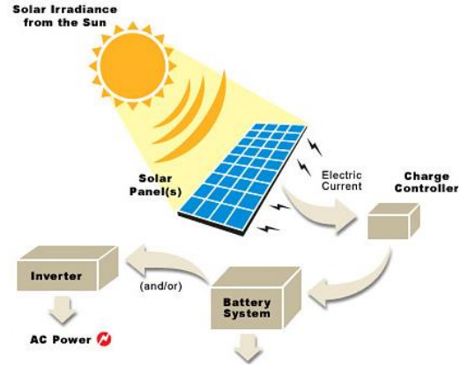

**Figure-1.1 Solar energy**

Solar energy now been used in many applications such as in the industrial and domestic applications. Different techniques used to utilise solar energy are solar cooking, solar lighting, solar cooling, space Technology etc. Fossil fuels are important part of solar energy which is stored in the form of organic matter. Most importantly fossil fuels affects environment badly and causes global warming acid rain smog pollution etc. as we know fossil fuels are decreasing day by day rapidly. That's why we have to select the alternate source of energy which can replace fossil fuels such as solar energy wind energy geothermal energy etc.

**1.3 TYPES OF SOLAR COLLECTORS**

**1.3.1 Concentrating collectors**

A concentrate collector that uses reflective surface with concentrated solar radiation on to a specific desired area, where solar collector plate is present which absorb the solar radiation and stores the solar energy in the form of thermal energy. Solar photovoltaic devices directly convert this solar radiation into electricity. In concentrator collector the power plus can be increased up to hundred times. Different types of concentric collectors are

❖ Parabolic concentrating collector

❖ Parabolic trough concentrating collector

❖ Fresnel lens concentrating collector

❖ Central receiver

❖ Moving receiver fixed reflector

❖ Fixed receiver moving reflector

**1.4 EXPERIMENTAL INVESTIGATION**

For the experiment an experimental setup is created for finding the data relating to heat transfer coefficient, friction factor and efficiency. by performing the experiment from the experimental setup the experimental readings achieved of artificial roughed Solar air heater with the arc shaped ribs on the smooth plate Solar air heater. We try to increase the heat transfer Coefficient value and thermos-hydraulic performance of solar air heater by using artificial roughness.

**1.4.1 Dimensions of experimental setup**

The experimental setup involves a blower, control valve, a Test duct having inlet and outlet section for air flow and various temperature and pressure measuring devices. The experimental setup is shown in figure below. Blower is used to suck the atmospheric air through the rectangular duct which is having artificial roughness. Artificial roughness is created by fixing Arc-shaped ribs having attack angle of 300and varying value of rib gap(g) from 1,2, 3,4,5 roughness on the bottom of the top plate.

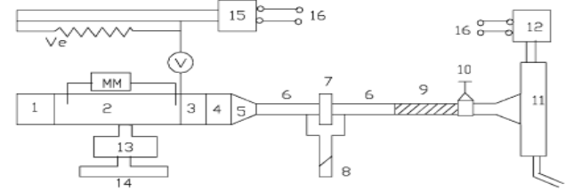

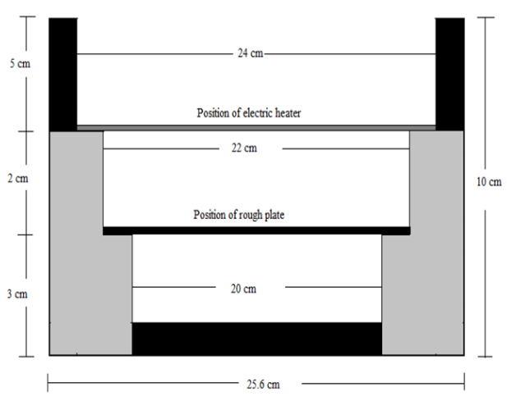

**Fig-1.2 Schematic diagram of experimental setup**

According to ASHRE standard 93-77(1950) the entry length is 5(H)3/2 , and exit length is 2.5(W.H )½ [25]. The experimental setup is designed according to this data. At the exit section three baffle plates are placed with an equal distance of 75mm Length. For proper mixing of air baffles are employed. At the exit of rectangular duct a plenum is installed to connect the circular pipe with rectangular duct. A HR plate having dimension 1500 mm x 200 mm x 1.6 mm is used as absorber plate which is having artificial roughness of arc shape at the test section of duct. The copper wires are stick on the underside of the absorber plate work as artificial roughness. The wire diameter and the angle of attack are remains fixed while the number of rib gaps varies to obtain very shape of roughness. To heat the plate uniform heat flux is supplied by electric heater assembly. The electric heater size is 1500mmx200mm was assembled by combining loops of parallel and series of heat resistance wire installed on asbestos sheet of 5 mm. thermal insulating material such as polystyrene is used on the backside of electric heater to reduce the thermal energy losses. The gap between absorber plate and electric heater is taken as 20 cm.

**1.5 EXPERIMENTAL PROCEDURE**

For correct operation the components and instruments are joined suitably with the experimental setup. The blower is then started. In GI pipe all the leakage proofing done on the joints to remove the errors. Flow control valve helps in controlling the mass flow rate of air for the testing section. It is important to control the air flow through the control valve to adjust the level of U tube pressure gauge and the micrometer. Experiment is performed under the Quasi-steady state condition to collect the data related to the heat transfer Coefficient and friction factor. After every adjustment in mass flow rate of air with the help of control valve, the data was recorded only when a stable state is achieved. as we change the operating condition at any point the system takes approximately 45 to 50 minutes to attend the quasi-steady state .To achieve accuracy in result the temperature of air stream flowing through the air duct were kept more than 100c on the grounds that the accuracy in determining the heat transfer coefficient is influenced by the temperature estimation. The temperature distinction has been kept more than 200c between the air temperature and absorber plate. The inlet of air flowing through the channel is kept limited between 300to 400c while testing in ambient condition. The outer temperature may vary between 500c to 800c. The plate temperature has taken just to achieve the steady state condition, if the plate temperature and outlet temperature of air didn’t change quite about 15 minutes. As the quasi-static state condition achieved, we measure the plate temperature, outlet and inlet temperature of air with the help of thermocouple while voltage and current of heater is measured by using voltmeter and digital ammeter respectively, the pressure drop over the operating plate and pressure drop over the pipe is measured with the help of U-Tube pressure manometer. Air flows with six various rates so the Reynolds number is carried for each of roughness height. The range of Reynolds number is taken from 2000 to 12000. By using data taker different parameters are measured in the experiment such as plate temperature, outlet temperature and inlet air temperature. Pressure drops over the pipe measured by pressure gauge and pressure drop over the whole plate is measured by U tube manometer.

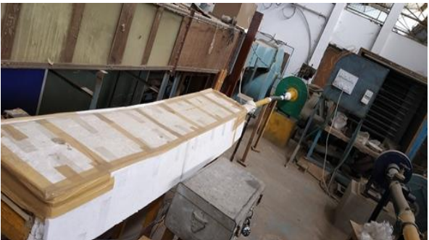

**Figure 1.3 Experimental setup**

**1.6 EXPERIMENTAL DATAS**

In this thesis the data is collected experimentally using various instruments for different roughness gap of absorber plate. The flow rate of air changed by control valve and the data collected for rough plate is compared with smooth plate. Different air flow characteristics such as Nusselt number, heat transfer coefficient, friction factor and thermal efficiency is determined by using experimental data.

**1.6.1 EXPERIMENTAL PARAMETERS**

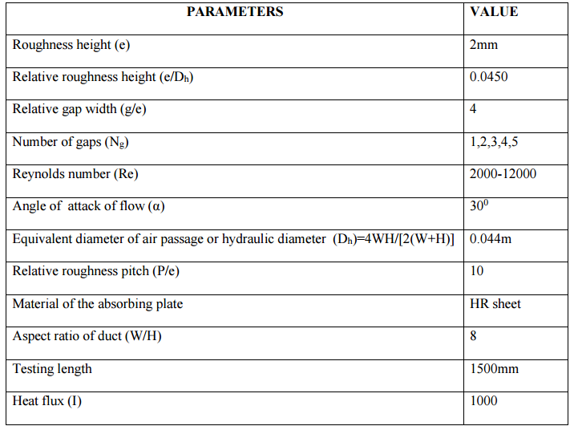

* 1. **RESULTS AND DISCUSSION**

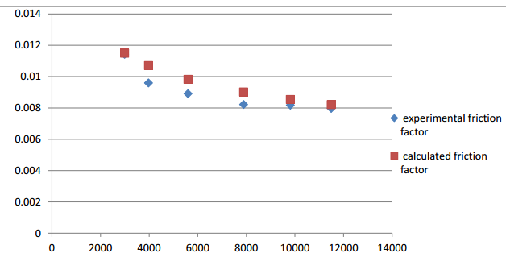

**Figure-1.4 Comparison of Experimental and Calculated value of friction factor (f) Vs**

**Reynolds number (Re) for smooth plate**

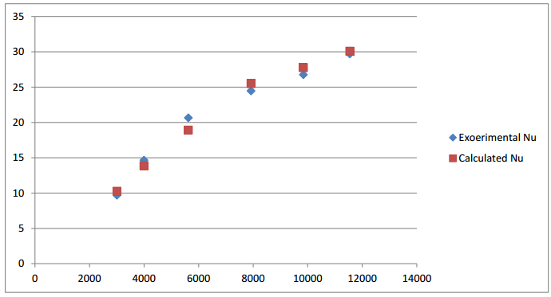

**Figure-1.5 Comparison of Experimental and Calculated value of Nusselt number (Nu) Vs**

**Reynolds number (Re) for smooth plate**

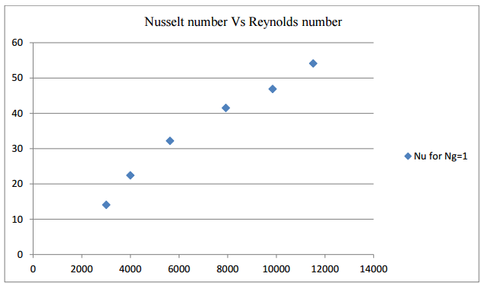

**Figure-1.6 Nusselt number vs Reynolds number for Ng=1**

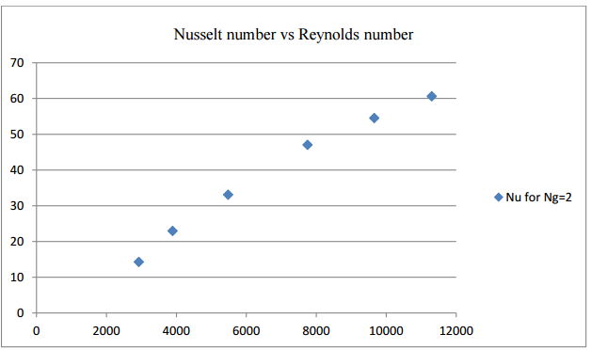

**Figure-1.7 Nusselt number vs Reynolds number for Ng=2**

* 1. **CONCLUSION**
* With increase in Reynolds number the Nusselt number increases and friction factor decreases. Friction factor and Nusselt number values of rough plate are higher in comparison with smooth plate for similar conditions.
* Maximum enhancement in Nusselt number occur at result table for number of gap (Ng)= 3 which is shown in figure-6.18 among all ( Ng=1,2,3,4,5 and smooth plate).
* Maximum enhancement in THP occur at result table for number of gap (Ng)= 3 which is shown in figure-6.20 among all ( Ng=1,2,3,4,5 and smooth plate).
* Enhancement in values of heat transfer coefficient and friction factor can be done by using arc type rib roughness on the absorber plate.

**REFERENCES**

1. Köppinger P, Schrey D, Gardner S, Thorpe E, Vutz Proceedings of a conference organized by the European Office of the Konrad-Adenauer-Stiftung and the EastWest Institute. Renewable energy: potential and benefits for developing countries; 2007.
2. Omer AM. Energy, environment and sustainable development. Renew Sustain Energy Rev 2008;12:2265–300.
3. Kalogirou SA. Environmental benefits of domestic solar energy systems. Energy Convers Manag 2004;45:3075–92.

Dinc I, Zamfirescu C. Sustainable energy systems and applications. New York Dordrecht Heidelberg London: Springer; 2011.

1. Ummadi singu, Amita, S. Concentrating solar power- Technology, potential and policy in India.
2. Xu C, et al. Research on the compensation of the end loss effect for parabolic trough solar collectors. Appl Energy 2014;115:128–39.
3. Lei D, et al. An experimental study of thermal characterization of parabolic trough receivers. Energy Convers Manag 2013;69:107–15Camel-solar, 2012. Flat-Plate Solar Collector.
4. V.B. Gawande, A.S. Dhoble, D.B. Zodpe, S. Chamoli Analytical approach for evaluation of thermo-hydraulic performance of roughened solar air heater.
5. Malhotra, H.P. Garg, A. Palit Heat loss calculation of flat-plate solar collectors J Therm Energy, 2 (2) (1981), pp. 59-62.
6. Lanjewar, J.L. Bhagoria, & Agrawal, M. K. review of development of artificial roughness in solar air heater and performance evaluation of different orientations for double arcribroughness (2015).
7. Lanjewar, J.L. Bhagoria, R.M. Sarviya Heat transfer and friction in solar air heater duct with W-shaped rib roughness on absorber plate.