**SMART ARTIFICIAL FISH FARMING AND MAINTENANCE [SAFF-M]**

**PREETHEP.S¹, DR. S. RATHINAVEL²**

1 Department of Electronics and Instrumentation, Bharathiar university, Coimbatore, Tamilnadu, India

2 Assistant Professor, Department of Electronics and Instrumentation, Bharathiar university, Coimbatore, Tamilnadu, India.

**ABSTRACT**

Fish farming, or aquaculture, is a profitable business with applications in food, medicine, and research industries, offering high protein sources from various fish types. Two main forms of fish farming are natural and artificial, with artificial farming evolving towards efficiency, productivity, and sustainability. Smart fish farming incorporates key components like microcontrollers, utilizing sensors for real-time monitoring of water quality and feeding. Future advancements involve Artificial Intelligence (AI) and Machine Learning to optimize operations and reduce errors. Automation technology streamlines tasks such as feeding and waste management, reducing labor requirements and ensuring optimal conditions for fish welfare. The Smart Artificial Fish Farming and Maintenance (SAFF-M) project focuses on precision in aquaculture techniques, aiming to enhance fish growth, minimize investor stress, and improve product quality and quantity. These advancements in smart fish farming are revolutionizing the industry by integrating technology for more efficient and sustainable practices.

**Keywords:** Fish farming, aquaculture, food industry, artificial farming, sensors, monitoring.

1. **INTRODUCTION**

The demand for fish protein globally is rising significantly in the coming decades. However, the fish farming methods face many challenges, including insufficient and excessive usage of water and feeding practices. To improve the quality and quantity of the fish resource, we have to think smart and reduce the workload to increase yield and profit. We use smart monitoring and maintenance in aquaculture farming based upon IOT (Internet of Things), which uses microcontrollers and sensors to detect and monitor the process [1]. There are two types of fish farming: natural fish farming and artificial fish farming. In natural fish farming, there are also two types, namely sea fish and river, lake, or pond fish. But we use freshwater fish farming using artificial methods. In artificial fish farming, many techniques are used. Such as creating an artificial pond, large tanks, barrel phonics, indoor fish farming, etc. The main challenges for maintaining the fish ponds are detecting the temperature, pH level, and water quality. The system for maintaining the fish ponds uses sensors such as temperature sensors, water quality maintenance sensors, and pH level sensors, which are crucial for fish farming [2,4,5,6,8,11]. To detect the temperature of the water for fish growth and environment and the pH level for the condition of the water. These parameters are helpful in the growth of healthy fish and their quality [5, 7, 13]. To analyze the data given by the sensors, identify patterns, predict potential issues, and enable proactive interventions and optimized decision-making using artificial intelligence or precalculated datasets that are helpful for the growth of healthy fish. [11,12,15,16,18,23]. The next part is automation, which automates the various tasks such as feeding the fish, management of the water resources, and aeration, reducing the usage of labor, and ensuring flow and consistency in the system operation [6, 16, 17, 19, 20, 25]. These are extremely beneficial in fish farming, as they reduce stress and increase profits. The power source, which also plays a major role in the following system, is also used to reduce the current charges on the bill, and the battery stores the power to maintain the artificial fish pond regularly [19]. The microcontroller that is used for the whole system is the PIC16F877A microcontroller [1, 16, 20]. In this smart artificial fish farming and maintenance (SAFF-M), there are some of the few techniques used to create a dual purpose in the following system, which has to farm the fish at the same time as farming the vegetables at the same time. The water resource in fish farming contains the water we need to change every once a week because of low water quality. So that water can be passed through the following vegetable plants, it grows simultaneously, gives benefits, and doubles profit, and the process is called aquaponics [3, 6, 24]. To address the challenges and ensure sustainable food production, smart artificial fish farming (SAFF-M) emerges as a revolutionary approach and practice. This introduction part sets the stage for the exploration of the transformative potential of smart artificial fish farming and maintenance (SAFF-M). We will dive deeper into the specified technologies that are to be employed and their benefits for production efficiency, sustainability, and disease prevention.  The challenges that are associated with the implementation and maintenance of this kind of innovative system. By understanding the power of smart artificial fish farming and maintenance (SAFF-M), we can pave the way for a more responsible and productive future for the fish farming industry or the aquaculture industry. This paper shows the monitoring and maintenance of complete fish farming in a smart way by using the following instances: There are some disadvantages in the following SAFF-M, where the detection of the temperature and the pH level in the following system is difficult and to get the approximate values of the system. Feeding practices such as insects and live-feeding organisms are not fed automatically, and some behavior checking of fish should be a minor defect of this system. The outcome of this system is to improve the efficiency of the electronic materials, and the data for the fish should be correctly noticed in the following systems. This leads to a good yield for the fish farming industry and improves the business.

1. **METHODOLOGY**

The methodology for developing a smart fish farming system employing the PIC16F877A microcontroller integrates various sensors and actuators crucial for efficient aquaculture management. The microcontroller, an 8-bit device with EEPROM data memory and built-in ADC channels, operates within a voltage range of 2V to 5.5V, featuring PWM capabilities, comparators, and self-programming functions. Temperature sensing, which is facilitated by the LM35 sensor with a wide range from -50ºC to 150ºC, and pH level monitoring, essential for water quality assessment, are central to the system. A servo motor governs mechanisms like the feed dispenser, while real-time data is displayed on a 20x4 LCD screen, adjustable via a 10K ohm potentiometer for contrast. Communication is facilitated by the GSM module (SIM900A), which enables SMS alerts for deviations in temperature and pH levels alongside continuous monitoring. Microcontroller programming entails firmware development in C or assembly language using the MPLAB X IDE, configuring ADC channels, implementing PWM control for the servo motor, and setting up UART communication for the GSM module. The system provides real-time monitoring, triggering SMS alerts and activating the heater if the temperature drops below 20ºC. Additionally, the servo motor aids in maintaining the pond by dispensing feed and indicating its operation status. This comprehensive approach enhances fish farming efficiency by ensuring optimal conditions and maximizing production.

**2.1 BLOCK DIAGRAM**

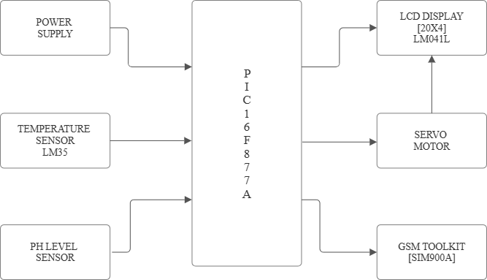

FIGURE.1. Overview of hardware setup

* 1. **HARDWARE COMPONENTS:**

**2.2.1 PIC16F877A MICROCONTROLLER**

The PIC16F877A microcontroller, manufactured by Microchip Technology, stands as a prominent 8-bit member within the PIC family, revered for its efficient Harvard architecture. This architecture, which segregates program instructions and data into distinct memory spaces, enhances performance and efficacy. Powered by a mid-range 8-bit RISC processor core, it swiftly decodes and executes instructions, boasting commendable performance and minimal power consumption. Operating at a peak clock speed of 20 MHz, it swiftly executes commands. Featuring EEPROM for non-volatile data storage, RAM for runtime data management, and flash memory for program instructions, it offers versatility. Moreover, an array of integrated peripherals like PWM, USART, SPI, and I2C, along with timers and counters, enrich its functionality. Its interrupt mechanism adeptly handles external events, while ample general-purpose I/O ports enable seamless interaction with external devices and sensors. With various low-power modes, it suits battery-operated or energy-efficient applications impeccably. Microchip provides a comprehensive development environment comprising MPLAB X IDE, MPLAB XC compilers, and hardware tools for application development, debugging, and modelling. Widely embraced in diverse domains including industrial control, consumer electronics, automotive systems, and medical devices, the PIC16F877A epitomizes a versatile microcontroller catering to multifaceted embedded systems applications.

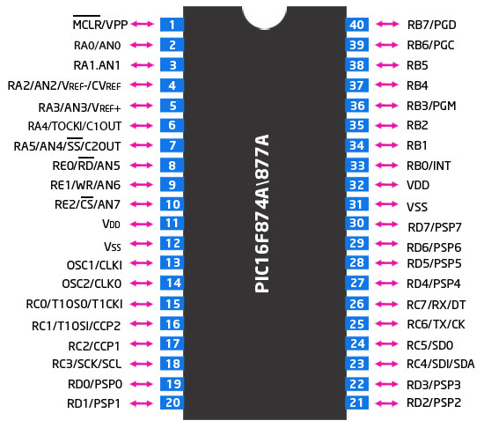PIN-CONFIGURATION**:**

Figure. 2. PIC16F877A MICROCONTROLLER

Port A of the PIC16F877A microcontroller interfaces with sensors, including the temperature sensor (RA0), pH level sensor (RA1), and turbidity sensor (RA2). Port B connects to indicator LEDs for temperature and pH level (RB1 and RB2, respectively), while the servo motor input is on RB3. Port C links to the RX and TX terminals of the GSM module (SIM900A), facilitating communication. Port D drives a 20x4 LCD with pins RD2-RD7, and RD1 controls the servo motor output. This configuration enables the microcontroller to gather sensor data from Port A, display information on the LCD through Port D, communicate via GSM with Port C, and actuate devices such as LEDs and a servo motor through Ports B and D, respectively, facilitating diverse embedded system applications.

**2.2.2 LCD DISPLAY (20X4):**

The next component used in the paper is the LMO41L. The LM041L is a 20x4-character LCD module commonly used in embedded systems and DIY projects. It has a large display area, supporting a standard set of alphanumeric characters, symbols, and special characters within a 5x8 pixel matrix. The module uses a parallel interface for communication with the microcontroller, requiring several data lines for sending character data and control signals. Many versions of the LM041L come with an integrated LED backlight for better visibility in low-light conditions. The LM041L is usually driven by an HD44780-compatible controller chip, which simplifies interfacing with the display and provides various functionalities. It operates at a 5V DC power supply, making it compatible with most microcontroller systems. The module is typically mounted on a PCB or within an enclosure, making it easy to integrate into various electronic projects. The LM041L is widely used in consumer electronics, industrial control panels, instrumentation, and DIY electronics projects due to its versatility and ease of use.

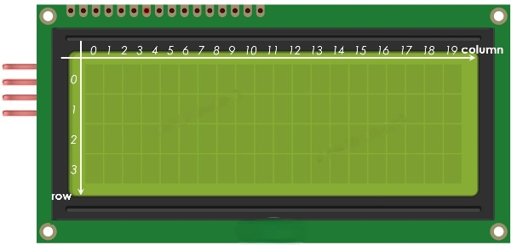PIN CONFIGURATION IN MICROCONTROLLER:

Figure.3. LCD DISPLAY (20X4)

PIN 21- RD2 which is connected to RS (Register Select), PIN 22- RD3 which is connected to EN (Enable), PIN 27- RD4 which is connected to the PIN(D4), PIN 28- RD5 which is connected to the PIN(D5), PIN 29- RD6 which is connected to the PIN(D6), PIN 30- RD7 which is connected to the PIN(D7) RW, D0, D1, D2, & D3 which are connected to the ground.

**2.2.3 LM35 [TEMPERATURE SENSOR]:**

The LM35 temperature sensor is renowned for its precision and ease of use, making it a preferred choice across various applications. Its linear output directly corresponds to temperature variations from -55°C to +150°C, simplifying monitoring tasks without complex calibration. With minimal self-heating and low power consumption (around 60 μA), it excels in critical environments and energy-conscious applications like environmental monitoring and industrial automation. Factory calibration eliminates the need for adjustments during implementation, streamlining the design process. Its compact form factor allows integration into space-constrained designs, while seamless interfacing options for microcontrollers and ADCs facilitate rapid development. Widely used in HVAC systems, automotive electronics, weather monitoring stations, and consumer devices, the LM35's reliability, precision, and affordability cater to engineers, hobbyists, and researchers worldwide. In essence, it stands as a dependable and cost-effective solution for temperature monitoring across industrial and recreational pursuits.

PIN CONFIGURATION IN MICROCONTROLLER:

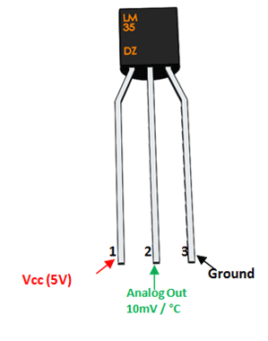

Figure.4. Temperature sensor [LM35]

PIN 2- RA0 for analog out and PIN 35- RB2 for led indication which temperature less than 20ºC.

**2.2.4 PH LEVEL SENSOR:**

Ph level sensors are integral components across diverse industries, offering critical monitoring of acidity and alkalinity levels. Functioning through electrochemical measurement, they utilize a glass membrane to detect Ph changes, generating voltage signals proportional to Ph levels. These sensors cover a broad Ph range, ensuring adaptability to various environments. Renowned for high accuracy and precision, they require periodic calibration to uphold reliability. Rapid response times enable real-time monitoring, which is crucial for maintaining desired Ph levels. Incorporating temperature compensation features, Ph sensors ensure accuracy despite temperature fluctuations. Compatible with different solutions, they find applications in agriculture, food, pharmaceuticals, and environmental monitoring. Maintenance, including calibration and cleaning, is imperative for longevity and accuracy. Ph sensors interface with electronic devices for data acquisition and analysis, offering voltage signals or digital data. Available in multiple forms, such as glass electrodes and solid-state sensors, they cater to diverse application needs. Ultimately, Ph sensors serve as indispensable tools for quality control, product safety, and environmental monitoring, owing to their accuracy, reliability, and versatility.

PIN CONFIGURATION IN MICROCONTROLLER:

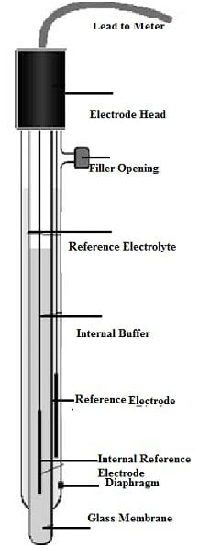

Figure.5. PH level sensor

PIN 3- RA1 for analog output and PIN 34- RB1 connected to solenoid valve and led for indication.

**2.2.5 SERVO MOTOR:**

Servo motors excel as rotary actuators, renowned for their unmatched precision in managing angular position, velocity, and acceleration through feedback control principles. Comprising a motor, feedback device (commonly a potentiometer or encoder), and control circuit, servo motors ensure optimal performance across diverse applications. Their hallmark precision in position control proves invaluable in sectors like robotics and CNC machining, while variable speed control enables smooth operation in scenarios like conveyor systems and robotic arms. Despite their compact dimensions, servo motors deliver impressive torque output, making them ideal for handling heavy loads in applications such as robotic manipulators and industrial machinery. Integral feedback mechanisms enable swift adjustments to maintain accuracy amidst external disturbances, ensuring consistent performance. With a compact, lightweight design, servo motors find extensive utility across industries ranging from robotics to aerospace and automotive. Their compatibility with PWM signals or serial communication protocols facilitates easy integration into electronic systems, underscoring their indispensability. In summary, servo motors epitomize precision and versatility in electromechanical systems, offering precise position control, variable speed capabilities, robust torque output, and reliable feedback mechanisms, thus meeting diverse application requirements for position, speed, and torque control.

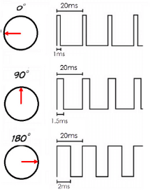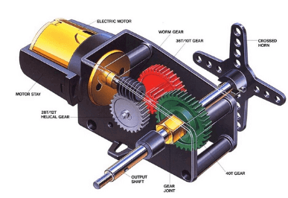PIN CONFIGURATION IN MICROCONTROLLER:

Figure.6. Interior view of servo motor Figure.7. Angles of servo motor

PIN 36 – RB3 for servo motor input and PIN 20 – RD1 for servo motor output.

**2.2.6 GSM TOOLKIT (SIM900A):**

The SIM900A GSM module is celebrated for its adaptability, enabling GSM communication across diverse electronic applications. Its standout features include seamless connectivity over GSM networks for SMS, voice calls, and GPRS data services. By supporting standard GSM frequencies, it ensures worldwide compatibility. Its compact form factor facilitates easy integration into small-scale devices, while the SIM card interface simplifies network connectivity. Through serial communication interfaces, it seamlessly interfaces with microcontrollers and single-board computers. Control is executed via AT commands, empowering users with commands over SMS, calls, and network settings. Operating on low-voltage DC power, it's suitable for battery-powered setups. Widely utilized in IoT, monitoring, tracking, automation, and security systems, it's indispensable for wireless communication needs. Some variants may incorporate GPS or Bluetooth, expanding their functionality. Overall, the SIM900A module serves as a cornerstone for GSM communication in electronic ventures, valued for its size, global compatibility, and extensive feature set, appealing to hobbyists, engineers, and developers alike.

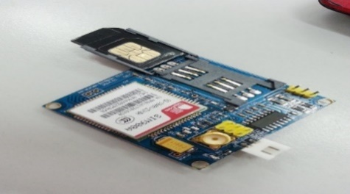PIN CONFIGURATION IN MICROCONTROLLER:

Figure.8. GSM TOOL [SIM900A]

PIN 25 – RC6 for TX and PIN 26 – RC7 for RX in virtual instrument

**2.3 SOFTWARE CONFIGURATION:**

**2.3.1 MPLAB X IDE:**

The MPLAB X IDE Compiler is vital to Microchip's MPLAB X Integrated Development Environment (IDE), crafted for embedded systems development. Seamlessly integrated with the MPLAB X IDE, it offers a unified platform for writing, compiling, debugging, and programming embedded applications. Supporting languages like C, C++, and Assembly, the compiler optimizes code for enhanced efficiency and performance on target microcontrollers. Its cross-platform compatibility enables developers to work on Windows, macOS, and Linux, while comprehensive device support spans various Microchip microcontrollers and DSCs. Integrated debugging tools aid in code analysis and troubleshooting, while project management features streamline organization and collaboration. Extensive documentation, tutorials, and support resources complement the compiler, enriching the user experience and providing valuable assistance. Essentially, the MPLAB X IDE Compiler empowers developers with advanced features, optimization capabilities, and extensive device support, driving progress in embedded system development across industries. This software is used to compile the code for this project.



Figure.9. Compiler software logo

1. **IMPLEMENTATION**

The microcontroller detects the temperature and pH level using the sensors to maintain the fish pond in good condition. The servo motor, which acts as a feeder in the following system, feeds fish automatically or manually. The LCD shows real-time data, such as temperature, pH level, servo motor condition, and NTU. The GSM toolkit alerts the mobile with a message.

* 1. **STEPS TO INTERFACE:**

The first step is to build a code for the temperature sensor, pH level sensor, servo motor, LCD (20X4), and gsm toolkit (sim900a) in the software called MPLAB X IDE compiler. Then code gets built successfully, then check with the simulation is done by using the software called proteus simulation. The components are placed in the software in a simulated way. Then check the conditions in the following cases:

**CASE-1:**When the temperature sensor LM35 is used for the detection of temperature in the following artificial fish pond by using the PIC16F877A microcontroller when the temperature is less than 20ºC, the LED goes on, it displays through the LCD, and the alert message goes to the mobile.

**CASE-2:** When the pH level sensor is used for the detection of water acidity and alkalinity in the artificial fish pond with the help of the PIC16F877A microcontroller When the pH level separates from 1 to 14, where 1 to 6.9 is called acidic and 7.1 to 14 is called base or alkalinity, these values are shown on the LCD display. We predefined and calibrated the value range for good fish growth in the collection of data. So, we set the values to range below 6, and the LED-2 goes on with the help of the solenoid valve. If the pH range is above 9, again, the LED-2 gets on and gives an indication. The alert message is sent by the gsm toolkit (sim900a) for the below and above indications.

**CASE-3:** The servo motor, which acts like a tap, or the valve, which is used to open or close in either automatic or manual mode, acts as a feeding system for fish. The angle for 0º is the feeder closed, and 90º is the feeder opened. The function is shown on the LCD display, and the alert message is sent to the mobile.

1. **RESULTS AND DISCUSSION**

With the help of the simulation software (Proteus Design ISIS Professional), we can view the results prior to moving on to the hardware configuration. For reference, the results of the simulation are displayed below.

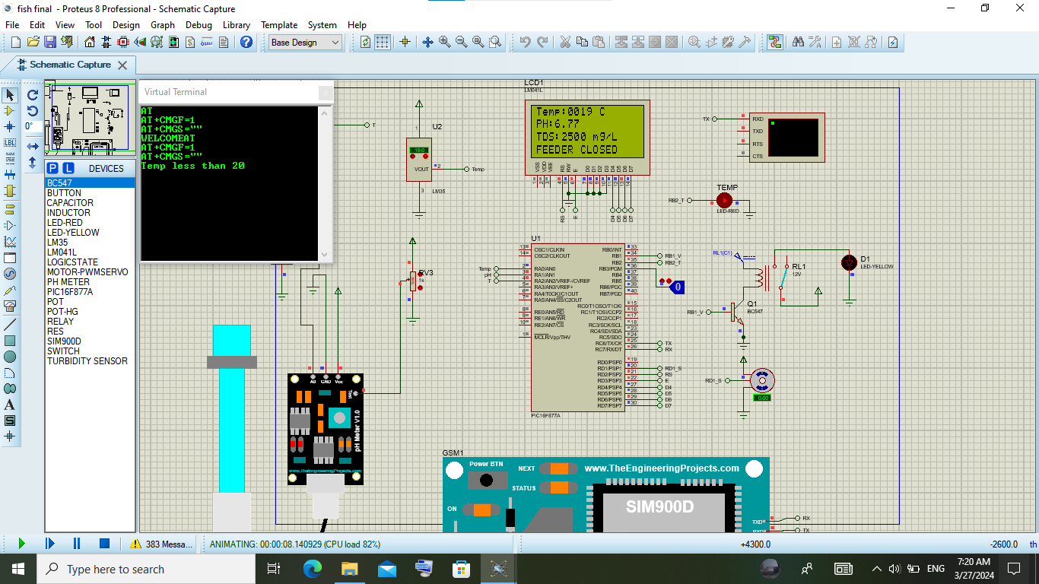

Figure.10. Simulation output-1

When the temperature is less than 20ºC, the temp LED gets on and sees values in real-time by LCD and the GSM which sends an alert message to the mobile.

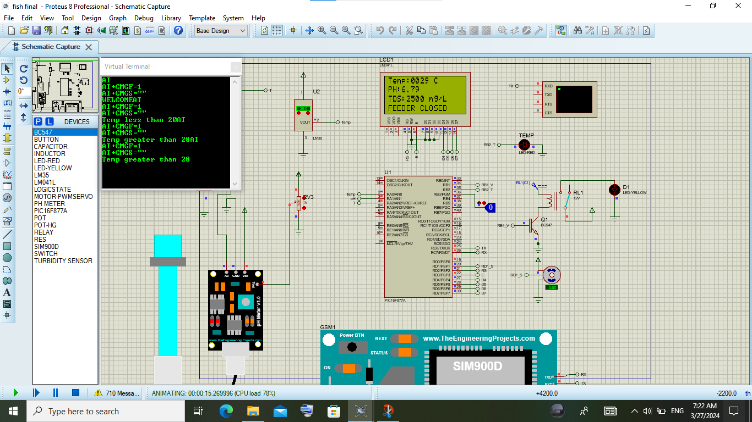

Figure.11. Simulation output-2

When the temperature is greater than 20, the temp LED gets off and sees values in real-time by the LCD and the GSM that sends an alert message to the mobile.

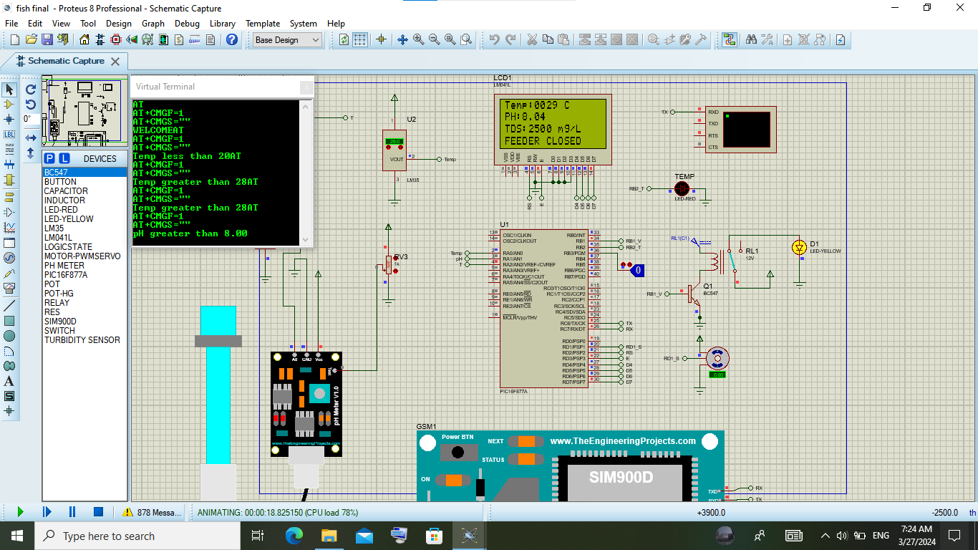

Figure.12. Simulation output-3

When the pH level is greater than 8, the LED connected with the solenoid valve gets on and values are shown in real time by LCD and the alert message is sent to mobile through the GSM toolkit (SIM900A).

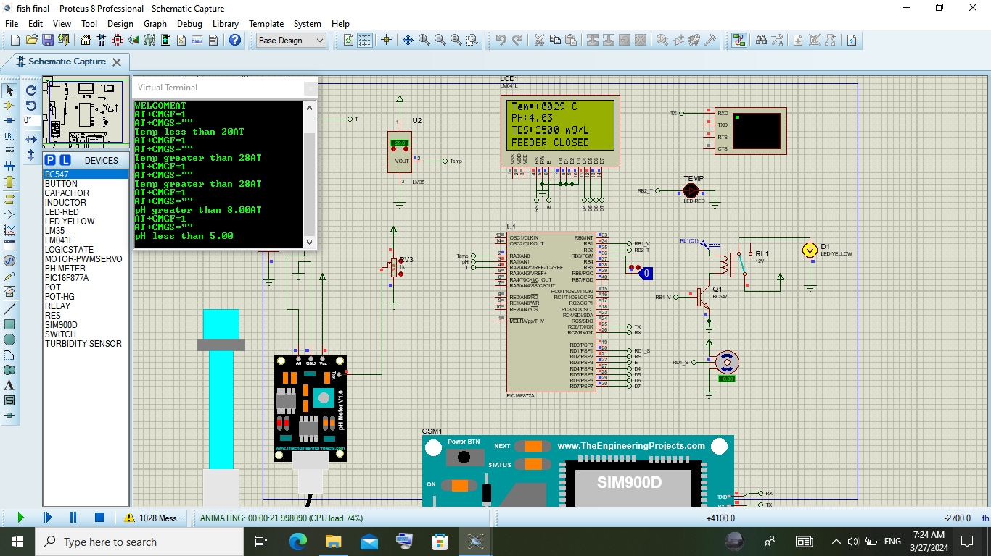

Figure.13. Simulation output-4

When the pH level is greater than 8, the LED connected with the solenoid valve gets on and the values are shown in real time by LCD and the alert message is sent to mobile through the GSM toolkit (SIM900A).

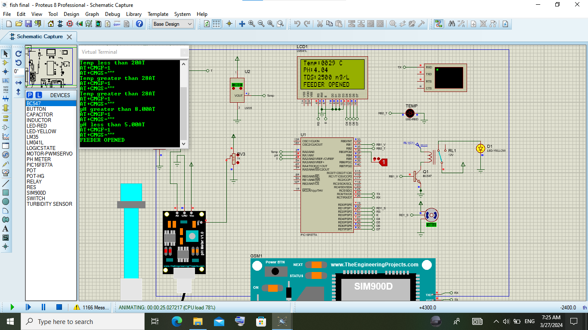

Figure.14. Simulation output-5

When the manual input is given to pin 36 in the microcontroller, the output comes out from pin 20, where the servo motor changes the angle from 0º to 90º as the feeder is open, and the LCDs the real-time data of the feeder being opened and the alert message sent by the gsm (sim900A) to the mobile.

1. **CONCLUSION**

The primary goal of this project is to enhance fish quality, boost production, minimize labour requirements, and ultimately increase profitability in the aquaculture business. Leveraging advancements in technology, particularly the utilization of PIC microcontrollers, has enabled the automation of manual tasks, resulting in heightened production levels while maintaining product quality. The system outlined in this study is fully automated, offering significant advantages in streamlining operations. In today's era, automation is pivotal in optimizing processes, and researchers employ various techniques such as artificial intelligence, machine learning, data analysis, and advanced microcontrollers to achieve this. This paper serves as a blueprint for establishing the future artificial aquaculture industry, highlighting the integration of innovative technologies to drive efficiency, productivity, and profitability in fish farming operations.

1. **REFERENCES**
2. Ramya, A., R. Rohini, and S. Ravi. "Iot based smart monitoring system for fish farming." *International Journal of Engineering and Advanced Technology* 8.6 Special Issue (2019): 420-424.
3. Bachri, Affan. "Freshwater Monitoring System Design In Real-Time For Fish Cultivation." *International Journal of Multidisciplinary Approach Research and Science* 2.01 (2024): 362-371.
4. Doyle, Laura, Lauren Oliver, and Cristina Whitworth. "Design of a climate smart farming system in East Africa." *2018 IEEE Global Humanitarian Technology Conference (GHTC)*. IEEE, 2018.
5. Teja, K. Bala Ravi, et al. "Smart monitoring system for pond management and automation in aquaculture." *2020 International Conference on Communication and Signal Processing (ICCSP)*. IEEE, 2020.
6. Kamisetti, Satya Nagabhushana Rao, Arvind Dattatreye Shaligram, and S. S. Sadistap. "Smart electronic system for pond management in fresh water aquaculture." *2012 IEEE Symposium on Industrial Electronics and Applications*. IEEE, 2012.
7. Mamatha, M. N., and S. N. Namratha. "Design & implementation of indoor farming using automated aquaponics system." *2017 IEEE International Conference on Smart Technologies and Management for Computing, Communication, Controls, Energy and Materials (ICSTM)*. IEEE, 2017.
8. Vishwakarma, Vinay, et al. "Acqua culture monitoring system." *2018 International Conference on Smart City and Emerging Technology (ICSCET)*. IEEE, 2018.
9. Sukrismon, Yoyok, et al. "Smart fish pond for economic growing in catfish farming." *2019 International Conference on Computer Science, Information Technology, and Electrical Engineering (ICOMITEE)*. IEEE, 2019.
10. Sansri, Siriporn, Wu-Yuin Hwang, and Theerasak Srikhumpa. "Design and implementaion of smart small aquaponics system." *2019 Twelfth International Conference on Ubi-Media Computing (Ubi-Media)*. IEEE, 2019.
11. Schraml, Rudolf, et al. “Towards fish individuality-based aquaculture.” *IEEE Transactions on Industrial Informatics* 17.6 (2020): 4356-4366.
12. Chen, Chiung-Hsing, et al. “IoT-based fish farm water quality monitoring system.” *Sensors* 22.17 (2022): 6700.
13. Ahamed, Istiaque, and Abir Ahmed. “Design of smart biofloc for real-time water quality management system.” *2021 2nd International Conference on Robotics, Electrical and Signal Processing Techniques (ICREST)*. IEEE, 2021.
14. Billah, Md Masum, et al. “Quality maintenance of fish farm: development of real-time water quality monitoring system.” *2019 IEEE International Conference on Smart Instrumentation, Measurement and Application (ICSIMA)*. IEEE, 2019.
15. Adnan, K. N. A. K., et al. “Water quality classification and monitoring using e-nose and e-tongue in aquaculture farming.” *2014 2nd International Conference on Electronic Design (ICED)*. IEEE, 2014.
16. Kostin, V. E., A. A. Silaev, and A. V. Savchic. “Information-Measuring System for Monitoring and Control Aquaculture of Pond Farm.” *2019 International Multi-Conference on Industrial Engineering and Modern Technologies (FarEastCon)*. IEEE, 2019.
17. Chen, Jui-Ho, Wen-Tsai Sung, and Guo-Yan Lin. “Automated monitoring system for the fish farm aquaculture environment.” *2015 IEEE International Conference on Systems, Man, and Cybernetics*. IEEE, 2015.
18. Elsokah, Moeid M., and Malek Sakah. “Next generation of smart aquaponics with internet of things solutions.” *2019 19th International Conference on Sciences and Techniques of Automatic Control and Computer Engineering (STA)*. IEEE, 2019.
19. Ahmed, Marzia, et al. “Analyzing the Quality of Water and Predicting the Suitability for Fish Farming based on IoT in the Context of Bangladesh.” *2019 International Conference on Sustainable Technologies for Industry 4.0 (STI)*. IEEE, 2019.
20. Fourie, Christiaan M., et al. “A solar-powered fish pond management system for fish farming conservation.” *2017 IEEE 26th International Symposium on Industrial Electronics (ISIE)*. IEEE, 2017.
21. Noor, M. Z. H., et al. “The design and development of automatic fish feeder system using PIC microcontroller.” *2012 IEEE control and system graduate research colloquium*. IEEE, 2012.
22. Ghosh, Ruby N., and Reza Loloee. “System for oxygen measurements in a fish farm.” *SENSORS, 2013 IEEE*. IEEE, 2013.
23. Atoum, Yousef, Steven Srivastava, and Xiaoming Liu. “Automatic feeding control for dense aquaculture fish tanks.” *IEEE Signal Processing Letters* 22.8 (2014): 1089-1093.
24. Sung, Wen-Tsai, Jui-Ho Chen, and His-Chun Wang. “Remote fish aquaculture monitoring system based on wireless transmission technology.” *2014 international conference on information science, electronics and electrical engineering*. Vol. 1. IEEE, 2014.
25. Desai, Komal, et al. “Pisciculture Monitoring System.” *2020 8th International Conference on Reliability, Infocom Technologies and Optimization (Trends and Future Directions) (ICRITO)*. IEEE, 2020.
26. Abinaya, M., et al. "Design and implementation of aquaculture monitoring and controlling system." *2019 International Conference on Computation of Power, Energy, Information and Communication (ICCPEIC)*. IEEE, 2019.