**Food storage monitoring system based on IoT**

Noel John1, Philipose Joseph2, P S Anaz Muhammed3, P Sidharth Sathiyandran4,

Dr Godwinraj D**5**, Ranjitha Rajan **6**

1,2,3,4 Student, Department of Electronics and Communication, Amal Jyothi College of Engineering, Kanjirapally, India

5, Associate Professor, Department of Electronics and Communication, Amal Jyothi College of Engineering, Kanjirapally, India

6, Assistant Professor, Department of Electronics and Communication, Amal Jyothi College of Engineering, Kanjirapally, India

**ABSTRACT**

In order to prevent food wastage, food safety and hygiene must be a priority. The quality of the food must be monitored and the food must not rot or decay due to environmental factors such as temperature, humidity, gases, fire and intruders. Therefore, it is beneficial to have quality monitoring devices in food stores. Quality monitoring devices keep an eye on the environmental factors that cause or accelerate the decay of food. Depending on the requirement, environmental factors can also be controlled such as refrigeration or vacuum storage. In this project work, we are focusing on a food monitoring system that proposes the systematic use of various sensors for the quality and quantity monitoring and control of the food materials. A smart food monitoring system is a device that controls the various parameters that cause decay or rotting in food materials, thus ensuring the appropriate quality of the food during different atmospheric changes.

This type of storage aims at preserving the fresh food for a certain amount of time. However, food safety is often not sufficiently ensured due to lack of technology and ignorance about the effects of humidity and temperature on raw materials. The main objective of this research is to reduce the monitoring of humans and to develop an Internet based real time temperature and humidity monitoring using the very available DHT-22. Sensor and ESP-32 module.

# INTRODUCTION

Food is the most important source of energy for living beings, food quality and safety have been the highest demands throughout history. Technologies like the Internet of Things (IoT) connect everything anywhere, anytime. Using IoT in the food supply chain (FSC), it helps to improve food quality by tracking and monitoring the condition of food by sharing consumer data in real time. Currently, the application of all IoT technology in FSC.is still in its early stages and there will be a lot of fixing. Food hygiene and safety is the most important thing to prevent food loss. The quality of the food should be controlled, it should also be prevented from spoilage and should be controlled by atmospheric factors such as darkness, humidity and temperature. Therefore, waste can be minimized by introducing quality control equipment in grocery stores. Such quality control equipment controls air factors that can cause food deterioration. In the past, atmospheric factors were controlled by\techniques such as refrigeration, vacuum storage, etc., food contamination occurs during the production process, it is mainly. caused by ineffective handling of food unsuitable food due to environmental conditions during transportation and storage. Several factors such as humidity and temperature changes cause food to rot, So a monitoring system that can measure humidity and temperature differences\during food storage and transportation is essential. Nowadays almost everyone is affected by the food they eat every day, not by garbage, but also preserved foods, foods that are used in everyday life, because their oxygen, temperature and humidity change from time to time, so they do not offer excellent quality. Since most consumers only pay attention to the information on the package, such as the amount of ingredients used and nutritional value, they blindly endanger their health by ignoring the atmospheric conditions to which those packages are exposed. To ensure food safety\food safety must be observed at all stages of the supply chain. Its purpose is to protect the health of consumers, maintain the required environmental conditions, to preserve food. Analyzing and performing routine measurements to detect changes does not guarantee the nutritional value of food. Information for policy analysis, trend forecasting, program\assessment and planning is collected through monitoring and control and must be analyzed and sent to decision makers in a format suitable to be of real value. Dissemination of information must be an interactive process. The most important function of monitoring and control systems is to monitor certain activities to ensure that certain activities are performed. Using various electronic sensors monitoring can be achieved. These stored values ​​should also be used for monitoring purposes. Data from Arduino-based sensors is compared to the desired values. If the sensor readings are detected as different from the desired values, the control circuit acts to influence the reserved function to keep it at the desired quality. We propose to use this principle to build a raw material storage system. An intelligent food control system is primarily designed to track and control food and prevent it from spoiling due to climate and atmospheric changes. Improper food storage also causes food waste. So, a smart food control system mainly focuses on safe food storage by monitoring and controlling many parameters affecting food. This monitoring system uses warehouse units embedded with various Arduino-based sensors that read parameters that affect food quality. Chains of custody designed to solve the problem of poor food conditions are an important part of this proposal. This project proposes an IoT platform that facilitates the tracking of food so that it does not deteriorate due to climatic conditions during storage.

* 1. **PROBLEM STATEMENT**

One of the biggest challenges in modern food supply chains is ensuring the quality and safety of food products from manufacturing to consumption. Despite advances in technology, there is still a significant gap in the ability to monitor and detect food spoilage in real-time. This is especially true when it comes to atmospheric factors like temperature, humidity or light exposure during storage or transportation. Current approaches do not provide the precision and efficiency needed to address these issues, resulting in significant food wastage and health risks for consumers. To fill this gap, there’s a pressing need for a cutting-edge solution that uses IoT and Arduino sensor based systems to detect and measure food spoilage accurately in real time. This solution should be able to continuously track key environmental parameters impacting food quality, allowing for early intervention to avoid spoilage and reduce food waste across the entire supply chain.

# LITERATURE SURVEY

In the paper [1] FOOD STORAGE MONITORING SYSTEM USING ARDUINO by V. AISHWARYA, G. NAGA SAI. In this paper author had a full-featured food storage monitoring solution using Arduino, IoT, various sensors to prevent food wastage and improve food safety. Monitoring parameters such as temperature and humidity, gas level, fire, intruder, and atmospheric changes will help maintain food quality. The system uses Arduino Uno & Nano, together with sensors such as DHT11 & MQ2 & IR to detect the conditions and to trigger actions. Communicate via GSM & Bluetooth to provide real time alerts & remote monitoring. Food industry, agriculture & home automation applications offer improved safety & real time monitoring & automated control. Benefits include early warning alerts & cost reduction. Future improvements could include lower power consumption & increased security. In the paper [2] AN ARDUINO SENSOR-BASED APPROACH FOR DETECTING THE FOOD SPOILAGE by Arun Kumar G. In this research paper author states that In this paper, we’ll be using IoT technology (Arduino and various sensors) to track food quality and avoid spoilage. We’ll be focusing on early detection by continuously monitoring factors such as temperature, gas levels, etc. The system we’re proposing will send alerts to users according to sensor readings to make sure food is safe to eat. Here are some of the components, benefits, and future improvements we can look forward to detect spoilage gases We’ll be looking at how spoilage gases can be detected in order to prevent spoiled food from being consumed. In the paper [3] Monitoring food storage humidity and temperature data using IoT by Asif Bin Karim, Md Zahid Hassan, Md Masum Akanda, Avijit Mallik. In this research paper author states that this paper examines the use of IoT technology to monitor food storage conditions in real-time, with a particular emphasis on humidity and temperature monitoring. The paper highlights the importance of real-time food storage monitoring in preventing food spoilage losses in food industries. The paper uses components such as DHT11 sensor, NodeMCU module and simple methodologies to explore the potential of the Internet of Things (IoT) for environmental monitoring applications. The results demonstrate the successful transmission of data to the cloud for remote monitoring. All in all, the study provides important insights into the use of IoT for effective food storage management.

In the paper [4] FOOD SPOILAGE DETECTION AND ALERTING SYSTEM by G. Rama Krishna, G. Mani Kotaiah K. Hanok, M. Ajay G. Swami. In this research paper author states a food spoilage detection and alerting system is designed to improve food safety and reduce wastage. Food quality monitoring is essential for public health and for economic development. The system uses sensors such as methane, humidity, moisture, and temperature to continuously track food materials. The data from the sensors is analyzed by the Arduino board. The results are displayed on the LCD screen and the user is notified by LED indicators and Wi-Fi. The goal of the proposed system is to detect food spoilage quickly to avoid consumption and reduce food waste. The results show that the system is effective in detecting spoiled food materials. There are many ways to improve the detection capabilities of the system, such as using advanced technologies such as nanotechnology or artificial intelligence. In the paper [5] Food Monitoring System Using IOT by D.Venkata Lakshmi, N.Harshitha, S.V.R.Chaitanya, K.Madhu Babu. . In this research paper author states a food quality monitoring system that monitors environmental factors such as temperature, humidity, light exposure, and more to reduce food waste. This text describes the components of the system, including the Arduino NANO, and various sensors. It also talks about the importance of using artificial means to preserve food to prevent spoilage or foodborne illnesses. The goal of the system is to detect contamination levels in the food samples by using biosensors, and to maintain freshness by using threshold values. The text also talks about the role of the Internet of Things (IoT) in food monitoring, and suggests future improvements such as direct consumer and dealer interactions through websites. All in all, this text provides a comprehensive overview of food quality monitoring using cutting-edge technology. In the paper [6] FOOD QUALITY MONITORING SYSTEM BY USING ARDUINO by B.Ravi Chande , P.A.Lovina,G.Shiva Kumari. In this research paper author states Developing a Food Quality Monitoring Device The goal of food quality monitoring devices is to reduce food waste by monitoring environmental variables such as temperature and humidity, alcohol concentration, light exposure, etc. A food quality monitoring system is a device that collects data from various sensors and transmits it to an Internet of Things (IoT) platform. The system is built using a microcontroller (Arduino UNO) and a Wi-Fi ESP8266 module that transmits the data to the IoT platform in real-time. The goal of the system is to improve food safety & hygiene by providing real-time information about food freshness & quality. In the paper [7] Food Monitoring System Using Iot by Bhargavi Vijendra Sanga, Jayashree G R, Dr. Girish V.Attimarad. In this research paper author states this paper presents an IoT food monitoring system using low cost sensors to protect food from environmental factors which can lead to spoilage. It highlights the importance of monitoring the gases emitted by the food for food quality as well as human health. The system uses sensors to measure the temperature, humidity and gas level emitted by food items. The results are displayed on an LCD screen and transmitted to your mobile phone via Telegram. The architecture consists of an Arduino, gas sensors MQ3 & MQ5, DHT11 temperature and humidity sensor, Node MCU and LCD display. The implementation includes sensor connection, threshold setting for different food samples and testing phases to make sure the system works properly. In conclusion, the system offers advantages such as: Preventing spoilage Maintaining hygiene Reducing commercial losses Finding applications in various industries. In the paper [8] IOT BASED FOOD SPOILAGE DETECTION SYSTEM USING ARDUINO by B. MOUNICA, CH. GAYATHRI DEVI, K. VISHNU VARDHAN, I.ANIL KUMAR, Dr. CHINMAYA KUMAR PRADHAN. . In this research paper author states this paper aims to provide an efficient solution for food detection using the latest Arduino technology. It focuses on food quality and food safety, and how sensors can be used to detect spoiled food. The paper uses various components, such as the Arduino Uno, gas sensors, LCD display, WiFi module, and LED, to detect spoiled food and alert users. The results show that the system can detect spoilage gases. The paper highlights the importance of early detection of spoiled food, and how technology can be used to improve food processing and increase consumer awareness.

1. **COMPONENTS**

**Table 1.** Components

|  |  |  |
| --- | --- | --- |
| SN. | Sample | Quantity (Liter) |
| 1 | ESP32 | 1 |
| 2 | Ultrasonic Sensor | 1 |
| 3 | RTC Module | 1 |
| 4 | MQ 4 | 1 |
| 5 | DHT 22 | 1 |
| 6 | Lithium Battery | 1 |
| 7 | TFT Display | 1 |

1. **GRAPHICAL ABSTRACT**

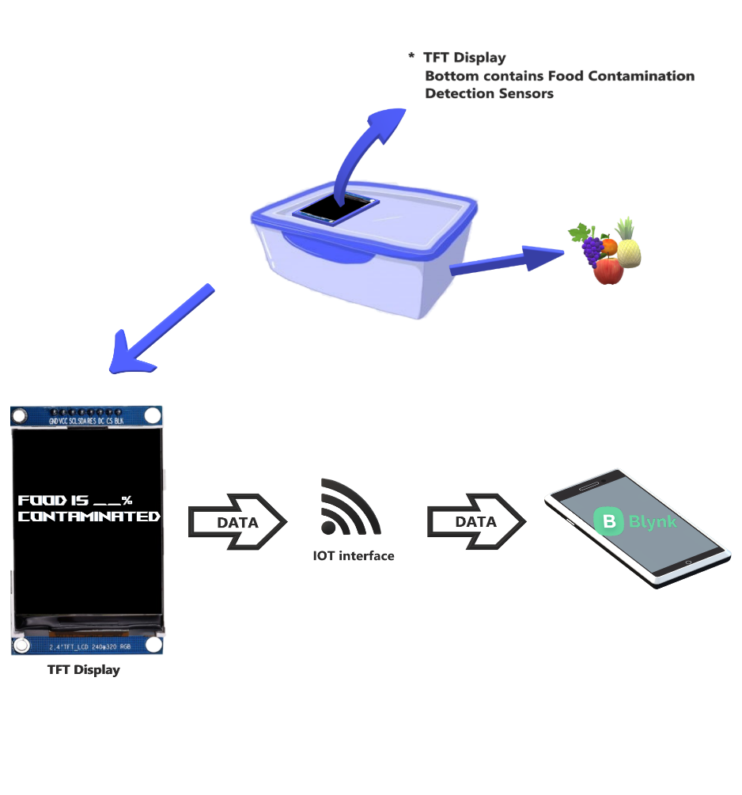

### Fig. 1

1. **CIRCUIT DIAGRAM**

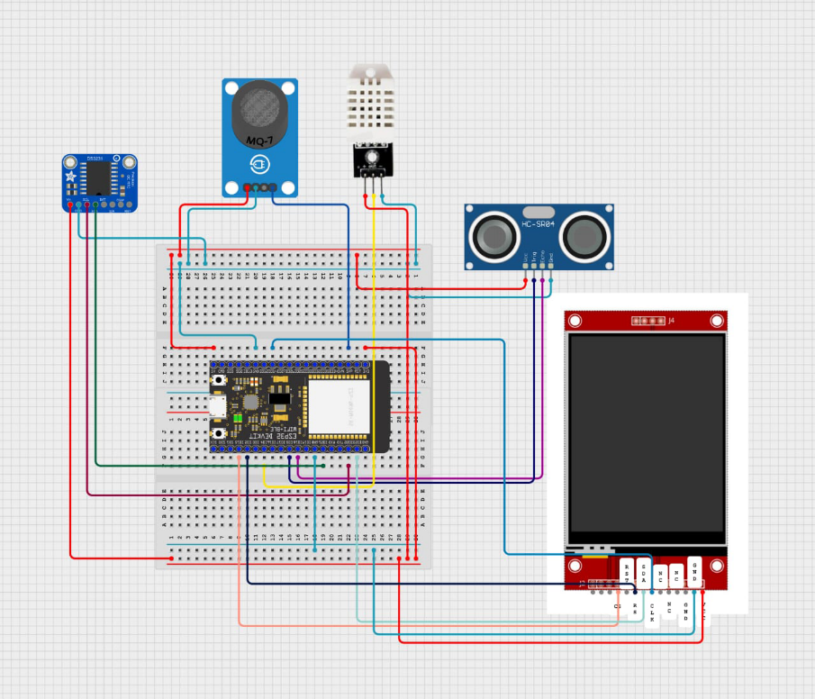

**Fig. 2**

1. **CONCLUSIONS**

The proposed IoT-based food storage monitoring system uses components such as the DHT22, ESP32, etc. to provide a comprehensive solution for food quality and food safety. The integrated sensors detect food conditions and the ESP32 microcontroller provides data processing and communication. The real-time food status monitoring is provided by the integrated LCD display and the LED alerts. The LCD display provides immediate feedback on the quality of the stored food items. The LED alerts allow users to take proactive measures to prevent the consumption of spoiled food items. The system can also send email alerts to notify users remotely about the status of stored food. The email alerts allow for timely action to be taken to prevent food spoilage. Not only does the proposed system address the immediate need for food quality monitoring, but it also promotes healthier consumption habits and reduces food wastage. The easy-to-use interface and proactive alerts empower consumers to make better food decisions, improving their well-being and overall health outcomes.

1. **NOVELTY**

IoT-based Food Monitoring System using Esp32 maintain food safety and reduce wastage by monitoring temperature, humidity, and methane gas levels in storage environments. The system utilizes sensors like the DHT22 for temperature and humidity, and the MQ4 for methane gas detection. The data is sent to Blynk for monitoring and can trigger email alerts if parameters exceed safe levels. The setup includes circuit diagrams, calibration procedures for sensors, and code snippets for implementation. It may be implemented across a variety of food supply chains due to its scalability and versatility. We expect to achieve even larger improvements in food quality, lower losses, and eventually support a more sustainable food environment as we continue to optimize and improve the system.

# REFRENCES

1. FOOD STORAGE MONITORING SYSTEM USING ARDUINO by V. AISHWARYA, G. NAGA SAI
2. AN ARDUINO SENSOR-BASED APPROACH FOR DETECTING THE FOOD SPOILAGE by Arun Kumar G.
3. Monitoring food storage humidity and temperature data using IoT by Asif Bin Karim, Md Zahid Hassan, Md Masum Akanda, Avijit Mallik.
4. FOOD SPOILAGE DETECTION AND ALERTING SYSTEM by G. Rama Krishna, G. Mani Kotaiah, K. Hanok, M. Ajay,G. Swami.
5. Food Monitoring System Using IOT by D.Venkata Lakshmi, N.Harshitha, S.V.R.Chaitanya, K.Madhu Babu.
6. FOOD QUALITY MONITORING SYSTEM BY USING ARDUINO by B.Ravi Chande , P.A.Lovina,G.Shiva Kumari.
7. Food Monitoring System Using Iot by Bhargavi Vijendra Sanga, Jayashree G R, Dr. Girish V.Attimarad.
8. IOT BASED FOOD SPOILAGE DETECTION SYSTEM USING ARDUINO by B. MOUNICA, CH. GAYATHRI DEVI, K. VISHNU VARDHAN, I.ANIL KUMAR, Dr. CHINMAYA KUMAR PRADHAN