**Review on Formulation and Evaluation of Toothpaste Using Clove**

**Kadam R.V., Waghmare K.D.,Dr.Garje S.Y.,Dr.Sayyad G.A.**

**Abstract**

Toothpaste, a gel or paste formulation, is utilized for oral hygiene maintenance alongside a toothbrush. While the toothbrush mechanically cleans, toothpaste incorporates excipients aiding in this process. This investigation focuses on assessing herbal toothpaste formulations. Various chemicals and preventive agents demonstrate efficacy in plaque control and oral disease prevention. Modern research aims to develop herbal toothpaste using ingredients such as clove and kalonji oil, known for their antibacterial and anti-inflammatory properties. Herbal toothpaste, comprising natural elements, garners greater public acceptance compared to synthetic, chemical-based formulations in contemporary oral care due their perceived safety and efficacy in combating dental caries and preventing other dental disorders.

**Keywords:** Natural toothpaste, formulation. Antimicrobial properties, Anti-inflammatory effects, Gingivitis prevention, Dentifrices formulation.

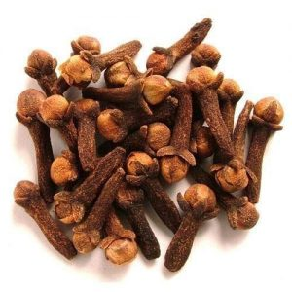

**Introduction**

The utilization of herbal and plant-based toothpaste dates back to ancient times and stands as a crucial component of oral health care practices. Toothpaste, a dentifrice, serves the purpose of cleansing teeth, maintaining their health, and enhancing their aesthetic appeal. Beyond mere oral hygiene maintenance, toothpaste acts as an abrasive agent, eliminating dental plaque and food particles from the teeth, thereby aiding in the prevention of halitosis and the release of active ingredients like fluoride to combat tooth and gum diseases such as gingivitis. Cloves, derived from the aromatic flower buds of the Syzygium aromaticum tree within the Myrtaceae family, are extensively used as a spice. Originating from Asia and South America, cloves are available throughout the year due to varying harvest seasons across different regions. Clove finds medicinal use in various forms including oils, dried buds, leaves, and stems, primarily applied directly to the gums for alleviating toothaches and dental discomfort. Predominantly cultivated in coastal regions below 200 meters in elevation, clove holds a significant place in Ayurvedic medicine, often referred to as "lavang." While commonly used in culinary preparations, clove oil boasts antibacterial, antiviral, anti-inflammatory, antidiabetic, and antioxidant properties. The oral cavity presents a diverse environment conducive to bacterial growth, with commensal bacteria playing essential roles in oral physiology. However, the proliferation of pathogenic microorganisms, particularly within biofilms, can lead to severe oral health issues. Streptococcus mutans, a primary oral colonizer, adheres to tooth surfaces, facilitating the adhesion of secondary colonizers like Lactobacillus species, thus contributing to oral infections and associated complications.

**Chemical Constituent**

The essential oil extracted from cloves primarily consists of eugenol, comprising approximately 72–90% of its composition, which imparts the characteristic fragrance to cloves. Complete extraction of this essential oil is achieved under pressure in water at 125 °C (257 °F), with the process requiring approximately 80 minutes to yield optimal results.

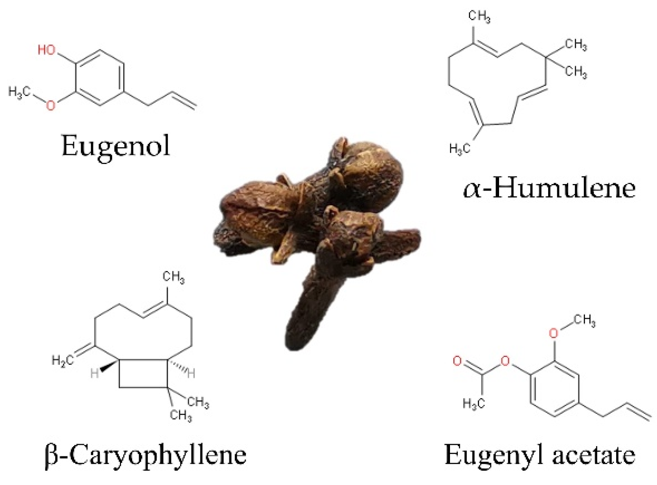

**Ideal Properties of Toothpaste**

1.Effective Abrasive Action

2.Gentle and Non-Irritating

3.Stain-Free Formula

4.Long-lasting Freshness and Cleanliness

5.Extended Efficacy

6.Cost-effective and Widely Accessible

**Materials and Methods**

A herbal toothpaste formulation was prepared using various ingredients: Calcium Carbonate for abrasiveness, Glycerin as a humectant, Sodium Lauryl Sulfate as a detergent and foaming agent, Peppermint Oil for flavoring, Sodium Benzoate as a preservative, and Sodium Saccharin as a sweetener. Additionally, an anti-inflammatory compound extracted from ginger oil was incorporated. The formulation process involved homogenization using a mortar and pestle to create the toothpaste base.

**Applications and Efficacy**

Anal Fissures: Preliminary studies suggest that applying a cream containing clove oil to anal tears for a duration of 6 weeks enhances healing compared to using stool softeners and lidocaine cream.

Plaque Reduction: Initial research indicates that the use of toothpaste or mouth rinse containing clove and other ingredients helps in reducing plaque buildup on the teeth.

**Method of Formulation**

Two primary methods are employed for toothpaste formulation:

1.Dry Gum Method

2.Wet Gum Method

**About Clove**

Synonym: Lavang

Biological Source: Clove is derived from the flowers and buds of the plants Eugenia caryophyllus and Syzygium aromaticum.

Family: Myrtaceae

Botanical Classification

Kingdom: Plantae

Sub Kingdom: Tracheobionta

Super Division: Spermatophyta

Division: Magnoliophyta

Class: Magnoliopsida

Subclass: Rosidae

Order: Myrtales

**Morphological characteristics:**

Clove exhibits a stalk and a head, with the head comprising four calyx. The upper section of the hypanthium contains a bilocular ovary. It is characterized by straight-walled cells and large anomocytic stomata. The oil glands are ovoid and schizolysigenous. Calcium crystals are present in numerous parenchymatous cells. While the clove itself does not contain starch, the mother clove does. Clove is of sesquiterpenoid nature.

**Uses-**

Clove serves various purposes including:

Carminative: Relieves flatulence and aids digestion.

Dental Analgesic: Alleviates toothaches and oral discomfort.

Stimulant: Boosts energy and promotes alertness.

**Forms of Clove:**

1.Clove is available in three primary forms:

2.Ground Cloves: These are less potent as most of the oil content has been removed.

3.Whole Cloves: Retaining some oil content, these cloves possess medium strength.

4.Clove Oil: The most potent form, often diluted with carrier oils for enhanced effectiveness, is the only form readily available.



**Conclusion**

The research conducted demonstrates the effectiveness of herbal toothpaste formulations, particularly those incorporating clove oil and kalonji oil to inhibit bacterial growth. These herbal toothpastes are vital for maintaining oral hygiene and preventing dental caries. Moreover, they are safer and have fewer negative effects compared to chemically based synthetic toothpaste alternatives. Herbal toothpaste is gaining recognition and acceptance in dental research due to its emphasis on safety and efficacy.

**Acknowledgement**

We express our sincere gratitude to our esteemed lecturers for their invaluable guidance and unwavering support throughout this research endeavor. Additionally, we extend heartfelt thanks to our parents for their constant encouragement and support.

**References**

1. WebMD. (n.d.). Clove. Retrieved from https://www.webmd.com/vitamins/ai/ingredientmono-251/clove

2. Mangilal, T., & Ravikumar, M. (2016). Preparation and evaluation of herbal toothpaste with commercial herbal toothpastes: An in-vitro study. International Journal of Ayurveda and Holistic Medicine, 6(3), 2266-2273.

3. Kew Science, Plants of the World Online. (2021). Syzygium aromaticum (L.) Merr. and L.M. Perry. Retrieved from https://www.kew.org/science/plants-of-the-world-online/plants/plant?id=201586

4. Katz, D. A. (2012). Toothpaste. All rights reserved.

5. Singh, K., Singh, P., & Oberai, G. (2016). Comparative studies between herbal toothpaste (dantkanti) and nonherbal toothpaste. International Journal of Dental Research, 4(2), 53-56.

6. Panda, S. K., & Sethi, A. (2020). Formulation and evaluation of a herbal toothpaste and compared with different marketed preparations. International Journal of Pharmaceutical Research and Applications, 5(2), 557-560..

7. Eugenol. PubChem, US National Library of Medicine. 2 November 2019. Retrieved 10 November 2019.

8 .Rovio, S.; Hartonen, K.; Holm, Y.; Hiltunen, R.; Riekkola, M.‐L. (7 February 2000). "Extraction of clove using pressurized hot water". Flavour and Fragrance Journal. 14 (6): 399–404. doi:10.1002/(SICI)1099-1026(199911/12)14:6<399::AID-FFJ851>3.0.CO;2-A.Wikipedia contributors. (n.d.). Clove. Wikipedia. Retrieved from <https://en.wikipedia.org/wiki/Clove>

9. Andres R. Sanchez, DDS, Roys. Rogers III, MD, and Phillip. J. Sheridan, DDS. Tetracycline-derived discoloration of dental enamel and the oral cavity. International Journal of Dermatology.

10. D. Mamatha, G. Naveen Kumar. Preparation, evaluation, and comparison of herbal toothpaste with commercially available counterparts. IOSR Journal of Pharmacy and Biological Science, 2017; Vol. 12, Issue 6: 1-6.

11. Dr. C.K. Kokate, A.P. Purohit, S.B. Gokhale. Terpenoids in Pharmacognosy. Pune: Dr. C.K. kokate; pp. 14.131-14.133.

12.Kankanam Gamage Chithramala Dissanayake, Waliwita Angoda Liyanage Chandrasiri, Ruwan Priyantha Liyanage. An overview of the medicinal applications of Zingiber officinale (Ginger). International Journal of Health Sciences and Research, 2020; Vol. 10, Issue 6: 142-148.

13 .Kavita Varma Shukla, Deepika Kumari. Development and assessment of herbal toothpaste for managing oral ailments. Journal of Drug Delivery and Therapeutics, 2019; 9(4-5): 98-104.

14. Kuldeep Singh, Pooja Singh, Gurpreet Oberoi. Comparative analysis of herbal toothpaste (Dantkanti) versus conventional toothpaste. International Journal of Dental Research, 2016; 4(2): 53-56.

15. Priyanka Sharma, Amit C Kharkwal, Harsha Kharkwal, M Z Abdin, Ajit Varma. A comprehensive review of the pharmacological attributes of Aloe vera. Int. J. Pharm. Science, 2014; 29(2): 31-37.

16. R.J. Reiter, S.A.Rosales-Corral, X.Y. Liu, D. Acuna-Castroviejo, G. Escames, D-X. Tan. Melatonin in the oral cavity: physiological and pathological implications. Journal of Periodontal Research, 2015; 50: 9-17.

17. Roshan Telrandhe, Pavan Deshmukh, Mahendra Gunde. Development and assessment of herbal toothpaste versus commercially available preparations. International Journal of Pharmaceutics and Drug Analysis, 2017; Vol. 5, Issue 10.

18. Sadeq-A. AL-Maweri, Mohammad Zakaria, Nader Alaizari, Butchibabu Kalakonda, Hashem M. Al-Shamiri, Mohammed N. Alhoji, Walid A. Al-Soneidar, Ahmed W. Alahmary. Comparative efficacy of Aloe vera mouthwash versus chlorhexidine on plaque and gingivitis: A systematic review. International Journal of Dental Hygiene, 2020; 18: 44-51

19. Davies R., Scully C., Preston A.J. Dentifrices: A Contemporary Overview. Med Oral Patol Oral Cir Bucal. 2010; 15 (6): 976-82.

20. Ersoy M., Tanalp J., Ozel E., Cengizlier R., Soyman M. Toothpaste Allergy: A Case Study. Allergolet Immunopathol. 2008; 36(6): 368-70.

21. Jardim J., Alves L., Maltz M. A Review of Oral Home-care Product Evolution and Global Market Trends. Braz Oral Res. 2009; 23 (1):17-22.

22. The Evolution of Toothpaste and Toothbrushes. Bbc.co.uk. 2013.Sheen S., Pontefract H., Moran J. Unveiling the Utility of Toothpaste: Assessing Its Efficacy in Plaque Control, Gingivitis Management, and More. Dent Update. 2001; 28(3):144-147.

23 .Dr. Nidhi Garg and Dr. Akhil Jain (2019) Therapeutic and Medicinal Applications of Clove: A Comprehensive Review. International Journal of Scientific Research. 8 (10); 2277-8179.

24. Jaiswal Sangeeta Manbodh, Choudhary Suhail Ahmed, Choudhary Sidra Eram (2021) Clove: A Versatile Spice and Its Diverse Utilizations. An Official Publication of Human Journals. 22 (1); 432-442.

25 .Brian P. Baker, Jennifer A. Grant, and Raksha Malakar-Kuenen. Cloves and Clove Oil: A Comprehensive Profile. Journal of Cornell Cooperative Extension. (1); 1-15.

26. D. Saikumari, S.K. Shiva Rani and Neeti Saxena (2016) Antibacterial Properties of Syzigium aromaticum L. (Clove). International Journal of Current Microbiology and Applied Sciences. 5 (11); 484-489.

27. Marwa Abd Elmonem Suliman, Fatma Galal Ahmed, Khaled Fahmy El-Kholy, Rehab Abd Elhay Mohamed and Lamiaa Fahmy Abdel-Mawla (2023) Impact of Clove (Syzygium aromaticum) on Growth Performance, Nutrient Composition, Digestibility, Blood Lipid Profile, Antioxidant Capacity, and Immune Response in Growing Rabbits. Online Journal of Animal and Feed Research. 13 (1); 01-09.

28. Shahid Hussain, Rafia Rahman, Ayesha Mushtaq, and Asma El Zerey-Belaskri. (2017) Clove: An Overview of a Valuable Species with Diverse Applications. International Journal of Chemical and Biochemical Sciences. 11; 129-133.

29. Suraj Maurya, Shashikant Maury, Piyush Yadav, Manoj Kumar Yadav, Vishal Prajapati (2021) Development of Clove Toothpaste Formulation. Journal of Prasad Institute of Technology. 8 (5); 315-318.

30. Mukesh Yadav, Piyush Yadav, Shradha Sahu, Vijay Yadav, Shyam Narayan Gupta (2021) A Literature Review on Clove. International Journal of Creative Research Thoughts. 9 (1); 1883-1888.

Top of Form

Top of Form

Top of Form

Top of Form