**PAPR Reduction for OFDM based IoT systems using Modified Selective Mapping**

Anjalee Chouhan1 , Dr. Nidhi Tiwari2

M.Tech Scholar1, Assistant Professor2

Dept. Of ECE, IET SAGE University, Indore(M.P)

***Abstract***—**Internet of Things (IoT) is an ecosystem of connected physical objects such as sensors, vehicles, equipments etc that are accessible through the internet. With increasing number of users, large data being generated and limited bandwidth available for systems, efficient multiplexing techniques are needed that use the available bandwidth efficiently. One of the most efficient multiplexing techniques available is the Orthogonal Frequency Division Multiplexing (OFDM). It is widely used in IoT based applications. One of the major challenges that OFDM suffers from is high value of Peak to Average Power Ratio (PAPR). This causes high Bit Error Rates and reduced Quality of Service. The proposed work uses a modified selective mapping technique and attains lower PAPR compared to previously existing work.**

***Keywords*:**-

**OFDM, PAPR-, High Power Amplifier, Clipping, Filtering SLM, PTS, Companding, Interleaving, Bit Error Rate (BER).**

**I. INTRODUCTION**

Internet of things (IoT) and industrial IoT has become one of the most important areas of current research for several applications. The diagram below explains the concept of IoT.



**Fig.1 Illustration of an IoT ecosystem.**

Internet of Things (IoT) is an ecosystem of connected physical objects that are accessible through the internet. Some applications of IoT are:

* Smart Cities.
* Healthcare
* Transportation
* Traffic Control
* Manufacturing
* Large Scale Automation
* Big Data Applications etc.

The major challenges of IoT based systems are:

* Increasing number of users, so need for more bandwidth.
* Limited Bandwidth availability.
* One of the techniques to address the above problems is using Orthogonal Frequency Division Multiplexing (OFDM) in IoT Based Systems.

1. **Need for OFDM in IoT**

Orthogonal Frequency Division Multiplexing or OFDM is a technique that works on the principle of orthogonality. The carriers or signals are mutually orthogonal and hence create no overlap. Using OFDM in place of FDM helps in accommodating more users or devices in the same available bandwidth.

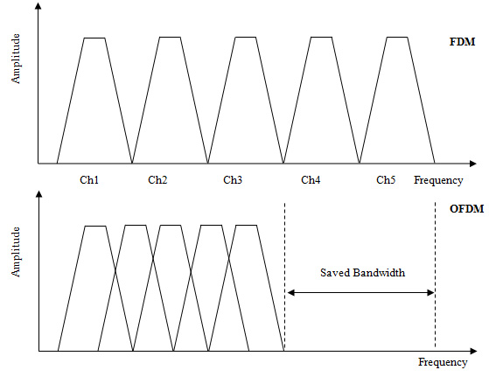

**Fig.2 Comparative Analysis of FDM and OFDM.**

The major advantages of this technique are high spectral efficiency and efficient digital implementation. The drawback lies in the fact that the amplitude variations of OFDM signals is large , which requires large back-off in the transmitter amplifier and hence

High Power Amplifiers (HPAs) are not efficiently used.In order to reduce the distortion caused by a HPA without setting it to large back-offs, several techniques have been introduced that limit the peak of the envelope of the signal (clipping)[1],[5], a problem that is usually referred to as peak-to-average power ratio (PAPR) reduction. These techniques have varying PAPR-reduction capabilities, power, and bandwidth and complexity requirements. PAPR is a very well-known measure of the envelope fluctuations of a multicarrier (MC) signal and plays a decisive role in the adoption of any particular technique. So the major problem with OFDM is high peak to power ratio or PAPR

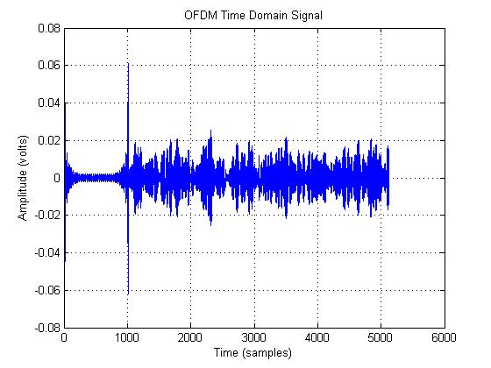

**Fig.3 OFDM Time Domain Signal**

The graph above shows the time domain OFDM signal. It can be seen that the signal has high peaks leading to high peak to average power ratio defined by:

**𝑃𝐴𝑃𝑅 = max {𝑥2( 𝑡) } / 𝑚𝑒𝑎𝑛{𝑥2( 𝑡) } (1)**

Where (𝑡) denotes the time domain OFDM signal.

The Complementary Cumulative Distribution Function (CCDF) is often used to analyze the magnitude of PAPR in an OFDM system, which is mathematically defined as:

**Probability (PAPR {x} > Y) =1 – (1-e-y)N(2)**

Here N is the number of sub-carriers,

Y is any arbitrary value of PAPR above which the possibility of attaining PAPR is evaluated. The CCDF plot clearly indicates the possibility of attaining PAPR greater than a particular PAPR value. Since the user data is random in nature, hence the modulated version of the OFDM signal is also random in nature. Hence probabilistic approaches need to be used for the analysis of PAPR.

1. **SELECTIVE MAPPING**

Selective mapping is the most fundamental and highly efficient technique to reduce PAPR. It provides a high performance as compared to normal OFDM. In this method set of m different symbols are generated of the same signal X and out of these m symbols the symbol with minimum PAPR is transmitted, which is given by:

Let the phase vector to be added to the OFDM signal be given by:

$B=\begin{matrix}p1 \\ p2 \\ \begin{matrix}⋮ \\ ⋮ \\ pn\end{matrix}\end{matrix}$**(3)**

The addition of the phase vectors will generate multiple copies of the signal given by:

$X=\begin{matrix}X1 \\ X2 \\ \begin{matrix}⋮ \\ ⋮ \\ Xn\end{matrix}\end{matrix}$**(4)**

The searching algorithm is to be used to find the following:

$K=\min{(PAPR1, PAPR2, PAPR3,…….PAPRn)}$**(5)**

**Min{PAPR(x(t)m} (6)**

The block diagram of the SLM technique is given below:

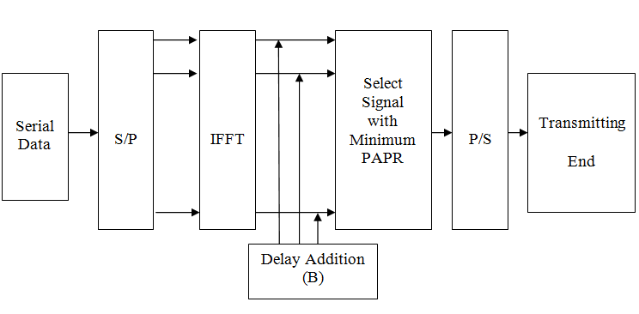

**Fig, 4 Block Diagram of SLM Technique**

The only disadvantage of SLM can be thought to be the increase in complexity in case more delay vectors are added which eventually increases the searching complexity. Each X block contain N wide variety of binary information, and those blocks are improved by means of one-of-a-kind phase sequence. These exclusive segment collection are termed as M. After multiplying with M distinctive stages a very changed information movement is acquired. This changed statistics circulate is implemented to the IDFT block which generates mutually orthogonal sub carriers and those sub carriers are modulated via the records movement. With out the IDFT blocks, N nearby oscillators could be wanted for generating N together orthogonal sub carriers which might in turn boom the complexity and electricity consumption of the gadget whilst making it cumbersome. The larger the wide variety of levels introduced, i.e. the bigger the period of the segment vector, extra is the PAPR discount capability.

1. **MODIFIED SELECTIVE MAPPING**

In the proposed selective mapping technique, the signal received after the selective mapping technique is analysed and residual peaks are found. The residual peaks are multiplied with an inverse sync function so as to reduce the residual peaks.

The selective mapping can be modified to remove residual peaks existent from the application of the SLM technique. This needs the concept of peak windowing. Peak windowing is a technique of detecting and removing residual peaks. This can be done using weighted functions. The function used in this case is the inverse sync function.

The sync function is mathematically defined as:

$sinc\left(x\right)=\frac{sin⁡(πx)}{(πx)}$**(7)**

A typical sync function resembles peaks in spectrum of the signal. Thus, if inverted sync functions are used, then it is possible to reduce the peaks in the windowed sections of the signal spectrum.

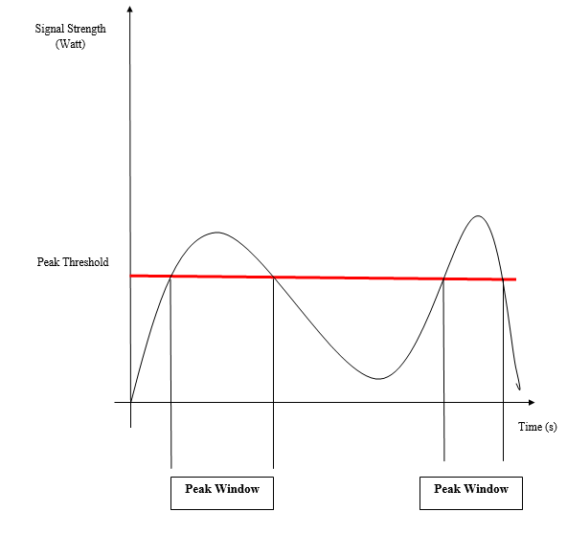

**Fig.5 Concept of Peak Windowing**

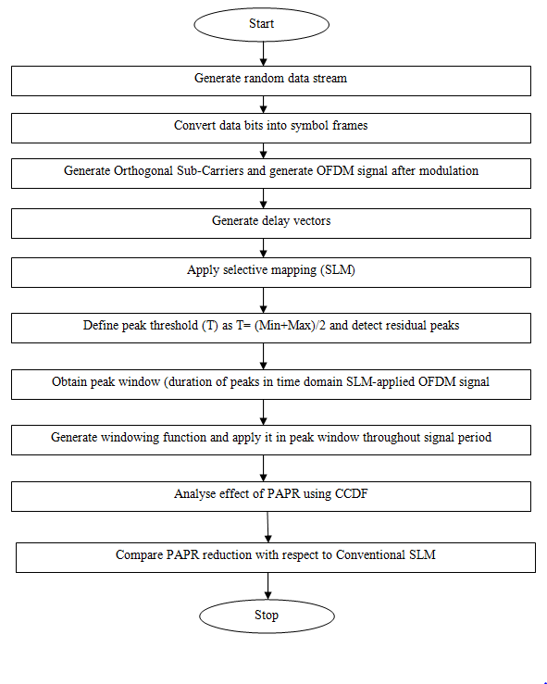

**Fig.6 Flowchart of Proposed Technique**

In the proposed scheme, an inverse sync window is multiplied with the residual peaks of the signal after SLM is applied. The inverted sync is chosen since it resembles the inverted peaks of a typical time domain OFDM signal. The inverted sync function is defined as:

**W=1-sinc(m)/π2.m2(8)**

The inverted sync function is shown in the figure below:

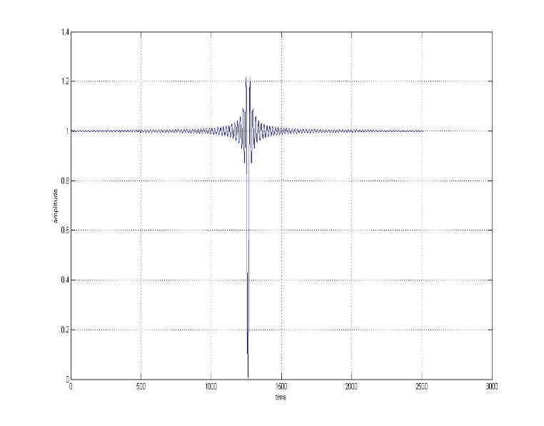

**Fig.7 Inverted sync windowing function.**

1. **RESULTS**

The results are analyzed using the CCDF curve and an earlier plummet or fall in the CCDF curve among two systems indicates that the PAPR has been reduced in the one with an earlier fall of CCDF or PAPR.

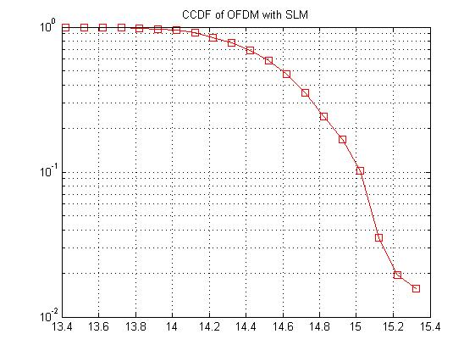

**Fig.8 CCDF of Conventional SLM**

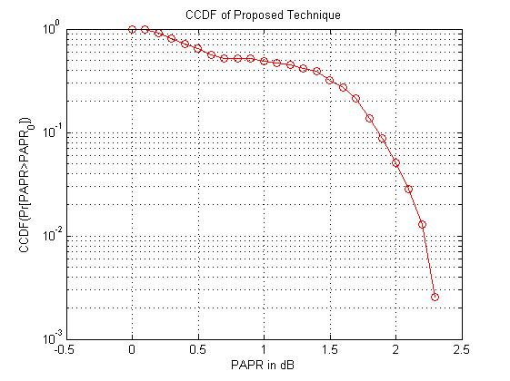

**Fig.9CCDF Proposed Technique**

A comparative analysis of the obtained CCDF of the PAPR for the various techniques is presented in table 1.

**Table 1. Comparative CCDF (PAPR) values for different techniques.**

|  |  |  |
| --- | --- | --- |
| **S.No.** | **Technique** | **PAPR value** |
| 1. | Original data stream | 21.5 |
| 2. | Clipping Approach | 17.8 |
| 3. | SLM | 15.4 |
| 4. | Windowed SLM | 3.4 |

It can be clearly observed from table 1 that the windowed SLM approach attains the highest PAPR reduction among all simulated approaches and hence the PAPR of the proposed approach has the least value of PAPR resulting in highest security.

Another important aspect of the SLM algorithm which needs to be investigated is the PAPR reduction capability of the algorithm as a function of vector length. It is tabulated in table 2.

**Table 2. PAPR variation with SLM vector length**

|  |  |  |
| --- | --- | --- |
| **S.No.** | **Vector length** | **PAPR value** |
| 1. | 2 | 9.5 |
| 2. | 4 | 8 |
| 3. | 8 | 7.1 |
| 4. | 16 | 6.3 |

Table 2 clearly shows the PAPR reduction capability of the SLM approach as the length of the phase vector increases.

The results of the proposed system clearly indicate the fact that the proposed system outperforms the clipping and the selective mapping based approaches in terms of the PAPR reduction capability.

**Conclusion**

**It can be concluded from the previous discussions and supporting results that the proposed technique is effective in reduction of OFDM based data transmission. A modification to the selective mapping technique has been proposed so as to reduce the PAPR of the system. The CCDF has been used for the analysis of the PAPR of the system. It can be seen from the results that the proposed system attains extremely low values of PAPR for OFDM based IoT systems**

**References**

1. Z. Xing, K. Liu, A. S. Rajasekaran, H. Yanikomeroglu and Y. Liu, "A Hybrid Companding and Clipping Scheme for PAPR Reduction in OFDM Systems”, IEEE 2022.

2. S. Lv, J. Zhao, L. Yang and Q. Li, "Genetic Algorithm Based Bilayer PTS Scheme for Peak-to-Average Power Ratio Reduction of FBMC/OQAM Signal”, IEEE 2021.

3. S. Gopi and S. Kalyani, "An Optimized SLM for PAPR Reduction in Non-Coherent OFDM-IM”, IEEE 2020.

4. MH Aghdam, AA Sharifi, “PAPR reduction in OFDM systems: An efficient PTS approach based on particle swarm optimization”, Elsevier 2019.

5. RS Suriavel Rao, P Malathi, “A novel PTS: grey wolf optimizer-based PAPR reduction technique in OFDM scheme for high-speed wireless applications” Springer 2019.

6. Zaid S. Al-Aubaidy, Saloa M. Ali,“ Low PAPR OFDM with Implicit Side Information and reduced Complexity for IoT Networks.”, IEEE 2018

7. Amber Sultan ,Xuelin Yang , Adnan A. E. Hajomer ,Weisheng Hu,“ Chaotic Constellation Mapping for Physical-Layer Data Encryption in OFDM-PON”, IEEE 2018

8. Adnan A. E. Hajomer , Xuelin Yang ,Weisheng Hu, “Chaotic Walsh–Hadamard Transform for Physical Layer Security in OFDM-PON”, IEEE 2017

9. Chongfu Zhang ,Wei Zhang , Xiujun He , Chen Chen ; Huijuan Zhang ; Kun Qiu, , “Physically Secured Optical OFDM by Employing Chaotic Pseudorandom RF Subcarriers”, IEEE 2017

10. Wei Zhang ,Chongfu Zhang ,Chen Chen ,Wei Jin ,Kun Qiu, “Joint PAPR Reduction and Physical Layer Security Enhancement in OFDMA-PON”,IEEE 2016

11. Wei Zhang ,Chongfu Zhang ,Wei Jin ,Kun Qiu ,Chen Chen,” Hybrid time-frequency domain chaotic interleaving for physical-layer security enhancement in OFDM based IOT systems”, IEEE 2016

12. Xiaonan Hu , Xuelin Yang , Zanwei Shen ,Hao He ,Weisheng Hu ,Chenglin Bai,” Chaos-OFDM based Partial Transmit Sequence Technique for Physical Layer Security in OFDM-PON”,IEEE 2015

13. Xuelin Yang , Xiaonan Hu ,Zanwei Shen ,Hao He ,Weisheng Hu ,Chenglin Bai, “Chaotic signal scrambling for physical layer security in OFDM-PON”,IEEE 2015

14. Bo Liu ,Lijia Zhang ,Xiangjun Xin ,Yongjun Wang,” Physical Layer Security in OFDM based on Dimension-Transformed Chaotic Permutation”, IEEE 2014

15. Wei Zhang ; Chongfu Zhang ; Wei Jin ; Chen Chen ; Ning Jiang ; Kun Qiu,” Chaos Coding-OFDM based IoT QAM IQ-Encryption for Improved Security in OFDMA-PON”, IEEE 2014