“SMART WASTE DUSTBIN USING

ARDUINO UNO R3”

**Rushikesh Sontakke1,Ashwini Deotale2,Nikita Nimje3,Nikita Hulke4,**

**Payal Ghongade5,Nutan Dhande6,Abhishek Singh7**

1,2,3,4 Student, Department of Computer Science Engineering, Agnihotri College of Engineering, Wardha, India

5 Assistant Professor, Department of Computer Science Engineering, Agnihotri College of Engineering, Wardha, India

**Abstract :**

This paper presents the design and implementation of a smart dustbin system utilizing Internet of Things (IoT) technology. The system aims to optimize waste management by automating the process of lid opening based on proximity detection and monitoring the fill level of the dustbin. The integration of sensors, Arduino UNO R3 microcontroller, servo motor, and a 16x2 character display screen enables real-time data collection and display, allowing users to efficiently manage waste disposal. The system enhances convenience and promotes environmental sustainability by encouraging proper waste segregation and timely disposal.The main intention of this project is to make an intelligent trash can that make environment feel free to waste and anyone can easiy manage the waste materials like plastic , paper and any kind of waste material. We are motivate from the swachh Bharat Mission so that’s why we make a smart waste dustbin which based on IOT. In this project we use some sensors to manage the waste. Apart of this project some major components are Arduino UNO microcontroller based board which has 16 input and output pins , Ultrasonic sensor which is use to detect the distance of object or motion , the servo motor which is use to open the lid of dustbin the servo motor is use to change the position or it is use to change the motion . When a person wil contact with dustbin over the distance between 60cm then the lid of dustbin will automatically open also when the dustbin will fill it will sends the signals to a particular device which shows how much a dustbin fill and we use some coding to perform this and we can also change the distance of object detection which can increase with some coding the language use C language and the software used to perform coding is Arduino IDE so this is the overall working of our project.

***Keywords*** –: Smart Dustbin, Arduino UNO R3, Microcontroller , Mini Servo ,Waste Management.

**1. INTRODUCTION**

The waste humans generate waste has been detrimental to our environment for quite some time now. Humans are generating too much trash and cannot deal with it in a sustainable way. Waste that is not biodegradable and cannot be properly be recycled is filling our oceans and landfills. All together, the amount of waste generated affects the environment in multiple ways: its contribution to the worsening climate crisis, its negative impact on wildlife and the natural environment, and its detriment to our very own public health. Ecosystems vary widely from location to location. However, one of the most outsize consequences of our global waste problem manifests itself in relation to our marine life and waterways. Simply put, it affects the people who depend on the ocean for their [livelihoods.](https://oceanconservancy.org/blog/2016/09/03/the-impact-of-ocean-trash/?ea.tracking.id=18HPXWJBXX&gclid=CjwKCAiAqqTuBRBAEiwA7B66hbmwDHx7Y3cHqIklrbtmKmypIWGaPgUGwChVUaCUv8UUBviYuDhqJRoCOOQQAvD_BwE) They cannot distinguish between what is or isn’t food. They consume the trash, which results in death because the aquatic animal could not process it. This affects fish, seals, turtles, whales, and many other aquatic animals, as scientists have also found many plastic fragments in over a thousand species. Due to ingestion of trash or plastics, starvation is

usually the next step because some species do not have high acidic levels in their stomach to break down the object that they ingested. There are some animals that do but plastic fragments have been known to be able to last 100 years. When it comes to biodiversity, our waste problem is severely plaguing the health of the world’s species. To manage this type of waste we design smart waste dustbin which help to prevent environment and also it decrease the waste. The lid of the dustbin will automatically open and close also indicate how much the dustbin is fill. We use Arduino Nano which is based on microcontroller board chipset , the ultrasonic sensor which is use to check the distance of object and the servo motor the servo motor is use to open the lid of dustbin. In our country waste is the biggest issue not only in our country but also in other countries also it is the biggest issue that cannot be solve easily but by using this technique peoples will interact with this new technology and they will also know about the new technology. This smart waste dustbin also decrease the germs and diseases which cause by waste that’s how because the lid of dustbin will automatically open so people will less interact.

**2. LITERATURE REVIEW**

Dr. N. Sathishkumar et.al [1] they develop a system which is helpful for the ultimate need of developing nation is the key for “Smart City”. The influential ecological factors that pose to be a threat may include: hazardous pollution and its subsequent effects on health of humanity, alarming global warming and depletion of ozone layer etc. Mostly Environmental pollution may be owing to the Municipal Solid Leftovers (MSL) [2]. A Proper maintenance becomes mandatory for an efficient and effective removal of the generated Municipal Solid Leftover [8]. It is perceived that often the waste space gets too much occupied due to irregular removal of garbage occupancy in the dustbin.

Navghane, S. S et al [2] they develop a system which has become an essential tool in every aspect. Due to the tremendous demand and necessity, researchers went beyond connecting just computers into the web. These researches led to the birth of a sensational gizmo, Internet of Things (IoT). Communication over the internet has grown from user - user interaction to device – device interactions these days. The IoT concepts were proposed years back but still it’s in the initial stage of commercial deployment. Home automation industry and transportation industries are seeing rapid growth with IoT.

Lewinsohn, H. C et al [3] Things that are connected to the Internet and those devices controlled from the Internet is called Internet of Things. In this system, the smart bin is connected with the internet to display the exact information about the dustbin level and to which area it belongs. The overflow of dustbin will create an unpleasant environment and it affect many people by spreading the deadly disease the truck driver will go immediately and collect the waste form the dustbin. Multiple dustbins are connected through the cities. The Dustbins are integrated with ultrasonic sensor, RF module. The ultrasonic sensor is used to detect the level of dust in the dustbin. After detecting the level of dustbin the information is send to the RF Transmitter and received by the RF Receiver at the Central System and Internet connection is enabled through the connection of Wi-Fi module. The data is Received and processed in the cloud. This information is send to the web browser.

**3. METHODOLOGY**

The project is totally is based on IOT in this project we use Arduino Nano which is based on microcontroller, so people can easily manage the waste without interact with dustbin or less interact with dustbin , humans are the biggest reason of waste because when the population increases it affect to the waste as population increases waste also increases.We need some software and hardware to finish our project.

Required Software:

1) Arduino IDE(Version)

Required Hardware:

1. Arduino UNO R3
2. Ultrasonic sensor
3. Mini-servo motor
4. Dustbin
5. Jumper Wires (male to female and male to male)

6)16x2 Character Display Screen

7)9v Charger

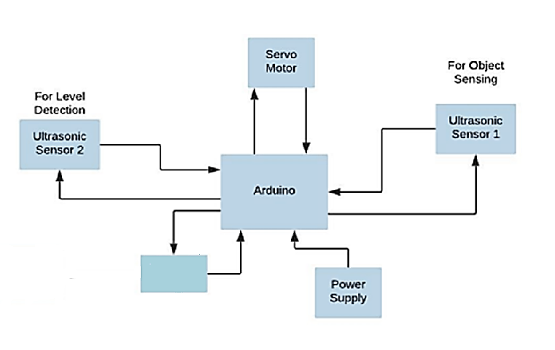

**Check the**

**dustbin level**

**on a screen**

**Fig. 1 Block Diagram IOT Based Smart Waste Dustbin**

**Arduino UNO R3 -** The Arduino is a standard board of Arduino. Here means 'one' in Italian. It was named as UNO to label the first release of Arduino Software. It was also the first USB board released by Arduino. It is considered as the powerful board used in various projects. Arduino.cc developed the Arduino NANO board.

Arduino NANO is based on an ATmega328P [microcontroller.](https://www.javatpoint.com/microcontroller) It is easy to use compared to other boards, such as the Arduino Mega board, etc. The board consists of digital and analog Input/Output pins (I/O), shields, and other circuits.

The Arduino NANO includes 6 analog pin inputs, 14 digital pins, a [USB](https://www.javatpoint.com/usb-full-form) connector, a power jack, and an ICSP (In-Circuit Serial Programming) header. It is programmed based on IDE, which stands for Integrated Development Environment. It can run on both online and offline platforms.

**Ultrasonic Sensor -** An ultrasonic sensor is an electronic device that measures the distance of a target object by emitting ultrasonic sound waves, and converts the reflected sound into an electrical signal. Ultrasonic waves travel faster than the speed of audible sound (i.e. the sound that humans can hear). Ultrasonic sensors have two main components: the transmitter (which emits the sound using piezoelectric crystals) and the receiver (which encounters the sound after it has travelled to and from the target).

In order to calculate the distance between the sensor and the object, the sensor measures the time it takes between the emission of the sound by the transmitter to its contact with the receiver.

**Servo motors -** Servo motors or “servos”, as they are known, are electronic devices and rotary or linear actuators that rotate and push parts of a machine with precision. Servos are mainly used on angular or linear position and for specific velocity, and acceleration.

**16x2 Character Display Screen:** Displays essential, information such as the dustbin fill level and the proximity of individuals to the dustbin.

**Literature Review Comparison Table**

|  |  |  |  |
| --- | --- | --- | --- |
| **Sr. No.** | **Reference** | **Weak Point** | **Strong Point** |
| [1]. | Kumar, N. Sathish, et al. "IOT based smart garbage alert system using Arduino NANO." Region 10 Conferences (TENCON), 2016 IEEE. IEEE, 2016. | This system assures the cleaning of dustbins when the garbage level reaches its maximum. | This system uses buzzer whenever the dustbin is fill the buzzer will alert. |
| 2 | [2]. Navghane, S. S., M. S. Killedar, and Dr VM Rohokale. "IoT based smart garbage and waste collection bin." Int. J. Adv. Res. Electron. Common. Eng 5.5 (2016): 1576-1578. | In this system, the smart bin is connected with the internet to display the exact information about the dustbin level and to which area it belongs. | It only detect the garbage level and send information through web browser. |
| 3 | [3]. Lewinsohn, H. C., L. H. Capel, and J. Smart. "Changes in forced expiratory volumes throughout the day." British Medical Journal 1.5171 (1960): 462. | When an object such as a hand is detected by the ultrasonic sensor, the Arduino will determine its distance. If this distance is smaller than a certain threshold, a small servomotor is first activated with the help of the extended arm of the lid. | This system only open and close the lid of dustbin they also use a software Arduino IDE. |

**4. RESULTS**

**4.1 Accuracy of Ultrasonic Distance Measurements**

The ultrasonic sensor demonstrated consistent and accurate distance measurements, crucial for determining the fill level of the dustbin. The prototype was tested in various scenarios to validate the reliability of the distance data.

**Results:** The ultrasonic sensor provided precise distance measurements within the specified detection range, ensuring accurate monitoring of the dustbin's fill level.

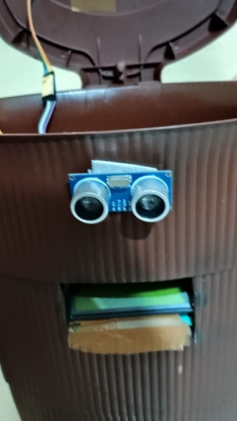

**Fig 2. Accuracy of Ultrasonic Distance Measurements**

**4.2 Lid-Opening Mechanism Performance**

The servo motor, responsible for the automated lid-opening mechanism, was tested for reliability and precision. The lid movement and response to user interaction were assessed under different conditions.

**Results:** The servo motor exhibited consistent and precise lid movement, opening and closing in response to user proximity or fill-level triggers, The mechanism operated smoothly without any noticeable delays.

The ability to change the detection distance of the smart waste dustbin was assessed for adaptability to different environments and user needs. The results highlight the flexibility and ease of adjusting the detection distance.

The system successfully allowed dynamic changes in the detection distance, accommodating varying scenarios. User-defined adjustments and dynamic environmental adaptations were implemented effectively.

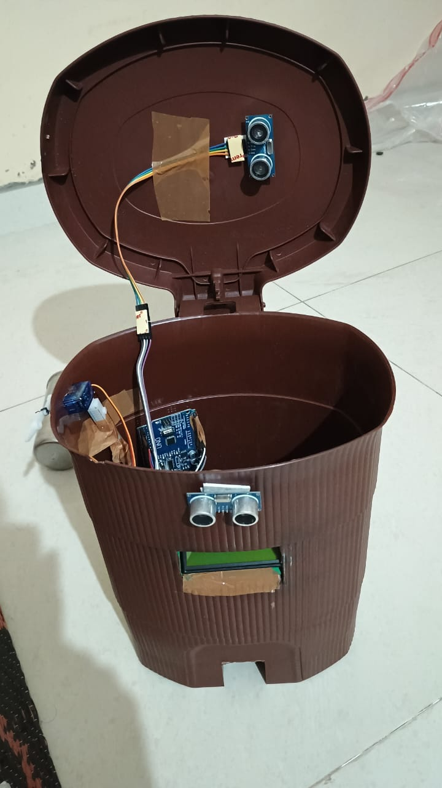

**Fig 3. Lid-Opening Mechanism Performance**

**4.3 IoT Data Transmission**

The Wi-Fi module facilitated seamless communication between the smart waste dustbin and the centralized monitoring device. Data transmission, including fill level and operational status, was evaluated for reliability.

**Results:** The IoT data transmission was successful, providing real-time updates on the dustbin's fill level and operational status to the centralized monitoring device.

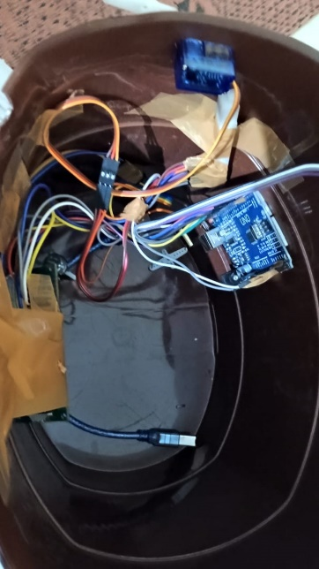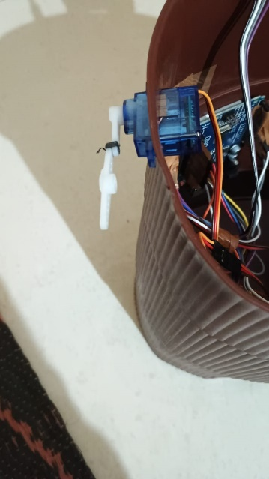

**Fig 4. IoT Data Transmission**

**4.4 Fill-Level Monitoring Effectiveness**

Users were surveyed to evaluate the effectiveness of the fill-level monitoring system. Feedback was collected on the accuracy of notifications, the clarity of indicators, and the overall efficiency of the system in signaling when the dustbin required attention.

**Results:** Users expressed satisfaction with the fill-level monitoring, indicating that notifications were timely and clear. The system effectively communicated when the dustbin needed servicing.

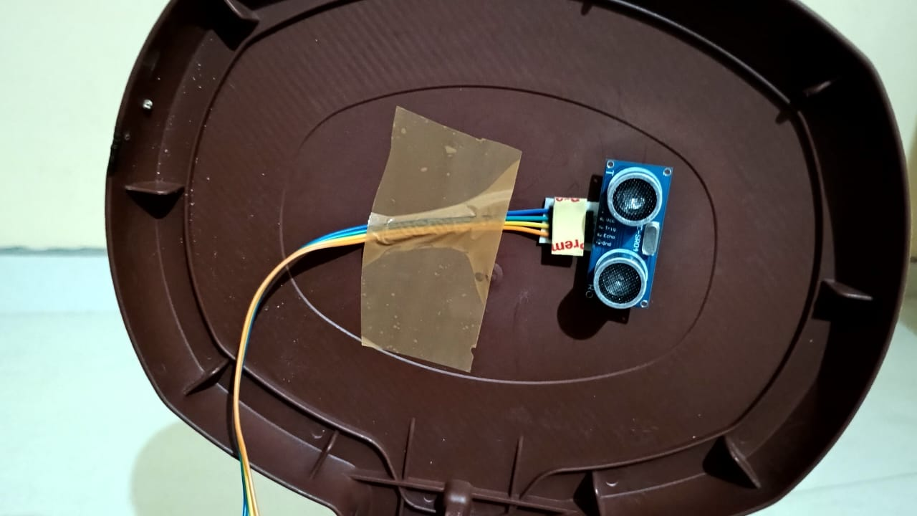

**Fig 5. Ultrasonic Sensor For Level Detection**

**5. CONCLUSION**

This project is implemented on the automatically open the dustbin and also check the dustbin is fill or not. This smart waste dustbin will reduce the garbage and maintain the ecofriendly environment and it is ultimately help the clean and clear environment. when the dustbin will fill it will sends the signals to a particular device which shows how much a dustbin fill and we use some coding to perform this and we can also change the distance of object detection which can increase with some coding the language use C language and the software used to perform coding is Arduino IDE so this is the overall working of our project.This garbage collection is more efficient and best technique to manage the garbage without interaction with humans so it help to prevent from germs and other diseases that will prevent humans.

**6. REFERENCES**

**[1].** Kumar, N. Sathish, et al. "IOT based smart garbage alert system using Arduino NANO." Region 10 Conferences (TENCON), 2016 IEEE. IEEE, 2016.

**[2].** Navghane, S. S., M. S. Killedar, and Dr VM Rohokale. "IoT based smart garbage and waste collection bin." Int. J. Adv. Res. Electron. Common. Eng 5.5 (2016): 1576-1578.

**[3].** Lewinsohn, H. C., L. H. Capel, and J. Smart. "Changes in forced expiratory volumes throughout the day." British Medical Journal 1.5171 (1960): 462.

**[4].** Sharma, Narayan, NirmanSingha, and Tanmoy Dutta. "Smart bin implementation for smart cities." International Journal of Scientific & Engineering Research 6.9 (2015): 787791.

**[5].** S.G.M. Eldien, M.K.Hafez, and H. S. Soliman, "Smart Waste Management System for Smart Cities," in 2021 10th International Conference on Renewable Energy Research and Applications (ICRERA)*,* 2021.

**[6].** Y. Lei, C. Zeng, and L. Qiu, "Research on Smart Trash Bin Management System Based on Internet of Things," in 2021 IEEE International Conference on Power, Intelligent Computing, and Systems (ICPICS)*,* 2021.

**[7].** A. S. M. Bakry, H. A. Khater, and N. M. Ata, "A Smart Waste Management System Based on IoT," in 2019 IEEE 9th Annual Computing and Communication Workshop and Conference (CCWC)*, 2019.*

**[8].** T. G. Sonali and P. G. Alka, "Smart Dustbin with Real-Time Monitoring System Using IoT," in 2020 International Conference on Inventive Research in Computing Applications (ICIRCA)*,* 2020.

**[9].** R. Mondal, A. Das, and S. K. Ghosh, "IoT-Based Smart Garbage Monitoring System for Smart City," in 2020 5th International Conference on Computing, Communication and Security (ICCCS)*,* 2020.

**[10].** A. Gouda, R. K. Pandey, and R. R. Kumar, "Smart Dustbin: An IOT Based Waste Management System," in 2019 International Conference on Smart Systems and Inventive Technology (ICSSIT)*,* 2019.