LIDAR Micro-Drone With Proximity Sensing
Ms. Shital Dharrao
Professor, Electronics and Telecommunication MVP'S Karamveer Adv. Baburao Ganpatrao Thakare College of Engineering, Nashik

Tanvi Bhamare
Student, BE Electronics and Telecommunication
MVP'S Karamveer Adv. Baburao Ganpatrao Thakare College of Engineering, Nashik

Tanuja Pagar
Student, BE Electronics and Telecommunication
MVP'S Karamveer Adv. Baburao Ganpatrao Thakare College of Engineering, Nashik

Vaishnavi Sonwane
Student, BE Electronics and Telecommunication
MVP'S Karamveer Adv. Baburao Ganpatrao Thakare College of Engineering, Nashik

---------------------------------------------------------------------***---------------------------------------------------------------------

Abstract –
The Lidar Micro Drone is an innovative unmanned aerial vehicle equipped with advanced sensors for proximity sensing and environmental data collection. This drone incorporates a VL53L0X sensor for precise distance measurements, enabling it to navigate and avoid obstacles with exceptional accuracy. Additionally, it integrates a DHT11 sensor to monitor temperature and humidity levels, providing valuable insights into the surrounding conditions. The inclusion of a BMP180 sensor enhances its capabilities by measuring atmospheric pressure, further enriching the data collected during flight. All these sensors are seamlessly connected to a Node MCU for data processing and transmission. The drone communicates its sensor data in real-time to a mobile application developed using Kodular, ensuring that users can access critical information effortlessly. Whether for applications in environmental monitoring, safety, or surveillance, the Lidar Micro Drone offers a versatile and powerful solution for proximity sensing and data collection, bridging the gap between advanced technology and user-friendly mobile interfaces.
1.INTRODUTION
Introducing the Lidar Micro Drone for Proximity Sensing, a cutting-edge aerial technology that combines a host of sensors to deliver precise and real-time environmental data. This micro drone is equipped with a VL53L0X sensor, a ESP32 Cam microcontroller, a DHT11 sensor for temperature and humidity monitoring, and a BMP180 sensor for atmospheric pressure readings. These components work in tandem to provide an array of crucial data points, all of which are seamlessly relayed to a mobile application created using Kodular. The star of the show, the VL53L0X sensor, is a state-of-the-art Lidar sensor that excels in proximity sensing. Its laser-based technology allows for highly accurate distance measurements, ensuring obstacle detection and avoidance during the drone's flight, making it an ideal choice for both indoor and outdoor applications. The ESP32 Cam microcontroller serves as the drone's brain, efficiently processing data from the sensors and enabling real-time communication with the mobile app. The addition of the DHT11 and BMP180 sensors enhances the drone's functionality. The DHT11 provides vital information about temperature and humidity levels in the drone's vicinity, which can be invaluable for environmental monitoring and control. Meanwhile, the BMP180 sensor contributes atmospheric pressure data, valuable for weather forecasting and altitude calculations. All these data streams are conveniently relayed to a user-friendly mobile application developed using Kodular, providing users with a holistic view of their surroundings. In a world where environmental data is increasingly important for various applications, the Lidar Micro Drone for Proximity Sensing sets a new standard for precision, convenience, and versatility, making it an indispensable tool for numerous industries and enthusiasts alike.
2.LITERATURE REVIEW
This work presents a concept of intelligent vision-less micro-drones, which are motivated by flying animals such as insects, birds, and bats. The presented micro-drone (named BAT: Blind Autonomous Tiny-drone) can perform bio-inspired complex tasks without the use of cameras. The BAT uses LIDARs and self emitted optical-flow in order to perform obstacle avoiding and maze-solving. The controlling algorithms were implemented on an onboard micro-controller, allowing the BAT to be fully autonomous. We further present a method for using the information collected by the drone to generate a detailed mapping of the environment. A complete model of the BAT was implemented and tested using several scenarios both in simulation and field experiments, in which it was able to explore and map complex building autonomously even in total darkness.[1]In this work, Vision-based obstacle size estimation algorithm and distance estimation based on the LIDAR (Light Detection and Ranging) sensor for autonomous navigation of MAV (Micro Aerial Vehicle) were proposed. First, the LIDAR sensor installed on the MAV was used to measure the obstacle distance. When the threshold distance between the MAV and the obstacle is equal to 1.5m, then the obstacle size (width and height) can be measured using the object images acquired using the camera sensor based on the proposed vision-based object size measurement algorithm. The collision can be avoided with the obstacle using the LIDAR sensor which works on time on flight principle, in addition to that based on obstacle's width and height with the tolerance of 0.01m, the MAV can change the flight route by either increase the altitude or roll/yaw. In addition, the proposed obstacle detection and collision avoidance algorithm implemented using the Raspberry Pi 3 flight controller can be used for real-time collision avoidance with obstacles.[2] This paper describes a lightweight obstacle detection system for Micro Aerial Vehicles (MAVs). This system is composed of multiple infrared (IR) proximity sensors interconnected through an open source development board. Standard methods for obstacle detection for UAVs commonly rely on sensory systems, such as, cameras and range finders. These sensors are usually very expensive. Moreover, their use is limited by both the payload and the computational resources available on the vehicle. By contrast, proximity sensors are cheap as well as lightweight. They can allow to detect the presence of objects in the nearby without any physical contact. We installed the system on a Parrot AR. Drone. This drone is a MAV with low payload capacity. Experiments in both simulation and real environments have been performed to test the effectiveness of our system. [3] This paper describes the implementation and the flight experiment result of the autonomous indoor proximity flight of a MAV (Micro Aero Vehicle) quadcopter. As the visual sensors for autonomous flight of the drone, light-weighted commercial products were used. For the flight control and visual sensor processing, several open software were used. After system structures are explained, the data processing procedures in software are explained briefly from the sensor input to the control of the drone. The flight simulation and real flight test were performed and their results are described.[4] Unmanned aerial vehicles (UAVs) are becoming popular in various applications. However, there are still challenging issues to be tackled, such as effective obstacle avoidance, target identification within a crowd, and specific target tracking. This paper focuses on dynamic target following and obstacle avoidance to realize a prototype of a quadcopter drone to serve as an autonomous object follower. An adaptive target identification system is proposed to recognize the specific target in the complicated background. For obstacle avoidance during flight, we introduce an idea of space detection and use it to develop a so-called contour and spiral convolution space detection (CASCSD) algorithm to evade obstacles. Thanks to the low architecture complexity, it is appropriate for implementation on onboard flight control systems. The target prediction is integrated with fuzzified flight control to fulfill an autonomous target tracker. When this series of technical research and development is completed, this system can be used for applications such as personal security guard and criminal detection systems.[5] Micro-drones can be integrated into various industrial applications but are constrained by their computing power and expert pilots, a secondary challenge. This study presents a computationally efficient deep convolutional neural network that utilizes Gabor filters and spatial separable convolutions with low computational complexities. An attention module is integrated with the model to complement the performance. Further, perception-based action space and trajectory generators are integrated with the model's predictions for intuitive navigation. The computationally-efficient model aids a human operator in controlling a micro-drone via gestures. Nearly 18% of computational resources are conserved using the NVIDIA GPU profiler during training. Using a low-cost DJI Tello drone for experiment verification, the computationally-efficient model shows promising results compared to a state-of-the-art and conventional computer vision-based technique.
3.METHODOLOGY
The proposed methodology for a LiDAR micro drone equipped with a VL53L0X sensor, a DHT11 sensor for temperature and humidity, and a BMP180 sensor for atmospheric pressure, reporting data to a mobile application developed using Kodular involves several key steps:Firstly, the hardware setup of the drone is crucial. The LiDAR sensor (VL53L0X), the DHT11, and the BMP180 need to be appropriately integrated into the drone's design, ensuring they are securely attached and connected to a microcontroller, such as a ESP32 Cam or a similar device.The VL53L0X LiDAR sensor will be utilized to provide proximity sensing capabilities, allowing the drone to detect and measure distances from obstacles or the ground. The data collected by the sensor will be communicated to the ESP32 Cam, which will act as the drone's central processing unit. In addition to proximity sensing, the DHT11 sensor will continuously monitor the temperature and humidity of the drone's environment, and the BMP180 will provide data on atmospheric pressure. These additional environmental parameters are essential for various applications, including weather monitoring, data analysis, and ensuring safe operation. The ESP32 Cam will collect data from all the sensors and compile it into a single dataset. It will then establish a connection with a mobile application, developed using Kodular, through a wireless communication protocol (e.g., Wi-Fi or Bluetooth). The mobile application will be designed to receive and display the data from the drone's sensors in a user-friendly and intuitive interface. The mobile application developed using Kodular will include features for real-time data visualization and storage. Users will be able to view the proximity data from the LiDAR sensor, temperature, humidity, and atmospheric pressure readings. Additionally, the app can log historical data and generate alerts or notifications in case of abnormal or critical readings.For enhanced functionality, the mobile application can also incorporate features such as remote control of the drone, flight planning, data logging, and data sharing. This can provide a comprehensive solution for both drone control and environmental monitoring in various contexts, including agriculture, research, and surveillance.It is important to conduct rigorous testing and calibration of the sensors and the entire system to ensure accurate and reliable data. Regular maintenance and software updates may be required to address issues or enhance the system's capabilities. Moreover, safety and privacy considerations should be taken into account when developing and deploying this technology.
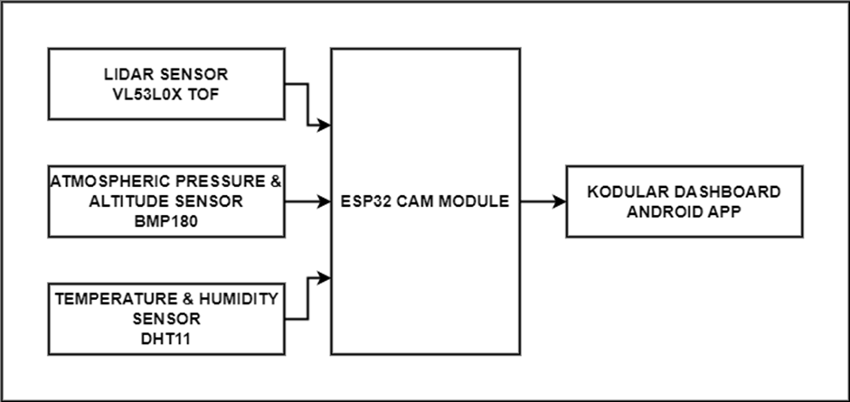
Fig. 1 Block Diagram
4.APPLICATIONS

They are used for a wide range of applications like aerial photography, surveillance, and agriculture.Drones have a wide range of applications in various fields. They can be used for aerial photography, surveillance and agriculture purposes.

Drones can be used for various purposes like monitoring the environment, search and rescue operations and disaster relief efforts. Drones can also be used to take photos or videos from an aerial perspective which is not possible with other equipment.

A drone is a flying robot that can be remotely controlled or self controlled.Drones are used for many tasks such as surveillance, military applications, and even for recreational purposes.Drones are used in the industries.

5.ADVANTAGES

Precise Proximity Sensing: The VL53L0X sensor is a time-of-flight (ToF) LiDAR sensor that provides highly accurate distance measurements, enabling the drone to navigate and detect obstacles with precision.
Real-time Data Collection: The combination of VL53L0X, DHT11, and BMP180 sensors allows the drone to collect and report real-time data on distance, temperature, humidity, and atmospheric pressure, making it versatile for various applications.
Environmental Monitoring: The DHT11 and BMP180 sensors provide valuable environmental data, which can be used for weather forecasting, environmental research, and indoor climate control.
Enhanced Safety: In applications where safety is a concern, such as search and rescue or industrial inspections, the drone can provide critical information about the surroundings, helping operators make informed decisions.
Automation and Remote Control: The drone can be programmed to operate autonomously or be remotely controlled through the mobile app, offering flexibility in its applications.
Data Logging and Analysis: Data collected by the sensors can be logged and analyzed over time, providing insights into trends and patterns that can be used for decision-making or research purposes
Versatility: The combination of sensors and mobile app integration makes this micro drone suitable for a wide range of applications, from agriculture and environmental monitoring to smart home systems and industrial automation.
Scalability: The system can be scaled up for more extensive data collection and monitoring by adding more drones or deploying them in different locations.
Cost-Effective Solution: Building a LiDAR micro drone with these sensors and ESP32 Cam can be cost-effective compared to specialized commercial solutions, making it accessible to hobbyists, researchers, and small businesses.

6.SIMULATION AND RESULT

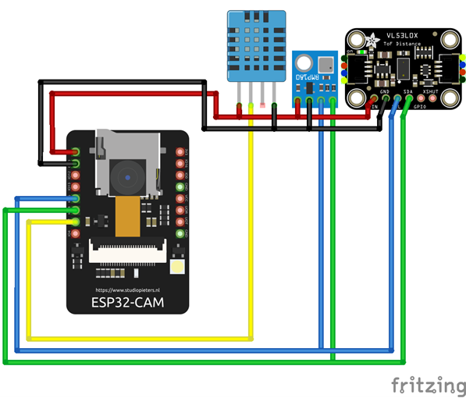

Fig. 3 Simulation

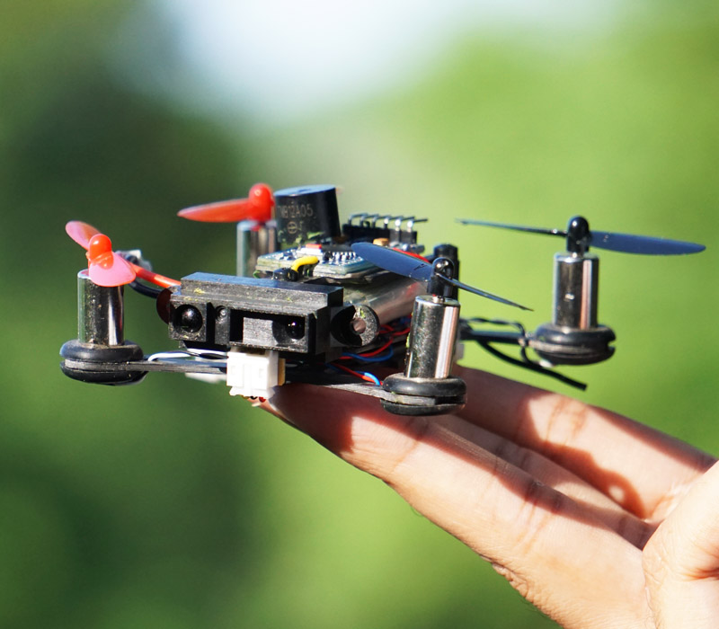

Fig. 4 Prototype

7.CONCLUSION

The development and utilization of a LiDAR micro drone equipped with a VL53L0X sensor, DHT11 for temperature and humidity sensing, and BMP180 for atmospheric pressure measurement, connected to a ESP32 Cam and linked to a mobile application created using Kodular, represents a significant advancement in proximity sensing technology. This innovative drone offers a versatile and highly precise solution for various applications, such as environment monitoring, infrastructure inspection, and industrial automation. The integration of the VL53L0X sensor facilitates accurate distance measurement, enabling the drone to navigate and interact with its surroundings effectively. Coupled with the environmental data provided by the DHT11 and BMP180 sensors, the mobile application receives comprehensive real-time information. This real-time data reporting feature is invaluable for making informed decisions and responding to dynamic environmental conditions. The LiDAR micro drone's capabilities open up possibilities for automation, safety, and data collection in a wide range of industries, from agriculture to construction. This technology not only enhances operational efficiency but also paves the way for more precise and sustainable solutions in a rapidly evolving world.
8. REFERENCES

1]Pikalov, Simon, et al. "Vision-Less Sensing for Autonomous Micro-Drones." Sensors 21.16 (2021).

2]Sakthivel, P., and B. Anbarasu. "Integration of vision and LIDAR for navigation of micro aerial vehicle." 2020 Third International Conference on Multimedia Processing, Communication & Information Technology (MPCIT). IEEE, 2020.
3]M. S. Uddin, "Low Cost Lightweight Obstacle Detection System for Micro Aerial Vehicles," 2019 IEEE 6th International Conference on Engineering Technologies and Applied Sciences (ICETAS), Kuala Lumpur, Malaysia, 2019.
4]Jang, Jong Tai, and Wonkeun Youn. "Autonomous indoor proximity flight of a quadcopter drone using a directional 3D lidar and VIO sensor." 2022 22nd International Conference on Control, Automation and Systems (ICCAS). IEEE, 2022.
5] Chen, Wen-Chieh, et al. "Quadcopter Drone for Vision-Based Autonomous Target Following." Aerospace 10.1 (2023).
6] Agyemang, Isaac Osei, et al. "Gesture Control of Micro-drone: A Lightweight-Net with Domain Randomization and Trajectory Generators." arXiv preprint arXiv:2301.12470 (2023).

