**Niosomes – A Targeted Drug Delivery System**

Adesh D. Kawarase1, Prof. Ankita P. Jatale2, Dr. Swati P. Deshmukh3

1)Shraddha Institute of Pharmacy, Washim

2)Department of Pharmaceutics.

3) Department Of Pharmacology.

**Abstract :**

Niosomes are multilameller vesicular structure of nonionic surfactants, similar to liposomes and are composed of non-ionic surfactant instead of phospholipids which are the components of liposomes. So, niosome or non-ionic surfactant vesicles are now widely studied as an alternative tool to liposome. Various types of surfactants have been reported to form vesicles, and have the capacity to entrap and retain the hydrophilic and hydrophobic solute particles. The niosomes have become the area of intrest in the drug delivery system their advantage one liposomes in the field of drug delivery system for being non-toxic makes them more suitable for drug delivery system. Their ability to encapsulate both hydrophilic , lipophilic drugs simultaneously has increased its demand in the present scenario. Niosomes are vesicles made up of non ionic surfactant,which are biodegradable, nontoxic ,more stable and inexpensive and have ability to substitute liposomes but they also flexibility in the routeof administration

**Keywords :** Niosomes, non- ionic surfactant, encapsulated, vesicles

**Introduction :**

Niosomes are multilameller vesicular structure of nonionic surfactants, similar to liposomes and are composed of non-ionic surfactant instead of phospholipids which are the components of liposomes. The presence of the steroidal system (cholesterol) improves the pressure of the bilayer and is vital factor of the mobile membrane and their presence in membrane affects bilayer fluidity and permeability. This provider system protects the drug molecules from the untimely degradation and inactivation because of undesirable immunological and pharmacological outcomes. In recent years, niosomes have been considerably studied for their capacity to serve as a carrier for the shipping of medication, antigens, hormones and other bioactive retailers. except this, niosome has been used to clear up the problem of insolubility, instability and speedy degradation of drugs. (1)

The idea of a drug-transport gadget refers to a procedure of administering pharmaceutical compounds at a predetermined fee to reap a therapeutic effect in humans or animals at a diseased website online, and on the equal time, reducing the attention of the medication in surrounding tissues. Localized drug motion enhances the efficacy of drug and decreases systemic toxic consequences to tissues. Paul Ehrlich proposed the idea of centered shipping immediately to the diseased cell with out unfavorable wholesome cells in 1909, and this strategy has been called the “magic bullet”. when you consider that then, a number of drug carrier systems have emerged, including immunoglobulins, serum proteins, artificial polymers, liposomes, microspheres, and niosomes. among those systems, liposomes and niosomes are nicely-documented vesicular drug delivery systems. In standard, a vesicular system is a drug-shipping platform that permits powerful bioavailability of medication through controlled launch of therapeutic capsules for a extended length. The vesicles consist of bilayer amphiphilic molecules that surround an aqueouscompartment. (2)

Niosomes are vesicles of nonionic surfactant (for example, alkyl ester and alkyl ether) and cholesterol that act as a carrier for amphiphilic and lipophilic drugs. Niosomes improve the therapeutic performance of encapsulated drug molecules by means of protective the drug from harsh biological environments, resulting of their not on time clearance.[3,4]

**Structure Of Niosomes :**

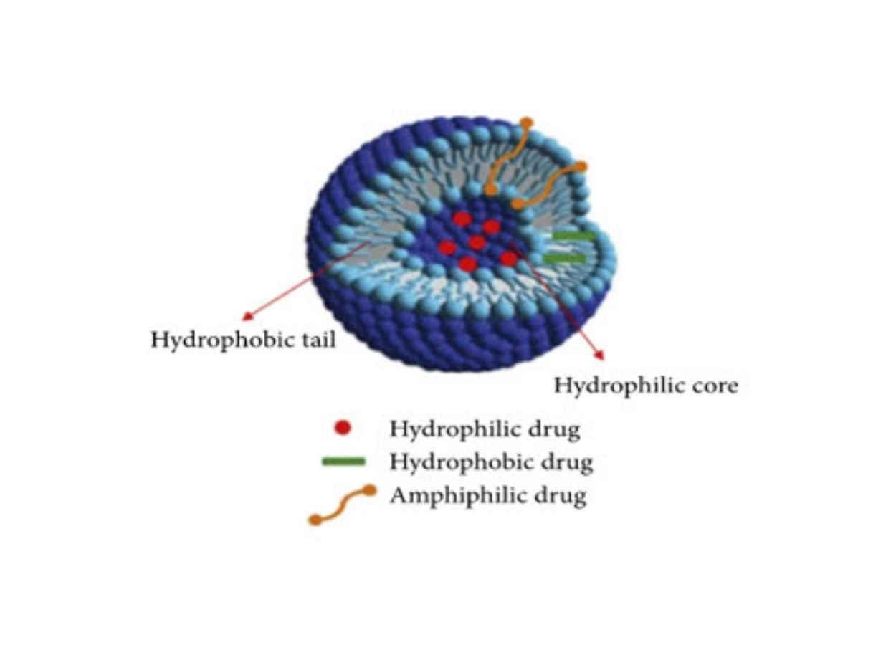

**Fig No.1 Structure Of Niosomes**

As compared to liposomes, niosomes, as shown in determine 1, are non-ionic vesicles which can be composed of two layers. Niosomes are chemically extra stable and much less costly than liposomes. The sizeable feature of the niosome structure is that they incorporate each a hydrophilic head and a hydrophobic tail. It approach they're capable of entrap a huge variety of drugs (hydrophilic and lipophilic) in their formation. Hydrophilic drugs are loaded into the aqueous core of the niosome, on the identical time that the lipophilic area of the bilayer includes lipophilic tablets [5,6].

**Compositions Of Niosomes:**

The two major components used for the preparation of niosomes are,

1. Cholesterol

2. Non ionic surfactants

**1) Cholesterols :**

Cholesterol is a steroid derivative used to impart rigidity and appropriate shape and conformation to the liposome preparation.

**2) Nonionic surfactants :**

Nonionic surfactantsare self-oriented in a two-layer lattice, where the polar or hydrophobic surface is arranged on the water body (between) and the hydrophobic head or hydrocarbon section thus assembled Interaction with the aquatic environment will be minimized. To ensure thermodynamic stability, each bilayer folds onto itself as a membrane, for example by forming a vesicle, so that the hydrocarbon/water interface is not exposed. The following types of nonionic surfactants are generally used to make vesicles. [7]

**Classification Of Niosomes :**

The niosomes are classified as a function of the number of bilayer (e.g. MLV, SUV) or as a

function of size. (e.g. LUV, SUV) or as a function the method of preparation.

The various types of niosomes are described below:

1)Multi lamellar vesicles (MLV, Size=>0.05 um)

2)Large unilamellar vesicles (LUV, Size=>0.10 um)

3)Small unilamellar vesicles (SUV, Size=0.025-0.05 um).

1)Multilamellar vesicles (MLV):

It consists of multiple bilayers surrounding aqueous lipid compartments. The diameter of these vesicles is approximately 0.5-10 microns. Multilayer vesicles are the most commonly used vesicles. These vesicles are well suited as drug carriers for lipophilic drugs. [8]

2)Large unilamellar vesicles (LUV):

This type of vesicle has a balanced water/lipid compartment and therefore allows the capture of large amounts of bioactive substances through the economical use of lipids. [9]

3)Small unilamellar vesicles (SUV):

Most small monolayer vesicles are prepared from multilayer vesicles by ultrasonic treatment, French press extrusion, and electrostatic stabilization with such hexadecyl phosphate in charged 5(6)-carboxyluciferin. (CF) In span-based vesicles. [9]

**Advantages Of Niosomes :**

1. Nanobodies increase the bioavailability of drugs by protecting them from acidic and enzymatic degradation in the intestinal tract, thus increasing the bioavailability of drugs

2. Due to its amphipathic structure, we can combine various drugs and use them in various medicines.

3. We can increase skin permeability by using nanobodies.

4. The therapeutic effect of drug molecules can be enhanced by slowing their elimination from the circulation.

5. Surfactants can be used and do not require special storage.

6. Vesicles serve as reservoirs from which the drug can be released in a controlled manner.

7. Patient compliance is often due to high fuel consumption.[10,11]

**Disadvantages Of Niosomes :**

1. There is more drug aggregation in it.

2. Some cause physical weakness.

3. The medicine inside the vesicles will leak.

4. Vesicle hydrolysis reduces the shelf life of encapsulated drugs.

5. Long preparation time.[12]

**Types of Niosomes:**

**1)Proniosomes**

Proniosomes are niosomal formulations containing a carrier and surfactant that require hydration before use. Hydration results in the formation of an aqueous dispersion of noisome. Proniosomes reduce the aggregation, leakage, and fusion problems associated with niosomal formulations. [13]

Carrier + surfactant = proniosomes

Proniosomes + water = niosomes

**2)Bola–surfactant niosomes**

Bola surfactant niosomes were prepared from omega-hexadecyl-bis-(1-aza-18-crown-6): span-80: cholesterol in a 2:3:1 molar ratio. Among them, omega-hexadecyl-bis-(1-aza-18-crown-6) is a surfactant. [14]

**3)Aspasomes**

Aspasomes The combination of ascorbyl palmitate, cholesterol, and the highly charged lipid diethyl phosphate leads to the formation of vesicles called aspasomes. Aspasomes are first hydrated with water/aqueous solution and then subjected to sonication to obtain niosomes. Aspasomes can be used to increase the transdermal permeability of drugs. Aspasome is also used to reduce diseases caused by reactive oxygen species due to its antioxidant properties. [15]

Aspasomes

↓

Hydration by aqueous solution

↓

Sonication

↓

Niosomes

**4)Discomes**

Discomes are large disc-shaped vesicles. The phase diagram of non-ionic surfactants exists only under certain conditions. When previously spherical vesicles were incubated for 1 h in a shaking bath at 24 and 74 °C, with different rates of respiration, discs of 11-60 μm in size were formed. Discoms are used as vehicles to deliver drugs to the eyes. Abdelkader et al. Ocular delivery formulations of naltrexone were prepared using a modified reverse phase evaporation technique. The temperature used for preparation is 60 °C, which is lower than the previously mentioned temperature and will therefore be beneficial for electrical equipment. [16,17,18]

**5)Elastic niosome**

They are made using nonionic surfactants, ethanol, and water. They can pass through pores that are larger than the vesicles found in the stratum corneum. They can be used to deliver low and high molecular weight drugs. Their effects last longer than vesicles and their penetration is weaker but depends on trans-epidermal hydration. Manosroi et al., 2013 prepared elastase niosome for scar treatment using Tween 61 and cholesterol in a chloroform/methanol (1:1) mixture. [19]

**6)Polyhedral niosomes**

Polyhedral vesicles are spherical vesicles but are not homogeneous. Polyhedral vesicles have approximately 4 to 12 equal sides. niosomes were prepared by mixing cetyl diglyceryl ether (C16G2) and inhaled C24 by Uchegbu and Florence, 1995 ; Uchegbu et al., 1997; and Uchegbu and Vyas, 1998. These can be prepared by adding small amounts of cholesterol to the mixture. Polyhedral niosomes can also be prepared by adding mixtures of C16EO5 and solan-C24 into low concentration of ethanol. [19]

**7)Vesicles in water and oil system**

These vesicles are formed by emulsifying aqueous vesicles in an oily system. If cooled to room temperature, the vesicle system turns into a gel. [20].

**Method Of Preparation:-**

**1)Ether injection method:**

This system provides a means of making niosomes by sluggishly introducing a result of surfactant dissolved in diethyl ether into warm water maintained at 60 °C. The surfactant admixture in ether is fitted through 14- hand needle into an waterless result of material. Vaporization of ether leads to conformation of single layered vesicles. Depending upon the conditions used the periphery of the vesicle range from 50 to 1000 nm. [21,22]

**2)Hand shaking method (Thin film hydration technique):**

Dissolve a mixture of surfactants and vesicle-forming components (e.g., cholesterol) in a volatileorganic solvent (diethyl ether, chloroform, or methanol) in a round-bottom flask. The organic solvent is removed using a field evaporator at room temperature (20 °C), leaving a thin layer of the mixture on the glass wall. The dry surfactant film can be rehydrated by gently mixing it with the aqueous phase at 0-60 °C. This process creates multilayered vesicles. Thermosensitive niosomes were prepared by evaporating the organic solvent at 60 °C, leaving a thin lipid film on the evaporator wall. Shake the bottle intermittently at room temperature, slowly add the aqueous phase containing the drug, and then perform ultrasonic cleaning. [22, 23]

**3)Sonication:**

One way to form vesicles is sonication of the solution as described by Cable. In this way, some of the solution is not added to the surfactant/cholesterol mixture in the 10 ml glass bottles. The mixture was sonicated for 3 min at 60°C using a sonicator with a titanium probe to form vesicles.[22, 24]

**4)Micro fluidization:**

Microfluidization is a new technology for the preparation of small-dispersion monolayer vesicles. This method is based on the submerged jet principle, in which two fluidizing flows interact at very high speeds in precisely defined microchannels in an intersection chamber. The impingement of thin liquid along the edge is a process that causes energy to enter the body while still in the area of vesicle formation. The result is to create vesicles with greater uniformity, smaller size, and better reproducibility.

**5)Multiple membrane extrusion method:**

Polycarbonate film placed up to 8 times in series. This is a good way to control niosomes size. The mixture of surfactant, cholesterol and hexadecyl phosphate in chloroform was evaporated to form a thin film. The film is hydrated with an aqueous solution and the resulting suspension is extruded up to 8 times in succession. This is a good way to address niosome size. [25]

**6)Reverse Phase Evaporation Technique:**

Dissolve cholesterol and surfactant (1:1) in a mixture of ether and chloroform. For this purpose, the aqueous phase with additives and the two resulting phases are treated with ultrasonic waves at a temperature of 4–5°C. The resulting gel is sonicated again after adding a small amount of phosphate-buffered saline (PBS). The organic layer was removed under reduced pressure and at a temperature of 40°C. The resulting vesicle suspension was diluted with PBS and heated in a water bath at 60°C for 10 min to form vesicles. There are also reports of using this method to prepare diclofenac sodium liposomes using Tween 85.[23]

**7)Trans membrane pH gradient Drug Uptake Process**:

Dissolve surfactant and cholesterol in chloroform. The solvent was then evaporated under reduced pressure to obtain a thin film on the wall of the round bottom flask. Wet the film by shaking it with 300 ml of citric acid (pH 4.0). Multilamellar vesicles were frozen and thawed three times and then sonicated. To extract vesicles, an aqueous solution containing 10 mg/ml solution was added and shaken to mix. The pH of the samples was then increased to 7.0–7.2 using 1M disodium phosphate. This mixture was heated at 60°C for 10 minutes to obtain niosomes. [26]

**8)The “Bubble” Method:**

This is a new technology for one-step preparation of liposomes and niosomes without the use of organic solvents. The frothing apparatus consists of a three-necked, round-bottomed flask in a water bath to control the temperature. Water-cooled reflux and thermometer are in the first and second neck, and nitrogen is entered in the third neck. Cholesterol and surfactant were eluted together in buffer (pH 7.4) at 70°C, and the dispersion was mixed with a high shear homogenizer for 15 s and immediately “sparperized” with nitrogen at 70°C. [27]

9)Formation of niosomes from proniosomes:

Another method of producing niosomes is coating with a water-soluble surfactant such as sorbitol. The result of the outer layer is dry structure. All water-soluble particles are coated with a thin film of dry surfactant. These preparations are called "Proniosomes". Vesicle body was determined by adding the aqueous phase at T > Tm and mixing briefly.

T = temperature. Tm = interphase transition temperature. [28]

**Conclusion:**

Nanobodies are a drug delivery system that can be used for the administration, delivery and distribution of drugs. There is interest in nanobodies due to their ability to encapsulate both hydrophilic and hydrophobic drugs. They can be used to encapsulate naturally occurring drugs, enzymes, peptides, genes, vaccines, antibiotics, and virtually any type of drug. They provide change not only in medication but also in management style. Their non-toxic properties make them suitable for drug delivery compared to liposomes. Therefore, it seems that research in the nanobodies business will increase and bring good business to the pharmaceutical industry.

**References:**

1. Rampal RAJERA, Kalpana NAGPAL, Shailendra Kumar Singh,* and Dina Nath MISHRA (2011) Division of Pharmaceutics, Department of Pharmaceutical Sciences, Niosomes: A Controlled and Novel Drug Delivery System, 34(7) 1-9.
2. Pei Ling Yeo, Chooi Ling Lim, Soi Moi Chye, (2017) Niosomes: a review of their structure, properties, methods of preparation, and medical applications, 11(4), 1-2.
3. Khan, R. and R.J.J.o.p.i. Irchhaiya, Niosomes: a potential tool for novel drug delivery. 2016. Page no. 195-204.
4. Ge, X., et al., Advances of non-ionic surfactant vesicles (niosomes) and theirapplication in drug delivery. 2019. 11(2): p. 55
5. Moghassemi, S. and A. Hadjizadeh, Nano-niosomes as nanoscale drug delivery systems: an illustrated review. J Control Release, 2014. 185: p. 22-36.
6. Marianecci, C., et al., Niosomes from 80s to present: the state of the art. Adv Colloid Interface Sci, 2014. 205: p. 187-206.
7. Vyas S. P., Khar R. K., “Targeted and Control Drug Delivery,” 1st ed.,Chap. 6, CBS Publishers and Distributors, New Delhi, 2002, pp.249—276.
8. Raymond C.R., Paul J.S., Sian C.O., 2006. Polyoxyethylene alkyl ethers. In: Handbook of Pharmaceutical Excipients, fifth ed. Pharmaceutical Press, London, pp. 564–571.
9. Okore, V.C., Attama, A.A., Ofokansi, K.C., Esimone, C.O., Onuigbo, E.B., 2011.Formulation and Evaluation of Niosomes. Indian J. Pharm Sci. 73 (3), 323–328.
10. Vadlamudi HC, Sevukarajan M. Niosomal Drug Delivery System-A Review. Indo American Journal of Pharmaceutical Research. 2012; 2(9).
11. Muzzalupo R, Tavano L. Niosomal Drug Delivery for Transdermal Targeting: Recent Advances, Research and Reports in Transdermal Drug Delivery. 2015:423-433.
12. Rageeb MD, Usman, Ghuge PR, Jain BV. Niosomes: A Novel Trend of Drug Delivery. EJBPS. 2017;4(7):436-442.
13. Rhodes D. G., Chengjiu H., Int. J. Pharm., 185, 23—35 (1999)
14. Junyaprasert V. B., Teeranachaideekul V., Supaperm T., AAPS PharmSciTech, 9, 851—859 (2008).
15. Gopinath D., Ravi D., Rao B.R., Apte S.S., Renuka D., Rambhau D.,Int. J. Pharm., 271, 95—113 (2004).
16. H. Abdelkader, S. Ismail, A. Kamal, R.G. Alany, Design and Evaluation of ControlledRelease Niosomes and Discomes for Naltrexone Hydrochloride Ocular Delivery, J. Pharm. Sci.100 (2011) 1833-1846.
17. H. Abdelkader, Z. Wu, R. Al-Kassas, R.G. Alany, Niosomes and discomes for ocular delivery of naltrexone hydrochloride: morphological, rheological, spreading properties and photo-protective effects, Int. J. Pharm. 433 (2012) 142-14418. A. Manosroia, P. Jantrawuta, J. Manosroia, Anti-inflammatory activity of gel
18. containing novel elastic niosomes entrapped with diclofenac diethylammonium, Int. J. Pharm. 360 (2008) 156-163.
19. Uchegbu and Florence, 1995; Uchegbu et al., 1997, and Uchegbu and Vyas 1998.
20. Gharbavi, Amani et al. 2018, Sharma, Kumar et al.(2019).
21. Rogerson A., Cummings J., Willmott N. and Florence A.T. The distribution of doxorubicin in mice following administration in niosomes. J Pharm Pharmacol. 1988; 40(5): 337–342.
22. Baillie A.J., Coombs G.H. and Dolan T.F. Non-ionic surfactant vesicles, niosomes, as delivery system for the anti-leishmanial drug, sodium stribogluconate J.Pharm. Pharmacol. 1986; 38: 502-505.
23. Raja Naresh R.A., Chandrashekhar G., Pillai G.K. and Udupa N. Antiinflammatory activity of Niosome encapsulated diclofenac sodium with Tween -85 in Arthitic rats. Ind. J. Pharmacol. 1994; 26:46-48.
24. Cable C. An examination of the effects of surface modifications on the physicochemical and biological properties of non-ionic surfactant vesicles. Glasgow: University of Strathclyde, 1989.
25. Khandare J.N., Madhavi G. and Tamhankar B.M. Niosomesnovel drug delivery system. The Eastern Pharmacist. 1994; 37: 61-64.
26. Maver L.D. Bally M.B. Hope. M.J. Cullis P.R. Biochem Biophys. Acta (1985), 816:294-302.
27. Chauhan S. and Luorence M.J. The preparation of polyoxyethylene containing non-ionic surfactant.Vesicles. J. Pharm. Pharmacol. 1989; 41: 6p
28. Blazek-Walsh A.I. and Rhodes D.G. SEM imaging predicts quality of niosomes from maltodextrin-based proniosomes. Pharm. Res. 2001; 18: 656-661.