**AUTO SERVICE ROBOT FOR CATERING**

**BUSINESSES USING ARDUINO MEGA 2560**

G.Sowmya, K.Afsiya Sulthana,G.Ayesha Farheen,B.Bhulakshmi**.**

**Department of Electronics and Communication Engineering**

**Santhiram Engineering College(Autonomous),Nandyal.**

Mail: sowmyaece87@gmail.com

**Abstract**

In today’s world the computerization innovation such as machine learning and mechanical technology play an progressively awesome part in regular life. At eateries clients confront a part of things due to swarming at top hours and inaccessibility of servers. By physical requesting prepare the clients squander their profitable time. These needs can be overcome by our plan "Automated WAITER”. It is utilized for requesting nourishment and cool drinks and conveying nourishment and refreshment drinks. The most imperative point of this automated server is it is a line taking after robot.

A Line Taking after Robot or automated server is an independent robot which is able to take after either a dark line that is drawn on the surface comprising of a differentiating dark colour. It is outlined to move naturally and take after the line. The robot employments clusters of optical sensors to distinguish the line, in this way helping the robot to remain on the track. The cluster of two sensor makes its development correct and adaptable and movable. The robot is driven by DC adapt engines to control the development of the wheels. The dc equip engine is driven by the engine driven circuit. This extend points to actualize the calculation and control the development of the robot by legitimate tuning of the control parameters and

in this way accomplish superior execution. It can be utilized mechanical robotized gear carriers, little family applications, visit guides in historical centers and other comparable applications, etc.

**INRODUCTION**

The field of independent robots is developing at a quick rate. Robots are finding their way into the world these days, extending from eateries to businesses. Independent robots are created to be vigorous sufficient to work next to people to carry out employments productively. Whereas they were in the works earlier to the COVID-19 widespread, request for contactless conveyance caused a boom. Covid-19 widespread has kept all the eateries and cafes to near their entryways to dine-in visitors. This episode may have restricted trade to numerous companies but if there is an elective to offer contactless benefit can avoid these businesses from going adrift. Mechanical conveyance administrations can guarantee contactless conveyance, a profoundly sought-after benefit beneath orders of social separating. For individuals to be able to appreciate their favorite nourishment at their favorite eateries, there is a require for contactless conveyance in the eateries. Independent robot is the ideal arrangement to this issue. Fundamental center of this investigate is room mapping on the robot's controller, most extreme weight that can be carried, robot summon calculation and nourishment conveyance with online requesting framework by means of site. Last objective of this ponder is to create a robot which can convey nourishment in a room. Infrared sensor was utilized to identify where the lines are and ultrasonic sensor was utilized to avoid the robot from smashing when moving from one point to another. There are too crisis frameworks in the frame of farther control, and an caution to alarm the client if the robot strays out of the line. The entire framework is controlled by a microcontroller.

Nourishment is the most basic need of people. So, cooking has turn into a principal prerequisite for human creatures. In cutting edge world, a differing qualities of cookware has been utilized by human and a apparatus utilized for cooking utensils is human hand. These days everyone commerce is raised and a keen kitchen framework has been pondered, still the cooking residential gadget that can cook itself is crucial. These days nourishment making gear is the exceptionally in vogue and about everybody require. Computerization prepare was presented to society for human welfare. Nourishment mechanization is the most fast-growing component. The Robotized nourishment creator instrument is an imaginative discernment in nourishment industrialized where it is planned to cook excess assortment of dishes. The quality and taste of nourishment may be shifted in individual to individual whereas planning. Some of the time the nourishment may be squandered due to ignorance of the amount arranged by human. But all these mistakes have been overcome by programmed machine. This programmed machine produces the same quality of nourishment all time. We can minimize mistakes and wastage of nourishment in case of an programmed machine. The machine gives quality nourishment, decrease in cooking time and less supervision is required by the client. An industry employments robotization prepare in case of generation of nourishment items over a expansive scale. Mechanization incredibly decreases the require for human physical and mental necessities. Directly, the purposeful of computerization in fabricating companies is to broaden the efficiency and lessening costs. For the most part, mechanization is routinely connected to boost the quality to a expansive degree in the fabricating prepare. The most imperative arrangement of Computerization in nourishment fabricating has been in upgrading the soundness, security and comfort of nourishment in preeminent buyer publicize.

Top of Form

If it is utilized on little scale at that point we can diminish the supervision time which we donate in ordinary cooking of our nourishment and we can diminish the chances of any mistakes which may alter the quality of nourishment which we are planning. If it is utilized on expansive scale it will decrease the generation time of nourishment items, quality is not compromised, labor fetched is diminished since there will be require of less supervision, so eventually businesses can pick up gigantic benefits by the offer assistance of computerization prepare. We can store endless number of nourishment items in the memory of machine for the generation and a legitimate cleanliness is kept up all through the handle.

**Literature survey**

**Energy conscious scheduling of a material handling robot in a manufacturing cell**

In cyclic planning of fabric taking care of robots in manufacturing cells, a common approach is to minimize the cycle time objective, which is a degree of the throughput of the cell. In a normal robot move cycle, robot move times constitute a noteworthy parcel of the cycle time. Amid taking care of operations, robots devour noteworthy sum of vitality, which is decided by their speed, stack and the separate they travel. In this paper, we propose considering robot speed choices along with robot move sequencing choices in a mechanical cell planning issue. We consider the trade-off between the cycle time and the vitality utilization of a robot in a automated cell which produces indistinguishable parts. In this cell, the robot loads and empties the machines. Each machine performs a diverse operation on a portion and the robot moves straightly along a track. We give models to discover proficient arrangements for cycle time and robot vitality utilization goals in an m-machine mechanical cell. In a case study for two machine automated cell, we appear that robot speed control can lead to noteworthy reserve funds in vitality utilization.

**Development of a new medical robot system for minimally invasive surgery**

Robot-assisted frameworks have been broadly utilized in negligibly obtrusive surgery (MIS) hone, and with them the exactness and precision of surgical strategies can be altogether moved forward. Advancing the advancement of robot innovation in MIS will move forward robot execution and offer assistance in handling issues from complex surgical methods. A therapeutic robot framework with a unused component for MIS was proposed to accomplish a two-dimensional (2D) farther middle of movement (RCM). An made strides surgical instrument was outlined to upgrade manipulability and dispense with the coupling movement between the wrist and the grippers. The control subsystem embraced a master-slave control mode, upon which a modern strategy with mistake recompense of tedious criticism can be based for the reverse kinematics arrangement. A one of a kind arrangement with less computation and higher palatable exactness was too gotten. Tremor filtration and direction arranging were too tended to with respect to the smoothness of the surgical instrument development. The robot framework was tried on pigs weighing 30-45 kg. The test comes about appear that the robot can effectively total a cholecystectomy and meet the requests of MIS. The comes about of the creature tests were fabulous, showing a promising clinical application of the robot with tall manipulability.

**Design of a low-cost indoor navigation system for food delivery robot based on multi-sensor information fusion.**

As the eatery industry is confronting labor deficiency issues, the utilize of feast conveyance robots instep of waiters/waitresses not as it were permits the clients to involvement the affect of robot innovation but moreover benefits the eatery trade fiscally by decreasing labor costs. Most existing supper conveyance robots utilize attractive route advances, which require attractive strip establishment and changes to the eatery stylistic layout. Once the moving way is changed, the attractive strips require to be re-laid. This think about proposes multisource data combination, i.e., the combination of ultra-wide band situating innovation with an odometer and a low-cost whirligig accelerometer, to accomplish the situating of a non-rail feast conveyance robot with route. By utilizing a low-cost electronic compass and whirligig accelerometer, the conveyance robot can move along a settled circle in a adaptable and cost-effective way with controlling control. Ultra-wide band (UWB) and track estimation calculation are combined by expanded Kalman channel (EKF), and the situating mistake after combination is almost 15 cm, which is acknowledged by eateries. In rundown, the proposed approach has a few potential for commercial applications.

**METHODOLOGY**

To accomplish the targets of the venture, our to begin with step was to distinguish the equipment and computer program necessities. For program prerequisites we recognized the inputs that would be required from the conclusion client to make an account and arrange nourishment. Different steps in computer program included making an account, selecting a table number, requesting nourishment, installments, arrange following. Along with arrange following we have too kept an choice for reservation and takeaway. This would offer assistance the restaurant's director to get it customers' prerequisites. Once the arrange was finalized, we chosen to utilize Wix site to make our webpage. For equipment prerequisites, we chosen to utilize Arduino mega 2560 since of the accessibility of computerized I/O pins and huge streak memory, which is the heart of the venture. Another was to recognize the different other components of the extend. A engine driver required to drive the engine which has a current dealing with capability of 30A, sensor required to examined the line and movement sensor to identify the nearness of an deterrent, a show screen to make the client encounter superior, OG 555 engine to drive the bulky robot. Meddle the components to the microcontroller was done step by step. A 12v to 5v buck converter is utilized to step down the voltage. The body of the robot was done with press fabric and plywood. We planned the shaft and the point for the engine mount and the base. In the nearness of an deterrent the robot will hold up for a indicated time and once more check for the impediment, if the impediment is once more found at that point the robot will bypass the deterrent and rejoin the past course. The engines will be controlled with PWM flag so the sudden twitch is dodged and there will be no nourishment falling. The robot utilized line supporter strategy to convey the nourishment, and a particular design will be drawn to identify the table number.

**Methodology**

**BLOCK DIAGRAM**

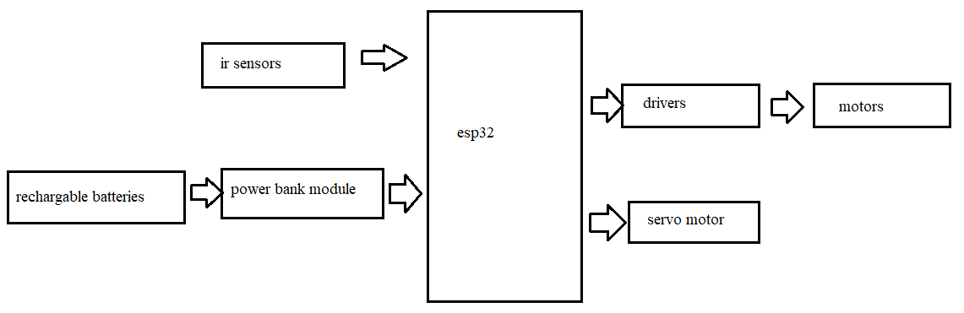

**Ir sensor**

Top of Form

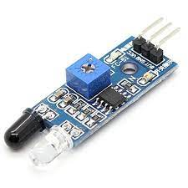

Top of Form

Bottom of Form

An infrared sensor (IR sensor) is a radiation-sensitive optoelectronic component with a ghostly affectability in the infrared wavelength extend 780 nm … 50 µm. In movement finders the IR sensors are presently broadly utilized, which are utilized in building administrations to switch on lights or in alert frameworks to distinguish unwelcome visitors and and utilized in farther controls .

**Robot body**

The robot's body is outlined in such a way that it can back the weights of the objects that are embedded in it, counting the battery, engine, components, motors, stack (nourishment), and other weights. The steadiness of the robot on its wheels serves as the premise for the external part's plan. Adobe Artist was utilized to plan the cage.

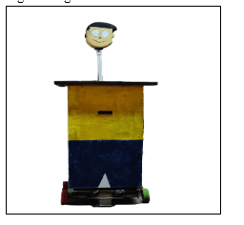

**B. Hardware**

The Orange OG555 12V 50 RPM DC engine is a lightweight, compact measured high-performance DC engine with a appraised torque of 346.8N-cm and a equip lessening of 180K having a 27mm long D molded shaft with a distance across of 6mm and a gap. The Input Voltage extend is from 6V to 15V and has a full stack current of 3.38A

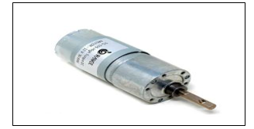

**Smart Motor Driver**

A engine driver takes the low-current flag from the controller circuit and amps it up into a high-current flag, to accurately drive the engine. Smarties Shrewd engine driver 15D is a double channel engine driver competent of providing 15 amps ceaseless with top streams up to 30 amps (10Sec) per channel. The Driver can be worked on radio control, analog, TTL serial and PWM modes.

Switching between any of 4 modes can be done with onboard 4 position DPDT mode switch. Onboard MOSFETs are exchanged at 16 KHz to guarantee calm operation. It has a microcontroller unit to give keen highlights such as numerous input modes and current restrain and warm security. The Driver is prepared with a temperature control include where If the temperature of the board comes to 80 degrees, at that point engine speed gets to be half and speed will be ordinary once the temperature comes to underneath 70 degrees. The engine driver will closed down at 100 degrees.

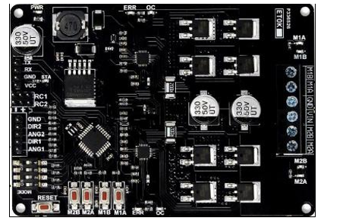

**Servo motor**

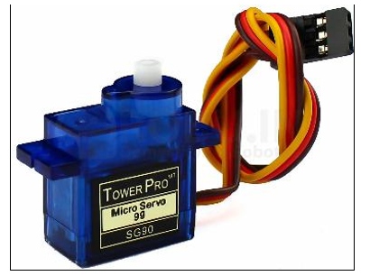

A servomotor is a rotational or straight actuator that permits for exact control of precise or direct position, speed and increasing speed comprising of a appropriate engine coupled to a sensor for position input. It requires a generally advanced controller, regularly a devoted module outlined particularly for utilize with servomotors. The Tower Pro SG90 is a advanced servo engine which gets and forms PWM signals, pivots 90° in each course (180° servo motor). It prepares modern inside circuitry that gives great torque, holding control and speedier upgrades in reaction to outside strengths. Its working voltage is 3.0V to 7.2V.

**Batteries**

Batteries are devices that store chemical vitality and change over it into electrical vitality through an electrochemical oxidation-reduction reaction. This response includes the exchange of electrons from one fabric to another by means of an electric circuit. In the battery the positive terminal is the cathode, and the negative terminal is the anode.

**MEGA 2560 R3**

The ATmel MCU ATMEGA16U2 MEGA 2560 R3 is a micro-controller board and it is based on the ATmega2560. To connect with Android based phones based on the MAX3421e IC used USB host interface to connect with Android based phones . The input/output pins has 54 digital input/output pins and 15 can be used as PWM output pins; 16 analog inputs; 4 UARTs (hardware serial ports); a 16 MHz crystal oscillator and a USB connection and a power jack and an ICSP header and a reset button. It can be powered with external power supply or via a USB connection. It features an ATmega8U2 program as a USB-to-serial converter.

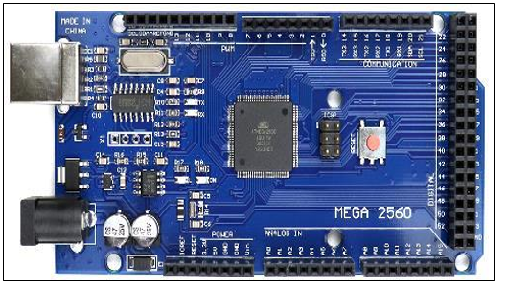

Esp32

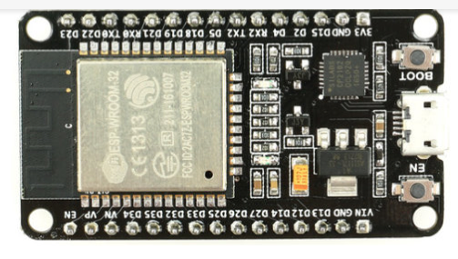

Microcontroller with built-in wireless networking and short power consumption; ESP32. It replaces the ESP8266, another low-cost Wi-Fi microprocessor with severely restricted capability. It has filters, low-noise amplifiers, power management circuitry, and an RF balun built right in. The total system requires a little footprint on the PCB. This board is compatible with TSMC's 40nm chip technology in order power and RF characteristics, and 2.4 GHz dual-mode WiFi as well as Bluetooth chips, making it suitable for a wide range of uses while remaining secure and dependable.

**Conclusion**

Lately in this modern technology world, people have started accepting robots as a part of their lives because it not only makes getting work easier but also the amount of time required is less. The ability and productivity of the robot is also more. Though there are many robots available all over country and cost has become a major factor to customers but our design of restaurant robot is cost efficient since we have used the concept of line follower to move the robot. The design used is very compact, comfortable and can be used in any restaurant and hotels. While serving food our design has ensured the almost safety factor for the robot. Restaurant is a place where family and friends come to have a fun time and to make their visit more enjoyable as well as memorable, robots are a different way to deliver food and beverage for the people. Our design also makes ordering and payment easy with just a few clicks on the button. Our automated robot waiter is a very useful solution to all types of restaurants and in future it can be enhanced more.

**References**

1. **[**1] E. O. P. Oni, J. P. Adefila and A. Dauda, “Small and Medium scale business (Restaurant): A career opportunity for Nigerian youths,” Arabian Journal of Business and Management Review (OMAN Chapter), vol. I, no. 10, pp. 28-44, May 2012.
2. [2] M. Tadashi, and D. Misaki. "Development of Japanese green tea serving robot" T- Bartender"." In Mechatronics and Automation, 2005 IEEE International Conference, vol. 2, pp. 1069-1074. IEEE, 2005.
3. [3] X. Chen, Y. Chen and J. Chase, “Mobile Robots- Past, Present and Future,” in Mobile Robots- State of the Art in Land, Sea, Air, and Collaborative Missions, Croatia, Intech Education and Publishing, 2009, pp. 1-32.
4. [4] M. Islam and M. Rahman, “Design and Fabrication of Line Follower robot,” Asian journal of Applied Science and Engineering, vol. II, no. 2, pp. 27-32, 2013.
5. [5] A. M. Rokonuzzaman, S. R. M.D and M. H. Mim, “Automated Restaurant Food Service Management system using a Line Follower Robot,” in International Conference on Mechanical, Industrial and Energy Engineering, Bangladesh, 2014.
6. [6] H. D. Chon, S. Jun, H. Jung and S. W. An, “Using RFID for Accurate Positioning,” Journal of Global Positioning Systems, vol. III, no. 1-2, pp. 32-39, 2004.
7. [7] K. Yelamarthi, S. Sherbrook, J. Beckwith, M. Williams and R. Lefief, “An RFID Based Autonomous Indoor Tour Guide Robot,” in Midwest Symposium on Circuits and Systems, Michigan, 2012.
8. [8] S. H. Reddy,B. Vangipuram and G. Vishal, “Line Tracking Pick and PlaceRobot Using RFID Technology,” International Journal of Advanced Research in Electrical, Electronics and Instrumentation Engineering, vol. 4, no. 10, pp. 8059-8063, 2015.
9. [9] L. P. Chuan, A. Johari, M. H. A. Wahab, D. M. Nor, N. S. A. M. Taujuddin and M. E. Ayob, “An RFID Warehouse Robot,” in International Conference on Intelligent and Advanced Systems, Malaysia, 2007.
10. [10] T. B. Huang, “An RFID Based Serving Robot,” Faculty of Electrical Engineering, University of Technology Malaysia, Malaysia, 2012.
11. [11] A. Abdulkareem, C. O. A. Awosope, S. A. Daramola and E. C. Nnorom, “Development of a programable Mobile Robot”, International Journals of Applied Engineering Research, vol. 11, no. 4, pp. 2314-2320, 2016. V. O. Matthew, S. I. Popoola, E. Adetiba, A. A.
12. [12] Atayero, “Cost-Effective Medical RoboticTelepresence Solution using PlasticMannequin”,International Journal of Electrical and Computer Science, vol. 7, no. 3, pp. 1212 1218.
13. [13] S. Smiley, “Active RFID vs. Passive RFID,” RFIDInsider, 4 March 2016
14. [14] Prejitha.CT , Vikram Raj.N, Harshavardhan Vibhandik,”Design of Restaurant Service Robot For Contact Less and Hygienic Eating Experiance”International ReasearchJournal of Engineering and Technology(IRJET) Volume:07,Issue:08,Aug 2020,e-ISSN:2395-0056,p-ISSN:2395-0072.
15. [15] Neelima Mishra, Dr. Dinesh Goyal, Dr. Ashish Dutt Sharma ‘’ Automation in Restaurants: Ordering to Robots in Restaurant via Smart Ordering System’’ Suresh Gyan Vihar University, Jaipur International Journal of Converging Technologies and Management (IJCTM) Volume 4, Issue 1, 2018 ISSN: 2455 –
16. [16] Neeti Malik et. al., “Serving Robot: New Generation Electronic Waiter”, International Journal of Engineering Science and Computing, Volume 6 Issue No. 4 April 2016.
17. [17] K. M. Hasan, Abdullah-Al-Nahid and A. Al Mamun, "Implementation of autonomous line follower robot," 2012 International Conference on Informatics, Electronics & Vision (ICIEV), Dhaka, 2012, pp. 865-869, doi: 10.1109/ICIEV.2012.6317486.
18. [18] Eksiri, Akkharaphong & Kimura, Tetsuya. (2015). Restaurant Service Robots Development in Thailand and Their Real Environment Evaluation. Journal of Robotics and Mechatronics. 27. 91-102.
19. **Sowmya et.al *“*VLSI IMPLEMENTATION OF TERNARY ADDER AND MULTIPLIER USING TANNER TOOL”,** JOURNAL OF PHARMACEUTICAL NEGATIVE RESULTS , VOLUME 13 ,SPECIAL ISSUE 5 ,2022
20. **Sowmya et.al“ENHANCED FIXED WIDTH BOOTH MULTIPLIER FOR IMPROVED ACCURACY”** JOURNAL OF PHARMACEUTICAL NEGATIVE RESULTS , VOLUME 13 ,SPECIAL ISSUE 5 ,2022
21. **Sowmya et.al“TEMPERATURE AND HUMIDITY SENSOR BASED AIR BLOWER CONTROLLER FOR FOOD DRYING”,** JOURNAL OF ALGEBRAIC STATISTICS, VOLUME 13, NO. 1, 2022, P. 869 – 876, ISSN: 1309-3452.
22. **Sowmya et.al *“*PACKET LOSS AWARE TRUST MANAGEMENT (PLATM) FOR IOT NETWORK** “,INTERNATIONAL JOURNAL OF ADVANCED SCIENCE AND TECHNOLOGY,VOL. 29, NO. 7S, (2020), PP. 5544-5550
23. **Sowmya et.al“TRUST AWARE ROUTING FOR WIRELESS SENSOR NETWORKS”,** ALOCHANA CHAKRA JOURNAL, PP-4283 TO 4289 JUNE 2020, 2231-3990
24. **Sowmya et.al“LABVIEW BASED TEXT DETECTION AND OBJECT RECOGNITION PROTOTYPE FOR THE BLIND AND THE DUMB PEOPLE**” JOURNAL OF EMERGING TECHNOLOGIES AND INNOVATIVE RESEARCH, VOL 6,ISSUE 5, PP-2255 TO 2258,(UGC)
25. **Sowmya et.al**“**MULTI-CONTEXT CLUSTER BASED TRUST AWARE ROUTING FOR INTERNET OF THINGS**”, JOURNAL OF MECHANICS OF CONTINUA AND MATHEMATICAL SCIENCES, VOL.-14, NO.-5, SEP - OCTOBER (2019), PP.396-418. DOI: [HTTP://DOI.ORG/10.26782/JMCMS.2019.10.00029](http://doi.org/10.26782/jmcms.2019.10.00029).
26. **Sowmya et.al“GRAPHICAL APPROACH FOR THE OPTIMIZATION OF MULTI-STANDARD SOFTWARE DEFINED RADIO (SDR) SYSTEMS USING VLSI**” JOURNAL OF EMERGING TECHNOLOGIES AND INNOVATIVE RESEARCH, VOL 6,ISSUE 2, PP-1148 TO 1152 ,FEB 2019(UGC)
27. **Sowmya et.al“PATIENT HEALTH MONITORING SYSTEM USING IOT**” JOURNAL OF EMERGING TECHNOLOGIES AND INNOVATIVE RESEARCH, VOL 6,ISSUE 1, PP-91-95, JAN 2019(UGC)
28. **Sowmya et.al“ PRIVACY AND SECURITY INVESTIGATION OF RFID AUTHENTICATION BASED ON ECC FOR IOT”**IN INTERNATIONAL JOURNAL OF PURE AND APPLIED MATHAMATICS SPECIAL ISSUE VOLUME 117NO 1091-952017**(SCOPUS INDEXED)**
29. **Sowmya et.al“INTEGRATED OPTICAL RECEIVER IMPLEMENTATION USING CMOS TECHNOLOGY**” JOURNAL OF EMERGING TECHNOLOGIES AND INNOVATIVE RESEARCH, VOL 5,ISSUE 10, PP-953-957,OCT 2018