**ANALYSIS OF DEGRADATION PROCESS OF MUNICIPAL SOLID WASTE IN ANAEROBIC BIOREACTOR USING MICROORGANISMS**

***Pawar Sachin Bhagawat 1, Khedkar Amit Trimbak2, Bahirat Sanket3, JoshiAditya 4, Prof. Shinde P.B5***

1,2,3,4 Student, Department Of Civil Engineering Vidya Niketan College of Engineering, Bota. 422602

5Lecturer, Department Of Civil Engineering, Vidya Niketan College Of Engineering, Bota. 422602

**ABSTRACT**

This study delves into the degradation dynamics of municipal solid waste (MSW) within anaerobic bioreactors, utilizing microorganisms for efficient waste breakdown. Through a thorough analysis, we evaluate key parameters influencing the degradation process, including microbial activity, temperature, and waste composition. Our aim is to uncover the microbial mechanisms driving MSW decomposition under anaerobic conditions, providing insights to optimize bioreactor performance. These findings have practical implications for enhancing the efficiency of anaerobic bioreactors in waste treatment facilities. Amid growing global concerns over waste management and environmental sustainability, our study contributes valuable insights to the evolving field of waste-to-energy technologies. The integration of microorganisms in anaerobic waste treatment processes offers a promising approach to mitigate the environmental impact of MSW while harnessing renewable energy resources.

***Keywords:*** Municipal Solid Waste, Anaerobic Bioreactor, Microorganisms, Waste Management, Renewable Energy, Sustainability.

**INTRODUCTION**

The escalating volume of municipal solid waste (MSW) poses a critical environmental challenge, necessitating innovative waste management strategies. Anaerobic digestion, facilitated by microorganisms, emerges as a promising approach for the sustainable degradation of MSW. This process involves the breakdown of organic matter in the absence of oxygen, yielding biogas as a valuable byproduct. As society increasingly gravitates towards eco-friendly practices, understanding the intricacies of MSW degradation within anaerobic bioreactors becomes imperative. This study investigates the dynamic interplay of microorganisms in the anaerobic decomposition of MSW, aiming to unravel the key factors influencing degradation efficiency. Insights garnered from this research not only contribute to optimizing waste treatment processes but also hold potential for harnessing renewable energy from organic waste streams. Furthermore, the rising global concern over environmental sustainability and the pressing need to mitigate the impact of waste on ecosystems underscore the urgency of exploring advanced waste treatment technologies. Anaerobic bioreactors, with their capacity to convert organic waste into biogas, stand out as a promising avenue for addressing both waste management and renewable energy needs. The microbial communities orchestrating the anaerobic degradation process play a pivotal role in determining the overall efficiency of these bioreactors. Understanding the intricate dynamics of these microorganisms and their response to various environmental factors is crucial for optimizing waste-to-energy conversion processes. This study aims to bridge existing knowledge gaps, shedding light on the nuanced interactions within anaerobic bioreactors and offering practical insights for enhancing the sustainability of municipal solid waste management practices. The inadequate disposal of municipal solid waste (MSW) poses a critical environmental challenge, necessitating sustainable and efficient waste management solutions. Anaerobic bioreactors offer a promising avenue for MSW treatment, but a comprehensive understanding of the degradation process involving microorganisms is lacking. Addressing this gap is crucial to optimize waste-to-energy conversion and minimize environmental impact.

**1.1 Process of Municipal Solid Waste in Anaerobic Bioreactor**

The process of municipal solid waste (MSW) treatment in an anaerobic bioreactor involves several key stages. It commences with waste collection from households and other sources, followed by sorting to remove recyclable materials like plastics, metals, and paper. Pre-treatment further breaks down large pieces and enhances organic material accessibility to microbial activity, often through shredding or grinding. The prepared waste is then loaded into the anaerobic bioreactor, a sealed, oxygen-free environment optimized for microbial digestion. Within the bioreactor, microorganisms, particularly bacteria, initiate the digestion process by breaking down complex organic compounds into simpler substances like methane and carbon dioxide. Generated biogas is collected and utilized as a renewable energy source for electricity generation, heating, or other applications. The residual material, called digestate, undergoes further treatment to remove contaminants and can be used as a nutrient-rich fertilizer for agricultural purposes. Throughout the process, monitoring and control systems ensure optimal conditions for microbial activity by managing parameters like temperature, pH, and retention time. Finally, any non-digestible materials or byproducts unsuitable for reuse or recycling are disposed of responsibly, adhering to waste management regulations and minimizing environmental impact. This comprehensive approach underscores the effectiveness of anaerobic bioreactors in sustainable waste management practices.

**1.2 Challenge of Managing Municipal Solid Waste (MSW)**

Managing municipal solid waste (MSW) offers a multidimensional problem caused by a number of linked elements. For starters, the world's constant increase in trash output, spurred by population expansion, urbanisation, and changing consumer habits, puts a pressure on current waste management systems. This growth needs novel ways for effectively handling bigger amounts of garbage. Second, the heterogeneous nature of MSW, which includes organic, inorganic, and toxic components, hampers management efforts. Different components need different treatment procedures, adding complexity to waste management solutions. Third, poor infrastructure and limited resources impede effective MSW management in many areas. Inadequate trash collection methods, antiquated processing facilities, and budgetary restrictions all hamper the adoption of comprehensive waste management procedures. Furthermore, incorrect waste management leads to environmental contamination and public health problems, necessitating a comprehensive strategy that incorporates waste management into overall environmental sustainability objectives. Furthermore, underutilization of recycling and resource recovery systems promotes landfill use and natural resource depletion. MSW management challenges are worsened by inadequacies in legal and regulatory frameworks, which result in uneven enforcement and noncompliance.

**LITERATURE REVIEW**

Quecholac-Piña and Xochitl (2020) delve into the degradation of plastics under anaerobic conditions, crucially examining the behavior of both conventional and biodegradable plastics. The study underscores the need for precise matching between plastic types and end-of-life conditions, cautioning against assumptions regarding anaerobic degradation. They emphasize the importance of sharing knowledge about biodegradable plastics' behavior in waste management systems to promote proper management practices. Krishna R. Reddy (2015) investigates the impact of degradation on the geotechnical properties of municipal solid waste (MSW) from Orchard Hills Landfill, USA. The study highlights significant changes in moisture content, organic content, bulk unit weight, and hydraulic conductivity during various degradation stages. It emphasizes the importance of considering degradation-induced changes in MSW properties in the design and analysis of bioreactor landfills. Trzcinski et al. (2009) explore the treatment of simulated Organic Fraction of Municipal Solid Waste (OFMSW) using an innovative anaerobic two-stage membrane process. Their study demonstrates the potential of anaerobic membrane bioreactor technology for effective solid waste stabilization, providing insights into optimizing anaerobic membrane bioreactor systems

.

Abrol (2018) focuses on waste settlement analysis in aerobic bioreactors, highlighting the impact of treated leachate recirculation on MSW degradation and settlement. The study underscores the effectiveness of treated leachate recirculation in enhancing MSW degradation and settlement in aerobic conditions. He (2005) investigates the biological degradation of MSW in a methanogenic reactor utilizing treated leachate recirculation, emphasizing the effectiveness of combined use of effective microorganisms (EMs) and methanogenic reactors in increasing MSW stabilization and gas production. Khobragade (2018) reviews methods to enhance the anaerobic degradation rate of MSW using microorganisms and leachate recirculation in bioreactor landfills. The review highlights the potential of inoculating MSW with lignocellulolytic fungi to enhance waste degradation and stabilization. Rendra (2010) studies the aerobic biodegradation of MSW in simulated bioreactor landfills, focusing on optimizing waste degradation through leachate recirculation and sludge addition. The study provides insights into adjusting operational parameters to influence MSW degradation efficiency in aerobic bioreactor landfills.

Rastogi (2014) reviews the anaerobic treatment of MSW in bioreactor landfills, emphasizing the significance of leachate recirculation in waste stabilization. The paper underscores the impact of leachate recirculation on organic degradation and subsequent waste stabilization in simulated bioreactors. Lakshmikanthan (2017) investigates a laboratory-scale anaerobic bioreactor treating mechanically biologically treated municipal solid waste (MBT-MSW), providing insights into the bioreactor's performance through experimental and modeling approaches. Xiao (2021) proposes an aerobic degradation model for landfilled municipal solid waste, considering various factors such as temperature, water content, and carbon to nitrogen ratio. The model accurately reflects the degradation laws of various substances under aerobic degradation conditions, offering insights for accelerated stabilization of aged landfills.Valencia Vázquez (2008) focuses on enhancing the stabilization of MSW in bioreactor landfills through systematic experimentation, identifying optimal conditions for waste degradation using leachate recirculation and sludge addition. Khalil and Gupta (2014) analyze the microbiological degradation of MSW in landfills for landfill gas (LFG) generation, highlighting the relationship between gas production, leachate composition, and solids decomposition. Slezak (2014) investigates the degradation of MSW in simulated landfill bioreactors under aerobic conditions, comparing the aerobic and anaerobic degradation processes. The study demonstrates the potential of aerobic landfills to achieve reduced emissions and positive impacts on climate protection through reduced methane emissions.

**2.1 Research Gap**

Although substantial study into many areas of municipal solid waste (MSW) management, there are some significant research gaps in the extant literature. One such gap is the need for extensive research that look at the long-term performance and scalability of novel waste management systems like anaerobic membrane bioreactors and aerobic bioreactor landfills. While some research have investigated the usefulness of these technologies in laboratory or small-scale settings, there is a scarcity of large-scale, long-term trials that may give reliable evidence on their practical feasibility and sustainability in real-world waste management situations. Furthermore, there is a need for study on the socioeconomic elements of MSW management, such as cost-effectiveness, stakeholder involvement, and the policy implications of deploying sophisticated waste treatment systems. Bridging these research gaps is critical for improving our knowledge of MSW management and creating effective solutions to the difficulties posed by rising waste production and limited disposal capacity.

**MATERIALS AND METHODS**

The study conducted enrichment experiments of aerobic and anaerobic ammonium oxidizing bacteria using various substrates such as fresh municipal solid waste (MSW), mined MSW, MSW slurry, and leachate from dumpsites in different types of reactors (preliminary, bench-scale, and large-scale). Landfill bioreactor experiments were carried out for in situ ammonia nitrogen removal using enriched biomass, and combined SHARON-ANAMMOX processes were evaluated for enhanced nitrogen removal. The material and methods encompassed reactor setup, operation, sampling techniques, and analytical methods for both enrichment and landfill bioreactor studies**.**

**4.1 Enrichment Studies of Aerobic and Anaerobic Ammonium Oxidising Bacteria**

Enrichment of AOB and AnAOB was carried out in different aerobic and anaerobic batch reactors. Fresh MSW (Organic fraction), mined MSW (partially degraded), MSW slurry and leachate were used as seed in enrichment reactors. Municipal solid waste (fresh and mined MSW) and leachate samples collected from a MSW dumpsite in Chennai, India, by manual excavation methods were used as seed for enrichment reactors.

**4.2 Experimental Setup**

Aerobic ammonium oxidizing bacteria enrichment was conducted in ten batch reactors: eight preliminary (100 mL), one bench-scale (2.5 L), and one large-scale (5 L) reactors operated for 30, 65, and 250 days, respectively. Reactors were aerated continuously using a BOYU air pump (U-9900, Germany) at 5 L/min with DO maintained around 1.0 mg/L. Nutrient addition included ammonium bicarbonate (50 mM) in the 5 L reactors.

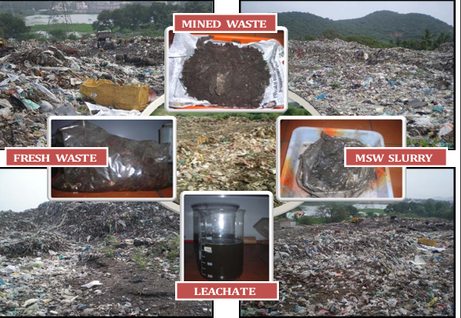

Fig 3. 1: Seed and substrate samples used in the study

**RESULT AND DISCUSSION**

This study presents and discusses the results of aerobic and anaerobic ammonium oxidizing bacteria (AOB and AnAOB) enrichment studies in various reactors (preliminary, bench-scale, and large-scale), in situ ammonia nitrogen removal in landfill bioreactor studies using enriched AOB and AnAOB biomass via SHARON and ANAMMOX processes, and enhanced nitrogen removal using combined SHARON-ANAMMOX processes in pilot-scale reactors.

**5.1 Characteristics of Seeds and Substrate**

The physico-chemical characteristics of four types of seeds of AOB and AnAOB such as fresh MSW, mined MSW, MSW slurry and leachate used for the preliminary enrichment studies is presented in Table 4.1. The fresh MSW and MSW slurry showed higher moisture content of 47% and 56%, respectively, when compared to the mined MSW (partially degraded) with 29%. Similarly, Karthikeyan et al (2007) reported higher moisture content for fresh MSW and lower moisture content for partially degraded MSW. Leachate contained only 0.7% of total solids with 50.3% of volatile fraction. The fresh MSW had higher volatile solids fraction (44% of TS) than mined MSW (21% of TS) and MSW slurry (17% of TS). Lechate had an organic load of 36000 mg/L and conductivity of 9540 µS/cm.

**Table 4.1 Physio-chemical characteristics of seeds used for enrichment studies**

|  |  |  |  |  |  |
| --- | --- | --- | --- | --- | --- |
| **Sr. No** | **Parameters** | **Enrichment seeds** | | | |
| **Fresh MSW** | **Mined MSW** | **MSW Slurry** | **Leachate** |
| 1. | Moisture content (%) | 46.7 | 29.3 | 55.7 | 99.3 |
| 2. | Total solids (%) | 53.3 | 70.7 | 44.3 | 0.7 |
| 3. | Volatile solids (%) | 44.2 | 21.0 | 16.7 | 50.3 |
| 4. | pH | 8.4 | 7.5 | 7.3 | 7.4 |
| 5. | Conductivity (µS/cm) | 3520 | 1321 | 1270 | 9540 |
| 6. | Water soluble Ammonia-N (mg/kg) | 240 | 124 | 218 | 350 mg/L |
| 7. | Water soluble Nitrate-N (mg/kg) | 123.0 | 44.6 | 30.0 | 20.0 mg/L |
| 8. | Water soluble Nitrite-N (mg/kg) | 0.1 | 3.6 | BDL | 3.0 mg/L |
| 9. | Water soluble COD (mg/kg) | 10000 | 6000 | 5000 | 36000 mg/L |

The physico-chemical analysis revealed that fresh MSW exhibited higher organic load and ammonia nitrogen content compared to mined MSW, MSW slurry, and leachate. However, nitrate nitrogen levels were within a similar range across samples, except for fresh MSW. Nitrite nitrogen was uniformly low in all samples. The pH ranged from 7.3 to 8.4, indicating favorable conditions for microbial activity. Mined MSW samples showed minor variations in characteristics, attributed to different locations and sampling times. Despite these variations, mined MSW demonstrated suitable physico-chemical characteristics, including moisture content, solids content, organic carbon content, and inorganic nitrogen content, making it conducive for AOB and AnAOB enrichment and landfill bioreactor studies. This suggests that mined MSW serves as an optimal seed and substrate for the conducted enrichment and bioreactor studies.

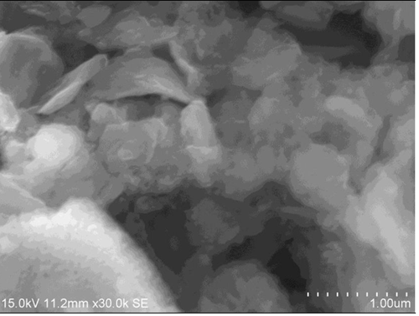

**Figure 4.1 SEM image of the mined MSW**

**5.2 ENRICHMENT OF ANAEROBIC AMMONIUM OXIDISING BACTERIA (AnAOB / ANAMMOX) IN BATCH REACTORS**

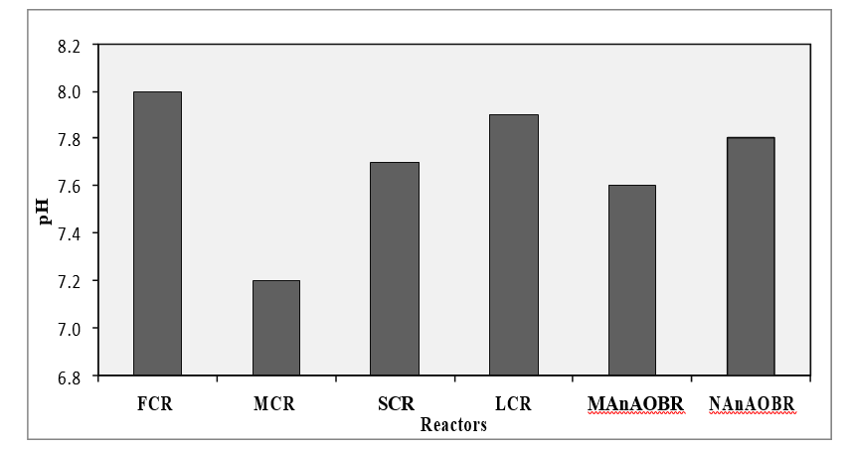

**Figure 5.1 Variations in pH among AnAOBs enrichment reactors**

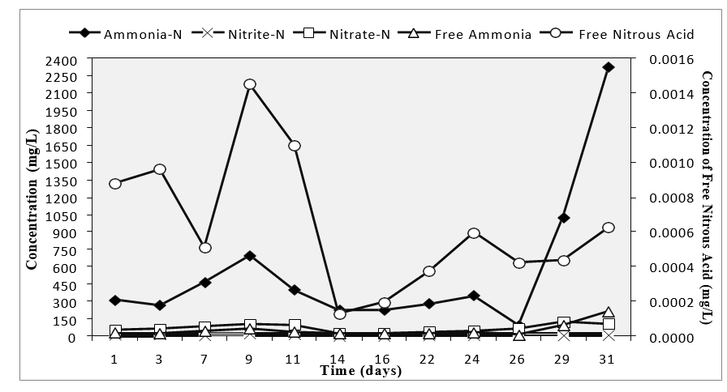

**Figure 5.2 Nitrogen transformation profiles during AnAOBs enrinchment in preliminary reactors with fresh MSW**

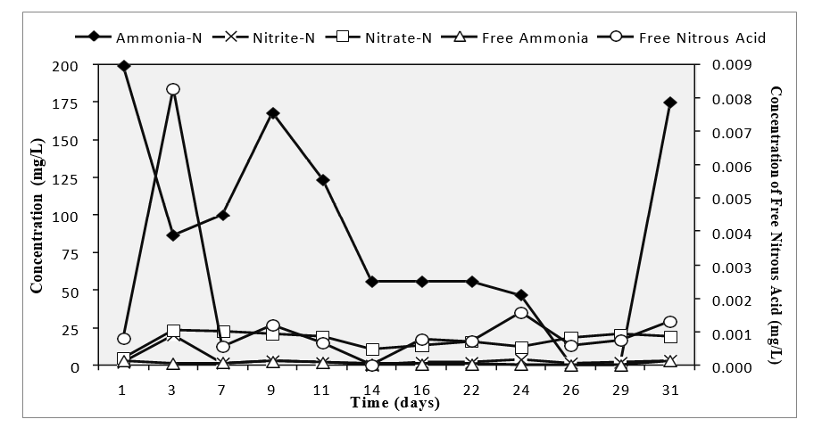

**Figure 5.3 Nitrogen transformation profiles during AnAOBs enrinchment in preliminary reactors with mined MSW**

**5.4 Confirmation of AnAOBs in preliminary reactors**

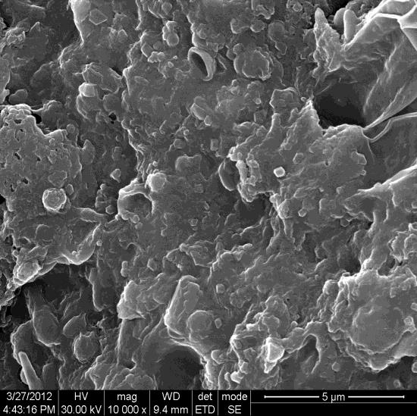 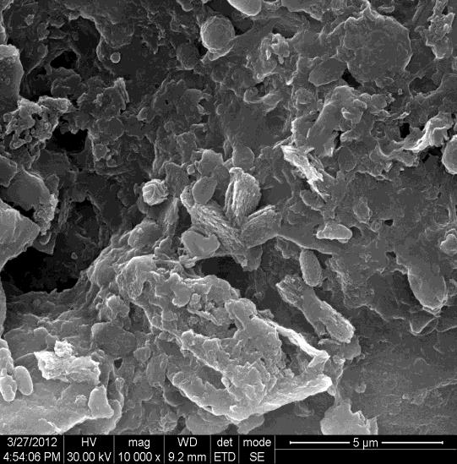

a) FCR b) MCR

* 1. **Control Landfill Bioreactor**

The Control LFBR (CLFBR) showed fluctuations in ammonia, nitrite, and nitrate nitrogen concentrations during the 336-day operational period. Ammonia levels peaked at 652 mg/L on the 77th day, with conductivity and salinity positively correlated with ammonia. Ammonia concentrations increased from 389 to 479 mg/L during Phase III (189 - 336 days) before gradually decreasing to 330 mg/L by the end of the study. Persistent high levels of ammonia were observed due to the absence of an anaerobic degradation pathway in landfill bioreactors, coupled with leachate recirculation accelerating ammonification. Despite elevated ammonia concentrations, they did not reach inhibitory levels (>1500 mg/L) reported in previous studies, suggesting manageable toxicity levels in the CLFBR.

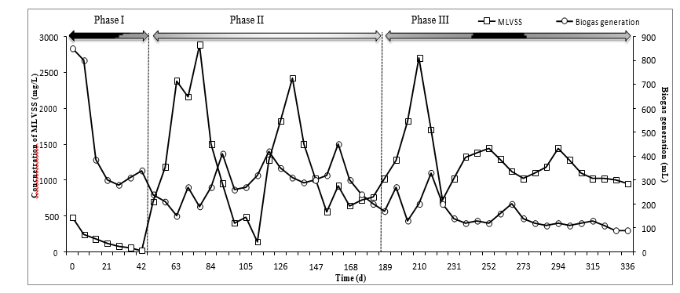

**Figure 5.4 Changes in Biogas generation and MLVSS in Control landfill bioreactor**

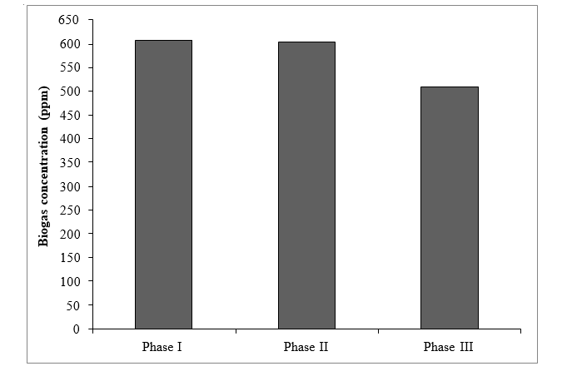

**Figure 5.5 Biogas concentrations in Control landfill bioreactor**

In the reactor, free ammonia ranged from 0.8 to 24 mg/L, averaging 9.1 mg/L, while free nitrous acid ranged from 0.0 to 0.1 mg/L, averaging 0.02 mg/L. According to Anthonisen et al. (1976), concentrations above 0.1 mg/L for free ammonia and 0.2 mg/L for free nitrous acid inhibit nitrite-oxidizing bacteria (NOBs). The presence of these concentrations suggests the inherent population of AOB and AnAOB in the substrate (mined MSW) contributed to ammonia nitrogen removal. Additionally, intermediates such as hydrazine and hydroxylamine were observed during the study period in the CLFBR.

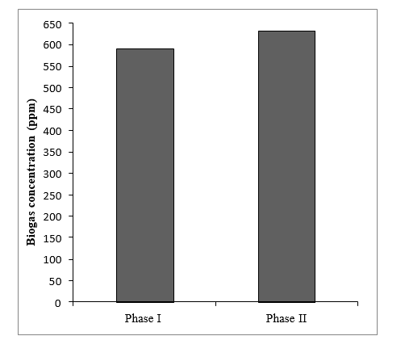

**Figure 5.6 Biogas concentrations in ANAMMOX landfill bioreactor**

**CONCLUSION**

In conclusion, the degradation process of municipal solid waste (MSW) within anaerobic bioreactors utilizing microorganisms presents a promising avenue for efficient waste treatment and renewable energy production. The enrichment of aerobic and anaerobic ammonium oxidizing bacteria (AOB and AnAOB) using mined MSW as a seed substrate proved highly effective in various reactor scales. The prevalence of Nitrosomonas species and Candidatus Brocadia anammoxidans as predominant AOBs and AnAOBs, respectively, underscored the success of the enrichment process. Notably, AOB activity exhibited significant ammonia removal and partial nitritation efficiency, while AnAOB activity demonstrated robust ammonia removal and nitrite utilization. The establishment of in situ SHARON and ANAMMOX processes in landfill bioreactors using enriched biomass further showcased the feasibility of ammonia nitrogen removal under real-world conditions. Combined SHARON-ANAMMOX processes yielded impressive nitrogen removal efficiencies, highlighting the potential for enhanced waste treatment. Despite challenges such as persistent ammonia accumulation, the controlled environment of anaerobic bioreactors offers a viable solution for sustainable MSW management. Overall, this study contributes valuable insights into optimizing bioreactors for efficient MSW degradation and underscores the pivotal role of microorganisms in driving the degradation process.

**REFRENCES**

1. Quecholac-Piña, X. (2020). Degradation of Plastics under Anaerobic Conditions. 1–18.
2. Reddy, K. R., Hettiarachchi, H., & Giri, R. K. (2015). Effects of Degradation on Geotechnical Properties of Municipal Solid Waste from Orchard Hills Landfill ,USA. International Journal of Geosynthetics and Ground Engineering, 1(3), 1–14. https://doi.org/10.1007/s40891-015-0026-2
3. Trzcinski, A. P. (2009). Anaerobic membrane bioreactor technology for solid waste stabilization. May.
4. Abrol, S. (2018). waste settlement analysis in an aerobic bioreactor. 162754.
5. He, R., Shen, D., Wang, J., He, Y., & Zhu, Y. (2005). Biological degradation of MSW in a methanogenic reactor using treated leachate recirculation. 40, 3660–3666. https://doi.org/10.1016/j.procbio.2005.02.022
6. Khobragade, S. P., Khanapure, V. U., & Sawant, M. M. (2018). A Review on Enhancing Anaerobic Degradation Rate of Municipal Solid Waste Using Micro-Organisms Along with Leachate Recirculation. VII(Iv), 367–371.
7. Taylor, P., Rendra, S., Warith, M. A., & Fernandes, L. (2010). Degradation of Municipal Solid Waste in Aerobic Bioreactor Landfills. September 2013, 37–41. https://doi.org/10.1080/09593332808618822
8. Rastogi, M., Hooda, R., & Nandal, M. (2014). Review on anaerobic treatment of municipal solid waste with leachate recirculation. 110–117.
9. Lakshmikanthan, P., Sughosh, P., White, J., & Babu, G. L. S. (2017). Experimental and modelling studies on a laboratory scale anaerobic bioreactor treating mechanically biologically treated municipal solid waste. https://doi.org/10.1177/0734242X17705722
10. Xiao, D., Chen, Y., & Xu, W. (2021). An Aerobic Degradation Model for Landfilled Municipal Solid Waste.
11. Vázquez, R. V. (2008). Enhanced stabilisation of municipal solid waste in bioreactor landfills.
12. Khalil, M. J., Gupta, R., & Sharma, K. (2014). Microbiological Degradation of Municipal Solid Waste in Landfills for LFG Generation. 10–14.
13. Slezak, R., Krzystek, L., & Ledakowicz, S. (2015). Degradation of municipal solid waste in simulated landfill bioreactors under aerobic conditions. WASTE MANAGEMENT. https://doi.org/10.1016/j.wasman.2015.06.017