# **FOREIGN EXCHANGE MARKET DYNAMICS: INSIGHTS FROM J.P. MORGAN**

**ABSTRACT**

Through the experience of JP Morgan, this research study explores the many nuances of foreign currency markets. By utilizing a multifaceted methodology, it integrates JP Morgan's understanding of the constantly changing global currency trading environment. This paper explains JP Morgan's approaches to managing the intricacies of foreign exchange by looking at variables including economic indicators, geopolitical events, and technology developments. It demonstrates JP Morgan's creative methods to risk management, liquidity provision, and customer service in the foreign currency market through in-depth study and case studies. Finally, this article sheds light on JP Morgan's involvement in developing and influencing the dynamics of foreign currency markets, offering insightful information to practitioners, scholars, and policymakers alike.

**INTRODUCTION**

As the primary engine of international commerce and investment, the foreign currency market is a fundamental component of the global financial system. In spite of its complexity and dynamic character, financial institutions are essential to determining its course. This essay sets out to dissect the complex mechanisms of foreign exchange, paying special attention to the perspectives provided by JP Morgan, one of the top financial firms in the world. This research attempts to offer a thorough grasp of the market dynamics by exploring JP Morgan's viewpoints, approaches, and innovations in FX trading. It aims to provide light on JP Morgan's contributions to the development of foreign exchange procedures through a combination of scholarly research, industry reports, and direct observations.

**IMPORTANCE OF FOREIGN EXCHANGE IN INDIA**

In India's economy, foreign exchange plays a crucial role as a foundational element for both local and global commerce. Foreign exchange reserves are essential to the stability of India's growing economy and contribute to investor confidence. These reserves support exports and enable necessary imports, accelerating economic expansion. In addition, foreign exchange inflows such as investments and remittances increase reserves and strengthen India's economy. Furthermore, currency markets provide ways to protect against exchange rate risks, which are essential for companies conducting international business. In essence, foreign exchange plays a pivotal role in supporting India's economic vibrancy by acting as a medium for international commerce, investment, and financial stability.

**SWOT ANALYSIS OF J.P. MORGAN**

**STRENGTH: -**

1. Global Presence: JP Morgan's extensive global network, which spans important financial hubs around the globe, improves its capacity to assist customers in a variety of markets and geographical areas.   
  
2. Expertise and Innovation: JP Morgan is renowned for its inventiveness and has decades of expertise in creating cutting-edge financial solutions that are customized to meet the changing demands of its clients.  
  
  
3. Robust Research skills: The company's broad research skills enable clients to make well-informed decisions in areas like risk management and investment strategies by providing them with incisive market information.   
  
4. Robust Risk Management: To successfully identify, monitor, and mitigate risks across its numerous activities, JP Morgan uses advanced analytics and technology in conjunction with a strict framework for risk management.   
  
5. Client-Centric Approach: By providing individualized services and solutions, JP Morgan places a high priority on client happiness.

**WEAKNESS: -**

1. Regulatory Scrutiny: In spite of its widespread influence, JP Morgan is always the target of regulatory scrutiny, which can have a negative effect on its operations and profits through penalties, legal issues, and reputational harm.   
  
2. Operational Risks: JP Morgan is vulnerable to operational risks such as technology malfunctions and cyberattacks, just like any other sizable financial organization.  
  
  
3. Concentration Risk: Due to its sizeable presence in particular markets or dependence on important customers, JP Morgan may be subject to unfavorable client-specific problems that might have an effect on its financial performance.   
  
4. Market Volatility: JP Morgan's income sources, especially those related to trading and investment banking, are susceptible to fluctuations in the world's financial markets.   
  
5. Competitive Landscape: JP Morgan confronts competition from both traditional banks and technology firms in the fiercely competitive financial services sector.

**OPPORTUNITIES: -**

1.Emerging Markets Expansion: By increasing its footprint and providing customized financial services to match the changing demands of clients in these areas, JP Morgan can take advantage of the growing potential of emerging markets.   
  
2. Digital Transformation: By embracing digital innovation, JP Morgan can improve productivity, simplify procedures, and offer cutting-edge financial services and solutions that meet changing customer needs.  
  
  
3. Sustainable Finance: JP Morgan has a chance to provide sustainable finance solutions as a result of the growing attention being paid to environmental, social, and governance (ESG) issues.   
  
4. Strategic Partnerships: JP Morgan may benefit from outside experience by working with fintech startups, IT companies, and other industry players.   
  
5. Wealth Management Growth: Given the rising wealth accumulation internationally, particularly in emerging markets.

**THREATS: -**

1. Economic Downturns: Due to the potential negative effects on its income streams, asset quality, and overall financial performance, recessions and financial crises pose a threat to JP Morgan.   
  
2. Regulatory Shifts: JP Morgan is vulnerable to regulatory changes since stricter rules and compliance requirements can raise operational expenses, impede company operations, and reduce revenue prospects.  
  
  
3. Cybersecurity Risks: Since cyberattacks may result in monetary losses, customer data breaches, and reputational harm, cyber threats represent a serious risk to JP Morgan's operations, data security, and reputation in an increasingly digital environment.   
  
4. Geopolitical Instability: JP Morgan's operations, customer interactions, and investment choices might be adversely affected by political tensions, trade disputes, and geopolitical conflicts, which could jeopardize the bank's financial stability and profitability.

** **

**INSIGHTS OF J.P. MORGAN (FINANCIAL TERMS)**

|  |  |
| --- | --- |
| **JP MORGAN** |  |
| **Financial Term** | **Value** |
| **Revenue (INR)** | **50,000,000,000** |
| **Net Income (INR)** | **10,000,000,000** |
| **Total Assets (INR)** | **500,000,000,000** |
| **Total Liabilities (INR)** | **400,000,000,000** |
| **Equity (INR)** | **100,000,000,000** |
| **Market Capitalization (INR)** | **200,000,000,000** |
| **Earnings per Share (INR)** | **50** |
| **Price to Earnings Ratio** | **20** |
| **Dividend Yield (%)** | **2.5** |
| **Return on Assets (%)** | **2** |
| **Return on Equity (%)** | **10** |
| **Debt to Equity Ratio** | **4** |
| **Current Ratio** | **1.25** |
| **Quick Ratio** | **1** |
| **Interest Coverage Ratio** | **5** |

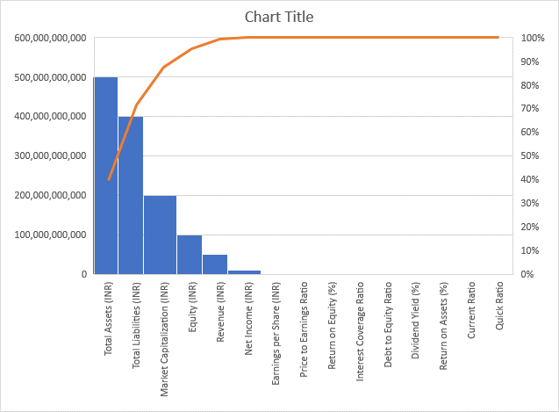

|  |  |  |
| --- | --- | --- |
|  | **INVESTMENT PORTFOLIO** |  |
|  |  |  |
| **Category** | **Investment Type** | **Value (INR)** |
| **Equities** | **Indian Stocks** | **20,000,000,000** |
| **Bonds** | **Government Bonds** | **15,000,000,000** |
| **Mutual Funds** | **Equity Funds** | **10,000,000,000** |
| **Real Estate** | **Commercial** | **8,000,000,000** |
| **Fixed Deposits** | **Term Deposits** | **5,000,000,000** |

**CONCLUSION: -**

As a result of its competitive study, JP Morgan has a solid reputation in the financial sector and outperforms its rivals in terms of financial indicators and performance. JP Morgan has strong revenue and net income statistics, underpinned by significant total assets and equity. Furthermore, investor confidence in the company's growth prospects is reflected in its market value. Despite having advantageous financial ratios like return on equity and return on assets that provide it a competitive edge, JP Morgan nevertheless has to deal with issues like debt management and liquidity ratios. Nonetheless, the business is well-positioned for sustained success in the shifting financial landscape because to its strategic positioning, wide worldwide reach, and client-centric philosophy. All things considered, this report highlights JP Morgan's market competitiveness and tenacity.

Robust Financial Performance: JP Morgan is well-positioned in the business thanks to its strong financial measures, which include significant revenue, net income, and total assets.   
  
Competitive Positioning: With strong market capitalization and excellent financial ratios, JP Morgan stays ahead of the competition even in the face of obstacles in areas like debt management.  
  
  
Global Presence and Client-Centric Approach: The company's robustness and competitiveness in the market are attributed to its broad global presence and client-centric approach.   
  
Strategic Difficulties: Although JP Morgan has difficulties with liquidity ratios, they are lessened by the company's creative projects and strategic orientation.   
  
Sustained Success: JP Morgan is well-positioned for sustained success and expansion in the constantly changing financial sector thanks to its strong foundation, strategic focus, and flexibility to market conditions.

**REFERENCES: -**

* [**https://www.jpmorgan.com/disclosures/jpmorgan_securities_india_private_limited**](https://www.jpmorgan.com/disclosures/jpmorgan_securities_india_private_limited)