**CRACK DIAGNOSIS IN I SECTION BY USING FUZZY CONTROLLER TECHNIQUE**

**Mr. Awari Amol1, Prof. B. M. Randhavan2**

1Student, M.E., Mechanical Engineering, SVCOET, Junnar, Pune, Maharashtra, India

2Professor, Mechanical Engineering, SVCOET, Junnar, Pune, Maharashtra, India

**ABSTRACT**

This paper explores crack analysis in I-section beams using vibration evaluation techniques. Structural health monitoring is critical for making sure the integrity and security of engineering structures. Vibration-based methods have emerged as fine tools for detecting and characterizing defects like cracks. The learn about focuses on the development of a reliable diagnostic method specifically tailor-made for I-section beams. Experimental modal evaluation is employed to extract modal parameters, and modifications in these parameters due to crack presence are analyzed. Various crack situations are simulated, and the effectiveness of vibration-based crack detection is evaluated. The effects demonstrate the potential of vibration strategies in accurately figuring out and assessing cracks in I-section beams, thereby contributing to improved structural fitness monitoring practices. The findings underscore the significance of proactive protection techniques based totally on advanced diagnostic equipment for making sure the longevity and protection of crucial infrastructure.

**Keywords:** Finite Element Analysis, Natural frequency, Fuzzy Controller Technique, Experimental Analysis.

1. **INTRODUCTION**

Crack is defined as any deviation produced to a structure, both intentionally or unintentionally, which badly impact the current or future efficiency of that system. Crack is most encountered damage varieties in the structures because of fatigue or manufacturing defects. Crack will initiate in a structure when the stresses near the crack tip will exceed the permissible limit. Cracks observed in structural elements may come up because of fatigue that take location below working life conditions for this reason of the confined fatigue force; they may also be as a result of mechanical defects such as blades of wind mills, compressor blades or may be because of defects because of manufacturing processes.

Beams are broadly used as machine elements and structural elements in civil, mechanical, naval and aeronautical engineering & relatively difficult design features of turbine blades or compressor blades as tapered beam of uniform thickness. Applications in not only non-uniform beams but also applications to fulfil designated sensible requisites and achieve a higher distribution of force and gravitational mass. These machine and structural factors are designed with extra care for distinctive load, with just right range of safety factors, and are inspected most often. Still there are unexpected sudden failures. In order to attain the maximum reliability of machinery and structures, there is not any method except monitoring the health of susceptible important components. [4] This leads to continuous gathering of knowledge of alterations in their static and dynamic behavior, this used the vibration characteristics to monitor the changes in the various structures among the different methods.

1. **OBJECTIVES**

* To measure the natural frequencies of pretty a quantity beam fashions by means of using Finite Element Method (FEM). ANSYS workbench 15.0 is used to discover herbal frequencies of all beams of unique crack sizes and pass section. • To introduce toolbox of Fuzzy good judgment in MATLAB.
* The toolbox Fuzzy good judgment in MATLAB software is one of the higher strategies to discover crack. Here introduction of fuzzy good judgment toolbox is discussed.
* To perceive the crack through the use of Fuzzy good judgment toolbox in MATLAB. A fuzzy model is developed for proposed theory and finds the numerical answer of the problem.

1. **METHODOLOGY**
2. Experimental calculations for first three natural frequencies of all beam models by using Finite Element Analysis (ANSYS).
3. Frequencies are provided as input to Fuzzy logic to obtained relative crack location and relative crack depth.
4. With the help of above mentioned two methods the three natural frequencies for cracked & uncracked beam will be compared with each other.
5. Comparison of outputs with theoretical ones.
6. **MATERIAL SELECTION AND DIEMENSIONS**

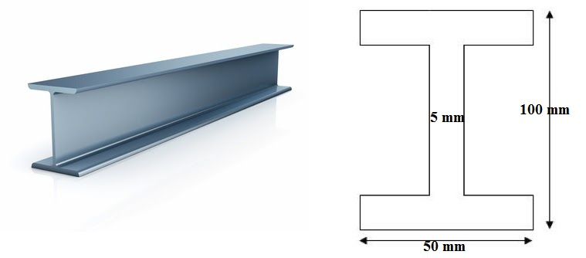

**Fig.4.1 Beam Models & Their Dimensions**

**Table 4.1 Different Beam models and their dimensions**

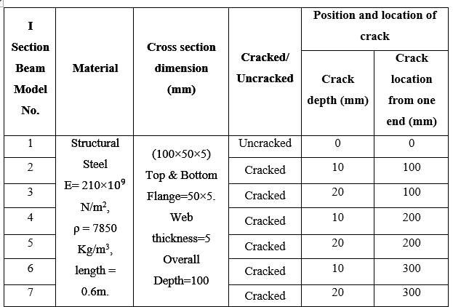

**5. FINITE ELEMENT ANALYSIS**

It is found that cracked beam model has lower frequencies than uncracked beam. After determination of natural frequencies we can easily find out at each frequency how much deformation every part of the beam model. All the data obtained by this method is summarized in following table:

**Table 5.1 Natural frequencies of beam model in Hz by using Finite Element Method**

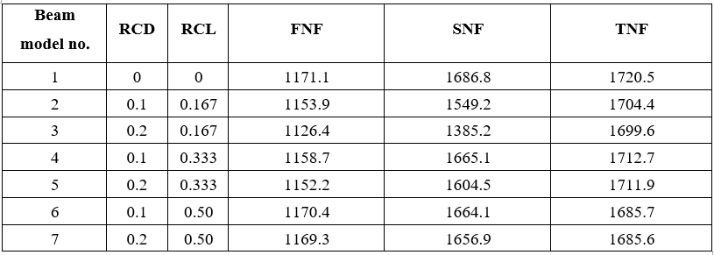

**5.1 Post-processing**

**5.1.1 Beam models obtained in ANSYS**

For all the beam models, first three natural frequencies are considered. Here we are presenting some sample of the beam model, all beam models in ANSYS are presented under Annexure I for first three natural frequencies with its total deformation.

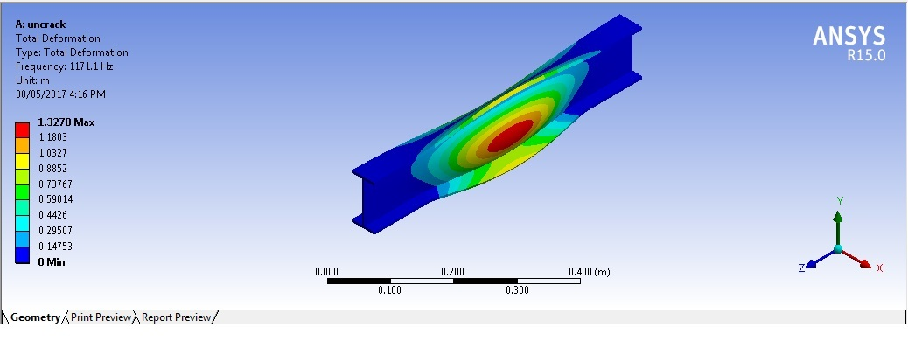

Fig.5.1 First mode of vibration of beam model 1

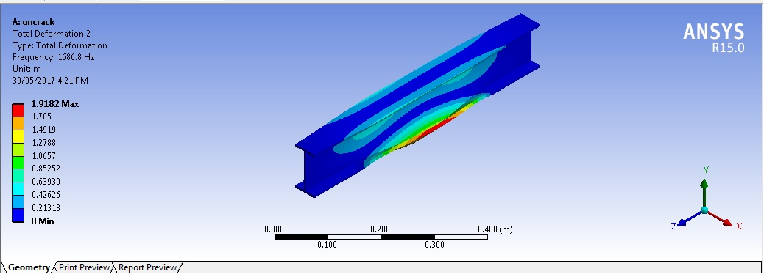

Fig.5.2 Second mode of vibration of beam model 1

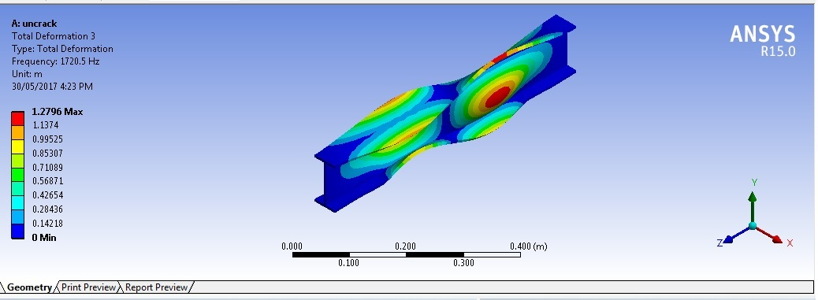

Fig.5.3 Third mode of vibration of beam model 1

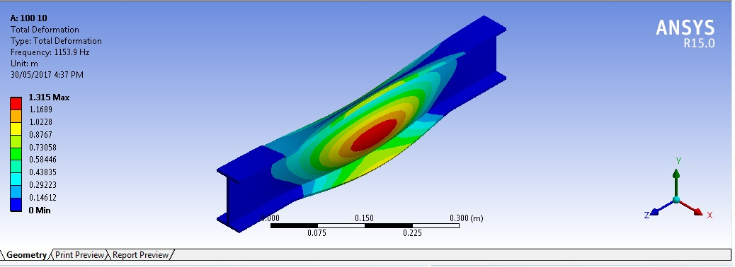

Fig.5.4 first mode of vibration of beam model 2

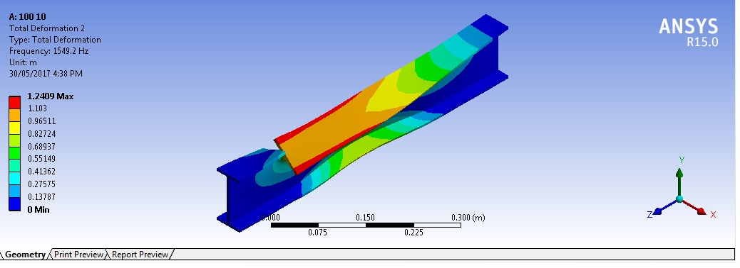

Fig.5.5 Second mode of vibration of beam model 2

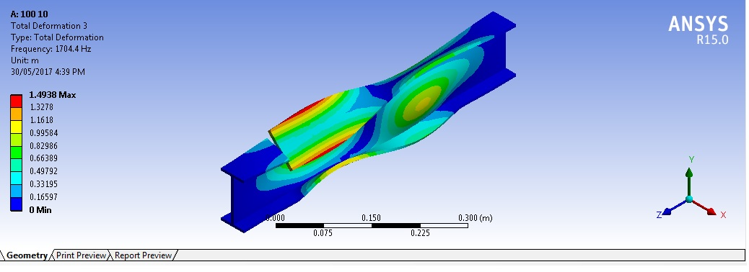

Fig.5.6 Third mode of vibration of beam model 2

1. **EXPERIMENTATION**

**6.1 Crack Detection By Fuzzy Logic Technique**

Logic is the study of the different methods and principles of reasoning in all its possible forms. Classical logic deals with propositions that are required to be either true or erroneous. Each proposition has its antithesis, which is conventionally kenned as negation of the proposition.

**6.2 Fuzzy Expert System**

A fuzzy logic expert system, as title suggests, is a computer-based system that emulates the reasoning process of a human trained within an exact area of cognizance. This system is mainly used in non-expert area for understanding, problem solving. We can say that they are designed for design and research, consulting and diagnosis, learning and decision support, planning. The kernel of any expert system consists of long-term memory i.e. knowledge base, a short-term memory i.e. database and an inference engine. All This three units communicate with the operator or trainer to form expert system.

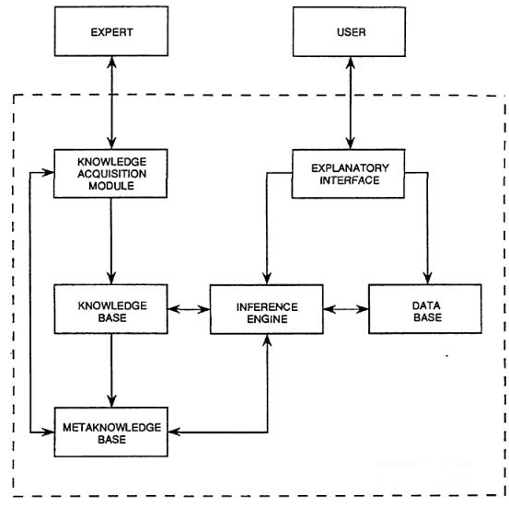

Fig.6.1 General Scheme of a fuzzy controller

**6.3 Analysis Of The Fuzzy Controller For Crack Detection**

This mainly concerned with finding out output which is relative crack depth and relative crack location when input are first three natural frequencies which are calculated earlier. This analysis is done in Matlab 7.10.0 (R2010a) where fuzzy logic toolbox is present. All above steps of formation of fuzzy model are applied in this toolbox.

**Table 6.1 Normalized frequencies of beam models**

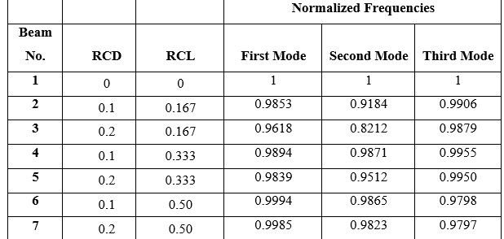

To develop the fuzzy logic model all variables should be enter in the toolbox. Same procedure is repeated for the all the variables. We can change here name of the variables and all membership functions. Here parameters of each membership function are also displayed. For next variable click twice on the next variable, previous one will be saving automatically.

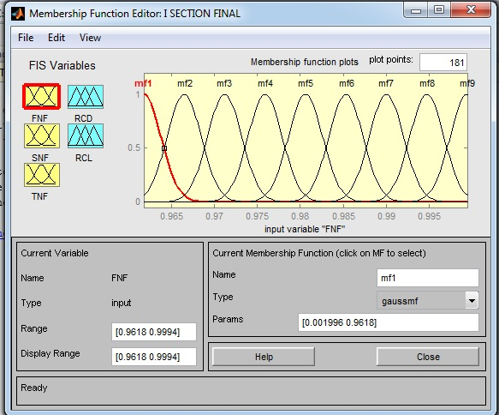

Fig.6.2 Gaussian Membership Function for First Natural Frequency (FNF)

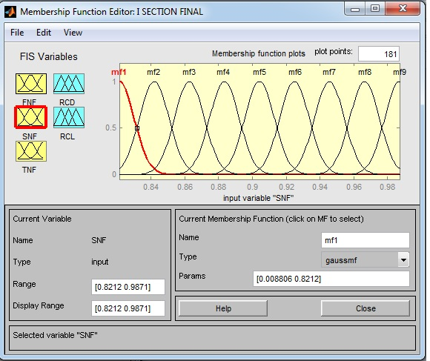

Fig.6.3 Gaussian Membership Function for Second Natural Frequency (SNF)

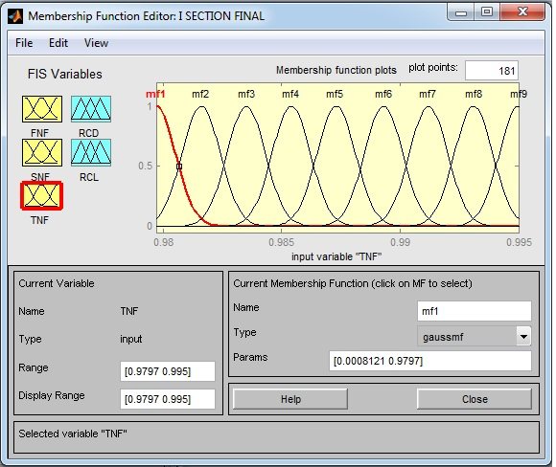

Fig.6.4 Gaussian Membership Function for Third Natural Frequency (TNF)

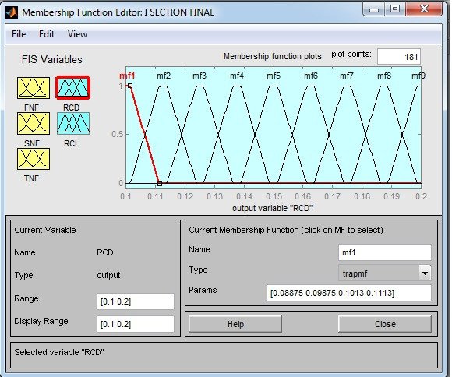

Fig.6.5 Trapezoidal Membership Function for Relative Crack Depth (RCD)

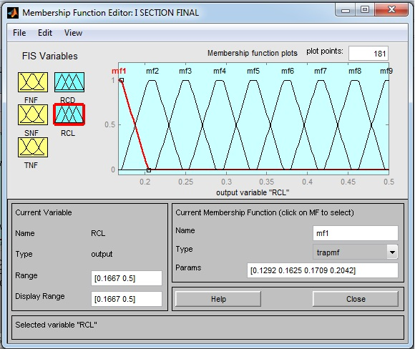

Fig.6.6 Trapezoidal Membership Function for Relative Crack Location (RCL)

After every FIS sub fuzzy system, go in ‘file’ option ‘Export to file’ to save the FIS file in MATLAB. Nowall the output obtained by same procedure for all beam models using fuzzy logic are summarized in following table 6.2.

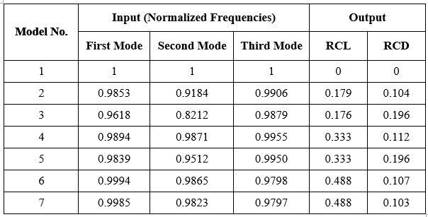

**6.4 Comparison of theoretical value and Fuzzy Logic Results**

Output obtained by the fuzzy logic model and theoretical values are compared. It is represented in following table.

**Table 6.3 Comparison of theoretical value and Fuzzy Logic Results**

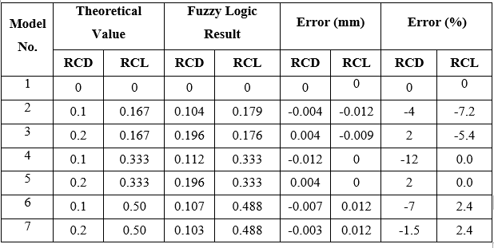

1. **CONCLUSION**

* Natural frequencies calculated by the finite element method and experimentation are close to each other.
* For the same crack location as the crack depth increases, first three natural frequencies are gradually decreases.
* Fuzzy logic results when compared with the theoretical ones, it is observed that fuzzy logic provides the exact location and depth of crack as output of the fuzzy model.
* For forming the fuzzy model, trained operator is required because fuzzy model required the higher precision to give accurate output within nanosecond.

**REFERENCES**

1. Divine M. Ashigbi, Michael N. Sackey, YesuenyeagbeA.K. Fiagbe, Jonathan Quaye-Ballard, November 2021, -Structural health monitoring Beam Fuzzy logic Natural frequency Kurtosis.
2. Runjian Wang1 1Beijing Gongke Solid Bridge Technology Co., Ltd, Beijing, China 2021- Research on Construction Crack Diagnosis and Treatment Technology of Double-Column Large Cantilever Pre-Stressed Bent Cap .
3. Praseed Kumar, Aqleem Siddiqui, Ashay Ghadi*, Denisa Tony, Stephen Rhenius, and Saleel Rane 2021- Damage Detection in beams using Vibration analysis and Artificial Neural Network.
4. M Seguini, [S Khatir](https://scholar.google.com/citations?user=LZ0euWMAAAAJ&hl=en&oi=sra), [D Boutchicha](https://scholar.google.com/citations?user=Q2Y-hUYAAAAJ&hl=en&oi=sra), D Nedjar, [M Abdel Wahab](https://scholar.google.com/citations?user=xoZMzPkAAAAJ&hl=en&oi=sra) -Smart Structures and Systems, 2021 Crack prediction in pipeline using ANN-PSO based on numerical and experimental modal analysis.
5. Mehmet Haskula and Murat Kisab (13 January 2021) - Free vibration of the double tapered cracked beam.
6. Rasheed Majeed Jorani, Maroua Haddar , Fakher Chaari and Mohamed Haddar (20 February 2023)-Gear Crack Detection Based on Vibration Analysis Techniques and Statistical Process Control Charts (SPCC).
7. Mohamad Hazwan Mohd Ghazali and Wan Rahiman (11 September 2021)- Vibration Analysis for Machine Monitoring and Diagnosis: A Systematic Review.