**Revolutionizing Attendance** **With Face Recognition**

Shivraj Pannase Dilkash Kamble Rupa Bawane

Dept. Information Tech. Dept. Information Tech. Dept. Information Tech.

Tulsiramji Gaikwad Patil Tulsiramji Gaikwad Patil Tulsiramji Gaikwad Patil

College of Engg. & Tech, College of Engg. & Tech, College of Engg. & Tech,

Mohgaon , Nagpur Mohgaon , Nagpur Mohgaon , Nagpur

[shivrajpannase@gmail.com](mailto:shivrajpannase@gmail.com) [dilkamble72@gmail.com](mailto:dilkamble72@gmail.com) [rupabawane19@gmail.com](mailto:rupabawane19@gmail.com)

Bhagyashri Agarwal Punam Sewatkar Guided by ;

Dept. Information Tech. Dept. Information Tech. Prof. Arti Sondawale

Tulsiramji Gaikwad Patil Tulsiramji Gaikwad Patil

College of Engg. & Tech, College of Engg. & Tech,

Mohgaon , Nagpur Mohgaon , Nagpur

[Bhagyashridagrawal2003@gmail.com](mailto:Bhagyashridagrawal2003@gmail.com) [punamsewatkar0111@gmail.com](mailto:punamsewatkar0111@gmail.com)

**Abstract-**

The Auto Face Attendance System with Facial Recognition is an innovative project designed to streamline and enhance traditional attendance tracking processes. This project leverages advanced facial recognition technology to automate the attendance marking process, eliminating the need for manual intervention and reducing the likelihood of errors associated with conventional methods. The system employs state-of-the-art deep learning algorithms for facial feature extraction and recognition. Through the utilization of a high-resolution camera, the system captures facial images of individuals in real-time during attendance sessions. These images are then processed using computer vision techniques to identify and match unique facial patterns, ensuring a high level of accuracy in attendance records.

Key features of the Auto Face Attendance System include user-friendly interfaces for administrators. Administrators can easily manage and monitor attendance records through a centralized dashboard, allowing for real-time tracking of attendance data. The system also provides comprehensive reporting tools, enabling administrators to generate attendance reports efficiently. Furthermore, the project prioritizes user privacy and data security. Facial data is securely stored and encrypted, adhering to the highest standards of data protection. Additionally, the system includes robust authentication protocols to ensure that only authorized personnel can access sensitive attendance information. The implementation of the Auto Face Attendance System offers several advantages, including time efficiency, increased accuracy, and reduced administrative workload. By automating the attendance process, organizations can allocate resources more effectively and focus on more strategic aspects of their operations.

In conclusion, the Auto Face Attendance System with Facial Recognition represents a significant advancement in attendance tracking technology. Its integration of cutting-edge facial recognition algorithms, user-friendly interfaces, and a commitment to privacy make it a valuable solution for organizations seeking to modernize and optimize the attendance management processes.

1. **Introduction**

In the fast-paced, technologically driven world of education, there is a growing need for efficient and accurate methods of tracking student attendance. Traditional methods of attendance taking, such as manual roll call, are not only time-consuming but also susceptible to errors. To address these challenges and usher in a new era of streamlined attendance management, we propose a revolutionary approach: – the implementation of a Student Attendance System with Face Recognition. This introduces our innovative project, which harnesses the power of facial recognition technology to transform the way educational institutions monitor and manage student attendance. The use of face recognition technology in academia holds the potential to revolutionize the administrative landscape, enhancing accuracy, efficiency, and data-driven decision-making while also addressing contemporary issues such as health and safety in the wake of the COVID-19 pandemic.

Face recognition technology has witnessed remarkable advancements in recent years, driven by machine learning, artificial intelligence, and computer vision. This technology has been harnessed for a wide range of applications, including security systems, mobile devices, and now, educational settings. The conventional methods of attendance tracking are laden with challenges. Manual attendance is labour-intensive and susceptible to errors, while other methods, like card swiping or RFID systems, are prone to abuse and manipulation. In contrast, a face recognition-based system offers numerous advantages. It promises higher accuracy, reduced administrative burdens, real-time monitoring, and the ability to provide valuable data for analysis. The student attendance system with face recognition offers a contactless, efficient, and secure method of monitoring attendance. By capturing and analysing the unique facial features of students, it can identify and record attendance quickly and with a high degree of accuracy. This technology not only automates attendance tracking but also provides insights into attendance trends, helping educational institutions make data-informed decisions to improve student engagement and overall performance.

We will explore the key components and features of our proposed student attendance system with face recognition, the technological infrastructure, data security measures, ethical considerations, and the potential impact on educational institutions. We will also discuss the advantages and limitations of this system and provide a glimpse of the research and development required for its successful implementation.

1. **Why Replacing Traditional Methods with New System**

While using traditional way, we may face a lot of major and minor problems, however these problems can be minimized or can be totally dissolved by our newly developed attendance system using facial recognition. Some issues we may face are mentioned below that we can removed by replacing our traditional way of attendance to the advanced system.

* Traditional attendance tracking methods, such as manual roll call or card swiping, are prone to human errors and manipulations, resulting in inaccurate attendance records.
* Manual attendance taking is a time-consuming process, leading to wasted instructional time and increased administrative burden on educators and staff.
* Educational institutions often face security issues, such as unauthorized access to exams, labs, or restricted areas, which can be addressed with enhanced attendance monitoring.
* In light of health concerns, the physical exchange of attendance sheets and the use of fingerprint scanners in traditional systems have raised hygiene and safety issues
* Traditional attendance systems do not provide a convenient way to collect and analyse attendance data, hindering institutions from making data-informed decisions to improve student engagement and performance
* The absence of a secure and automated attendance system can lead to accountability issues. Students may manipulate or falsify attendance records, which can impact academic integrity.
* Manual attendance management methods are associated with ongoing administrative costs, including printing attendance sheets and manual data entry. These costs can be reduced with a more automated system.
* Integrating manual attendance data with existing student information systems and educational management software can be challenging, leading to inconsistencies and inefficiencies in data management.
* The collection and storage of biometric data, such as facial images for attendance tracking, raise privacy concerns among students, faculty, and parents. Ensuring the responsible and secure handling of this data is essential.

1. **Project Scope**

* **To Improve Attendance Accuracy:** The primary objective of implementing a student attendance system with face recognition is to enhance the accuracy of attendance tracking. By using facial recognition technology, we aim to reduce the potential for errors associated with traditional attendance methods and manual data entry.
* **To Increase Administrative Efficiency:** Our project aims to streamline the attendance management process in educational institutions. We seek to reduce the time and effort required by teachers and administrators to take attendance, allowing them to focus on more productive tasks.
* **Real-Time Monitoring:** We aim to provide real-time attendance monitoring, allowing educators and administrators to access attendance data as it is recorded. This real-time data can be used to address attendance issues promptly and make timely interventions
* **Data-Driven Decision Making:** Our project aims to generate valuable data on attendance patterns and trends. By analysing this data, educational institutions can make informed decisions to improve student engagement and overall performance.
* **Enhanced Security:** Implementing face recognition technology can enhance the security of educational institutions by ensuring that only authorized individuals gain access to certain areas or activities, such as exams, labs, or libraries.
* **Contactless and Hygienic Attendance:** In response to health concerns, especially in the post-COVID-19 world, our objective is to provide a contactless and hygienic method of attendance tracking that minimizes physical contact with attendance sheets or fingerprint scanners.
* **Cost Savings:** We aim to reduce the long-term administrative costs associated with manual attendance tracking and paperwork by implementing an automated face recognition system.
* **Student Accountability:** Our project seeks to promote greater accountability among students regarding their attendance. With face recognition in place, students are less likely to manipulate attendance records.
* **Integration with Existing Systems:** We aim to seamlessly integrate the face recognition attendance system with existing educational management software and student information systems for a cohesive and efficient solution.

1. **Work-Flow**

In the pursuit of modernizing attendance tracking systems, this project leverages cutting-edge technologies to introduce an automated solution enriched with facial recognition capabilities. Attendance management is a critical aspect of various domains, and the integration of facial recognition not only enhances efficiency but also introduces a touchless and secure mechanism for identity verification. The design and methodology employed in this system are meticulously crafted, incorporating advanced feature extraction techniques, deep learning architectures, and robust preprocessing steps. By delving into the intricacies of the training process, data augmentation strategies, and the choice of evaluation metrics, this project aims to offer a comprehensive understanding of the mechanisms that underpin the development of an accurate and reliable auto attendance system. Additionally, considerations for real-time implementation, privacy safeguards, and robustness testing underscore our commitment to delivering a solution that not only meets but exceeds the expectations of modern attendance management, seamlessly merging innovation with practicality.

Here we are going to discuss about the workflow and mechanics about our freshly developing “Auto Attendance with Facial Recognition” System. As our project also having implementation of machine learning and deep learning to analyse and recognition of data with the help of external supported camera, our project is having two data-flow structures one working in front providing a friendly user interface and other as backend continuously working in background for detection and recognition purpose.

Different tasks are done by different methods for examples tasks like: -

1. Deep Learning Architecture:

Specify the deep learning architecture employed for face recognition, such as a Convolutional Neural Network (CNN) or a pre-trained model like VGG-Face or FaceNet, outlining the layers and parameters used.

1. Data Augmentation:

Discuss any data augmentation techniques applied to increase the diversity of the training dataset, enhancing the model's ability to generalize across different facial expressions, lighting conditions, and orientations.

1. Deep Learning Architecture:

Specify the deep learning architecture employed for face recognition, such as a Convolutional Neural Network (CNN) or a pre-trained model like VGG-Face or FaceNet, outlining the layers and parameters used.

Working process

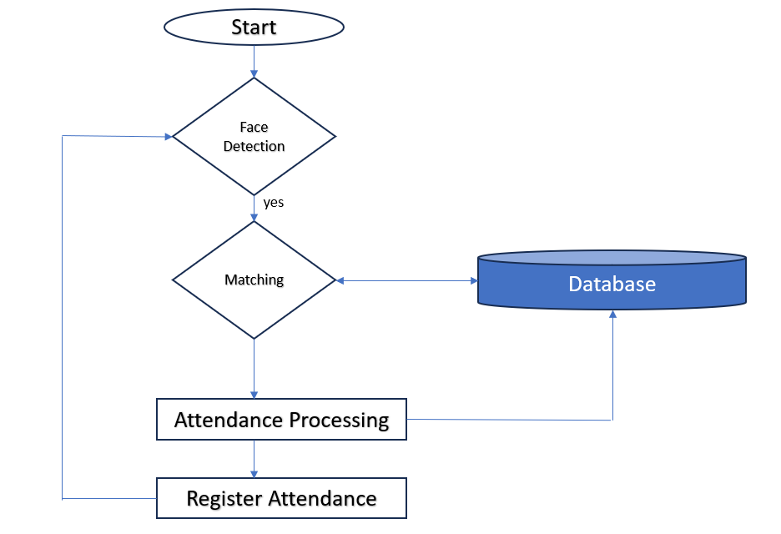

In our system, Backend works continuously implementing Machine Learning, Deep Learning and Detection. From the system startup to the closure backend processes are in continuously in work from the beginning to until the power cut. The workflow goes as follows.

Backend workflow for an auto-attendance system with face recognition involves orchestrating various components to ensure seamless data flow, processing, and storage. Here's an outline of the backend workflow:

**Data Collection:**

* Source: Gather attendance data from various sources, such as cameras or image repositories.
* Frequency: Establish a schedule for data collection to ensure up-to-date information.

**Image Preprocessing:**

* Normalization: Normalize facial images for consistent lighting and colour conditions.
* Resize: Standardize image dimensions for input consistency to the face recognition model.
* Quality Enhancement: Apply filters or enhancement techniques to improve image quality.

**Feature Extraction:**

* Facial Feature Extraction: Utilize advanced techniques (e.g., Local Binary Patterns, HOG) to extract discriminative features from facial images.
* Data Augmentation: Increase dataset diversity through augmentation techniques to enhance model generalization.

**Face Recognition Model:**

* Choose Model: Implement a pre-trained deep learning model (e.g., VGG-Face, FaceNet) or train a custom Convolutional Neural Network (CNN) for face recognition.
* Training: Train the model using a labelled dataset, optimizing for accuracy and efficiency.
* Model Validation: Assess model performance on a separate validation dataset to ensure robustness.

**Real-time Processing:**

* Integration: Integrate the trained model into the backend system for real-time processing.
* Request Handling: Develop APIs or endpoints to receive image data for recognition requests.

**Attendance Management:**

* Recognition Result Processing: Evaluate the model's output to determine the identity of the recognized face.
* Attendance Logging: Maintain a secure and centralized attendance log, updating it with recognized identities and timestamps.

**Database Integration:**

* Database Structure: Design a database schema to store attendance records, user information, and other relevant data.
* Connection: Establish a secure connection between the backend system and the database.

**Security Measures:**

* Encryption: Implement encryption techniques for storing sensitive information like facial features or user identities.
* Access Controls: Set up strict access controls to ensure that only authorized personnel can interact with the system.

**Privacy Compliance:**

* Consent Mechanism: Implement mechanisms for obtaining and managing user consent for facial recognition.
* Data Protection: Adhere to data protection regulations and standards, ensuring user privacy is a top priority.

**Monitoring and Maintenance:**

* Logging: Implement comprehensive logging to track system activities and errors.
* Alerts: Set up alerts for potential issues, ensuring prompt responses to maintain system integrity.
* Regular Updates: Schedule regular updates for the face recognition model and backend infrastructure to address security vulnerabilities and improve performance.

1. **References**

* [attendance-using-face-recognition · GitHub Topics · GitHub](https://github.com/topics/attendance-using-face-recognition)
* [Face Recognition Attendance System Using Python (With Code) (analyticsvidhya.com)](https://www.analyticsvidhya.com/blog/2021/11/build-face-recognition-attendance-system-using-python/)
* [Face recognition with OpenCV, Python, and deep learning - PyImageSearch](https://pyimagesearch.com/2018/06/18/face-recognition-with-opencv-python-and-deep-learning/)
* [ijcrt.org/papers/IJCRT2106079.pdf](https://ijcrt.org/papers/IJCRT2106079.pdf)
* [Attendance Monitoring with Face Recognition using Python (pythonawesome.com)](https://pythonawesome.com/attendance-monitoring-with-face-recognition-using-python/)
* [FACE RECOGNITION BASED STUDENT ATTENDANCE USING PYTHON AND OPENCV (researchgate.net)](https://www.researchgate.net/publication/367730561_FACE_RECOGNITION_BASED_STUDENT_ATTENDANCE_USING_PYTHON_AND_OPENCV)
* [GoDaddy Security - Access Denied (jetir.org)](https://www.jetir.org/view?paper=JETIR2010064)
* [Student Attendance Monitoring System Using Face Recognition by E CHARAN SAI, SHAIK ALTHAF HUSSAIN, SYED KHAJA, AMARA SHYAM :: SSRN](https://papers.ssrn.com/sol3/papers.cfm?abstract_id=3851056)
* [Student Attendance System using Face Recognition | IEEE Conference Publication | IEEE Xplore](https://ieeexplore.ieee.org/document/9215441)
* [Student attendance with face recognition (LBPH or CNN): Systematic literature review - ScienceDirect](https://www.sciencedirect.com/science/article/pii/S187705092202186X)
* [Face Recognition Smart Attendance System using Deep Transfer Learning - ScienceDirect](https://www.sciencedirect.com/science/article/pii/S1877050921019232)
* [Automatic Attendance System using Face Recognition | IEEE Conference Publication | IEEE Xplore](https://ieeexplore.ieee.org/document/9641486)
* [Smart Student Attendance System Based on Facial Recognition and Machine Learning | SpringerLink](https://link.springer.com/chapter/10.1007/978-981-19-3575-6_53)
* [Student Attendance Management System Project In Python | 2022 (itsourcecode.com)](https://itsourcecode.com/free-projects/python-projects/real-time-student-attendance-management-system-project-in-python/)
* [arxiv.org/pdf/2211.07582.pdf](https://arxiv.org/pdf/2211.07582.pdf)