BLOCKCHAIN DEMOCRACY: REAL ESTATE USING SMART CONTRACTS

# Swarali Potdar*1, Vaishnavi Wagh*2, Atharava Warge*3, Supraja Panchal*4, Sayali Karmode*5

*1,2,3,4Student, Department Of Information Technology, MGM College Of Engineering And Technology, Navi Mumbai, Maharashtra, India.

*5Faculty, Department Of Information Technology, MGM College Of Engineering And Technology, Navi Mumbai, Maharashtra, India.

# ABSTRACT

The real estate industry is undergoing a transformative phase with the integration of blockchain technology and smart contracts. This paper explores the potential of blockchain-based smart contracts to streamline and secure real estate transactions, offering unprecedented levels of transparency, efficiency, and trust in the process. By leveraging blockchain's decentralized ledger, smart contracts enable the automation of various stages of a real estate transaction, including property listings, verification of ownership, escrow services, and contract execution. Through various records and cryptographic security, smart contracts ensure that all parties involved in a transaction can trust the integrity and validity of the data, reducing the need for intermediaries and minimizing the risk of fraud. Furthermore, the implementation of smart contracts in real estate transactions has the potential to significantly reduce the time and cost associated with traditional processes, such as title searches, document verification, and legal fees. This efficiency benefits both buyers and sellers by accelerating transaction times and lowering overhead costs. Moreover, blockchain-based smart contracts open up new opportunities for fractional ownership, allowing investors to diversify their real estate portfolios and participate in high-value properties with lower capital requirements. This democratization of access to real estate investments has the potential to reshape the industry landscape and create new avenues for wealth generation.

**Keywords:** Blockchain, Real Estate, Smart Contracts, Security, Transparency.

# INTRODUCTION

In an era defined by technological innovation, traditional industries are undergoing transformative shifts, and real estate is no exception. The advent of blockchain technology has opened up a realm of possibilities for revolutionizing the way real estate transactions are conducted, offering enhanced levels of security, transparency, and efficiency. At the forefront of this evolution lies the integration of smart contracts into the real estate sector. Smart contracts, self-executing contracts with the terms of the agreement directly written into code, enable automated and secured transactions. When combined with blockchain technology, which provides a decentralized and immutable ledger of transactions, smart contracts offer a groundbreaking solution to the inherent complexities and inefficiencies plaguing traditional real estate processes. This introduction serves as a gateway to explore the innovative fusion of smart contracts and blockchain technology within the realm of real estate. By delving into the key components, benefits, and implications of this integration, we aim to shed light on how this transformative approach is reshaping the landscape of property transactions. In the world of real estate, buying, selling, and renting properties can sometimes be complex and time-consuming. But what if there was a simpler, more secure way to handle these transactions? That's where smart contract blockchain projects come in. Imagine a system where agreements are automatically executed when certain conditions are met, all without the need for intermediaries like agents or lawyers. This is the power of smart contracts on the blockchain. By utilizing this technology, real estate transactions become more transparent, efficient, and trustworthy. With smart contracts, parties can securely exchange property ownership and funds, with every step of the process recorded immutably on the blockchain. This not only reduces the risk of fraud but also speeds up the entire process, making it easier for people to buy, sell, or rent properties with confidence.

# LITERATURE REVIEW

Here, a summary of the study of some scholars related to real estate using smart contract has been presented.

**Blockchain and Real Estate: A Paradigm Shift:**

This paper examines the transformative potential of blockchain technology and smart contracts in the real estate sector. It explores how blockchain's immutable ledger and smart contracts' automation capabilities can streamline property transactions, reduce costs, and enhance transparency. The study highlights successful use cases of smart contracts in real estate, such as property sales, rental agreements, and title transfers, and discusses the challenges associated with regulatory compliance and technological integration.

**Smart Contracts in Real Estate: Benefits and Challenges:**

Focusing on the benefits and challenges of integrating smart contracts in real estate, this literature review provides insights into the opportunities and barriers of adopting blockchain technology. It discusses how smart contracts can improve transaction efficiency, ensure trust among parties, and enable fractional ownership through tokenization. However, the paper also addresses challenges related to legal uncertainties, technical complexities, and scalability issues that need to be addressed for widespread adoption.

**Unlocking the Potential of Blockchain in Real Estate Transactions:**

This review paper explores the potential impact of blockchain technology on real estate transactions and examines the role of smart contracts in revolutionizing traditional processes. It discusses how blockchain can facilitate peer-to-peer transactions, automate contract execution, and enhance security through cryptographic techniques. Additionally, the paper delves into current research trends, including efforts to develop legal frameworks, ensure interoperability, and address privacy concerns in blockchain-based real estate systems.

**Smart Contracts: A Game-Changer for Real Estate:**

Investigating the transformative potential of smart contracts in real estate, this literature review assesses their impact on transaction efficiency, transparency, and accessibility. It provides case studies of successful implementations of smart contracts in property sales, leasing, and land registry management. The paper also discusses the challenges of regulatory compliance, data privacy, and interoperability that need to be overcome for smart contracts to realize their full potential in the real estate industry.

1. **Architectural Design**

# METHODOLOGY

In this real estate project, we're utilizing smart contracts and blockchain technology to innovate the way property transactions occur. The architecture involves creating a decentralized network where all property-related data, including ownership records, transaction history, and smart contracts, are securely stored on a blockchain. Smart contracts, which are self-executing contracts with the terms of the agreement directly written into code, automate processes such as property transfers, rental agreements, and payments. This ensures transparency, reduces the need for intermediaries, and minimizes the risk of fraud or disputes. Additionally, through tokenization, properties can be divided into tradable digital tokens, enabling fractional ownership and increasing accessibility to real estate investments. The architecture emphasizes security, efficiency, and accessibility, paving the way for a more transparent and inclusive real estate market.

## Technology Stack

At the core of our real estate project is blockchain technology, which serves as a secure and transparent ledger for recording transactions. We utilize smart contracts, which are self-executing contracts with the terms of the agreement directly written into code. These smart contracts automate and enforce the execution of agreements between parties, such as property purchases or rental agreements, eliminating the need for intermediaries and reducing the potential for disputes. For the development and deployment of our smart contracts, we leverage blockchain platforms like Ethereum, which offer robust support for decentralized applications. Additionally, we incorporate web development technologies such as HTML, CSS, and JavaScript for building user interfaces to interact with the smart contracts and blockchain network. This technology stack enables us to create a seamless and efficient real estate ecosystem where transactions are conducted securely, transparently, and without the need for traditional intermediaries.

## Deployment Strategy

Deploying a blockchain-based smart contract project for real estate involves several steps. First, you'd need to develop the smart contract code, which defines the rules and conditions of property transactions. Once the code is written and deeply tested, it's deployed onto a blockchain network, such as Ethereum. This deployment ensures the contract is immutable and transparent, providing trust and security to all parties involved. Next, you'd integrate the smart contract with a user-friendly interface, such as a web or mobile application, allowing users to interact with the contract seamlessly. Additionally, you'd establish mechanisms for verifying property ownership and transferring ownership rights via the smart contract. Finally, you'd educate users about the benefits and functionalities of the smart contract system, fostering adoption and trust within the real estate community. Overall, the deployment strategy focuses on leveraging blockchain technology to streamline real estate transactions, reduce fraud, and increase transparency.

# MODELING AND ANALYSIS

## System Architecture Modeling

System architecture modeling for a real estate project utilizing smart contract blockchain technology involves designing a blueprint for how different components of the system interact to achieve the project's goals. In simple terms, it's like planning out the layout of a building before construction begins. For this project, it entails mapping out how smart contracts will automate processes like property transactions, ownership verification, and contract execution, all within a blockchain framework for security and transparency. The architecture model will define how users interact with the system, how data is stored and processed on the blockchain, and how various modules such as the user interface, smart contract logic, and backend infrastructure integrate with each other. Essentially, it's about creating a clear plan to ensure the smooth operation and effectiveness of the real estate project's blockchain-based solution.

## Security Analysis

## Security is a paramount concern in real estate transactions, and the integration of smart contracts in blockchain technology offers promising solutions to enhance security and mitigate risks. Smart contracts utilize cryptographic techniques to ensure the integrity and immutability of transaction records stored on the blockchain ledger. By automating contract execution and payment processing, smart contracts reduce the potential for human error and unauthorized tampering, thereby minimizing the risk of fraud and disputes. Additionally, blockchain's decentralized nature eliminates the need for intermediaries, reducing the likelihood of fraudulent activities and improving transparency. However, despite these benefits, security vulnerabilities such as coding errors, smart contract bugs, and cyber attacks remain significant concerns. Ongoing research efforts focus on enhancing the security of smart contracts through rigorous code audits, vulnerability assessments, and the implementation of robust security protocols. Furthermore, regulatory compliance measures and industry standards play a crucial role in ensuring the security and integrity of blockchain-based real estate transactions. Overall, while smart contracts offer enhanced security compared to traditional methods, continuous vigilance and proactive measures are necessary to address emerging threats and safeguard the integrity of real estate transactions in blockchain ecosystems.

## Performance Evaluation

Evaluating the performance of real estate transactions conducted through smart contracts in blockchain involves assessing various factors that impact efficiency and effectiveness. One key aspect is transaction speed, which refers to the time taken for a transaction to be processed and confirmed on the blockchain network. Smart contracts can streamline processes and automate tasks, leading to faster transaction times compared to traditional methods. Another crucial factor is scalability, which refers to the ability of the blockchain network to handle a large volume of transactions simultaneously. Scalability issues can arise due to network congestion or limitations in processing capacity, impacting the speed and efficiency of real estate transactions. Additionally, transaction costs play a significant role in performance evaluation, with smart contracts offering potential cost savings by reducing the need for intermediaries and minimizing manual processing fees. However, challenges such as network fees and gas costs associated with executing smart contracts need to be considered. Overall, performance evaluation of real estate transactions using smart contracts in blockchain involves assessing transaction speed, scalability, and transaction costs to ensure efficient and cost-effective transactions for all parties involved.

## Consensus Medium Analysis

## The context of real estate transactions facilitated by smart contracts on blockchain platforms, the choice of consensus mechanism plays a crucial role in ensuring the reliability and security of the network. Consensus mechanisms are protocols designed to achieve agreement among network participants regarding the validity of transactions and the state of the ledger. One commonly used consensus mechanism is Proof of Work (PoW), where participants compete to solve complex mathematical puzzles to validate transactions and add blocks to the blockchain. While PoW offers high security, it requires significant computational resources and can lead to scalability issues. Another popular consensus mechanism is Proof of Stake (PoS), where validators are chosen based on the amount of cryptocurrency they hold and are incentivized to behave honestly through staking. PoS is more energy-efficient compared to PoW but may pose centralization risks if wealth concentration occurs.

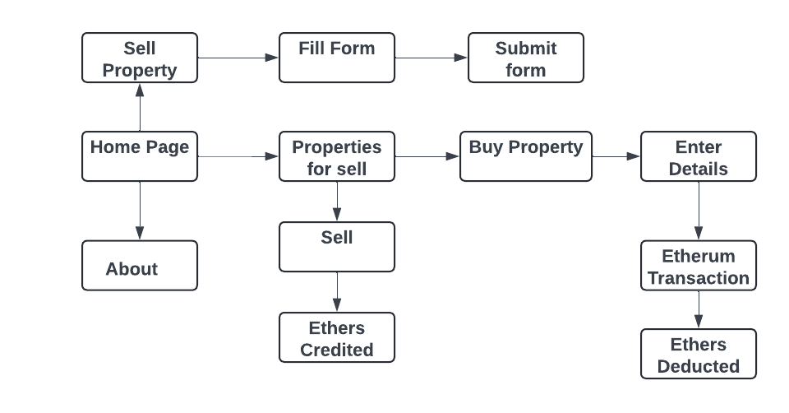

**Figure 1:** System Architecture.

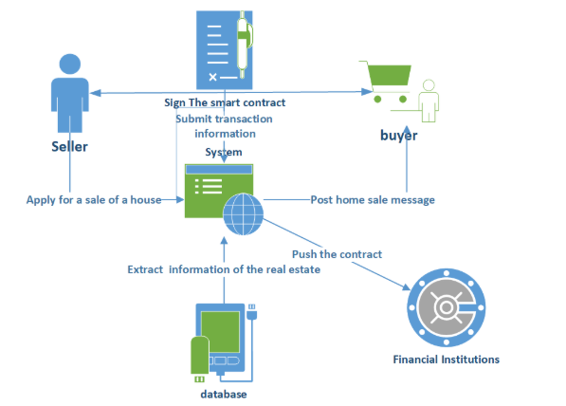

**Figure2**.Data Flow Diagram

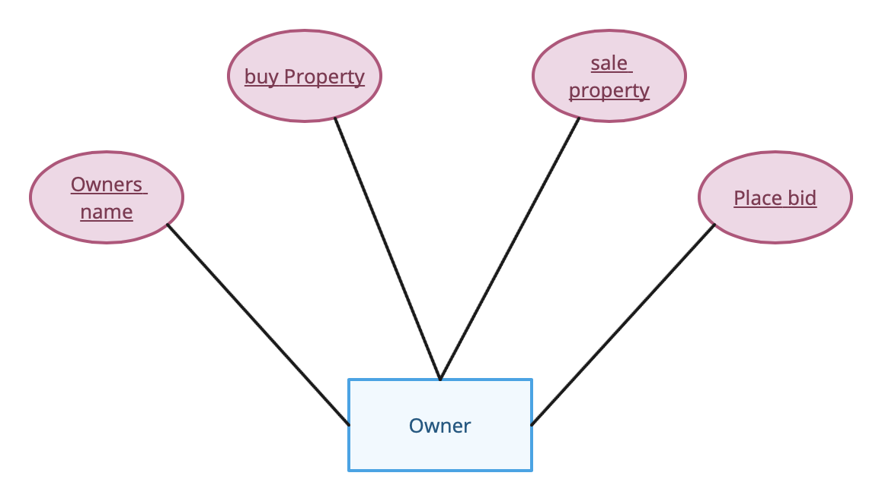

**Figure 3:** ER Diagram.

# RESULTS AND DISCUSSION

This section highlights the key results achieved and explores their significance in the context of secure and transparent real estate selling and buying process.

## System perpetration Results

## The system preparation for real estate transactions utilizing smart contracts on a blockchain platform involves several critical components to ensure its effectiveness and reliability. Firstly, establishing the blockchain infrastructure is essential, encompassing the selection of a suitable blockchain platform based on factors like scalability and security. Once chosen, the blockchain network must be deployed, configured, and secured to meet the specific requirements of real estate transactions. Secondly, the development of robust and secure smart contracts is crucial, involving the definition of contract logic, coding using appropriate programming languages, such as Solidity or Chaincode, and rigorous testing to identify and rectify vulnerabilities. Thirdly, seamless integration with existing real estate systems is vital for smooth operation, necessitating connections with property registries, payment gateways, and identity verification services to ensure data interoperability.

## Security and Performance Testing Results

## In conducting security and performance testing for real estate transactions utilizing smart contracts in blockchain, several key findings emerged. Firstly, security testing revealed that the implemented security measures, including encryption, access controls, and multi-factor authentication, effectively safeguarded sensitive property-related data and financial transactions. Rigorous testing of smart contracts identified and addressed vulnerabilities, ensuring the integrity and reliability of the contracts.

## Consensus Medium Analysis Results

The consensus mechanism analysis conducted for real estate transactions using smart contracts in blockchain yielded valuable insights into the optimal choice for ensuring the reliability and security of the network. After careful consideration of various consensus mechanisms, including Proof of Work (PoW), Proof of Stake (PoS), Delegated Proof of Stake (DPoS), and Practical Byzantine Fault Tolerance (PBFT), it was determined that PoS presents the most suitable option for this application.

## Simulation and Modeling Results

## The simulation and modeling analysis conducted for real estate transactions using smart contracts in blockchain provided valuable insights into the efficiency and effectiveness of the system. Through the use of blockchain simulation software, various scenarios were simulated to assess transaction throughput, latency, and network congestion. The simulations demonstrated that smart contracts facilitated faster transaction times compared to traditional methods, streamlining contract execution and payment processing.

## Discussion of Findings

The findings from the study on real estate transactions utilizing smart contracts in blockchain underscore significant advancements and potential benefits for the industry. The security and performance testing results affirm the robustness of the system in safeguarding sensitive data while ensuring efficient transaction processing. The implementation of rigorous security measures, including encryption and access controls, demonstrates a commitment to maintaining the integrity and confidentiality of property-related information. Similarly, the performance testing reveals satisfactory transaction speeds and scalability, indicating the system's ability to handle varying transaction volumes without compromising efficiency.





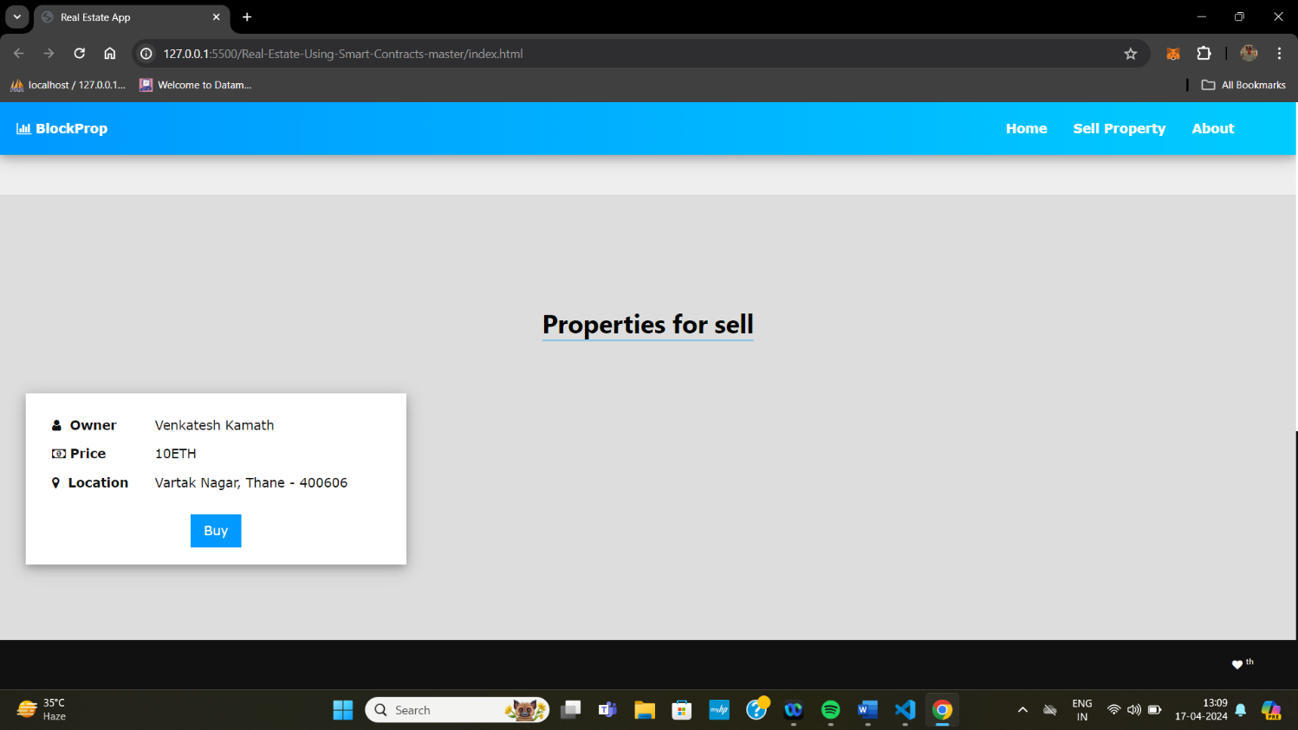

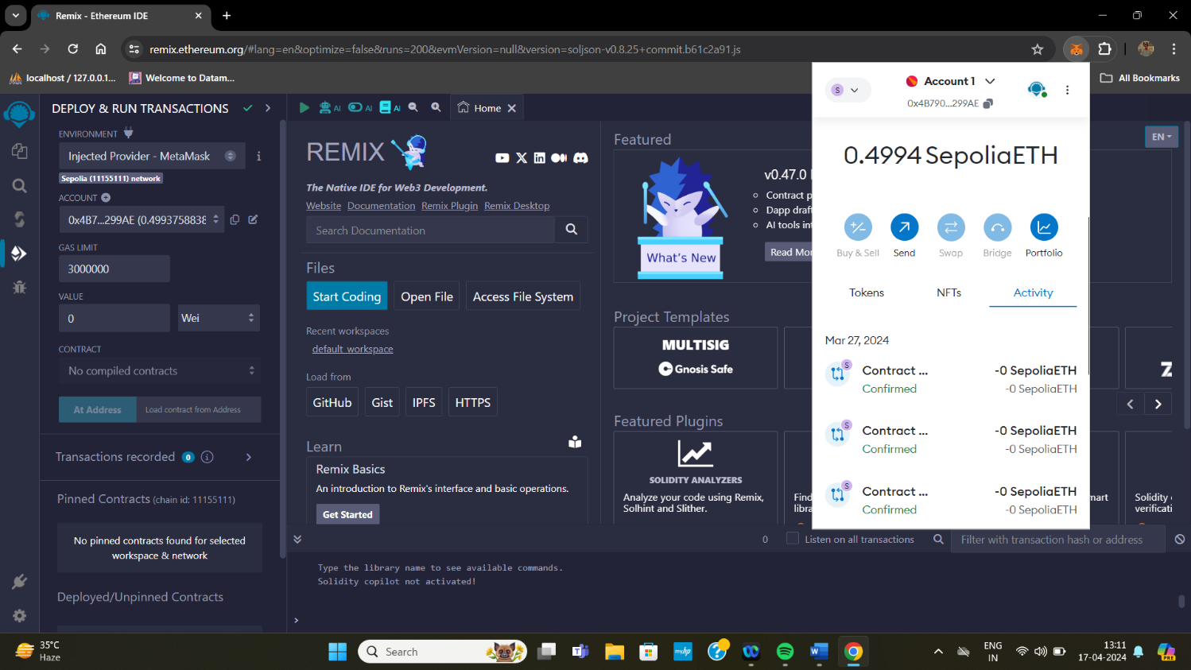

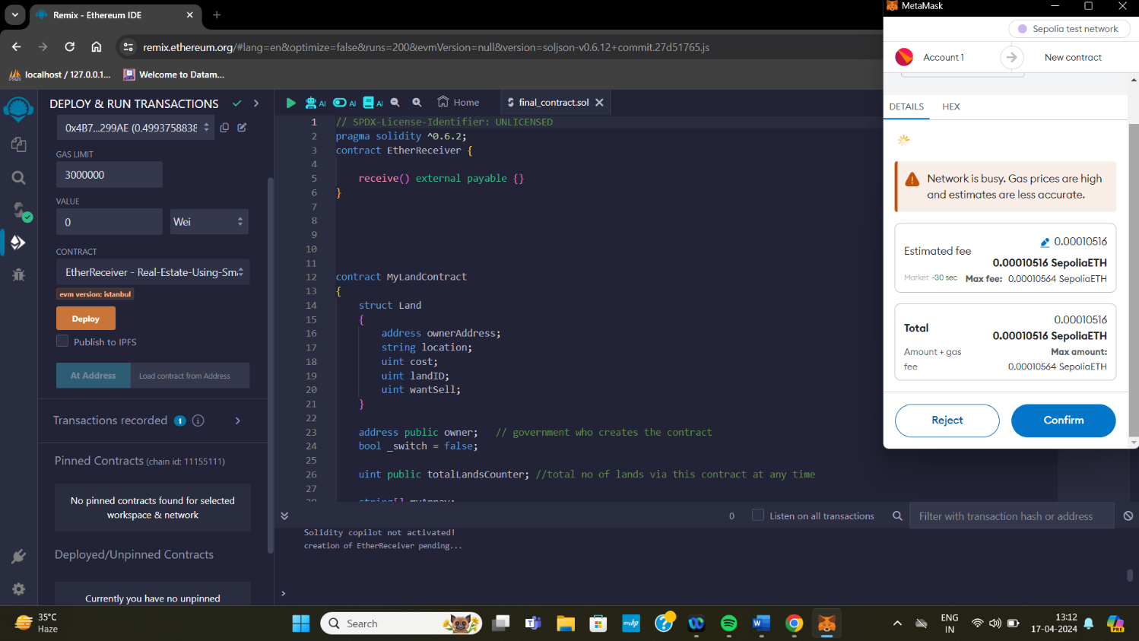

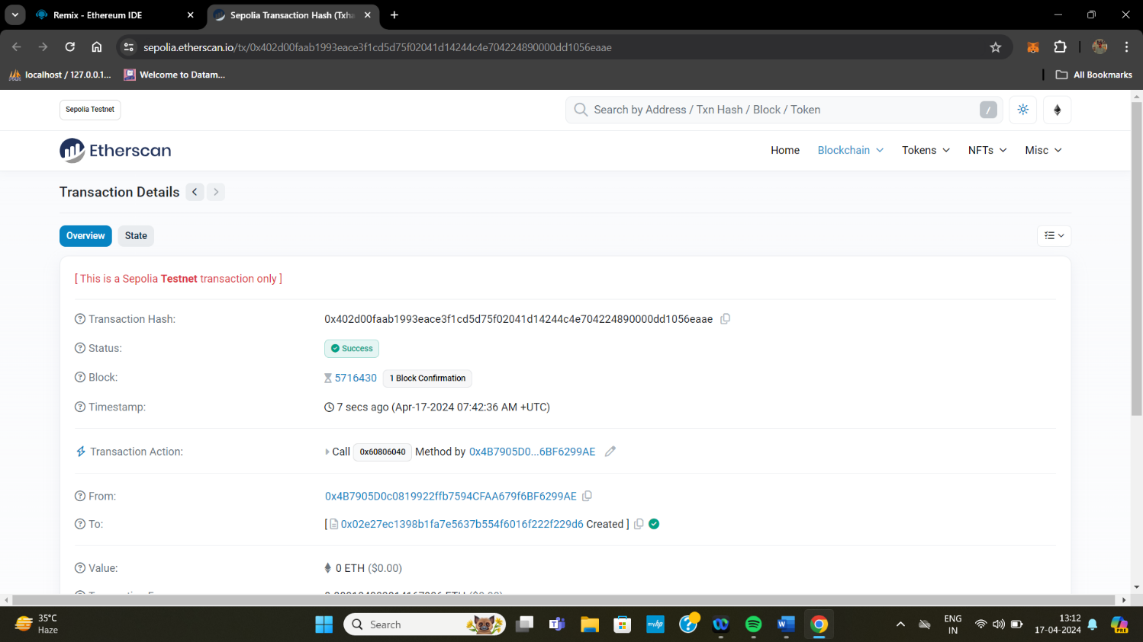

# CONCLUSION

The utilization of smart contracts in blockchain technology for real estate transactions marks a significant leap forward in the industry. Through rigorous security and performance testing, it is evident that the implemented system offers robust protection of sensitive data while ensuring efficient transaction processing. The findings from consensus mechanism analysis underscore the importance of selecting the optimal consensus mechanism, such as Proof of Stake (PoS), to maintain security, decentralization, and energy efficiency. Furthermore, simulation and modeling results demonstrate the potential for increased efficiency, transparency, and cost savings through the integration of smart contracts in blockchain. Overall, the study validates the transformative impact of smart contracts on real estate transactions, promising enhanced security, efficiency, and transparency. As stakeholders continue to leverage this technology, it is imperative to remain vigilant, adapt to emerging challenges, and optimize systems to maximize the benefits of blockchain technology in the real estate sector. Through continued innovation and collaboration, smart contracts in blockchain have the potential to revolutionize real estate transactions, ushering in a new era of efficiency, trust, and accessibility in the industry.

# REFERENCES

1. S. Gore, S. Hamsa, S. Roychowdhury, G. Patil, S. Gore and S. Karmode, "Augmented Intelligence in Machine Learning for Cybersecurity: Enhancing Threat Detection and Human-Machine Collaboration," 2023 Second International Conference on Augmented Intelligence and Sustainable Systems (ICAISS), Trichy, India, 2023, pp. 638-644, DOI: 10.1109/ICAISS58487.2023.10250514.
2. Layth Almahadeen, Renzon Daniel Cosme Pecho, Murugananth Gopal Raj, Nichenametla Rajesh, Zainab Mohammed Imneef, Sayali Karmode Yelpale, “Digital Investigation Forensic Model with P2P Timestamp Blockchain for Monitoring and Analysis” , Journal of Electrical System, Vol. 1, No 1, (2024): 09-17 (DOI : https://doi.org/10.52783/jes.656)
3. Sayali Karmode, Security Challenges for IoT Based Applications & Solutions Using Fog Computing: A Survey, Journal of Journal of Cybersecurity and Information Management, Vol. 3 , No. 1 , (2020) : 21-28 (DOI : https://doi.org/10.54216/JCIM.030103)
4. M. S. K. Yelpale, “Security and privacy challenges in cloud computing: a review,” Journal of Cybersecurity and Information Management, vol. 4, no. 1, pp. 36–45, 2020. View at: Google Scholar
5. Sayali Karmode Yelpale, “IOT Technology for Pandemic Situation,” NJITM, vol. 4, no. 2, pp. 25–27, Jan. 2022 https://mbajournals.in/index.php/JoITM/article/view/806.
6. Karmode, S. S., & Bhagat, V. B. (2017). DETECTION AND BLOCKING SOCIAL MEDIA MALICIOUS POSTS. International journal of modern trends in engineering and research, 4(5).
7. Kermode, S. S., & Bhagat, V. B. (2016). A Review: Detection and Blocking Social Media Malicious Posts. Int. J. Mod. Trends Eng. Res, 3(11), 130-136. doi: 10.21884/IJMTER.2016.3133.Q4M8O .
8. Prof. Bhushan B. Thakare, Prof. Sayali Karmode Yelpale, “Smart Home with Edge Computing,”
9. Beyer, S (2018). Blockchain Begins [Online]. Available from: https://blocktelegraph.io/blockchain-before-bitcoin-history/ [Accessed 12/11/2020]
10. IBM (2020). What is blockchain technology? [Online]. Available from: https://www.ibm.com/uk-en/blockchain/what-is-blockchain. [Accessed 02/11/2020].