**DESIGN ANALYSIS OF TWO WHEELER DISC BRAKE BY USING CERAMIC MATRIX COMPOSITE MATERIAL**

**Mr. Kanwade Sachin1, Prof. B. M. Randhavan2**

1Student, M.E., Mechanical Engineering, SVCOET, Junnar, Pune, Maharashtra, India

2Professor, Mechanical Engineering, SVCOET, Junnar, Pune, Maharashtra, India

**ABSTRACT**

The structural analysis of a disc brake using Finite Element Analysis (FEA) plays a crucial role in understanding its mechanical behavior and performance characteristics under varying operating conditions. This study focuses on employing FEA techniques to simulate and analyze the structural integrity of a typical disc brake rotor subjected to thermal and mechanical loading. The objectives include assessing stress distribution, deformation patterns, and thermal gradients within the disc brake rotor. Key aspects of the analysis involve modeling the disc brake rotor geometry, applying realistic boundary conditions including thermal loads induced by braking, and predicting stress concentrations and deformation patterns using FEA software. Material properties such as thermal conductivity, specific heat capacity, and mechanical properties are incorporated into the simulation to ensure accuracy.

The findings from this study aim to provide valuable insights into the performance and reliability of disc brake systems, aiding in the optimization of design parameters to enhance durability and efficiency. This abstract outlines the methodology and scope of the structural analysis, underscoring its significance in advancing the understanding of disc brake behavior through computational simulations.

**Keywords:** Finite Element Analysis, Disc brake, Material optimization comparative analysis..

1. **INTRODUCTION**

A brake is a mechanism used to apply artificial frictional resistance to a moving machine part, with the goal of halting the machine's motion. In this process, brakes absorb either the kinetic energy of the moving part or the potential energy released by objects being lowered by devices like hoists or elevators. The energy absorbed by brakes is dissipated as heat into the surroundings.

**Brake Design Considerations:**

* Brakes must provide sufficient stopping power to halt a vehicle within a minimal distance during emergencies.
* They should allow the driver precise control over the vehicle during braking, preventing skidding.
* Brakes must maintain consistent effectiveness even with prolonged or constant use (anti-fade characteristics).
* They should demonstrate good resistance to wear over time.

1. **OBJECTIVES**

* Aim is to design and develop the disc brake which sustains the structural load acting on brake disc during action of braking.
* Compare the strength of two different designs of disc brake with existing disc brake.
* The disc brake with higher strength of design is selected for the disc brake application.
* Existing design of disc brake is modeled in CATIA.
* The structural analysis is carried out in ANSYS.

1. **METHODOLOGY**

Methodology used in the failure analysis and design of the disc brake is as follow

1. Cad Model Creation
2. Mesh Generation
3. Material Properties
4. Boundary Conditions
5. Loading Conditions
6. Structural Analysis
7. Comparison Of Results

**4. FINITE ELEMENT ANALYSIS**

Finite Element Method is a numerical procedure for solving continuum mechanics of problem with accuracy acceptable to engineers. Finite Element Method is a mathematical modelling tool involving discretization of a continuous domain.

**Structural Analysis of Proposed Design**

The total deformation and stress plots are shown in below Figures for the proposed disc designs.

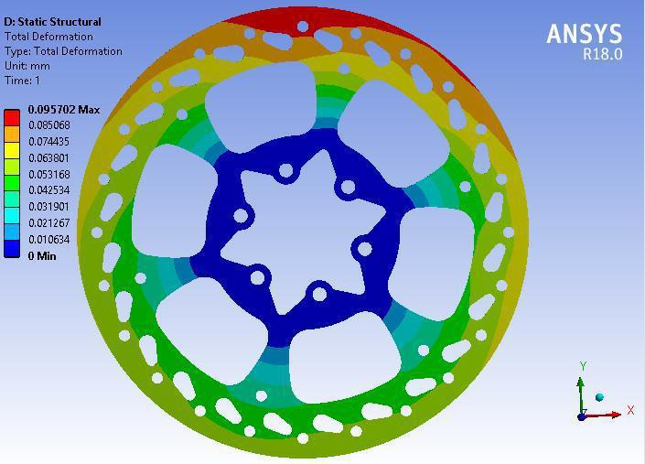

**Figure 4.1 : Von-Mises stress contour plot of proposed design disc**

The maximum deformation shown by the proposed disc brake is 0.0957 mm.

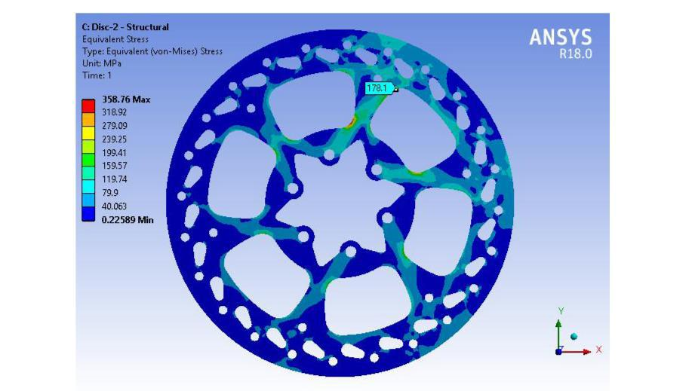

**Figure 4.2 : Von-Mises stress contour plot of proposed design disc**

The von-mises stress of proposed disc observed is 359 MPa.

The maximum equivalent stress observed in the proposed disc is 359 MPa. The yield strength of the material is 395 MPa. According to results, the von-Mises stress 359 MPa is less than yield strength of the material. The safety factor observed is 1.12 for the disc which is higher than the baseline model.

**4.5 Summary (From Finite Element Analysis)**

Analysis of the results reveals that the highest stress levels occur in the baseline model, aligning precisely with observed field failures. A comparison of maximum total deformation and equivalent stress values across various designs of the disc was conducted using Finite Element Analysis (FEA). The table below presents this comparative analysis among different disc designs.

Table 4.1: FEA Results

|  |  |  |  |
| --- | --- | --- | --- |
| Sr. No | Description | Deformation | Stress analysis |
| 1 | Baseline model | 0.139 | 363 |
| 2 | Proposed model | 0.095 | 359 |

The proposed disc design is feasible and carried forward for manufacturing and compared the experimental results with finite element study.

**5. CONCLUSION**

The comparative study of different disc brake designs has led to the following conclusions:

* The proposed disc design exhibits less deformation compared to the baseline model.
* The von-Mises stress in the proposed disc design is lower than that in the baseline model design.
* Therefore, based on design and manufacturing considerations, the proposed disc design is deemed the most suitable and feasible for the current application.

**REFERENCES**

1. Anderson A. E. And Knapp R. A., Hot Spotting in Automotive Friction System Wear, vol. 135, page 319-337, (1990).
2. Barber J. R., Contact Problems Involving a Cooled Punch, J. Elasticity, vol. 8, page 409-423, (1978).
3. Brilla J., Laplace Transform and New Mathematical Theory of Visco elasticity, vol. 32, page 187-195, (1997).
4. Burton R. A., Thermal Deformation in Frictionally Heated Contact, Wear, vol. 59, page 1-20, (1980).
5. Flouet A. And Dubourg M.C., Non axis symmetric effect three dimensional Analyses of a Brake, ASME J. Tribology, vol. 116, page 401-407. (1994).
6. Kennedy F. E., et. al., Improved Techniques for Finite Element Analysis of Sliding Surface Temperatures. Westbury House page 138-150, (1984).
7. Manjunath T. V. And Dr. Suresh P. M., (2013 Dec), Structural and Thermal Analysis of Rotor Disc of Disc Brake,[Online].Available: https://www.ijirset.com/upload/2013/december/51A_Structural.pdf
8. Pigozzi G. And Ceretto E., Combined Thermal and Mechanical Analysis of Truck Brakes, Conference Innovation and Reliability in Automotive Design and Testing, Vol. 2, page 921-933, (1992).