**Optimizing Cutting Parameters in Turning Operations through the Taguchi Method for Multi-Objectives Purpose**

**1Kalpana, 2Yogesh Mishra, 3Ramnarayan Sahu**

1Research Scholar, Master of Technology (APS) Department of Mechanical Engineering, NIIST, Bhopal

2 Assistant Professor & Head, Department of Mechanical Engineering, NIIST, Bhopal

3 Assistant Professor, Department of Mechanical Engineering, NIIST, Bhopal

**Abstract:** This study focuses on the parametric optimization of the turning process using the Taguchi method to enhance the quality of manufactured goods and advance engineering design for variability analysis. The experiment involves utilizing SS-304 as the workpiece to optimize material removal rate and surface roughness, considering three key machining parameters: spindle speed, feed rate, and depth of cut. By systematically varying one parameter at a time while keeping the others constant, the project employs dry turning of SS-304 steel with a carbide insert tool (SNMG120408MS, SNMG432MS). The cutting parameters' range includes cutting speed (40, 66, and 92 m/min), feed rate (0.05, 0.1, and 0.15 mm/rev), and depth of cut (0.25, 0.5, and 0.75 mm). The Taguchi orthogonal array, designed using Minitab version 16 software, incorporates three levels of turning parameters. The Taguchi method emphasizes studying response variation through the signal-to-noise (S/N) ratio to minimize the variation in quality characteristics caused by uncontrolled parameters. This approach proves effective in optimizing various machining parameters by reducing the number of experiments. The results reveal optimal values for the input factors, validated through a confirmatory test.

***Keywords:*** *Depth of Cut; Feed; Speed; Spindle Speed; Taguchi Orthogonal Array;*

**Introduction:** Turning is one of the major machining processes which includes metal cutting as removal of metal chips in order to get finished product of desired shape, size and surface roughness. The engineers have to face challenge in order to get optimal parameters for preferred output using available sources. Usually, selection of machining parameters is very much difficult for desired product. Actually, it depends upon experience of the engineers and the table given by machine-tool designer. So, the importance of optimization arises in order to satisfy economy and quality of machined part. The Taguchi’s method talks about reduction in variation in order to improve quality by method of offline or online quality control. The offline quality control helps in improving quality of processes, where online quality control helps in maintaining conformance to the original or intended design. The main and fundamental part of Taguchi’s design is to ensure that the product perform well even in noise; it helps in making the product long lasting. Taguchi method is applied in a very short period of time without lots of efforts. That is why Taguchi’s method is adopted in various industries in order to improve the process quality in manufacturing sectors. Surface roughness and cutting force are two very important parameters in machining process. Cutting force is necessary for calculation of power machining. Cutting forces influences dimensional accuracy, deformation of work-piece and chip formation. Components of certain surface roughness are always required in industries as per customer requirement. This can be achieved by optimization process which we are going to discuss about.



**Figure 1 Machining Process** **of Single Point Cutting Tool**

The angle between the side relief face of the tool and machining plane is called side relief angle α. The relief angle depends upon rate of feed parameter, if feed increases, then relief angle increases in order to avoid friction between relief surface and cutting edge. The angle between the top and side relief surface of the tool is known as lip angle β. The angle between the plane perpendicular to the cutting plane and the top surface of the tool is known as side rake angle γ. The mechanism of turning process is shown in Fig. 1.

**Literature Review:** Literature reviews are integral components of academic research papers, theses, dissertations, and scholarly articles. They serve to situate the research within the existing body of knowledge, demonstrate the researcher's familiarity with prior work, and justify the need for new investigations. **Choudhury and Bartarya (2023)** focused on design of experiments and the neural network for prediction of tool wear. The input parameters were cutting speed, feed and depth of cut; flank wear, surface finish and cutting zone temperature were selected as outputs. Empirical relation between different responses and input variables and also through neural network (NN) program helped in predictions for all the three response variables and compared which method was best for the prediction [1]. **Chien and Tsai (2023)** developed a model for the prediction of tool flank wear followed by an optimization model for the determination of optimal cutting conditions in machining 17-4PH stainless steel. The back-propagation neural network (BPN) was used to construct the predictive model. The genetic algorithm (GA) was used for model optimization [2]. **Kirby et al. (2023)** developed the prediction model for surface roughness in turning operation. The regression model was developed by a single cutting parameter and vibrations along three axes were chosen for in-process surface roughness prediction system. By using multiple regression and Analysis of Variance (ANOVA) a strong linear relationship among the parameters (feed rate and vibration measured in three axes) and the response (surface roughness) was found. The authors demonstrated that spindle speed and depth of cut might not necessarily have to be fixed for an effective surface roughness prediction model [3]. **Őzel and Karpat (2023)** studied for prediction of surface roughness and tool flank wear by utilizing the neural network model in comparison with regression model. The data set from measured surface roughness and tool flank wear were employed to train the neural network models. Predictive neural network models were found to be capable of better predictions for surface roughness and tool flank wear within the range in between they were trained [4]. **Luo et al. (2023)** carried out theoretical and experimental studies to investigate the intrinsic relationship between tool flank wear and operational conditions in metal cutting processes using carbide cutting inserts. The authors developed the model to predict tool flank wear land width which combined cutting mechanics simulation and an empirical model. The study revealed that cutting speed had more dramatic effect on tool life than feed rate [5]. **Kohli and Dixit (2022)** proposed a neural-network-based methodology with the acceleration of the radial vibration of the tool holder as feedback. For the surface roughness prediction in turning process the back-propagation algorithm was used for training the network model. The methodology was validated for dry and wet turning of steel using high speed steel and carbide tool and observed that the proposed methodology was able to make accurate prediction of surface roughness by utilizing small sized training and testing datasets [6]. **Zhong et al. (2022) [16]** predicted the surface roughness of turned surfaces using networks with seven inputs namely tool insert grade, work piece material, tool nose radius, rake angle, depth of cut, spindle rate, and feed rate [7]. **Kumanan et al. (2022)** proposed the methodology for prediction of machining forces using multi-layered perceptron trained by genetic algorithm (GA). The data obtained from experimental results of a turning process were explored to train the proposed artificial neural networks (ANNs) with three inputs to get machining forces as output. The optimal ANN weights were obtained using GA search. This function-replacing hybrid made of GA and ANN was found computationally efficient as well as accurate to predict the machining forces for the input machining conditions [8]. **Mahmoud and Abdelkarim (2022)** studied on turning operation using High-Speed Steel (HSS) cutting tool with 450 approach angles. This tool showed that it could perform cutting operation at higher speed and longer tool life than traditional tool with 90-degree approach angle. The study finally determined optimal cutting speed for high production rate and minimum cost, tool like, production time and operation costs [9]. **Doniavi et al. (2022)** used response surface methodology (RSM) in order to develop empirical model for the prediction of surface roughness by deciding the optimum cutting condition in turning. The authors showed that the feed rate influenced surface roughness remarkably. With increase in feed rate surface roughness was found to be increased. With increase in cutting speed the surface roughness decreased. The analysis of variance was applied which showed that the influence of feed and speed were more in surface roughness than depth of cut [10]. **Kassab and Khoshnaw (2022)** examined the correlation between surface roughness and cutting tool vibration for turning operation. The process parameters were cutting speed, depth of cut, feed rate and tool overhanging. The experiments were carried out on lathe using dry turning (no cutting fluid) operation of medium carbon steel with different level of aforesaid process parameters. Dry turning was helpful for good correlation between surface roughness and cutting tool vibration because of clean environment. The authors developed good correlation between the cutting tool vibration and surface roughness for controlling the surface finish of the work pieces during mass production. The study concluded that the surface roughness of work piece was observed to be affected more by cutting tool acceleration; acceleration increased with overhang of cutting tool. Surface roughness was found to be increased with increase in feed rate [11]. **Ozel et al. (2021)** carried out finish turning of AISI D2 steels (60 HRC) using ceramic wiper (multi-radii) design inserts for surface finish and tool flank wear investigation. For prediction of surface roughness and tool flank wear multiple linear regression models and neural network models were developed. Neural network-based predictions of surface roughness and tool flank wear were carried out, compared with a non-training experimental data and the results thereof showed that the proposed neural network models were efficient to predict tool wear and surface roughness patterns for a range of cutting conditions. The studyconcluded that best tool life was obtained in lowest feed rate and lowest cutting speed combination [12]. **Wang and Lan (2021)** used Orthogonal Array of Taguchi method coupled with grey relational analysis considering four parameters viz. speed, cutting depth, feed rate, tool nose run off etc. for optimizing three responses: surface roughness, tool wear and material removal rate in precision turning on an ECOCA-3807 CNC Lathe. The MINITAB software was explored to analyze the mean effect of Signal-to-Noise (S/N) ratio to achieve the multi-objective features. This study not only proposed an optimization approach using Orthogonal Array and grey relational analysis but also contributed a satisfactory technique for improving the multiple machining performances in precision CNC turning with profound insight [13]. **Srikanth and Kamala (2020)** evaluated optimal values of cutting parameters by using a Real Coded Genetic Algorithm (RCGA) and explained various issues of RCGA and its advantages over the existing approach of Binary Coded Genetic Algorithm (BCGA). They concluded that RCGA was reliable and accurate for solving the cutting parameter optimization and construct optimization problem with multiple decision variables. These decision variables were cutting speed, feed, depth of cut and nose radius. The authors highlighted that the faster solution can be obtain with RCGA with relatively high rate of success, with selected machining conditions thereby providing overall improvement of the product quality by reduction in production cost, reduction in production time, flexibility in machining parameter selection [14].

**Objectives:** The objective of work is to observe the cutting parameters in turning and to calculate the optimum value of the parameters in order to optimize the surface roughness and tool wear using Taguchi method. The statistical analysis is to be performed for better machining operation which can be used for quality control of machining parts. This will help to concerned R and D researchers or industrial experts.

**Methodology:** Systematically categorize the extracted data to identify common trends, variations, and emerging patterns across different studies. Group findings based on the specific cutting parameters optimized, the objectives targeted, and the Taguchi Method's application variations. In-depth analysis of case studies illustrating the application of the Taguchi Method in turning operations. Evaluate the experimental designs, methodologies employed, and the effectiveness of the Taguchi Method in achieving multi-objective optimization. Discuss the implications of each case study's results. Identify challenges and limitations associated with the application of the Taguchi Method in turning operations for multi-objective optimization. Explore issues related to experimental design complexities, parameter interactions, and practical implications in real-world manufacturing scenarios.

**Cutting tool specification**

The specification of cutting tool used is SNMG 120408MS and the dimensions are as follows.

Table 1: Specification of cutting tool (mm)

|  |  |  |  |  |  |
| --- | --- | --- | --- | --- | --- |
| Cutting Edge Length | Inscribed Circle or Height | Thickness | Hole Diameter | Corner Radius | Side Clearance |
| 12.7 | 12.7 | 4.76 | 5.16 | 0.8 | 0° |

**Composition and application of work piece**

S.S. 304 is a most widely used austenitic steel popularly known as 18/8 stainless steel. The Fig. 2 shows the experimental set up of turning operation with work piece of S. S. 304 graded steel.



**Fig. 2 Experimental set up for machining**

**Result and Discussion:** the criterion of Smaller-The-Better is adopted for the optimization. The analysis of S/N ratio and Means are carried out by the software. Then, ANOVA analysis of each parameter is done after simulation of optimization. And lastly the influences of residuals on parameters are carried out by plotting graphs.

**Taguchi Analysis: Tool Wear versus Speed, Feed, Doc**

The following terms cannot be estimated, and were removed.

Speed*Feed

Speed*Doc

Feed*Doc

The interaction terms are not be analyzed by Taguchi.

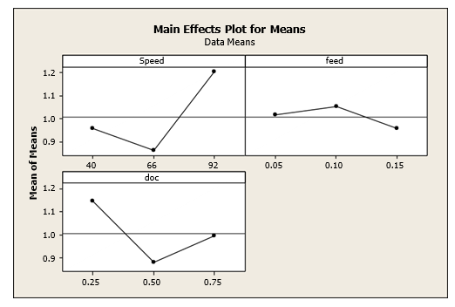

**Fig. 3 Main Effects Plot for Means**

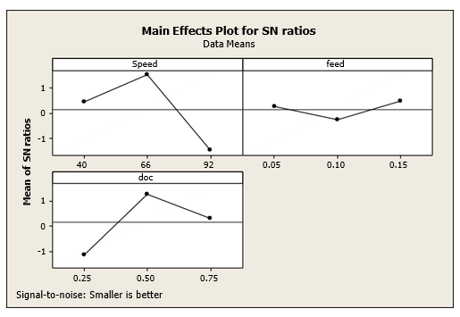

**Fig. 3 Main Effects Plot for S/N ratios**

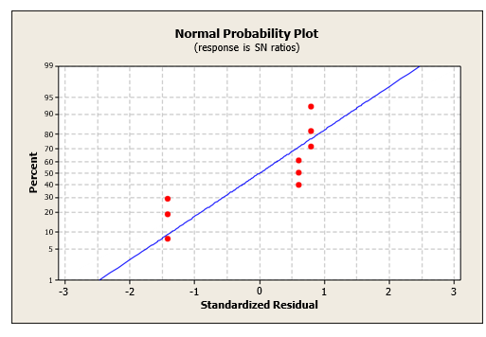

**Fig. 4 Normal plot of Residuals for S/N ratios**

**Conclusions:** A conclusion is the final piece of writing in a research paper, essay, or article that summarize the entire words The conclusion paragraph should restate your thesis, summarize the key supporting ideas you discussed throughout the work, and offer your final impression on the central idea.

* Conclusion can be derived from the experimentation done using S. S. 304 graded steel and carbide cutting tool.
* A set of levels of parameter is obtained in order to minimize surface roughness as well as tool wear.
* It is found that cutting velocity affects more while calculating tool wear and where depth of cut affects more while experimentation of surface roughness.
* A conformation test is done in order to get optimal setting, it is evidenced that A2 B3 C2 for measuring tool wear and it is found to be 0.659 micron and A1 B2 C1 for surface roughness, it is found to be 1.253 micron.

**References:**

[1.] Choudhury S. K. and Bartarya G., (2023), “Role of temperature and surface finish in predicting tool wear using neural network and design of experiments”, International Journal of Machine Tools and Manufacture, Volume 43, pp. 747–753

[2.] Chien W.-T. and Tsai C.-S., (2023), “The investigation on the prediction of tool wear and the determination of optimum cutting conditions in machining 17-4PH stainless steel”, Journal of Materials Processing Technology, Volume 140, pp. 340–345.

[3.] Kirby E. D., Zhang Z. and Chen J. C., (2023), “Development of An Accelerometer based surface roughness Prediction System in Turning Operation Using Multiple Regression Techniques”, Journal of Industrial Technology, Volume 20, Number 4, pp. 1-8.

[4.] Özel T. and Karpat Y., (2023), “Predictive modeling of surface roughness and tool wear in hard turning using regression and neural networks”, International Journal of Machine Tools and Manufacture, Volume 45, pp. 467–479

[5.] Antony J., (2023), “multi-response optimization in industrial experiments using Taguchi’s quality loss function and Principal Component Analysis”, Quality and Reliability Engineering International, Volume 16, pp.3-8

[6.] Zhong Z. W., Khoo L. P. and Han S. T., (2022), “Prediction of surface roughness of turned surfaces using neural networks”, International Journal of Advance Manufacturing Technology, Volume 28, pp. 688–693.

[7.] Kumanan S., Saheb S. K. N. and Jesuthanam C. P., (2022), “Prediction of Machining Forces using Neural Networks Trained by a Genetic Algorithm”, Institution of Engineers (India) Journal, Volume 87, pp. 11-15.

[8.] Mahmoud E. A. E. and Abdelkarim H. A., (2022), “Optimum Cutting Parameters in Turning Operations using HSS Cutting Tool with 450 Approach Angle”, Sudan Engineering Scoeiety Journal, Volume 53, Number 48, pp. 25-30.

[9.] Doniavi A., Eskanderzade M. and Tahmsebian M., (2022), “Empirical Modeling of Surface Roughness in Turning Process of 1060 steel using Factorial Design Methodology”, Journal of Applied Sciences, Volume 7, Number17, pp. 2509-2513.

[10.] Kassab S. Y. and Khoshnaw Y. K., (2022), “The Effect of Cutting Tool Vibration on Surface Roughness of Work piece in Dry Turning Operation”, Engineering and Technology, Volume 25, Number 7, pp. 879-889.

[11.] Al-Ahmari A. M. A., (2021),” Predictive machinability models for a selected hard material in turning operations”, Journal of Materials Processing Technology, Volume, 190, pp. 305–311.

[12.] Özel T. and Karpat Y., (2021), “Predictive modeling of surface roughness and tool wear in hard turning using regression and neural networks”, International Journal of Machine Tools and Manufacture, Volume 45, pp. 467–479.

[13.] Wang M. Y. and Lan T. S., (2021), “Parametric Optimization on Multi-Objective Precision Turning Using Grey Relational Analysis”. Information Technology Journal, Volume 7, pp.1072-1076.

[14.] Srikanth T. and Kamala V., (2020), “A Real Coded Genetic Algorithm for Optimization of Cutting Parameters in Turning IJCSNS”, International Journal of Computer Science and Network Security, Volume 8 Number 6, pp. 189-193.