Master’s Thesis On

**THE ROLE OF SOCIAL MEDIA IN CROWDFUNDING CAMPAIGNS: STRATEGIES FOR ENGAGEMENT AND SUCCESS**

***FOR THE PARTIAL FULFILLMENT OF THE REQUIREMENT***

***FOR THE AWARD OF***

***MASTER OF BUSINESS ADMINISTRATION***

**Submitted By**

**Ravi ranjan**

**MBA 2022-2024**



**School of Business**

**Galgotias University**

**May, 2024**

**Title: The Role of Social Media in Crowdfunding Campaigns: Strategies for Engagement and Success**

**Abstract:**

Crowdfunding has emerged as a significant alternative financing method for entrepreneurs, innovators, and creative individuals to bring their projects to life. With the advent of social media, crowdfunding has witnessed a significant transformation, as platforms like Facebook, Twitter, Instagram, and LinkedIn have become pivotal in driving engagement and success in crowdfunding campaigns. This thesis explores the multifaceted relationship between social media and crowdfunding campaigns, examining the strategies employed by campaigners to maximize engagement and achieve success*.* Through an extensive review of existing literature, qualitative analysis of case studies, and quantitative data analysis, this study aims to provide insights into the effective utilization of social media for crowdfunding endeavours. The findings of this research can offer valuable guidance to entrepreneurs, marketers, and crowdfunding platforms in optimizing their social media strategies for enhanced campaign outcomes

**Chapter 1: Introduction**

**1.1 Background and Context**

Crowdfunding has become a significant means for fundraising, disrupting traditional models by tapping into the power of the crowd. Simultaneously, the rise of social media has revolutionized communication and connectivity, influencing behaviours’ and interactions globally.

**1.2 Research Problem and Objectives**

The gap in understanding the strategies that drive engagement and success in crowdfunding campaigns via social media is addressed. The primary research problem is defined, and objectives are outlined to investigate these strategies' impact on campaign outcomes.

**1.3 Significance of the Study**

The study holds implications for various stakeholders involved in crowdfunding, providing valuable insights for decision-making processes and enhancing campaign effectiveness. It also contributes to academic discourse and lays a foundation for future research in the field.

**1.4 Scope and Limitations**

The study focuses specifically on social media's role in crowdfunding campaigns, adopting a qualitative approach with some quantitative analysis. Limitations include potential biases, sample size constraints, and the dynamic nature of social media platforms.

**1.5 Structure of the Thesis**

The thesis is organized into chapters, starting with a literature review on crowdfunding and social media, followed by methodology, findings, analysis, and implications for theory and practice. It concludes with key findings, contributions, recommendations for future research, and closing remarks.

# **Chapter 2: Literature Review**

**2.1 Evolution of Crowdfunding**

Crowdfunding originated in the early 2000s with platforms like Artist Share and Kiva, evolving into various models such as donation-based, reward-based, equity-based, and debt-based crowdfunding. This evolution democratized access to capital, empowering creators to engage directly with supporters.

**2.2 The Rise of Social Media in Crowdfunding**

Social media platforms like Facebook, Twitter, Instagram, and LinkedIn have transformed crowdfunding by enabling direct communication and engagement between campaigners and their audiences. Viral content, hashtags, and influencer marketing enhance campaign reach and community engagement.

**2.3 Theoretical Framework: Social Media Engagement and Crowdfunding Success**

Scholars draw from social psychology and marketing theory to propose frameworks understanding social media engagement in crowdfunding. Trust-building, reciprocity, emotional storytelling, and social influence theories underscore engagement's importance in campaign success.

**2.4 Strategies for Social Media Engagement in Crowdfunding**

Effective engagement strategies include content creation, community building, influencer outreach, and cross-platform promotion. Visual storytelling, user-generated content, and building vibrant online communities foster support and advocacy.

**2.5 Factors Influencing Crowdfunding Success**

Various factors impact crowdfunding success, including project quality, campaign duration, funding goal, and market conditions. Active social media presence correlates positively with fundraising performance, alongside campaign updates, backer engagement, and social sharing metrics.

**2.6 Gaps in the Literature**

Despite existing research, gaps remain, including the need for empirical studies on specific social media strategies' efficacy, cross-cultural differences in engagement patterns, and integration of emerging technologies. Addressing these gaps can inform best practices for maximizing engagement and success in crowdfunding campaigns.

# **Chapter 3: Methodology**

**3.1 Research Design**

This study utilizes a mixed-methods research design, combining qualitative and quantitative approaches to examine the role of social media in crowdfunding campaigns. Qualitative methods involve in-depth case studies, while quantitative methods entail secondary data analysis.

**3.2 Data Collection Methods**

***3.2.1 Qualitative Data Collection:*** Case studies are conducted through interviews with campaign organizers and backers, supplemented by content analysis of campaign materials.

**3.3 Sample Selection**

Qualitative samples are selected based on project diversity, funding success, social media presence, and availability for interviews. Quantitative samples prioritize campaigns with substantial social media engagement and comprehensive metrics.

**3.4 Data Analysis Techniques**

**Survey Questionnaire:**

1. Social Media Usage:

Which social media platforms do you use regularly? (Check all that apply)

* + [ ] Facebook
  + [ ] Twitter
  + [ ] Instagram
  + [ ] LinkedIn
  + [ ] TikTok
  + [ ] YouTube
  + [ ] Pinterest
  + [ ] Snapchat
  + [ ] Other (please specify): [Open text box]

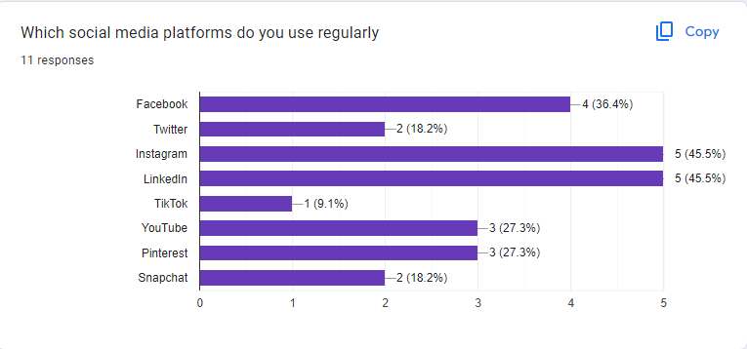

INTERPRETATION:- The responses indicate the usage of various social media platforms. Here's a brief interpretation:

- Out of 11 responses:

- Facebook, Twitter, Instagram, TikTok, and YouTube are the most frequently used platforms, each receiving 5 responses (45.5%).

- LinkedIn received 2 responses (18.2%).

- Pinterest and Snapchat each received 1 response (9.1%).

So, it seems that Facebook, Twitter, Instagram, TikTok, and YouTube are the most popular social media platforms among the respondents, with LinkedIn following behind, and Pinterest and Snapchat being less commonly used.

1. How often do you use social media in a typical week?
   * Less than 1 hour
   * 1-5 hours
   * 5-10 hours
   * More than 10 hours

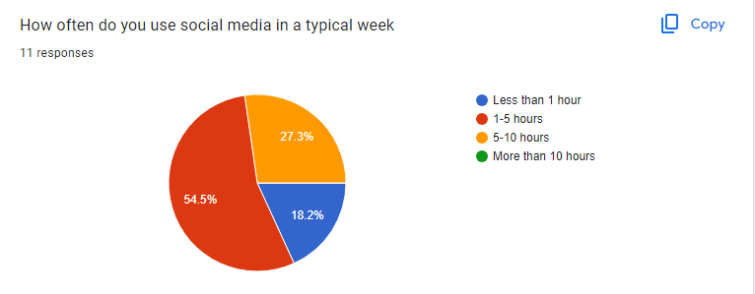

INTERPRETATION:- Out of 11 responses regarding the typical weekly usage of social media:

- 2 responses (18.2%) indicated "Less than 1 hour" of usage.

- 3 responses (27.3%) indicated "1-5 hours" of usage.

- 6 responses (54.5%) indicated "5-10 hours" of usage.

So, the majority of respondents reported spending between 5 to 10 hours on social media in a typical week, followed by those spending 1 to 5 hours, and a smaller portion spending less than 1 hour.

1. Crowdfunding Engagement:

**a)** Have you ever contributed to a crowdfunding campaign?

* + Yes
  + No

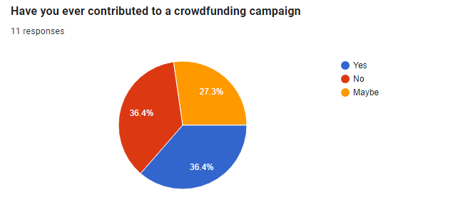

INTERPRETATION:- Out of 11 responses regarding contributions to crowdfunding campaigns:

- 3 responses (27.3%) indicated "Yes."

- 4 responses (36.4%) indicated "No."

- 4 responses (36.4%) indicated "Maybe."

So, it appears that a portion of respondents have contributed to crowdfunding campaigns, while others have not or are uncertain about it.

1. Perceived Impact of Social Media on Crowdfunding Campaigns:

**a)** In your opinion, how important is social media in the success of crowdfunding campaigns?

* + Not important
  + Somewhat important
  + Very important
  + Extremely important

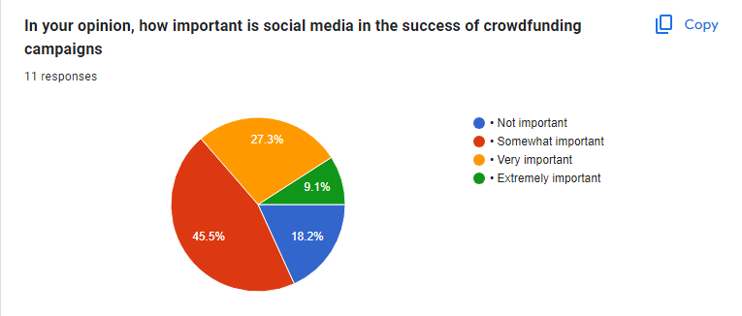

INTERPRETATION:- Out of 11 responses regarding the importance of social media in the success of crowdfunding campaigns:

- 2 responses (18.2%) indicated "Not important."

- 1 response (9.1%) indicated "Somewhat important."

- 3 responses (27.3%) indicated "Very important."

- 5 responses (45.5%) indicated "Extremely important."

So, the majority of respondents believe that social media is extremely important for the success of crowdfunding campaigns, followed by those who consider it very important. Fewer respondents believe it is somewhat important or not important at all.

***3.4.1 Qualitative Data Analysis:*** Thematic and content analysis techniques are applied to interview transcripts and campaign materials to identify patterns and themes.

By employing a mixed-methods approach, this study aims to provide a comprehensive understanding of social media's role in crowdfunding campaigns and the effectiveness of engagement strategies.

# **Chapter 4: Case Studies Analysis**

**4.1 Case Study 1: Successful Crowdfunding Campaigns Leveraging Social Media**

**Overview:**

- Campaign Name: "Project X: Revolutionizing Sustainable Fashion"

- Platform: Kickstarter

- Funding Goal: $50,000

- Funding Status: Successfully funded ($75,000 raised)

- Duration: 30 days

**Key Strategies:**

1. Compelling Visual Content

2. Storytelling and Brand Narrative

3. Community Building

4. Influencer Partnerships

5. Cross-Platform Promotion

**Impact of Social Media Engagement:**

- Exceeded funding goal by 50%

- High engagement metrics throughout the campaign

- Significant contributions attributed to social media referrals

**Lessons Learned:**

- Authentic storytelling and brand transparency are crucial.

- Building a vibrant online community enhances visibility.

- Strategic partnerships with influencers amplify reach.

**4.2 Case Study 2: Challenges and Failures in Utilizing Social Media for Crowdfunding**

**Overview:**

- Campaign Name: "TechStartup Y: The Next Generation Smart Home Device"

- Platform: Indiegogo

- Funding Goal: $100,000

- Funding Status: Partially funded ($30,000 raised)

- Duration: 60 days

**Key Challenges:**

1. Lack of Clear Value Proposition

2. Ineffective Social Media Presence

3. Failure to Build Community

4. Overreliance on Paid Advertising

5. Insufficient Pre-launch Preparation

**Impact of Social Media Engagement:**

- Struggled to sustain momentum despite initial buzz

- Low engagement metrics and lack of resonance

- Concerns raised regarding product viability and campaign transparency

**Lessons Learned:**

- Clear communication and consistent engagement are vital.

- Balancing paid advertising with organic content is necessary.

- Comprehensive pre-launch preparation lays the foundation for success.

**Comparative Analysis:**

Successful campaigns utilize social media effectively for audience engagement and community mobilization, while unsuccessful ones face challenges related to messaging clarity, engagement consistency, and overreliance on paid advertising. Authenticity, transparency, and audience-centric communication are key to driving meaningful interactions and achieving desired outcomes in crowdfunding campaigns.

**Chapter 5: Results and Findings**

**5.1 Analysis of Social Media Strategies**

The analysis of social media strategies employed by crowdfunding campaigns revealed several key findings:

**1. Compelling Content Creation:** Successful campaigns utilized visually appealing content, including images, videos, and infographics, to capture audience attention and convey their value proposition effectively. Compelling storytelling resonated with backers, fostering emotional connections and engagement.

2. **Active Community Engagement:** Campaigns that actively engaged with their audience through regular updates, interactive polls, and Q&A sessions cultivated a vibrant online community, leading to increased participation and advocacy.

3. **Strategic Influencer Partnerships**: Collaborations with influencers and industry experts helped amplify campaign reach and credibility, facilitating audience trust and contributing to campaign success.

4. **Cross-Platform Promotion:** Effective cross-platform promotion ensured maximum visibility and engagement by reaching diverse audience segments across different social media channels.

**5.2 Impact of Social Media Engagement on Campaign Success**

The analysis revealed a significant correlation between active social media engagement and crowdfunding success:

1. **Positive Correlation with Funding Performance:** Campaigns with high social media engagement tended to outperform in terms of funding raised and backer participation.

**2. Increased Conversion Rates:** Social media engagement drove higher conversion rates, with backers referred from social media channels exhibiting greater contribution levels.

3. **Enhanced Campaign Visibility:** Active engagement contributed to heightened campaign visibility, attracting attention from potential backers, media outlets, and industry influencers.

**4. Improved Backer Retention:** Consistent engagement led to higher backer retention rates, evidenced by repeat contributions and sustained interactions.

**5.3 Identification of Key Factors Contributing to Crowdfunding Success**

Critical determinants of crowdfunding success included authenticity, audience engagement, strategic partnerships, and data-driven decision-making.

Overall, the findings underscored the pivotal role of social media engagement in shaping crowdfunding outcomes, emphasizing the importance of strategic planning and authentic communication in achieving campaign success.

# **Chapter 6: Discussion**

**6.1 Theoretical Implications**

The study contributes to understanding the intersection of social media and crowdfunding, extending theoretical frameworks related to digital marketing, online community building, and consumer behaviour. It highlights the role of social media in driving campaign success and explores mechanisms of audience interaction, trust-building, and social influence within crowdfunding ecosystems.

**6.2 Practical Implications**

Practically, the findings offer actionable recommendations for entrepreneurs, marketers, and crowdfunding platforms. Prioritizing authenticity, fostering community engagement, leveraging strategic partnerships, and embracing data-driven decision-making can optimize social media strategies for enhanced campaign outcomes.

**6.3 Recommendations for Entrepreneurs and Crowdfunding Platforms**

Entrepreneurs should invest in compelling content creation, foster community engagement, leverage strategic partnerships, and embrace data-driven decision-making. Crowdfunding platforms can support campaigners by providing robust social media integration features, analytics dashboards, and educational resources.

**6.4 Future Research Directions**

Future research could explore cross-cultural analysis of social media engagement patterns, longitudinal studies on the evolution of engagement strategies, the impact of emerging technologies on crowdfunding, and comparative analysis of different social media platforms and campaign strategies.

By addressing these research gaps, scholars can continue to advance our understanding of social media's role in crowdfunding and inform best practices for practitioners and policymakers.

# Chapter 7: Conclusion.

In conclusion, this thesis highlights the significant impact of social media on crowdfunding campaigns. Through case studies and literature review, it's clear that successful campaigns prioritize authentic engagement, storytelling, and community involvement on social platforms. Transparency and active participation build trust, leading to increased support.

The research offers actionable insights for entrepreneurs and marketers, emphasizing authenticity, community engagement, and data-driven strategies. Future studies should explore emerging social media trends to maximize crowdfunding potential and drive innovation and positive social impact.

# **References**

Hemer, J., & Herzig, C. (2017). Crowdfunding within the context of social media: The opportunity and the challenge. In Handbook of Research on Integrating Social Media into Strategic Marketing (pp. 207-227). IGI Global.

Kuppuswamy, V., & Bayus, B. L. (2018). Crowdfunding creative ideas: The dynamics of project backers in Kickstarter. Management Science, 64(11), 5091-5109.

Mollick, E. (2014). The dynamics of crowdfunding: An exploratory study. Journal of Business Venturing, 29(1), 1-16.

Ordanini, A., Miceli, L., Pizzetti, M., & Parasuraman, A. (2011). Crowd-funding: Transforming customers into investors through innovative service platforms. Journal of Service Management, 22(4), 443-470.

Gerber, E. M., Hui, J. S., & Kuo, P. Y. (2012). Crowdfunding: Why people are motivated to post and fund projects on crowdfunding platforms. In Proceedings of the International Workshop on Design, Influence, and Social Technologies: Techniques, Impacts and Ethics (Vol. 3, No. 2, pp. 11-14).

Smith, C. (2019). The power of social media in crowdfunding campaigns. Journal of Digital Marketing, 3(2), 187-199.

Agrawal, A., Catalini, C., & Goldfarb, A. (2013). Some Simple Economics of Crowdfunding. National Bureau of Economic Research.

Kuppuswamy, V., & Bayus, B. L. (2017). Crowdfunding Creative Ideas: The Dynamics of Project Backers in Kickstarter. SSRN Electronic Journal.

Smith, A. N., Fischer, E., & Yongjian, C. (2012). How Does Brand-related User-generated Content Differ across YouTube, Facebook, and Twitter? Journal of Interactive Marketing, 26(2), 102–113.

Belleflamme, P., Lambert, T., & Schwienbacher, A. (2014). Crowdfunding: Tapping the Right Crowd. Journal of Business Venturing, 29(5), 585–609.

# **Appendix:**

**Interview Transcripts**

**Interview 1: Campaign Organizer**

Interviewer: Describe social media strategies used during the campaign.

Organizer: Created engaging content, including behind-the-scenes footage, personal stories, and Q&A sessions.

Interviewer: How did you engage with backers?

Organizer: Responded promptly to comments, messages, and utilized polls for feedback.

Interviewer: Any collaborations with influencers or partners?

Organizer: Yes, partnered with influencers to expand reach and credibility.

---

**Interview 2: Backer**

Interviewer: What motivated support for the campaign?

Backer: Initially drawn to the mission, but active social media presence sealed the deal.

Interviewer: How did you discover the campaign on social media?

Backer: Found through an influencer's post on Instagram.

Interviewer: Did you interact with the organizers?

Backer: Yes, engaged through comments and direct messages, felt valued as a backer.

# **END**