**IOT Based Digital LED Scrolling Notice Board**

1Dr M.V. Sruthi, L. Haritha, B.N Sai Sahithya, A. Kalyani,G. Vyshnavi,D. Sindhu

1 Professor,Head of the Department, Department Of ECE, Dr.K.V.Subbareddy institute of Technology, Dupadu Railway Station, NH-44,Laksmipuram – Post, Kurnool, Andhra Pradesh 518218, India

2 B.Tech scholars , Department Of ECE, Dr.K.V.Subbareddy institute of Technology, Dupadu Railway Station, NH-44,Laksmipuram – Post, Kurnool, Andhra Pradesh 518218, India

shruthimv@gmail.com

*Abstract*— *IOT based LED scrolling notice board Provides the user to display text on LED IOT panel. And also it facilitate remote access using IoT technology. Key components include the P10 Red LED Display Panel Module, an SMPS power supply, and an NodeMCU microcontroller. For software development programmed in C++ using the Arduino IDE. Communication is facilitated through the MQTT (Message Queuing Telemetry Transport) protocol, ensuring efficient data exchange. The P10 Red LED Display Panel Module serves as the vibrant visual interface, capturing attention with scrolling messages. The SMPS power supply ensures system-wide reliability and stability, contributing to enhanced durability. Acting as the system's central processing unit, the NodeMCU microcontroller executes programmed logic for message retrieval and display control and easy customization through C++ programming. To enable remote control and real-time updates, MQTT protocol implementation facilitates smooth information exchange between the NodeMCU microcontroller and the user interface. An Android app, developed for user-friendly interaction, communicates with the NodeMCU via MQTT. Its integration of advanced hardware components, efficient communication protocols, and user-friendly interfaces positions. The entire system will developed in our laboratory and will test its functioning*.

Keywords— IoT, MQTT, Arduino IDE, NodeMCU Microcontroller Introduction

Introduction :

The LED Display Systems are tailored for use in educational institutions, financial markets, and various other settings, serving as dynamic platforms for disseminating real-time updates, essential notices, and pertinent information. Leveraging Internet of Things (IoT) technology, these systems offer unparalleled flexibility in broadcasting flash news or announcements swiftly, outpacing traditional programmable systems. Moreover, IoT-based LED display systems find application across a diverse range of environments such as retail outlets, transportation hubs, healthcare facilities, manufacturing plants, railway stations, and public gardens, seamlessly integrating into their surroundings. The core components of an IoT-based LED display system typically include a Wi-Fi module as the receiver and a display toolkit, controllable via an authorized mobile device. Data transmission occurs through an Android application (App), with the display unit executing necessary code conversions to showcase the desired information promptly. This system functions as an electronic notice display board, facilitating instant dissemination of critical notices while mitigating unnecessary delays. Its wireless nature enables effortless scalability, empowering users to expand the network by adding display panels as needed and at any location. Despite the popularity of LED Matrix Scrolling Displays in venues such as shopping malls, cinemas, public transport systems, and roadside signage, a significant drawback lies in the cumbersome process of message transmission. Users often grapple with the need to carry personal computers, laptops, or specialized keyboards for updating messages on LED displays, leading to inconvenience. However, the integration of MQTT protocol, Node MCU, and P10 LED panels revolutionizes this landscape by streamlining message transmission processes[1,2]. With MQTT facilitating efficient communication between devices and Node MCU serving as the IoT controller, users can seamlessly transmit messages to P10 LED displays, eliminating the need for cumbersome equipment and enhancing user convenience significantly.

# Literature review

The project draws inspiration from existing systems and combines elements from two separate projects into a cohesive unit. It extends the capabilities of conventional LED scrolling display boards by integrating speech-to-text technology via a mobile application connected through a Wi-Fi module. This advancement aims to improve the portability of LED displays by enabling the use of an Android phone instead of bulky computers or keyboards for message updates. Using speech signals generated from spoken words on a mobile device, the system transmits data to LED moving display boards via Wi-Fi connectivity. A Wi-Fi module interfaces with the LED display hardware to receive converted speech-to-text messages and relay them to the controller circuitry. The controller circuit, responsible for driving the LED matrix, stores the received data in an externally interfaced RAM and matches it with the lookup table stored in the controller program, effectively displaying the corresponding text on the LED displays. The integration of Wi-Fi connectivity allows users to remotely alter the messages displayed on the LED boards through speech commands from any location within the country. This innovative approach reduces the overall cost associated with traditional LED display boards and simplifies the process of transmitting data to these displays. At the display end, Wi-Fi connectivity is implemented to receive speech signals, while an IC 8051 microcontroller serves as the controller for driving the LED display board. Additionally, switch mode power supplies regulate power distribution to the microcontroller, LED driver, and LED matrix, ensuring optimal system performance. [3,7]

# hardware and software

The Hardware and Software section of this paper provides an overview of the components and programming environment utilized in the project. It details the hardware components, such as NodeMCU, sensors, and display panels, along with the software tools, including Arduino IDE and MQTT protocol. The block diagram of the system is shown in figure-1

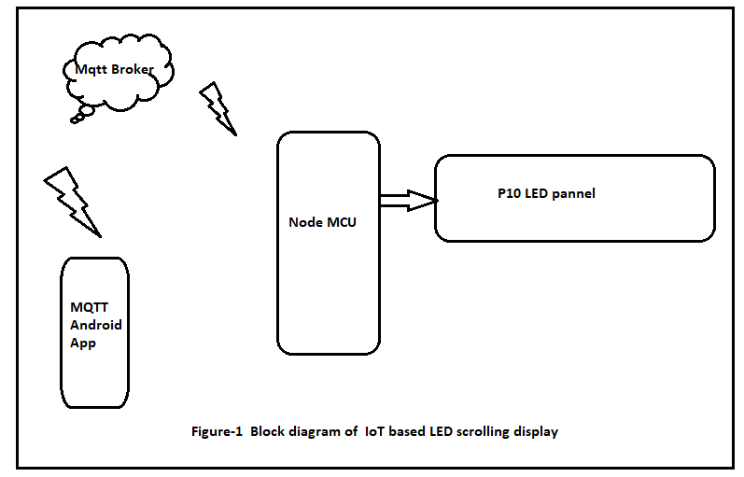

## NodeMCU

NodeMCU is a versatile chip designed to offer Wi-Fi connectivity for IoT devices. It operates on an open-source LUA-based firmware specifically developed for the ESP8266 microcontroller. This firmware facilitates rapid prototyping and development of IoT applications, thanks to its user-friendly scripting language. NodeMCU enables seamless integration of Wi-Fi capabilities into various electronic projects, ranging from home automation to remote sensing systems. Its compact size and low cost make it an ideal choice for DIY enthusiasts and professional developers alike. NodeMCU simplifies the process of connecting IoT devices to the internet, allowing for easy remote monitoring and control. With its robust Wi-Fi functionality, NodeMCU supports secure communication protocols, ensuring data integrity and privacy in IoT applications. Its flexibility and versatility make it a popular choice for IoT projects across different domains. NodeMCU's extensive community support provides access to a wealth of resources, including libraries, tutorials, and forums, facilitating the development of innovative IoT solutions. Figure-2 shows the NodeMCU

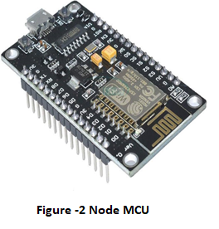

## P10 Led pannel

## The P10 LED Display Module emerges as the optimal solution for creating LED display notice boards, adaptable for both indoor and outdoor environments. Offering versatility in data connectivity, it supports both serial and parallel protocols. Noteworthy specifications include a voltage input of 5V and a maximum power consumption of 20W. Key control features include pins like Enable, A, and B, utilized for managing brightness levels and selecting multiplex rows. Additionally, standard shift register control pins - Shift clock (CLK), Store clock (SCLK), and Data - facilitate seamless data transmission. With the ability to be remotely controlled, the P10 LED Matrix Module enables dynamic content updates, real-time monitoring, and efficient scheduling. Each module, measuring 320*160mm, accommodates 512 LEDs, ensuring a vibrant and impactful display solution suitable for various applications.Figure-3 shows P10 led panel and its pin diagram.

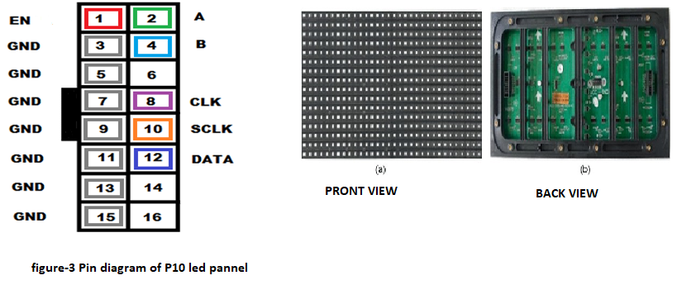

## MQTT(Message Queuing Telemetry Transport

The MQTT stands as an OASIS standard messaging protocol crafted specifically for the Internet of Things (IoT) realm. Engineered to be incredibly lightweight, it serves as an optimal publish/subscribe messaging transport, seamlessly connecting remote devices with minimal code footprint and network bandwidth requirements. Widely embraced across industries including automotive, manufacturing, and telecommunications, MQTT facilitates IoT applications by enabling connectivity and communication with low-power devices such as sensors and actuators. Its scalability allows it to efficiently handle single or thousands of sensors, providing real-time, reliable messaging services for network-connected devices even in unreliable network environments. Operating on a publish-subscribe model, MQTT fosters communication between devices by separating clients into two distinct groups: publishers, responsible for sending data, and subscribers, tasked with receiving the data. Notably, MQTT clients operate independently from one another, with publishers and subscribers never directly contacting each other, distinguishing it from the traditional client-server model.Figure-4 shows the Mqtt architecture.

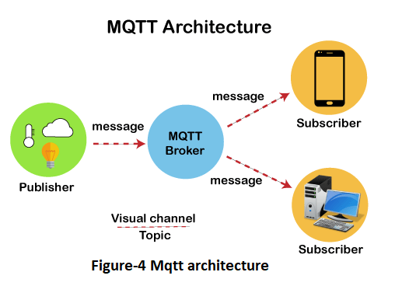

## Mqtt Android App

The MQTT-based Android app serves as a versatile platform for real-time communication between IoT devices. Utilizing the MQTT protocol, it enables seamless interaction with connected devices, facilitating data transmission and control. The app provides an intuitive user interface for monitoring and managing IoT devices remotely. With support for both publishing and subscribing to MQTT topics, it offers bidirectional communication capabilities. Users can receive instant updates and notifications from IoT devices, enhancing convenience and efficiency. The app's lightweight design ensures optimal performance on Android devices while minimizing resource consumption. It fosters integration with a wide range of IoT applications, spanning home automation, industrial monitoring, and smart agriculture. Leveraging MQTT's reliability and efficiency, the app ensures robust connectivity and data exchange between Android smartphones and IoT devices. Its customizable features allow users to tailor the app to their specific IoT requirements, enhancing flexibility and scalability. Overall, the MQTT-based Android app empowers users to harness. Figure-5 Shows the Mqtt Android App.

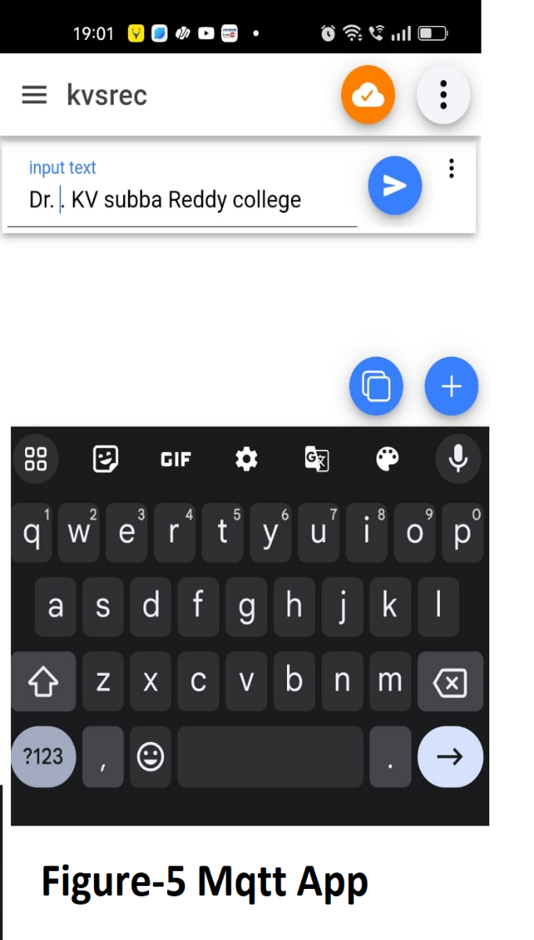

## Arduino IDE And C++

Arduino IDE and C++ serve as integral tools for developing embedded systems and IoT projects. The Arduino IDE provides a user-friendly environment for writing, compiling, and uploading code to Arduino boards. C++ is the primary programming language used in Arduino development, offering flexibility and efficiency. With Arduino IDE, developers can easily interface with hardware components and peripherals using simple syntax. C++ allows for object-oriented programming, enabling the creation of modular and reusable code. Arduino IDE's extensive library ecosystem simplifies complex tasks, from sensor interfacing to communication protocols. C++'s robust features, such as classes and inheritance, enhance code organization and maintainability. Arduino IDE's integrated serial monitor facilitates real-time debugging and data visualization. C++'s efficiency makes it ideal for resource-constrained environments, optimizing code execution on microcontrollers. Arduino IDE's cross-platform compatibility ensures seamless development across different operating systems. In summary, Arduino IDE and C++ form a powerful combination for building embedded systems and IoT applications, offering simplicity, flexibility, and efficiency to developers.

## Power supplay

Two distinct power supply technologies: transformer-based and SMPS (Switched Mode Power Supply). Specifically, we opt for SMPS due to its efficiency and suitability for our application's needs. The project necessitates SMPS units: one delivering 5V and 3A for the LED matrix, and same providing 5V and 3A for the microcontroller and LED drivers. SMPS facilitates DC-to-DC conversion, ensuring optimal power delivery and utilization. Its compact design and high efficiency make it a preferred choice for modern electronic projects. By incorporating SMPS technology, we enhance the reliability and performance of our system while minimizing power wastage. This strategic selection aligns with our project's goals of efficiency and sustainability.

# results and discussion

The results of our project showcase the successful integration and utilization of IoT technology, specifically the MQTT protocol, NodeMCU microcontroller, and P10 LED display panel, to create an efficient LED scrolling notice board. Through rigorous testing, we verified the seamless functionality of the system, enabling users to display text on the LED panel remotely via an Android app. The MQTT protocol facilitated efficient data exchange between the NodeMCU microcontroller and the user interface, ensuring real-time updates and remote control capabilities. The P10 LED display panel served as a vibrant visual interface, capturing attention with scrolling messages and enhancing user engagement. Additionally, the SMPS power supply units provided reliable and stable power distribution to the LED matrix and microcontroller, contributing to the overall durability of the system. The integration of advanced hardware components, efficient communication protocols, and user-friendly interfaces positioned our project as a versatile solution for various applications. Moving forward, further testing and refinement will be conducted to optimize the system's performance and ensure its seamless operation in real-world scenarios. Figure-6 and 7 shows the working models of the project.

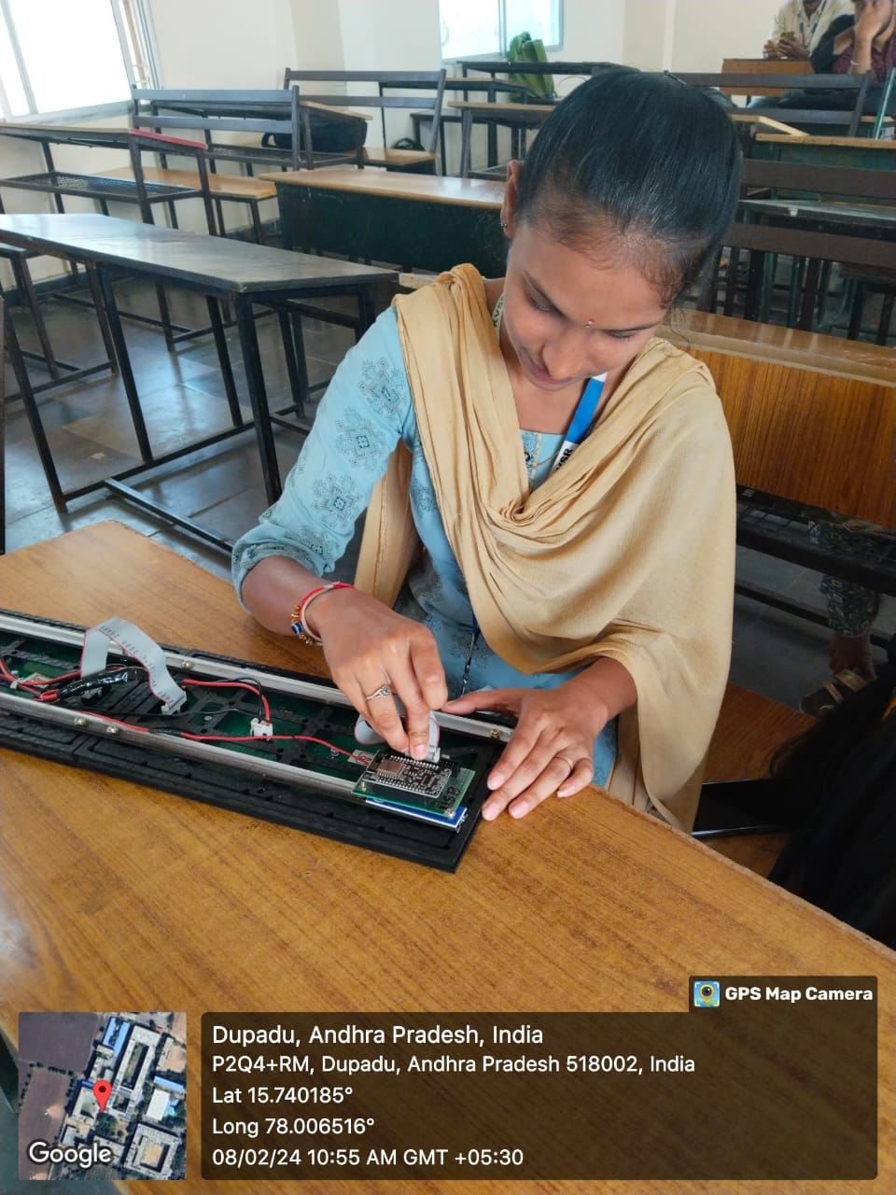

Figure-6 working molde-1

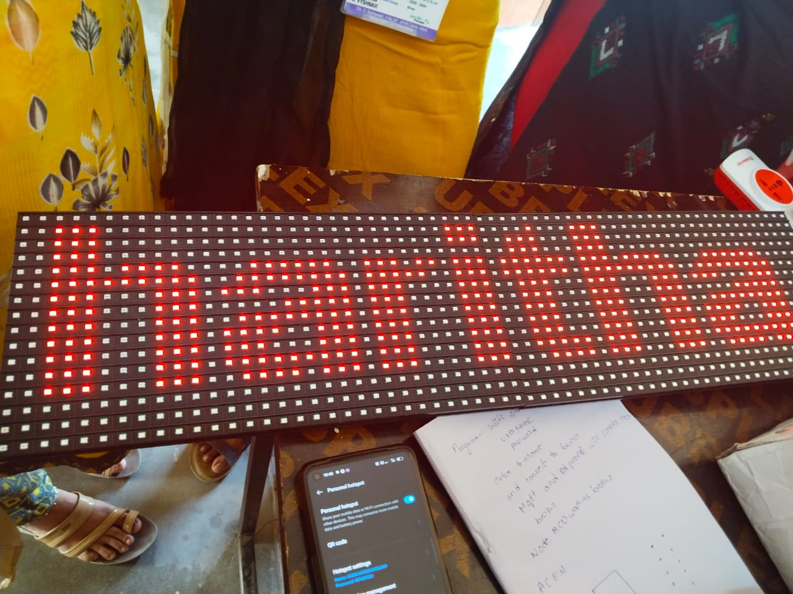

Figure-7 working model-2

The discussion focuses on the significance of our project's implementation, highlighting its contributions to IoT-based display systems. We emphasize the effectiveness of utilizing MQTT protocol for seamless communication and remote control capabilities. The integration of NodeMCU microcontroller and P10 LED display panel underscores the system's versatility and user-friendliness. We discuss the implications of our findings for various industries, including education, finance, and transportation. Furthermore, we emphasize the importance of SMPS power supply units in ensuring reliable power distribution and system stability. Our project's successful demonstration of IoT technology sets a precedent for future developments in LED display systems, paving the way for enhanced functionality and efficiency in real-world applications. The figure 6 and seven shows the project working models.

##### References

1. . Prachee U. Ketkar, Kunal P. Tayade, Akash P. Kulkarni, Rajkishor M. Tugnayat: GSM Mobile Phone Based LED Scrolling Message Display System, International Journal of Scientific Engineering and Technology Volume 2 Issue 3; PP : 149-155
2. .Foram Kamdar, Anubbhav Malhotra and Pritish Mahadik

Display Message on Notice Board using GSM, ISSN 2231-

1297, Volume 3, Number 7 (2013); pp. 827-832

1. Darshankumar C. Dalwadi, Ninad Trivedi, Amit Kasundra : WIRELESS NOTICE BOARD, National Conference on Recent Trends in Engineering & Technology [4]. Information on http://www. 8051projects. Net
2. D.Yanchuang,G.Jinying,”LED Display Screen Design and Proteus Simulation Based on Single-chip Microcontroller, “International Conference on Information Engg and Computer science (ICIECS)2010 2nd
3. Jeena Joy, Athira Poovathody, Athul R S, Athul Subran,Basil Paul, Implementation of Digital Dice Game‖,Professor, Dept. of EEE, Mar Athanasius College of Engineering, Kothamangalam1 UG Student, Dept. Of IEEE,
4. Mar Athanasius College of Engineering, Kothamangalam,India2, 3, 4, 5, Vol. 3, Issue 2, February 2014.
5. Ervin John U. Benigra, Bryan Leonard D. Montaño and

Engr. Maridee B. Adiong,‖ RUNNING MESSAGE BOARD USING DOT-MATRIX DISPLAY‖ Capitol University,College of Engineering, Cagayan de Oro City.

**.**