Research Paper

IMPACT OF SOCIAL MEDIA ON STUDENTS

Raj Ranjan Jha
Galgotias University
Professor Dr. Surinder K Dhingra

ABSTRACT

In the contemporary digital age, social media has become an integral part of daily life, profoundly influencing various aspects of society, including education. This research paper delves into the multifaceted impact of social media on students, encompassing both the positive and negative ramifications.
The positive effects of social media on students include enhanced communication and collaboration, access to vast educational resources, and opportunities for self-expression and creativity. Additionally, social media platforms can facilitate peer support networks, fostering a sense of belonging and community among students. Moreover, social media can serve as a platform for academic and career networking, enabling students to connect with mentors, professionals, and potential employers.
However, the pervasive use of social media also poses significant challenges and risks for students. Excessive screen time and engagement with social media have been linked to decreased academic performance, attention deficits, and sleep disturbances. Furthermore, social media platforms often expose students to cyberbullying, online harassment, and negative social comparison, leading to psychological distress and decreased self-esteem. Moreover, the dissemination of misinformation and fake news on social media can hinder students' critical thinking skills and undermine their ability to discern credible sources of information.
This research paper synthesizes existing literature to provide a comprehensive understanding of the impact of social media on students, highlighting the complexities and nuances of this phenomenon. By elucidating the various dimensions of social media's influence on students, this paper aims to inform educators, parents, policymakers, and students themselves about the opportunities and challenges inherent in navigating the digital landscape. Additionally, the paper proposes recommendations for promoting responsible social media usage and mitigating its adverse effects on students' well-being and academic success.

INTRODUCTION

In an age defined by connectivity and instantaneous information dissemination, social media platforms have emerged as ubiquitous fixtures in the lives of students worldwide. The pervasive influence of social media extends beyond mere communication; it shapes attitudes, behaviors, and perceptions, profoundly impacting various facets of student life, including academic performance, social interactions, and mental well-being. As the digital landscape evolves at an unprecedented pace, understanding the multifaceted effects of social media on students becomes imperative for educators, parents, policymakers, and society at large.The advent of social media has revolutionized the way students engage with information, each other, and the world around them. Platforms like Facebook, Instagram, Twitter, and Snapchat offer avenues for instantaneous communication, self-expression, and information sharing. These platforms have blurred the lines between personal and public domains, creating virtual spaces where students navigate identity formation, social validation, and peer influence. However, alongside the benefits of connectivity, social media introduces a myriad of challenges and complexities that warrant closer examination.One of the primary areas of concern regarding social media's impact on students is its influence on academic performance. While digital platforms offer unprecedented access to educational resources and collaborative tools, they also present distractions and temptations that can detract from academic focus. The constant influx of notifications, the allure of trending content, and the pressure to maintain online personas pose significant challenges to student productivity and concentration. Furthermore, the prevalence of cyberbullying, misinformation, and digital plagiarism exacerbates the negative impact of social media on academic integrity and student well-being.
Beyond academics, social media profoundly shapes students' social interactions and relationships. The digital realm serves as a virtual playground where friendships are forged, maintained, and sometimes tested. However, the curated nature of online profiles and the prevalence of comparison culture can foster feelings of inadequacy, loneliness, and social isolation among students. Moreover, the blurring of boundaries between online and offline worlds can complicate interpersonal dynamics, leading to misunderstandings, conflicts, and digital dependency.
Additionally, the pervasive use of social media has raised concerns about its impact on students' mental health and well-being. Studies have linked excessive social media usage to heightened levels of stress, anxiety, depression, and poor sleep quality among students. The constant exposure to curated images of perfection, unrealistic beauty standards, and filtered lifestyles can contribute to feelings of inadequacy and low self-esteem. Moreover, the phenomenon of "FOMO" (Fear of Missing Out) perpetuated by social media feeds into a cycle of comparison and anxiety, exacerbating mental health challenges among students.
In light of these multifaceted effects, it is essential to explore the intricate interplay between social media usage and student outcomes comprehensively. By examining the nuances of social media engagement, its impact on academic performance, social relationships, and mental well-being can be better understood. Through empirical research, qualitative analyses, and interdisciplinary perspectives, this study aims to shed light on the complexities of the digital landscape and equip stakeholders with insights to navigate the challenges and opportunities presented by social media in the lives of students.
OBJECTIVE OF THE STUDY

To Assess Social Media Usage Patterns: This objective focuses on analyzing how frequently students use different social media platforms, the duration of their usage, and the purposes for which they use them (e.g., socializing, academic-related activities, entertainment).
To Examine the Effects on Academic Performance: This objective aims to investigate whether there is a correlation between social media usage and academic performance. It may involve analyzing factors such as time spent on social media versus time spent studying, grades achieved by heavy social media users compared to light users, and any perceived impact on concentration and focus.
To Explore Psychological and Emotional Effects: This objective involves studying the psychological and emotional impact of social media use on students. It may include examining feelings of loneliness, anxiety, depression, or self-esteem issues that could arise from social media interactions, as well as exploring the role of cyberbullying.
To Investigate Social Interaction and Relationships: This objective seeks to understand how social media affects students' social interactions and relationships. It may involve examining the quality of friendships formed online versus offline, the impact of social media on face-to-face communication skills, and the prevalence of online harassment or negative interactions. To Identify Strategies for Healthy Social Media Use: This objective focuses on identifying best practices and strategies for promoting healthy and responsible social media use among students. It may involve developing recommendations for educators, parents, and students themselves to mitigate any negative effects and maximize the benefits of social media.

The objectives of this study are as follows:

- Analysis of how often and for how long social media platforms are used by students.

- Student opinion analysis of the social media platform which includes the following:

  - Reason for using social media

  - The positive / negative effects of social media on:

    - Scholars

    - Social behavior

    - Physical health

    - Privacy

METHODOLOGY

considering the affect of social media on understudies is imperative and how it relates to existing inquire about or societal concerns.

Theoretical System: Talk about the hypothetical viewpoint or system that will advise your consider. This may include hypotheses from brain research, human science, communication thinks about, or other significant disciplines that offer assistance clarify how social media impacts behavior and Presentation to the Think about: Begin by presenting the point and its importance. Clarify why attitudes.
Research Plan: Depict the generally plan of your think about, counting its technique and approach. Will you utilize subjective, quantitative, or blended strategies. Clarify why this approach is suitable for tending to your inquire about questions.
Sampling Technique: Diagram how you will select members for your think about. Will you utilize arbitrary testing, comfort testing, or another strategy. Give avocation for your chosen approach and talk about any potential limitations.
Data Collection Methods:This might incorporate studies, interviews, substance examination, or perceptions. Clarify how these strategies will permit you to accumulate pertinent data almost students' social media utilization and its effects.
Data Examination Procedures: Portray how you will analyze the information you collect. Will you utilize factual examination, topical coding, or another strategy. Talk about how these methods will offer assistance you distinguish designs, patterns, or connections in the data.
Ethical Contemplations: Address any moral concerns related with your inquire about, such as educated assent, security, and privacy. Clarify how you will guarantee that participants' rights are ensured all through the study.
PEOPLE PERCEPTION IMPACT OF SOCIAL MEDIA ON STUDENTS

The influence of social media on students has become a prominent topic of discussion in recent years. From enhancing communication to impacting mental health, social media platforms have a multifaceted effect on students' lives.

One significant aspect is the way social media facilitates communication. Students can easily connect with peers, educators, and experts, breaking down geographical barriers and fostering collaboration. This connectivity can be advantageous for educational purposes, allowing for the exchange of ideas and resources beyond the confines of traditional classrooms.

Excessive use can lead to distraction from academic responsibilities, affecting students' concentration and productivity. Moreover, the constant exposure to curated images and narratives on platforms like Instagram and Facebook can contribute to feelings of inadequacy and low self-esteem among students, as they compare themselves to idealized portrayals.

Another concern is the potential for cyberbullying and online harassment. Social media platforms provide a platform for individuals to spread negativity anonymously, leading to emotional distress and psychological harm among students. The anonymity afforded by social media can embolden perpetrators and make it difficult for victims to seek support.

Furthermore, the addictive nature of social media is a growing concern. The dopamine rush from likes, comments, and shares can create a cycle of seeking validation and approval, detracting from real-world interactions and activities. This addiction can have detrimental effects on students' mental health, leading to increased anxiety, depression, and sleep disturbances.

DATA ANALYSIS

In order to produce useful results for a firm conclusion and decision-making, it is important to analyse the data. The process of converting all acquired data into useful data and getting a clear conclusion about the data is the analysis process. The analysis process also includes data analysis.

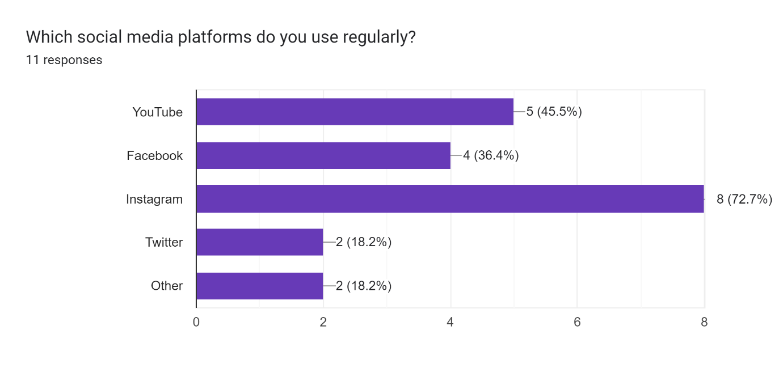

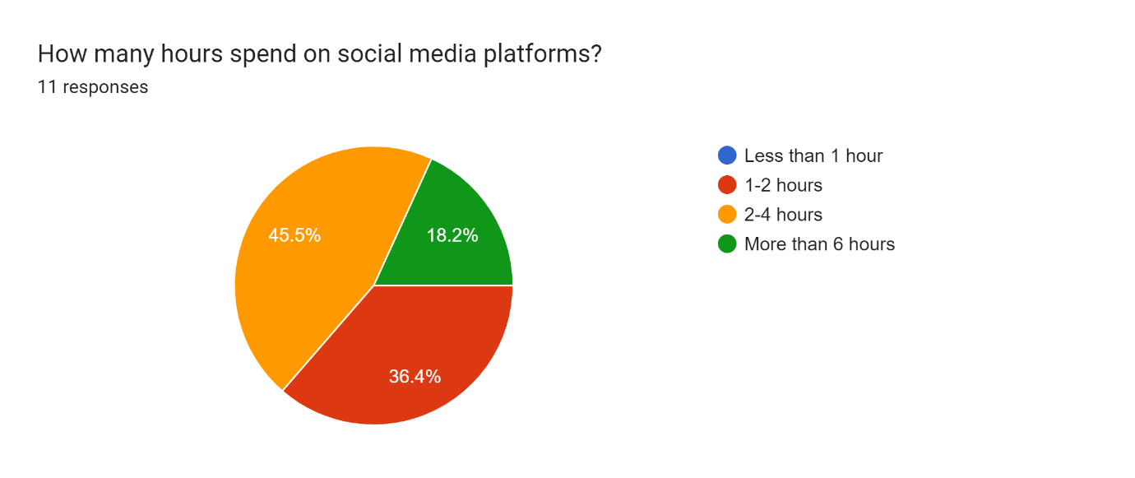

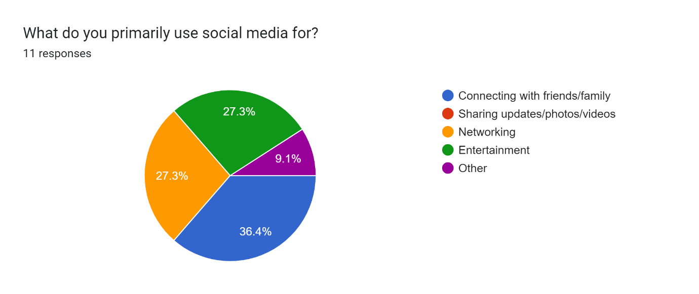
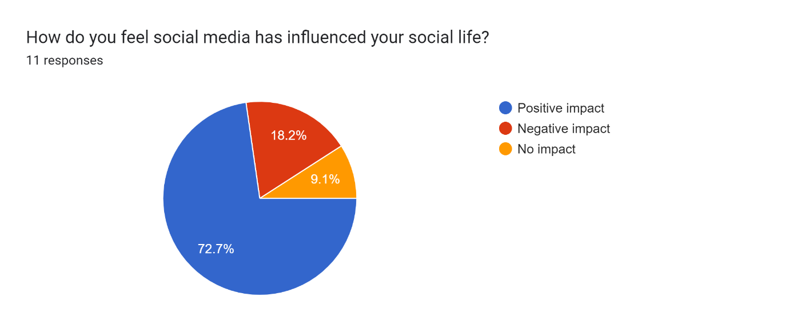

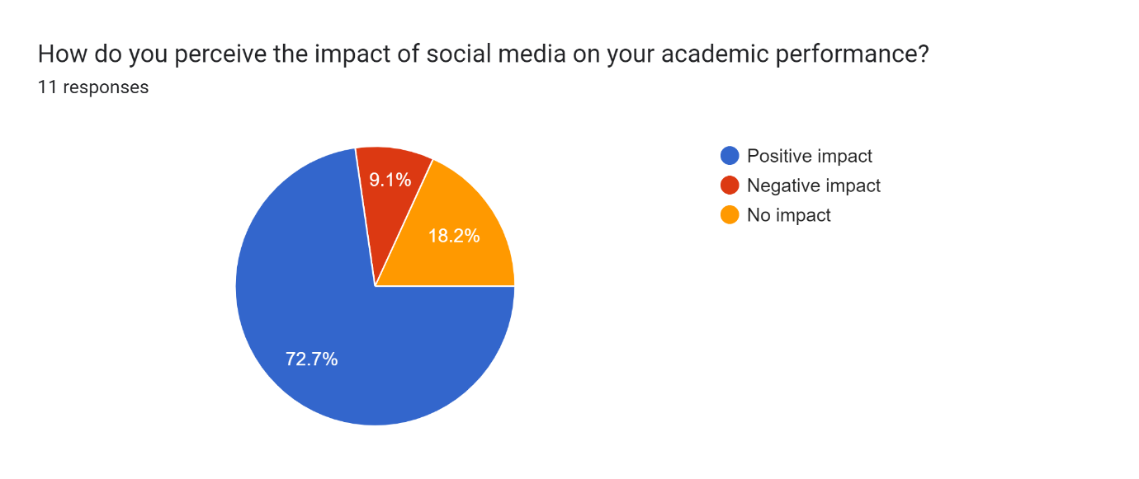

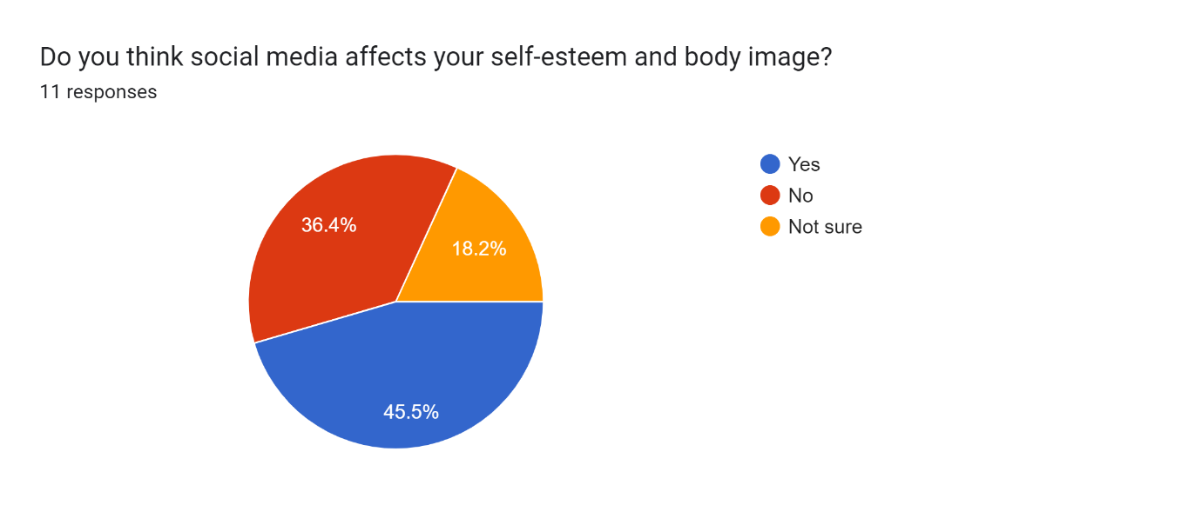
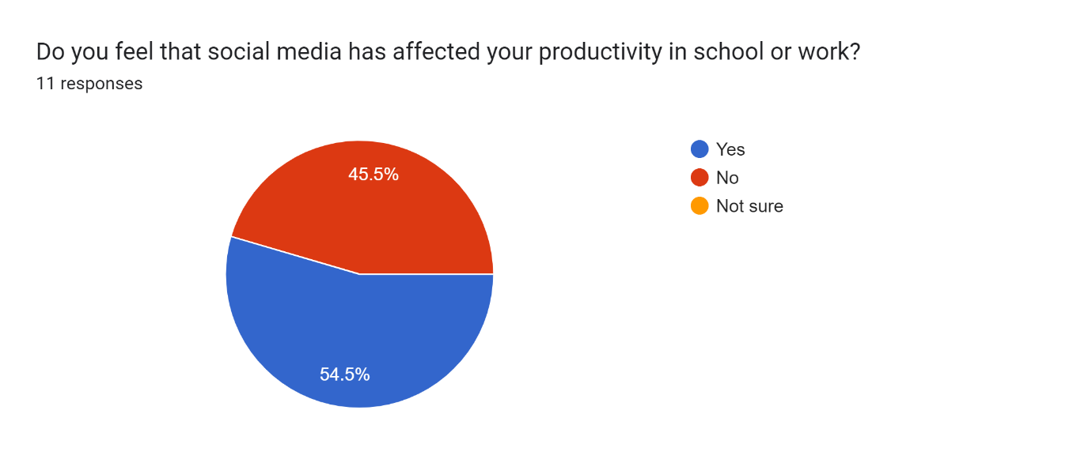
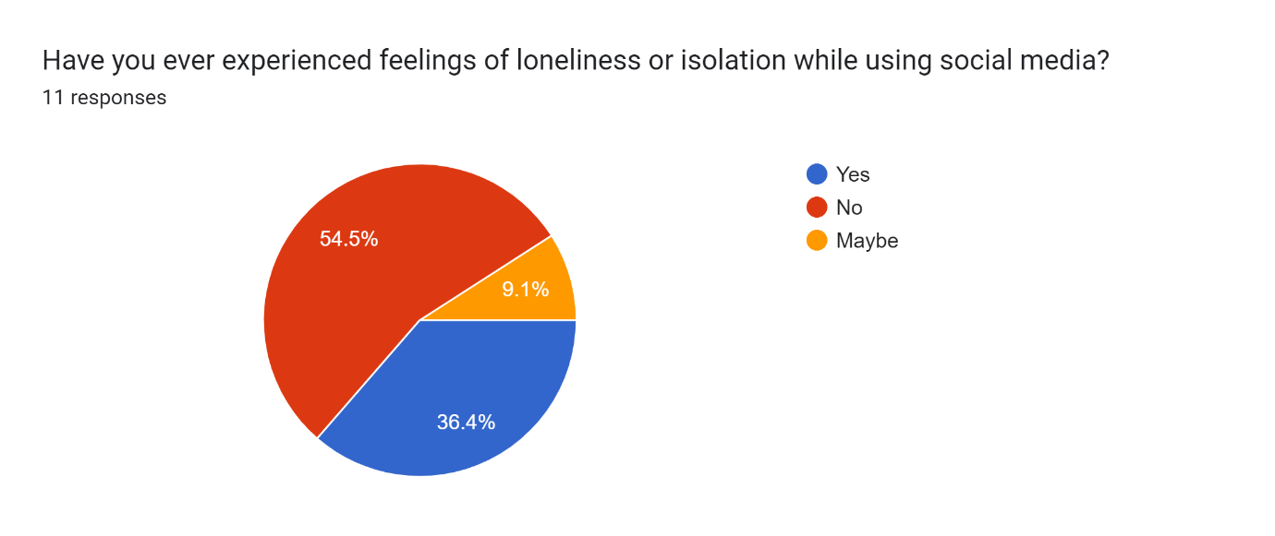
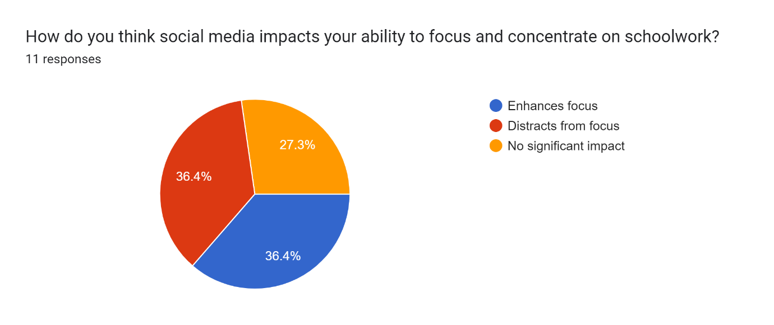
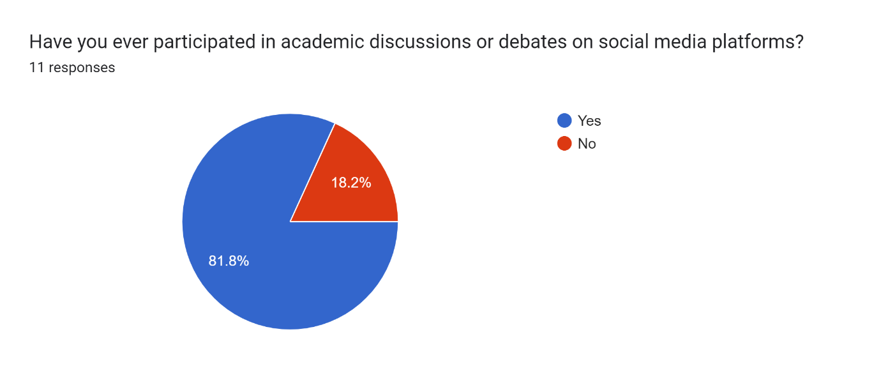
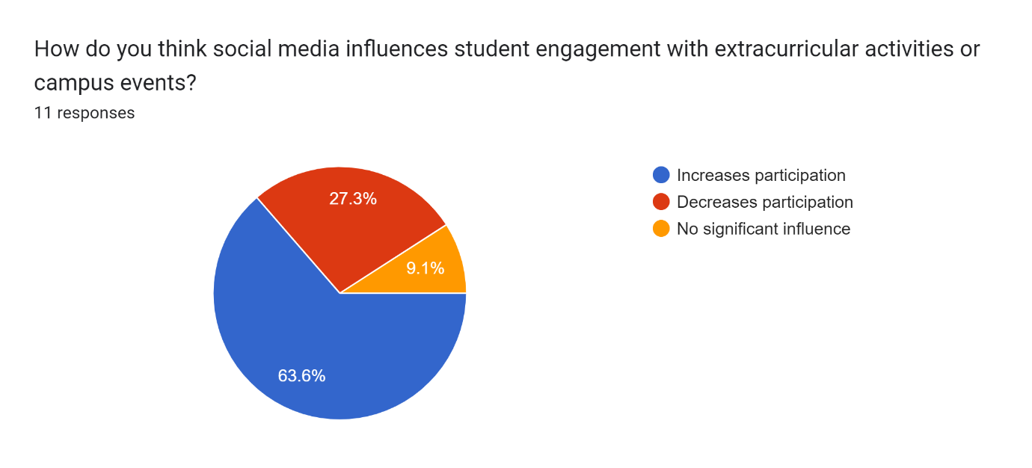

FINDINGS
Research on the impact of social media on students has yielded diverse findings, shedding light on both positive and negative effects. One significant finding is the influence of social media on academic performance. Some studies suggest that excessive use of social media can lead to lower academic achievement due to distractions and decreased study time. Conversely, other research indicates that social media can facilitate learning and collaboration among students, enhancing academic outcomes.

Additionally, social media has been linked to changes in social behavior and mental health. Studies have found correlations between heavy social media use and increased feelings of loneliness, anxiety, and depression among students. On the other hand, social media platforms provide avenues for social connection and support, which can mitigate feelings of isolation for some individuals.

Furthermore, research highlights the impact of social media on self-esteem and body image. Exposure to idealized images on platforms like Instagram and Snapchat has been associated with negative body image perceptions and low self-esteem, particularly among adolescent girls. However, social media can also serve as a platform for self-expression and activism, empowering students to challenge societal norms and promote body positivity.

Overall, while research findings on the impact of social media on students vary, they underscore the complex interplay between technology use and well-being. Understanding these nuances is crucial for developing strategies to maximize the benefits of social media while mitigating its potential harms among student populations.

LIMITATION

Sampling Bias: The study may have focused on a specific demographic or population, limiting the applicability of findings to other groups of students.
Self-Reported Data: Reliance on self-reported data from students may introduce response bias or inaccuracies due to social desirability or memory recall issues.
Cross-Sectional Design: Many studies adopt a cross-sectional design, which captures data at a single point in time. This design limitation prevents establishing causality or understanding long-term effects.
Limited Time Frame: Research may be conducted within a limited time frame, which might not capture the evolving nature of social media platforms or trends among students.
Ethical Concerns: There could be ethical considerations regarding privacy, consent, and potential harm to participants, especially when studying sensitive topics related to social media use.
Generalizability: Findings from a particular geographical area or cultural context may not generalize to other regions or societies with different social media usage patterns or norms.
Measurement Tools: The tools used to measure social media impact or student outcomes may lack reliability or validity, affecting the accuracy of results.
External Factors: Other variables such as family environment, socioeconomic status, or academic performance could confound the relationship between social media use and student outcomes.
Publication Bias: Studies with significant findings are more likely to be published, leading to an overrepresentation of positive or negative effects of social media on students.
Technology Changes: Rapid advancements in technology may render findings obsolete or outdated, particularly if the study does not account for emerging social media platforms or features.

CONCLUSION
Previously, free transmission and sharing of information between people was limited by long distances and lack of resources. In any case, now, even these barriers cannot stop the flow of data and information. The new social network allows free sharing of thoughts, photos, videos, news, business, genres and other updates.
In a recent study, when students were asked if they thought there was a privacy issue identified through social networking websites, more than half of them agreed. In particular, according to male readers the issue has been found to be very dangerous using social media. On the other hand according to female students the worst thing about using social media is that it has a negative impact on their grades and studies.
Therefore, it can be concluded that male students are aware of problems related to the privacy of their personal data through the use of social media. Female students are more concerned with their grades than male students. The use of social media does not have much impact on real students' lives and grades. In fact, this study has shown that social media can be a useful research tool for students and can help them in their studies.
However, according to current research, most students spend at least 2 to 5 hours a day on social media. When students were asked if using a certain type of social media is important in modern life or not, more than 80% of students agreed. Social media addiction can be a problem that needs to be addressed in a certain way. To address this issue, the conclusions reached by Akubugwo, Ijeoma and Maria Burke in their research may be helpful. Research has shown that the automated software system, which will shut down over time, should be used to control its use by students.
Also, teachers who need to use social media in their lessons to improve students' learning capacity should be organized to empower students and make them active in the learning process. The notion that students are capable of using social media effectively may serve as a barrier to those students who need to be monitored closely. The e-learning system can play a very important role for students to work together and interact with the social media channel. All in all, it could be concluded that, if used properly, the use of social media can be a very useful source of learning, sharing and healthy activities.

REFERENCES

- Danah M. Boyd and Nocle B. Ellison, “Social Network Sites: Definition, History, and
Scholarship,”, in Journal of Computer-Mediated Communication, Volume 13, Issue 1, pages 210-230, October 2007.
- “Which social media site fits your personality”, [Online] Available: https://www.google.com/search?q=social+media&biw=1280&bih=566&source=lnms &tbm=isch&sa=X&sqi=2&ved=0ahUKEwjM6KyXl93KAhXL6CYKHTPmCJcQ_AUIBygC #imgrc=mDnD-YID1HUMtM%3A
- “The history of social media”, [Online] Available:
http://historycooperative.org/the-history-of-social-media/
- “Teens, Social Media & Technology Overview 2015”, [Online] Available: http://www.pewinternet.org/2015/04/09/teens-social-media-technology- 2015/
- “Social Networking Fact Sheet”, [Online] Available:
http://www.pewinternet.org/fact-sheets/social-networking-fact-sheet//

