SMART FARM IRRIGATION USING ESP 32

**Madhav G S1, Merin Joseph2, Nandana Raghunath3, Dr.Godwinraj D4,**

**Ranjitha Rajan**

**5** 1,2,3,4Students, Electronics & Communication Engineering,Amal Jyothi colleague of Engineering,India

## 5Assistant Professor, Electronics &Communication Engineering,Amal Jyothi College of Engineering, India.



**ABSTRACT**

Soil moisture sensors, weather sensors, Arduino microcontrollers, actuators, and a centralized edge control unit are among the main parts of the suggested system. While weather sensors gather information on the state of the environment, soil moisture sensors measure the amount of moisture in the soil. After processing the sensor data, Arduino microcontrollers decide where to apply irrigation locally using user-defined parameters and pre-defined algorithms. The system's brain, the edge control unit, performs irrigation control logic at the field level without requiring continuous internet connectivity. This edge computing strategy reduces latency and improves system dependability, particularly in isolated farming regions with inadequate network connectivity. Through an intuitive user interface, the technology enables farmers to remotely monitor the irrigation process, create irrigation schedules, and receive real-time data updates.

**Keywords:**ESP-32 wifi module,Motor drive module,Moisture sensor

# INTRODUCTION

This introduction focuses on a Smart Farm Irrigation System that enhances water management through ESP-32. Water scarcity and inefficient irrigation methods are major problems for agriculture; therefore, it's imperative to put creative solutions into place that make the best use of the water resources that are available. The proposed approach builds an autonomous and responsive watering system with Arduino microcontrollers and edge computing. The combination of Arduino, a versatile and cheaply cost microcontroller platform, and edge computing enables realtime data processing and field-level decision-making. The method is more dependable and suitable for remote agricultural areas with insufficient infrastructure as it does not depend on centralized servers or constant internet connectivity.

| Agriculture faces the urgent need for improved efficiency and sustainability. One key area demanding attention is irrigation management, which significantly influences crop yield, resource conservation, and operational expenses. Traditional irrigation methods often suffer from inefficiencies like overwatering or inadequate water supply due to manual or basic timer-based systems. However, the emergence of smart technologies offers a promising remedy. Smart farm irrigation systems, powered by technologies such as Arduino microcontrollers and edge computing, provide precise, automated, and data-driven control over irrigation processes. Arduino, a versatile open-source electronics platform, forms the heart of these smart systems. By integrating sensors, actuators, and communication modules, Arduino enables realtime monitoring and control of crucial irrigation parameters like soil moisture, weather conditions, and crop water requirements. This fusion of hardware and software empowers farmers to make informed decisions, optimizing water usage for better crop health and productivity. The emergence of smart farm irrigation systems marks a significant advancement in agriculture, promising enhanced efficiency and sustainability. At the core of these systems is Arduino technology, providing a flexible and cost-effective solution for controlling irrigation processes at the field level. By integrating sensors, actuators, and communication modules directly into agricultural operations, Arduino enables real-time monitoring and adjustment of irrigation activities based on precise data. |
| --- |
| Arduino's versatility and affordability make it an attractive option for implementing ESP-32 in smart farm irrigation systems. Its open-source platform and strong community support empower farmers and researchers to develop customized solutions tailored to their specific needs. Whether it involves measuring soil moisture, monitoring weather conditions, or regulating irrigation timing, Arduino-based systems offer a scalable and adaptable approach to irrigation management.  Moreover, the integration of these systems into the Internet of Things (Iot) ecosystem extends their capabilities beyond local control. By connecting to centralized data platforms, smart farm irrigation systems facilitate remote monitoring and |
| management, empowering farmers to oversee their operations from anywhere with internet access. This connectivity not only streamlines operational processes but also enables data-driven decision-making and adaptive management practices.  In summary, smart farm irrigation systems utilizing ESP-32 represent a fusion of technology and agriculture, offering opportunities to optimize resource utilization, improve crop yields, and foster sustainability in farming practices. Given the pressing challenges facing the agricultural sector, such as water scarcity and climate change, the adoption of innovative technologies like Arduino-based irrigation systems becomes increasingly crucial. Subsequent sections will delve deeper into the components, functionalities, and advantages of these systems, exploring the latest advancements and research in this field. |

### 1.1PROBLEM STATEMENT

Agriculture is essential to the continuation of human life, and crop growth depends on effective water management. The imprecision of conventional irrigation techniques frequently results in water waste, higher operating expenses, and environmental issues. The creation of a Smart Farm Irrigation System with Arduino edge control is suggested as a solution to these problems. Problems: Ineffective Water Use: Conventional irrigation systems have the potential to overwater or submerge crops, resulting in ineffective water use and possible crop damage. Manual Monitoring and Control: A lot of farms still schedule irrigation using manual techniques, which can be labourintensive and prone to human mistake.

# LITERATURE SURVEY

# The agricultural industry in India is losing ground daily, which has an impact on the ecosystem's ability to produce more. There's a rising need to find a solution to bring agriculture back to life and put it on a higher growth path. An extensive agricultural system requires a lot of maintenance, expertise, and supervision. The Internet of Things (IoT) is a network of networked devices that can perform tasks without the need for human intervention and send and receive data via the internet. Crop yields are raised by the abundance of data analysis parameters that agriculture offers. Modernizing information and communication is aided by the usage of IoT devices in smart farming. It can be anticipated that moisture, minerals, light, and other elements will improve crop development. A review of literature concerning smart farm irrigation systems utilizing Arduino edge control unveils a landscape ripe with innovation and promise for agricultural advancement. These systems, anchored on the Arduino platform, offer a pathway to revolutionize irrigation practices by seamlessly integrating sensors, actuators, and communication modules directly into agricultural fields. Through an analysis of various scholarly works and publications, it becomes evident that Arduino-based solutions enable meticulous monitoring and control of irrigation processes, resulting in heightened productivity, resource efficiency, and sustainability in farming practices. The survey underscores notable strides in hardware evolution, control algorithms, and communication protocols tailored to meet the demands of smart irrigation applications. Advanced algorithms, leveraging real-time sensor data, have been developed to optimize water usage while simultaneously maximizing crop yields. Furthermore, the integration of Arduino-based systems into IoT frameworks streamlines remote monitoring and control, empowering farmers to effectively manage expansive agricultural operations. Nevertheless, challenges such as power management, sensor precision, and system reliability persist as areas requiring ongoing research and development efforts. Overcoming these hurdles is pivotal for the widespread adoption of smart farm irrigation systems employing Arduino edge control, particularly in regions with limited resources. Looking forward, future research endeavours may concentrate on enhancing energy efficiency, exploring novel sensor technologies, and refining predictive irrigation control algorithms. In essence, Arduino-based edge control embodies significant potential to transform irrigation methodologies in agriculture, fostering increased crop yields, water conservation, and sustainable food production. Sustained collaboration and innovation across diverse fields will be instrumental in unlocking the full capabilities of these systems within agricultural contexts.

### 3.GRAPHICAL ABSTRACT

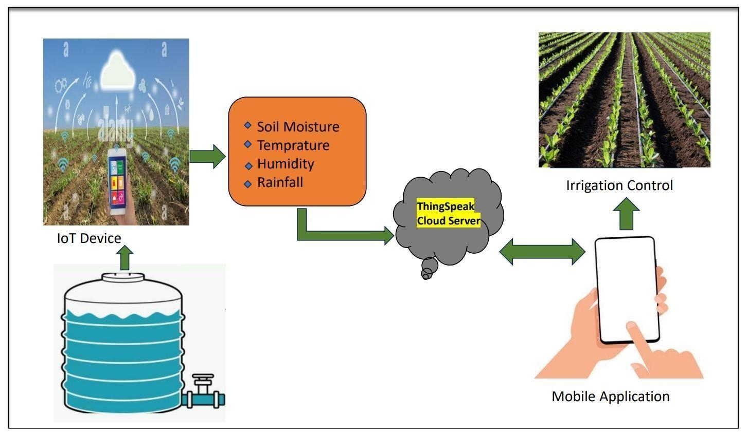

### CIRCUIT DIAGRAM

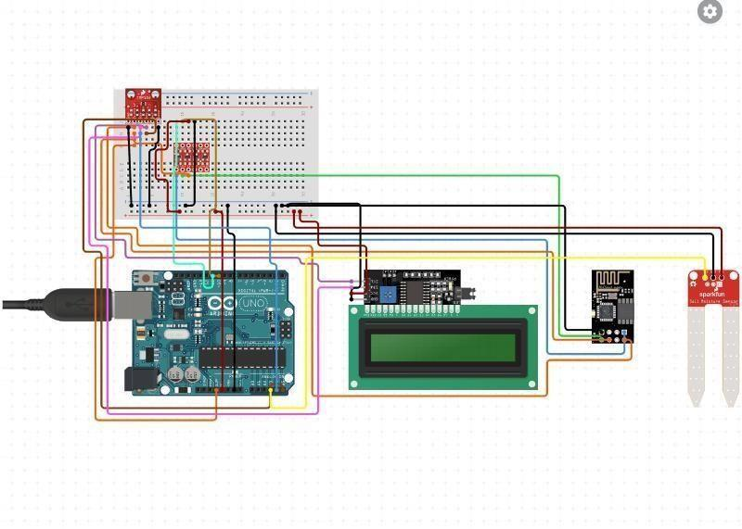

**Fig .**

1. **CONCLUSIONS**

| In conclusion, smart farm irrigation is a technology that is revolutionizing the way we manage water resources and |
| --- |
| improve crop yields. By conserving water resources and improving crop yields, smart irrigation systems are an important step forward in sustainable agriculture. Employing Arduino for edge control in smart farm irrigation systems presents a promising approach to enhance agricultural productivity, efficiency, and sustainability. By integrating sensors, actuators, and communication modules, Arduino-based systems allow precise monitoring and management of irrigation activities directly at the field level.  The review of existing literature highlights significant progress in hardware development, control algorithms, and communication protocols tailored for smart irrigation. Advanced irrigation scheduling algorithms have been devised to optimize water usage based on real-time sensor data, aiming to maximize crop yields. |
| Moreover, integrating Arduino-based systems into IoT frameworks enables remote monitoring and control, facilitating |
| prompt decision-making and adaptive management practices. This connectivity not only improves scalability but also empowers farmers to efficiently manage larger agricultural operations.  However, challenges such as power management, sensor accuracy, and system reliability persist and require further investigation. Addressing these challenges is crucial for widespread adoption, especially in areas with limited resources.  Looking forward, future research may focus on improving energy efficiency, exploring innovative sensor technologies, and developing predictive irrigation control algorithms. Additionally, conducting field trials and validation studies will |
| be essential to assess system performance under diverse agricultural conditions. |

**Fig.3**

# REFRENCES

[1]G. Bilal, A.-K. Khaled and C. Khaled, “A Poultry Farming Control System Using a ZigBee-based Wireless Sensor Network,” International Journal of Control and Automation, vol. 10, no. 9, pp. 191-198,2017 <https://www.bau.edu.lb/Engineering/Publication/2017-2018/APoultry-Farming-Control-System-Using-a-ZigBee-based-WirelessSensor-Network>.

[2] K. Drishti, S. Divyata, R. Rakhi and M. Jimmy, “Smart Farm: Extending Automation to The Farm Level,” International Journal of Scientific & Technology Research, vol. 3, no. 7, pp. 109-112, 2014. <http://www.ijstr.org/final-print/july2014/Smart-Farm-ExtendingAutomation-To-The-Farm-Level.pdf>.

[3] A. Geetanjali and N.A. Dawande, “A Survey on Smart Poultry Farm Automation and Monitoring System,” International Journal of Innovative Research in Science, Engineering and Technology, vol. 6, no. 3, pp. 4806-4809, 2017. https://www.ijirset.com/upload/2017/march/242_A_Survey_on__IEE E.pdf.

[4] K. Sinduja, S. Jenifer, M. Abishek and B. Sivasankari, “Automated Control System for Poultry Farm Based on Embedded System,” International Research Journal of Engineering and Technology, vol. 3, no. 3, pp. 620-623, 2016 <https://www.irjet.net/archives/V3/i3/IRJETV3I3136.pdf>.

[5] M. Mohsin, M. Y. Khawaja and M. H. Ghulam, “Web Based Poultry Farm Monitoring System Using Wireless Sensor Network,” 3 December 2015. [Online]. Available: https://www.researchgate.net. [Accessed 3 August 2018].

[6] D. S. S. S. Rupali B. Mahale, “Smart Poultry Farm: An Integrated Solution Using WSN and GPRS Based Network,” International Journal of Advanced Research in Computer Engineering & Technology, vol. 5, no. 6, pp. 1984-1988, 2016. <http://ijarcet.org/wpcontent/uploads/IJARCET-VOL-5-ISSUE-6-1984-1988.pdf>.

[7] R. Prabakaran, “Good practices in planning and management of integrated commercial poultry production in South Asia”, Rome: FAO Animal Production and health paper, 2003 http://www.fao.org/publications/card/en/c/30742ebf-2f44-5855-89f7- d21ce3d0cabd/.

[8] Margaret Rouse, “automatic transfer switch (ATS),” February 2018. [Online]. Available: https://searchdatacenter.techtarget.com/definition/Automatic-transferswitch-ATS. [Accessed 8 10 2018].

[9] National farm animalcare council, “Codes of Practice,” 2018. [Online]. Available: http://www.nfacc.ca/poultry-code-of-practice. [Accessed 2 10 2018].

[10] Hy-Line International, “House Temperature and Relative Humidity,” 2018. [Online]. Available: https://www.hyline.com/aspx/redbook/redbook.aspx?s=2&p=29. [Accessed 2 october 2018].

[11] J. Hulzebosch, “Effective Heating Systems for Poultry Houses,” WORLD POULTRY, vol. 22, no. 2, p. 19, 2006. [12] PuTTY PC TCP client, https://putty.org. [13] ESP 32 Datasheet V1.9 Espressif Inc. October 2017.