# ENHANCING ORGANIZATIONAL EFFECTIVENESS THROUGH PERFORMANCE MANAGEMENT: A CASE STUDY ANALYSIS OF ONE POINT ONE SOLUTION PVT LTD

# WAQUAR WALID

BBA, SCHOOL OF BUSINESS, GALGOTIAS UNIVERSITY, GREATER NOIDA, UP

# ABSTRACT

With a focus on One Point One Solution Pvt Ltd, the study explores the relationship between an organization's approach to employee performance management and its overall performance. It carefully looks at all the aspects of performance management, such as goal-setting, giving feedback, and conducting performance reviews, in order to determine how they all affect workers' job performance, productivity, and the competitive advantage of the organisation. The main goal is to determine how these many elements come together to affect worker effectiveness, organisational efficiency, and, in the end, the success of the business in its sector.

In the ever-changing company environment of today, when efficiency and competitive advantage are the primary goals, it is critical to comprehend good employee performance management. It becomes essential to the overall performance of the company and goes beyond just guaranteeing the success of each individual employee. The goal of the research is to provide important new information for academic research as well as real-world use. Through the explanation of the importance of customised and efficient performance management procedures, it aims to provide businesses with the information required to foster work conditions that promote employee success and long-term organisational success.

In the end, the research envisions a paradigm change in which businesses realise how crucial it is to support employee growth and performance in order to ensure long-term organisational success. Through a thorough analysis of these factors, the research aims to enable organisations to develop strategies that support employee development, improve organisational performance, and strengthen their position as market leaders.

# INTRODUCTION

The foundation of organisational success in today's fast-paced and intensely competitive corporate environment is effective performance management. Taking into account the particular dynamics and difficulties that One Point One Solution Pvt Ltd presents, this research aims to clarify the critical role that performance management plays in this particular setting. Through a thorough examination of performance management procedures, it seeks to offer customised insights that cater to the unique requirements and goals of the organisation.

Fundamental to the functioning of an organisation is the capacity to establish explicit goals, track advancement, and give staff members insightful evaluation. Navigating these complexities, however, calls for a sophisticated comprehension of business trends, organisational dynamics, and the interactions between different performance management components. This study aims to identify the fundamental factors that propel employee engagement, productivity, and ultimately organisational success through a thorough evaluation of performance management approaches.

Through filling up the current gaps in knowledge and comprehension, this study aims to provide new insights and useful advice for improving performance management efficiency at One Point One Solution Pvt Ltd. In the end, it seeks to provide practitioners and organisational leaders with the knowledge and skills needed to successfully negotiate the intricacies of performance management and promote competitiveness and sustainable growth in the rapidly changing business landscape of today.

# METHODOLOGY

In order to fully examine the impact of performance management on organisational effectiveness at One Point One Solution Pvt Ltd, this thesis will use a mixed-methods methodology. The descriptive method is one particular research technique used in this approach, with the goal of characterising a phenomenon.

**Primary Data**: Accurate information obtained especially for this study is referred to as primary data. The study uses primary data collecting techniques, and responses are gathered using a properly designed questionnaire.   
  
**Secondary Data**: Pre-existing information gathered for different reasons is included in the category of secondary data. Secondary data for this study was obtained from a range of sources, including books, journals, articles, research papers, and internet sites.

**Data Collection Methods**: A questionnaire is used in the study to collect primary data. Sources including books, journals, business publications, and websites are used to gather secondary data.  
  
**Data Utilisation**: This study makes use of both primary and secondary data. Primary data is collected through questionnaires; secondary data is gathered through web portals and corporate reviews, especially when it comes to sales growth through promotions.   
  
**Data Analysis Process**: Primary and secondary data are both included in the report. While secondary data is gathered from several journals, periodicals, and research papers, primary data is answers to questionnaires completed by respondents. MS Excel and Google Forms are used to organise primary data, making it easier to formulate and present ideas using graphs and charts. This streamlines the reporting process and cuts down on paperwork.

**RESEARCH DESIGN:**

A descriptive research design is used in "The Impact of Performance Management on Organisational Effectiveness" study.   
 **SCOPEOF THE STUDY**:

This investigation aims to evaluate performance management techniques used by the organisation and to ascertain the importance of effective performance management.

**SAMPLING**

**1. Sample Size Determination**: Practicality, resource availability, and the desired degree of accuracy for the study's results all play a role in the selection of a sample size that includes 50 participants.  
Even while a greater sample size may result in higher statistical reliability, a sample of 50 people might still provide insightful information, especially if it accurately reflects the target population.   
  
**2. Stratified Random Sampling**: This method entails dividing the population into discrete subgroups, or strata, according to pertinent attributes such as tenure, job function, or department.   
In this case, stakeholders, managers, and employees make up the population; each may have something special to say about performance management. Therefore, it is essential to guarantee that each stratum is represented proportionately.

**3. Ensuring Inclusivity**: By using stratified random sampling, all organisational groupings are fully represented in the sample. Participants are chosen from each department according to its share of the entire population, for instance, if the organisation consists of departments like sales, marketing, and operations.  
  
**4. Bias Mitigation**: By giving every demographic segment an equal probability of selection, stratified random sampling effectively lowers sampling bias. This methodological technique increases the accuracy and applicability of the findings by reducing the possibility of bias or oversight towards particular groups.   
  
**5. Expansion General Applicability**: By using stratified random sample, research findings can reach a wider range of managers, stakeholders, and workers inside the company. This methodology improves the study results' generalizability and relevance to the reference context.

# MODELING AND ANALYSIS

Forms response chart. Question title: Section 1: Demographics




1.1. Position/Job Title:. Number of responses: 8 responses.

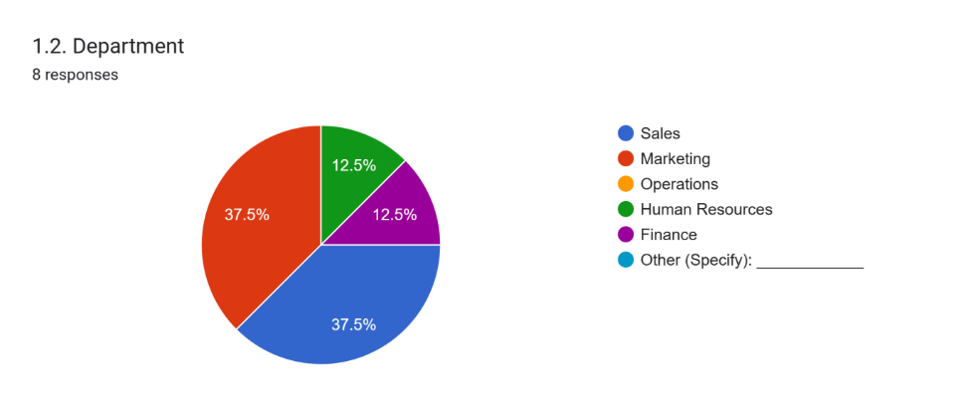

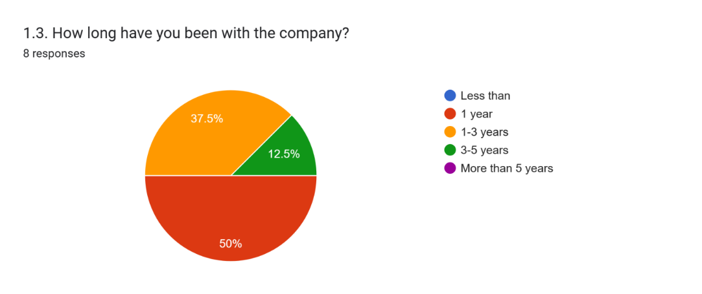

Demographics:   
The data demonstrates a fair allocation among different employment levels, with entry-level, mid-level, and senior-level roles each receiving an equal 50% of the total. This suggests a formalised institution that provides avenues for professional growth.  
When it comes to personnel representation among departments, Marketing and Sales stand out as having 37.5% of the total. This indicates the main business domains for the organisation.   
  
When it comes to tenure, the bulk of workers (50%) have been there for less than a year, indicating that the workforce is primarily young.

Forms response chart. Question title: Section 2: Performance Management Practices


2.1. How frequently do you have performance reviews?. Number of responses: 8 responses.

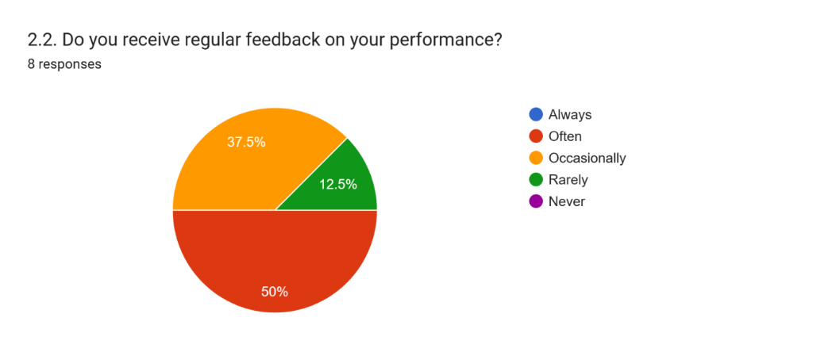

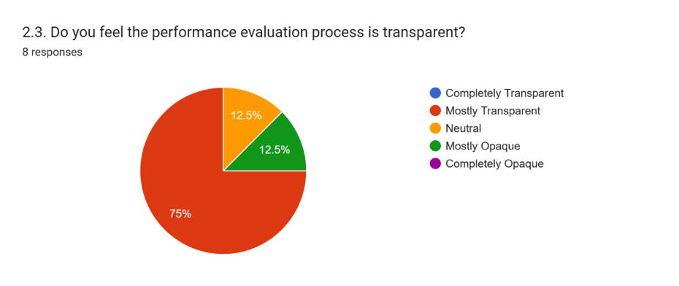

2 Performance Management Practices:

All personnel undergo performance evaluations twice a year, indicating a regular and consistent method of assessment.   
Most employees (50%) or always (37.5%) receive feedback on their performance, demonstrating active participation in continuous improvement initiatives.   
A significant portion of the population (75%) believes that the performance review process is transparent, indicating a high degree of confidence in the evaluation methods.

Forms response chart. Question title: Section 3: Goal-Setting


3.1. How often are your performance goals revised throughout the year?. Number of responses: 8 responses.

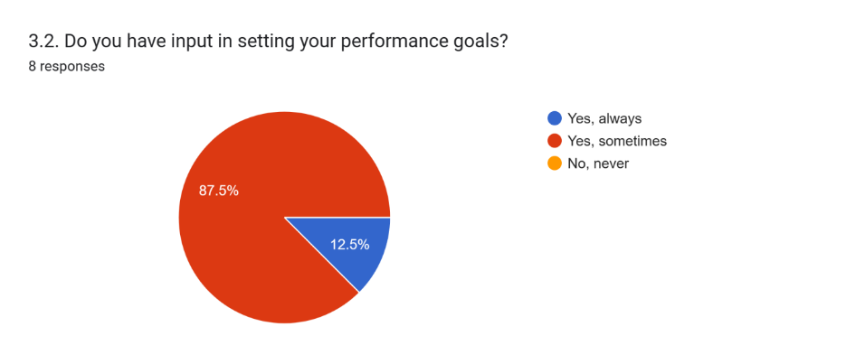

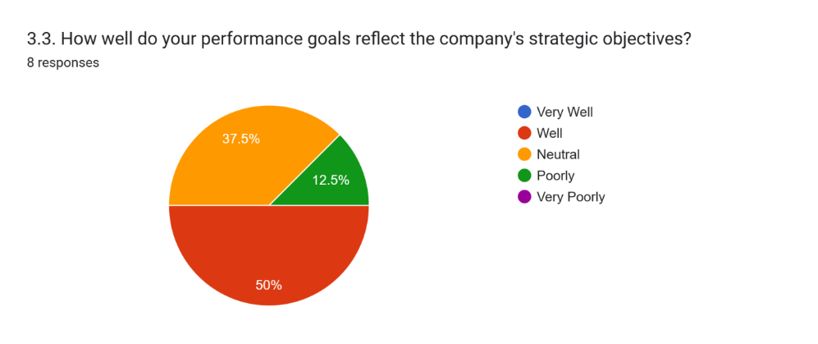

3 Goal setting:

For most employees (87.5%), performance targets are adjusted semi-annually, which encourages flexibility in response to changing company needs.   
Even though the majority of workers (87.5%) are involved in determining their own performance goals, there is room for improvement to guarantee inclusion for everyone.  
The majority (50%) believe that their performance targets are in line with the company's strategic objectives, demonstrating congruence between personal and group ambitions.

Forms response chart. Question title: Section 4: Employee Productivity and Motivation




4.1. Has the performance management system positively impacted your productivity?

. Number of responses: 8 responses.

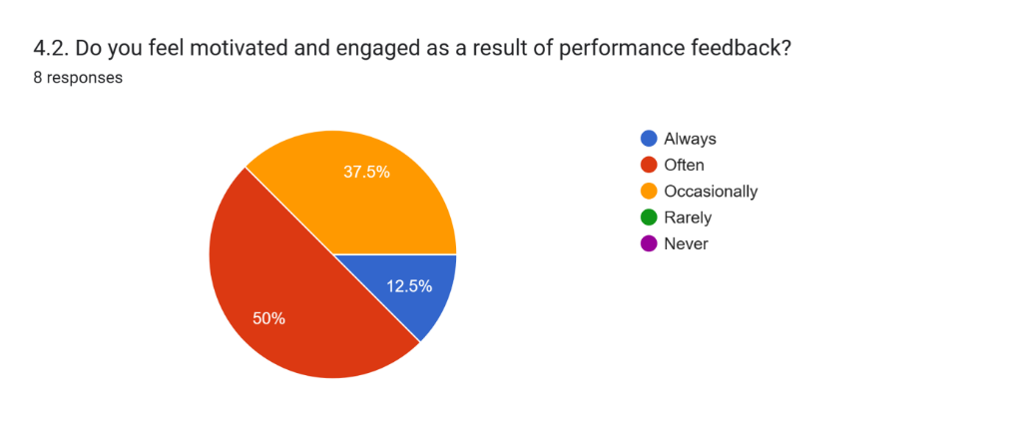

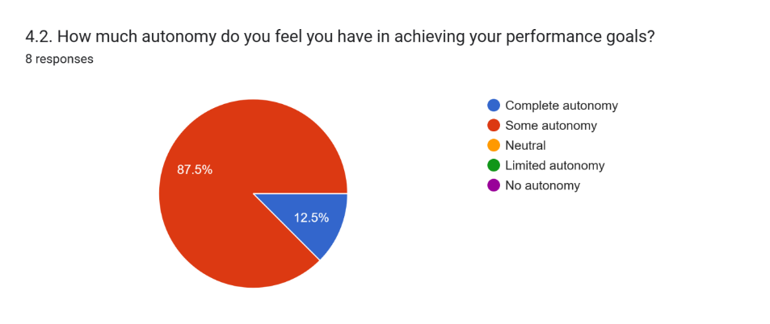

4. Employee Productivity and Motivation:

The performance management system is viewed favorably by 75% of employees, indicating its efficacy in enhancing productivity.

A significant portion (50%) of employees frequently feel motivated and engaged due to performance feedback, fostering a culture of ongoing improvement.

The majority (87.5%) perceive having autonomy in achieving their performance objectives, potentially bolstering motivation and accountability.Forms response chart. Question title: Section 5: Overall Satisfaction




5.1. How satisfied are you with the performance management system in One Point One Solution Ltd?

. Number of responses: 8 responses.

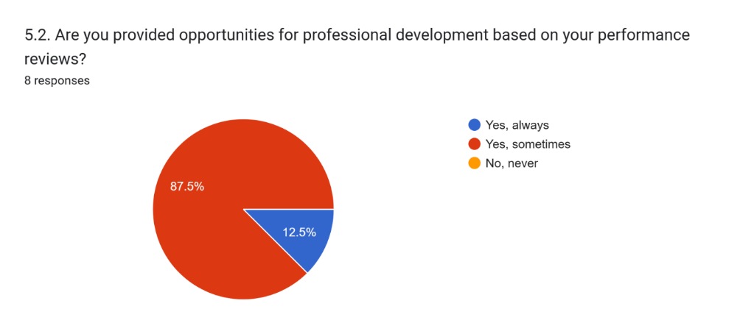

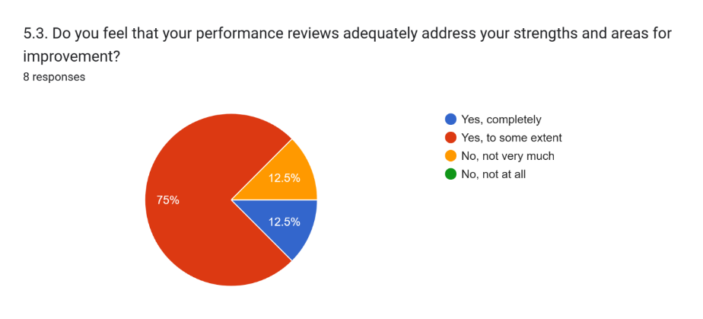

5. Overall Satisfaction:

With 75% of employees indicating happiness or high satisfaction levels, the performance management system has a notable high general level of satisfaction.  
However, there is room for improvement when it comes to the availability of opportunities for professional growth linked to performance reviews, as only 87.5% of workers infrequently get them.

Forms response chart. Question title: Section 6: Overall Satisfaction


6.1. How effectively does the performance management system encourage collaboration among team members?

. Number of responses: 8 responses.

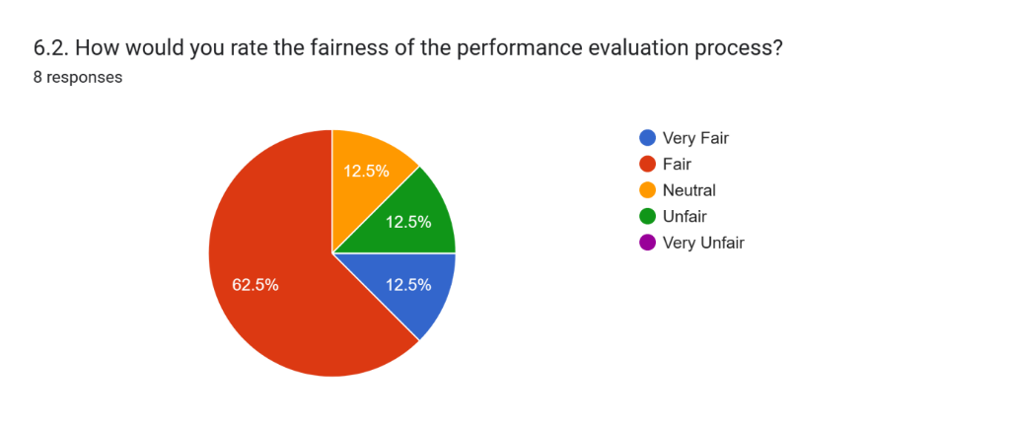

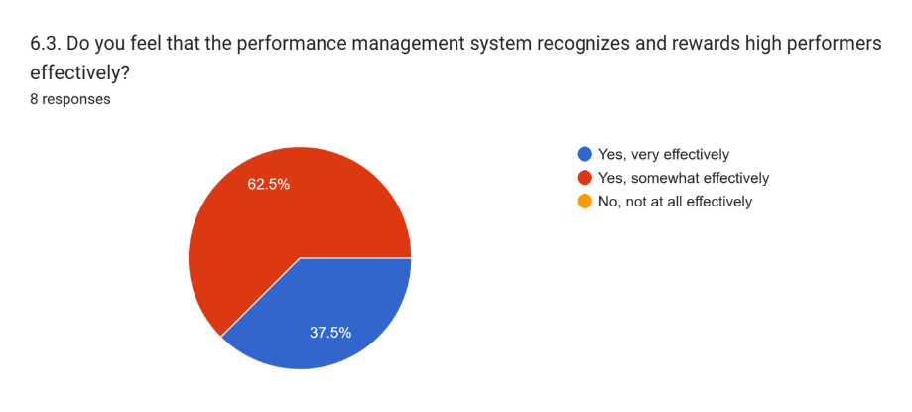

6. Collaboration and Fairness:

A sizeable percentage of respondents (50%) believe that the performance management system does a good job of encouraging teamwork, which is essential to achieving organisational goals.  
With 62.5% of employees assessing the performance review procedure as fair or extremely fair, it is generally regarded as fair.

Forms response chart. Question title: Section 7: Performance Management


 Please rate your overall satisfaction with the current performance management system in One Point One Solution Ltd:

. Number of responses: 8 responses.

7 Recognition and Rewards:

Most workers (62.5%) believe that strong performers are somewhat recognised and rewarded by the performance management system, indicating possible possibilities for improvement in this area.

Forms response chart. Question title: Section 8: Understanding Organizational Dynamics and Challenge


 Please rate the extent to which you believe the current performance management system effectively addresses the unique dynamics and challenges within our organization:

. Number of responses: 8 responses.

8.Understanding Organizational Dynamics and Challenges:

Regarding the performance management system's ability to understand organisational dynamics and challenges—which are crucial for promoting organisational success—there is agreement (50%) on this point.   
  
In summary, the data suggests that although One Point One Solution Ltd.'s performance management system is generally effective and well-received by staff, there are several areas that require improvement. Increasing staff goal-setting involvement and introducing more thorough awards and recognition programmes for top performers are two of these. By focusing on these areas, you may improve employee happiness even further and boost organisational success.

# RESULTS AND DISCUSSION

An analysis of One Point One Solution Ltd.'s performance management procedures provide insightful information on the workings of the company and employee satisfaction. A balanced distribution of workers across different employment levels is shown by the statistics, suggesting plenty of room for professional advancement. The company's main goals are strategically aligned with the focus placed on the marketing and sales departments.   
  
Semi-annual performance evaluations are regularly scheduled, which demonstrates the organization's commitment to encouraging ongoing feedback and development. The regular receipt of feedback highlights an environment at work that values candid communication and teamwork.  
  
A foundation of justice and trust inside the organisation is signalled by employees' perceptions of openness in the performance review process. However, there is still room to include staff members in goal-setting even more in order to increase their dedication to and alignment with company objectives.

Overall, while satisfaction with the performance management system is high, there's room for enhancement in providing comprehensive professional development opportunities tied to performance reviews, fostering ongoing employee growth and skill enhancement, ultimately advancing organizational success.

Moreover, positive perceptions of collaboration underscore effective teamwork and communication. However, there's an opportunity to improve recognition and rewards for high performers to better inspire and retain talent.

In summary, while One Point One Solution Ltd's performance management practices are largely effective, opportunities for improvement lie in inclusive goal-setting, professional development provisions, and recognition strategies. Addressing these areas can enhance employee satisfaction, engagement, and organizational performance.

**RECOMMENDATIONS:**

The following recommendations are meant to improve One Point One Solution Ltd.'s performance management:   
  
1. Involve Workers in Goal Setting: Assist all staff members in determining their own performance targets and ensuring that they are in line with the business's aims.   
  
  
2. Provide More Opportunities for Development: Establish an organised programme for staff members' professional development that includes workshops, mentoring, and training.   
  
3. Honour High Performers: Create an official recognition programme to honour exceptional work and inspire others to reach new heights.   
  
4. Enhance Communication: Promote open feedback and increase openness by outlining expectations and career routes.   
  
5. Align Practices with ideals: Make sure that the performance management system emphasises creativity and cooperation in line with the company's ideals.   
6. Review and Adjust Frequently: Evaluate the performance management system on a regular basis and solicit employee input to make the required changes At One Point One Solution Ltd., putting these ideas into practice can improve worker engagement, satisfaction, and productivity.

**LIMITATIONS:**

* There were time restrictions for the report, which would have affected the thoroughness of the investigation.
* The small sample size (50 people) might not accurately reflect the variety of the sector.
* Results from small sample sizes may not be statistically significant.
* Difficulty in gathering personal information since respondents were reluctant.
* Completing the questionnaire was impacted by time limitations.
* There were several outliers as a result of the participants' diversity.
* Limited willingness to participate on the side of the responders.

# CONCLUSION

A thorough analysis of One Point One Solution Ltd.'s performance management techniques indicates a complex but generally positive environment within the organisation. Overall, the company is making a concerted effort to foster a growth-oriented and supportive work environment, as seen by the number of employee input it receives and its frequent semi-annual performance reviews. The even distribution of demographics throughout job levels implies that there are plenty of options for professional growth and promotion within the company, which raises employee satisfaction and increases retention rates.   
  
While most employees consider the performance evaluation procedure to be fair and transparent, there are certain aspects that need to be improved, especially when it comes to inclusive goal-setting techniques and the availability of possibilities for professional growth. enabling workers to have an active role in determining Performance goals may increase a person's feeling of accountability and alignment with the organization's overall objectives, which will support both individual and group performance indicators. Furthermore, providing employees with more extensive opportunities for professional development based on the information obtained from performance reviews can help them develop their skills over time, which will keep them motivated and prepared to meet the changing needs of the business environment.  
  
  
The majority of team members have a favourable attitude towards cooperation, which highlights the effectiveness of One Point One Solution Ltd.'s internal workgroup dynamics and communication channels. However, there is still room for improvement in terms of identifying and compensating top performers in order to further encourage and retain top talent. Increasing the effectiveness of the company's recognition initiatives can foster a culture of excellence and innovation, driving the business towards long-term success in its specialised field.  
  
In conclusion, One Point One Solution Ltd.'s performance management procedures provide a strong basis for both organisational growth and personnel development, even though there is room for improvement. The organisation may enhance employee happiness and engagement levels, as well as its competitive standing in the market, by tackling the highlighted areas for development and using its current assets. Maintaining an emphasis on openness, diversity, and acknowledgment will be essential to sustaining an excellent culture and guiding the company towards long-term success.

# AKNOWLEDGEMENT

I would like to extend my sincere gratitude to everyone who contributed to the construction of this study paper on the Impact of Performance Management in organizations.

First and foremost, I am deeply thankful to my supervisor, Dr. Nakul, for his invaluable guidance and unwavering support throughout this endeavor. Additionally, I extend my gratitude to One Point One Solution and all individuals who were directly or indirectly involved. Your insightful advice and critical feedback played a pivotal role in shaping the direction of this paper.

I am also grateful to the participants who generously shared their perspectives and experiences. Without your cooperation, this study would not have been possible. Your willingness to engage and provide candid feedback was instrumental in enriching the findings of this research.

Furthermore, I wish to acknowledge the contributions of the numerous academics and professionals whose work served as a foundation for this paper. Your research and expertise in the field of consumer psychology in digital marketing have greatly informed my understanding of the subject matter.

Last but not least, I want to express my heartfelt appreciation to my social circle and friends. Your unwavering support and encouragement have been a constant source of inspiration throughout my academic journey. Your belief in my abilities has fueled my determination to excel in my endeavors.

# REFRENCES

1. In 2019 **Aguinis H.** Aguinis' work offers a thorough perspective on performance management by delving into the domains of organisational performance. This Pearson resource, now in its fourth edition, captures changing tactics and insights that are essential for modern organisations.   
  
2. **Baron, A. and Armstrong**, M. (2004). Armstrong and Baron's groundbreaking work, "Managing Performance: Performance Management in Action," published by CIPD, provides practical insights for anybody starting a performance management journey. When negotiating the complexities of performance management in practical situations, this resource acts as a guide.  
  
  
3. In 1996, **Becker, B. E. and Gerhart, B.** The transformational power of good HR practices is shown by Becker and Gerhart's key research in the Academy of Management Journal, which examines the relationship between HR management and organisational performance. Their labour, One of the most important resources for comprehending the complex link between HRM and performance is "The Impact of Human Resource Management on Organisational Performance: Progress and Prospects."  
  
4. **W. E. Deming (1986).** Deming's groundbreaking work, "Out of the Crisis," published by MIT Press, established the foundations of quality management and is still widely read in a variety of fields. Deming's ideas, which centre on organisational excellence and continual improvement, are ageless for overcoming obstacles and promoting a culture of quality.  
  
5. **T. H. Davenport (2013).** **Davenport's book**, "Process Innovation: Reengineering Work Through Information Technology," which was released by Harvard Business Press, explores the intersection of process innovation and IT and provides a road map for using IT to improve organisational effectiveness and efficiency.