RESEARCH ON THE USE OF BY-PRODUCTS AND INDUSTRIAL WASTES FOR HIGHWAY CONSTRUCTION

RABIA AIJAZ¹, Er. MAANI SHARMA²

¹ M.Tech Scholar,Desh Bhagat University Gobindgarh Punjab,India
iruayoub@gmail.com

2 Assistant Professor, Desh Bhagat University Gobindgarh Punjab,India
Katwalrekha7@gmail.com

ABSTRACT

The construction sector is confronted with growing difficulties in procuring sustainable materials for highway building while simultaneously reducing environmental effect. This study provides a thorough examination of the research carried out on the utilise of by-products and industrial wastes in the building of highways. By-products and industrial wastes, such as fly ash, slag, foundry sand, and similar materials, have the potential to be utilised as alternative building materials. This may provide economic, environmental, and performance advantages.

The study analyses many research that investigate the engineering qualities, performance characteristics, and environmental consequences of using by-products and industrial wastes in the building materials for highways. The research results emphasise the capacity of these materials to improve the mechanical characteristics, longevity, and ecological viability of roadway infrastructure. In addition, the utilise of by-products and industrial wastes helps to minimise waste, save resources, and reduce carbon footprint.

The study focutilises on many important subjects, such as the utilise of fly ash and slag in asphalt concrete and concrete mixes, the integration of waste foundry sand in road foundation and subbase layers, and the implementation of other industrial by-products in soil stabilisation and pavement building. Moreover, the paper examines the difficulties, restrictions, and potential areas of future investigation in the utilise of by-products and industrial wastes for the purpose of constructing highways.

This research highlights the significance of investigating creative approaches for constructing environmentally-friendly highways by efficiently using by-products and industrial trash. Adopting these methods may result in substantial progress in the long-term durability of infrastructure, the effective utilise of resources, and the responsible management of the environment in the transportation industry.
Key Words: By-products, Industrial Wastes, Highway Construction, Sustainable Materials, Recycling, Utilization, Waste Management, Pavement Materials

INTRODUCTION

Every growing nation must make an effort to establish fundamental public facilities, along with essential farming and industrial advancements. (a) A few of the infrastructure facilities that the government will provide for public utilise include roads joining significant regions of the area either urban or rural, which may include expressways, NH, SH, major district roads and village roads (b) overpass, tunnels and bridges, (c) frivolous, zoo or animal parks, (d) water retaining bodies and controlling services, various irrigation heavy structures like canals, aqueducts, barrages-dams and many more.

Now, the attention is on the necessity of sustainable development to preserve environment for coming generations. By 2030, almost 60% of the world's population will reside in urban regions, according to UN statistics. Cities in the world consumes 60-80 percent of the energy and emits 75 percent of its carbon, although covering only 3 percent of the planet's surface. Urbanization puts more strain on the water and sewage systems as well as the quality of life.

The environment and public health Increased city density is expected to boost efficiency and technological innovation while simultaneously depleting natural resources and enhancing energy usage. To achieve sustainable development, it is necessary to strike a balance between interrelated factors such as economic growth, social inclusion, and environmental conservation. These three key aspects benefit both individuals and society. The United Nations has established 17 global transformation objectives based on sustainable development. One of the UN's (URL-1) 2030 goals is to diminish cities' undesirable per capita environmental impact. Focusing on air quality a s well as public and other waste management can help achieve this. The importance of long-term development is summarized in the following way (URL-2):

To Preserve Technological Assets

People nowadays just can envisage a life without the current modern technology that is employed in everyday life. Natural resources were not utilised as raw resources in the progress of these technologies. Minerals and other auxiliary Substances are needed in large quantities to make the items we utilise every day. It is possible to ensure that current technological requirements are addressed while also conserving resources for future generations through sustainable development.

To meet basic human requirements

As the world's population grows, basic necessities such as food, water, and shelter become enhancingly important. These requirements rely on current infrastructure, which must be preserved for the future. If they are utilised indefinitely without regard for future needs, the expense and environmental depletion will be so great that meeting even the most basic necessities may become impossible.

Agricultural Demand
Increased population will almost probably require more farming activities. If the current unsustainable tilling, sowing, watering, spraying, and harvesting processes are continued, resources will run out sooner, making them very expensive. Crop rotation and efficient seeding procedures are two

sustainable agriculture practices that can help achieve very high yields. It will also help to protect the soil's integrity by producing food for a bigger lot of persons.

Climate Change Prevention
Climate change is a critical concern in today's world. Climate change is said to have a negative impact on the world and, as a result, on life on the planet. It's also worth noting that human-cautilised climate change is attributed to the discharge of greenhoutilise gases into the sky. If no actions are made to control and eliminate these emissions, future peaceful living on Earth will be impossible. Sustainable development may be viewed of as an alternative that could give at least a partial answer or treatment for climate change control. Sustainable growth will necessitate a reduction in the usage of fuels that are both sustainable and emit greenhoutilise emissions.

Ensure financial security
Financially sustainable economies may be attained by taking global efforts toward sustainable development. By taking efforts to save resources, resource-poor economies will get more room to utilize the resources saved by adopting sustainable development, and so will be able to contribute to social and economic progress. This would also help to alleviate some of the problems with unemployment.

Biodiversity Preservation
It is stated that over-consumption and unsustainable development methods have harmful consequences on the biodiversity. For example, if unsustainable agricultural techniques that are being conducted are employed with relation to pesticides, this may have detrimental influence on the survival of bees and other pollinators. It's also worth noting that without bees, roughly 19 main food crops would decline, and over half of the world's food would be unavailable. Pollution from unsustainable development pollutes the oceans, which are home to a enormous quantity of algal species. As a result, one of the most crucial initiatives we can take to conserve our ecology is to pursue sustainable growth.

OBJECTIVES

The objectives are as follow:

- Evaluate the appropriateness of by-products and industrial wastes for different uses in highway development.

- Analyse the physical, chemical, and mechanical properties of these materials in order to comprehend their performance characteristics.

- Examine the ecological consequences of using these materials, particularly their capacity to decrease carbon emissions and waste production

- Analyse the economic viability of integrating by-products and industrial trash into highway building projects.

- Create novel processing methods to improve the characteristics and effectiveness of these materials.

- Perform performance studies to evaluate the resilience, robustness, and long-term performance of roadway constructions constructed utilising these materials.

- Ensure adherence to applicable regulations, standards, and specifications that govern roadway construction to maintain regulatory compliance.

- Seek ways to include stakeholders and work together to encourage the sharing of information and the implementation of sustainable practices.

- Identify the possible obstacles and difficulties that may hinder the general acceptance of by-products and industrial wastes in the building of highways.

- The objective is to enhance the sustainability, efficiency, and resilience of transportation infrastructure while minimising the negative effects on the environment and the use of resources.

LITERATURE REVIEW

“The objective of the review of the literature is to analyse the environmental impacts of employing industrial waste water and products in the construction of roads, with a specific emphasis on their influence on soil strength measurements such as CBR, UCC, and split tensile strength.”
APPLICATION OF INDUSTRIAL EFFLUENTS IN HIGHWAY BUILDING
Sen and Mishra (2010). investigated the potential for constructing village roads out of Industrial byproducts and wastes such as fly ash, blast furnace slag and dust from cement kilns discarded plastic baggage, WFS, collierysand and phospogypsum.
Schroeder (1994). Discovered several waste Substances that have been previously or are now being utilised consecutively for the construction of highways or embankments. The author observes that highway construction companies may effectively utilise large quantitys of diverse Substances.
Swamy and Das (2012). Explored the possible benefits of leftover from industries such as fly ash, abandoned transparent material, deconstruction particles, colliery refutilise, slag, furnace sandy soil, and oven dust.
Dawson et al. (1995). Assessed the viability of a British manufacturing byproduct for utilise in pavement construction.
“The components were ranked based on both their strength and their ease of utilise in creating high quality roadways. The outcomes of the study demonstrated that industrial byproduct may be effectively utilised as either aggregates, binder, or both in the construction of road foundations layers.”

HIGHWAY CONSTRUCTION WITH WFS
Kirk (1998). It has been shown that WFS from the iron sector may possess engineering characteristics that meet the standards required for constructing roadway banks. In addition, he said that the MicrotoxTM bioassay evaluation will be utilised for screening the WFS in order to verify that it does not contaminate the natural world. The research utilised WFS and regular soil material (as control embankments) to construct embankments.
Geotechnical Examinations reveal that WFS performs as well as natural sand does in terms of strength and deformation when utilised as a structural fill. But it must be emphasized such as WFS fill should not be thought of as without restrictions draining. According to the MicrotoxTM bioassay, the toxicity of WFS material was comparable to that of unprocessed sand. The author claims that the absence of decision-based scientific instruments, like as life-cycle or risk-based analytical techniques, is one of the obstacles to the effective reutilise of WFS.
To evaluate the suitability of WFS (WFS) as a resource for road embankments, Mast & Fox (1998) carried out a significant field study. In their project, they looked at geotechnical parameters such deformation, strength, hydraulic properties, and ease of construction. Three distinct types of embankment sections—I clay borrow, II river sand, and III WFS—were the subject of their analysis. Their field demonstration experiment demonstrated that WFS may be effectively employed as bank fill elements for highway construction from a geotechnical standpoint.
The description of IITPAVE was provided by IRC 37 (2012). The laboratory-based strength values and IITPAVE were eventually utilised to establish sub-base thicknesses. IITPAVE may be utilised to Conduct experiments with various combinations of traffic and pavement surface composition.
FLY ASH IN HIGHWAY CONSTRUCTION
According to Dhawan et al., fly ash would be applied as a sub base and sub grade component (1994). The reaserchers investigated the Characteristics of soil and coal ash mixtures that may be utilised to construct roadways. Through laboratory research, the strength parameter of the combinations under study was determined.
Prabakar et al. (2004) conducted an experimental Examination on the effect of fly ash addition on soil shear strength. Authers noticed that the shear properties of the soil with a assured quantity of fly ash increased. Shear strength is observed to vary non-linearly with varied quantitys of fly ash. It was too explored that enhancing the quantity of fly ash utilised reduced soil swelling. They came to the conclusion that fly ash combined with soil can be utilized as a roadway base material.
Lav & Lav (2014) investigated the impact of stabilisation on the resilient behaviour of fly ash to be utilised as a roadway pavement material by means of repetitive load indirect tensile and repetitive load triaxial tests. They stated that while using fly ash in the upper layers of the pavement, stability is critical.
They also stated that using fly ash in highway building did not pose a risk to the environment. The stress-strain behaviour of stabilised fly ash is nonlinear, according to their findings. They suggest that stabilised FA is a stress-dependent material that should be built in larger layers for highway construction than normal pavement layers.
Kolias et al. (2005) conducted experiments on the utilise of fly ash to stabilize clayey soil. They claimed that fly ash and cement might be utilised to even out clayey soil.

Wind-blown loess, according to Zia & Fox (2000), may be compacted on optimum water content and utilised as highway building material. They studied the engineering qualities of the loess-fly ash mixes through tests.
HIGHWAY CONSTRUCTION WITH RED MUD
Kalkan (2006) published the findings of an inquiry on red mud for practical utilise. It was looked at using red mud as a stabilizing material. This research is looking at the impact of red mud on soil stability. The investigators conducted an experiment to evaluate the unconfined strength in compression, hydraulic conductivity, and swelling. They found that the condensed clay samples, which included red mud and cement-red mud additions, exhibited a high level of strength in compression. They further claim that when compared to natural clay samples, the hydraulic conductivity and swelling percentage are lower.
Singh et al. in explored the manufacture of special cements with red mud sourced from a company HINDALCO Industries Limited, located in Renukoot, India. In their research, they looked at three different types of cement. On the cement characteristics, the impacts of composition, fire temperature, and time were investigated. The cements manufactured using lime, red mud , bauxite and gypsum have strengths same to or better than standard Portland cement, according to test findings (OPC). Those made with lime, red clay, and fly ash, however, lacked adequate strength.
SUBSTANCES FOR SOIL STABILIZATION
Little (1995) published a guide on the utilise of lime for the stabilization of highway and airfield base, sub-base, and subgrades. (a) The processes of lime-soil interaction, (b) mixture proportioning, (c) The engineering benefits of lime stabilising soils and aggregates, (d) design of pavement thickness, (e) building and quality regulator, and (f) lifespan budget are all covered in the handbook.
Little and Nair (2009) published a study on the utilise of classic calcium-based stabilizers including Portland cement, lime, and fly ash to treat soil. The interactions that occur between the soil and the stabilizers and soil are described and compared in their report. The study also provides stability mechanisms.
CLUSTER ANALYSIS
Performing a large number of experimental Examinations while adjusting various conceivable factors or characteristics of the specimen under examination might yield a large quantity of experimental data. The experiment results must be evaluated in order to draw inferences and draw conclusions.
Cluster analysis is one approach that may be utilised to help with this sorting issue. Normally, while evaluating the findings of studies, the influence of one or more factors on another variable is investigated. Also, based on the interpretation of the experimental results, the order of the effect of several factors on a given variable may have to be determined.

METHODOLOGY

UTILISED SUBSTANCES
WFS
“After receiving WFS from a foundry plant in J&K India, it was noted that the sand had a black colour. In order to eliminate any clumps, foreign particles, and fine particles, the WFS underwent an initial filtration process using a coarse sieve with a size larger than 4.75. Afterwards, an analysis was conducted on both the physical and chemical features of the WFS. The WFS utilised mostly sand particles that were able to pass through a 2.36 mm screen, making up almost the whole sample. A sieve examination was performed to ascertain the gradation Characteristics of the WFS, which unveiled homogeneity in the size of sand particles. The physical Examination revealed that the WFS exhibited a lack of substantial cohesive properties.”
Figure 4.1 depicts the WFS image utilized in this work, while Figure 4.2 depicts the distribution of particle size curve derived for the alike.
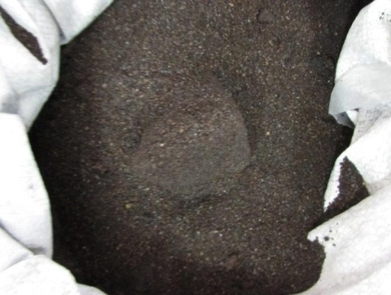

Figure 4.1 WFS utilised
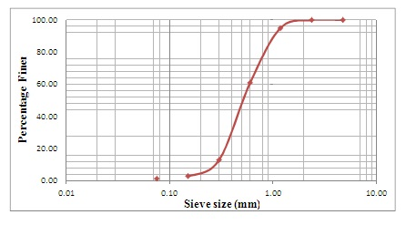
Figure 4.2 “Curve of Particle Size Distribution for WFS””

Fly Ash
“Industrial furnace stack gases, upon cooling, generate fly ash in the form of a finely powdered substance. The Characteristics and attributes of the fly ash are determined by the specific kind of fuel utilised. Fly ash generally comprises of spherical particles that enhance flow characteristics and reduce the quantity of water needed in combinations. The material exhibits a low specific gravity, a consistent particle size distribution, and a lack of malleability. The specific gravity of fly ash ranges from 2.0 to 2.6, depending on its chemical makeup. When fly ash comes into contact with water, its pH level may vary from 8 to 12. Fly ash is often utilised in the building industry as a substitute for natural pozzolanas, owing to its comparable qualities to cement. When fly ash is combined with water, it displays cement-like characteristics that are similar to cement, resulting in the formation of hydration compounds. Therefore, it is often utilised in construction as a replacement for cement, giving cohesiveness to the combinations being studied. “Fly ash is categorised into two distinct classifications: Class C and Class F. Class C fly ash is regarded preferable than Class F fly ash becautilise it has greater cementitious properties. Nevertheless, this Examination utilised Class F fly ash. Figure 4.3 depicts the Class F fly ash that was employed in this Examination. Table 4.2 lists the chemical characteristics of the fly ash utilized in this research.”
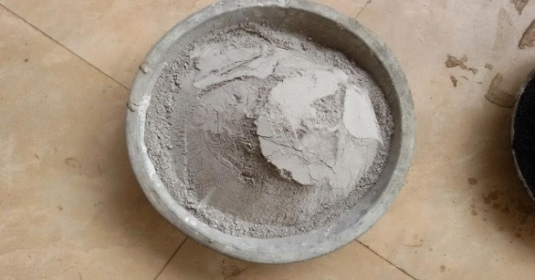
Figure 4.3 Fly ash of Class F type
Table 4.1 Fly ash chemical composition

S.No | ingredients | %
1 | quantity of SiO2 | 52.30
2 | Total quantity of Alumina | 18.50
3 | Total quantity of Ferric oxide | 10.70
4 | Total quantity of calcium | 7.90
5 | Free lime content | 2.90
6 | Magnesium content | 0.85
7 | Titanium | 0.25
8 | Potassium | 3.30
9 | Sodium | 0.15
10 | Loss on ignition | 1.95

The sieve analysis revealed a fineness modulus of 0.058. Fly ash with a specific gravity of 2.28.
Red Mud
“This is an intractable residue resulting from the Beyer's process utilised in the production of aluminium. Red dirt is collected from the aluminium industry in J&K India. The scarlet mud was pulverised into a fine dust. Figure 3.4 illustrates a specimen of red mud utilised in the study.”
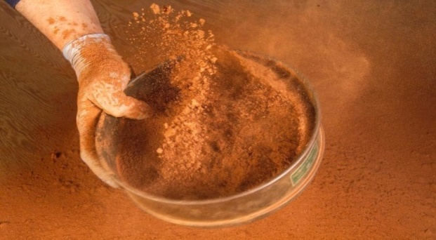
Figure 4.4 Red Mud Utilised

The material was completely dried before utilise. The Atterberg limits of red mud are determined using IS-2720. Red mud particles range in size from 75 to 100 microns. The results of the sieve analysis of red mud utilised in this experiment are shown in Table A1.3 in Appendix 1. The effective size of red dirt was determined to be 0.012 mm. The particle size distribution curvature for red mud is presented in Figure 3.6.
The chemical Characteristics of the red mud conceded out in current experiment are shown in Table 4.2.
Table 4.2 Chemical Composition

S.N. | Constituents | %
1 | Iron oxide | 25.34
2 | Aluminium Oxide | 17.76
3 | Silica | 6.90
4 | CaO | 21.50
5 | Sodium oxide | 4.80
6 | Titanium Oxide | 6.0
7 | Potasium Oxide | 0.06
8 | Sc₂O₃ | 0.80
9 | V₂O₅ | 0.28
10 | Nb₂O₅ | 0.011
11 | Losses | 7.85

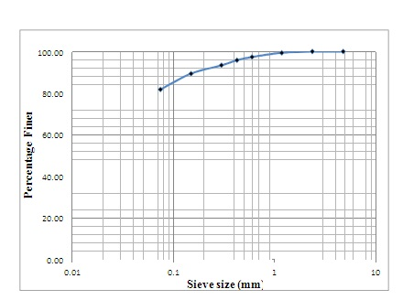
Figure 4.5 Distribution of red mud particle sizes
Cement
The research study utilised Ordinary Portland Cement (OPC) Grade 53, following the standards stated in IS 12269 (1987). The full characteristics of the cement utilised in the research are outlined in the table provided below.

Table 4.3 Cement Characteristics

S. No | Property descriptions | Observed Value
1 | Cement SP.GR | 3.17
2 | Cement having Fineness modulus | 10%
3 | Cement having Consistency | 27.3%
4 | Cement having Initial setting time | 35 minutes

Lime
Figure 4.5 Illustrates the acquisition of lime, which served as a stabilising ingredient in the field experiment, from a nearby marketplace.
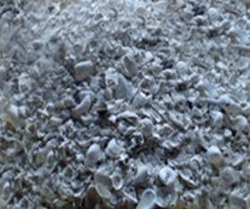

Figure 4.5 Seashells were employed in the experiment
The lime utilised in the present study was produced by the process of calcination of seashells followed by the application of water, resulting in the formation of a powdered substance.
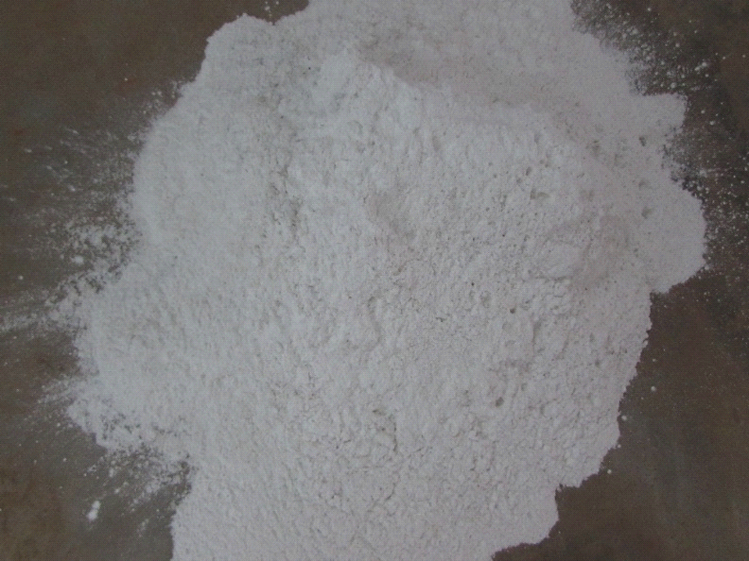
Figure 4.6 Lime was employed in the research

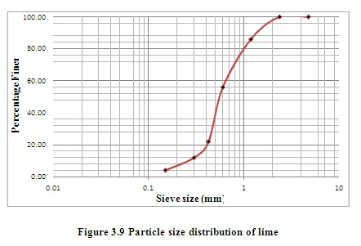

STUDY OF EXPERIMENTATION
Using various mix quantities of industrial offshoot and waste, the experimental Examination examines strength characteristics such as the UCC, CBR and Split Tensile Strength. The industrial by-product percentages vary to accommodate a wide range of mix formulations.
The CBR test considers each component of the mixtures.
The field of inquiry has a grand total of 55 samples. The Examination utilised samples consisting mostly of WFS and fly ash. By substituting different quantitys of fly ash for WFS, many combinations may be created.
Table 4.4 CBR testing consider the amounts of the combination.
ID | Industrial effluents/industrial offshoot |  |  | Stabilizing agent
 | W.F.S. | Fly ash | Red mud | Cement | Lime
S1 | 80 | 5 | 5 | 5 | 5
S2 | 70 | 10 | 5 | 5 | 5
S3 | 90 | 10 | 5 | 5 | 5
S4 | 60 | 20 | 5 | 0 | 5
S5 | 50 | 40 | 5 | 0 | 5
S6 | 80 | 10 | 0 | 5 | 5
S7 | 70 | 5 | 0 | 0 | 5
S8 | 60 | 5 | 0 | 0 | 5
S9 | 70 | 20 | 0 | 0 | 5
S10 | 60 | 30 | 0 | 0 | 5
S11 | 70 | 10 | 5 | 0 | 5
S12 | 60 | 20 | 15 | 0 | 5
S13 | 70 | 30 | 5 | 0 | 5
S14 | 60 | 40 | 5 | 0 | 0
S15 | 80 | 10 | 5 | 0 | 0
S16 | 60 | 20 | 5 | 0 | 0
S17 | 80 | 30 | 5 | 0 | 0
S18 | 80 | 40 | 5 | 0 | 0
S19 | 70 | 10 | 10 | 5 | 0
S20 | 90 | 15 | 0 | 5 | 0
S21 | 80 | 15 | 0 | 5 | 0
S22 | 70 | 25 | 0 | 5 | 0
S23 | 80 | 35 | 0 | 5 | 0
S24 | 70 | 10 | 0 | 5 | 0
S25 | 60 | 20 | 0 | 5 | 0
S26 | 55 | 15 | 0 | 5 | 0
S27 | 65 | 25 | 0 | 5 | 0

- RESULT

The results and comments of the This section presents both practical and analytical investigations. The findings and comments related to the experiments are provided first, followed by the findings and discussions related to the analytical work.

STRENGTH PARAMETERS
CBR (California Bearing Ratio)
Table 5.1 shows the results of CBR testing.
Table 5.1 CBR Test: Results of Mixture Quantities are taken into account
ID | Industrial effluents/industrial offshoot |  |  | Stabilizing agent |  | CBR
 | W.F.S. | Fly ash | Red mud | Cement | Lime
S1 | 90 | 5 | 5 | 5 | 5 | 11
S2 | 100 | 0 | 5 | 0 | 5 | 52
S3 | 70 | 10 | 5 | 5 | 5 | 71
S4 | 80 | 20 | 5 | 5 | 5 | 81
S5 | 70 | 25 | 5 | 0 | 5 | 68
S6 | 80 | 5 | 0 | 5 | 5 | 36
S7 | 70 | 0 | 0 | 0 | 0 | 68
S8 | 60 | 15 | 0 | 5 | 5 | 83
S9 | 70 | 20 | 0 | 5 | 5 | 74
S10 | 60 | 30 | 0 | 0 | 5 | 61
S11 | 70 | 0 | 5 | 5 | 5 | 49
S12 | 80 | 10 | 5 | 5 | 5 | 71
S13 | 70 | 20 | 5 | 0 | 0 | 62
S14 | 60 | 30 | 5 | 5 | 0 | 42
S15 | 80 | 0 | 5 | 0 | 0 | 34
S16 | 70 | 5 | 5 | 5 | 0 | 47
S17 | 50 | 10 | 5 | 5 | 0 | 51
S18 | 70 | 20 | 5 | 5 | 0 | 44
S19 | 80 | 5 | 0 | 5 | 0 | 27
S20 | 90 | 15 | 0 | 5 | 0 | 44

Table 5.1 (Continued)
ID | Industrial effluents/industrial offshoot |  |  | Stabilizing material |  | CBR
 | WFS | Fly ash | Red mud | Cement | Lime
S21 | 60 | 15 | 0 | 5 | 0 | 55
S22 | 70 | 25 | 10 | 5 | 0 | 50
S23 | 60 | 35 | 10 | 5 | 0 | 37
S24 | 90 | 10 | 5 | 5 | 0 | 30
S25 | 60 | 20 | 5 | 0 | 5 | 48
S26 | 70 | 20 | 5 | 0 | 5 | 46
S27 | 60 | 40 | 5 | 0 | 5 | 35

The impact of changing the percentage of WFS (WFS) with different percentages of red mud, together with the addition of 5% cement as a stabilising agent, on the California Bearing Ratio (CBR) value of mix quantities is visually shown in Figures 5.1–5.3
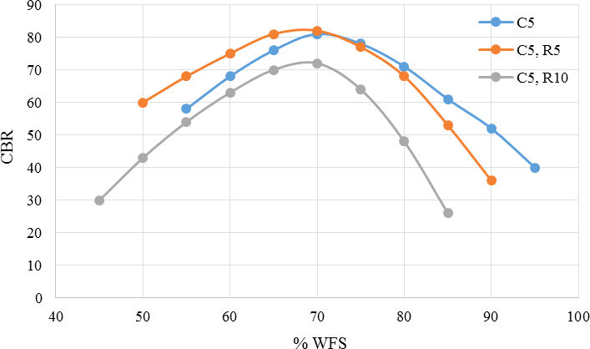
Figure 5.1 CBR differentials based on the percentage utilisation of WFS, Red Mud, and Cement
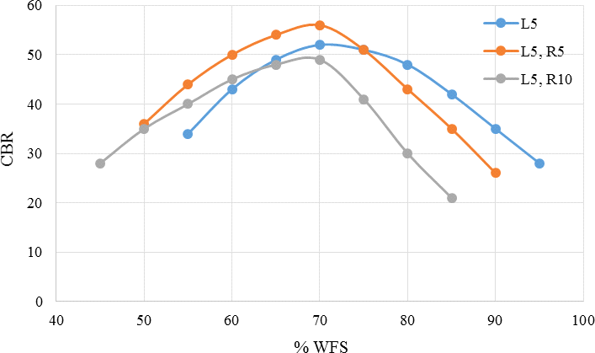
Figure 5.2 CBR differentials based on the percentage utilisation of WFS, Red Mud, and Lime

The relationship between the CBR and the percentage of WFS exhibits a non-linear fluctuation, as seen in Figures 5.1 and 452. Moreover, for both types of stabilising Substances utilised, there exists an optimum percentage of WFS that leads to a higher CBR value. Figures 5.1 and 5.2 demonstrate that including 5% red mud increases the CBR value when the proportion of WFS is below the optimal quantity. When ten percent red mud is added, the CBR value reduces for both of the tested stabilising Substances. The utilise of 10% red dirt significantly reduces the CBR value for all tested versions of WFS.

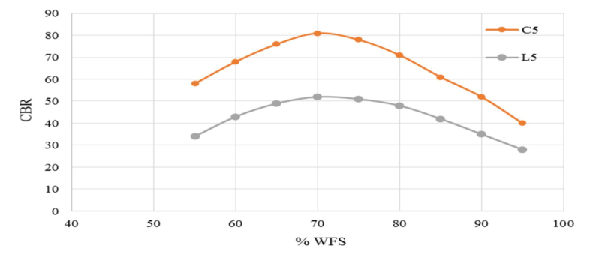
Figure 5.3 Effect of Stabilizing Agent on CBR

- CONCLUSION

This section provides a summary of the results drawn from the investigatio Subsequently, the findings drawn from the evaluations are presented.

    - Generally, the relationship between the CBR value and the percentage of WFS utilised in the mixture is non-linear.
    - There exists an optimal percentage of WFS (WFS) for the stabilising Substances, namely cement and lime, utilised in this research. This percentage leads to a higher CBR value for the combination.

    - The inclusion of 10% red mud in the mixture resulted in a reduce in the CBR value for almost all of the WFS percentage differentials examined.

    - The utilise of WFS for 70% of the duration was shown to provide enhanced strength, as indicated by the CBR value.

    - Using 5.5% red mud in the ideal WFS led to an increased CBR value.

    - 20 per cent The optimal mixture among the mixture quantities investigated for the experimental Examination is 7. 20% utilise of fly ash, 5% utilise of red mud, and 70% utilise of WFS.

    - The CBR value of the combination is reduced by more than 20% when fly ash is utilised

    - Utilizing cement as a stabilizing ingredient improved the CBR value of the combination by about 60% as compared to using lime as a stabilising agent. Nonetheless, the percentage of red mud in the combination has an impact on the rise in strength.

    - There are several varieties Differentials in the CBR value of the mixture as a result of changing the % utilise of red mud are largely due to changes in fly ash.

    - The presence of varied percentages of red mud evaluated in this study has a considerably smaller influence on the CBR value for different WFS to fly ash ratios in general. Both stabilizing chemicals have a less influence on the CBR value when varying quantitys of red mud are utilised.

    - When the ratio of WFS to fly ash % is less than 5, it has the most impact on the mixture's strength.

    - By enhancing the percentage of WFS or fly ash in the mixture proportion, the mixture may be made to have almost the same strength (CBR value).

    - The UCC strength of the mixture quantities studied in this study increases as the fraction of WFS utilised increases up to 70%.

    - In general, enhancing the curing time improves the UCC strength of the combination quantities investigated in this study.

    - The presence of red mud appears to alter the pace at which the UCC strength of the mixes under consideration increases or reduces.

- REFERENCES

- Boehlen, A, Heinemann, U, & Henneberger, C 2016, ‘Hierarchical spike clustering analysis for Examination of interneuron heterogeneity’, Neuroscience Letters, vol. 619, pp. 86-91.
- Tao Yi, Lin Zhu, Wan-Ling Peng, Xi-Cheng He, Hong-Li Chen, JieLic, Tao Yu, Zhi-Tao Liang, Zhong-Zhen Zhao& Hu-Biao Chen 2015,‘Comparison of ten major constituents in seven types of processed tea using HPLC-DAD-MS followed by principal component and hierarchical cluster analysis’, LWT - Food Science and Technology, vol. 62, no.1, Part 1, pp. 194-201
- AleksanderAstel, RajmundMichalski, Aleksandra Łyko, Magdalena Jabłońska-Czapla, KatarzynaBigus, Sebastian Szopa& Adriana Kwiecińska 2014, ‘Characterization of bottled mineral waters marketed in Poland using hierarchical cluster analysis’, Journal of Geochemical Exploration,vol.143, pp. 136-145.
- Abu-Daabes, M, Qdais, HA & Alsyouri, H 2013, ‘Assessment of Heavy Metals and Organics in Municipal Solid Waste Leachates from Landfills with Different Ages in Jordan’, Journal of Environmental Protection, vol.4, pp. 344-352.
- Trivedi, JS, Nair, S &Iyyunni, C 2013,‘Optimum Utilization of Fly ash for Stabilization of Sub-Grade Soil using Genetic Algorithm’, Procedia Engineering, vol. 51, pp. 250–258. doi:10.1016/j.proeng.2013.01.034
- Duan, P, Shui, Z, Chen, W &Shen, C, 2013, ‘Effects of metakaolin, silica fume and slag on pore structure, interfacial transition zone and compressive strength of concrete’, Construction and Building Substances, vol. 44, pp. 1-6.
- Huang, CH, Lin, SK, Chang, CS & Chen, HJ 2013, ‘Mix quantities and mechanical Characteristics of concrete containing very high-volume of Class F fly ash’, Construction and Building Substances, vol. 46, pp. 71-78.
- IRC: 37-2012. Guidelines for the design of flexible pavements.
- IRC:SP:89-2010. Guidelines for soil and granular material stabilization using cement, lime and fly ash.
- Al-Jabri, KS, Al-Saidy, AH &Taha, R 2011, ‘Effect of copper slag as a fine aggregate on the Characteristics of cement mortars and concrete’, Construction and Building Substances, vol. 25, no. 2, pp. 933-938.
- Swamy, AK & Das, A 2012,‘Possible Utilise of Some Waste Substances in Road Construction’, The Masterbuilder.

