Master’s Thesis On

**A FEASIBILITY ANALYSIS OF ZERO-CARBON EMISSION THROUGH ELECTRIC VEHICLE**

***FOR THE PARTIAL FULFILLMENT OF THE REQUIREMENT***

***FOR THE AWARD OF***

***MASTER OF BUSINESS ADMINISTRATION***

UNDER THE GUIDANCE OF

PROF. DR. RANJUL RASTOGI

SUBMITTED BY

VIVEK KUMAR  
22042010154

MBA 2022-2024



SCHOOL OF BUSINESS

GALGOTIAS UNIVERSITY

MAY, 2024

**CERTIFICATE**

This is to certify that the Master’s Thesis “A Feasibility Analysis of Zero-Carbon Emission Through Electric Vehicle” has been prepared by Mr. Vivek Kumar under my supervision and guidance. The project report is submitted towards the partial fulfillment of 2 year, Full-time Master of Business Administration.

Name:- Dr. Ranjul Rastogi   
  
Signature of Faculty

Date

**DECLARATION**

I, **Vivek Kumar Roll No.22042010154**, student of School of Business, Galgotias University, Greater Noida, hereby declare that the Master’s Thesis on “**A Feasibility Analysis of Zero-Carbon Emission Through Electric Vehicle** ”is an original and authenticated work done by me.

I further declare that it has not been submitted elsewhere by any other person in any of the institutes for the award of any degree or diploma.

Name:- Vivek Kumar  
  
Signature:-

Date:-

**ACKNOWLEDGMENT**

I am honored to extend my heartfelt gratitude to all those who played a pivotal role in the successful completion of my project, "**A Feasibility Analysis of Zero-Carbon Emission Through Electric Vehicles**" Their invaluable contributions and unwavering support have been instrumental throughout this endeavor.

First and foremost, I am deeply thankful to **Dr. Ranjul Rastogi**, my esteemed faculty guide, for her invaluable guidance, expertise, and continuous encouragement. Her mentorship has been invaluable in shaping the direction and execution of this project.

Furthermore, I extend my heartfelt thanks to all my dear friends for their unwavering cooperation, insightful advice, and constant encouragement throughout the journey of conducting this project and compiling this report. Their support has been a source of strength and motivation, making the arduous task more manageable.

Lastly, I am grateful to the entire academic community and all individuals who have contributed in any capacity, directly or indirectly, towards the realization of this project.

With deepest regards,

Vivek Kumar

**TABLE OF CONTENT**

|  |  |  |
| --- | --- | --- |
| S. No. | DESCRIPTION | PAGE NO. |
| 1 | ABSTRACT | 6 |
| 2 | INTRODUCTION | 7-11 |
| 3 | GOVERNMENT INITIATIVE FOR EV | 12-13 |
| 4 | RESEARCH DESIGN AND METHODOLOGY | 14-19 |
| 5 | LIMITATIONS | 20-21 |
| 6 | DATA ANALYSIS | 21-36 |
| 7 | CONCLUSION AND RECOMMENDATIONS | 37-40 |
| 8 | REFERENCES | 41 |
| 9 | BIBLIOGRAPHY | 42-44 |

**ABSTRACT**

The transition towards zero-carbon emissions represents a critical imperative in combating climate change and promoting sustainable development. This master thesis project explores the feasibility of achieving zero-carbon emissions through the widespread adoption of electric vehicles (EVs). Framed within the context of entrepreneurship and innovation, the study examines the current trends, challenges, and opportunities surrounding EVs and green energy initiatives. A comprehensive literature review highlights the environmental, performance, and cost-related disparities between EVs and traditional gasoline-powered vehicles, while also identifying key barriers to adoption such as range anxiety and infrastructure limitations. Employing a mixed-methods approach, the research synthesizes secondary and primary data sources to propose strategic interventions aimed at accelerating EV adoption, including the establishment of residential charging stations, mobile EV charging units, and discounted charging infrastructure. Furthermore, the study advocates for the development of a centralized application to streamline EV charging accessibility and utilization. By addressing these challenges and implementing targeted solutions, this thesis underscores the pivotal role of innovation and collaboration in realizing a future powered by zero-carbon emissions through electric mobility.

**INTRODUCTION:**

The global imperative to mitigate climate change and transition towards sustainable energy sources has ushered in a new era of innovation and entrepreneurship. In this context, the widespread adoption of electric vehicles (EVs) emerges as a pivotal strategy in achieving zero-carbon emissions and fostering green mobility solutions. As the world grapples with the escalating environmental challenges posed by traditional gasoline-powered vehicles, the need for transformative action in the transportation sector becomes increasingly urgent.

This research paper endeavors to explore the feasibility of realizing zero-carbon emissions through the proliferation of EVs, situated within the nexus of entrepreneurship, innovation, and sustainable development. The introduction sets the stage by contextualizing the overarching goals and objectives of the study, delineating the key themes, trends, challenges, and opportunities inherent in the realm of EV adoption and green energy initiatives.

By delving into the multifaceted dimensions of EV technology, this paper aims to elucidate the critical drivers and barriers shaping the trajectory of electric mobility. Through a comprehensive review of existing literature, the environmental, economic, and societal implications of transitioning from conventional vehicles to EVs will be examined. Moreover, this introduction outlines the methodological framework underpinning the research endeavor, emphasizing the utilization of a mixed-methods approach to synthesize both quantitative and qualitative data sources.

Ultimately, this research endeavors to contribute to the burgeoning discourse on sustainable transportation by providing insights, analyses, and recommendations aimed at accelerating the transition towards a zero-carbon future powered by electric mobility. Through interdisciplinary collaboration and strategic innovation, the vision of achieving emissions-free transportation systems becomes not only aspirational but also achievable in the pursuit of a cleaner, greener tomorrow.

**Background Of Research**

In recent years, the urgent need to address climate change and reduce greenhouse gas emissions has propelled the transition towards sustainable energy solutions in various sectors, including transportation. As one of the largest contributors to carbon emissions globally, the transportation sector has become a focal point for innovation and policy intervention aimed at mitigating environmental impacts and promoting cleaner, greener alternatives.

Electric vehicles (EVs) have emerged as a promising solution to decarbonize transportation and achieve zero-carbon emissions. By utilizing electricity stored in rechargeable batteries, EVs offer a viable alternative to traditional gasoline-powered vehicles, reducing reliance on fossil fuels and mitigating air pollution. However, despite significant advancements in EV technology and increasing awareness of environmental issues, barriers to widespread adoption persist, hindering the realization of zero-carbon emissions in the transportation sector.

**Need of Research:**

The need for research on the feasibility of achieving zero-carbon emissions through electric vehicles arises from several key factors:

1. Environmental Imperatives: With climate change posing unprecedented challenges to ecosystems and communities worldwide, urgent action is required to curb greenhouse gas emissions and limit global warming. Research into the viability of EVs as a sustainable transportation solution is essential for informing policy decisions and accelerating the transition towards a low-carbon economy.

2. Technological Advancements: Rapid advancements in battery technology, charging infrastructure, and electric vehicle design have significantly improved the performance, range, and affordability of EVs. However, further research is needed to assess the scalability and long-term sustainability of EV adoption, particularly in the context of achieving zero-carbon emissions.

3. Policy and Regulatory Frameworks: Government incentives, regulations, and investment strategies play a crucial role in shaping the adoption of electric vehicles and supporting the transition to sustainable transportation systems. Research into the effectiveness of policy interventions and their impact on EV adoption rates is essential for informing evidence-based policymaking and maximizing environmental benefits.

**Importance of Research:**

1. Environmental Impact: By evaluating the potential of EVs to reduce carbon emissions and improve air quality, research can contribute to the development of strategies and initiatives aimed at mitigating the environmental impacts of transportation and combating climate change.

2. Economic Opportunities: The transition to electric mobility presents significant economic opportunities, including job creation, technological innovation, and reduced dependence on imported fossil fuels. Research into the economic viability and market potential of EVs can inform investment decisions and stimulate sustainable growth in the transportation sector.

3. Social Equity: Access to clean, affordable transportation is essential for promoting social equity and addressing disparities in mobility and air quality. Research into the accessibility and affordability of electric vehicles can help identify barriers to adoption and develop inclusive policies that ensure equitable access to sustainable transportation options for all communities.

**Research Objectives:**

* Assess the effectiveness of government incentives in promoting the adoption of electric vehicles, measured by changes in EV sales figures following the implementation of incentive programs.
* To evaluate the impact of range anxiety on consumers' purchase decisions regarding electric vehicles, quantified through surveys and market analysis.
* To analyze the relationship between the availability of charging infrastructure and the adoption rate of electric vehicles, measured by the density of charging stations and EV sales data.
* Compare the total cost of ownership between electric vehicles and traditional gasoline-powered vehicles, quantified by calculating lifetime ownership costs and conducting cost-benefit analyses.
* The research aims to provide empirical evidence and insights into the factors influencing the adoption of electric vehicles, offering a comprehensive understanding of the challenges and opportunities associated with electric mobility.
* It seeks to establish benchmarks and metrics for assessing the effectiveness of policies, incentives, and infrastructure investments in promoting the transition to electric mobility and achieving zero-carbon emissions in the transportation sector.
* The research endeavors to generate actionable recommendations and best practices for policymakers, industry stakeholders, and management decision-makers to inform strategic planning and investment decisions in the realm of sustainable transportation.
* Providing empirical evidence and insights into the effectiveness of various strategies and interventions in promoting electric vehicle adoption, the research aids management decision-making by informing the development of targeted policies, incentives, and infrastructure investments.
* Through comparative analyses and cost-benefit assessments, the research enables management to evaluate the economic viability and sustainability of transitioning to electric mobility, guiding investment decisions and resource allocation.
* The research outcomes serve as a basis for developing evidence-based recommendations and actionable insights to support management in formulating long-term sustainability strategies, enhancing competitiveness, and mitigating environmental risks in the transportation sector.

**GOVERNMENT INITIATIVE FOR EV**

The government of India is proposing a plan to push for faster manufacture and adoption of electric and ( HYBRID) vehicles. this plan called Fame aims to achieve 30% ev sales penetration for cars, 70% for commercial vehicles, 40% for buses, and 80% for 2 and 3-wheelers by 2030 [6]

Some Government Schemes and policies to encourage the adoption of EVs are:

* National Electric Mobility Mission Plan (NEMMP):- Introduced by the Ministry of Heavy Industries and Public Enterprises, NEMMP aims to accelerate the adoption of electric vehicles in India and make the country a global hub for manufacturing electric vehicles and their components. The mission sets ambitious targets for electric vehicle penetration and outlines strategies for infrastructure development, technology innovation, and market creation.
* Faster Adoption and Manufacturing of (Hybrid &) Electric Vehicles in India (FAME India) Scheme: Launched by the Ministry of Heavy Industries and Public Enterprises, FAME India aims to promote the adoption of electric and hybrid vehicles to reduce dependency on fossil fuels and curb vehicular emissions. The scheme provides financial incentives for the purchase of electric vehicles, charging infrastructure development, and research and development in the EV sector.
* Production-linked incentive (PLI) scheme:- The Production-linked Incentive (PLI) scheme is an initiative launched by the Indian government to boost domestic manufacturing across various sectors, including electric vehicles.
* Under the PLI scheme, manufacturers are offered financial incentives based on their production output and sales performance.
* The scheme aims to enhance the competitiveness of domestic manufacturing industries, reduce import dependence, and promote self-reliance.
* For the electric vehicle sector, the PLI scheme incentivizes the production of key components such as batteries, motors, power electronics, and charging infrastructure.
* Manufacturers who meet the eligibility criteria and achieve specified production targets are eligible to receive incentives in the form of cash subsidies, tax benefits, or other financial incentives.
* By incentivizing domestic production and investment in the electric vehicle ecosystem, the PLI scheme aims to accelerate the growth of the sector, create employment opportunities, and strengthen India's position as a global hub for electric mobility.
* Duty reduction on EVs
  1. Nickel ore and concentrates 5% to 0%
  2. Nickel oxide 10% to 0%
  3. Ferro nickel 15% to 2.5%
  4. GST on the electric charger 18% to 5% [7]

ELECTRIC VEHICLE INCENTIVES

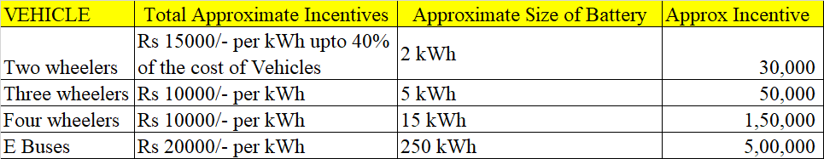

**RESEARCH DESIGN AND METHODOLOGY**

1. Research Type:

The research will employ a quantitative research design to gather numerical data and analyze relationships between variables related to electric vehicle adoption and charging infrastructure perceptions.

2. Sample Size:

The research will target a sample size of 60 respondents. This sample size is chosen based on considerations of feasibility, resources, and the need for statistical significance in the analysis.

3. Sample Area:

The research will focus on two specific geographic areas: the National Capital Region (NCR) and Surat. These areas are selected due to their significance in terms of population density, urbanization, and potential for electric vehicle adoption & Charging station availability.

4. Sampling Technique:

The sampling technique employed will be online survey distribution using Google Forms. Respondents from the NCR and Surat will be invited to participate in the survey through online platforms such as social media, email lists, and community forums. Convenience sampling will be utilized, whereby individuals who have access to the survey link and meet the eligibility criteria (residents of NCR or Surat, interested in electric vehicles) can participate voluntarily. Google Forms allows for easy dissemination of the survey link, collection of responses, and data management, making it a convenient and efficient tool for online survey administration.

5. Data Collection Method and Forms:  
  
Google Forms is chosen as the data collection medium for this research due to its accessibility, ease of use, and ability to efficiently gather responses from a diverse sample population.

The self-administered online survey format allows respondents to provide their input at their convenience, facilitating a larger sample size and reducing potential biases associated with in-person or phone interviews.

6. Data Collection Medium:

Google Forms is selected for its convenience and accessibility, enabling respondents to participate in the survey from any location with internet access.

The questionnaire comprises a mix of closed-ended and multiple-choice questions designed to elicit quantitative data on respondents' demographics, vehicle ownership, familiarity with electric vehicles, perceptions, and purchasing intentions.

The questions are logically sequenced to progress from general inquiries about demographics and current vehicle ownership to more specific inquiries about familiarity with electric vehicles, factors influencing purchasing decisions, and perceptions of government incentives and policies.

Likert scales are employed to measure respondents' familiarity with electric vehicles, perception of EVs, concerns about climate change and air pollution, and likelihood of considering EVs based on the availability of charging infrastructure.

Multiple-choice questions are utilized to gather data on respondents' vehicle ownership status, consideration of purchasing a new vehicle, and awareness of government incentives and policies related to EV adoption.

Open-ended questions allow respondents to provide additional insights and comments regarding the feasibility of achieving zero-carbon emissions through electric vehicles.

Appendix: [A copy of the survey questionnaire will be included here]

7. Sampling design and plan.

The target population for this research includes individuals residing in the designated study area who are of legal driving age and have the potential to purchase or influence the purchase of a vehicle, particularly electric vehicles.

The sampling frame comprises a list of individuals within the target population who can be contacted or accessed for participation in the survey. This may include residents of specific cities or regions, obtained from demographic databases or online platforms.

The sample units used in this study are individual respondents who participate in the survey through Google Forms, providing their opinions and information regarding electric vehicles and their feasibility in achieving zero-carbon emissions.

Convenience Sampling: Respondents are selected based on their accessibility and willingness to participate in the online survey. Recruitment efforts may involve dissemination of the survey link through social media channels, email lists, and community forums.

Snowball Sampling: Participants who complete the survey may be encouraged to share the survey link with their networks, thereby expanding the sample size and diversifying the pool of respondents.

The sample size for this research is determined based on considerations of statistical power, confidence level, and desired precision of estimates. A larger sample size enhances the reliability and generalizability of the findings. However, the exact sample size may vary depending on resource constraints and the targeted population size.

The response rate refers to the proportion of individuals contacted who actively participate in the survey. Efforts will be made to maximize the response rate through clear communication of the survey purpose, incentives for participation, and reminders to non-respondents. The response rate will be monitored and reported to gauge the representativeness of the sample and potential biases.

8. Fieldwork.

The fieldwork for this research involved the dissemination of the survey questionnaire through Google Forms to the target population via online platforms and communication channels.

The survey link was shared through various channels such as social media platforms (e.g., Facebook, Twitter, LinkedIn), email lists, online forums, and community groups relevant to the study area.

Participants were able to access the survey at their convenience from any location with internet connectivity, enabling a wide geographic reach and diverse participant demographics.

Prior to launching the main study, a pretesting phase was conducted to evaluate the effectiveness and clarity of the questionnaire, as well as to identify any potential issues or ambiguities that needed to be addressed.

During the pretesting phase, a small sample of individuals representative of the target population was invited to complete the survey and provide feedback on their experience, comprehension of questions, and overall usability of the questionnaire.

Feedback from the pretest participants was analyzed to identify areas of improvement, such as unclear wording, ambiguous response options, or missing questions that could provide valuable insights.

Based on the feedback received, revisions were made to the questionnaire to enhance clarity, relevance, and usability for the main study.

The pretesting phase helped ensure that the survey instrument was well-designed and effectively captured the intended data, thereby improving the quality and reliability of the data collected during the main study.

Modifications made during the pretesting phase contributed to minimizing respondent confusion, reducing non-response rates, and increasing the overall validity of the research findings.

**literature review**

1. Environmental Sustainability and Climate Change:

Studies on the environmental impacts of transportation, including carbon emissions, air pollution, and their implications for climate change.

Research on the importance of transitioning to low-carbon transportation systems to mitigate the adverse effects of climate change and achieve sustainability goals.

2. Electric Vehicles and Sustainable Mobility:

Scholarly works exploring the potential of electric vehicles as a sustainable alternative to traditional gasoline-powered vehicles.

Research on the technological advancements, market trends, and consumer preferences driving the adoption of electric vehicles.

Studies on the benefits of electric mobility, including reduced greenhouse gas emissions, improved air quality, and energy efficiency.

3. Policy and Regulatory Frameworks:

Literature examining government policies, incentives, and regulations aimed at promoting electric vehicle adoption and supporting the transition to sustainable transportation.

Research on the effectiveness of policy interventions, such as tax incentives, subsidies, and infrastructure investments, in accelerating the deployment of electric vehicles.

4. Challenges and Barriers to Electric Vehicle Adoption:

Studies identifying barriers and challenges hindering the widespread adoption of electric vehicles, including range anxiety, charging infrastructure limitations, and upfront costs.

Research on consumer perceptions, attitudes, and behaviors towards electric vehicles, as well as strategies to overcome barriers and promote EV adoption.

5. Business and Industry Perspectives:

Literature on the role of businesses, industries, and supply chains in driving the transition to electric mobility, including investment trends, technological innovation, and market competition.

Case studies and empirical research examining the business models, strategies, and best practices of companies involved in the electric vehicle ecosystem.

**Hypotheses:**

**Hypothesis 1:** There is a positive correlation between government incentives (such as tax breaks and subsidies) and the adoption rate of electric vehicles.

**Hypothesis 2:** Range anxiety significantly influences consumers' willingness to purchase electric vehicles.

**Hypothesis 3:** The availability of charging infrastructure has a direct impact on the adoption of electric vehicles.

**Hypothesis 4:** The total cost of ownership of electric vehicles is lower than that of traditional gasoline-powered vehicles over the vehicle's lifetime.

**LIMITATIONS**

While this research project aims to provide valuable insights into the feasibility of achieving zero-carbon emissions through the widespread adoption of electric vehicles (EVs), it is important to acknowledge certain limitations that may impact the scope and generalizability of the findings:

**1.** **Sample Size and Scope**: The research relies on a sample size of 60 respondents from the National Capital Region (NCR) and Surat, which may not fully represent the diversity of perspectives and experiences across different regions and demographic groups. As a result, the findings may not be generalizable to broader populations or other geographical areas.

**2**. **Sampling Bias**: The use of a Google Form for data collection may introduce sampling bias, as respondents who have access to the internet and are familiar with online surveys are more likely to participate. This could lead to underrepresentation of certain demographics or viewpoints, potentially skewing the results.

**3.** **Self-Reported Data**: The data collected through the survey questionnaire rely on self-reported responses from participants, which may be subject to recall bias, social desirability bias, or misinterpretation of survey questions. This could affect the accuracy and reliability of the data collected.

4. **Cross-Sectional Design**: The research employs a cross-sectional design, capturing data at a single point in time. As a result, it may not capture changes or trends in attitudes, behaviors, or market dynamics over time, limiting the ability to draw causal inferences or longitudinal conclusions.

**5**. **Data Analysis Methods**: While the research outlines a plan for data analysis, including descriptive statistics and interpretation of findings, the depth and sophistication of the analytical techniques may be constrained by resource limitations or methodological constraints. This could impact the depth of insights generated from the data.

**6**. **External Factors**: The research may be influenced by external factors such as technological advancements, policy changes, market fluctuations, or unforeseen events (e.g., pandemics, economic crises) that could impact the dynamics of EV adoption and charging infrastructure development.

**7**. **Generalization to Other Contexts**: The findings and recommendations of the research may be context-specific to the regions studied (NCR and Surat) and may not be directly applicable to other geographic locations or cultural contexts with different socio-economic, regulatory, or infrastructural conditions.

**DATA ANALYSIS**

**Data Preparation and Processing Procedure:**

* Data preparation involves organizing, cleaning, and transforming raw survey data into a format suitable for analysis. This includes removing any inconsistencies, errors, or missing values in the dataset.
* The data processing procedure begins with importing the survey responses from Google Forms into a spreadsheet software such as Microsoft Excel or Google Sheets. Responses are then coded and categorized based on the variables of interest.
* Data cleaning involves identifying and resolving any problems with the dataset, such as duplicate entries, inconsistent responses, or outliers. Missing values may be imputed or addressed using appropriate techniques.

**Problems Requiring Editing:**

Common problems encountered during data processing may include

* Inconsistent responses: Respondents may provide contradictory or incomplete answers to survey questions, requiring clarification or correction.
* Missing data: Some respondents may skip questions or provide invalid responses, leading to missing values in the dataset.
* Outliers: Extreme or unusual responses that deviate significantly from the rest of the data may need to be identified and addressed.
* Data formatting issues: Variations in formatting, such as different date formats or units of measurement, may require standardization for consistency in analysis.

**Data Analysis and Interpretation, and Discussion of Findings:  
Question 1:-  
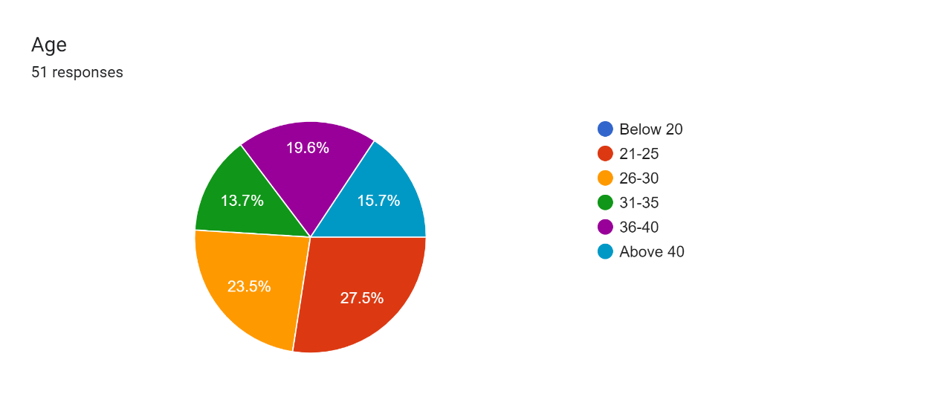**

**Summary of Response**

|  |  |
| --- | --- |
| **Age** | **Response** |
| 21-25 | 14 |
| 26-30 | 12 |
| 36-40 | 10 |
| Above 40 | 8 |
| 31-35 | 7 |

**Data Analysis:-**

To analyze the data according to the response to the question about age, we can use descriptive statistics to understand the distribution of responses:

1. Frequency Distribution:

- The frequency distribution shows the number of respondents in each age category.

- From the provided data:

- Age 21-25: 14 respondents

- Age 26-30: 12 respondents

- Age 31-35: 7 respondents

- Age 36-40: 10 respondents

- Age Above 40: 8 respondents

2. Central Tendency:

- Mean Age: To calculate the mean age, we can assign a midpoint to each age category and calculate the weighted average based on the number of respondents in each category.

- Midpoint of Age 21-25: (21 + 25) / 2 = 23

- Midpoint of Age 26-30: (26 + 30) / 2 = 28

- Midpoint of Age 31-35: (31 + 35) / 2 = 33

- Midpoint of Age 36-40: (36 + 40) / 2 = 38

- Midpoint of Age Above 40: Assume 45 (a midpoint between 41 and 50)

- Weighted Mean Age = ((23 * 14) + (28 * 12) + (33 * 7) + (38 * 10) + (45 * 8)) / (14 + 12 + 7 + 10 + 8)= 31

3. Variability:

- Range: The range can be calculated as the difference between the highest and lowest age categories.

- Range = Highest Age - Lowest Age = 45 - 21 = 24

- Interquartile Range (IQR): The IQR represents the spread of the middle 50% of the data and can be calculated using quartiles.

**Question 2:-**

**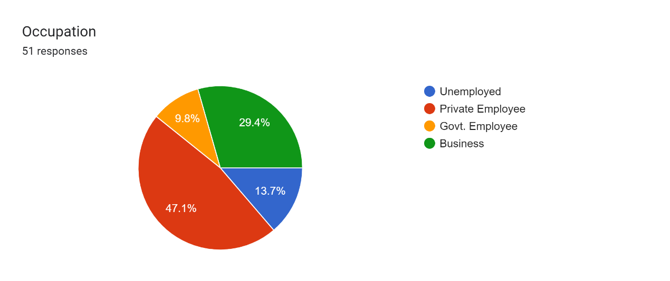  
Summary**

|  |  |
| --- | --- |
| **Occupation** | **Response** |
| Private Employee | 24 |
| Business | 15 |
| Unemployed | 7 |
| Govt. Employee | 5 |

**Data Analysis:-**  
  
Frequency Distribution:

The frequency distribution shows the number of respondents in each occupation category.

From the provided data:

Private Employee: 24 respondents

Business: 15 respondents

Unemployed: 7 respondents

Govt. Employee: 5 respondents

**Question 3:-**  
  
Location

|  |  |
| --- | --- |
| **Location ( City)** | **Response** |
| Delhi | 30 |
| Surat | 21 |

**Data Analysis**To analyze the data according to the response to the question about location (city), we can use descriptive statistics to understand the distribution of responses:

1. Frequency Distribution:

- The frequency distribution shows the number of respondents in each city category.

- From the provided data:

- Delhi: 30 respondents

- Surat: 21 respondents

2. Proportions:

- Proportions can be calculated to determine the relative representation of each city category within the sample.

- Proportion of respondents from Delhi: (30 / 51) * 100% = 60%

- Proportion of respondents from Surat: (21 / 51) * 100% = 40%

By analyzing the data according to the response to the question about location (city), we can gain insights into the geographic distribution of the respondents and understand the representation of different cities within the sample population. This information can help understand regional variations in attitudes towards electric vehicles and perceptions of charging infrastructure, as well as identify any geographic trends or patterns in the data.  
  
**Question 4:-**

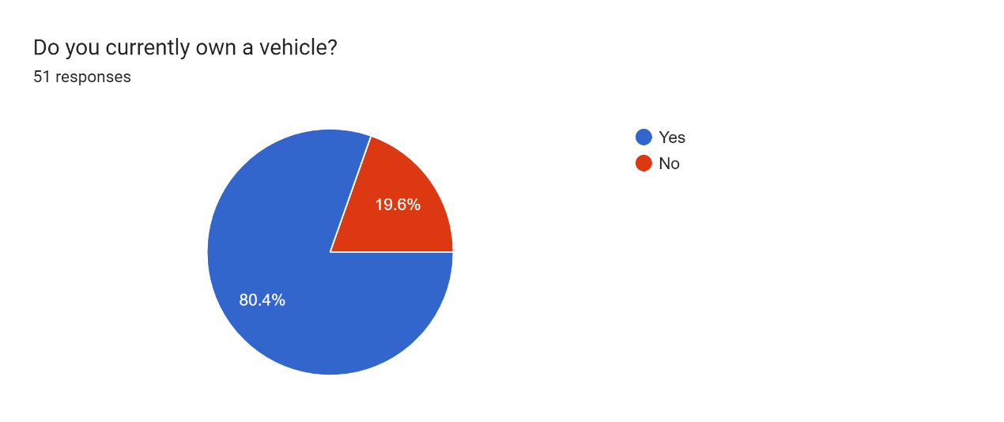

|  |  |
| --- | --- |
| **Currently own a vehicle** | **Response** |
| Yes | 41 |
| No | 10 |

**Data Analysis:-**

By analyzing the data according to the response to whether respondents currently own a vehicle, we can gain insights into the ownership status of the sample population. This information can help understand the prevalence of vehicle ownership among respondents and its potential impact on attitudes toward electric vehicles and perceptions of charging infrastructure**.**

**Question 5:-**

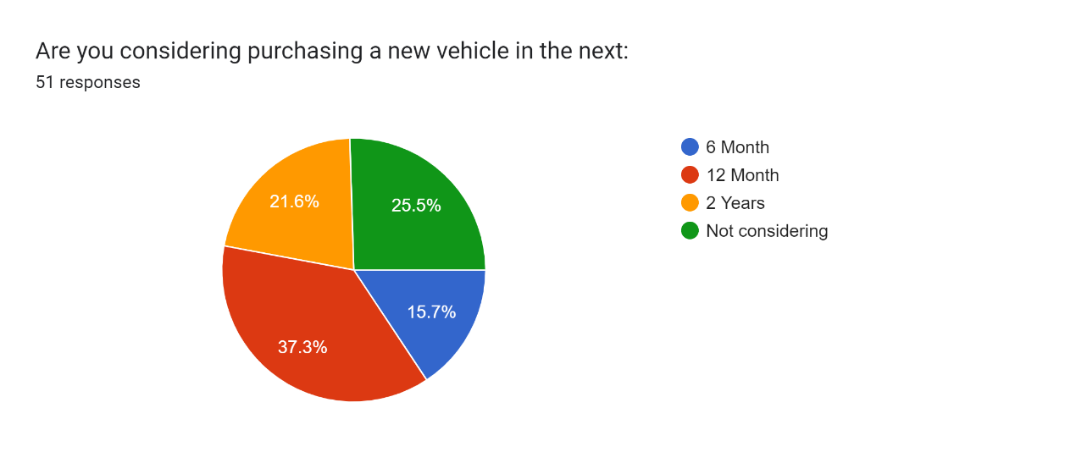

|  |  |
| --- | --- |
| **New vehicle in the next:** | **Response** |
| 12 Month | 19 |
| Not considering | 13 |
| 2 Years | 11 |
| 2 Years | 11 |

**Data Analysis :-**

By analyzing the data according to the response to the question about considering purchasing a new vehicle in the next specified time frames, we can gain insights into the intention of respondents to acquire a new vehicle and the timeframe within which they plan to do so. This information can help in understanding the potential demand for electric vehicles and other types of vehicles in the market within different time frames.

**Question 6 :-**  
  
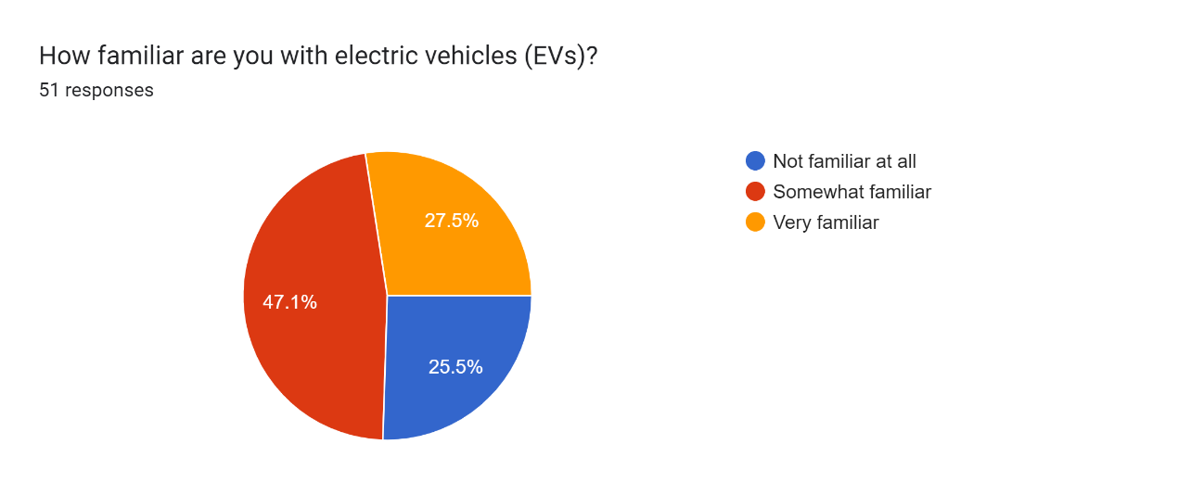

|  |  |
| --- | --- |
| **How familiar for Evs** | **Response** |
| Somewhat familiar | 24 |
| Very familiar | 14 |
| Not familiar at all | 13 |

**Data Analysis:-**

By analyzing the data according to the response to the question about respondents' familiarity with EVs, we can gain insights into the level of awareness and knowledge about electric vehicles within the sample population. This information can help in understanding the current level of consumer awareness and education about EVs and may inform strategies to promote EV adoption and address any knowledge gaps or misconceptions.

**Question 7 :-**  
  
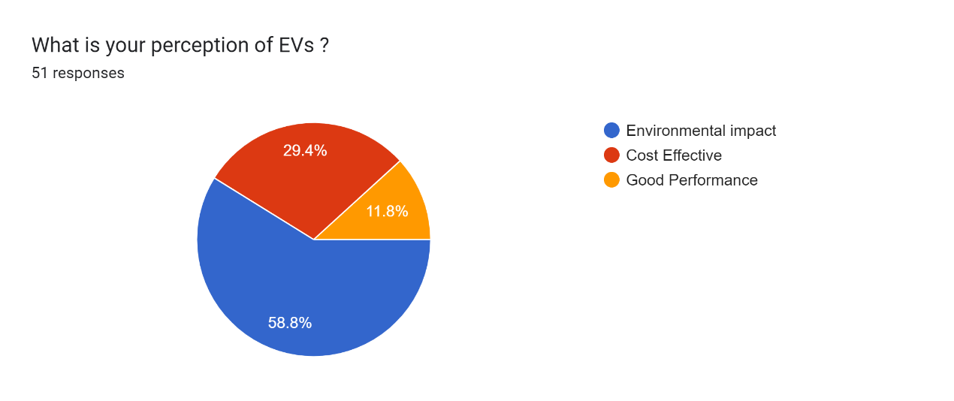

|  |  |
| --- | --- |
| **Perception of EVs** | **Response** |
| Environmental impact | 30 |
| Cost Effective | 15 |
| Good Performance | 6 |

**Data Analysis:-**

By analyzing the data according to the response to the question about respondents' perception of EVs, we can gain insights into the factors driving their attitudes and opinions towards electric vehicles. This information can help in understanding the perceived benefits and challenges associated with EV adoption and may inform strategies to address misconceptions and promote positive perceptions of EVs.  
  
**Question 8:-**  
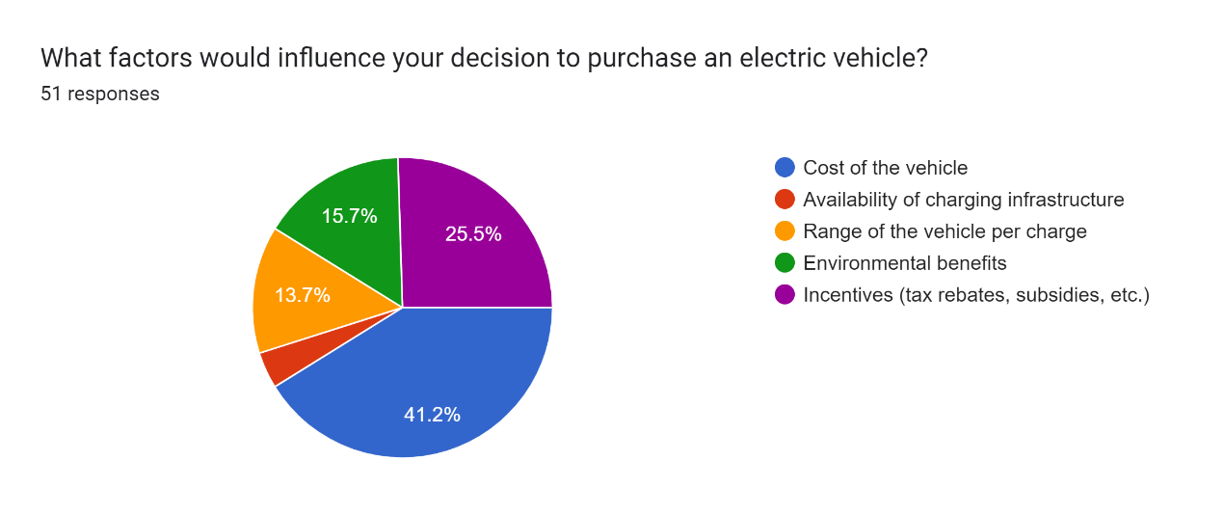

|  |  |
| --- | --- |
| **Factors influence to purchase an EVs** | **Response** |
| Cost of the vehicle | 21 |
| Incentives (tax rebates, subsidies, etc.) | 13 |
| Environmental benefits | 8 |
| Range of the vehicle per charge | 7 |
| Availability of charging infrastructure | 2 |

Data Analysis:-

By analyzing the data related to the factors influencing respondents' decisions to purchase EVs, we can gain insights into the key considerations driving their purchasing behavior. This information can help us understand the factors that are most important to consumers when considering EV adoption and may inform strategies to address barriers and promote EV uptake. Additionally, the lack of charging stations may deter customers from purchasing EVs.

**Question 9:-  
  
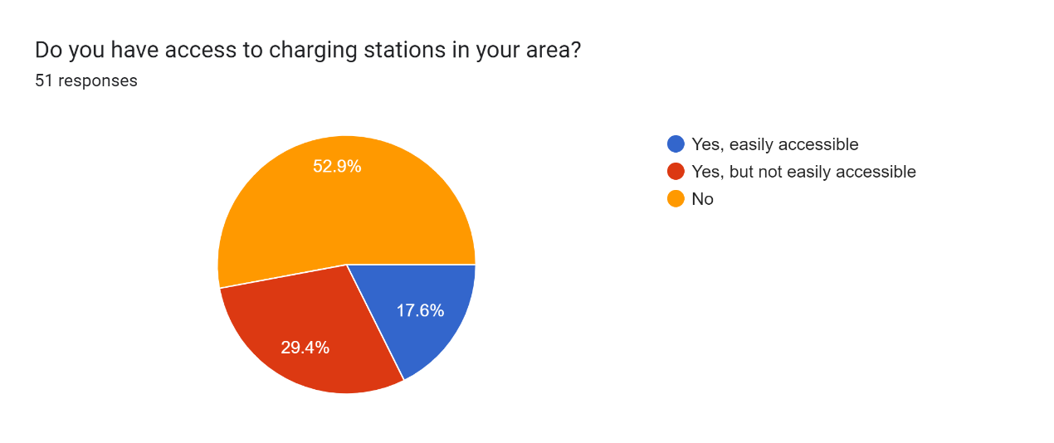**

|  |  |
| --- | --- |
| **Access to charging stations** | **Response** |
| No | 27 |
| Yes, but not easily accessible | 15 |
| Yes, easily accessible | 9 |

**Data Analysis:-**

By analyzing the data according to respondents' access to charging stations, we can gain insights into the availability and accessibility of charging infrastructure. This information can help in understanding the current state of charging infrastructure deployment and identifying areas where improvements are needed to support EV adoption.

**Question 10:-**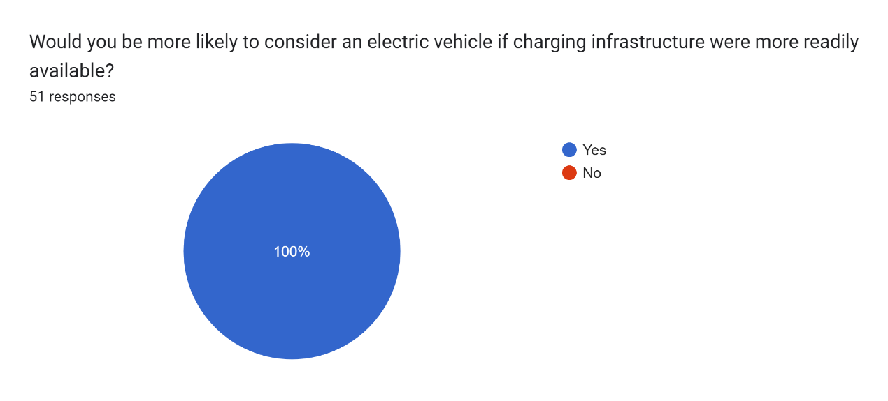

|  |  |
| --- | --- |
| **Consider an electric vehicle if charging infrastructure were more readily available** | **Response** |
| Yes | 51 |

**Data Analysis:-**  
By analyzing the data, we find that a majority of respondents (51 out of the total) would consider purchasing an electric vehicle if charging infrastructure were more readily available. This indicates a potential willingness among respondents to adopt electric vehicles if infrastructure barriers are addressed, highlighting the importance of expanding charging infrastructure to promote EV uptake

**Question 11:-  
  
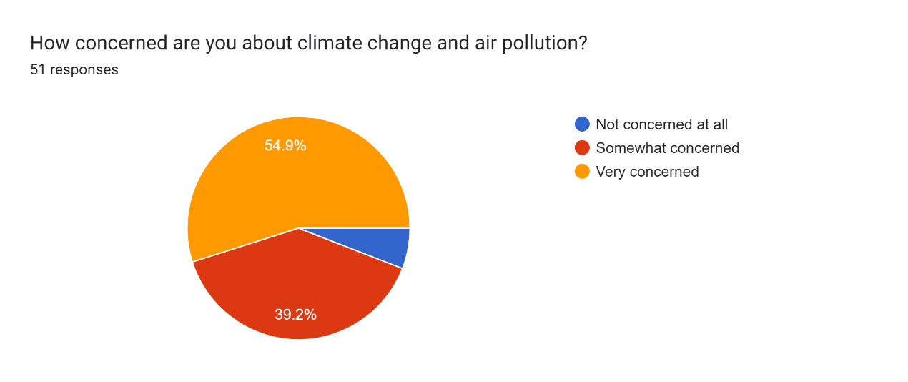**

|  |  |
| --- | --- |
| **Concerned about climate change and air pollution** | **Response** |
| Very concerned | 28 |
| Somewhat concerned | 20 |
| Not concerned at all | 3 |

**Data Analysis:-**

By analyzing the data, we can gain insights into the level of awareness and concern among respondents regarding climate change and air pollution. The majority of respondents seem to express some level of concern, with a significant proportion indicating they are very concerned. This underscores the importance of addressing environmental issues such as air pollution, which can be a motivating factor for the adoption of electric vehicles.

**Question 12:-**

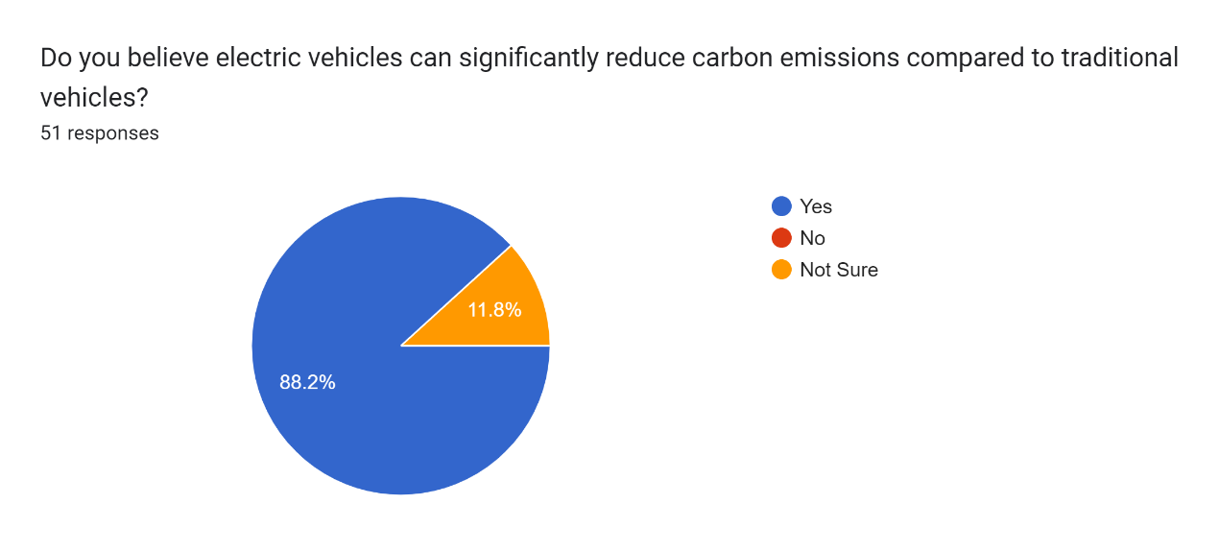

|  |  |
| --- | --- |
| **Electric vehicles can significantly reduce carbon emissions compared to traditional vehicles** | **Response** |
| Yes | 45 |
| Not Sure | 6 |

**Data Analysis:-**

By analyzing the data, we find that a majority of respondents (45 out of the total) believe that electric vehicles can significantly reduce carbon emissions compared to traditional vehicles. This indicates a positive perception among respondents regarding the environmental benefits of electric vehicles, which may influence their attitudes towards EV adoption and support for policies promoting clean transportation.

**Question 13 :-**

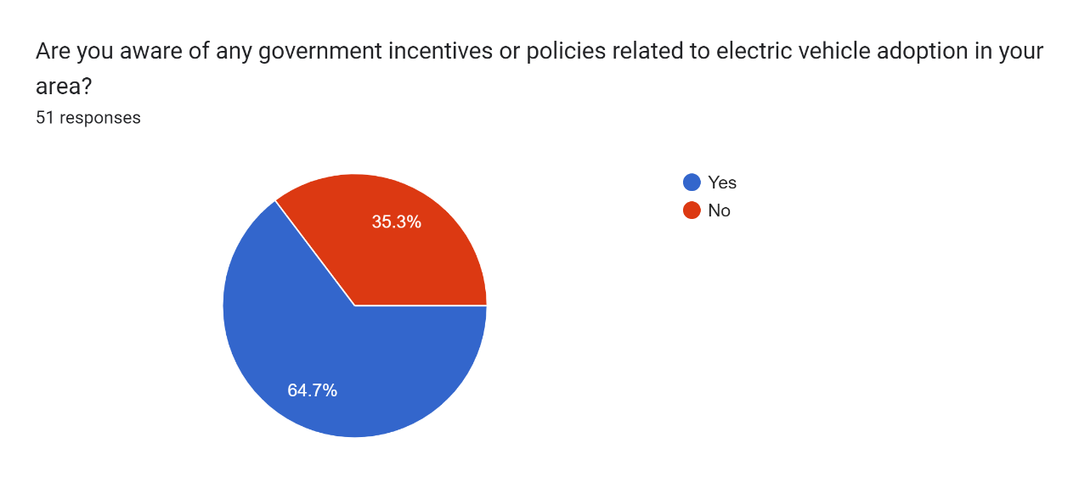

|  |  |
| --- | --- |
| **Aware of any government incentives or policies related to electric vehicle adoption** | **Response** |
| Yes | 33 |
| No | 18 |

**Data Analysis:-**

By analyzing the data, we find that a majority of respondents (33 out of the total) are aware of government incentives or policies related to electric vehicle adoption. This indicates a level of awareness among respondents regarding government initiatives aimed at promoting electric vehicles, which may influence their decision-making process regarding EV adoption.

**Question 14 :-**

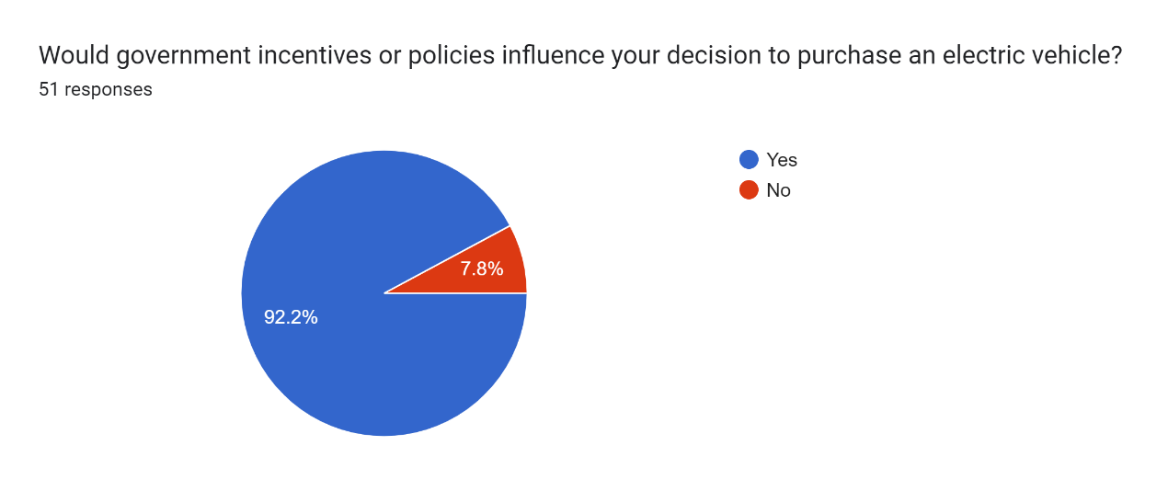

|  |  |
| --- | --- |
| **Government incentives or policies influence your decision to purchase an EVs** | **Response** |
| Yes | 47 |
| No | 4 |

**Data Analysis:-**

By analyzing the data, we find that the majority of respondents (47 out of the total) believe that government incentives or policies influence their decision to purchase an EV. This suggests that respondents perceive government support as a significant factor in their decision-making process regarding EV adoption, highlighting the importance of supportive policies in promoting the uptake of electric vehicles.

**Question 15:-**

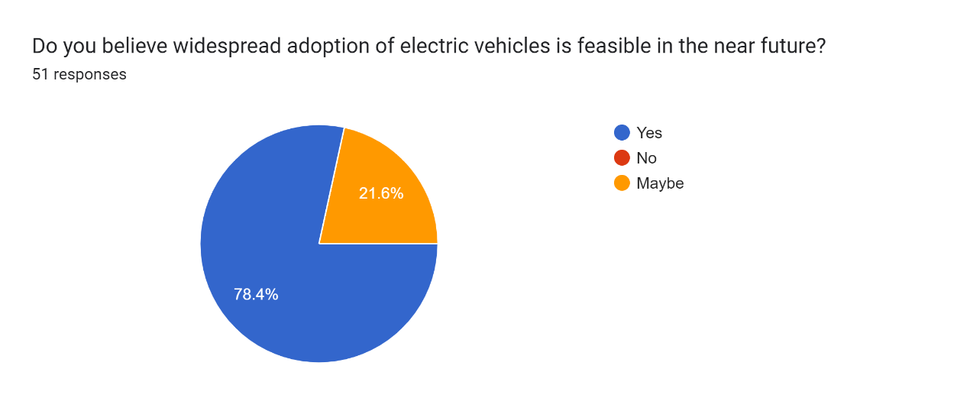

|  |  |
| --- | --- |
| **Widespread adoption of electric vehicles is feasible** | **Response** |
| Yes | 40 |
| Maybe | 11 |

**Data Analysis:-**  
  
By analyzing the data, we find that a majority of respondents (40 out of the total) believe that widespread adoption of electric vehicles is feasible. However, there is a portion of respondents (11 out of the total) who are unsure about the feasibility. This indicates varying perceptions among respondents regarding the potential for widespread adoption of electric vehicles, which may be influenced by factors such as technological advancements, infrastructure development, and government support.

**Question 16:-**

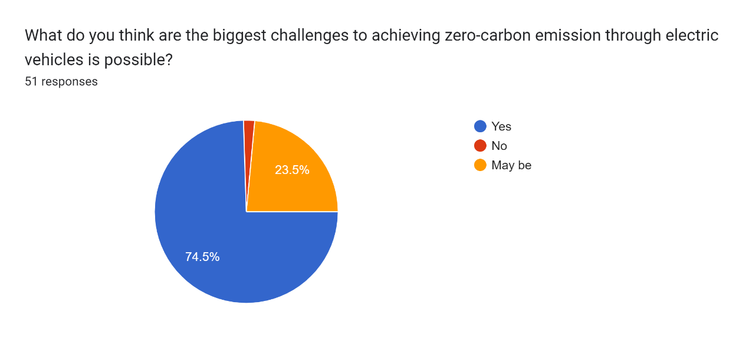

|  |  |
| --- | --- |
| **Biggest challenge to achieving zero-carbon emissions through electric vehicles is possible** | **Response** |
| Yes | 38 |
| May be | 12 |
| No | 1 |

**Data Analysis:-**

By analyzing the data, we find that a majority of respondents (38 out of the total) believe that there are challenges to achieving zero-carbon emissions through electric vehicles. However, there is a portion of respondents (12 out of the total) who are unsure about whether such challenges exist, and only one respondent does not believe there are challenges. This indicates differing perceptions among respondents regarding the obstacles to achieving zero-carbon emissions through electric vehicles, which may reflect varying levels of awareness and understanding of the issues involved.

**CONCLUSIONS AND RECOMMENDATIONS**

* Positive Perception of EVs: The majority of respondents demonstrate a positive perception of electric vehicles, with a significant number acknowledging their potential to reduce carbon emissions compared to traditional vehicles. This suggests a growing awareness and acceptance of EVs as a sustainable transportation option.
* Awareness of Government Incentives: A substantial portion of respondents are aware of government incentives or policies related to electric vehicle adoption, indicating a level of interest and engagement with government initiatives aimed at promoting clean transportation.
* Influence of Government Policies: Many respondents believe that government incentives or policies influence their decision to purchase an electric vehicle, highlighting the importance of supportive policies in driving EV adoption and market growth.
* Perceived Feasibility of Widespread EV Adoption: A significant majority of respondents believe that widespread adoption of electric vehicles is feasible, indicating optimism about the potential for EVs to become mainstream transportation solutions in the future.
* Challenges to Achieving Zero-Carbon Emissions: While most respondents recognize the challenges associated with achieving zero-carbon emissions through electric vehicles, there is some uncertainty among a portion of respondents. This underscores the complexity of transitioning to a zero-emission transportation system and the need for further research and action to address barriers and facilitate the transition.

**Recommendation**

**1.** **Exploring the Economic Viability of Home Charging Stations**: Conduct research to assess the economic feasibility of setting up charging stations at residential properties. This could involve analyzing the potential income generated for homeowners, considering factors such as electricity costs, demand for charging services, and regulatory requirements.

**2.** **Evaluation of Mobile EV Charging Stations**: Investigate the effectiveness and practicality of mobile EV charging stations as a solution to address charging infrastructure limitations. This research could examine factors such as deployment strategies, cost-effectiveness, and scalability of mobile charging services.

**3.** **Assessment of Discounted Charging Station Programs**: Evaluate the impact of providing EV charging stations at discounted rates from the market. This could involve studying consumer behavior and adoption rates in response to pricing incentives, as well as analyzing the financial implications for charging station operators and government stakeholders.

**4.** **Development and Implementation of Charging Station Management Applications**: Research and develop a comprehensive charging station management application that enables users to easily locate, book, and access charging stations. This could involve user interface design, functionality testing, and integration with existing infrastructure.

**5**. **Analysis of Consumer Behavior and Perception**: Conduct surveys or focus groups to understand consumer preferences, attitudes, and barriers related to EV adoption and charging infrastructure. This research could provide valuable insights for policymakers, industry stakeholders, and service providers in developing targeted strategies to promote EV uptake.

**6**. **Investigation of Regulatory and Policy Frameworks**: Examine existing regulations and policies governing EV charging infrastructure deployment and operation. This research could identify regulatory barriers and opportunities for streamlining processes, enhancing investment incentives, and promoting innovation in the EV sector.

7. **Case Studies and Best Practices**: Conduct case studies and analysis of successful EV charging infrastructure projects and initiatives worldwide. This research could highlight best practices, lessons learned, and key success factors for replicating and scaling up effective solutions in different contexts.

**8**. **Integration of Renewable Energy Sources**: Investigate the integration of renewable energy sources, such as solar and wind power, into EV charging infrastructure. This research could explore the feasibility and benefits of utilizing clean energy sources to power charging stations, reducing carbon emissions and enhancing sustainability.

**9.** **Grid Integration and Smart Charging Technologies**: Research smart charging technologies and grid integration solutions to optimize the utilization of electricity resources and manage peak demand. This could involve studying advanced charging algorithms, demand response mechanisms, and vehicle-to-grid (V2G) systems to enhance grid stability and efficiency.

**10. Accessibility and Equity Considerations**: Examine accessibility and equity considerations in EV charging infrastructure planning and deployment. This research could assess disparities in charging infrastructure access among different demographic groups and geographic areas, and propose strategies to ensure equitable distribution and affordability of charging services.

**11. Public-Private Partnerships and Funding Mechanisms**: Explore public-private partnership models and innovative funding mechanisms to finance EV charging infrastructure projects. This research could investigate successful collaboration models, financing options, and investment incentives to attract private sector participation and accelerate infrastructure development.

* Once the charging stations are installed, all of them would be listed on an application from where people could easily track the details of the nearest charging stations. This would result in

A. Saving charging time.

B. Booking the slots in advance.

C. Charging at a lower cost.

D. Help in building a network.

This plan will act as a strong bridge between consumers and charging stations.

By addressing these research areas, stakeholders can gain valuable insights and develop evidence-based strategies to overcome barriers, optimize opportunities, and accelerate the transition to a sustainable, zero-carbon transportation future powered by electric mobility.

# References

International Energy Agency (IEA). (2020). Global EV Outlook 2020: Entering the decade of electric drive? Paris: IEA

European Environment Agency (EEA). (2021). Electric and hybrid vehicles in Europe: Benefits and challenges. Copenhagen: EEA.

International Council on Clean Transportation (ICCT). (2019). Electric vehicles: Driving growth in the auto industry. Washington, DC: ICCT.

United Nations Environment Programme (UNEP). (2020). Emissions Gap Report 2020. Nairobi: UNEP.

National Renewable Energy Laboratory (NREL). (2018). Electric Vehicles Research, Development, and Deployment in the United States: Key Opportunities and Challenges. Golden, CO: NREL.

BloombergNEF. (2021). Electric Vehicle Outlook 2021. New York: BloombergNEF.

Intergovernmental Panel on Climate Change (IPCC). (2018). Special Report on Global Warming of 1.5°C. Geneva: IPCC.

World Economic Forum (WEF). (2019). The Global Risks Report 2019. Geneva: WEF.

National Academies of Sciences, Engineering, and Medicine. (2020). Advancing the Science of Climate Change. Washington, DC: National Academies Press.

**APPENDICES**

**Data Collection Forms:-**

1) Name*



Your answer

2) Age*

Below 20

21-25

26-30

31-35

36-40

Above 40

3) Occupation

Unemployed

Private Employee

Govt. Employee

Business

Other:



4) Location ( City)*



Your answer

5) Do you currently own a vehicle?*

Yes

No

6) If yes, what type of vehicle do you own

gasoline/diesel

Hybrid

electric

7)Are you considering purchasing a new vehicle in the next:*

6 Month

12 Month

2 Years

Not considering

8) How familiar are you with electric vehicles (EVs)?*

Not familiar at all

Somewhat familiar

Very familiar

9) What is your perception of EVs ?*

Environmental impact

Cost Effective

Good Performance

10) What factors would influence your decision to purchase an electric vehicle?*

Cost of the vehicle

Availability of charging infrastructure

Range of the vehicle per charge

Environmental benefits

Incentives (tax rebates, subsidies, etc.)

Other:



11) Do you have access to charging stations in your area?*

Yes, easily accessible

Yes, but not easily accessible

No

12) Would you be more likely to consider an electric vehicle if charging infrastructure were more readily available?*

Yes

No

12) How concerned are you about climate change and air pollution?*

Not concerned at all

Somewhat concerned

Very concerned

13) Do you believe electric vehicles can significantly reduce carbon emissions compared to traditional vehicles?*

Yes

No

Not Sure

14) Are you aware of any government incentives or policies related to electric vehicle adoption in your area?*

Yes

No

15) Would government incentives or policies influence your decision to purchase an electric vehicle?*

Yes

No

16) Do you believe widespread adoption of electric vehicles is feasible in the near future?*

Yes

No

Maybe

17) What do you think are the biggest challenges to achieving zero-carbon emission through electric vehicles is possible?*

Yes

No

May be

18) Is there anything else you would like to add regarding electric vehicles and their feasibility in achieving zero-carbon emissions?