A Short note on “Article Types” for research
A Smitha Kranthi#, Anil Kumar Matta*, Dhanvi Matta*
#Department of BES-I, Koneru Lakshmaiah education foundation, Green fields, Guntur, A.P-522302, India.
asmithakranthi@kluniversity.in
*Data Scientist, NC, NH, Vijayawada, A.P-520011, India.
anilkumarmatta7@gmail.com
*Nalanda Vidyaniketan, Gayatri Nagar, A.P-520010, India.
dhanvi.m@nalanda.edu.in

Abstract—A researcher needs to publish high quality research in their respective subjects. However, a brief introduction on article types helps researcher to get concrete research publications in their respective field. So, this work is intended to give a complete glance on book review, case report, clinical study, commentaries and letters to editors, conference materials, Data notes/ Data article/ Micro article, Letters and Rapid or short reports or short communications, method articles, posters and slides, registered report, research article/ full length article, review article, software tool articles by citing with different examples and communications to journals. The output is shown as journals: materials letters, renewable and sustainable energy reviews, lubrication science, data in brief, which increases the intensity of articles than normalized techniques of approaching journals.

Keywords— Article Types, Article communications, Article submissions, publications.
- Introduction

Articles are the researchers work with a latest literature of past 10 years & times cited [2-8] to have a good impact on the field. Articles deliver a specific research in a field giving a sound knowledge on the respective field. In the final volumes the articles will be read by the readers or scholars. [1] Articles can be proven results, hypothesis, or a scientific theory on a specific topic. These articles will strongly influence the research domain of their field, so we propose a work for the readers to have standard assessment of articles to a particular domain.

- ARTICLE TYPES

A research article is a thesis or a project preferably with technically proven results. For a researcher his or her conceptual data need to be published in a journal before going for a technical presentation. Based on time and depth in studies the data need to be published, when we go for a standard journal the data or project in form of a paper which needs to submitted in an article type. Types of research articles are book review, case report, clinical study, commentaries and letters to editors, conference materials, Data notes/ Data article/ Micro article, Letters and Rapid or short reports or short communications, method articles, posters and slides, registered report, research article/ full length article, review article, software tool articles.

1. Book review:
Many online platforms are giving aid in writing books for them eg. Notion press it gives genre in various aspects like literature friction, true stories, outdoor and nature, travel, music and entertainment and many more.
2. Case report:
This especially patient’s data, we can also analyse this data from getting data from different repositories.
Braking systems from cars [9-12] can also be case reported, some of the online software’s are ‘VBOX Automotive- VBOX Test Suite-[13-21] Brake Test Plugin’ and the software is ‘Products- dSPACE- Brakes Software.
A case report can also be done for wool by collecting online sweater industries repositories data.
A case report is a case study of different temperatures on a disc of a 2 wheeler braking system, where the readings can be optimized for the study to check the exact temperature on the disc rotor for hot spot analysis [22-32].
3. Clinical Study
Clinical study is a report of clinical trial results
4. Commentaries and letters to editors
In depth discussions on a research topic.
5. Conference materials
Materials published in a conference for a scientific record.
6. Data Notes/ Data article/ Micro article
Data from repositories.
Only research output, it can be data, software, videos etc as shown in Fig.4.

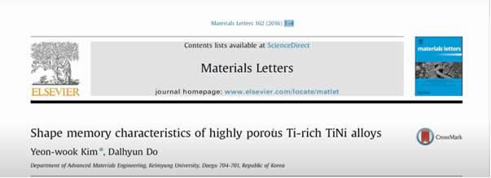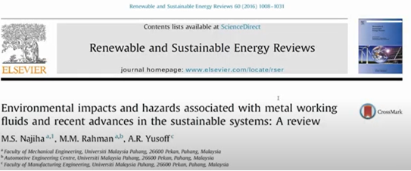

Fig.1. Letters/ Short Communications Fig.2. Review Paper Fig.3. Full Length article
7. Letters & Rapid or short reports or short communications
Editors publishing platform on a curative research topic. Fig.1 shows letters of communication open access journals where a author can publish the data. It Looks like a full length article but researcher wants to tell they are the first one to publish with small references and less pages.
8. Method article
Research procedures with new study methods
9. Posters and slides
These are usually published in a conference, where a full length article is kept in poster form.

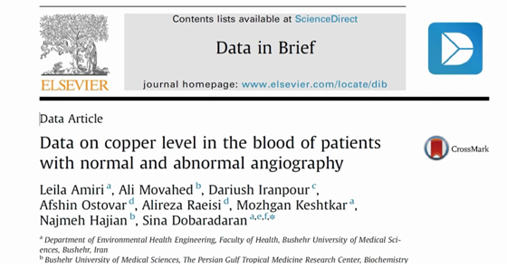

Fig.4: Data Article/ Micro article

10. Registered reports
In a registered reports one is study of data before interpretation and the other is study on results and interpretations.
11. Research article / Full Length article
Studies related to new work also called original work, this article includes complete segments of paper viz abstract, introduction, methodology, results, discussion, conclusion and future scope. A thorough investigation with novelty and experimental results are required as shown in Fig.3.
Complete data introduction, methodology, experimentation, Software analysis [33-43], results and conclusions. Maximum 12 to 15 pages.
12. Review article
This analyzing of existing literature as shown in Fig.2, going through several papers to find the gaps among them and construct a new doctoral problem from many articles, usually after publication of review article it gets many citations. Some of the types of review articles are:
Literature review: presenting the current knowledge.
Systematic review: Use explicit, systematic methods to produce reliable findings via decision making process.
Meta analysis: Obtains results through critical trials.
13. Software Tool articles
This suggests the development of new software tool and the details of code developed and involved in it. Should give the complete details of programming and must be written in open access programming languages. Top 10 programming languages of now 2023 are: [44-51] Python, JavaScript, Golang (GO), Java C#, R, C++, Shift, Kotlin, Ruby. Many online compilers helps us to run different programs.

- DISCUSSION
The article types will influence the decision making of researcher effectively on a research field. The researchers will get rapid awareness on a particular topic where he is approaching. And helps to publish articles faster for a reader in worldwide hub. The complete scenario on article types will make a researcher complete and on go in research in his life time.

- Conclusions

From the article types it is evident & clear that it makes huge impact on all the research fields globally. So this analysis have found that article for scientific progress will pave the way for future advancements in research on all domains of research.
References

Durgesh Kumar tripathi. An introductory overview of new article type “Opinion” in Plant Nano Biology : Plant NanoBiology6(2023)100056.
- KVS Hari Prasad. Scientometric analysis of endocrinology research from India: JSCIRES, 2013.
- Xiaohong He. Self healing concrete: A scientometric analysis based review of the research development and scientific mapping, Case studies in construction materials, 2022.
- Anil Kumar Matta. Top Journals on metals and alloys: Scientometric based review analysis with scientific mapping, Scope, vol 13, issue 1, 2023.
- Anil Kumar Matta. Bibilometric analysis with top cited articles in magnesium alloys/ az91e mg alloy from dimensions, IJSET, 2023.
- Anil Kumar Matta. Theoretical Prediction of 3D Printed accelerator pedal using machine learning regressions, Notion Press, 2023.
- Anil Kumar Matta. Machine learning : Bibilometric analysis for most cited article, vol.4, no.6, pp. 3221-3224, IJRPR, 2023.
- Anil Kumar Matta. Authors research impact on the world: A Bibilometric analysis from wos data, IJPREMS, 2023.

A.K.Matta. Metallic Product Prototyping, testing and web visibility for manufacturers: Reference module in materials science and materials Engineering, Oxford: Elsevier 2018, pp 1-10.
- A.K.Matta. Metal Prototyping the future of Automobile Industry: A review: elseiver, procedia material science, materials today proceedings 5(9),17597-17601,2018.
- A.K.Matta. C based design Methodology and topological change for an Indian Agricultural tractor component: journal of the Institution of Engineers(India): Series A., Springer, vol.04, issue.13, pp.375-378, 2017.
- A.K.Matta. Development and Impact Testing of a pultruded composite material highway guardrail: Research Journal of engineering and Technology,Volume 4, Issue 3 July-Sept, 2013, pp 132-135.
- A.K.Matta. Experimental analysis of Erosive behavior on Al-Sicp based MMC using micro particle (Al₂O₃) as Erodent: IOP Conference Series: Material science and engineering, 455(1), pages 012094, 2017.
- A.K.Matta. Computer-aided Engineering for four wheeler accelerator pedal:IJPAM, vol.18, issue 24, 2018. PP.1-10.
- A.K.Matta. Problems and Challenges in MMC contributing to RP, IJMTST: vol.04, issue 1, 2017.
- A.K.Matta. Modeling of micro turbine for Rapid prototyping : vol.no.2,issue 7,IJMTST, july 2016, pp 19- 22.
- A.K.Matta. Modeling and optimization of Rapid prototyping for an Agricultural Tractor component: Discovery Engineering, 2016. vol.04, issue.13, pp.375-378.
- A.K.Matta. 3D Design support and software compensation for Rapid Virtual prototyping of Tractor Rockshaft arm: Taylor and Francis, CRC PRESS, Balkema publication, 2015, PP.91-94.
- A.K.Matta. Optimization of Brake rotor by using Taguchi method and 3D Finite Elements:IJAER, Volume 10, Number 13, pp 33175-33177 (2015).
- A.K.Matta. Optimization of operation parameters on a Novel internally ventilated cross drilled disc brake by using Taguchi Method : IJESTA,Volume 1, Number 5 (2015), pp. 8-14.
- A.K.Matta. The integration of CAD/CAM and RapidPrototyping in Product Development A review: elseiver, procedia material science pp.3438- 3445,vol.2,2015.
- A.K.Matta. Brake Rotor Design and Finite Element Analysis: IJMER,Volume 4, Number 1 (2014), pp. 29-33.
- A.K.Matta. Construction of a Test Bench for bike rim and Brake Rotor: IOSR Journal of engineering Volume 2, Issue 8 (August 2012), PP 40-44.
- A.K.Matta. Design and Analysis of Steam Turbine Blades using FEM: International Journal of Mechanical Engineering Research,Volume 2, Number 2 (2012), pp. 67-73,2012.
- A.K.Matta. Analysis of Gas Turbine blades with materials N155 and INCONEL 718: International Journal of Advances in Science and Technology, Vol.4,No.1, pp 46-50, 2012.
- A.K.Matta. Convective Heat Transfer Analysis of Gas Turbine Blades Using Finite Element Method: IJMER , Vol1,no.3, pp 391-397 , 2011.
- A.K.Matta. An approach to predict loads on Tractor rockshaft arm: ICAI, Space society of mechanical engineers,Gujarat, 5th to 6thapril, PP.290-293, 2016.
- A.K.Matta. Sparse Social Dimension Based Collective Behavior Learning in Social Networks: Springer, ICCIDM-2014 20-21st Dec 2014.
- A.K.Matta. Analysis of Novel Brake Rotor using FEM: AIMTDR-2014 IIT Guwahati,12-14 ^{th}Dec 2014.
- A.K.Matta. Experimental Heat Transfer And Transient State Stress Analysis Of a Brake Rotor: APM-2013,CIPET,Lucknow,1-3 March 2013,PP 17.10-17.20.
- A.K.Matta. Scallable learning of collective behaviour. 978-3-330-35098-4.
- A.K.Matta. How to develop a component and file a patent. 978-620-2-30228-9. https://www.amazon.com/How-develop-component-file-patent/dp/6202302283, 2017.
- A.K.Matta. Allaying of Tractor Wing. 978-613-8-95950-2. https://www.morebooks.de/store/fr/book/allaying-of-tractor-wing/isbn/978-613-8-95950-2, 2021.
- https://rapid-prototyping-consultancy.business.site
- A.K.Matta. MATLAB to Scallable learning, Notion Press, 2022.
- A.K.Matta. Making of AZ91E series, Notion Press, 2022.
- A.K.Matta. Examination of AZ91E with Ni0.21 Ca0.03, Notion Press, 2022.
- A.K.Matta. AZ91E towards GCI, Notion Press, 2022.
- A.K.Matta. Relevance of AZ series to humanity, Notion Press, 2022.
- A.K.Matta. Modified RS Arm, Indian Patents, 2021.
- Anil Kumar Matta. Recent studies on particulate reinforcement AZ91 Magnesium composites fabricated by stir casting- A Review: JMEE, 2020, pp.115-126.
- A.K Matta. Preparation and toughness studies of Acetol (POM) & PTFE blend: IJMTST, 2016, pp.63-67.
- A.K Matta. Fabrication of six legged robot with crank and slotted lever mechanism using RF communication: IJAER, 2015.
- A.K Matta. Preparation and characterization of biodegradable PLA/PCL polymeric blends: Procedia material science, 2014.
- A.K Matta. The six sigma approach to reduce specific roll consumption in medium merchant and structural mill: IOSRJEN, 2013.
- A.K Matta. Construction of a test bench for bike rim and brake rotor: IOSRJEN, 2012.
- A.K Matta. 3D Design support and software compensation for rapid virtual prototyping of tractor rockshaft arm: ICCASCE, 2015.
- A.K Matta. Construction of a test bench for bike rim and brake rotor: IOSRJEN, 2012.
- A.K Matta. Preparation and characterization of ternary blends composed of polylactide and MWCNT: ICEMAP, 2013.
- A.K Matta. Convective heat transfer analysis of gas turbine blades using fem: ICCMM, 2011.
- M Anil Kumar. T24 Experimental Investigation of Neem Oil as a fuel in CI engine: ACME, 2010.

