Master’s Thesis On

**THE IMPACT OF DIGITAL TRANSFORMATION ON RETAIL AND COMMERCIAL BANKING**

***FOR THE PARTIAL FULFILLMENT OF THE REQUIREMENT***

***FOR THE AWARD OF***

***MASTER OF BUSINESS ADMINISTRATION***

**UNDER THE GUIDANCE OF**

**Prof. Jyoti Nain**

**Submitted By**

**Deep Raj**

**22042010155**

**MBA 2022-2024**

**School of Business**

**Galgotias University**

**May, 2024**

# Abstract

The rapid advancement of digital technologies has revolutionized the banking industry, reshaping the way financial services are delivered and consumed. In an effort to shed light on how technology is transforming financial institutions and their clientele, this study examines how digitization has affected the retail and commercial banking industries. This study aims to analyse the factors driving digitalization in banking, look at the trends in digital channel usage, and assess the effects on business models, customer experience, and operational efficiency.

This study synthesizes existing research and identifies upcoming trends and issues in the digital banking ecosystem through a thorough analysis of the literature. The paper examines the tactics used by banks to use digital technology for client engagement and competitive advantage, based on empirical data and theoretical frameworks. Additionally, it examines how cyber security, regulatory frameworks, and data privacy issues influence banking institutions' digitalization goals.

The research methodology encompasses a mixed-methods approach, combining quantitative analysis of industry data with qualitative insights from interviews and surveys with banking professionals and customers. Through the utilization of sophisticated analytical methods and the triangulation of data sources, the research attempts to offer a comprehensive grasp of the many effects of digitalization on the banking industry.

The study's conclusions add to the corpus of information about the digital transformation of the banking industry and have applications for regulators, legislators, banks, and other stakeholders. This study aims to provide information for strategic decision-making and to encourage educated discussion on the future of banking in a world that is becoming more and more digital by clarifying the benefits and drawbacks of digitalization.

# Chapter 1: Introduction

The Indian banking sector has been steadily attempting to integrate technological advancements into its banking operations in recent years. Indian banks consistently promote information technology investments, such as ATMs,   
internet and mobile banking, computerization of banks, plastic money, call center establishment, etc. Through the use of Electronic Clearing Services (ECS), Electronic Funds Transfer (EFT), Indian Financial Network (INFINET), Real-Time Gross Settlement (RTGS) System, Centralized Funds Management System (CFMS), Negotiated Dealing System (NDS), and other means, RBI has also embraced IT to support the ongoing modernization and functionality of the payment system. India S) Card and the Structured Financial Messaging System (SFM.   
As a result, the Indian banking sector is now more in line with international financial system standards. This explosive The development of information technology has significantly altered how commercial banks carry out their operations. The banks are placing more emphasis on comprehending the factors that lead to success in order to provide superior financial performance in order to survive and adjust to the changing environment. Information technology's effect on an organization's success remains a conundrum.   
Therefore, the current study aims to map the influence of IT on the banking sector's performance for public, private, and foreign sector banks that are scheduled commercial banks operating in India.

# History of Digital Banking

The introduction of ATMs and credit cards in the 1960s marked the beginning of digital banking. Digital networks connected retailers with suppliers and customers as the internet and early broadband emerged in the 1980s, creating a demand for the first online inventory and catalogue software systems. With the advent of the Internet in the 1990s, online banking began to gain traction. Early in the new millennium, advances in e-commerce and broadband infrastructure gave rise to a landscape that mirrored the state of contemporary digital banking. Through the course of the following ten years, the widespread use of smartphones made it possible to conduct transactions outside of ATMs. Nowadays, more than 60% of consumers prefer to use their smartphones for digital banking.

Banks now have the task of facilitating requests that link suppliers with funds via channels chosen by the end-user. Customer relationship management (CRM) software can foster customer satisfaction by leveraging this dynamic. As a result, CRM needs to be incorporated into a digital banking system since it gives banks a way to speak with customers directly. End-to-end consistency and services that prioritize user experience and convenience are in high demand. Cross-platform front ends are offered by the market, allowing consumers to base their purchases on the technology they already own, whether it's a desktop computer at home or a smart television. Banks must continue to concentrate on developing digital technology that offers agility, scalability, and efficiency if they are to satisfy customer demands.

**1994:** Microsoft Money includes built-in online banking. A million households start using the internet to access their bank accounts. Stanford Credit Union paves the way for other credit unions and banks nationwide by starting to provide banking services through their website.

**2001:** Twenty million people use online banking, with eight different US banks reaching a minimum of one million users.

In order to support banks and other financial institutions in their digital transformations, Avoka was founded in 2002.

**2007:** With the release of the iPhone, desktop computers are starting to give way to smartphones for digital banking.

**2009:** saw 54 million Americans sign up for online banking.

**2016:** Millennials are successful in radically changing consumer preferences for online banking.

**2021:** There are presently 47 million online bank customers in India.

# Digital Banking in India: Growth Story

In 1996, ICICI became the pioneer bank in India to provide internet-based banking services. Other banks adopted similar strategies, but in the early years digital   
  
Due to the high cost of internet, banking had a limited reach. The revolution in digital banking began to gather steam as the price of internet began to decline and the range of services available online increased. The majority of banks in the banking sector are public sector institutions, which have only recently begun to provide digital banking services with reluctance. The banks began to view digital banking as an extension of the conventional banking method rather than as a stand-alone service after realizing the costs and revenue potential of the technology. Due to the popularity of digital banking, India's first digital-only bank, called Digi Bank, opened its doors in year 2016. Since then, numerous other digital-only banks have emerged. The amount of data that indicates the growth of digital banking in India of online purchases made throughout the years. As can be seen from Table 1 below, up until the year 2011–12, there was a remarkable increase in both the quantity and number of transactions. The global financial crisis did, however, cause a decrease in transaction value in 2008–2009. The remarkable expansion observed in 2012–13 can be attributed to the incorporation of data that was previously unavailable. The number of digital transactions has consistently increased in the years after 2012–2013.

# Objective of the study

The objectives of this research on "The Impact of Digitalization in Indian Retail and Commercial Banking" are as follows:

* To investigate the integration of digital technology inside the Indian retail and commercial banking sector.
* To identify the newest digitalization trends and assess the ways in which the banking industry is using various technologies.
* - To examine how digital technology affects banking operations' efficacy and efficiency.

# How Banks Function

Banks get revenue from charging you for services rendered and from lending out your money at interest. Banks never stop making loans.   
  
The fees that banks charge are one of their main sources of additional revenue. Every service provided by a bank, including electronic transactions and allowing transfers via the Internet banking system, is charged for.

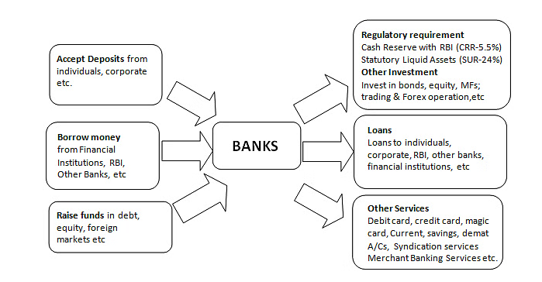

Interest income, which accounts for 75–85% of almost all Indian banks' total revenue, is the primary source of operating income for banks. A bank's sources of income include interest, commissions and exchange fees, income from treasury operations, and other fee-based income from other banking activities. Because banks have been given a special role in the nation's economic development, the Reserve Bank of India (RBI) has mandated that a portion of bank lending go toward the development of the priority sector—the under banked and underprivileged sections. According to current regulations, foreign banks must lend 32% and domestic banks 40% of their net credit to the priority sector.

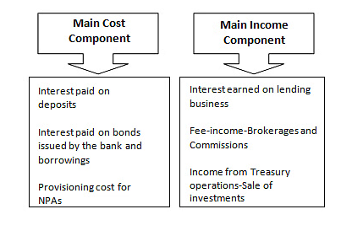

**Types of Businesses of Banks**

Retail banking (services for individual customers), wholesale or corporate banking (services for businesses and institutions), treasury operations (managing a bank's assets and liabilities), and other banking activities are the various categories into which the banking industry can be subdivided.

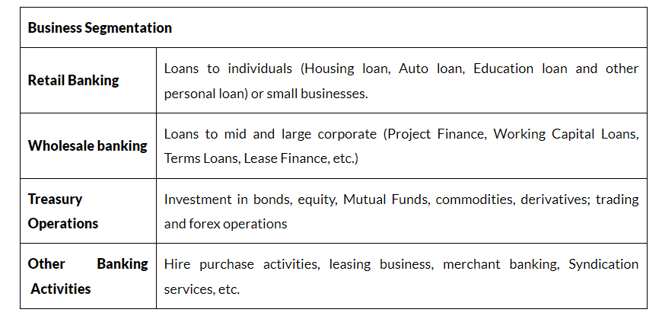

**Retail Banking**

In retail banking, also known as consumer banking, a bank offers services directly to customers rather than through intermediaries like businesses or other financial organizations. Debit and credit cards, home loans, personal loans, savings and checking accounts, and credit cards are examples of these services. In the banking sector, retail banking is regarded as a high-margin enterprise. ICICI Bank leads the Indian banking industry in this regard, with SBI, PNB, and HDFC Bank following closely behind.

Individuals can usually obtain a range of financial products and services from retail banks. Typical goods provided by retail banks include:

* **Savings and current accounts**: These are places where people can keep track of their daily finances, make deposits and withdrawals, and earn interest on savings.
* . **Debit cards:** Cards that can be used to make purchases and take money out of a bank account directly.
* **ATM cards:** These are cards that let people use automated teller machines (ATMs) to get cash out and do other banking operations.
* **Credit cards:** Cards that let customers make purchases using credit and then have the option to gradually repay the amount borrowed.
* **Traveler's checks:** Safe and practical substitutes for cash that tourists can use overseas.
* **Mortgages**: Bank loans used as collateral for properties intended to assist people in buying homes.
* **Home equity loans:** These are loans that let homeowners take out various types of loans against the equity in their houses
* **Personal loans:** Unsecured loans given to people for non-business purposes, like debt consolidation or home renovations.
* **Certificates of deposit**: also known as term deposits, are time deposits that give savers a safe investment option by offering a fixed interest rate if the money is kept in the account for a predetermined amount of time.

# SWOT Analysis of Retail and Commercial Banking

## SWOT Analysis of Retail Banking

**STRENGTH**

* **Diversified asset portfolio**  
  diversified collection of assets Retail banking offers a vast array of financial services and products. These consist of deposit products, mortgages, loans secured by equity shares, auto loans, credit cards, debit cards, and bill payment. Banks that have such diverse asset portfolios see higher profits and comparatively lower non-performing assets.
* **Customer Relationship Management (CRM)**

Relationship Management for Customers (CRM) By using CRM tools to implement customer service and quality, banks can increase customer satisfaction and acceptance of their banking products, both of which will eventually result in financial gain.

* **Continuous Innovative product development**constantly developing novel products The potential for growth and innovation in the financial services industry is virtually limitless. Banks ought to speak with their clients to learn about their financial needs and issues, then design their product and service development plans accordingly.

**WEAKNESS**

* **High capital investment**

Capital expenditures for retail banking are substantial. A significant amount is spent on managing the wide variety of goods and services, which calls for a sizable workforce and top-notch equipment. All of this lowers the bank's profitability overall.

* **Changes in technology**

Bank expansion may be hampered if they are unable to adapt to the newest technological advancements. Additionally, the technology is very capital-intensive, and if it fails, the bank's reputation will suffer and it might lose business.

* **High Cost Marketing**

Strong internal and external marketing strategies must be implemented by banks offering retail banking services. The management of retail banking needs staff members who can properly introduce products to their clients. The merchandise that the staff members are presenting to customers’ needs to be known to them. Banks must also invest a significant amount of money in public product marketing. All of this raises the time and money that banks must spend introducing the product.

**OPPORTUNITIES**

* **Increase in per Capita income**

Growth in per capita income: The per capita income has increased recently and is predicted to continue growing in the coming years. Growth and development in the economy have also raised purchasing power. India's GDP is likewise growing at a very strong rate. It is currently between 8 and 9% and is anticipated to increase soon.

* **Innovation in financial products & services**

Since banks strive to offer their clients an increasing number of products and services in response to their requests, this market offers greater room for innovation. Banks are able to adapt their offerings on a constant basis to meet consumer needs and remain viable in this cutthroat environment.

* **India - Growing Economy**

In an expanding economy such as India's, retail banking presents vast prospects. Among the 30 emerging markets, India was ranked as the "second most attractive retail destination" by global management consulting firm A.T. Kearney.

**THREATS**

* **Large Default in loans repayment(NPA)**

Significant Loan Repayment Default (NPA) Due to increased competition, banks are now offering a wide range of consumer loans—including credit card, auto, and home loans—on favorable terms with little to no investigation. As a result, there are now more cases of loan repayment default. As a result, the bank now has more nonperforming assets (NPA) and bad debts.

* **Customer inconvenience and privacy issues**

One of the main issues from the perspective of the customer is that bank customer service agents call their clients at any time while they are at work to tell them about new goods and services. This could be inconvenient for customers who are busy. Additionally, banks are in charge of disclosing consumer personal information to outside organizations like market research firms**.**

* **Information Technology**

The number of frauds and scams falling under the category of cyber crimes has increased due to the ongoing advancements in technology. There have always been bank attacks by dishonest people. These elements have frequently stolen passwords, credit card numbers, and other private customer information.

.

# Review of literature

This literature review is related to digitalization in the banking sector. In order to serve the purpose, researchers have gone through more research papers to know about the analytical fate scenario.

1. **Ravi Sharma et al.(2021), “Analysis of Consumers Perception Towards Digitalization in Banking Sector With special Reference of ICICI Bank”** As per the understand the psychological behavior of consumers towards digitalization in private sector banks. It was found that From the above Analysis which was made on the basis of dimensions such as tangibility, reliability, Responsiveness, assurance, empathy, accuracy and security at 5% level of significance we conclude that there may be selective perception of consumer towards services provided by private banking sector in reference to ICICI Bank. And the objective, to understand the psychological behavior of consumers towards digitalization in private banking sector in reference to ICICI Bank was fulfilled in a positive manner to further give more wings to Digitalization.
2. **Gourab Das, Nishant Tiwari.(2020), “Impact of Digital Banking in Indian Banking Sector”** As per the to know the concept of digital India and impact of digitalization in banking sector. It was found that that peoples are now taking more and more advantages of the digitalization in case of banking practices. Earlier banks use to focus on pushing the product rather than satisfying customer but in recent times banks are very keen about their customer satisfaction.
3. **Mykhailo Krupka, Nataliya shulga et al.(2021),“The Level of Digital Transformation affecting the competitiveness of banks’’** As per the digitalization level affecting the general competitiveness of banks andits components based on Ukrainian banks. It was concluded that the cluster and regression analysis, it can beconsidered proven that in the digital economy, The influence of Internet banking and mobile bankingtechnologies initiates the transformation of competitive factors found in ensuring the banks’ competitivecapacity through revolutionary changes from a traditional model to an online platform model with a wideoutreach of customers and tools.
4. **Mrs. Manisha Vikas Jagtap.(2019),‘‘The Impact of Digitalization Indian Banking Sector’’** As per the impact of Digitalization in Indian Banking Sector. It was concluded that banking practice use to focus on ‘product push’ (increasing sales target) rather than understanding how best to delight its customers. It is crucial to ensure regulatory compliance for smooth and long term execution. The change to digitalization and the continuity of it should serve to reduce costs for the industry, since this will reduce labor and automate the system.

# Research Methodology

In order to complete this research project, secondary data sources will be used. In order to gather the crucial secondary data required for analysis, the report will conduct a thorough and in-depth examination using data and information gathered from a variety of sources, including academic journals, research papers, reports from the Reserve Bank of India, and other reliable online resources and banking websites. To get relevant findings and insights that will advance a thorough comprehension of the topic, the data will be meticulously examined, evaluated, and interpreted. To ensure that the data we collect is reliable and accurate and that our report is credible and well-informed, our research methodology will be centered around maintaining this quality.

Digital Technology Integration in Indian Retail and Commercial Banking

In recent years, the Indian retail and commercial banking sector has placed a lot of emphasis on the integration of digital technologies. Customers are increasingly turning to online and mobile platforms for their banking needs as a result of the growth of digital banking services. In order to improve customer experience and streamline operations, banks are following this trend and investing in digital technologies like chatbots powered by artificial intelligence (AI), online payment systems, and mobile banking apps.

The integration of digital technology in the Indian retail and commercial banking sector has experienced a notable upsurge in the past few years. Several causes are responsible for this trend, including:

**Growing customer demand for easy and efficient banking services:** As more people look for easy and efficient ways to handle their money, the use of digital banking is growing.

**Banks must maintain their competitiveness:** Banks are using digital technologies to improve their services and hold onto market share in the face of growing competition from fintech firms and other digital players.

**Government initiatives:** By actively promoting digital financial inclusion through programs like Digital India, the Indian government has accelerated the banking industry's embrace of digital technologies.

# Impact of Digital integration

**Better customer experience:** Customers can now bank in a way that is more convenient, effective, and customized thanks to digital technologies.  
  
**Enhanced operational efficiency:** Banks can use digitalization to lower expenses, simplify internal procedures, and boost operational efficiency.   
  
**Financial inclusion:** By giving underbanked and unbanked people access to banking services, digital technologies are significantly contributing to the promotion of financial inclusion.

**Enhanced competition:** As a result of the banking industry's increased competition brought about by the integration of digital technologies, better service offerings and innovation have resulted.

# 

# Data Analysis and Interpretation

**Technological Milestones in Indian Banks**

|  |  |  |  |  |
| --- | --- | --- | --- | --- |
| S.No | 1980 | 1990 | 2010 | 2020 |
| 1 | MICR | ATMs | IMPS | Bio Metrics |
| 2 | Standard cheque | Electronic Funds  Transfer | RTGS | Mobile Banking |
| 3 | Encoders | Branch Connectivity | NEFT | Banking Cheque |
| 4 | - | Computerization | NECS | Truncation UPI |
| 5 | - | - | Online Banking | USSD |
| 6 | - | - | Tele Banking | E-Wallet |

The table gives an overview of significant technological developments that Indian banks have made during the last 40 years, from the 1980s to the 2020s. The table is organized by decade, with each row highlighting a new system or technological advancement that was implemented in that decade. Indian banks most likely made great progress in implementing new systems and technology in the 1980s to enhance their operations and offerings.

1980s   
Indian banks started using automation and mechanization in the 1980s in an effort to increase accuracy and efficiency. Among the crucial technologies were:   
  
By processing checks using MICR (Magnetic Ink Character Recognition) technology: bank and account numbers could be read more quickly and accurately.   
Standard Cheque: By introducing standard checks, banking procedures became more efficient and error rates decreased.   
Encoders: Tools that help with the automated processing of bank documents by encoding information on checks.

1990s  
Indian banks achieved great progress in branch connectivity and electronic banking in the 1990s. This decade witnessed the debut of

**ATMs (Automated Teller Machines):** With the advent of these devices, clients can now take out cash and conduct other financial operations without going to a physical bank location

.**Electronic Funds Transfer (EFT):** With the implementation of EFT, funds could be transferred electronically more quickly and securely.

**Branch Connectivity:** With this, the process of electronically connecting various branches was initiated.

**Computerization:** Banks started putting computers into their operations, which set the stage for later developments in digital solutions.

2010s   
The decade of the 2010s was marked by a significant move toward online and digital banking. During this time, important developments included:  
  
  
2010s   
The decade of the 2010s was marked by a significant move toward online and digital banking. During this time, important developments included

**IMPS:** Instant Payment Service, or IMPS, was a real-time payment system that made it possible to send money instantly between banks.

**RTGS:** An additional real-time payment system for high-value transactions is real-time gross settlement.

**NEFT:** Electronic funds transfers across the country were made possible by the NEFT (National Electronic Funds Transfer) system.

**NECS:** The National Electronic Clearing Service (NECS) is a clearinghouse for electronic payments, including pensions, salaries, and dividends.

**Online Banking:** With the achievement of this milestone, clients could now conduct a variety of financial operations online.

**TELE BANKING:** Customers could now use telebanking to obtain banking services over the phone.

2020s   
Indian banks kept up their digital revolution in the 2020s, emphasizing mobile and biometric technologies. Among the significant turning points are:  
  
**Biometrics:** Encrypting financial transactions using a biometric identity, such as an iris or fingerprint.

**Mobile Banking:** The proliferation of apps for mobile banking that let users access and manage their accounts while on the go.

**Banking Cheque Truncation:** An electronic check processing method that removes the need for a physical check transfer

.   
**UPI:** Instantaneous transfers and integration with a variety of payment apps were made possible by the UPI (Unified Payments Interface) platform, which completely changed digital payments.

**USSD:** Unstructured Supplementary Service Data, or USSD, is a system that enables mobile banking services even in the absence of internet access.

**E-Wallet:** Digital wallets that allow payments and transactions online without requiring hard currency.

**Digital Population in India as of January, 2022**

|  |  |
| --- | --- |
| **Particulars** | **Number of Users (in Million)** |
| **Active internet users** | **825.30** |
| **Active mobile internet users** | **799** |
| **Active social media users** | **467** |

India's digital population as of January 2022 is shown to have a sizable and expanding digital presence. Let's examine and analyze each category's numerical results:   
  
Eighty-five million people in India are considered to be active internet users (825.30 million). This number shows that a sizable portion of the populace has access to and regularly uses the internet. With over 1.4 billion people living in India at the time, this indicates that about 59% of the people there use the internet regularly.

799 million people are classified as active mobile internet users, which is the portion of internet users who mainly use mobile devices, like tablets or smartphones, to access the internet. The number of active mobile internet users is relatively close to the total number of active internet users, suggesting that mobile platforms account for the majority of internet usage in India. This fits with the patterns observed in developing nations where mobile technology is more widely available than computers.

467 million Active Social Media Users: This statistic displays the amount of people who use social media sites like Facebook, Instagram, Twitter, and Whatsapp on a regular basis. Even though there are a lot of people using the internet, only a small percentage of them—roughly 56% of all users or 33% of the population—are active on social media. This might point to a moderate but increasing uptake of social media platforms, or it might point to differences in online behavior between various internet user groups.

|  |  |
| --- | --- |
| **Top 3 devices** | **percentage** |
| mobile phones | 75.91% |
| laptop and desktop | 23..67% |
| tablet | 0.42% |

We can learn more about the main methods that people use to access digital content from the data on the most popular devices in India, expressed as a percentage. Let's dissect each category's interpretation:

**Mobile phones**: With a percentage of 75.91 percent, it is clear that in India, mobile phones are the most widely used device for accessing digital content. Mobile devices are the predominant platform for online activities, as evidenced by the fact that over 75% of digital traffic originates from mobile phones. In emerging markets, where mobile phones are frequently more accessible and affordable than other devices, this is in line with the trend of mobile-first strategies.

**Desktops & Laptops (23.67%):**

Even though they are used far less frequently than mobile phones, laptops and desktop computers nevertheless make up a sizable share of all devices. This shows that traditional computing devices are still relevant at nearly 24%, especially for professional or more complex tasks. Additionally, this percentage shows a wider range of device usage, indicating that some population segments are still dependent on these devices for their digital needs.

**Tablets: (0.42%):**   
The comparatively low percentage for tablets suggests that the digital landscape in India is not very dominated by these devices. With less than 5% of all devices, tablets are probably only utilized by specialized audiences or for particular tasks. This could result from a number of things, such as the price of tablets and their adaptability.

**Growth of Digital payment transactions**

Digital payments have increased significantly in recent years as a result of the Government's and all involved parties' collaborative efforts. Union Minister of State for Finance Dr. Bhagwat Kisanrao Karad provided this information in writing in response to a Rajya Sabha question.

The Minister further stated that at a compound annual growth rate (CAGR) of forty-five percent, the total volume of digital payment transactions increased from 2.071 billion in the fiscal year 2017–18 to 13.462 billion in the fiscal year 2022–23. The total number of digital payment transactions as of December 11, 2023, in the current fiscal year 2023–24, is 11.66 billion.

**Growth of Digital payment transactions during the last six years and current year are as below:**

|  |  |
| --- | --- |
| **Financial Year** | **Volume (in crore)** |
| 2017-18 | 2,071 |
| 2018-19 | 3,134 |
| 2019-20 | 4,572 |
| 2020-21 | 5,554 |
| 2021-22 | 8,839 |
| 2022-23 | 13,462 |
| 2023-24  (Till 11th Dec) | 11,660 |

*Source: Reserve Bank of India (RBI), National Payments Corporation of India (NPCI) & DIGIDHAN Portal*

The growth of digital payment transactions (possibly involving money or transactions) is shown in this table for each fiscal year between 2017–18 and 2023–24, expressed in crores, or ten million. From 2,071 crore in 2017–18 to 11,660 crore on December 11th, 2023–24, the volume increases yearly. The numbers indicate a consistent rise in volume over time. The steadily increasing number of digital payments is indicative of how the world of finance is changing. This upward trajectory indicates a notable shift in payment methods toward digital ones and a growing reliance on technology for financial transactions. Examining the specifics of every fiscal year reveals an engaging story about how digital payment methods have been adopted, customized, and incorporated into everyday life.

**.  UPI journey in India with Year-on-Year growth statistics till Jan 2023**

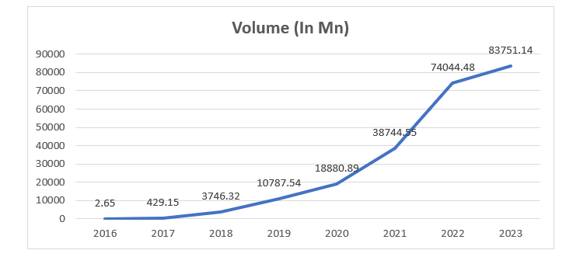

*Source: National Informatics Centre Government department*

The Unified Payments Interface (UPI) has grown significantly in India since the National Payments Corporation of India (NPCI) introduced it in 2016.

The Unified Payments Interface (UPI) processed over 100 million transactions worth INR 67 billion in 2017, representing a Year-on-Year (YoY) growth of 900%. In 2018, the YoY growth decreased to 246%, but over INR 1.5 trillion worth of transactions were processed. 2019 saw a further decline in YoY growth to 67% with transactions exceeding INR 2.9 trillion. With a year-over-year growth of 63% by the end of 2020, UPI processed over INR 4.3 trillion in transactions in December. By June of 2021, there had been over 1.49 billion transactions processed, valued at INR 5.6 trillion, representing a 72% YoY growth. UPI's total transaction value by the end of 2022 was INR 125.95 trillion, a 1.75-fold YoY increase. , and making up almost 86% of India's GDP in the 2022 fiscal year. UPI will have completed 83.75 billion transactions by the end of 2023.

## Growth in Deposits

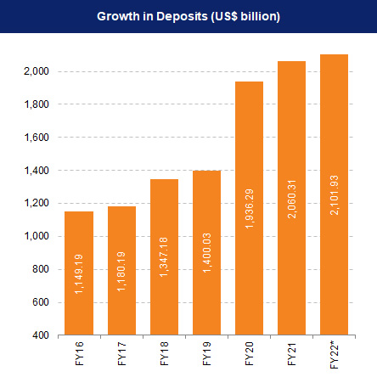

In addition to cooperative credit institutions, the Indian banking system is made up of 12 public sector banks, 22 private sector banks, 46 foreign banks, 56 regional rural banks, 1485 urban cooperative banks, and 96,000 rural cooperative banks. 15,30,287 micro ATMs were operating in India as of October 2023. In addition, there are 93,771 off-site ATMs and Cash Recycling Machines (CRMs) in addition to 1,25,969 on-site ATMs.

Banks installed 2,796 new ATMs in the first four months of the 2023 fiscal year (FY23), more than in the corresponding fiscal years of 2022 (1,486) and 2021 (2,815). In rural India, bank accounts are now opened exclusively online. According to projections made by the Boston Consulting Group (BCG), digital payments will account for 65% of all payments by 2026.

The total assets of the public and private banking sectors as of December 1, 2023, were US$ 1688.15 billion and US$ 1017.26 billion, respectively. 58.32% of all banking assets, including those of public, private, and foreign banks, were held by public sector banks.

As of December 1st, 2023, public sector banks generated US$ 102.51 billion in interest income, or more than 57.48% of the total interest income. The private banking industry made $70.07 billion in interest revenue during that same time period.

Put simply, the Indian digital lending market has grown at an annual rate of about 39.5% during the last ten years. It is anticipated that India's digital consumer lending market will surpass US$ 720 billion by 2030. This sum is expected to represent approximately 55% of the nation's estimated US$ 1.3 trillion digital lending market opportunity. This suggests that lending and borrowing through digital platforms has increased significantly in India.

Put simply, the statement indicates that, as of December 1st, 2023, deposits in Indian banks had increased significantly by Rs. 1.75 lakh crore. This sum of money is substantial.   
  
According to the BCG Banking Sector Roundup Report, bank loan growth will reach 18.1% in the fiscal year 2022–2023. This is noteworthy because the growth rate will be double digits for the first time in eight years.

The report also notes that, in November 2022, loans unrelated to food production increased by 17.6% from the previous year's 7.1%. An increase in loan demand in industries like agriculture, personal finance, services, and manufacturing is the reason for this growth.

# Findings

Retail and commercial banking now function in a totally different way thanks to digital transformation, which has made them more efficient, user-friendly, and customer-focused. These are the main findings or outcomes of this change.

**Key Findings**

**Operational Efficiency and Customer Engagement:**

Banks now operate much more efficiently thanks to automation, a decrease in manual labor, and streamlined processes. This results in a workforce that is more productive, fewer errors, and quicker transaction processing. Banks can serve more customers at once by processing a higher volume of transactions thanks to automation.   
  
**Customer Engagement**: The use of digital innovations in customer service, online banking, and mobile apps has increased customer engagement. Now that they can communicate with their banks from anywhere at any time, customers have a more convenient and adaptable experience. The transition to digital platforms not only improves the client experience but also lessens the need for in-person meetings, which saves banks' operating expenses.

**Evolution of Customer Relationships**: Technological advancements have brought about a significant change in the way customers interact with banks over time. Consumers can now interact with their banks via chatbots, virtual assistants, online banking platforms, and mobile apps. Customer service has improved as a result of this shift, providing more flexibility and individualized experiences.   
  
- Mobile banking apps: With the help of these apps, users can manage their accounts, transfer money, pay their bills, and even apply for loans without having to go to a physical bank branch.  
- Online Support: Clients can now contact virtual assistants, email, and online chat services for help, which decreases wait times and boosts customer satisfaction.

The transition to digital interactions has given banks the opportunity to build closer relationships with their clients, get feedback instantly, and offer specialized services based on each person's tastes and habits.

**Innovation in Banking Business Models:** Novel Banking Business Models   
The drive towards digitalization has compelled banks to reevaluate their methods of operation, leading to innovative approaches to customer service and revenue generation. Here are a few instances of this innovation:  
  
Digital branch stores, or e-branch stores, offer a variety of banking services online without the need for a conventional physical location. These branches can reduce expenses without sacrificing customer accessibility to their services by utilizing technology.   
  
Point-of-sale (POS) terminals are now available from banks to merchants, facilitating quick and easy transactions for both consumers and companies.

The term "virtual banking" describes the practice of accessing and completing transactions through online platforms. Because it enables users to manage their accounts without physically visiting bank branches, this trend is growing in popularity.

Financial institutions can cut expenses related to operating physical branches and sizable workforces by switching to virtual banking. In the end, banks will save money and operate more efficiently as a result of this shift to virtual banking.

.   
  
**FinTech and Tech Organization Convergence:** The combination of financial institutions, FinTech firms, technology companies, and social media platforms has created new opportunities for collaboration and innovation. The outcome of this merger is:

1. New Partnerships: To offer new services and reach a larger audience, banks are collaborating with FinTech and tech companies.   
2. Mergers and Acquisitions: In order to leverage technology and expand their market presence, banks and FinTech companies are teaming up with other tech companies.   
3. Better Customer Experience: By collaborating, banks are able to provide a greater range of services, which eventually improves the general customer experience.

This trend of coming together is leading to new ideas and improvements in the banking industry. Banks are using technology to keep up with their competitors and adapt to the evolving needs of their customers. This shift also promotes a more unified approach to financial services, as banks work together with technology and social media companies to provide customers with smooth and efficient experiences.

**Conclusion**

To sum up, this study explores the significant effects of digitization on the retail and commercial banking industries, concentrating on the Indian setting. The study's conclusions offer important new perspectives on how the banking sector is changing in the digital age.   
The swift advancement of digital technologies has profoundly transformed the banking industry, transforming the manner in which financial services are provided and encountered. This study finds new trends, problems, and difficulties in the digital banking ecosystem by synthesizing the body of previous material. We look at the strategies banks use to use digital technology for competitive advantage and customer engagement, offering theoretical frameworks and empirical data to help us better understand the complex implications of digitalization.  
A thorough examination of the effects of digitalization is made possible by the study methodology, which uses a mixed-methods approach. This study aims to convey a comprehensive knowledge of the complex dynamics at play by combining quantitative analysis of industry data with qualitative observations from surveys and interviews with banking professionals and clients. The conclusions are more valid and reliable when the data sources are triangulated. The study's goals are accomplished by a methodical assessment of the use of technology in Indian retail and commercial banking, a study of current trends in digitalization, and an investigation of how the adoption of digital technology affects banking performance. The analysis clarifies customer happiness, operational effectiveness, and prosperity in terms of finances in the commercial and retail banking domains. The literature study highlights the importance of digitalization in the banking industry by incorporating a range of research publications. The extensive body of knowledge on this topic is enriched by analyses of consumer perceptions, comprehension of the effects of digital banking, and evaluation of the degree of digital transformation on banks' competitiveness.   
The report indicates that digitalization has been positively received and utilized in the Indian banking sector. Customers view digital services positively, and banks are placing a higher priority on client delight than just pushing products. While there are possibilities associated with the shift to digitization, maintaining regulatory compliance is equally essential to a successful and long-lasting implementation.

Conclusively, the research findings offer significant direction to lawmakers, regulators, banks, and other relevant parties in molding strategies, policies, and operations within the dynamic domain of digital banking. This report helps to make educated decisions and promotes a thoughtful conversation about the future of banking in a world that is becoming more and more digital by outlining both the advantages and disadvantages of digitization.

# References

https://pib.gov.in/PressReleasePage.aspx?PRID=19883700

https://www.nic.in/blogs/digital-payments-driving-the-growth-of-digital-economy/#:~:text=According%20to%20a%20report%20by,million%20by%202025%5B3%5D

https://finmodelslab.com/products/commercial-banking-swot-analysis

file:///C:/Users/hp/Downloads/ImpactofDigitalisationonBankPerformanceAStudyofIndianBanks.pdf

https://www.rbi.org.in/Scripts/Statistics.aspx

https://www.rbi.org.in/Scripts/BS_ViewBulletin.aspx

https://unacademy.com/content/bank-exam/study-material/general-awareness/banking-technologies/

Ravi,S.et al.(2021).Analysis of Consumers Perception Towards Digitalization In Banking Sector with

special Reference of ICICI Bank.International Journal of Multidisciplinary Educational Research,10(4)54-61.

Gourab,D.N.(2020).Impact of Digital Banking in Indian Banking Sector.Dogo Rangsang Research

Journal,10(6)165-174.

Mykhai,K.et al.(2021).The Level of Digital Transformation affecting the competitiveness of banks.Business

Perspective,16(1)81-91.

https://www.ibef.org/industry/banking-india.