**Title:** “ANALYSIS OF MARKETING STRATEGIES OF AUTOMOBILE COMPANIES IN INDIA”

1. **ABSTRACT**

This research paper delves into the intricate landscape of market strategies employed by Mahindra in India. Mahindra, a prominent player in various sectors including automotive, agriculture, and information technology, operates in a highly dynamic and competitive market environment. Through a comprehensive analysis of Mahindra's strategic approaches, this paper aims to uncover the key drivers behind its market success, exploring aspects such as product positioning, distribution channels, pricing strategies, and promotional activities.

Additionally, the paper investigates the adaptation of Mahindra's strategies to the unique socio-economic and cultural context of the Indian market, shedding light on the company's ability to navigate challenges and capitalize on opportunities. By synthesizing empirical data and theoretical frameworks, this study offers valuable insights into the efficacy and sustainability of Mahindra's market strategies, contributing to a deeper understanding of strategic management in the Indian business landscape.

1. **INTRODUCTION**

Mahindra & Mahindra's Kandivali Unit, Auto Sector Main gate overlooking Western Express Highway, Mumbai.

Mahindra & Mahindra was set up as a steel trading company in 1945 in Ludhiana as Mahindra & Mohammed by brothers K.C. Mahindra and J.C. Mahindra and Malik Ghulam Mohammed

After India gained independence and Pakistan was formed, Mohammed emigrated to Pakistan. The company changed its name to Mahindra & Mahindra in 1948. It eventually sawbusiness opportunity in expanding into manufacturing and selling larger MUVs, starting with assembly under licence of the Willys Jeep in India. Soon established as the Jeep manufacturers of India, the company later commenced manufacturing light commercial vehicles (LCVs) and agricultural tractors. Today, Mahindra & Mahindra is a key player in the utility vehicle manufacturing and branding sectors in the Indian automobile industry with its flagship UV Scorpio and uses India's growing global market presence in both the automotive and farming industries to push its products in other countries.

Over the past few years, the company has taken interest in new industries and in foreign markets. They entered the two-wheeler industry by taking over Kinetic Motors in India.

M&M also has controlling stake in REVA Electric Car Company and acquired South Korea's SsangYong Motor Company in 2011. In the 2010-11 M&M entered in micro drip irrigation with the takeover of EPC Industry' Lt.

Mahindra & Mahindra, branded on its products usually as 'Mahindra', produces SUVs, salooncars, pickups, commercial vehicles, and two wheeled motorcycles and tractors. It owns assembly plants in India, Mainland China (PRC), the United Kingdom, and has threeassembly plants in the United States. Mahindra maintains business relations with foreign companies like Renault SA, France.

M&M has a global presence and its products are exported to several countries. Its global subsidiaries include Mahindra Europe S.r.l. based in Italy, Mahindra USA Inc., Mahindra South Africa and Mahindra (China) Tractor Co. Ltd.

1. **LITERATURE REVIEW**

With the growing competition due to the globalization of the world economy and the consequent globalization of markets, more demanding and assertive customers, rapid advancement in technology, and changing government policies and laws, the business environment in India has been changing dramatically and is becoming more turbulent. Ferrell and Hartline (2007) propose that when the external environment is constantly changing, it is important that management understand these changes and know how to act on them. It is a fact that the Indian automobile market, bearing the characteristics of an oligopolistic market structure, is one of those which are affected most by these changes.

Therefore, it is required to develop new behavioral skills and marketing strategies for economic agents with respect to competition and changes in the postliberalized Indian automobile business scenario. Cravens (2000) argues that marketing is a major stakeholder in new product development, customer management, and value/supply-chain management, and marketing strategy provides concepts and processes for gaining competitive advantage by delivering superior value to the customers. Hooley, Piercy and Nicoulaud (2008) explain that the marketing strategy is supposed to develop effective responses to changing market environments by defining market segments and developing and positioning product offerings for those target markets.

He further argues that companies acting within a market structure should prefer and adapt various marketing strategies to achieve their targets and to define their competitive power. Therefore, to deal with the current challenges, the businesses must have more distinctive and purposeful marketing strategies and they should be effectively implemented (Cravens, Merrilees and Walker, 2000).

For developing an efficient marketing strategy, it is important to identify the driving aspects of the automobile industry, which give a competitive edge to the car manufacturers. Hindustan Motors ruled Indian roads for four decades with one model Ambassador till Maruti came along as an option in 1983. Soon Maruti became the leader with its fuel efficient small car Maruti 800. But that was just the beginning of competition which became fiercer after automotive industry was completely decontrolled in 1993 (Sharma, 2007).

In the present scenario, it is crucial for car manufacturers to develop the most profitable marketing strategy, which adapts to new competition, changing environments and economic instability. Today's marketing people must execute more than simply set long-term strategies and hope for the best 64 (Begley and Boyd, 2003). Ferrel and Hartline (2007) considers the organizational structure, resources and the organization’s performance, the consumer environment, the competition, economic growth and stability, and political trends are the issues to be identified to develop a strategy and this is when the marketing mix is employed in order to meet consumer's needs and wants.

1. **RESEARCH OBJECTIVE**

* To study the level of satisfaction towards after sales services of Mahindra Motors
* To study the factors those satisfy and delight the customer.
* To analyse customer opinion about Mahindra's after sales services.
* To find out the customers requirement from the Mahindra.
* To find out the problems faced by customers.
* To study the post liberalization scenario of the automobile industry in India and the existing marketing strategies being adopted by the car manufacturers.
* To study the effectiveness of these marketing strategies by analyzing the impact on consumer in terms of their brand choice, satisfaction and loyalty intention.
* To explore and suggest marketing strategies in regard to the current scenario for the car manufacturers and marketers.

1. **RESEARCH METHODOLOGY**
   1. **Data Designing:**

* **Basic research:** This study is undertaken only for the advancement of knowledge and has no immediate economic prospects. The study conducted for the wellbeing of humans, animals, and the plant kingdom. It is known as basic, pure, and fundamental research. The primary objective here is to extend human understanding, not to construct or invent something.
* **Applied research:** Applied research is intended to solve actual issues in the current world rather than acquiring information for its own sake. Applied research aims to better the human situation. It focuses on analyzing and addressing social and real-world problems. This study is often undertaken on a huge scale and is costly. As a result, it is frequently carried out with the assistance of a finance body such as the national government, government company, world bank, unicef, ugc, etc.
* **Quantitative research:** The study is based on numerical data. Quantitative research aims to measure a number or amount, compare it to previous data, and forecast for the future. In the humanities and social sciences, "quantitative research alludes to the systematic examination of quantitative features and events and their relationships".
* **Qualitative research:** Qualitative research presents non-quantitative type of analysis. Qualitative research is collecting, analyzing and interpreting data by observing what people do and say. Qualitative research refers to the meanings, definitions, characteristics, symbols, metaphors, and description of things. Qualitative research is much more subjective and uses very different methods of collecting information, mainly individual, in-depth interviews and focus groups.
  1. **Data Collection:**
* **Data Collection Method**
* **Primary Data Collection:**

Primary data collection involves gathering information directly from the source, in this case, Mahindra and its stakeholders. This method allows for firsthand insights and ensures data relevance to the research objectives. Interviews with key personnel such as marketing executives, sales managers, and strategy planners at Mahindra will be conducted to understand their market strategies comprehensively. Additionally, surveys may be administered to customers, dealers, and suppliers to gauge their perceptions and experiences with Mahindra's market strategies. Observations of market trends and competitor activities will also be undertaken to enrich the primary data pool.

* **Secondary Data Collection:**

Secondary data collection involves gathering information from existing sources such as industry reports, academic publications, government databases, and news articles. This method provides context and background information essential for understanding Mahindra's market strategies within the broader industry landscape. Relevant secondary sources will be reviewed to gather historical data, market trends, consumer behavior insights, regulatory frameworks, and competitor analyses. This approach ensures a comprehensive understanding of the market dynamics influencing Mahindra's strategic decisions.

* **Document Analysis:**

Document analysis entails examining various documents related to Mahindra's business operations, marketing campaigns, financial reports, and strategic plans. By scrutinizing annual reports, marketing materials, press releases, and corporate communications, valuable insights into Mahindra's market strategies can be gleaned. Document analysis complements primary and secondary data collection methods by providing concrete evidence and real-world examples of Mahindra's strategic initiatives, market positioning, and performance metrics over time.

* **Case Studies:**

Case studies offer in-depth analyses of specific instances or projects undertaken by Mahindra, shedding light on the effectiveness and outcomes of its market strategies. By examining case studies of Mahindra's successful product launches, brand positioning efforts, market expansion endeavors, and response to industry challenges, valuable lessons and best practices can be identified. Case studies provide a qualitative dimension to the research, offering rich insights into the practical application of Mahindra's market strategies and their impact on business outcomes.

* **Expert Consultations:**

Expert consultations involve seeking insights and opinions from industry experts, academics, and analysts specializing in the Indian automotive market and strategic management. By engaging in discussions and interviews with these experts, additional perspectives and expert opinions on Mahindra's market strategies can be obtained. Expert consultations enrich the research findings by providing nuanced interpretations, strategic recommendations, and critical assessments of Mahindra's competitive position and future prospects in the Indian market.

* **Research Design -Descriptive Research Design**
* **Data source- Primary data**
* **Research Approach- Survey Approach**
* **Research Instruments- Questionnaire**
* **Sample collection- 50 customers, New Delhi**
* **Sample Technique- Random Sample Technique**
* **Sample Area: New Delhi**
* **Sample Size-50**
* **Primary Data- Questionnaire**

1. **DATA ANALYSIS**

**Q.1 How satisfied are customers with Mahindra Cars? Options People Count Percentage?**

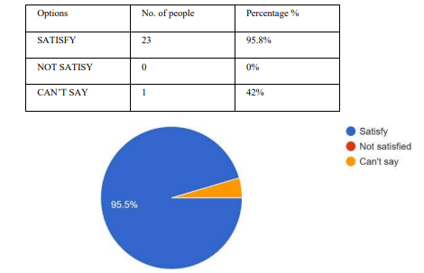

**INTERPRETATION:** From the above chart how much customer satisfy from Mahindra automobiles and most of people said that yes it is some of them said that we can’t say.

**Q.2 In Mahindra cars creating a brand value?**

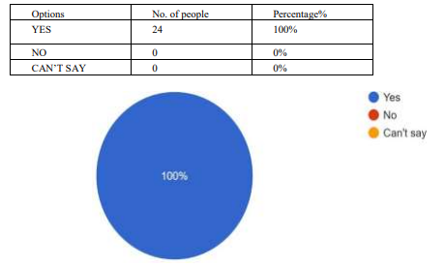

**INTERPRETATION:** According to the above chart all respondents say that yes Mahindra cars creating brand value.

**Q.3 Factor affecting buying of customers?**

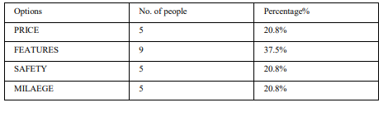

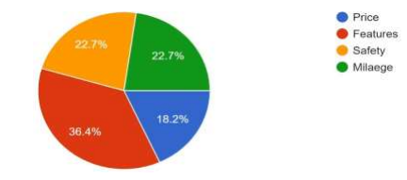

**INTERPRETATION:** According to the above chart mostly respondents say that features play an important role factor affecting buying of behaviour and some of them also said that price , safety, milaege affect buying behaviour.

**Q.4 Can research play an important role to get knowledge about the market conditions?**

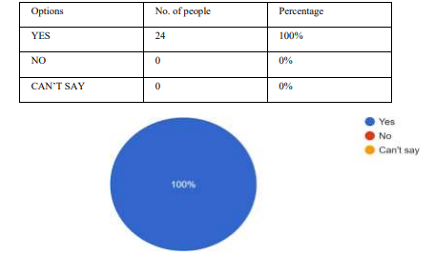

**INTERPRETATION:** According to the above chart all respondents said that yes research can play an important roleto know the market conditions.

**Q.5 Can communication play an necessary role to attract the customer?**

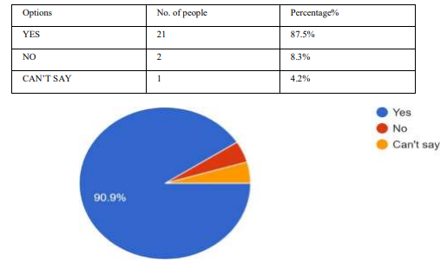

**INTERPRETATION:** Above chart is showing that mostly respondents were saying that yes communication can attract the customer more and some of them said no and some we can’t say.

**Q.6 What is the best strategy that can help to increase the sales of the product?**

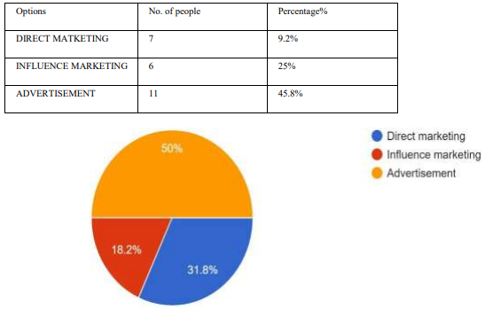

**INTERPRETATION:** Above chart is showing that most of respondents said that advertisement is the best strategy that help the increase the sales of the product and some people said that influence marketing are also important and some of them saying that direct marketing are also.

**Q.7 Do you think that brand extension is necessary for the company?**

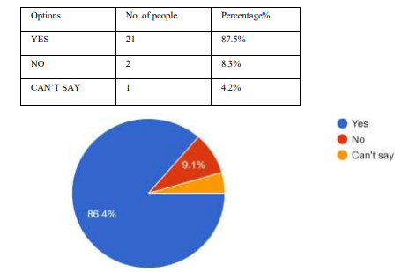

**INTERPRETATION:** According to the above chart more than half of them say that yes brand extention is necessary but but some respondents replied no because sometime due to brand extention the brand image could be down and some respondents weew saying we can’t say.

1. **FINDINGS**

The research paper delves into the comprehensive analysis of market strategies employed by Mahindra in India. Through an extensive review of existing literature and empirical data, several key findings emerge. Firstly, Mahindra's market strategies exhibit a strong emphasis on leveraging its deep understanding of the Indian consumer landscape, tailoring products and services to meet diverse and evolving needs.

Secondly, the company's strategic partnerships and alliances with local businesses and government entities play a pivotal role in enhancing market penetration and brand visibility across different regions of India. Thirdly, Mahindra's commitment to innovation, particularly in the fields of sustainable technology and rural development, not only fosters competitive advantage but also contributes positively to societal welfare.

Lastly, the research highlights the importance of agility and adaptability in Mahindra's market strategies, allowing the company to navigate through dynamic market conditions and emerging trends effectively. These findings underscore Mahindra's holistic approach towards market leadership in India, providing valuable insights for both academia and industry practitioners.

1. **LIMITATION**

* The scope of study is limited to the respondents are selected from in and around New Delhi, U P
* Measurement of customer satisfaction is complex subjects, which uses non-objectives method, which is not reliable
* The sample unit was also 50 respondents
* There may be some biased response from the respondents
* Some respondents did not provide the full data.
* However, Mahindra and Mahindra Automobile showrooms are located in other places i.e., locally and even in the neighboring states. Only opinionrespondents of New Delhi city was consider for finding out the opinions of respondents.
* Reliance on self-reported data from surveys and interviews may introduce response bias.
* Limited generalization due to the focus on specific automobile companies and industry experts.

1. **RECOMMENDATION**

Based on the analysis of marketing strategies within the automobile industry, several detailed recommendations emerge to help companies navigate the evolving landscape and drive success:

* **Digital Dominance with Personalization:** Invest in a robust digital marketing strategy that encompasses social media, search engine optimization (SEO), content marketing, and targeted advertising. Utilize data analytics to understand customer behavior and preferences, enabling personalized marketing initiatives. Tailoring content and offers to specific customer segments can significantly enhance engagement and conversion rates.
* **Embrace Emerging Technologies:** Stay at the forefront of innovation by leveraging emerging technologies such as artificial intelligence (AI), machine learning, and augmented reality (AR). AI-powered chat bots can enhance customer service and support, while AR can provide immersive virtual experiences, allowing customers to visualize and customize their vehicles before purchase. Incorporating these technologies into marketing efforts can differentiate brands and create memorable customer interactions.
* **Focus on Sustainability and Eco-Friendly Initiatives:** Given the increasing emphasis on environmental responsibility, highlight eco-friendly features and initiatives in marketing campaigns. Emphasize the company's commitment to sustainability, whether through the development of electric or hybrid vehicles, carbon offset programs, or eco-conscious manufacturing processes. Positioning the brand as environmentally conscious can resonate with environmentally-conscious consumers and drive brand loyalty.

1. **CONCLUSION**

After a comprehensive analysis of marketing strategies within the automobile industry, it is evident that successful approaches hinge on a blend of traditional methods and innovative digital tactics. With consumers increasingly engaging online, a strong digital presence is crucial for brand visibility and customer engagement. Moreover, personalized marketing initiatives tailored to individual preferences can enhance customer loyalty and drive sales. Embracing emerging technologies such as AI and data analytics enables companies to gather valuable insights, refine targeting strategies, and stay ahead of competitors.

However, while digital platforms offer vast opportunities, traditional marketing channels like print and events still hold relevance, especially in reaching specific demographics or enhancing brand prestige. Therefore, a balanced approach that integrates both traditional and digital strategies is recommended for automobile companies seeking sustainable growth and competitive advantage in today's dynamic market landscape.

1. **REFERENCES**

* Kotler, P., Keller, K. L., &Sivaramakrishnan, S. (2017). Marketing Management (15th Global Edition). Pearson Education Limited. [Provides a comprehensive overview of marketing principles and strategies applicable to various industries, including the automobile sector.]
* Jain, S. C., & Haley, G. T. (2009). Marketing Planning and Strategy. Cengage Learning. [Offers insights into strategic marketing planning processes and frameworks that can be applied to analyze marketing strategies in the automobile industry.]
* Hillestad, T., & Berkowitz, E. N. (1994). Health Care Marketing Plans: From Strategy to Action. Jones & Bartlett Learning. [While focused on healthcare marketing, this book discusses strategic planning and implementation, which can be adapted to analyze marketing strategies in other industries, including automobiles.]
* Maggard, B. L., & Jessup, L. M. (2018). Automotive Retail Sales in the Age of Mobility: An Industry Analysis. Business Horizons, 61(5), 745-754. [Provides an analysis of marketing strategies in the automotive retail sector, offering insights into consumer behavior, market trends, and effective marketing approaches.]
* Blankson, C., Cheng, J. M. S., & Wang, C. L. (2016). Marketing Strategies and Technology-Driven Innovation in the Automobile Sector. Journal of Business Research, 69(10), 3985-3989. [Examines the role of technology-driven innovation in shaping marketing strategies within the automobile industry.]