A NEW INTELLIGENT HOME AUTOMATION WITH INTEGRATION OF SOLAR AND GRID
J.R. Sudharsan¹, S. Balamurugan², K. Lalithaasri³, S. Srisanth⁴, P. Boopathi⁵, P.Manikandan⁶
^{1,2,3,4 &5} B.E. Electrical and Electronics Engineering, Sengunthar Engineering College, Tamilnadu–637205, India.

ABSTRACT

A revolutionary shift in residential energy management and automation, introducing an innovative solution that seamlessly integrates two distinct energy sources: solar and conventional grid (EB) power. By prioritizing solar energy as the primary power supply and utilizing the versatile ESP32 microcontroller for meticulous control, the system ensures a consistent and reliable energy supply. It intelligently switches to grid power when solar resources are scarce, seamlessly reverting back to solar power as soon as it becomes available again. In addition to its dynamic energy management capabilities, the project features an LCD screen that provides homeowners with real-time insights into their energy consumption patterns. This comprehensive overview of usage data from both energy sources empowers users to make informed decisions about their energy usage habits, fostering a more conscious and efficient approach to power consumption. Moreover, the integration of the Blynk 2.0 IoT platform elevates the project by enabling remote monitoring and control of the system. Through this intuitive interface, users can effortlessly manage their energy usage from anywhere using their smartphones or computers, ensuring maximum flexibility and convenience. Going beyond traditional energy management, the project explores home automation with the incorporation of an additional ESP32 microcontroller. This feature-rich functionality enables users to remotely control lighting fixtures, enhance safety measures with gas detection capabilities utilizing MQ2 sensors, and efficiently monitor water levels using ultrasonic sensors, all seamlessly integrated into the IoT ecosystem. This holistic solution not only prioritizes renewable energy sources and automates power source transitions but also leverages the transformative potential of IoT technology to create a sustainable and intelligent approach to energy management. Powered by ESP32 technology, this project serves as a trailblazer for the future of smart, efficient, and eco-friendly homes, setting a new standard for residential energy management and automation.

KeyWords: ESP 32, Solar Panel, Ultrasonic Sensor, Gas Sensor, Voltage Sensor, Current Sensor, Relay, Blynk 2.0.

- INTRODUCTION

This visionary project represents a groundbreaking fusion of advanced technology and sustainable energy practices, ushering in a new era of contemporary living. Anchored by an unwavering commitment to harnessing solar energy, strategically positioned solar panels underscore its dedication to environmental preservation and ecological stewardship. Beyond its environmental benefits, this endeavor promises significant economic advantages, offering substantial cost savings and reducing reliance on conventional energy sources. At the heart of its innovative design lies a sophisticated energy management system, orchestrating the seamless integration of solar power and conventional grid electricity (EB supply) to ensure a reliable energy supply under all circumstances. However, the project's aspirations extend beyond energy management; it boldly ventures into home automation, utilizing state-of-the-art sensors to regulate lighting, monitor gas levels, and optimize water consumption with unparalleled precision. Empowered by the transformative potential of the Internet of Things (IoT), this project provides users with unprecedented control through a user-friendly mobile application interface, enabling individuals to customize and manage their living environment effortlessly. Ultimately, this initiative transcends mere construction, embodying a profound shift towards a more sustainable, intelligent, and harmonious way of life. Here, the convergence of environmental consciousness and technological innovation fosters a new ethos—one where sustainability and technological advancement redefine modern living.

EXISTINGSYSTEM
An innovative ESP32-based system has been ingeniously engineered to revolutionize household device control. This cutting-edge system provides users with unparalleled convenience and flexibility through its dual control methods: manual operation via physical switches and remote management using the Blynk 2.0 mobile application. The physical switches, seamlessly integrated into the system, offer users immediate access to device control. These switches are intelligently wired to relay modules, establishing a direct link to the ESP32. This setup ensures that users can effortlessly toggle devices on or off with a simple flick of a switch. Whether it's turning on the lights or adjusting the thermostat, the physical switches provide an intuitive and responsive interface for users to interact with their household devices. Complementing the manual control option is the advanced remote management functionality enabled by the Blynk 2.0 mobile app. With this powerful application, users gain the ability to oversee and manipulate their devices from anywhere in the world. Through a user-friendly interface accessible via smartphones or tablets, users can remotely monitor device status, adjust settings, and initiate commands with unparalleled ease. Whether they're at home, at work, or on vacation, users remain in complete control of their household devices at all times. The synergy between manual operation via physical switches and remote management through the Blynk 2.0 app represents the pinnacle of convenience and efficiency in home automation. By offering dual control methods, this ESP32-based system caters to the diverse needs and preferences of users, ensuring a seamless and enjoyable experience in managing their household devices. With its innovative features and intuitive interface, this system sets a new standard for smart home technology, empowering users to effortlessly optimize their living spaces for comfort, convenience, and peace of mind. This dual-control feature facilitates convenience and flexibility, enabling users to adapt to different scenarios easily. The ESP32 acts as the intermediary, synchronizing the state of devices between the physical switches and the app, ensuring accurate feedback, and providing notifications when the state changes.

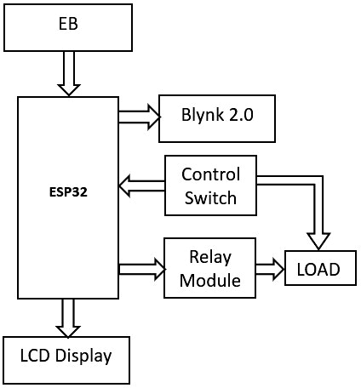

PROPOSEDSYSTEM

This project leverages the potential of solar energy to promote sustainable living while offering advanced home automation capabilities. At its core, it features a sophisticated infrastructure comprising solar panels, charge controllers, inverters, and batteries, meticulously designed to optimize energy efficiency and autonomy. Solar panels, strategically positioned to capture sunlight, serve as the primary energy source. A robust charge controller oversees the influx of solar energy, ensuring efficient battery charging and electricity regulation. Inverters then convert solar energy into a usable form for powering various household appliances and devices. What distinguishes this system is its seamless integration with an ESP32 microcontroller, serving as the central control unit. Continuously monitoring solar energy production, the ESP32 orchestrates dynamic energy management strategies. Surplus energy generated during peak production periods is stored in batteries for later use, ensuring uninterrupted energy supply during periods of low solar output by seamlessly transitioning to grid power. Real-time energy consumption and production data are readily accessible through an LCD screen and the Blynk 2.0 app. This intuitive interface empowers users to monitor energy usage, track solar generation, and make informed decisions to optimize energy efficiency, whether at home or on the go. Furthermore, the system extends its functionality beyond energy management to encompass home automation. With a separate ESP32 microcontroller, users can remotely control lighting, monitor gas and water levels, and access various automation features through the Blynk 2.0 app. This comprehensive solution simplifies daily tasks and enhances overall efficiency and convenience. In essence, this project embodies a holistic approach to modern living, seamlessly integrating renewable energy sources, intelligent energy management, and advanced home automation. By combining sustainability with technological innovation, it paves the way for a greener, smarter future, where energy efficiency and comfort harmoniously coexist.
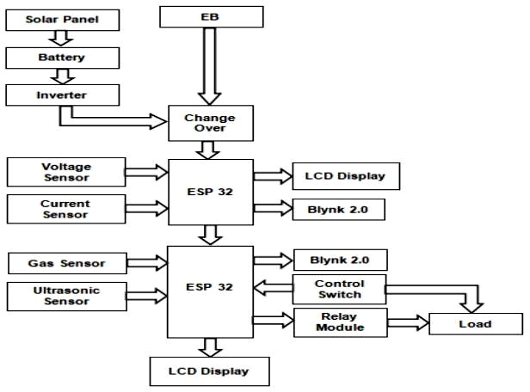

SIMULATION

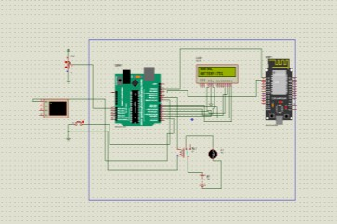
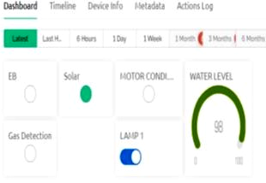
Simulation plays a crucial role in prototyping, testing, and refining systems before their physical implementation. This simulation endeavor embarks on a journey to recreate a virtual environment mirroring the complexities of the real-world system, encompassing circuit design, energy sources, microcontroller programming, and user interface integration. At its core, the simulation involves crafting a detailed circuit layout incorporating ESP32 microcontrollers, sensors, and an LCD display. The ESP32s serve as central controllers, orchestrating the operation of the system. Sens
including those for solar energy monitoring and environmental parameters, provide real-time data crucial for decision- making. The LCD display serves as the user interface, presenting information clearly and concisely. Next, the simulation replicates the energy sources powering the system. Virtual solar panels and grid power sources are meticulously configured to mimic their real-world counterparts. The behavior of these sources is simulated based on parameters such as sunlight intensity and grid availability, ensuring a lifelike representation of energy dynamics. Programming the ESP32 microcontrollers to control energy sources and interface with the LCD display is a critical aspect of the simulation. Through code implementation, the ESP32s autonomously manage energy flow, seamlessly transitioning between solar and grid power as needed. Additionally, communication protocols are established to relay data to the LCD display for real-time visualization. The crowning achievement of the simulation lies in the integration of a virtual Blynk app interface. This interface provides users with remote access to monitor and control the system from anywhere with an internet connection. By emulating the functionality of the Blynk app, users can interact with the simulated system, adjust settings, and visualize energy metrics with ease.
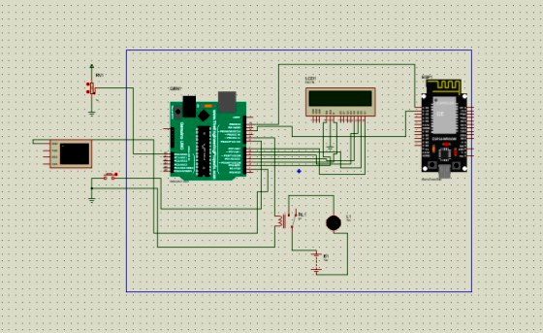

RESULT
This sophisticated system orchestrates a harmonious blend of solar power and grid electricity, ensuring a seamless energy supply through automatic transitions between sources to meet varying demands. Users have instant access to comprehensive energy consumption data displayed effortlessly on an LCD screen. Additionally, the Blynk 2.0 app extends this accessibility remotely, empowering informed decision-making for optimal energy usage. Beyond its energy management prowess, the system enhances the concept of home automation, enabling users to effortlessly control lighting, monitor gas levels, and track water levels with precision, thereby fostering a sustainable and intelligent living environment conducive to modern lifestyles. In the Blynk 2.0 application, a gauge feature accurately measures the water level within the tank, providing users with real-time insights into water storage. Simultaneously, switches are used to remotely control various appliances within the home through the mobile interface. This seamless integration of gauge readings and switch functionality empowers users to monitor and manage their home's water resources efficiently and conveniently from their mobile devices. Whether adjusting appliance settings or monitoring water levels, the Blynk 2.0 platform offers intuitive control and monitoring capabilities, enhancing the overall convenience and efficiency of home management.
5.1 E.B Supply of the Proposed System
In instances where the household relies on conventional grid electricity (EB supply), a prominent indicator within the user interface of the Blynk 2.0 software lights up conspicuously. This illuminated emblem, boldly labeled "EB," acts as an unmistakable beacon, promptly alerting users to the utilization of grid power. The illumination of this "EB" light serves not only as a visual cue but also signifies a seamless integration of transparency and clarity within the energy management system. By providing users with this intuitive and visually engaging feedback mechanism, the system facilitates effortless discernment of the current energy source, empowering individuals to make informed decisions and enhancing overall transparency in their energy management endeavors.

5.2 Solar Supply of the Proposed System
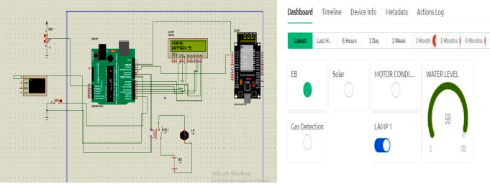
When the residence is powered by solar energy, a distinct indicator labeled "Solar Power" prominently illuminates within the Blynk 2.0 software interface. This radiant beacon serves as an unequivocal symbol, instantly conveying to users that the home is currently drawing its energy from solar panels. This visual cue is not merely informative; it represents a transparent window into the home's energy ecosystem, empowering residents with a deeper understanding of their energy consumption habits and encouraging mindful energy usage. By providing users with this intuitive and visually compelling feedback mechanism, the system promotes a culture of transparency and informed decision-making, ultimately fostering a more sustainable and conscientious approach to energy consumption within the home.

5.3 Gas Detection of the Proposed System

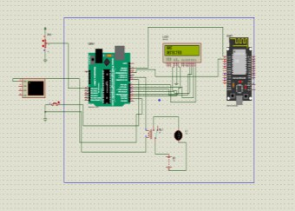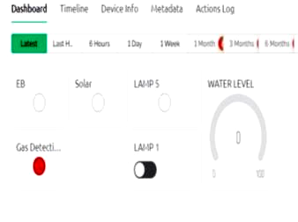

In the event of gas leakage detection within the home, a robust and proactive safety protocol swiftly springs into action, meticulously designed to shield occupants and property from potential harm. With remarkable efficiency, both the conventional grid electricity (EB) and solar power supplies are promptly and automatically deactivated, serving as a preemptive measure to mitigate any potential risks associated with the gas leak. Concurrently, an alert is expediently dispatched to the Blynk 2.0 software interface, where a conspicuous and instantly recognizable notification labeled "Gas Detected" promptly materializes. This immediate and unambiguous indication serves as a beacon of warning, ensuring that users are promptly made aware of the looming hazard. This timely notification empowers occupants to swiftly initiate appropriate response measures, thereby facilitating rapid mitigation efforts to address the threat effectively. Through the seamless integration of real-time monitoring capabilities and responsive control mechanisms, the system places an unwavering emphasis on prioritizing safety above all else. By providing occupants with timely and actionable alerts, the system not only instills a sense of security but also engenders peace of mind, reinforcing its steadfast commitment to furnishing a secure and reliable living environment for homeowners and their families

CONCLUSION
The culmination of this project marks a significant stride forward in revolutionizing energy management practices and advancing sustainable lifestyles. Through the seamless integration of both solar and grid power sources, coupled with the real-time monitoring and control capabilities offered by the innovative Blynk 2.0 application, users are bestowed with unprecedented levels of energy efficiency and convenience. This holistic approach not only empowers individuals to make informed decisions about their energy consumption but also fosters a deeper connection with their environmental impact. Moreover, the inclusion of home automation features, such as precise lighting control, vigilant gas monitoring, and meticulous water level tracking, introduces an additional layer of sophistication to modern living. These intelligent systems not only streamline daily routines but also contribute to a more harmonious and sustainable household environment. In essence, this project serves as a beacon of promise, heralding a future where homes are not merely structures but dynamic ecosystems of energy efficiency, environmental responsibility, and technological connectivity. As society continues to evolve towards a more sustainable ethos, initiatives like this play a pivotal role in shaping a world where every action, no matter how small, contributes to a brighter and more interconnected future for all.

REFERENCES
- M.Khoa, Ngo & V. Dai, Le & Nguyen, An-Toan & Tung, Doan. A New Design of IoT-Based Network Architecture for Monitoring and Controlling Power Consumption in Distribution Grids. International Journal of Renewable Energy Research. 11, 1461-1468, 2021.
- Mishu, M.K. Rokonuzzaman, M.Pasupuleti, J. Shakeri,M. Rahman, K.S. Binzaid, S. Tiong, S.K. Amin, N. An adaptive TE-PV hybrid energy harvesting system for self-powered iot sensor applications. Sensors 2021, 21, 2604.
- Ahmed, Musse & Qays, Md Ohirul & Abu-Siada, A. & Muyeen, S M & Hossain, M.L. CostEffective Design of IoT- BasedSmartHouseholdDistributionSystem.Designs. 5. 55.10.3390/designs5030055,2021.
- Saha,C.R. Huda, M.N. Mumtaz, A. Debnath, A.Thomas,S. Jinks, R. Photovoltaic (PV) and thermo-electric energy harvestersforchargingapplications.MicroElectron. J.2020,96,104685.
- Di Rienzo, M. Rizzo, G. Işilay, Z.M. Lombardi, P.SeisMote A Multi-SensorWireless Platform for Cardiovascular Monitoring in Laboratory, Daily Life, and Telemedicine.Sensors2020,20,680.
- Rokonuzzaman, M. Shakeri, M. Hamid, F.A. Mishu, M.K. Pasupuleti, J. Rahman, K.S. Tiong, S.K. Amin, N. Iot-enabled high efficiency smart solar charge controller with maximum power point tracking-Design, hardware implementation and performance testing Electronic.2020, 9, 1267.
- Qiu, C. Wu, F. Lee, C. Yuce, M.R. Self-powered control interfacebased onGray codewith hybrid triboelectric and photovoltaics energy harvesting for IoT smart home and accesscontrolapplications. NanoEnergy2020,70, 104456.
- Liu,Q.Wang,X.X.Song,W.Z.Qiu,H.J.Zhang,J.Fan,Z.Yu, M. Long, Y.Z. Wireless Single-Electrode Self-Powered Piezoelectric Sensor for Monitoring. ACS Appl. Mater. Interfaces 2020, 12, 8288–8295.
- Samanta, A. Bhattacharjee, M. Pramanik, A. Das, K. D. Bhattacharya, H. Saha, Internet of things based smart energy management in a vanadium redox flow battery storage integrated biosolar microgrid, Journal of Energy Storage, Volume 32, 2020.
[10] Abella, C.S. Bonina, S. Cucuccio, A. D’Angelo, S. Giustolisi,G.Grasso,A.D.Imbruglia,A.Mauro,G.S.Nastasi G.A.M. Palumbo, G. et al. Autonomous Energy-Efficient Wireless Sensor Network Platform for Home/OfficeAutomation.IEEESens.J.2019,19,3501–3512.

