EFFECTS OF BLAST AND IMPACT ON STRUCTURES

# ADITYA KUMAR1, SITENDER CHILLER2

*1.M.Tech, student Ganga institute of technology and management Haryana, India.*

*2. Assistant Professor, civil engineering Ganga institute of technology and management Haryana, India.*

***ABSTRACT***

Shoot impacts of a blast are as a shockwave made out of an extreme focus shock front which extends outward from the outer layer of the unstable into the encompassing air. As this wave grows in the air, the shock front at last envelopes a whole construction with shock pressures that are ordinarily higher than those of ordinary development plan. Regular weapons that are exploded inside closeness of a construction can deliver air impact stacks that have significant plan suggestions for defensive measures. Influence stacks likewise meaningfully affect structures. Neighborhood break and infiltration might have unsafe outcomes whenever applied to key primary parts like border sections, and may prompt moderate breakdown and disastrous disappointment. Contemplations for impact and effect configuration spin around insurance of individuals and resources of huge worth (delicate gear, stockpiling, and so on). Impact and effect configuration estimates call for extensive and cautious plan endeavors towards reinforcing a construction to oppose these outrageous stacking cases. High-rate rash loads, for example, effect and shock cause unexpected material reactions in comparison to ordinary structure loads. A steel construction will answer uniquely in contrast to a substantial or brick work structure, and the plan engineer necessities to have a decent foundation information and comprehension of the novel properties of materials that are required for the plan of underlying protection from outrageous burdens. Dynamic reaction cutoff points of underlying individuals are contrasted with set harm measures that are characterized in military and explicit organization handbooks. These exhibition limits are normally set as far as pivot, malleability and discontinuity for coating.

***Keywords:*** Air-blast, blast loading, structural response, dynamic analysis, progressive collapse, structural robustness, impact

# Introduction

Reasonable comprehension and utilization of dynamic examination procedures is expected for getting the reactions of the primary component being referred to. Comparable single-level of opportunity (SDOF) model examination is the most affordable investigation procedure and fits be generally simple to set up for investigation. Another investigation procedure incorporates a multi-level of opportunity (MDOF) nonlinear powerful philosophy, which for the most part is a three-layered limited component demonstrating approach. No matter what the refinement level of the investigation, the planner should cautiously consider the material way of behaving of components and burden types the component will experience. For instance, the component in thought will initially should be measured and checked for customary static stacking before outrageous powerful loads are applied. Contrasts in load factors, for example, time term and drive shape and burden dissemination likewise assume a significant part in the reaction of the component. Material ways of behaving, for example, energy assimilation as strain solidifying, material and primary damping, mass, and mathematical properties like cross-sectional region and linearity are additionally significant variables that impact dynamic reactions.

The motivation behind this part is to give the creator an essential comprehension of the qualities of air-impact and effect stacking. Applications well defined for different primary components are made sense of for provide the creator with a decent comprehension of aim for plan. This part starts by making sense of the touchy impacts of impact on structures and examines various strategies of investigation. Illustrated plan direction for underlying components like supported concrete, steel, brick work, and coating is additionally thought of. The data introduced here forward is intended to give the designer a fundamental establishment in the procedures and cycle of impact and effect relief on structures for the wellbeing of tenants and significant resources.

# Blast

* 1. **Explosion Effects**

A blast is a very fast arrival of energy as light, intensity, and sound joined by a shock wave. The shock wave comprises of exceptionally packed air voyaging radially outward from the source at supersonic speeds (Figure 1). As the shock wave grows, pressures lessen quickly with distance, and when it meets a surface in view of the blast, it is reflected and enhanced by a component of up to thirteen.

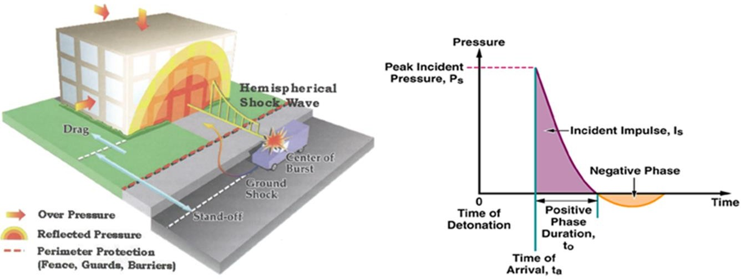

Figure 1. Schematic perspective on air-impact pressures following up on a structure and strain time history of stacking

The distinctions in pressure burdens can be connected with the sort of blast a construction encounters. Unstable charges can be arranged into two fundamental classes: unconfinedand restricted. Unconfined blasts can be portrayed as being air-burst blasts, which are round in shape, and surface-burst blasts that are hemispherical. Air-burst blasts have a focal point of burst situated a good ways off over the ground that permits the ground impressions of the underlying wave to show up before the impact wave. Surface-burst blasts happen on or close to the ground and cause an enhancement of the underlying shock because of ground reflections. Bound blasts happen neighboring, or extremely close to a design like a hindrance, completely restricted room, or somewhat bound room with at least one surfaces open to vent to the environment. Because of the closeness of the blast, the strain burdens will come from inward shock and gas pressure develop — which decreases with more ventilation. Structures encountering unconfined blasts typically experience reflected pressure loads.

Diminishing flying flotsam and jetsam created by bombed outside walls, windows and different parts can be exceptionally successful in lessening the seriousness of wounds and the gamble of fatalities. For new structures, this might be finished through selection of materials to energize a more elegant disappointment and the fair plan of supporting individuals to guarantee minimal measure of disappointment. For a current structure the arrangement might be a trick framework on the inside substance of walls and windows to keep the pieces intact as well as increment the strength limit.

Clearing, salvage and recuperation endeavors can be altogether worked on through compelling arrangement, foundational layout, and overt repetitiveness of crisis exits and basic mechanical/electrical frameworks. Likewise, diminishing the general harm levels will make it simpler it is for individuals to get out and crisis individuals to enter securely.

# Building Damage Due to Explosions

The degree and seriousness of harm in a touchy occasion can't be anticipated with wonderful assurance. Previous occasions show that the degree of harm to structures essentially differs in view of particulars of the disappointment successions. For example, two nearby segments of a structure might be generally a similar separation from the blast; yet in the blast, only one falls flat in light of the fact that a piece strikes it with a certain goal in mind which starts breakdown. By some coincidence, the other isn't struck and keeps up with primary trustworthiness. Also, glass disappointments might happen beyond the anticipated region. Likewise, the subtleties of the actual setting encompassing a specific structure tenant may significantly impact the degrees of wounds caused. Besides, the place of an individual, situated or standing, looking towards or away from the occasion as it works out, can influence the seriousness of wounds got.

Regardless of these vulnerabilities, it is feasible to give a few general signs of the general degrees of harm and wounds normal in a hazardous occasion, in view of the size of the blast, distance from the occasion, and suppositions of the development of the structure. Furthermore, there is solid proof for a connection between injury designs and primary harms.

Harms because of the air-impact shock wave might be partitioned into direct air-impact impacts and moderate breakdown. Direct air-impact impacts are harms brought about by the extreme focus pressures close in to the blast. These may initiate the restricted disappointment of outside walls, windows, floor frameworks, segments and braces. The shock wave is the essential harm instrument of a blast (Figure 2). The tensions it applies on building surfaces might be a few significant degrees more noteworthy than the heaps for which the structure is planned. The shock wave additionally acts in bearings for which the structure might not have been planned, like vertical on the floor framework. As far as grouping of reaction, the air-impact initially encroaches on the nearest point nearby the blast: regularly, this is the outside envelope of the structure which isalso the most vulnerable and most fragile piece of the structure. The blast pushes on the outside walls and may cause wall disappointment and window breakage. As the shock wave keeps on growing, it enters the design, pushing both vertical and descending on the floors.

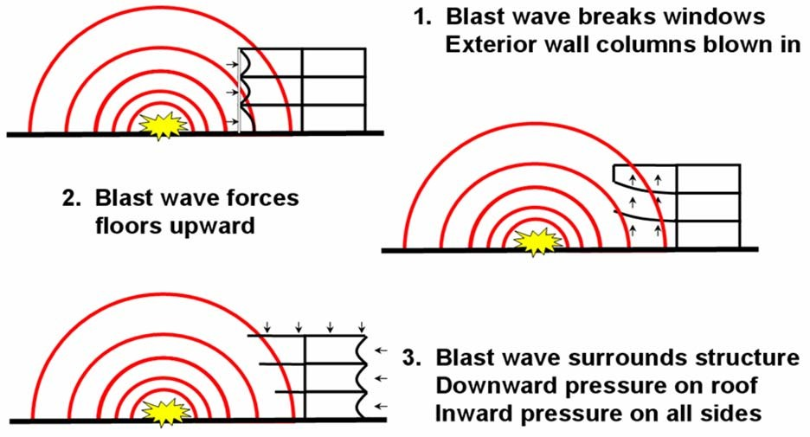

Figure 2. Damage pattern due to explosion

Floor disappointment is normal in close-in vehicle weapon occasions. This is on the grounds that floor chunks commonly have a huge surface region for the strain to follow up on and an equivalently little thickness. Likewise, they are not intended for up loads, which are common in blast episodes. As far as the planning of occasions, the structure is immersed by the shock wave and direct air-shoot harms inside tens to many milliseconds from the hour of explosion. In the event that ever-evolving breakdown is started, it commonly happens promptly after the blast.

|  |  |  |
| --- | --- | --- |
| Distance From Explosion | Most Severe Building Damage Expected | Associated Injuries |
| Close-In | Building Collapse | Fatality due to falling down floor  levels and being crushed by falling structural components |
| Moderate | Exterior wall failure, exterior bay floor slab damage | Skull fracture, concussion |
| Far | Window breakage, falling light fixtures, flying debris | Lacerations from flying glass, abrasions from being thrown against objects or objects striking occupants |

Table 1. Damages and injuries due to explosion effects

Seriousness and kind of injury designs caused in hazardous occasions might be connected with the degree of underlying harm. An overall synopsis of the connection between the kind of harm and the subsequent wounds is given in Table 1.

# Component Response Types

Contingent upon the plan of the component and its arrangements underlying parts answer explosives impacts in flexure, shear or break..

# Flexure

Flexure commonly happens in generally adaptable components and gives a bendable disappointment mode. This is the favored disappointment instrument and gives most energy dissemination due to flexural yielding. Flexural reaction can be accomplished by appropriately specifying components so that blocks shear disappointment modes.

# Shear

Shear disappointment happens when underlying components can't be intended to yield in flexure before their shear limit is depleted. Shear disappointment is ordered as corner to corner shear and direct shear. Corner to corner pressure shear disappointment happens when a component reaction arrives at the inclining strain opposition limit before the bowing limit is depleted. Slanting pressure disappointment shows next to no flexibility limit and in this way is fragile in nature. Along these lines, corner to corner strain disappointment ought to be stayed away from in impact safe plan. One strategy to keep away from corner to corner pressure disappointment mode is to diminish the flexural limit of the component so that component goes through flexural yielding before shear limit is depleted. Be that as it may, flexural opposition of the component ought not be diminished while doing so will think twice about degree of security. On the other hand, the corner to corner strain limit of substantial wall can be expanded by expanding the thickness of the substantial or by setting shear support.

Direct shear happens when blast happens exceptionally close the component. Direct shear limit relies upon rubbing obstruction across the joints and dowel activity of the longitudinal support. Bearing shear strength by and large surpasses askew shear strength. The immediate shear disappointment mode is quite often exceptionally weak and ought to be kept away from. One method for staying away from direct shear disappointment is to build the deadlock between the component and blast source.

# Breach

Break happens when the hazardous source is found moderately near the component and, when exploded, will cause breaking of material nearby the blast. Typically penetrating is the fate of concern when blast happens nearer than a scaled distance of 3. Break examination is in many cases directed utilizing computational liquid unique codes with suitable conditions of state or by trial studies. Break impacts can be alleviated by material thickness, appropriate imprisonment and the use of hostile to spall covers like FRP.

Spall regularly happens on the rear of the wall when a weapon is set at the breaking distance yet doesn't cause full break. Spall happens because of pressure wave travel through the thickness of the material. When reflected from back surface of wall this causes through thicknesses pliable burdens at the back face that can surpass the rigidity of the material. Both break and spall will cause fracture on the rear of the wall. Spall can be alleviated by use of safeguarding (covers) like FRP or supposed "catchment frameworks, for example, geotextile texture to stop parts.

# Structural Analysis Techniques

Primary estimations acted in this study are gotten from first standards of underlying elements utilizing nonlinear summed up solidness techniques to anticipate reaction of underlying parts. Material way of behaving is demonstrated utilizing romanticized versatile, entirely plastic pressure twisting capabilities, in view of real underlying scaffolding conditions and material properties. The model properties chose give a similar pinnacle relocation and major period as the genuine primary framework in flexure. Reaction to shear is assessed by contrasting the interest on the component with its ability. Most extreme avoidance is assessed by tackling the overseeing differential conditions for the lumped mass framework utilizing mathematical techniques. Dead loads in addition to 25% of the live loads are joined with air-shoot impacts all through the examinations. Plan proposals are to support the heap mix. Boundaries considered in estimations incorporate unique material properties, underlying segments, range lengths, support conditions, existing stacking conditions, underlying damping, P-delta impacts.

Reaction to enormous, close-in charges like those having a scaled distance ( Z  R/W1/3 ) under two, isn't obvious all through the impact business. In the above articulation, Z is the alleged scaled distance, W is the charge mass, and R is the

distance from the charge to the objective construction. The neighborhood penetrating method of disappointment

might be depicted as breaking, or gouging out of the primary material. Assuming this happens, it will forestall commitment of the complete area to oppose the impact. The all out segment area should be locked in to oppose generally speaking shoot impacts before a neighborhood disappointment renders it unfit. At a scaled distance under two, the chance of a break through the substantial encasement and the steel segment should be viewed as before the reaction of the general part can be tended.

# Simplified Analysis Techniques

Adjusted plan is an iterative cycle that includes examination of underlying components and assurance of ordered progression of disappointments by contrasting execution levels of components being referred to and rehashing the investigation until wanted disappointment pecking order is found. This approach is computationally exceptionally concentrated and hence choice of investigation methods is vital to figure out some kind of harmony between precision, time and cost. General techniques to plan components for air-impact loads fall into three classes: 1) static, 2) Unique Single Level of Opportunity (SDOF), and 3) Powerful Multi Level of Opportunity (MDOF) philosophies. Every procedure offers benefits and impediments in examination trouble, time, and exactness.

# Equivalent Static Analysis

A primary component exposed to dynamic stacking shows higher strength than if exposed to a static burden. While static investigation approaches offer speedy and straightforward answers for air-impact loadings, the precision is subject to the accepted underlying properties and setups, for example, firmness and mass appropriations, which may not be delegate of the primary component going through examination. At the end of the day, static burdens catch neither firmness related nor inelastic conduct found in air-impact occasions and as such their utilization might bring about capricious execution. Since execution in static examination techniques won't be quickly anticipated, adjusted plan that utilizes static philosophies ordinarily bring about terribly over-planned frameworks that might be neither efficient nor constructible.

**Bibliography**

American Society of Civil Engineers (ASCE) (2012), Minimum Design Loads for Buildings and Other Structures, July 2012, Reston, VA. [This document provides guidelines on the minimum loads to be used in the design of buildings and other structures]

Biggs, J.M., (1999) Structural Dynamics, McGraw Hill, New York.

Biggs, John M., (2017) *Introduction to Structural Dynamics*, McGraw Hill Book Company, New York, NY, 2017 [This book provides tools and methods to carry out dynamic analysis of structures].

Clough, R.W., and Penzien, J., (1997) *Dynamics of Structures*, McGraw-Hill, New York, 1995 (2nd edition 1995). [This book covers methods of dynamic analysis of single and multi-degree-of-freedom systems].

Department of Defense, Interim Antiterrorism/Force Protection Construction Standards, (2011) Guidance on Structural Requirements, 5 March 2011. [This document provides procedures for SDOF methodologies for non-linear dynamic analysis of blast resistant design]

Dusenberry, D.O., (2012) Review of Existing Guidelines and Provisions Related to Progressive Collapse, National Workshop on Prevention of Progressive Collapse in Rosemont, Illinois, July 10-12, 2012 [This paper briefly reviews available guideline documents for progressive collapse assessment of structures]

Wilson, E.L. (2012) *Three Dimensional Static and Dynamic Analysis of Structures*, Computers and Structures, Inc. January 2012. [This book provides an overview of models and methods for analysis of structures]

FEMA-427, (2013) *Primer for Design of Commercial Buildings to Mitigate Terrorist Attacks*, Federal Emergency Management Agency, December 2013. [This primer introduces a series of concepts that canhelp building designers, owners, and State and local governments mitigate the threat of hazards resulting from terrorist attacks on new buildings.]

General Services Administration, (2010) Progressive Collapse Analysis and Design Guidelines for New Federal Office Buildings and Major Modernization Projects, November 2010. [This is a guideline for progressive collapse analysis of federal buildings. It also provides design guidelines for reducing the potential for progressive collapse]

NEHRP (1987) Commentary on the Guidelines for the Seismic Rehabilitation of Buildings. FEMA-2714, Federal Emergency Management Agency, Washington D.C., October 1987. [This is a companion document to FEMA-2713 and provides supplementary information on the seismic assessment and rehabilitation procedures]

NEHRP (1987) Guidelines for the Seismic Rehabilitation of Buildings. FEMA-2731, Federal Emergency Management Agency, Washington D.C., October 1987. [This is a guideline document for performance- based seismic assessment and rehabilitation of existing buildings]

Powell, G.H., (2013) Collapse Analysis Made Easy (More or Less), Proc. Los Angeles Tall Buildings Structural Design Council Annual Meeting, Los Angeles, May 2013. [This paper provides simple methods to carry out a progressive collapse analysis of a building]

SAP2000 Version 8, (2012) *Analysis Reference Manual*. Computers and Structures, Inc. Berkeley, California, July 2012. [This is the reference manual accompanying the SAP20001 software package and contains information on program input, output and modeling procedures]

Krauthammer, T. Hall, R.L. Woodson, S.C. and Baylot, J.T. (2012) Development of Progressive Collapse Analysis Procedure and Condition Assessment for Structures. National Workshop on Prevention of Progressive Collapse in Rosemont, Illinois, July 10-12, 2012. [This paper reviews analysis methodologies for progressive collapse analysis of structures]