**INTEGRATING IOT AND MACHINE LEARNING FOR ADAPTIVE ACCIDENT PREVENTION SYSTEM FOR ENHANCED SAFETY ON ROADS**

**SRISABARI S1, AFRIN S2, TAMILSELVI R3, SUDHA M4**

123Bachelor of Engineering, Sri Venkateswaraa College of Technology, Sriperumbudur, Tamilnadu, India.

4 Bachelor of Engineering, Sri Venkateswaraa College of Technology, Sriperumbudur, Tamilnadu, India.

**ABSTRACT**

This paper presents an innovative approach to accident prevention through the integration of machine learning and IOT. By combining sensors, data processing, and real-time monitoring, the proposed system identifies potential risks and promptly notifies users to take preventive action. Key components include GPS tracking, vehicle performance monitoring, driver behavior analysis, risk assessment, automated alerts and compliance management. By leveraging advanced technology this integrated approach aims to mitigate accidents and promote a culture of safety.

**Keywords:** Machine learning, Internet of Things, ESP 32, Safety, Accident prevention.

1. **INTRODUCTION**

Accidents in workplaces, on roads, and across various contexts represent a significant global challenge, resulting in substantial human suffering and financial losses. Addressing this issue requires innovative approaches that harness cutting-edge technologies to preemptively identify and mitigate potential risks. This paper presents a pioneering initiative aimed at revolutionizing accident prevention through the integration of machine learning and IoT (Internet of Things) Technologies. The proposed system capitalizes on the synergy between machine learning algorithms and IoT sensors, which collectively enable the seamless collection, processing, and analysis of data in real-time. By leveraging these capabilities, the system can identify potential hazards and promptly alert users to take preventive actions, thereby reducing the likelihood of accidents occurring.

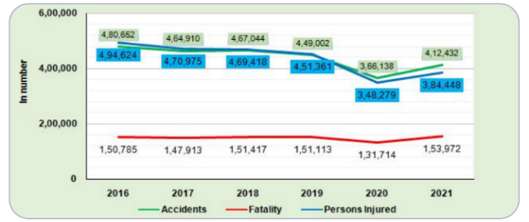

**Figure 1:** Accident rate chart

The above figure 1 shows the number of accident rate occur in a year in India. Automated alerts and compliance management features ensure that users receive timely notifications and adhere to safety protocols, while also facilitating regulatory compliance. Through the integration of these advanced technologies, the system aims not only to mitigate accidents but also to cultivate a culture of safety within organizations and communities. This paper outlines the conceptual framework of the integrated accident prevention system, highlighting its potential to transform safety practices across various domains. By harnessing the power of machine learning and IoT, this initiative represents a significant step towards mitigating accidents and promoting a safer environment for all.

1. **METHODOLOGY**

This system represents a significant advancement in the field of automotive safety, leveraging cutting-edge sensor technologies to monitor various critical parameters within the vehicle environment and ensure the well-being of both the driver and passengers. Central to the system's functionality is the integration of a diverse array of sensors strategically positioned throughout the vehicle and on the driver's person. These sensors include an alcohol sensor, tasked with detecting any instances of alcohol consumption by the driver, a heart rate monitor continuously tracking the driver's cardiovascular health, and a sophisticated camera system adept at identifying signs of driver drowsiness. Furthermore, the system incorporates speed and gas sensors, providing real-time data on vehicle speed and detecting any indications of smoke or fire within the vehicle cabin.

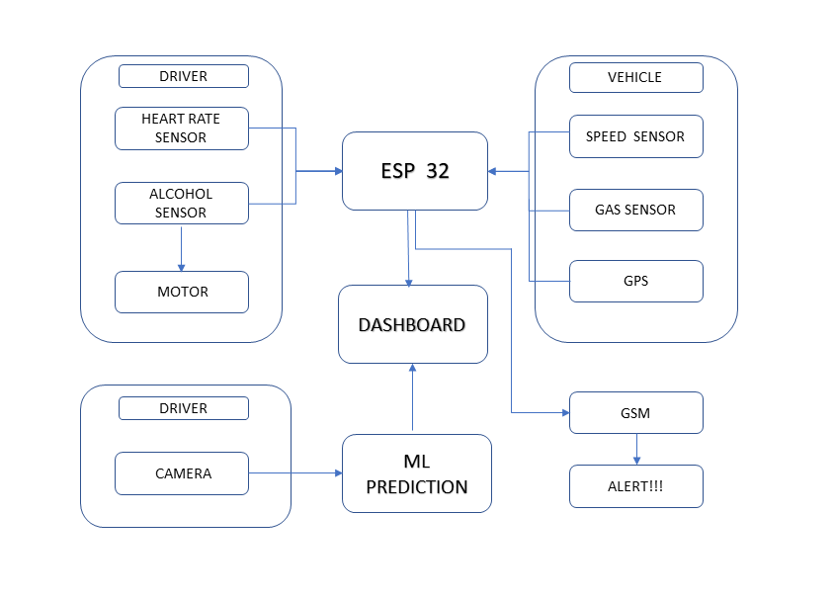

**Figure 2:** Schematic Block Diagram

Upon detecting abnormal readings from any of these sensors, the system promptly triggers alarms and initiates a series of predefined actions to mitigate potential risks and ensure the safety of the driver and passengers. For instance, in the event of detected alcohol consumption, the system automatically disables the vehicle's motor to prevent any further operation until the driver's sobriety can be confirmed. Similarly, upon identifying signs of driver drowsiness through the camera system's advanced image processing algorithms, the system generates alarms and promptly notifies designated emergency contacts, ensuring timely intervention to prevent potential accidents. Moreover, the integration of GSM communication capabilities enables the system to send instant alerts to relevant authorities, such as fire stations, in the event of smoke or fire detection, facilitating swift response and mitigation of hazards.

The ESP32 microcontroller serves as the central hub of the system, orchestrating the seamless integration of sensor data, decision-making algorithms, and communication protocols to enable real-time monitoring and response. Leveraging the microcontroller's powerful processing capabilities, the system analyzes sensor data with remarkable speed and accuracy, allowing for swift and decisive action in critical situations. Furthermore, the ESP32's versatility enables the system to adapt to various use cases and scenarios, ensuring its effectiveness across a wide range of driving conditions and environments.

In addition to its robust sensor integration and decision-making capabilities, the vehicle safety system excels in its data visualization and analysis capabilities, facilitated by its integration with platforms such as Thingsboard. This integration enables users to easily access and interpret live data streams, empowering them with valuable insights into vehicle safety metrics and enabling informed decision-making. Through intuitive dashboards and analytics tools, users can gain a comprehensive understanding of the system's performance and identify areas for improvement, ultimately enhancing the overall effectiveness of the safety system.

Moreover, the paper delves into the ethical and safety considerations inherent in the design and implementation of such advanced automotive safety systems. Recognizing the importance of user privacy and data security, the system incorporates stringent measures to safeguard sensitive information and ensure compliance with regulatory standards. Additionally, comprehensive safety protocols are implemented to mitigate the risk of false alarms or system failures, prioritizing user safety and confidence in the system's reliability.

1. **SYSTEM IMPLEMENTATION**

**DATASET CREATION:**

We are collecting images for drowsy detection especially both eye images from online MRL Eye data set it contains 84000 of eye images which includes both left and right eye (i.e) 42000 of closed eye and 42000 of open eye images. We splitted the images these into two groups one is for training which contains approximately 80000 images and the remaining 4000 images is used for testing purpose.

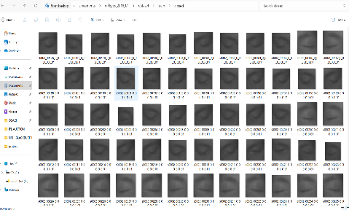

**Figure 3:** Dataset

**TRAINING MODEL:**

We are Training our model with Jupyter notebook with the collected dataset. Once the model is trained we will get an .h5 file and that could be our trained model.

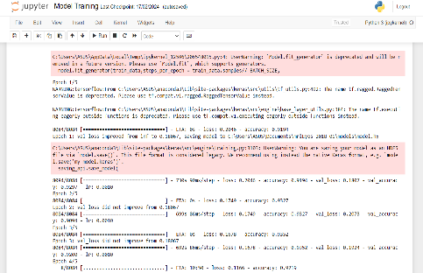

**Figure 4:** Model Training

**ESP 32 SETUP AND SENSOR CONNECTIONS:**

Connecting the ESP 32 with board to get ready for sensor connections. Connecting it with the CPU via USB cable. Connecting the various sensors and motor with the ESP 32 as perthe circuit connection.

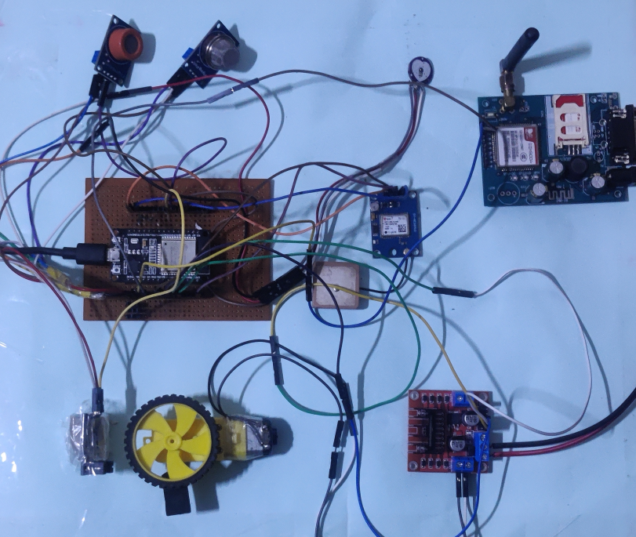

**Figure 5:** Kit Setup

**ARDUINO IDE:**

Installing Arduino IDE on CPU and installing the required packages. Selecting the board as ESP 32 and Com port as well. Then coding on IDE as per our requirement.

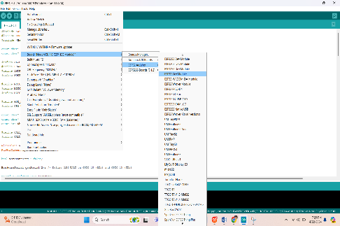

**Figure 5:** Arduino IDE

**THINGS BOARD:**

Connecting it with the Arduino IDE. Creating Widgets as per requirement for creating dashboard.



**Figure 6:** Dashboard

1. **RESULTS AND DISCUSSION**

When executing the system it will detect for abnormal conditions with the help of sensors and camera.

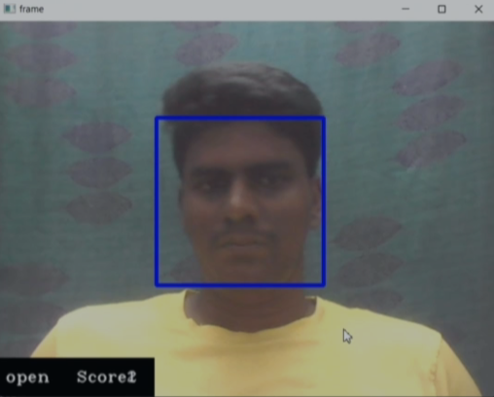

**Figure 7:** Not drowsy detected by ML model

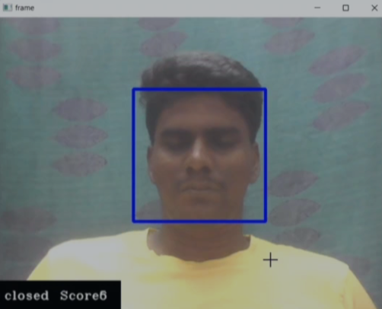

**Figure 8:** Drowsy detected by ML model

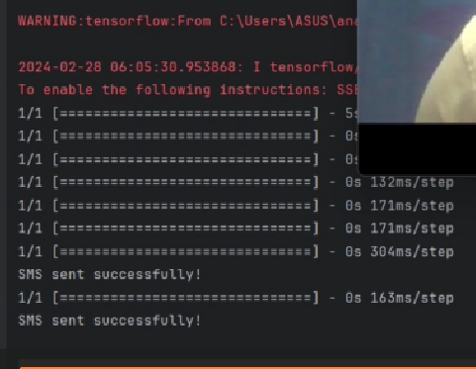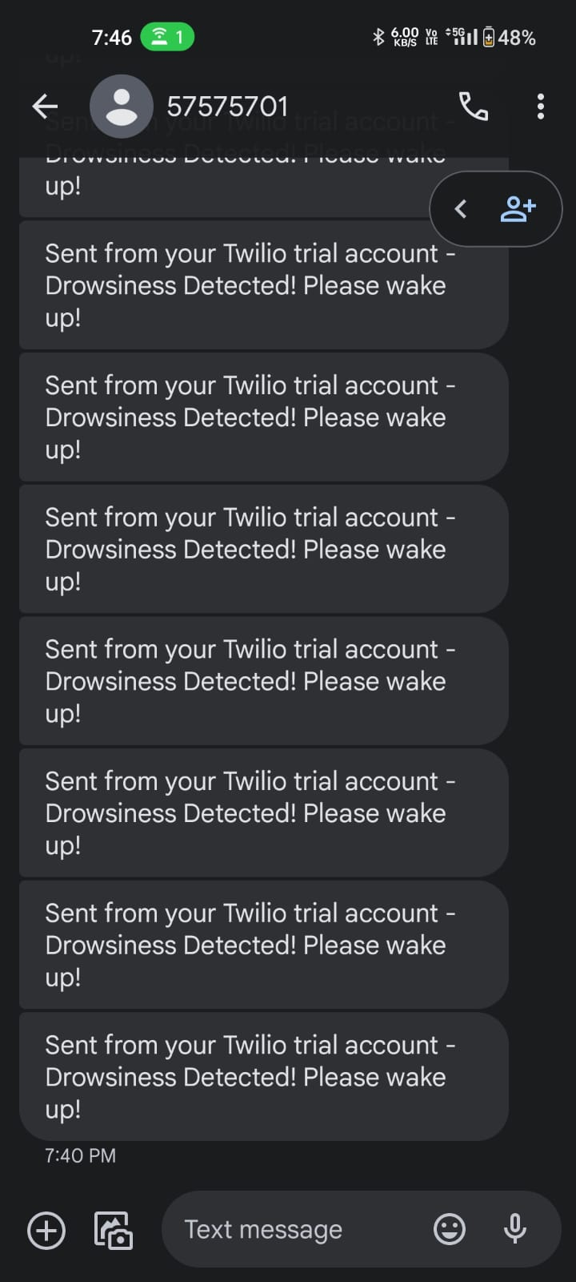

**Figure 9:** Alert Generation via SMS

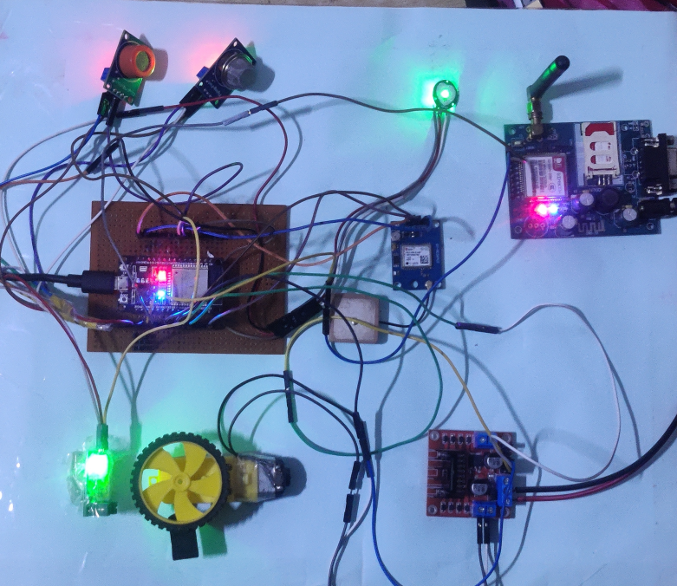

**Figure 10:** Collecting values from sensors

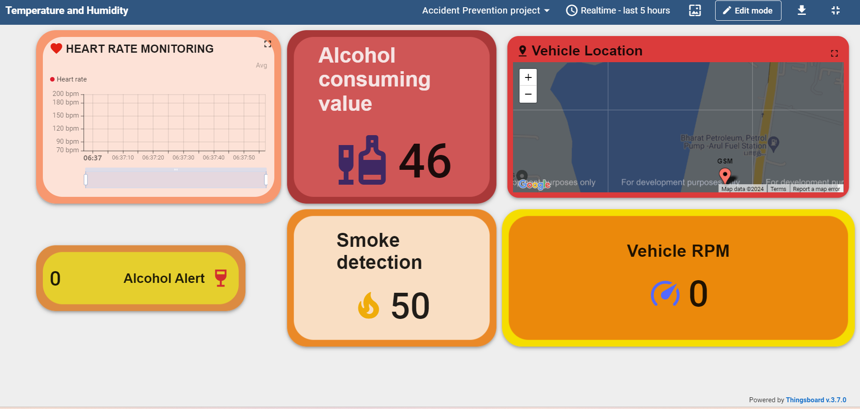

**Figure 11:** Final Dashboard

1. **CONCLUSION**

In conclusion, the development and implementation of the comprehensive vehicle safety system utilizing the ESP32 microcontroller represent a significant milestone in advancing road safety and driver well-being. By integrating a diverse array of sensors and leveraging IoT technologies, the system demonstrates remarkable capabilities in real-time monitoring, detection, and response to potential risks on the road. The seamless integration of sensor data, decision-making algorithms, and communication protocols ensures swift and effective intervention in critical situations, ultimately enhancing overall safety for drivers and passengers alike. Moving forward, continued research and innovation in IoT-based automotive safety systems hold the potential to further reduce the incidence of accidents and save lives on the road, paving the way for a safer and more secure transportation landscape.

1. **REFERENCES**

[1] H. Kim, S. Kim, and J. Park, Development of a Drowsiness Detection System Based on Blink and Yawn Recognition Using Deep Learning, IEEE Access,8**,** (2017).

[2] Muralidharan J, Sindhuja L "Smart Safety and Accident Prevention System" ICONNECT-2023 E3S Web of Conferences 399, 01006 (2023)

[3] C.K. Shejwal, Mr. V.V. Mhaske, Mr. S.C Thorat "ARDUINO BASED ACCIDENT PREVENTION SYSTEM USING EYE BLINK SENSOR" International Research Journal of Modernization in Engineering Technology and Science Volume:04/Issue:01/January-2022 .

[4] Dr Aziz Makandar, Mrs. Kanchan Wangi "VEHICLE ACCIDENT PREVENTION SYSTEM" International Research Journal of Engineering and Technology (IRJET) Volume: 08 Issue: 11 | Nov 2021

[5] Anand M G,A Dhanyakumar,A Dhanyakumar , Sensor Based Accident Prevention System in Curving, IJARIIE(Vol-5 Issue-2 2019).

[6] S. S. Kannan, S. Subramanian, and R. K. Gnanamurthy, Real-time Monitoring of Driver Drowsiness Using Wearable Devices, IEEE Transactions on Instrumentation and Measurement, 68 (2019).

[7] Aravinda B, Chaithralakshmi C, Deeksha, Ashutha K “Sensor Based Accident Prevention System” International Journal of Innovative Research in Electrical, Electronics, Instrumentation And Control Engineering Vol. 4, Issue 6, June 2016.