**ENHANCING REINFORCED CONCRETE STRUCTURE: PERFORMANCE EVALUATION OF HYBRID FIBER REINFORCED POLYMER REINFORCEMENTS IN ONE-WAY SLABS UNDER STATIC**

**LOADING CONDITIONS**

**AKSHAYDEEP1, Mr. NITIN2**

**1** M.Tech Scholar,Matu Ram Institute Of Engineering & Management, Rohtak, India

*Akshayah173*[@gmail.com](mailto:sheelamalik2209@gmail.com)

Assistant Professor, Matu Ram Institute Of Engineering & Management, Rohtak, India [nralhara884@gmail.com](mailto:nralhara884@gmail.com)

## **ABSTRACT**

“Fibre reinforced polymer  composites are becoming increasingly popular all over the globe and in construction as well as an interior reinforcement system for concrete buildings. The corrosive effect of the reinforcements encased in the concrete is believed to be the primary cause of the ongoing issue of reinforced concrete (RC) structural degradation. Numerous recommendations, such as the application of waterproof membranes, epoxy-coated reinforcements, and water proofing admixtures in concrete, are made in an attempt to address the issue of steel reinforcement corrosion; however, none of these solutions is particularly practical from a financial or commercial standpoint. Many strategies, including cathodic protection, epoxy-coated bars, and synthetic membranes, have been developed as corrosion restoration procedures. Non-metallic reinforcement is used to prolong the life of concrete constructions and to replace steel bars. Although there hasn't been a widespread distribution of these combination bars due to their high starting cost, the ongoing costs of constructions using these reinforcements are significantly lower than those of traditionally reinforced buildings. Compared to steel reinforcements, FRP offer a number of benefits, such as resistance to high strength to weight ratios, electrochemical rust resistance ease of manufacture, and electromagnetic insulating qualities. Furthermore, FRPs can be purchased commercially as sheets, rods, or reinforcements. The two parts of FRP reinforcements are the matrix and the fibres. The filaments include of glass, carbon, aramid, and basalt fibres; the matrix is typically a thermo-set resin like vinyl ester or epoxy. The organic fibres include flax (linen), cotton wool, hemp, jute, and hemp.

In this study, Hybrid Fibre Reinforcement Polymer (HFRP) used to replace the steel reinforcements is a mixture of Glass FRP (GFRP) skin over a Carbon FRP (CFRP) core. Mechanical properties like Density test, Tensile test, Transverse shear test, coefficient of linear thermal expansion test are conducted to find the strength properties of the HFRP bars. Pullout test are also conducted to find the bond performance between the concrete and the HFRP bars.”

**Key Words:** HFRP Slabs, Load versus deflection curves, stress versus strain curves, load versus crack width curves

# INTRODUCTION

Concrete is susceptible to chemicals assaults in an active surroundings, including carbonated and chlorine pollution, which dissolve the cement matrix's alkali buffer. As a result, rust may affect the steel reinforcing materials used in concrete constructions. Because of the steel reinforcing's increased volume, these events cause the mortar to delaminate at the reinforcement's level and to fracture and spall. Many academics have looked at different strategies to prevent corrosion in steel reinforcement. Replacing traditional steel bars with non-corrosive materials is one way to potentially prevent corrosion in reinforcement for new construction. FRP reinforcements have high tensile strength, are portable, and are impermeable to rust, which makes them ideal for these kinds of uses.

Because of their outstanding durability against rust high tensile strength relative to weight ratio and excellent non magnetization qualities FRP reinforcement have been used in concrete buildings at a fast rate in the past few decades. After associated to old building resources like steel timber and reinforced concrete  FRP solutions function better structurally with regard to of stiffness  rigidity, strength and endurance.Ease in mass production with strict supervision of quality and comparative economics are further considerations.

“Yet since FRP has a lesser modulus of elasticity than steel concrete parts reinforced with FRP sheets show greater deflection and fracture breadth. Therefore, servicing limit-states often dictate the construction for these parts, therefore it could be very advantageous to have a generic technique of investigation that can reasonably determine the predicted load detours of FRP reinforced elements. The process of design for concrete structures reinforced with steel bars may not always apply to those reinforced with fiber-reinforced polymer (FRP) bars due to the latter's mechanical characteristics, which differ from the ones found in steel bars. These characteristics take in high tensile strength coupled with low elastic modulus and elastic brittle stress-strain connections. As a consequence of greater building security, steel reinforcements have been replaced by hybrid fiber-reinforced polymer (HFRP) reinforcements.”

**HISTORY OF FRP REINFORCEMENT**

The concept of fusing both separate parts to create mixed substances isn't unique; the ancient Egyptians utilised straws to strengthen the clay and create a more durable substance. Fibre Reinforced Polymer  was first used in the automotive and aerospace sectors in the early 1950s, after the end of the Second World War. Since polymers are more lightweight and fatigue resistant than traditional materials, most major components of contemporary aeroplanes are constructed out of them. Composite are also used in a variety of current vehicle parts.

During the beginning of the 1960s, a large number of highway bridges and other buildings have begun to fail as a consequence of corrosive problems with the steel used for reinforcement. The rusting was hastened by road salts used for de-icing in cooler climes or saltwater in coast locations. In past times, several measures have been adopted to prevent the rust of steel reinforcement, including painting the exterior of the reinforcing bars with galvanised paint and using epoxy coated reinforcing bars.

**DEVELOPMENT OF FRP MATERIALS**

FRP is a combination of fibres and Polymer resin. The maximum kinds of fibres are aramid carbon and glass fibres. In the1950 FRP has been presented to the construction world as an alternate to the conventional reinforcements. The widespread of utilization of FRP composites resulted in various applications with various shapes. After 1970, the commercial application of FRP products has been developed. More than thirty years FRP bars and grids have been produced commercially. In 1980 FRP have been improved to meet out special performance requirements and adopted in the construction of marine structures, and structures in aggressive chemical environments. Since 1986 prestressing techniques are also applied in the construction of highway bridges in various countries. The advantages of FRP materials have been accepted since of its high strength high stiffness less density and low cost specially used for air travel and space exploration. In 1970 FRP materials have been promoted in the market with an affordable price. Later on the researchers have been financially supported to take FRP economically into the development of research activities. After 2000, there entered many successful projects to assure the effective performance of FRP in structural field.

**TYPES OF FIBRES AND ITS CONSTITUENTS**

The substance being used is often an epoxy resin, polyvinyl ester, or poly a thermosetting plastics, whereas the fibres are typically carbon, glass, the aramid, and volcanic fibre reinforced plastics. Strong rigidity, durability, and endurance are characteristics of fibres. As contrasted with conventional reinforcement made of steel, parameters like width, sectional area, form, and chemical makeup are important in giving fibres desirable properties and making them immune to rust. Furthermore, fibre reinforced polymer (FRP) materials are a more cost-effective option than traditional alternatives like stainless steel when weatherproofing is needed.

**Fibres and properties**

Fibre characteristics may vary depending on the manufacturing technique and bar diameter. FRP maintains a linear stress-strain connection until it ruptures, without experiencing breaking or strain hardenin, it compared to steelSince the carbon fibres in FRP bars are the primary component responsible for bearing loads, their kind, proportion, and direction greatly influence the bars' durability. They further calculate the necessary quality control, manufacturing procedure, and curing rate.

**FRP in Structural Engineering**

Composites have evolved over over twenty years becoming technically and financially sound construction and bridge components. Figure 1.3 Standard stress-strain curve in strain for steel and FRP bar types. FRP is employed in structural engineering currently in many different conducts such as structural fundamentals for new building, reinforcing materials for current constructions and reinforcement materials for fresh concrete construction. FRP Can serve as permanent structure , interior rebars, and prestressing ligaments in new building. The FRP rebars' surfaces might be twisted, centred, sand-coated, have ribs, or have an exterior spiral winding. A variety of readily accessible FRP rebar with various surface textures is seen in Figure 1.4.

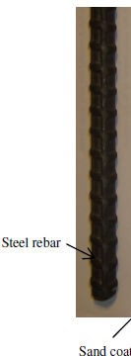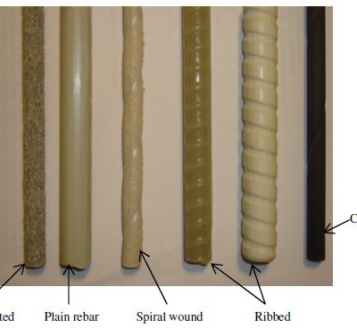

***Glass Fibres***

Glasses fibres, which is derived by the mineral silica, is sold professionally in various grades. Electromagnetic  high-strength  & alkali-resistant  are the three kinds of glass fibres. Electronic glass offers excellent strength, a low susceptibility to humidity or moisture, and strong electrical protection. Although S-glass is more expensive than E-glass, it is still less optimal due to its greater tensile strength and elasticity. In cement-based matrices, AR-glass is very robust to alkali attack; but, at this stage of research, thermoset resin, which is often used to pultrude FRP bars, is not readily available for estimation. Glass fibre compositions provide excellent thermal and electrical barrier qualities.

***Carbon Fibres***

Carbon fibre is the primary material used in building applications. Carbon fibre is manufactured from predecessors such as polyacrylonitrile pitch or rayon fibres that are PAN-based. Polyacrylamide carbon fibre has good bending strength and a moderately high modulus. Carbon fibre with a pitch-based structure has a High elasticity but weak strength which makes it suited for aviation submissions. Viscose and isotropic in nature pitch predecessors are used to produce carbon fibre with low modulus. Carbon fibre has great fatigue strength, excellent durability against acid rust, a little coefficients of enlargement under heat  comparatively poor bearing resistance, and strong electrical conductivity. It may induce galvanic erosion when in interaction with alloys. Furthermore, it is not simply permeated by resin, consequently requiring size earlier being embedded in the resin.

***Aramid Fibres***

The material fibre is an aromatic nylon biological fibre. It has excellent mechanical characteristics with little density, high toughness, and substantial impact tolerance. Aramid fibre is an excellent insulation for electricity and heat, and it is resistant to organic solvents, fuels, and lubrication. It reacts to ultraviolet  radiation, higher temperatures, & more moisture. The breaking strength and elasticity of the aramid fibre are roughly fifty percent more than those of crystal. Kevlar is one of the most well recognised aramid fibre available on the market, identified as Kevlar 29, 49, and 149. The high cost restricts the usage of this kind of fibre for producing FRP bars.

***Basalt Fibres***

Lava fibre is somewhat more durable and stiff than Electronic glass and it is safe in environment, by its nontoxic, noncorrosive, and nonmagnetic, high-hear stablity and protecting attributes. In spite of the fact that basalt fibre is fabricated with a similar innovation used for E-glass fibre, its procedure needs less energy, and the essential material is accessible all over the world. Its mechanical properties of this fibre having an elastic modulus higher than that of E-glass and, it are high biosolubility in nature. The final stuff signifies the capacity of basalt fibre to break down in the intermediate to long term when in interaction with natural fluids.

***Epoxies***

The chief benefits of epoxy resin are its high mechanical abilities easy release little reduction after curing and durable adherence to a broad range of fibres. It has superior corrosion resistance and is more resistant to water and heat compared to other polymeric matrices. Epoxies are are primarily employed to produce powerful materials that possess exceptional toughness, durability against corrosive liquids and environments, as well as good electrical characteristics, and effectiveness at high temperatures. Epoxy resins may be readily mixed with glass, carbon, aramid, and basalt fibres. To get certain performance characteristics, it may be mixed with other materials or integrated with other resins. Epoxy resin has drawbacks such as high cost and extended curing time, sometimes necessitating a post-curing step.

***Polyesters***

The fundamental benefit of polyester resins is in their balanced mechanical organic and electric qualities dimensional constancy cost effectiveness, and simplicity of dispensation. Polyester resins are usually affordable and have favourable mechanical and electrical properties. The product is chemically tailored to suit a variety of uses. Various specialised polyesters with properties such as elasticity electric filling rust resistance temperature and UV light resistance fire retardancy and optical translucence are commercially accessible to meet particular performance requirements. Styrene is often added in significant amounts (over 10% by mass of the polymer resin) to reduce the viscosity of the liquid. Due to its Although it has minor chemical resistance as opposed to vinyl ester compounds, it is advantageous for the manufacturing of FRP bars.

***Vinyl Esters***

Vinyl esters exhibit chemical resistance and high strength as well as viscosity and quick curing. It exhibits well base resistance well wet out and moral bond with glass fiber that build them the optimal to production Hybrid fibre reinforced polymer (HFRP) composites. Composition of FRP material between polymers resin matrix and fibres are shown in Fig 1.7. Generally the capacity portion of fibres is greater than that of resin. Suitable additives namely hardeners, foaming agents and colouring pigments and fillers are added to the material in order to achieve the curing or otherwise to improve the quality of the material. Fig 1.8 depicts the stress strain characteristics of the resin, fibres and FRP composites.

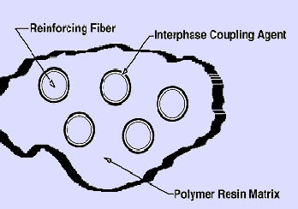

Different types of FRP rebars available commercially

# OBJECTIVES

* + - To examine the mechanical belongings of concrete, steel, and HFRP additional troops, including weight, bending strength,  flexibility, coefficient of linear expansion due to heat, and the strength of the bond.
    - To empirically analyse the flexibility of slabs of concrete strengthened with HFRP reinforcement and reinforcements made of steel under two-point static load circumstances.
    - To investigate Investigating the flexibility of concrete slabs strengthened with HFRP and traditional reinforcements at 2 point stationary stress situations. using FE modelling using ANSYS 15.1 software.
    - To provide revised theoretical formulas for the bending strength, deformations, and crack widths of HFRP concrete-reinforced oneway slabs subjected to two point static stress.
    - To conduct Monte Carlo calculations via data that is random to create a resistance model for the flexibility of HFRP concrete reinforced one-way slab.

# LITERATURE REVIEW

The remainder of this sector includes an in-depth review of the research that serves as the foundation for the current investigation. This chapter's first portion discusses the mechanical properties of reinforcements made of FRP and their long-lasting features. The subsequent part provides an analysis of the connection quality between reinforcements made from FRP and concrete. The final part provides a concise summary of study focused on the Bending behaviour of FRP reinforced components of structure. The concluding part discusses analytical frameworks for analysing FRP reinforced building elements. The goals and extent of this study are determined by an assessment of existing research.

**Review on FRP properties**

Currently different shapes of FRP complex ingredients are adopted for the structural engineering applications all over the world. This section highlights the literature on the important possessions of FRP materials which are used as internal reinforcements for concrete applications.

FRP bars density is noticed to be 1/6 to 1/4 fewer than that of steel. The treatment of FRP bars on the site is eased because of the reduced weight. In FRP bars, the tensile modulus of elasticity is 25% higher than the modulus of elasticity of steel. “Though the compression is weaker than the tensi on in FRP bars, it is expected to be higher value at lower stress ratio. FRP bars show good fatigue resistance, but the fatigue strength of FRP is lower than that of steel at lower stress ratio. The coefficient of thermal expansion of FRP is almost nearer to that of steel reinforcement. Fibre properties dominate the longitudinal coefficient of thermal expansion, whereas resin dominates the transverse coefficient.” The tensile strength hinges on the fibre volume fraction, the rate of curing, and the manufacturing process. In the tensile properties of FRP members are supposed to be as curtained by the bar manufacturer.FRP exhibits brittle behaviour on application of load. It does not undergo yielding. The compressive modulus of elasticity of FRP reinforcing bars seems to be lesser smaller than its tensile modulus of elasticity. FRP reinforcing bars subjected to a constant load for long time can suddenly fail. This phenomenon is known as creep rupture. Among the various types of fibers, carbon fibres are least liable; aramid fibres are moderately susceptible; and the glass fibres are severely susceptible to creep rupture.

**Javier Malvar (1995)** The tensile performance of fibreglass reinforced plastic bars was analysed using ASTM D 3916-84, which suggested that the tensile characteristics are dependent on the outermost distortion of the FRP rods.

**Fujisaki and Kobayashi (1995)** Studied the FRP bars embedded in cement lenses with a five millimetre clear lengths at both ends while in pressure. The compression strength of The material  Graphite and Glasses Grp bar is ten percent, thirty to fifty percent, and thirty to forty percent lower than their tensile strength values.

**Bank et al., (1998)** directed the dispersion test on E-glass/vinylester FRP rods and demonstrated that the temperature influences the moisture content at immersion point. At last, it has been recommended that the material degradation during the testing period has been indicated as increased voids and moisture substance.

**Hayes et al., (1998)** “has estimated a decrease in tensile strength and Young's modulus, roughly 26%, for glass/vinylester arrangement after wet/dry cycles at 4500C for 30 days.”

**Castro et al., (1998)** introduced different anchors used for tensile testing of FRP bars and prescribed a testing plan consisting of FRP bar installed in steel tubes loaded up with high strength gypsum cement mortar.

**Pantuso et al., (1998)** Deliberate the effects of purified water and an acidic atmosphere on the longevity of glassy fiber/polyester pultruded rods. The analysis encompassed immersing GFRP specimens in distilled water for one day at 23°C, then dryness for a single day. This process was repeated for a total of sixty days. A similar technique has been rehash for the samples implanted in cement to explore the impact of alkaline environment condition. The decrease in tensile strength has been seen at 1-7% and 6-21% for water and alkali condition.

**Tang (1999)** Considering the low specific gravity of FRP rods in comparison to steel rods, it exhibit strong tensile strength and remarkable resistance to the outdoor factors and chemicals assaults. The reinforcement of substance is used to link fibres collectively utilising bonding chemicals like varnishes and concrete, leading in various shapes and patterns. Several scientific and practical trainings were directed to assess the feasibility of employing FRP for strengthening concrete buildings.

**Dong-Woo Seo et al., (2013)** introduced an examination on the stretchable belongings of "FRP Hybrid Bars". The consequences of this investigation showed that the elastic modulus of the hybrid GFRP bar was increased by 5 to 204 % by the material hybridization.

# METHODOLOGY

* Conducting important tests to study the properties of materials.
* Mix design is done for concrete (M30;M40;M50)
* Design of one-way slabs
* Casting of conventional slabs (nine numbers) and HFRP slabs (nine numbers).
* Experimental investigations on HFRP and conventional slabs strengthened concrete slabs with one direction subjected to two point dynamic stress (First crack load, Ultimate load, Deflection, Strain, Crack width).
* Modelling of HFRP and conventional slabs using ANSYS (comparison between FEM results and experimental results).
* Modification of Theoretical expressions of conventional Bending members to frame the new expressions for the selection of Bending maximum volume of HFRP slabs based on the experimental investigations (Comparison of theoretical and experimental results).
* Determination of reliability index and resistance model for HFRP one-way slabs by conducting reliability analysis.

## **MATERIAL PROPERTIES**

### **CONCRETE**

Normal Strength Concrete (NSC) of grades 30MPa, 40MPa and 50MPa are used to cast the concrete one-way slabs. Ordinary Portland Cement (OPC), coarse aggregate size of 20mm and fine aggregate of size ranging up to 4.75mm sieve are used in casting the slabs and in real environmental conditions. After 28 days of curing the compressive strength of cubes are determined with 150mm size of standard test cubes using Compression testing machine and the properties of concrete are tabulated in Table 1 below.

|  |  |  |  |
| --- | --- | --- | --- |
| **Material** | **M30 grade of**  **concrete** | **M40 grade of**  **concrete** | **M50 grade of**  **concrete** |
| Cement, kg/m3 | 425.34 | 430 | 450 |
| Fine aggregate, kg/m3 | 615.21 | 664 | 701 |
| Coarse aggregate, kg/m3 | 1181.52 | 1174 | 1163 |
| Water, kg/m3 | 191.58 | 165 | 160 |
| Average compressive  strength, N/mm2 | 38 | 49 | 56 |

**Table 1:** Properties of Concrete

### **REINFORCEMENT**

The properties of reinforcements are already explained in the section 3.3.2 and the values are extracted and shown in Table 2 below.

|  |  |  |
| --- | --- | --- |
| **Type of Rebar** | **HFRP** | **STEEL** |
| **Properties** |
| Tensile Strength, MPa | 1217.93 | 583.67 |
| Compressive strength, MPa | 746.17 | 435.68 |
| Elastic modulus, GPa | 50 | 200 |
| Transverse Shear strength, MPa | 418.4 | 302.5 |
| Coefficient of linear expansion, /0 C | 9x10-6 | 20 x10-6 |

## **Table 2:** Properties of Reinforcements used in the study

## **TEST SPECIMEN PREPARATION**

The experimental program consists of eighteen one-way slabs of length 2400mm and 600mm width. The various parameters that are involved in the present study and their designations are tabulated in Table 3. The reinforcements of size 8 mm are used as secondary reinforcements in the transverse direction of slab i.e widthwise and 10 mm reinforcements are used as main reinforcements in the span direction of slab i.e. lengthwise at three different spacing viz.,

186.6 mm c/c, 140 mm c/c and 93 mm c/c. Main and secondary HFRP reinforcements are tied with help of Nylon zip ties. Secondary (8mm steel/HFRP) reinforcements are spaced at 210 mm c/c. Main reinforcements are given a bottom cover of 20mm for all the slabs. Mixing of concrete is done with help of rotary mixers. The slabs are designated with the parameters of m1hρ1D1, m1hρ2D1, m1hρ3D1, m2hρ1D1, m2hρ2D1, m2hρ3D1, m1hρ1D2, m2hρ1D2, m3hρ1D2, m1sρ1D1, m1sρ2D1, m1sρ3D1, m2sρ1D1, m2sρ2D1, m2sρ3D1, m1sρ1D2, m2sq1D2, m3sq1D2 Normal moist curing is done for all slabs; After curing, grid points are marked to locate the loading points and strain measuring positions; Brass pellets are fixed to measure strains using Demouldable mechanical (Demec) strain gauge. In the next section a detailed experimental setup is explained under different loading conditions.

|  |  |  |
| --- | --- | --- |
| **Parameters** | **Description** | **Designation** |
| Types of reinforcements | HFRP | *h* |
| Steel | *s* |
| Thickness of slabs | 100 mm | *D*1 |
| 120 mm | *D*2 |
| Grades of concrete | M30 | *m 1* |
| M40 | *m*2 |
| M50 | *m*3 |
| Reinforcement ratios | 0.49% | *hρ1 , sρ1* |
| 0.65% | *hρ2 , sρ2* |
| 0.81% | *hρ3 , sρ3* |

**Table 3:** Various Parameters involved in the construction of slabs

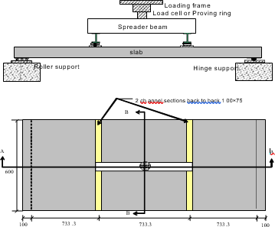

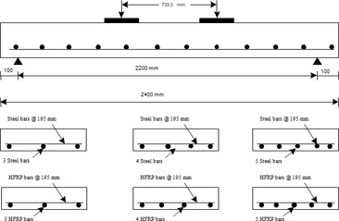**Fig. 1:** Experimental Test setup

**Fig. 2:** Reinforcements Details for HFRP and Conventional Slabs

**RESULTS & DISCUSSIONS**

|  |  |  |  |  |  |  |  |  |
| --- | --- | --- | --- | --- | --- | --- | --- | --- |
| **Sl No** | | **Designation of slabs** | | ***P*u (kN)** | | ***Mu,***  **kNm** | | **Ultimate Deflection**  **(mm)** |
| 1 | | *m1hρ1D1* | | 40 | | 16 | | 97.63 |
| 2 | | *m1hρ2D1* | | 42.5 | | 17 | | 89.54 |
| 3 | | *m1hρ3D1* | | 45 | | 18 | | 80.44 |
| 4 | | *m2hρ1D1* | | 47.5 | | 19 | | 79.18 |
| 5 | | *m2hρ2D1* | | 50.25 | | 20 | | 77.72 |
| 6 | | *m2hρ3D1* | | 55 | | 22 | | 74.56 |
| 7 | | *m1hρ1D2* | | 57.5 | | 23 | | 70.80 |
| 8 | | *m2hρ1D2* | | 60 | | 24 | | 69.24 |
| 9 | | *m3hρ1D2* | | 75 | | 30 | | 58.45 |
| 10 | | *m1sρ1D1* | | 25 | | 10 | | 42.42 |
| 11 | | *m1sρ2D1* | | 27.5 | | 11 | | 40.71 |
| 12 | | *m1sρ3D1* | | 30 | | 12 | | 39.38 |
| 13 | | *m2sρ1D1* | | 27.5 | | 11 | | 36.75 |
| 14 | | *m2sρ2D1* | | 30 | | 12 | | 31.28 |
| 15 | | *m2sρ3D1* | | 32.5 | | 13 | | 30.12 | |
| 16 | | *m1sρ1D2* | | 35 | | 14 | | 30.6 | |
| 17 | | *m2sρ1D2* | | 30 | | 12 | | 30.55 | |
| 18 | | *m3sρ1D2* | | 27.5 | | 11 | | 35.95 | |

**Table 4:** Experimental Results

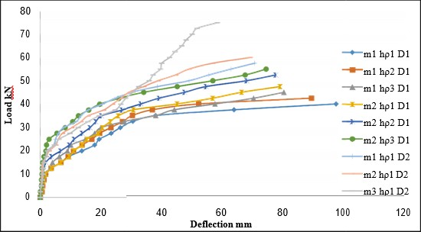

**Chart -1**: Comparison of Load versus Deflection for all HFRP slabs.

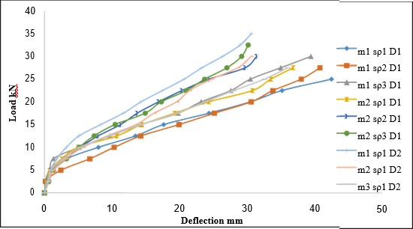

**Chart -2**: Comparison of Load versus Deflection for all conventional slabs

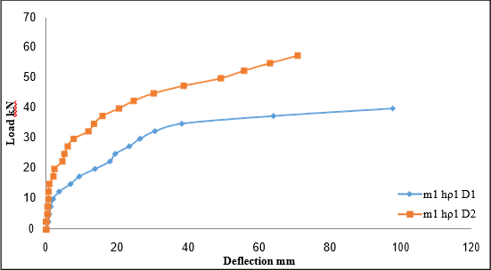

**Chart -3**: Comparison of Load versus Deflection for HFRP slabs with different thickness of slabs

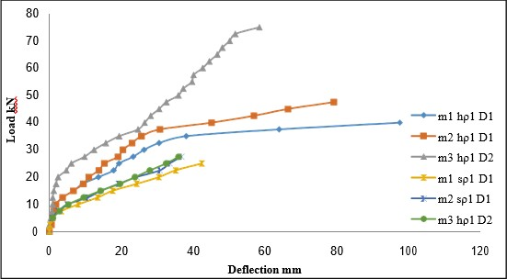

**Chart -4**: Comparison of Load versus Deflection for HFRP and conventional slabs with different grades of concrete



**Chart -5**: Comparison of Load versus Deflection for HFRP and conventional slabs with different grades of concrete

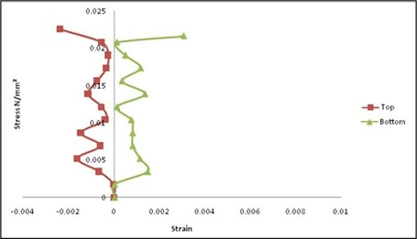

**Chart -6**: Comparison of stress versus strain for HFRP slab for m1hρ1D1 at top and bottom levels

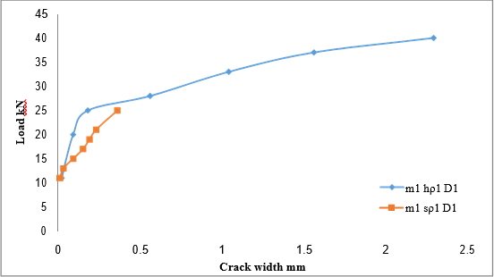

**Chart -16**: Comparison on Load versus crack width between HFRP slabs and conventional slabs

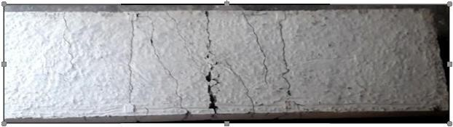

Crack patterns of conventional slabs

# CONCLUSION

* Load deflection response due to static loading shows a greater reduction in stiffness in the case of HFRP reinforced slabs than the conventional slabs. For conventional slabs, a wider deflection occurs due to its yielding nature, whereas HFRP reinforced slabs show no yielding of reinforcements but a larger deflection occur due to load increments.
* The flexural response of RC members is divided into two distinct stages. The first stage describes the uncracked portion of the member, and the second describes the cracked portion of the member.
* In the second stage, the concrete tensile resistance reduces due to cracks and so that the tensile loads are carried entirely by the reinforcement. The flexural stiffness of a RC member is greatly reduced in this stage, but the cracked response remains well above that of a member that is fully cracked. This is possible only, due to good bonding and the by transferring mechanism of rebar, some of the tension to its surroundings, which leads to the contribution of concrete between individual cracks.
* On further loading, the tensile stress increases to develop additional cracks. The process continues until crack spacing reduces in such a way not to develop new cracks. Such crack pattern is termed as the stabilized crack pattern in which additional load widens existing cracks, with limited effects on flexural stiffness.
* The slab m1hρ1D1 shows 6.25 % increase in load carrying capacity than m1hρ2D1 slab whereas the deflection is 1.09 times greater m1hρ2D1 than slab. The slab m1hρ1D1 shows 12.5 % increase in load carrying capacity than m1hρ3D1 slab whereas the deflection is 1.21 times greater m1hρ2D1 than slab.
* The strain distributions across the thickness of HFRP slabs are shown above. HFRP reinforcements in tension side of the concrete slabs behave similar to the HFRP reinforcements tested under pure tension (Tensile test specimen) Reflecting good bonding between concrete and HFRP reinforcements. The concrete surface strain in HFRP reinforced slabs shuttles between 1.5 to 2 times greater than the conventional slabs under the similar load level. The experimental observations resembles to the observations made by the authors (Benmokrane 1995, Theriault 1998 and Craig 1998).
* Experimental contributions on Crack widths and Crack patterns are shown clearly. The first crack appears at the middle of the slab and develops slowly across the width of the slab. When more loads is applied gradually, new cracks are developed on the slabs. At the same time, the existing crack has been widened. This is continued up to 75% of ultimate load and then the formation of new split up into smaller cracks close to the main bars. All the slabs experience flexural type of failure. At ultimate load, HFRP reinforced slabs experience concrete crushing and Steel reinforced slabs show the flexural type of failure. Fig.3.41 and Fig.3.42 depict the crack pattern of slabs for various parameters.
* Crack pattern of slab m3hρ1D2 in which the rupture of HFRP rebars has been noticed with a pronounced shrinking stating that the slab is designed as under reinforced slab.
* The ultimate load carrying capacities of HFRP reinforced slabs are increased and the corresponding deflections, strains and crack width are reduced by increasing the thickness, grade of concrete, reinforcement ratio of the slabs. This is mainly attributed due to the almost closer values of the modulus of elasticity for HFRP reinforcements and concrete in addition to the linear elastic behaviour of HFRP reinforcements.
* There is a direct relationship between the strain in the reinforcing bars and the crack width. Codal provisions

# REFERENCES

1. ACI 440.1R-15: Guide for the Design and Construction of Structural Concrete Reinforced with FRP Bars. 2015, American Concrete Institute: Farmington Hills, MI.
2. ACI 440.1R-06: Guide for the Design and Construction of Structural Concrete Reinforced with FRP Bars. 2006, American Concrete Institute: Farmington Hills, MI.
3. ACI Committee 318 (1971), Building code requirements for Reinforced Concrete, Detroit.
4. ACI 440R-96, State-of-the-Art Report on Fibre Reinforced Plastic (FRP) Reinforcement for Concrete Structures.
5. ACI 440.1R-03, Guide and Construction of Concrete Reinforced with FRP Bars.
6. ACI Committee 440.XR (2007) Report on fiber-reinforced polymer (FRP) reinforcement for concrete. Structures American Concrete Institute.
7. ACI 440.5-08, Specification for Carbon and Glass Fibre Reinforced Polymer Reinforcing Bars.
8. American Association of State and Highway Transportation Officials (2009) AASHTO LRFD Bridge Design Guide Specifications for GRFP-Reinforced Concrete Bridge Decks and Traffic Railings. Washington, D.C.: AASHTO
9. ASTM-D 3916-84, Standard Test Methods for Tensile properties of Pultruded Glass-Fibre Reinforced Plastic Rod.
10. ASTM D792-2013, Standard test method for density and specific gravity (relative density) of plastics, ASTM International, 100 Barr harbor drive, PO Box C700, West Conshohocken, PA 19428-2959, United states.
11. ASTM D7205/7205M-2006, Standard Test Method for Tensile Properties of Fiber Reinforced Polymer Matrix Composite Bars, ASTM International, 100 Barr Harbor Drive, PO Box C700, West Conshohocken, PA 19428-2959: United States.
12. ASTM D7913/D7913M-2014, Standard Test Method for bond strength of fiber-reinforced polymer matrix composite bars to concrete by pull out testing, ASTM International, 100 Barr Harbor Drive, PO Box C700, West Conshohocken, PA 19428-2959: United States.
13. ASTM D7617/D7617M-2011,Standard Test Method for Transverse Shear Strength of Fiber-reinforced Polymer Matrix Composite Bars, ASTM International, 100 Barr Harbor Drive, PO Box C700, West Conshohocken, PA 19428-2959: United States.
14. Abdalla, H.A. (2002), Evaluation of deflection in concrete members reinforced with Fibre Reinforced Polymer (FRP) bars, Journal of composite structures, Vol.56(1), April pp.63-71.
15. Achillides, Z., and Pilakoutas, K. (2004), Bond Behavior of Fiber Reinforced Polymer Bars under Direct Pullout Conditions, ASCE Journal of Composites for Construction, Vol. 8(2), March pp. 173-181.
16. Aiello,M.A., and Ombres,L. (2000), Load – deflection analysis of FRP reinforced concrete Bending members, Journal of composite construction, Vol.4(4), Nov., pp.164-17.
17. Al-Harthy, A., and Frangopol, D.M. (1994), Reliability assessment of prestressed concrete beams, Journal of Structural Engineering, Vol.120(1), April pp.180-199.
18. Al-Sunna, R., Pilakoutas, K., Hajirasouliha, I. and Guadagnini M. (2012), Deflection behaviour of FRP reinforced concrete beams and slabs: An experimental investigation. Composites Part B: Engineering, Vol.43(5), March, pp. 2125 - 2134.