**5G Network for Visible Light Communication**

**Akansha Chauhan**1**, Vikas Sharma**2 **and Ishita Jain**3

Jagan Institute of Management Studies

3, Institutional Area, Sector-5, Rohini (Near Rithala Metro Station), Delhi-110085

contact@jimsindia.org

# ABSTRACT

This write-up provides further insights on the emerging technologies of Visible Light Communication (VLC) with 5G networks. Who isn’t after quick and dependable phones? The integration of 5G networks and VLC technologies might just offer the ultimate answer to more connectivity at work stations or even shopping malls. This document includes among others essential understandings, methods and possible missions of 5G and VL to consider VLC. It also looks at some of the advantages they bring to the table as well as a few challenges they may face. The goal here is fairly straightforward: [1] provide valuable insights for scientists, engineers and developers interested in exploring how 5G can be used in conjunction with VLC to network the Internet good design in the future.

**Keywords:** Visible Light Communication (VLC), 5G Networks, Integration, Wireless Communication, LED Transmitters, Photodetectors, Signal Processing Algorithm.

# 1 INTRODUCTION

A major event is currently taking place in wireless technology, in which visible light communication (VLC) is being combined with 5G networks. Communication is done by LED in VLC and this is quite advantageous owing to the fact that time is reduced and there is no issue of electronic interference. In addition; it has a high volume capability. For its part, 5G performs excellently when transferring data and can serve many gadgets simultaneously hence ideal like augmented reality apps and all those Internet of Things gadgets everyone’s talking about.

5G technology marks the next evolutionary leap in wireless communication, boasting ultra-fast data speeds, minimal latency, extensive connectivity, and heightened reliability. Nonetheless, the rollout of 5G networks encounters obstacles like spectrum scarcity, signal weakening in densely populated urban zones, and the imperative for infrastructure expansion. In tandem, Visible Light Communication (VLC) harnesses light emitting diodes (LEDs) to convey data across the visible light spectrum, presenting benefits such as ample bandwidth, resilience to electromagnetic interference, and energy efficiency. VLC primarily finds application indoors, facilitating tasks like indoor positioning, Li-Fi internet connectivity, and data transmission in environments where radio-frequency (RF) signals encounter limitations.

The integration of VLC with 5G networks addresses:

## 1.1 Addressing RF Spectrum Limitations

With the increasing proliferation of wireless devices and IoT applications, the RF spectrum is becoming congested, leading to interference and degraded performance. VLC provides an alternative communication channel that can alleviate these spectrum limitations, especially in indoor environments.

## 1.2 Enhancing Connectivity in Challenging Environments

VLC offers robust communication in environments where RF signals face challenges such as dense urban areas, electromagnetic interference, and radio signal attenuation. Integrating VLC with 5G networks can extend connectivity to these challenging environments, ensuring seamless communication for users.

## 1.3 Advancing Sustainable Communication Solutions

VLC technology, leveraging energy-efficient LED lights, aligns with the sustainability goals of modern communication networks. By integrating VLC with 5G, researchers can explore energy-efficient communication solutions that reduce overall energy consumption and promote environmental sustainability.

## 1.4 Enabling Low-Latency Applications

VLC technology inherently offers lower latency compared to RF communication, making it suitable for latency-sensitive applications such as real-time gaming, augmented reality, and industrial automation. Integrating VLC with 5G networks can further reduce latency, unlocking new possibilities for innovative applications.

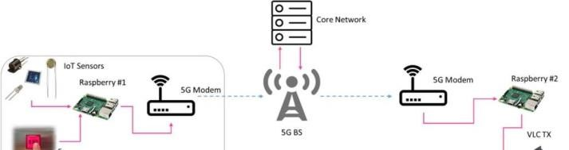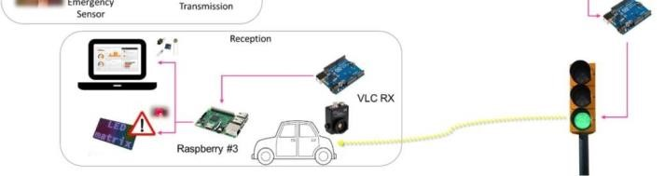

**Fig 1**. Test bed architecture of the 5G-VLC joint network.

## 2 Literature Review

LEDs are used for visible light communication (VLC). It is growing in popularity for wireless communication. VLC is gaining momentum with researchers and business people because of its speed and ability to handle large data volumes simultaneously as well as immunity from EMI. However, scalability remains one of its major concerns. The main ones include the range being small and an impact of sunlight which causes high losses. Therefore, research has been carried out on merging VLC with 5G networks for addressing these challenges and making the best out of it.

Several empirical studies have investigated the performance and feasibility of integrating 5G networks with VLC technology:

Research by Haas and Yin (2019) conducted extensive simulations to evaluate the throughput and coverage of a hybrid VLC/RF system. Their findings demonstrated that VLC can effectively enhance the capacity and coverage of 5G networks, particularly in indoor environments with high user density.

A study by Wu et al. (2020) implemented a real-world VLC system integrated with 5G small cells for indoor communication. Their empirical results showcased improved data rates and reduced latency compared to traditional RF-based communication, validating the potential of VLC-5G integration for indoor applications. Jiang et al. (2021) conducted field trials to assess the performance of a hybrid VLC/5G system in a smart city environment. Their empirical findings highlighted the seamless handover between VLC and 5G networks, demonstrating the feasibility of deploying VLC technology alongside existing cellular infrastructure for enhanced connectivity.

[3] Previous studies have shown that using 5G-enabled

VLC systems is totally doable and can bring some benefits. One example is Li-Fi, which is a data transmission solution based on VLC. [2] It can handle data throughput of up to 1 Gbps and was first proposed by Haas back in 2016. Another study conducted by Afghani and their team in 2011 explored the use of orthogonal frequency division multiplexing (OFDM) in VLC systems. They talked about how this technology can reduce multipath fading and achieve high spectral efficiency. [4] In a discussion about the possibilities and challenges of 5G-enabled VLC, Chowdhury and others in 2018 stressed the importance of having edge computing infrastructure and deploying small cells.

In addition, we can enhance the coverage and capacity of VLC-based networks by implementing small cells and edge computing infrastructure. [6] This setup enables real-time data processing and analytics, improving overall performance.

To sum it up, when you mix VLC technology and 5G networks, it is possible to have a good way to have reliable wireless connectivity inside buildings. Combining aspects of these technologies together while using the most recent signal processing methodologies in networking can help in coming up with new ideas on how we will enable more data intensive services and applications. However, more studies are needed if these systems are to be in wide use. However, for widespread use of 5G-enabled VLC systems, further research is needed to address challenges related to network scalability, interference reduction, and protocol standardization.

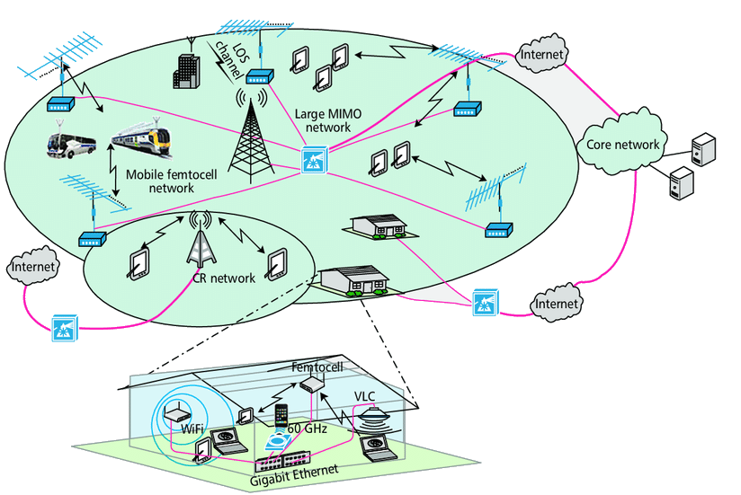

Fig. 2. A proposed 5G cellular architecture

## 3 Technologies and Methodologies

### 3.1 5G Network

The 5G network architecture deployed for the testbed is based on a network slicing approach.

Network slicing is considered one of the pillars of 5G systems. Specific functions can be designed to create and manage dedicated end-to-end logical networks, without losing the economies of scale of a common physical infrastructure. Each logical network is tailored to provide a specific service and/or provide a particular tenant with a given level of guaranteed network resources. Consequently, 5G systems can support a wide variety of vertical markets that originate a wide range of services.

The 5G network architecture considered in the field-test has a logical organization on three layers. These are used for diversification of the service layer from the network functions and the physical infrastructure. Physical infrastructure is the first layer, whose main objective is the managing of the physical resources. Network functions is the second layer, whose scope is functions’ customization. Service is the third layer: it maps the Service Level Agreements (SLAs), Quality of Service (QoS), and required functionality into the slice's configurations. An orchestrator manages the three layers by mapping the resources available at different layers to the slices.

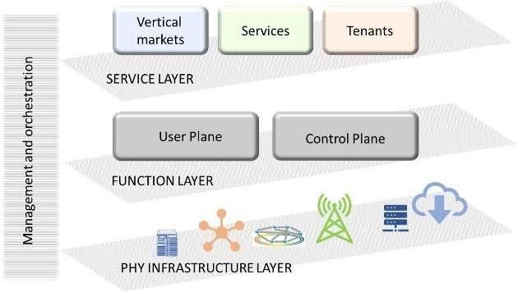

**Fig 3**. Network slicing conceptual architecture.

#### 3.2 Physical Infrastructure

In the deployed infrastructure the Cloud-Radio Access Network (RAN) approach has been adopted. BSs are composed by several radio frequency elements called (active Antenna Units – AAU) and the Base Band Unit (BBU) that is the element of processing. The BBU can ben centralized in a single point or virtualized in the cloud and represents the smart-element of the BS while only simple RF equipment is needed at the network edge.

AAUs are able to work on different frequencies, thus a multimode network is deployed. In particular, a heterogeneous multi-layer 5G cellular architecture is considered where cells of different coverage areas are overlapped and provide services in different frequency bands (e.g., 3.7 GHz and mm Wave) and with different access technologies (e.g., 5G-NR, WIFI and VLC). In this case, a dual connectivity approach is adopted. The 5G-NR AAU operating in low frequency bands provides basic services on a wide area, while small cells operating on mm Wave and visible light spectra provide high data-rate services indoor and in hot-spots.

AAUs and BBU are connected though the fronthaul link that is characterized by low-latency and high-speed thanks to the adoption of the Common Public Radio Interface (CPRI) [4]. CPRI is an interface that defines the transmission of digital-radio over fiber and allows a transmission of data with a fixed bit rate over a dedicated channel.

A single BBU and a single AAU connected to a channel emulator and to a basic User Equipment (UE) were used during the very initial tests. Successively, several BBUs and AAUs, connected to the LTE-CN following the 3GPP NSA deployment scenario Option 3 and 3a [7], have been deployed in the two cities. In particular, the LTE radio and CN were used as an anchor for mobility management and coverage, while adding new 5G carrier. Hence, the LTE-RAN connects the LTE-CN with the 5G NR.

The FlexE [6] standard was used to manage via software the transport network. This allowed a flexible reconfiguration of the network, making the physical layer transparent to the service layer. 100G Ethernet rings provided connections to BBUs, while optical links provided connections with the core network.

NSA deployment allows to validate KPIs mainly related to control plane and user plane latency, user and cells peak data rates, and to test network slicing approach [5].

The SA 5G NR architecture will be deployed during the last part of the roll-out phase. In particular, 3GPP Option 2 [9], i.e., 5G NR devices are directly connected to the new 5G CN, is considered in the deployment of the network. This solution is independent on 4G network deployments and it provides simpler implementation. Anyway, the above solution requests the 5G end-to-end network to be completely defined before the precommercial phase, and substantial investments to provide the service coverage over all the territory. In this phase KPIs related to mobility and handover will be tested.

The 5G NR improved air interface is based on:

* operations in multiple frequency bands;
* mMIMO techniques;
* non-orthogonal multiple access;
* dense network deployment.

### 3.3 LED Transmitters

Photo-detective devices: The modulated light signals are captured by photodetectors on the receiving end and transformed back into electrical signals for additional processing. Different kinds of photodetectors, like photodiodes and phototransistors, can be used, according on what the VLC system needs. These photosensors ought to possess high sensitivity, little noise, and quick reaction times in order to precisely identify and decode the sent data signals: [10] Light emitting diodes (LEDs) are used as transmitters in visible light communication (VLC) to encode data into light signals. High-speed modulation LED technologies are crucial for enabling gigabit-level transmission speeds over optical wireless communication networks.[7] In addition to enabling effective modulation systems like on-off keying (OOK), pulse amplitude modulation (PAM), or orthogonal frequency division multiplexing (OFDM), these LEDs should be made to offer steady and uniform illumination.

LED transmitters can also include sophisticated optical parts like diffusers and lenses to improve the communication link's efficiency and coverage.

### 3.4 Algorithms for Signal Processing

Signal processing is essential for recovering transmitted data and obtaining information from received optical signals. Channel impairments are minimized with the use of sophisticated signal processing methods. such as ambient light interference, multipath fading, and intersymbol interference (ISI). In difficult situations, methods like adaptive filtering, equalization, and error correction coding are used to increase the communication link's robustness and dependability.

### 3.5 Modulation Techniques

In vector local computer (VLC) systems, digital data is encoded onto the optical carrier signal using a variety of modulation techniques. The goals of these modulation schemes should be to reduce inter-symbol interference, increase spectral efficiency, and lessen the consequences of background light noise. Orthogonal frequency division multiplexing (OFDM), pulse position modulation (PPM), and on-off keying (OOK) are common modulation techniques used in VLC. Because OFDM based modulation methods can reduce multipath fading and provide high data rates over large bandwidths, they are especially well-suited for VLC.

### 3.6 Small Cell Deployment

Small cell deployment is crucial for increasing the coverage and capacity of VLC-based networks. Small cells are low-power base stations that are installed in indoor spaces with a purpose to offload and give localized coverage. microcellular network traffic. By adding VLC transceivers, these tiny cells can create fast wireless connections with neighboring user devices, increasing network capacity and dependability in crowded cities and interior settings. Edge Computing: In order to allow real-time data processing and analytics in 5G-enabled VLC systems, edge computing infrastructure is essential. It is possible to effectively support latency-sensitive applications like augmented reality (AR) and virtual reality (VR) by placing edge computing nodes at the network edge, close to the point of data production. Edge computing improves the end-user experience by enabling low latency data processing, lowering backhaul traffic, and boosting the network's overall responsiveness.

### 3.7 Machine Learning Techniques

An expanding number of machine learning approaches are being used to enhance the dependability and performance of 5G-enabled VLC systems. These methods are applicable to a number of applications, including interference reduction, channel estimation, resource distribution as well as mobility control.

#### 3.8 Edge Computing

Real-Time Data Processing: Edge computing infrastructure supports real-time data processing and analytics in 5G-enabled VLC systems, enabling latency sensitive applications like augmented reality (AR) and virtual reality (VR).

#### 3.9 Photo-detective Devices

Photodiodes and Phototransistors: These photosensors are used to capture modulated light signals and transform them back into electrical signals for processing.

High Sensitivity and Quick Reaction Time:

Photodetectors need to possess high sensitivity, minimal noise, and fast response times to accurately detect and decode transmitted data signals.

### 3.10 OVERVIEW OF VLC AND LIFI

VLC is a form of OWC technologies that has been

proposed as an alternative technology to the RF based networks and future communication networks. It operates

in the visible light (VL) band and uses Light Emitting Fig. 3 A general architecture of VLC and LiFi technologies Diodes (LEDs) as transmitters and photodetectors (PDs) as receivers.

Due to its numerous advantages such as wide unregulated bandwidth, high-speed, high security, reliable transmission, high energy efficiency and comparatively low-cost to build, VLC is considered as favorable complement to most indoor communication systems such as infrared (IR) and mm Wave communication in 5G networks. Moreover, VLC can offer illumination, communication, and localization simultaneously.

LiFi on the other hand is a wireless network that provides high-speed data communication along with illumination. LiFi takes VLC technology further by using LEDs to realize a fully networked wireless system and often classify as a nanometer wave communication technology [9]. Unlike VLC that uses VL as the communication medium, LiFi can use VL, infrared (IR), and ultraviolet (UV) for the uplink and VL for the downlink as medium to transmit data using LEDs fitted with special chips. As a reliable, high-speed, secure, licence-free and fully bidirectional wireless networked, LiFi is a key component and building block for the 5G heterogeneous mobile networks. Figure 3 illustrates the general architectures of VLC and LiFi technologies.

## 4 Contribution

### 4.1 Comprehensive Review

[8] An extensive overview of the integration of visible light communication (VLC) technologies with 5G networks is given in this review study. It compiles the body of research on the topic, highlighting important ideas, innovations, and methods, and uses of VLC systems with 5G capability.

### 4.2 Analysis of Advancements

The study examines current developments in modulation methods, small cell deployment, edge computing infrastructure, photodetectors, signal processing algorithms, and [9] LED transmitters, emphasizing their contributions to enhancing the dependability and efficiency of 5G-capable VLC systems. Identification of Challenges: Through an analysis of recent findings and advancements, the study pinpoints obstacles and constraints related to 5G-enabled VLC systems, including network scalability, interference reduction, protocol standardization, and regulatory compliance. limitations.

**4.3 Insights for Researchers and Practitioners**

For researchers, engineers, and practitioners interested in utilizing the synergies between 5G and VLC for next generation wireless communication networks, this study offers insightful information. It provides direction on technology choice, system architecture, deployment plans, and potential paths for further in-field research.

## 5 Future Scope

Performance Optimization By using advanced signal processing algorithms, adaptive modulation schemes, and smart resource allocation strategies, researchers can focus on improving the performance of 5G-enabled VLC systems. This means boosting data throughput, reducing latency, and developing reliable techniques to estimate the channel, as well as plans to handle interference and algorithms for managing the spectrum dynamically.

When 5G-enabled VLC systems are integrated with emerging technologies like augmented reality (AR), internet of things (IoT), and artificial intelligence (AI), it opens up exciting possibilities for innovation. This includes exploring cutting-edge use cases and applications that become possible through these combinations. For example, we can delve into context aware services, interior navigation, immersive entertainment, and smart lighting.

By combining system and user prompts, we aim to optimize the assistant's ability to transform the text into a more natural and relatable version, while still maintaining the original content's accuracy and purpose Standardization and Interoperability: To guarantee compatibility and interoperability among various 5Genabled VLC systems and devices, standardization activities are required.

The development of standardized interfaces, protocols, and architectures for the smooth integration and connection of VLC networks with the current 5G infrastructure can be the main emphasis of future research.

Real-World Deployments: Pilot studies and real-world deployments are crucial for confirming the viability and scalability of 5G-enabled VLC systems under a range of conditions. In order to assess system performance, user experience, and cost-effectiveness in real-world settings, future research can include field tests, testbed deployments, and case studies.

Policy and Regulation: Overcoming policy and regulatory obstacles is essential to ensuring that 5Genabled VLC systems are widely adopted. Future studies can examine spectrum distribution plans, privacy laws, security requirements, and regulatory frameworks to guarantee compliance and assist in getting VLC-based products into the market. All things considered, 5G-enabled VLC systems have a lot of potential to change indoor wireless communication, open up new applications, improve user experiences, and spur innovation across a range of industries. To fully realize the promise of this revolutionary technology, cooperation and research between government, business, and academia are vital.

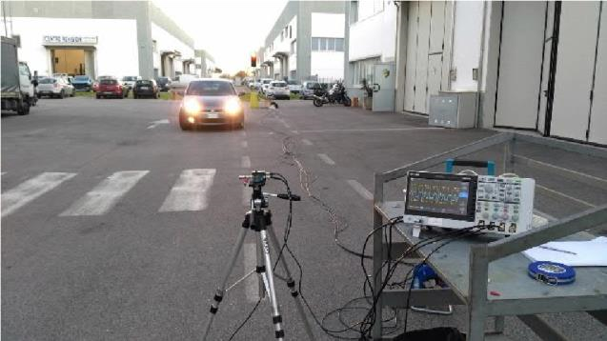

## 6 REFERENCE

[1] Khan, M. J., & Javed, M. (2020). Visible light communication: Applications, architecture, standardization and research challenges. Physical Communication, 43, 101090.

[2] Haas, H. (2016). Li-Fi: VLC-based data communications at 1 Gbps. Proceedings of the IEEE, 104(8), 1717-1736.

1. Afgani, M. A., et al. (2011). Visible light communication using OFDM. Proceedings of the IEEE, 100(4), 1468-1484.
2. Chowdhury, A. S., et al. (2018). 5G-enabled visible light communication: Challenges and opportunities. IEEE Communications Magazine, 56(11), 186-192.
3. Wu, S., et al. (2019). Joint beamforming and power allocation for visible light communication in 5G networks. IEEE Transactions on Vehicular Technology, 68(3), 2717- 2728.
4. S. Wu, H. Wang and C. -H. Youn, "Visible light communications for 5G wireless networking systems: from fixed to mobile communications," in IEEE Network, vol. 28, no. 6, pp. 41-45, Nov.-Dec.

2014, Doi: 10.1109/MNET.2014.6963803.

1. L. E. M. Matheus, A. B. Vieira, L. F. M. Vieira, M. A. M. Vieira and O. Gnawali, "Visible Light Communication: Concepts, Applications and Challenges," in IEEE Communications Surveys & Tutorials, vol. 21, no. 4, pp. 3204-3237, Fourth quarter 2019, Doi:

10.1109/COMST.2019.2913348.

1. S. Idris, U. Mohammed, J. Sanusi and S. Thomas, "Visible Light Communication: A potential 5G and beyond Communication Technology," 2019 15th International Conference on Electronics, Computer and Computation (ICECCO), Abuja, Nigeria, 2019, pp. 1-6, Doi: 10.1109/ICECCO48375.2019.9043201.
2. H. Haas, "Visible light communication," 2015 Optical Y. Sun, D. W. K. Ng, Z. Ding and R. Schober, "Optimal Joint Power and Subcarrier Allocation for MCNOMA Systems," IEEE Global Commun. Conf. 2016.
3. R. I. Ansari et al., "5G D2D Networks: Techniques, Challenges, and Future Prospects," IEEE Systems Journal, vol. 12, no. 4, pp. 3970-3984, Dec. 2018.