**Food Wastage Monitoring System**

Dr.M.Sridevi G.Nagender Reddy K.Kumara Srinivas Reddy S.Dhanush Reddy

[hodds@anurag.edu.in](mailto:hodds@anurag.edu.in) [20eg110107@anurag.edu.in](mailto:20eg110107@anurag.edu.in) [20eg110113@anurag.edu.in](mailto:20eg110113@anurag.edu.in) [20eg110126@anurag.edu.in](mailto:20eg110126@anurag.edu.in)

Associate Professor Anurag University Anurag University Anurag University

Head of the department Hyderabad Hyderabad Hyderabad

Department of Datascience

1. **Abstract**

The Food Wastage Monitoring System for College Canteen is a project aimed at reducing food waste in college canteens by implementing an efficient monitoring system. Our motivation for this project is to tackle the issue of food waste in our college canteen by implementing a Food Wastage Monitoring System. We believe that by taking action at the canteen level, we can inspire a culture of sustainability within our college community and contribute to a more sustainable future. Food wastage in college canteens is a significant issue that contributes to inventory loss, financial inefficiency, overproduction and also spoils the college environment. As a result, valuable resources are wasted, leading to increased costs and negative impacts. To address the food wastage issue in the college canteen, we propose implementing a Food Wastage Monitoring System using IoT devices. The system will utilize smart weighing scales, load cells, RFID-enabled weighing systems, and IoT-enabled display units to measure the weight of food items and display it in real-time. The weight data will be saved using data logging devices for further analysis.

1. **INTRODUCTION**

Food wastage is a pressing global concern with far-reaching implications for the environment, finances, and sustainability. In educational institutions such as college canteens, this issue is particularly significant due to the large volumes of food prepared daily and the associated challenges of managing food inventory efficiently. Our project, the "Food Wastage Monitoring System " addresses this critical problem by implementing an innovative and technology-driven solution. This project is motivated by the urgent need to reduce food wastage within our college community while instilling a culture of sustainability. By employing Internet of Things (IoT) devices, data collection, and cloud-based analytics, we have developed a comprehensive system that not only monitors the quantities of food being wasted but also actively engages students and canteen management in understanding and mitigating this wastage. According to the FSSAI (Food Safety and Standards Authority of India), one-third of all food in India is wasted or gets spoilt before it is eaten. Food Wastage Monitoring System showcases how technology, sustainability, and community involvement come together. It highlights our dedication to reducing food wastage, encouraging mindful eating, and supporting environmental protection efforts. Our project helps to raise awareness among students about the amount of food wasted in the canteen and to educate students about the consequences of food waste, such as its environmental impact and the social implications for communities.

**Proposed System:**

To address the food wastage issue in the college canteen, we propose implementing a Food Wastage Monitoring System using IoT devices. The system will utilize smart weighing scales, load cells, HX711,Arduino and IoT-enabled display units to measure the weight of food items and display it in real-time.The weight data will be saved using data logging devices for further analysis.

1. **Installation of sensors and IoT devices:** Implement sensors and IoT devices in various garbage bins of the canteen to monitor food disposal.
2. **Data collection and analysis:** Gather data from sensors and IoT devices, including food items purchased, prepared, consumed, and wasted. Analyze the collected data to identify patterns and trends.
3. **Real-time monitoring:** Develop a device to display real-time data on food waste levels.
4. **Reporting and insights:** Generate regular reports and insights based on the data analysis, highlighting areas of improvement and suggesting strategies to minimize food waste.

The software and hardware requirements for this project have been thoughtfully selected to a wide range of user needs, balancing accuracy and flexibility.

The development environment comprises essential tools like Arduino UNO Board, LoadCell, Button , Buzzer, LED Display, Wifi Modular, Aling Board. The Arduino UNO board processes the measured weight data and stores it for analysis.

If there is a significant change in the weight, indicating food wastage, the system processes this information for further action. The Food Wastage Monitoring System continuously measures food waste, and transmits data for analysis. The system empowers food service establishments to take proactive measures to reduce food wastage, improve operational efficiency, and contribute to environmental sustainability.

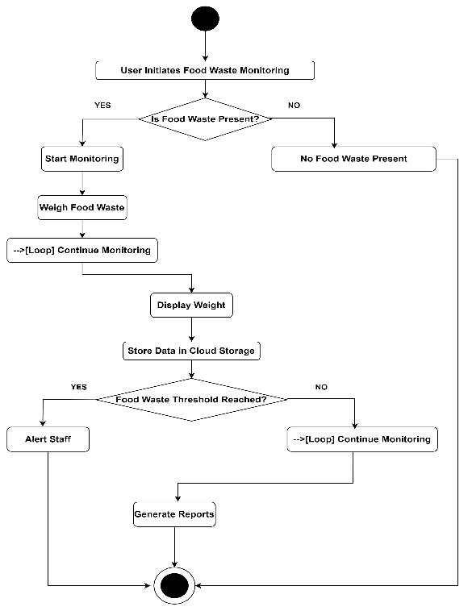

1. **IMPLEMENTATION**

The Food Wastage Monitoring System project can be broken down into several modules, each responsible for specific functions and components of the system. Here's a module description for the project:

1. Hardware Module:This module encompasses all the physical hardware components of the system, including the load cell, button, buzzer, LED display, Arduino UNO board, WiFi module, and alignment board.

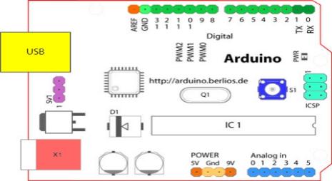

**Figure 1 Structure of Arduino Board**

1. Data Processing Module:This module focuses on processing the data collected from the load cell. It involves data manipulation and storage for further analysis.

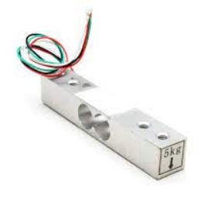

**Figure 2 : Load Cell**

1. User Interface Module:This module deals with the user interaction aspect of the system. It includes the interface elements such as buttons and LED displays.

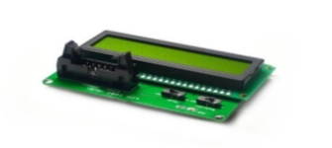

**Figure 3 : LCD Display**

1. Data Transmission Module:This module handles the communication between the system and external servers or dashboards. It utilizes the WiFi module for real-time data transmission.

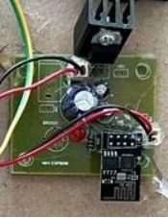

**Figure 4 : WIFI Module**

1. Data Analysis and Reporting Module:This module is responsible for analyzing the data collected by the system to identify patterns, trends, and areas for waste reduction.
2. **Results:**

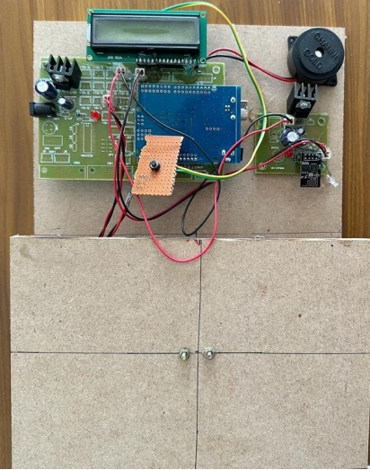

**Figure 5: Final Device**

The above Figure is the Final Device which consists of all the components described and it succesfullly measures the weight and sends it to the ThingSpeak Cloud Platform

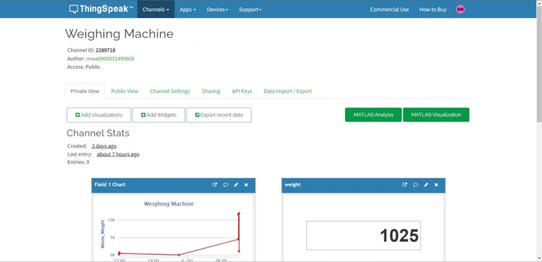

**Figure 6: Thingspeak Platform**

The above Figure is the platform which arduino send the weight data and this platform provide features like Visual representation, Displaying way in numeric or Guage form and also exports data in form of filetypes like JSON, XML, CSV.

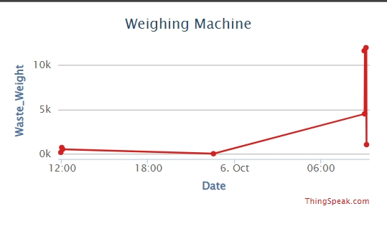

**Figure 7: Visual Represntation**

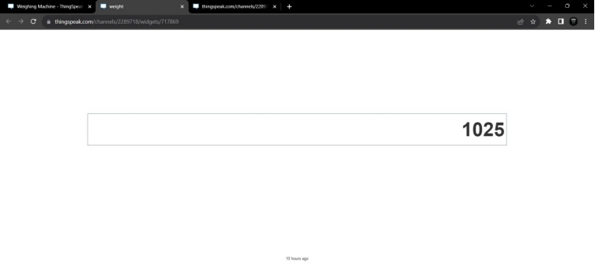 **Figure 8 Numeric Display**

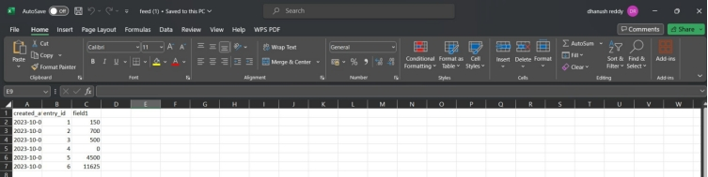

**Figure 9: Exported data in form of CSV file**

1. **CONCLUSION**

Food Wastage Monitoring System for College Canteen' project reflects our dedication to solving a global issue: food wastage. We've combined technology, sustainability, and community involvement to create a practical solution that works.This project isn't just about high-tech gadgets; it's about doing our part to reduce food waste. We've shown that by working together and using smart solutions, we can make a big difference in the fight against food wastage."

Through the deployment of Internet of Things (IoT) devices, a cloud-based analytics platform, and a user-friendly interface, we have not only successfully monitored and quantified food wastage in our college canteen but also initiated a transformation in behavior and awareness among students and canteen staff. By shedding light on the extent of food wastage and its consequences, we have empowered our community to make informed decisions about food consumption and waste reduction.

1. **Acknowledgement:**

We extend our sincere gratitude to all those who contributed to the development and implemention of Food wastage monitoring system . We would like to express our appreciation to Dr. M. Sridevi ,Assosiate Professor, Head of the Department, Department of Data Science, for her valuable guidance and support throughout the project. We also acknowledge the efforts of our team for their dedication and hardwork in bringing this project to fruition. Additionally, we would like to thank the faculty and participated in testing and refining the application. Finally, we are grateful for the support and resources provided by Anurag University, which made this project possible.

1. **References**
2. Soujanya V. Kivadanavar. A Novel Approach to Food Waste Management. International Journal of Scientific Research in Science and Technology (IJSRST), Volume 3, Issue 6, Print ISSN: 2395-6011, Online ISSN: 2395-602X

[2] Tejashree Kadus, Pawankumar Nirmal, and Kartikee Kulkarni. Smart Waste Management System using IOT. International Journal of Engineering Research and vol. V9, no. 04, May 2020

[3] S. Navghane, M. Killedar, and V. Rohokale, “IoT based smart garbage and waste collection bin,” *International Journal of Advanced Research in Electronics and Communication Engineering*, vol. 5, no. 5, pp. 1576–1578, 2016

[4] Louis, Leo. (2018). Working Principle of Arduino and Using it as a Tool for StudyandResearch. International Journal of Control, Automation, Communication and Systems.

[5] Nettikadan, David & Raj M S, Subodh. (2018). Smart Community MonitoringSystemusing Thingspeak IoT Plaform.

[6] Hong, S. Park, B. Lee, J. Lee, D. Jeong, and S. Park. IoT-based smart garbage systemforefficient food waste management. The Scientific World

Journal, vol.2014, Article ID 646953, 13 pages, 2014.

[7] R. Jai Ganesh, A. Arun Kumar, B. Devisri, P. Pragadeesh, N. Srivathsan. IoTbasedCovid Patient health monitor during self-quarantine. Turkish Online Journal of Qualitative Inquiry (TOJQI) Volume 12, Issue 6, July, 2021: 7750-7762.

[8] Daniel Gold Sam C, Mohamedabdulazeez M, Mithinesh S, Jeyanthi S. Air and Water Quality Monitoring System. International Journal of Scientific

Research in Science and Technology (IJSRST), Volume 9, Issue 1, March-April 2021, Print ISSN: 2395-6011, Online ISSN: 2395-602X.

1. Pranav Kaarthick. R, Dhamodaran. P, Ramanan. S, Bharathi. B, Jeyanthi. S. IB- SAEMACS: IoT Based Smart Autonomous Environment Monitoring and Control System. Vol. 8, Issue 2, February 2019, ISSN (Print): 2320 – 3765 ISSN(Online): 2278 – 8875.
2. Pavan Manjunath, Pritam Gajkumar Shah. IOT Based Food Management System. WebPublication. https://ieeexplore.ieee.org/document/903253.
3. Shazmina Gull, Imran Sarwar Bajwa, Waheed Anwar, and Rubina Rashid. IoT-basedsmart garbage system for efficient food waste management. The Research Article, vol. 2021, Article ID 9931228, 13 pages, 2021.

[12] N.Gayathri , A.R.Divagaran , C.D.Akhilesh ,V.M.Aswiin , N.Charan. IoT- basedsmart garbage system for efficient food waste management. 7th International conference on advanced computing and communication systems, vol.2021, Article ID 9441819.