### FREIGHT FORWARDING OPERATIONS AT 5 WAY LOGISTICS SOLUTION PRIVATE LIMITED, CHENNAI

**Mohamed Hanifsha A, MBA (SLM) Dr.D.Anitha Kumari, Assistant Professor SCHOOL OF MANAGEMENT STUDIES**

**VELS INSTITUTE OF SCIENCE, TECHNOLOGY AND ADVANCED STUDIES (VISTAS),CHENNAI - 600 117**

## ABSTRACT

The complex planning required to move goods from one location to another is known as freight forwarding operations, and it is an essential part of international trade. Serving as a go-between for shippers and carriers, freight forwarders painstakingly plan every step of the shipping process, from comprehending the needs of the client to organizing the modes of transportation, handling paperwork and compliance, facilitating customs clearance, organizing warehouse storage, guaranteeing safe handling and packaging of the cargo, offering risk management and insurance, facilitating final delivery and distribution, and providing ongoing customer support. Bills of lading, packing lists, customs declarations, commercial invoices, and other important shipping documents are essential to this process. Freight forwarders simplify logistical difficulties, maximize transit routes and modes, guarantee regulatory compliance, reduce risks, improve supply chain efficiency, and speed up international trade procedures by utilizing their experience.

### INTRODUCTION

The process of organizing the movement of products from one place to another, including activities like delivery, pick-up, and customs clearance, is known as freight forwarding. By coordinating different logistics services to ensure smooth transportation of commodities, it plays a critical role in global trade. As a middleman between shippers and carriers, freight forwarders arrange the various modes of transportation according to the needs of their clients and take care of all paperwork, customs clearance, and logistical planning. They manage things like choosing the best means of transportation, making reservations, processing paperwork and compliance, clearing customs, storing cargo in warehouses, handling insurance, making the final delivery, and providing customer service. Careful planning, knowledge of international logistics, and compliance with trade laws are all necessary for the procedure. Logistics risks are decreased, operational efficiency is increased, supply chain efficiency is optimized, and international trade is facilitated by freight forwarding service International trade is facilitated by freight forwarding services, which also lower logistical risks, increase operational efficiency, and maximize supply chain efficiency.

The process of organizing international cargo transportation, including pick-up, delivery, and managing required documentation and customs clearance, is known as

freight forwarding. As go-betweens for shippers and carriers, freight forwarders handle logistics on behalf of customers. Understanding client requirements, choosing the best mode of transportation, keeping track of paperwork and compliance, scheduling with carriers, facilitating customs clearance, organizing warehouse storage, supervising cargo handling and packaging, offering risk management and insurance, planning final delivery and distribution, and providing customer service and support are all crucial elements. The commercial invoice, packing list, customs declaration, bill of lading, marine waybill, air waybill, rail waybill, arrival notice, certificate of origin, and letter of credit are among the most crucial shipping documents. International trade is facilitated by freight forwarding

In order to transfer goods from one place to another effectively, logistics and transportation must be coordinated, a process known as freight forwarding is essential to international trade. It includes things like choosing a mode of transportation, making sure all paperwork is in order, clearing customs, managing cargo, and making the final delivery. By serving as a go-between for shippers and carriers, freight forwarders guarantee efficient operations and adherence to global laws. They make it easier for commodities to move by cutting costs, reducing hazards with preventative measures like cargo insurance, and optimizing transportation routes and modes. For companies involved in international trade, freight forwarding is critical because it facilitates smooth customs clearance and compliance, optimizes transportation routes, and manages risks.

Coordinating the movement of products from one place to another, including pick-up, transport, and delivery, in addition to managing the required documentation and customs clearance, is known as freight forwarding. This service is essential to international trade since it manages a variety of logistics and transportation services, maximizing supply chain efficiency and enabling smooth international trade. As a middleman between shippers and carriers, freight forwarders arrange for various modes of transportation, take care of paperwork and compliance, make reservations with carriers, handle customs clearance, provide warehouse storage, supervise the handling and packaging of cargo, provide insurance and risk management, plan final delivery and distribution, and offer customer support. The freight forwarder, shipper/exporter, carrier/transporter, customs brokers, consignee/importer, warehouse operator, documentation specialist, and others are the main responsibilities in freight forwarding activities.

The process of organizing the movement of products from one place to another, including pick-up, delivery, and handling documentation and customs clearance, is known as freight forwarding. In order to guarantee seamless shipments, freight forwarders serve as a go-between for shippers and carriers, organizing shipping services and handling logistics. Understanding client requirements, choosing transportation options, managing paperwork and compliance, scheduling and processing shipments, overseeing customs clearance, organizing warehouse storage, managing cargo and packaging, offering insurance and risk management, planning final delivery and distribution, and providing customer service and support are all important aspects of freight forwarding. Commercial invoices, packing lists, bills of lading, customs declarations, maritime waybills, air waybills, rail waybills, arrival notifications, certificates of origin, and letters are among the crucial shipping documents involved.

## INDUSTRY PROFILE

As the backbone of international trade, the shipping sector makes it easier to transport commodities across great distances and links economies all over the world. This business, with its complex web of ships, ports, and logistics facilities, is essential to the continuation of global trade. Shipping is an essential means of moving goods across waterways, seas, and oceans, from the delivery of finished items to the conveyance of raw materials. It is important for more than just transportation; it is important for supply chain management, logistics, and regulatory compliance. As the backbone of the world economy, the shipping sector is always changing to meet the needs of a connected world, overcoming obstacles and seizing chances for advancement and expansion. The significance of the maritime sector The maritime sector is extremely significant in

From 2023 to 2032, the global freight forwarding market is expected to develop at a rate driven by the ongoing expansion of international trade and logistics. Over this time, the market is expected to grow at a compound annual growth rate of about 5.5%. The market is projected to reach USD 320 billion by 2032, from a projected valuation of USD 200 billion in 2022. The global supply chain relies heavily on the freight forwarding sector to make it easier for commodities to travel between different forms of transportation. This market includes a range of services that serve different end- users and sectors, such as air, ocean, road, and rail freight. The size of the worldwide freight forwarding market was estimated at USD 200.98 billion in 2022, and compound annual growth is anticipated.

.

## COMPANY PROFILE

In addition to air and marine freight forwarding, 5way International Logistics Solutions provides full logistics services and transportation solutions through a variety of cargo channels worldwide. Being a non-asset-based forwarder, they provide a range of choices and specialized methods to satisfy specific shipping requirements, both domestically and abroad. They guarantee the prompt and safe delivery of shipments through their expert administration of air and sea freight forwarding, which includes customs brokerage and bonded warehousing. With a dedication to quality and security, along with years of experience, they offer cost-effective shipping, logistics, and marine services on a global scale. Their goal is to surpass client expectations, dominate the multimodal logistics industry, and create enduring bonds with honesty, excellence, devotion, and innovation. Their services include international transportation, warehouse logistics, freight forwarding, customs clearance.

## OBJECTIVE OF STUDY PRIMARY OBJECTIVE

* Freight forwarding operations.

## SECONDARY OBJECTIVE

* To understand the process involved in the fright forwarding in the 5 way logistics.
* To analyse the effectiveness of transportation services provided in the company.
* To identify service quality towards the documentation process in the company.
* To assess the overall operational process involved in the fright forwarding.

## NEED FOR STUDY

A study of freight forwarding facilitates understanding of international trade and the cross-border movement of products.By mastering freight forwarding procedures, one may effectively control the shipping process and guarantee that items arrive at their destination on schedule.Understanding and following trade laws and customs processes, together with freight forwarding, can help avoid delays and fines.Ensuring seamless operations involves identifying and minimizing risks, such as cargo damage or customs issues.Coordinating freight forwarding entails managing a number of supply chain activities, such as documentation, transportation, customs clearance, and regulatory compliance. Comprehending these intricacies is crucial for effectively overseeing the transportation of commodities across various means of transportation and international boundaries.The operations of freight forwarding carry inherent risks,

such as non-compliance with regulations, delays, damages, and geopolitical uncertainty. Researching freight forwarding facilitates the identification of possible hazards and the application of tactics.

## SCOPE OF STUDY

* The study provides the state of art of technology that may very from situation to situation.
* Import and Exporter need to knowledgeable about all the important process involved in the documentation.
* The purpose of the study is understanding the satisfaction of clients at 5Way logistics the covers the different work schedules.

## STATEMENT OF PROBLEM

During freight forwarding operations, a number of crucial problems may occur that affect the efficacy, dependability, and affordability of cargo transportation. The absence of real-time visibility and openness in the supply chain is a major issue. Stakeholders frequently have difficulties in effectively monitoring the flow of commodities, which can result in delays, inefficiencies, and possible interruptions. Navigating trade laws, compliance standards, and customs procedures can be difficult due to the complicated regulatory environment. For freight forwarders and their clients, this may mean more paperwork, penalties, and delays. Furthermore, obsolete technologies and ineffective documentation procedures amplify operational difficulties, obstructing the efficient movement of goods and lowering supply chain performance overall. In addition, the sector has to deal with sustainability issues like carbon emissions, environmental effects, and the requirement for more eco-friendly procedures. Taking these issues up

## REVIEW OF LITERATURE

**Apeksha Garg (2023),** Analyze primary goal of this research was to comprehend some of the difficulties and factors that influence the goods forwarding industry that companies who handle the distribution and forwarding of shipper cargo face in their logistical operations. A goods forwarder is an individual or business that arranges shipping for people or businesses to get significant orders from producers or manufacturers to markets or ultimate points of distribution. Forwarders will get into a contract with a carrier to help with the transportation of goods. A forwarder is a supply chain specialist rather than a carrier in most cases.

**J Kirubakaran (2012),**They addition to general-purpose cargo, India's marine trade consists of export-import trade in a variety of bulk commodities, including coal, iron

ore, and other petroleum products. An upheaval in the management of value-added items through containers and the transportation of cargo to many Indian ports results from the economic emancipation. These services have been redefined by container transportation, which has likewise developed into an extremely complex logistical industry. Many goods forwarding agents today arrange for commodities to be transported by land, sea or air. Their areas of expertise are shipping and insurance arrangements. They relieve the exporters of a significant amount of effort. They adhere to all documentation requirements for customs clearance. Additionally, they handle the cargo storage and carting both prior to export consignment shipment and following discharge**.**

**G Yoganandan, KE Balaji (2018),** Analyze the clients compare the features of many businesses where they are happy with the services provided, they should have a better view of the services provided by those companies. In contrast to other product and industrial sectors, goods forwarding clients have high expectations for their services. Also referred to as a non-vessel operating common carrier (NVOCC), a goods forwarder, forwarder, or forwarding agent arranges shipments for individuals or businesses so that their products are delivered from a producer or manufacturer to a market, client, or final point of distribution. For the purpose of moving the goods, forwarders enter into contracts with one or more carriers. An agency that organizes cargo on behalf of importers, exporters, or other organization is known as a goods forwarder.

**Svitalana Illinich, Nikhil Singh (2023),**A study on primary goal of this research was to comprehend some of the difficulties and factors that influence the goods forwarding industry that companies who handle the distribution and forwarding of shipper cargo face in their logistical operations. A goods forwarder is an individual or business that arranges shipping for people or businesses to get significant orders from producers or manufacturers to markets or ultimate points of distribution. Forwarders will get into a contract with a carrier to help with the transportation of goods. A forwarder is a supply chain specialist rather than a carrier in most cases.

## RESEARCH METHODOLOGY

A methodical technique to resolving the research challenge is known as research methodology. As long as research is done in a scientific manner, it can be done as a science. The research process is crucial to gathering data. Commonly speaking, research is the pursuit of knowledge. Research can also be defined as a methodical, scientific search for relevant data on a certain subject. Actually, research is a kind of artistic scientific inquiry. Research is defined as "a careful investigation or enquiry, especially through search for new facts in any brand of knowledge" in the Learner's Dictionary of Current English.Traveling from the known to the unknown is the definition of research. It's an attempt to make a discovery. Clifford Woody states that "defining and redefining problems is a part of research."

The questionnaire design covers six parts, covering personal details of employees and their perceptions of various issues related to freight forwarding. Hypotheses are formulated to explore relationships between different variables, and several hypotheses are presented to investigate various aspects of the research problem. Statistical tools used for data analysis include percentage analysis, chi-square analysis, correlation analysis, and weighted average calculation. SPSS (Statistical Package for the Social Sciences) is used as the primary statistical tool for data analysis, offering features for descriptive statistics, inferential statistics, and data visualization. Analytical tools such as Microsoft Excel and chart diagrams are also utilized for data interpretation.

However, the study acknowledges limitations, including potential biases in employee opinions, respondents' reluctance to disclose information due to management fears, and the need for caution when generalizing results to other contexts. Additionally, challenges related to sample collection due to the relatively small size of logistics and shipping companies are highlighted

## DATA ANALYSIS AND INTERPRETATION

TABLE 1:FREIGHT FORWARDERS PROVIDE EFFICIENT AND RELIABLE TRANSPORTATION SOLUTIONS.

|  |  |  |
| --- | --- | --- |
| **FACTORS** | **NO OF RESPONSE** | **PERCENTAGE** |
| STRONGLY AGREE | 8 | 12% |
| AGREE | 33 | 52% |
| NEUTRAL | 10 | 10% |
| DISAGREE | 11 | 11% |
| STRONGLY DISAGREE | 8 | 2% |
| **TOTAL** | 70 | 100% |

TABLE 1:FREIGHT FORWARDERS PROVIDE EFFICIENT AND RELIABLE TRANSPORTATION SOLUTIONS.

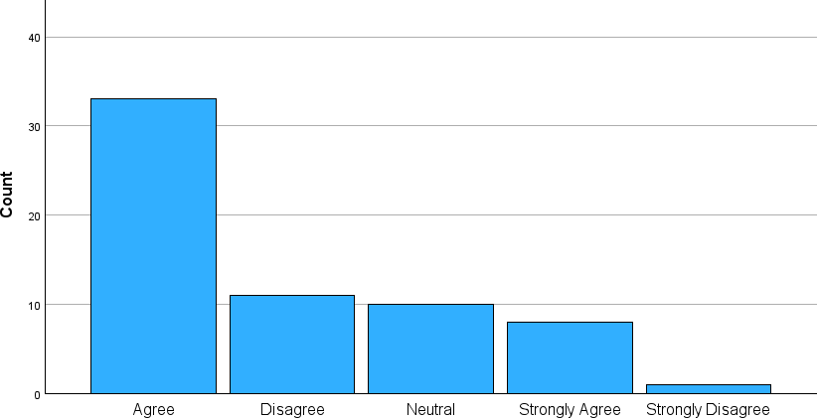

# INFERENCE:

From the above chart we can see 52% of respondents Agree, 2% of respondents Strongly Disagree to provide efficient and reliable transportation solutions.

### TABLE 2;FREIGHT FORWARDERS ACCURATELY HANDLE DOCUMENTATION AND CUSTOMS CLEARANCE

|  |  |  |
| --- | --- | --- |
| **FACTORS** | **NO OF RESPONSE** | **PERCENTAGE** |
| STRONGLY AGREE | 19 | 30.27% |
| AGREE | 21 | 33.3% |
| NEUTRAL | 10 | 16% |
| DISAGREE | 8 | 12.7% |
| STRONGLY DISAGREE | 5 | 5% |
| **TOTAL** | 63 | 100% |

**TABLE 2;FREIGHT FORWARDERS ACCURATELY HANDLE DOCUMENTATION AND CUSTOMS CLEARANCE**

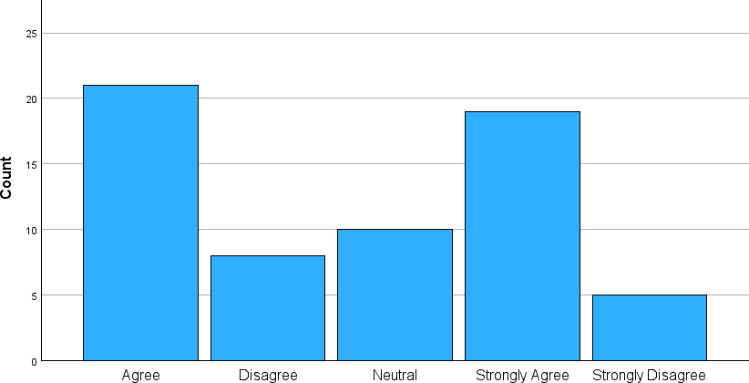

# INFERENCE:

From the above chart we can see 5% of respondents Strongly Disagree, 33.3% of respondents Agree to accurately handle documentation and customs clearance

### TABLE 3: FREIGHT FORWARDERS EFFICIENTLY HANDLE UNEXPECTED ISSUES OR DELAYS

|  |  |  |
| --- | --- | --- |
| **FACTORS** | **NO OF RESPONSE** | **PERCENTAGE** |
| STRONGLY AGREE | 12 | 19% |
| AGREE | 19 | 30% |
| NEUTRAL | 10 | 16% |
| DISAGREE | 15 | 23.3% |
| STRONGLY DISAGREE | 7 | 11.1% |
| **TOTAL** | 63 | 100% |

**TABLE 3: FREIGHT FORWARDERS EFFICIENTLY HANDLE UNEXPECTED ISSUES OR DELAYS**

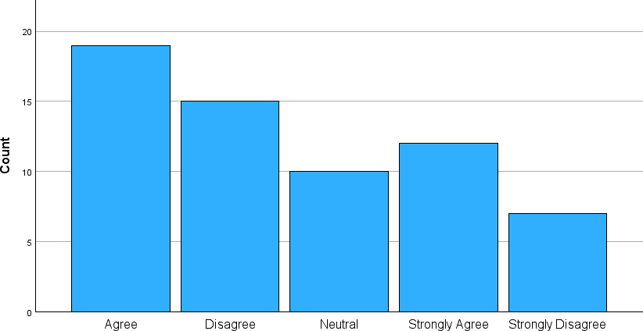

# INFERENCE:

From the above chart we can see 30% of respondents Agree, 11.1% of respondents Strongly Disagree to handle unexpected issues or delays.

## WEIGHTED AVERAGE METHOD

**TABLE 1: WEIGHTED AVERAGE METHOD FOR THE FREIGHT FORWARDERS EFFICIENTLY HANDLE UNEXPECTED ISSUES OR DELAYS.**

|  |  |  |  |
| --- | --- | --- | --- |
| **LEVEL OF**  **AGREE** | **NO OF RESPONDENTS** | **WEIGHTED ASSIGNED** | **WEIGHT AVERAGE** |
| STRONGLY  AGREE | 12 | 5 | 60 |
| AGREE | 19 | 4 | 76 |
| NEUTRAL | 10 | 3 | 30 |
| DISAGREE | 15 | 2 | 30 |
| STRONGLY  DISAGREE | 7 | 1 | 7 |
| TOTAL | 63 |  | 203 |

Source: Primary data

Weight Average Method=total of weight average/total of number of respondents.

=203/63

=3.22

# INFERENCE:

Its is inferred that majority of the respondents agree that the freight forwarding efficiently handle unexpected issues and delays.

**Null Hypothesis(H0):**

**CHI SQUARE**

There is no significant association between the transportation services provide by the company are reliable and the documentation is update regularly to reflect changes in company process.

### Alternate Hypothesis(H1):

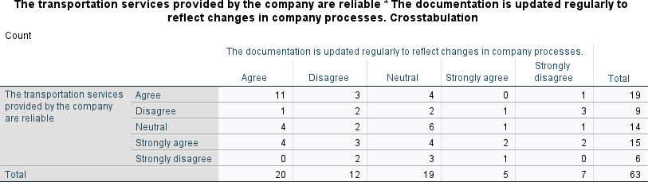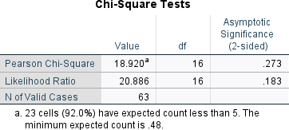There is significant association between the transportation services provide by the company are reliable and the documentation is update regularly to reflect changes in company process.

From the above table, the P value is 18.920 and the significant level is .273 since the calculated value is greater than the P value (.273>0.05). Therefore it denotes null hypothesis is accepted and rejects the alternative hypothesis, so there is no significant association between the transportation services provide by the company are reliable and the documentation is update regularly to reflect changes in company process.

## CORRELATIONS

**Null Hypothesis (H0):**

There is no significant relationship between freight forwarders accurately handle documentation and customs clearance and freight forwarders efficiently handle unexpected issues or delays.

## ALTERNATE HYPOTHESIS (H1):

There is no significant relationship between freight forwarders accurately handle documentation and customs clearance and freight forwarders efficiently handle unexpected issues or delays.

**Correlations** Freight forwarders accurately handle documentation and customs clearance

|  |  |  |  |
| --- | --- | --- | --- |
| Freight forwarders accurately handle documentation and customs clearance | Pearson Correlation | 1 | -.108 |
| Sig. (2-  tailed) |  | .398 |
| N | 63 | 63 |
| Freight forwarders efficiently handle unexpected issues or delays | Pearson Correlation | -.108 | 1 |
| Sig. (2-  tailed) | .398 |  |
| N | 63 | 63 |

Freight forwarders efficiently handle unexpected issues or delays

Correlation value is -.108 and the p value is .398

Correlation r 65 = (Total number of sample size-degrees of freedom, (i-e)63-2=61) Since the calculated value is greater than the P value (-.108<0.05).then it denotes null hypothesis is rejected and accepted the alternative hypothesis. So the test is significant (There is no significant relationship between freight forwarders accurately handle documentation and customs clearance and freight forwarders efficiently handle unexpected issues or delays and the correlation lies between +1 to -1

### RESULT

**R (61) = -.108, P .398.**

## XII. FINDING OF STUDY

**FINDING**

* 33% of respondents think neutral that The booking and reservation process for transportation services is straightforward.
* 34% of respondents think agree for The transportation services are accessible and available when needed
* 34.9% of respondents think agree of the The transportation services are accessible and available when needed

### CHI SQUARE

* There is no significant association between the transportation services provide by the company are reliable and the documentation is update regularly to reflect changes in company process.
* There is no significant association between the transportation services provide by the freight forwarders provide efficient and reliable transportation solutions and communications between freight forwarders and clients is clear and effective.

### CORRELATION

* There is no significant relationship between freight forwarders provide efficient and reliable transportation solution and communication between freight forwarders and clients is clear and effective.
* There is no significant relationship between freight forwarders accurately handle documentation and customs clearance and freight forwarders efficiently handle unexpected issues or delays.

### WEIGHTED AVERAGE

* Its is inferred that majority of the respondents agree that the freight forwarding efficiently handle unexpected issues and delays.
* Its is inferred that majority of the respondents agree that the tracking and monitoring of shipment are accurate and timely.

## XXI. SUGGESTIONS

* Transportation services tailored to individual client requirements, taking cargo kind, destination, and urgency into account. Constantly broaden and fortify alliances with suppliers, agents, and carriers to guarantee worldwide coverage and a variety of service choices.

●

To ensure seamless clearance and compliance, stay up to date on all documentation requirements, such as customs papers, permits, and certificates.

Install strong security measures, including as tracking systems, secure packing, and surveillance, to guard against theft, tampering, or damage to shipments while they are in transit.

●

Maximize container usage and save expenses for the company and its clients by optimizing cargo consolidation.

Make delivering prompt updates, proactive communication, and prompt resolution of questions or difficulties your top priority in order to deliver outstanding customer service

* .

Provide a variety of transportation methods (air, sea, road, and rail) and adaptable delivery choices to meet the demands of different clienteles and price ranges.

## XIV. CONCLUSION

The successful and effective delivery of commodities from point of origin to point of destination is the result of freight forwarding activities. This calls for exacting attention to detail at every stage of the procedure, including coordination of the logistics, paperwork, and adherence to regulations. It is crucial to make sure the goods are safely received and that any problems are resolved as soon as they arise. The completion of financial transactions and the collection of customer feedback allow for ongoing service quality improvement. Regulation compliance, route optimization, and carrier performance evaluation are still top priorities. In the end, the completion of freight forwarding operations denotes the achievement of logistical goals while maintaining a dedication to quality and client satisfaction.

The successful and dependable transportation of commodities from their point of origin to their destination is the result of freight forwarding operations. This calls for painstaking attention to detail at every stage of the procedure, from