**An analysing of DG cargo documentation and handling procedures**

**SARAN.S, MBA shipping and logistics management, Vels Institute of Science and Technology and Advanced Studies (VISTAS), Pallavaram, chennai** [**saransekar5610@gmail.com**](mailto:saransekar5610@gmail.com)

**Corresponding Author: Anitha Kumari D, Professor, School Management studies, Vels Institute of Science and Technology and Advanced Studies (VISTAS), Pallavaram, Chennai,** [**anitha.sma@velsuniv.ac.in**](mailto:anitha.sma@velsuniv.ac.in)

**ABSTRACT:**  
  
The present investigation looks at the ways in which the transportation sector handles and documents cargo classified as dangerous goods (DG). In relation to the transportation of DG goods, it examines the legal framework, paperwork specifications, and handling procedures. Enhancing safety, compliance, and efficiency in the transportation of hazardous materials is the main goal of the research, which attempts to uncover best practices and problems in DG cargo management. Assuring regulatory compliance across the supply chain and refining DG freight handling protocols are two goals that are further advanced by the findings.

**INTRODUCTION:**  
  
The transportation of Dangerous Goods (DG) presents distinct issues since handling hazardous chemicals might include possible dangers. For the transportation of DG cargo to be both safe and compliant, efficient documentation and handling procedures are necessary. An extensive examination of DG cargo documentation and handling practices in the transportation sector is given by this report. Through an analysis of the regulatory environment, documentation specifications, and handling procedures, this study seeks to pinpoint issues and optimal methods related to the movement of hazardous chemicals. The analysis's conclusions help to improve DG cargo management's efficiency, safety, and compliance, which enhances supply chain integrity and public safety overall.

**OBJECTIVES:**

* To analyze the documentations and handling procedures in DG cargo.
* To study the documentation accuracy of dangerous goods
* To study the importance of the training and awareness of DG cargo.
* To suggest new strategies for improving the service level for freyer international logistics.

**NEED FOR THE STUDY:**

Understanding DG cargo documentation and handling procedures is critical for both air and sea transportation. In air freight, compliance with regulations from organizations like IATA ensures safe handling and transport of hazardous materials, preventing incidents that could endanger aircraft and personnel. Similarly, in sea freight, adherence to regulations set by bodies like the IMO ensures the safe loading, stowage, and unloading of DG cargo, reducing the risk of accidents at sea. Proper documentation and handling procedures in both air and sea freight are essential for maintaining safety, regulatory compliance, and the efficient movement of goods across international borders.

**SCOPE OF STUDY:**

"DG Cargo" refers to a research that is concentrated on the transportation of dangerous goods (DG). One might focus on a few important aspects in order to scope this investigation properly. The regulatory environment around DG freight transportation has to be carefully examined on a national and worldwide scale, to start. An examination of the laws in force and how they are applied to various forms of transportation, including road, rail, sea, and air, would be necessary for this. Second, the research may go into detail on DG cargo-specific risk assessment and management. Examining risk assessment techniques, risk management tactics' efficacy, and the effect of technology on efficiency and safety are all part of this. Furthermore, the investigation might examine the ecological consequences of DG freight transportation, possible technology remedies, financial implications, training, and instruction. programs for education and training, as well as upcoming developments in the industry. By concentrating on these areas, the study may offer insightful information about enhancing the effectiveness and safety of DG freight transportation.

**REVIEW OF LITERATURE:**

**Svensson, C. J., & Wang, X. (2009).** There are laws and guidelines governing dangerous commodities that apply to individual modes of transportation but not to multimodal ones. What does this entail for dangerous good intermodal transports, and what issues arise at the interfaces between intermodal transports? The goal is to provide answers to the aforementioned queries and enhance the effectiveness and security of multimodal transportation of hazardous materials. The final product will show the intended flow of risky goods transportation across many modes. A number of interviews and a theoretical study based on business process improvement techniques and rules have made crucial data available for analysis and conclusion. An study of the existing state of affairs and the ideal state is presented, evaluated, and suggestions for resolving some of the issues that are present today are given. Volvo Technology Corporate has mandated the thesis work, which will help with the Secure Transport Scenario that will be showcased at the ITS World Congress as part of a Demo Theatre project.

**Batarlienė, N. (2020).** There is a significant risk of accident when transporting hazardous materials by rail, so every precaution should be taken to guarantee the highest level of safety. The primary goals of the research were to evaluate and identify the primary risks connected to the rail transportation of hazardous materials as well as to identify and evaluate the primary components of safe transportation to lower the likelihood of an accident. To achieve this, systematisation, generalisation, expert judgement, and literature analysis were used. According to the article, in order to guarantee the safe transportation of hazardous materials by rail, rules pertaining to the loading and unloading of hazardous materials, established specifications and guidelines, waggon technical conditions and labelling, and risk-reduction measures must all be followed. Guidelines for minimising mishaps and mishaps in the railway transportation of hazardous materials are offered.

**Ali, R. (1989).** The topic of this study is the safety of dangerous products in Pakistani ports, namely the Port of Karachi. The goal is not to draw attention to or seek to address shortcomings. This is just an attempt to highlight the risk factors that are inherent to business under normal operating conditions. It suggests that a safer environment can be created and unintended events can be avoided by adapting and implementing international regulations and by adhering to the established systems and procedures of other developed countries. Sensible operations at all levels, though occasionally challenging, will create and continue to evolve a safe and healthy environment. It is clear that in some cases, a false sense of security, fortunately due to the lack of very serious incidents, has been created in certain areas of the industry. This feeling of complacency is harmful and needs to be changed. Creating a culture of high safety consciousness within the company is one of Port Management's most crucial responsibilities. Large quantities of money may be spent by Governing Bodies and Port Authorities on high-tech equipment and costly accident prevention devices, but these expenditures are simply squandered if there is no emphasis on safety throughout the whole company.

**Ots, T. (2000).**The dissertation aims to explain various issues of handling and transportation of risky goods in port locations. The thesis covers a wide range of topics because it is a broad topic. The amount of hazardous cargo handled in various ports throughout the world is summarized below to highlight how important it is to transportation global trade. In addition, the author highlights the need of maintaining records on the transportation of hazardous materials and illustrates how gathered data contributes to public awareness and safety efforts. Hundreds of compounds with various properties are included in the concept of "dangerous cargo." The dissertation describes the physical and chemical properties that make handling these materials risky. An account of historical mishaps is provided to demonstrate the risk of cargo that is deemed unsafe. Many techniques have been developed during the past few decades to lower the possibility of potential accidents. The dissertation devotes a significant portion of its analysis to national and international (Estonian) laws pertaining to the handling and transportation of hazardous materials in port environments. The primary infractions of the laws now in effect in terminals are displayed in the Estonian chapter.

**Maternová, A., & Materna, M. (2022)**.Risks may arise from dangerous goods (DGs) that are not notified for transit as required by legislation, as they may jeopardize the environment or public safety. This paper describes the most prevalent undeclared DGs on board airplanes and marine vessels, the regulatory frameworks governing the appropriate transportation of DGs, and the main preventative measures that help to mitigate the dangers associated with undeclared DG shipments. The duties of every party participating in the DG transportation procedure are outlined in this article. This paper's primary goal is to expose supply chain fraud and human mistake when DGs are flown and sent by sea.

**PERCENTAGE ANALYSIS:**

**TABLE 1:** the most frequent difficulties in DG freight documentation

|  |  |  |  |  |  |
| --- | --- | --- | --- | --- | --- |
|  | | | | | |
|  | | Frequency | Percent | Valid Percent | Cumulative Percent |
| Valid | Ensuring accurate labeling and classification | 23 | 41.8 | 41.8 | 41.8 |
| Variability in Documentation Requirements | 22 | 40.0 | 40.0 | 81.8 |
| Complex Regulations | 8 | 14.5 | 14.5 | 96.4 |
| Delays in Processing | 2 | 3.6 | 3.6 | 100.0 |
| Total | 55 | 100.0 | 100.0 |  |

CHART 1: the most frequent difficulties in DG freight documentation.

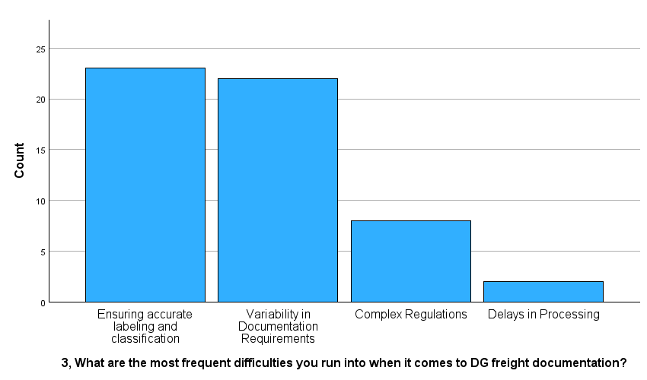

|  |  |  |  |  |  |  |
| --- | --- | --- | --- | --- | --- | --- |
|  | | | | | | |
| **TABLE 3:** DG cargo handling aspects are the most important | | | | | | |
|  | | Frequency | Percent | Valid Percent | Cumulative Percent |
| Valid | Seeking guidance from supervisors | 19 | 34.5 | 34.5 | 34.5 |
| Making quick decisions to avoid delays | 21 | 38.2 | 38.2 | 72.7 |
| Review Historical Data | 12 | 21.8 | 21.8 | 94.5 |
| Review Detailed Information | 3 | 5.5 | 5.5 | 100.0 |
| Total | 55 | 100.0 | 100.0 |  |

CHART 2: DG cargo handling aspects are the most important

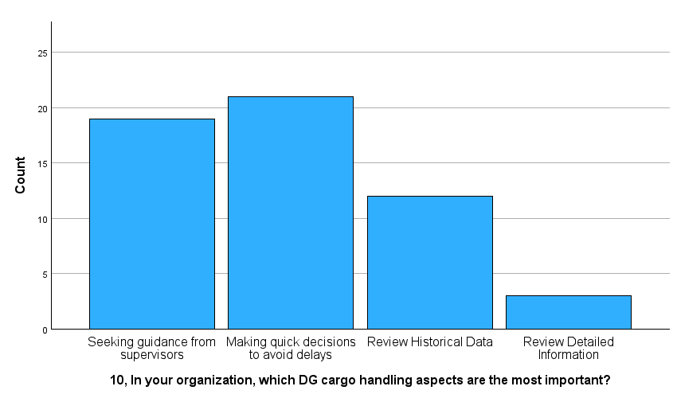

**INTERPRETATION:**

From the above table and chart inferred that 34.5% of respondents considered this aspect to be the most important. And 38.2% of respondents indicated that making quick decisions to avoid delays is the most important aspect. And 21.8% of respondents valued reviewing historical data as the most important aspect. and 5.5% of respondents considered reviewing detailed information to be the most important aspect. This data suggests that the majority of respondents prioritize making quick decisions to avoid delays and seeking guidance from supervisors when handling dangerous cargo within the organization.

**Chi-Square Tests:**

comparing two variables between in managing hazardous materials, which aspect is most important to you? And in your organization, which DG cargo handling aspects are the most important?

TABLE 3:

|  |  |  |  |
| --- | --- | --- | --- |
| **Chi-Square Tests** | | | |
|  | Value | df | Asymptotic Significance (2-sided) |
| Pearson Chi-Square | 10.654a | 9 | .300 |
| Likelihood Ratio | 11.703 | 9 | .231 |
| N of Valid Cases | 55 |  |  |
| a. 12 cells (75.0%) have expected count less than 5. The minimum expected count is .16. | | | |

Inference:

The test was conducted to determine if there is a association between managing hazardous material and DG cargo handling. The pearson di – square test statistics is 10.654 and 9 degrees of freedom. The like hood 11.703and 9 degree of freedom.

If the calculated value is 0.5> rejected null (NO).

Result:

Here, there is an association between managing hazardous material and DG cargo handling. rejected the null hypothesis and accepted the alternative hypothesis.

TABLE :4

comparing two variables between What difficulties do you run across when managing the documentation for DG cargo? And What part does technology, in your opinion, play in enhancing DG freight handling practices?

|  |  |  |  |
| --- | --- | --- | --- |
| **Chi-Square Tests** | | | |
|  | Value | df | Asymptotic Significance (2-sided) |
| Pearson Chi-Square | 7.583a | 9 | .577 |
| Likelihood Ratio | 9.526 | 9 | .390 |
| N of Valid Cases | 55 |  |  |
| a. 13 cells (81.3%) have expected count less than 5. The minimum expected count is .89. | | | |

Inference:

The test was conducted to determine if there is a association between did the procedures for importing documents and principal difficulties you have encountered. the pearson chi-square test statistics is 7.583 and 9 degrees of freedom. The like hood ratio test statistics is 9.529 and 9 degrees of freedom.

If the calculated value is 0.5< accepted null (NO).

Result:

Here, there is no association between did the procedures for importing documents and principal difficulties you have encountered.

Accepted the null hypothesis and rejected the alternative hypothesis.

**Research gap:**

The study limited resources and time available, it may be difficult to address every relevant documentation and handling procedures in-depth due to the extensive and intricate nature of DG cargo processes in marine freight. Period of study was restricted to two months. The results of the study might vary depending on factors like age, job title, experience, and so on. It is challenging to get the necessary samples since the logistics and shipping company employs a smaller number of employees. Since the information is sensitive, the organization didn't provide the proper data.

**RESEARCH METHODOLOGY:**

A research technique is a systematic way of approaching a research problem. It may be thought of as an industry that studies the methods used in scientific research. This essay looks at the several phases a researcher usually takes to investigate his study subject and the arguments behind each step. The majority of the planned study will be descriptive in nature. Research design is crucial to doing research as effectively as feasible since it guarantees that the various research procedures operate as intended.

**CONCLUSION:**

To sum up, the examination of hazardous cargo documentation and handling protocols highlights the vital necessity of industry standardization, education, and cooperation. Resolving issues with training, documentation, and communication is essential to reducing safety hazards and guaranteeing legal compliance. Through the implementation of the recommended procedures, concerned parties may strive towards the establishment of a more secure and effective framework for managing hazardous cargo, which will eventually improve the integrity of international supply chains.

**REFERENCE:**

* Secure and Efficient Intermodal Dangerous Goods Transport
* Improving safety of transportation of dangerous goods by railway transport. Infrastructures, 5(7), 54.
* How do dangerous goods regulations apply to uncrewed aerial vehicles transporting medical cargos? Drones, 5(2), 38.
* Parameter sensitivity analysis during risk management of road transportation of dangerous goods.
* Transport and handling of dangerous cargoes in port areas: weaknesses of existing international and Estonian regulations.