Wave Generator Mechanism

*Prof. Umesh Chavan, Shreya Raut, Omkar Rasal, Rhutu Kulkarni, Rudrabhishek Choudhury, Atharva Salunkhe.*

**Department of Mechanical Engineering , Vishwakarma Institute of Technology, Pune, 411037, Maharashtra, India.**

*Abstract: This research delves into the development and optimization of a Wave Generator Mechanism leveraging the Scotch yoke mechanism for wave simulation. This paper explores the integration of a meticulously designed artificial slope within the Scotch yoke system, providing insights into its practical application and efficiency in replicating wave patterns. The study details the comprehensive methodology and manufacturing process, examining the critical components, materials, and considerations in achieving accurate wave simulation. Experimentation demonstrates the successful generation of waves in a controlled environment, allowing for energy dissipation without wave reflection. The research underscores the effectiveness of the integrated mechanism in imitating natural fluid dynamics, presenting a cost-effective, reliable, and versatile solution for wave simulation systems in scientific and industrial domains. The paper concludes by addressing potential future developments and references key sources for further exploration.*

*Keywords — Wave Generator Mechanism, Scotch yoke mechanism, wave reflection.*

1. **INTRODUCTION**

The Scotch yoke mechanism, renowned for its simplicity and reliability, embodies key characteristics that make it a preferred choice in industrial settings. Its direct and robust design facilitates precise linear motion conversion from rotational input, ensuring consistent and controlled movement within complex systems. The mechanism's efficiency and durability enable it to

withstand rigorous operational demands, making it an ideal choice for a wide array of applications.

In the realm of wave generation, the Scotch yoke's predictable and smooth motion serves as a cornerstone for accurately replicating wave patterns. The mechanism's consistent motion control allows for the emulation of varying wave heights and frequencies, essential in simulating the dynamic behavior of natural water bodies. Its capacity to regulate movement with precision ensures the faithful reproduction of wave characteristics, contributing to realistic and reliable simulations.

The integrated artificial slope, complementing the Scotch yoke mechanism, is designed with meticulous attention to detail. Its gently sloping structure mirrors the gradual incline of a natural shoreline, strategically dissipating the kinetic energy of the waves. This carefully engineered feature prevents the unwanted formation of standing waves by redirecting the waves' momentum, thereby fostering an environment where wave interactions closely mirror those found in nature.

Moreover, the Scotch yoke's design boasts advantages such as reduced friction, low maintenance requirements, and a relatively uncomplicated construction, rendering it a cost- effective and dependable choice for industrial applications. Its adaptability and resilience in various operating conditions make it an indispensable element in systems where precise and controlled linear motion is imperative.

Together, the Scotch yoke mechanism and the adjunct artificial slope not only exemplify innovative engineering solutions but also symbolize a harmonious fusion of practicality and precision. Their synergy in wave simulation systems epitomizes a sophisticated yet dependable

approach in replicating the complexities of natural fluid dynamics, enabling researchers and engineers to conduct highly accurate and insightful experiments while minimizing undesirable wave interference.

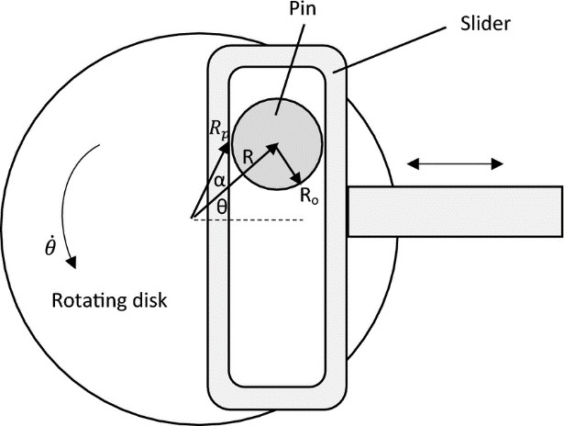

*Diagrammatic representation of scotch yoke mechanism.*

*(Fig. 1)*

There are 5 main components in a scotch yoke mechanism. Each part has its own importance and use in helping convert uniform rotary motion into linear simple harmonic motion.

1. Yoke: The stationary part of the mechanism, guiding the slider's motion.
2. Slider: Moves back and forth linearly.
3. Crank: Rotates, driving the mechanism.
4. Connecting Rod: Connects the slider to the crankshaft.
5. Drive Mechanism: Such as an electric motor or hand crank, provides rotary power.

In our setup the yoke is what is connected to the wedge that helps generate the waves. This wedge

generates waves because when it is lowered into the water it displaces some amount which is equal to its volume. Which volume that gets displaced doesn't make all the water rise simultaneously causing a wave to generate. Doing this raising and lowering of the wedge generates many waves in a row.

To generate waves in the tank we need a mechanism which provides to and fro motion for producing the waves. There can be many mechanism like slider crank, 4 bar, quick return mechanism but we have specifically used Scotch yoke for many reasons, because it is-

1. Small in size and can fit in any space.
2. Easy to assemble.
3. Can produce a higher torque than a slider crank mechanism
4. Less material is used as compare to scotch yoke mechanism.
5. Cost efficient.
6. **MATERIAL**
7. Material of yoke: Mild Steel
8. Material of slider: Mild Steel
9. Material of disk/connecting rod and crank: Mild Steel
10. Driving Mechanism Specifications: DC 180v 5A
11. Material of Slope(Plank): Wood + Galvanized Iron Sheet
12. Material of Tank: Glass

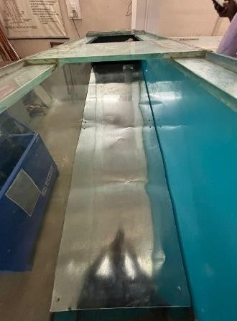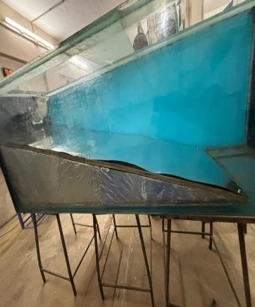

*Slope (Wood + Galvanized Iron Sheet (Fig. 2)*

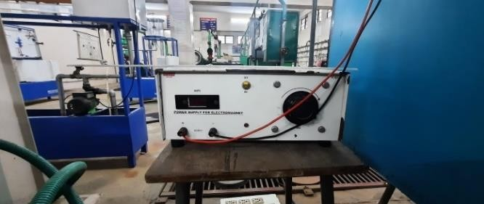

*Power Supply (Fig. 3)*

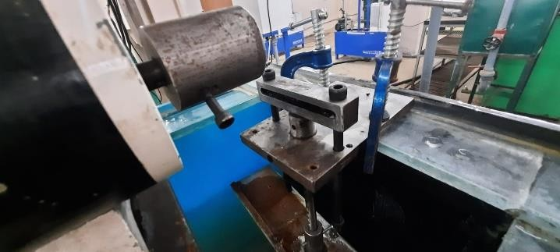

*(Fig. 4)*

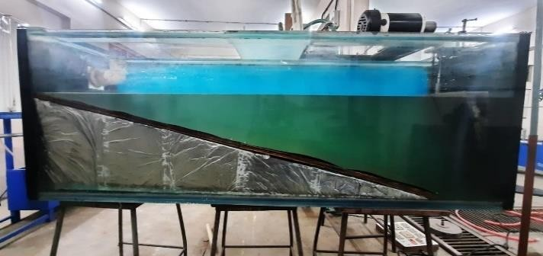

*Wave generator setup (Fig. 5)*

1. **Low cost of wood facilitates design adaptability:** Wood is generally more affordable compared to other construction materials. This cost-effectiveness allows for greater flexibility in design changes. If adjustments or alterations are needed, wood's affordability makes it easier to adapt the design without incurring significant costs.
2. **A galvanized iron sheet (GI sheet):** Galvanized iron sheets are coated with zinc to prevent corrosion, ensuring the structure remains submerged without floating to the surface. It is use to on the plank so that we can

have smooth surface finish for the water to flow over it with minimal resistance to waves produced in the tank.

1. **Metal Bars**: Metal bars are attached to the plank to add weight to wooden pieces because it may float if the water goes through the plank, so to avoid the buoyancy of the wood we put those bars. Those bars are attached with the

help of metal strings so that the bar remains in its position.

1. **Translucency:** Glass is transparent and allows for clear visibility, which is beneficial when observing or measuring waves or any activities within the tank.
2. **Strength:** Glass tanks can be stronger than acrylic under certain conditions. They are less prone to warping or bending over time, especially in large tanks where the pressure of the water can be substantial.
3. **Scratch Resistance:** Glass is more resistant to scratches compared to acrylic, which can be

Crucial for maintaining the tank's clarity over an extended period.

1. **Widely Available:** Glass tanks, especially smaller to medium-sized ones, are commonly available due to their extensive use in the aquarium industry. Larger custom tanks might also be easier to acquire in glass due to its common availability and ease of manufacturing.
2. **METHODOLOGY**

For making this set up first we have to see all the parameters that need to be considered for making the Wave Generator Mechanisms. So first we need to decide the tank size according to one feasibility. Then according to the tank we decide the plank dimensions. These dimensions are made in such a way that the waves should dissipate all its energy at the shore and not give a reflecting wave.

What happens when these waves move towards shore and encounter shallow water? Remember that in deep water, a wave’s speed depends on its wavelength, but in shallow water wave speed

depends on the depth. When waves approach the shore they will “touch bottom” at a depth equal to half of their wavelength; in other words, when the water depth equals the depth of the wave base *(Fig. 6)*. At this point their behavior will begin to be influenced by the bottom.

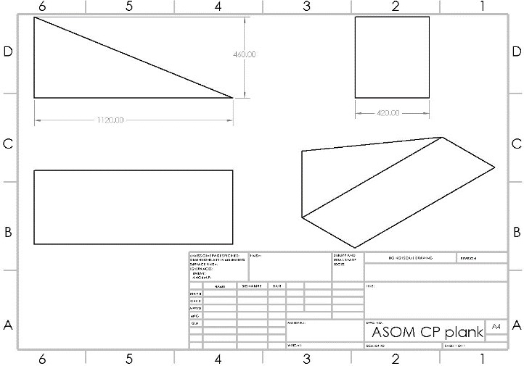

*1st iteration( this design was rejected due to the plank height and not following 13 degree rule which may have produced the reflecting waves.*

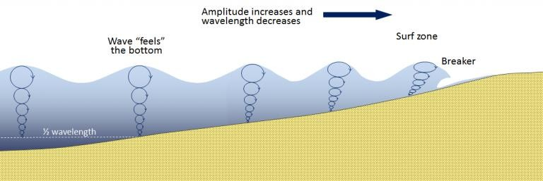

*(Fig. 7)*

*Steven Earle “Physical Geology”. (Fig. 6)*

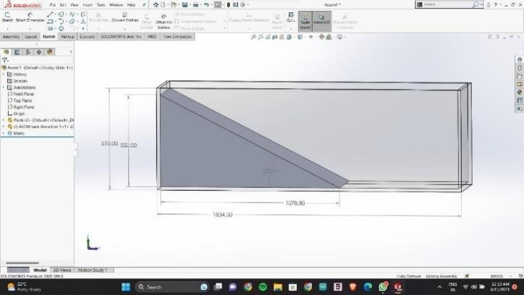

When the wave touches the bottom, friction causes the wave to slow down. As one wave slows down, the one behind it catches up to it, thus decreasing

the wavelength. However, the wave still contains the same amount of energy, so while the wavelength decreases, the wave height increases. Eventually the wave height exceeds 1/7 of the wavelength, and the wave becomes unstable and forms a breaker. Often breakers will start to curl forwards as they break. This is because the bottom of the wave begins to slow down before the top of the wave, as it is the first part to encounter the seafloor. So the crest of the wave gets “ahead” of the rest of the wave, but has no water underneath it to support it (FIG.2). After reading a lot of papers we have come across a point that the length of plank should be at least 80 to 85 percent of the original length of the tank. And the height of the plank should be such that the angle between hypotenuse side of the plank and floor should be between 10 to 13 degrees only for the waves to dissipate and not produce reflecting waves.

Many iterations were made for the plank:

*2nd iteration the length was not sufficient for the waves to reflect back*

*(Fig. 8)*

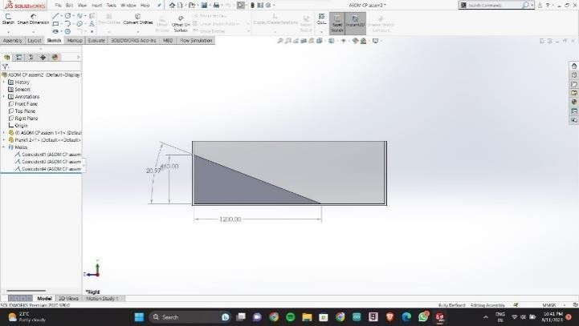

*The angle was not accurate for the waves to dissipate at the shore*

*(Fig. 9)*

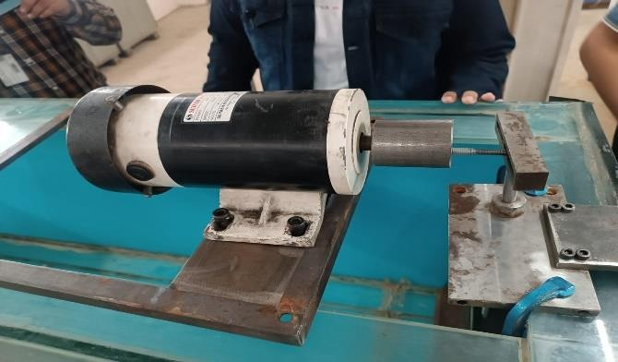

*Final design of the plank where we achieve the plank angle at 13 degree*

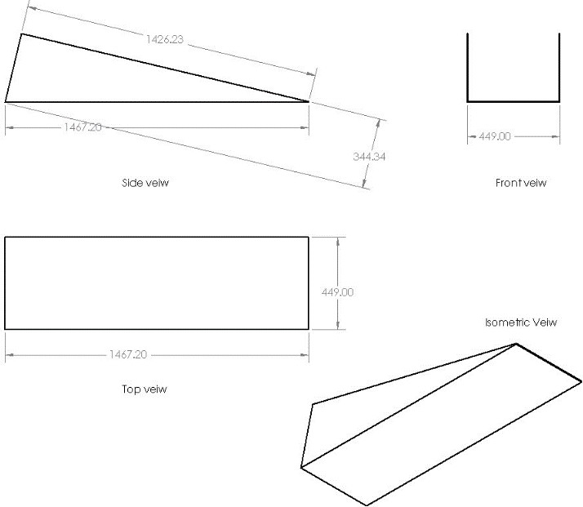

*(Fig. 10)*

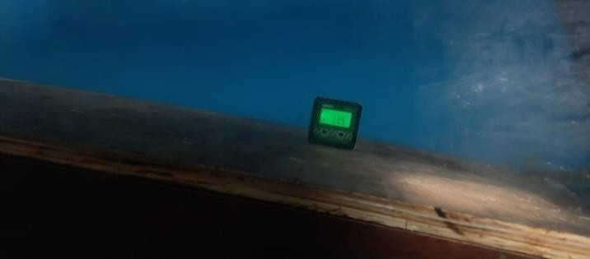

*Post manufacturing the plank angle is 13.5 degree (Near to 13)*

*(Fig. 11)*

For Scotch yoke mechanism we need a rotating disc, slider and a pin. The rotating disc has a point where the pin is bolted at the periphery of the disc. Then the pin is attached to the slider where it moves freely and makes the rotatory motion to linear motion. All the parts of this mechanism are shown in *(Fig. 12)*

.

*Actual image of the mechanism (Fig. 12)*

We are using a DC motor of 180V for rotary motion, attached to it we have a DC regulated power supply to control the current rate in the motor. It is used to maintain the speed of the motor. Max capacity of this device is 5 Amp.

For the set up to hold at one place we have also made the fixture of the motor and Scotch yoke mechanism. The motor is held in one position on a metal plank where it is bolted. The metal plank is further held on the glass with C clamps so that it does not move. We have added rubber pads between the fixture plate and the glass so that it absorbs all the vibrations produced by the motor and do not break the glass, these rubber pads are High voltage insulating in case there is current flow in the fixture plate the rubber pad will not allow to flow to the tank.

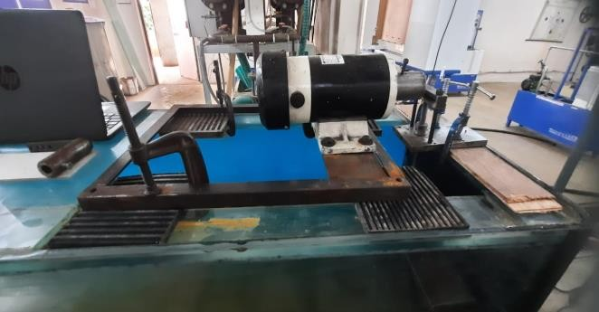

*Fixture for the motor and mechanism assembly (Fig. 13)*

1. **EXPERIMENTATIONS**

For the experiment, the tank is filled with water upto such a height that a very little part of the plank is visible just like a shore. Then we attach the wedge to the slider to produce the waves as in the *(Fig. 14)*.

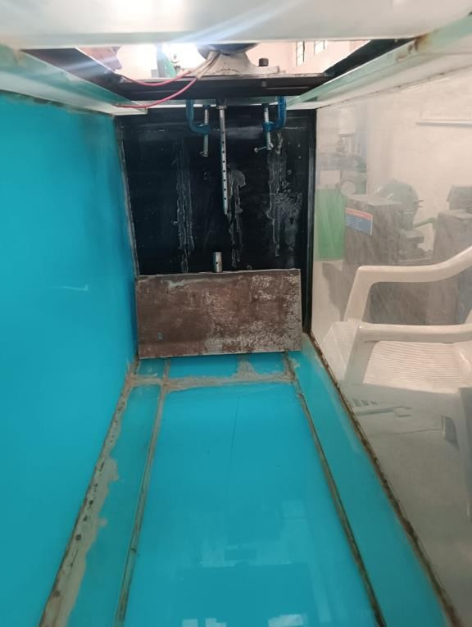

*Wedge attachment point. (Fig. 14)*

To make the experiment start, power supply is gradually given to the motor, as the current increases the speed of the motor also increases. As the rotatory motion increases the the frequency of the slider increases and that decides the amplitude of the waves produced. The waves produce go ahead and dissipate all its energy at the shore i.e the waves do not produce back. So, this makes the purpose of our project where we have designed the set up for the prototype testing in this mini seashore.

1. **RESULTS**

As per experiments and trials the waves were produced and dissipate the energy of the wave. These wave amplitudes were measured using Ultrasonic sensor. The serial monitor showed that the amplitude ranged from 141 to 156 mm. These readings were taken using the Arduino UNO board in which Ultrasonic sensor were added.

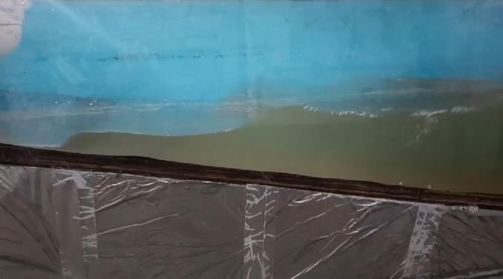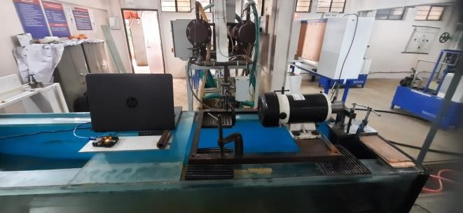

*Position of arduino uno on the tank (Fig. 15)*

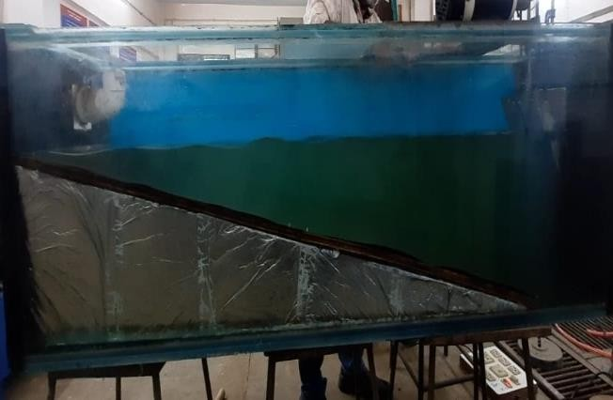

*Waves dissipating on the shore of the plank.*

*(Fig. 16)*

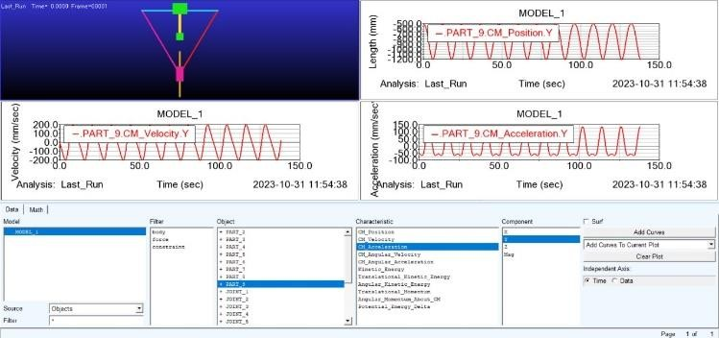

*Scotch Yoke mechanism by using Adams software and Sinusoid graph*

*(Fig. 17)*

1. **REFRENCES**
   1. The wave forces acting on a floating hemisphere undergoing forced periodic oscillations By A.HULME Department of Mathematics, University of Manchester,Oxford Road, Manchester M13 9PL (Received 21 October 1981).
   2. Experimental and numerical study on the wave force calculation of a partially immersed horizontal cylindrical float Bijin Liu a, Danjuan Fu a, *, Youquan Zhang b, Xiaoyun Chen a School of Civil Engineering and Architecture, Xiamen University of Technology, Xiamen, 361024, China b Fujian Marine Forecasts, Fuzhou, 350500, China.
   3. A TRIDENT SCHOLAR PROJECT REPORT NO. 237 "WAVE INTERACTIONS WITH VERTICAL WAVE BARRIERS' UNITED STATES NAVAL ACADEMY ANNAPOLIS, MARYLAND This document has been approved for public release and sale; its

distribution is unlimited. DTIC QUALITY

* 1. WAVES AND STRUCTURES By Dr M C Deo Professor of Civil Engineering Indian Institute of Technology Bombay Powai, Mumbai 400 076