**CRYPTOCURRENCY PRICE PREDICTION USING LSTM**

**Yashaswi R1, Bishal Timalsina2, Ali Aksar Hawari3,Ajay Khadka4 ,Sandeep Panjiyar 5**

1Asst Professor,Dept.of CSE,Sambhram Institute of Technology,Bengaluru Urban,Karnataka,India.

2Final Year Students,Dept.of CSe,Sambhram Institute of Technology,Bengaluru Urban,Karnataka,India.

**ABSTRACT**

The use of cryptocurrencies has skyrocketed in the last several years due to the instruction of blockchain technology. However,because of the market’s unpredictable nature and extreme price volatility,cryptocurrencies are not regard as a viable investment option.Because they are deterministic,the majority of the techniques for price forecasting of cryptocurriencies documented in the literature could not be appropriate for real time price prediction. We provide a stochastic neural network model for cryptocurrency price prediction,driven by the aforementioned problems.The prediction model also incorporates a method for figuring out the market’s reaction pattern.We used Bitcoin,Ethereum,and Litecoin to train the multi-Layer perceptron(MLP) and Long Short-Term Memory(LSTM) models.The finding demonstrate the superiority of the suggested model over the deterministic model.

**Keywords:** Cryptocurrency price prediction Research.

**1. INTRODUCTION**

The most valuable cryptocurrency in the world, bitcoin is traded on more than 40 exchanges throughout the globe that accept more than 30 different currencies. According to https://www.blockchain.info/, it now has a market valuation of $9 billion USD and processes over 250,000 transactions per day. Because of its volatility—which is far higher than that of conventional currencies—and relative youth, Bitcoin presents a unique potential for price prediction as a currency. Its open nature sets it apart from conventional fiat currencies as well; comprehensive data on cash transactions and money in circulation for fiat currencies is nonexistent. Long-term financial market prediction, like that of the stock market, has been studied extensively. Given that Bitcoin is a time series prediction issue in a market that is still in its infancy, it offers an intriguing analogy to this. Conventional time series prediction techniques, such Holt-Winters exponential smoothing models, depend on linear assumptions and need trend, seasonal, and noise-free data in order to function. When it comes to tasks like sales forecasting, where seasonal impacts are evident, this kind of technique works better. These strategies are not particularly successful for this purpose because of the significant volatility and lack of seasonality in the Bitcoin market. Based on its performance in related fields, deep learning presents an intriguing technical answer given the task's complexity. Because Bitcoin data is temporally structured, recurrent neural networks (RNNs) and long short-term memories (LSTMs) are preferred over extra multilayer perceptrons (MLPs). The purpose of this article is to examine parallelization techniques used in multi-core and GPU contexts, as well as to investigate the accuracy with which the price of Bitcoin may be forecasted using machine learning.The contribution of this work is as follows: out of about 653 publications published on Bitcoin, only 7 (as of this writing) deal with machine learning for prediction. In addition, an ARIMA time series model is built for performance comparison with the neural network models to enable a comparison to more conventional techniques in financial forecasting. The CoinDesk Bitcoin Price Index's closing price for Bitcoin in USD serves as the study's independent variable. We use the average price from five major Bitcoin exchanges—Bit Stamp, Biaffine, Coinbase, OkCoin, and itBit—instead of concentrating on a single exchange. It would be advantageous to concentrate on a single exchange if we were to execute transactions based on the indications. We utilize the root mean to evaluate a model's performance. The final phase permits the inclusion of additional performance indicators, such as classification accuracy, specificity, sensitivity, and precision, which might be helpful to a trader in formulating a trading strategy. This paper's dependent variables are taken from Blockchain.info and the Coindesk website. Blockchain metrics, such as the hash rate and mining difficulty, are presented in addition to the closing price, opening price, daily high, and daily low. The designed characteristics, which are regarded as technical analysis indicators, consist of a de-noised closing price and two simple moving averages (SMA).

**LITERATUIRE SURVEY**

There isn't enough data on machine learning algorithms especially used for Bitcoin price prediction. created a latent source model by forecasting the price of Bitcoin and recording an 89% return in 50 days with a Sharpe ratio of 4.1. Additionally, there have been attempts to forecast Bitcoin values using text data from other sources, like social media.studied the relationship between the network hash rate, the frequency of Wikipedia views, and sentiment analysis using support vector machines. examined the connection between the price of bitcoin, tweets about it, and views on Google Trends. used a similar process, except they used Google Trends views to anticipate trade volume rather than the price of Bitcoin. The tendency for false information to propagate across various (social) media channels, like Twitter, or on message boards, like Reddit, artificially inflates or deflates prices, is a weakness of these research, though. Liquidity on Bitcoin exchanges is severely constrained. The market is therefore more vulnerable to manipulation. Social media sentiment is thus not taken into further consideration. Support vector machines (SVM) and artificial neural networks (ANN) were used to analyze the Bitcoin Blockchain and predict the price of the cryptocurrency. A typical ANN produced price direction accuracy of 55%. They came to the conclusion that Blockchain data by itself lacked a great deal of predictability. used Blockchain data as well as SVM, Random Forests, and Binomial GLM (generalized linear model), noting above 97% prediction accuracy; however, the results' generalizability was limited by the lack of cross-validation in their models.The Long Short-Term Memory (LSTM) network is another type of RNN. Unlike Elman RNN, they have the ability to select which data to remember and which to ignore depending on the significance and weight of each characteristic, in addition to having a memory. used an LSTM for a time series prediction job and discovered that it outperformed an RNN in this regard. This kind of model is also used in this instance. A drawback of training both RNNs and LSTMs is the amount of computation needed. A network of 50 days, for instance, is equivalent to training 50 distinct MLP models. The field of machine learning has seen a significant increase in the creation of applications that utilize the GPU's very parallel capabilities since NVIDIA's CUDA framework was developed in 2006. said that when using a GPU instead of a CPU, its ANN model could be trained and tested nearly three times quicker.

**Motivation:**

Although not exactly the same, the value of bitcoin fluctuates. Various algorithms are applied to stock market data in order to anticipate prices. But there are differences in the characteristics that impact Bitcoin. Thus, in order to make wise investment choices, it is essential to forecast the value of Bitcoin. Unlike stock market fluctuations, the price of Bitcoin is independent of business events and government intervention. Therefore, we think it's essential to use machine learning technology to forecast the value in order to estimate the price of Bitcoin.

**Objective**

Many researchers have attempted to use prediction models in the wake of bitcoins' recent surge in popularity. Developing a prediction model for a machine learning problem is challenging since each unique use case requires extensive empirical testing to get the optimal fit, which cannot be determined in advance.

**Scope:**

This creative undergrad project aims to demonstrate how, with sufficient data and processing capacity, a trained machine model can forecast the price of a cryptocurrency. A graph with the anticipated values is shown. The most widely used technology is the kind that has the potential to enable human prediction of future occurrences. We are finally approaching a time when precise forecasts can be made based on actual, true facts, thanks to the enormous volumes of data that are created and collected every day.

**PROJECT ANALYSIS**

**Existing System**

Since cryptocurrency is a time series prediction issue in a nascent market, it raises interesting questions. Conventional time series prediction techniques, such Holt-Winters exponential smoothing models, are based on linear assumptions and do not work well with data that cannot be separated into trend, seasonal, and noise categories. reported that training and testing of their ANN model on a GPU as opposed to a CPU was completed more than three times quicker.

**Disadvantage of the Existing System:**

* It gets more difficult to mine bitcoins as the total amount in circulation gets closer to the limit.
* Developing a system that could anticipate prices with accuracy was one of the challenges that analysts and researchers had to deal with.

**Proposed System**

The cryptocurrency price from the Coin Desk expressed in USD For this analysis, the price of bitcoin is taken into account as an independent variable. I chose the mean. My project's primary objective is to determine how well machine learning can be used to forecast Bitcoin prices. An ARIMA time series model is created using neural network models for performance illustration reasons, which aids in showing more conventional methods in financial forecasting. closing prices on five of the biggest Bitcoin exchanges: Bitfinex, Coinbase, Ok Coin, Bit Stamp, and it Bit

**RESULTS AND DISCUSSION**

The CRISP data mining approach is used in this work.1. The prediction task's commercial context serves as the driving force for the choice of CRISP-DM over the more conventional KDD. The dates covered by the Bitcoin dataset are August 19,2013, through July 19, 2016. Data that was collected before August 2013 has been omitted as it is no longer an accurate

representation of the network. Apart from the Open, High, Low, Close (OHLC) information sourced from CoinDesk, the Blockchain provides the difficulty and hash rate. Additionally, the data was normalized to have a mean of 0 and a standard deviation of 1. Since standardization better fits the activation functions that the deep learning models utilize, it was selected over normalization.

1. **A. Feature Engineering and Feature Evaluation**

The skill of feature engineering involves identifying meaningful patterns in data to facilitate machine learning models' prediction performance. To get good results in prediction jobs, it may be regarded as one of the most crucial steps in the data mining process. Indicators such as the Simple Moving Average (SMA) have been used in a number of articles in recent years for machine learning categorization problems.

Using Boruta, a wrapper over the random forest classification technique, the characteristics to include were assessed. Several classifiers vote on each other to perform classification in this ensemble approach. The algorithm and the random forest classifier operate on a similar premise. In order to assess qualities and give a clear picture of which attributes are significant, it introduces randomness into the model and gathers data from the ensemble of randomized samples. Based on random forest, all characteristics were considered significant by the model; among the evaluated averages, 5 and 10 days (by SMA) were found to be the most significant. An additional crucial factor was the de-noised closing price.

**B.Deep Learning Models**

The effectiveness of deep learning models depends on their network parameters being designed appropriately. When it comes to selecting search strategies for deep learning models, there are three primary options: random search, grid search, and heuristic search techniques like genetic algorithms. In this investigation, Bayesian optimization and manual grid search were used. The method known as "grid search," which is applied to the Elman RNN, involves choosing two hyperparameters, each having a minimum and maximum. Then, one looks for the parameters that perform the best by searching that feature space. This method was used for parameters that weren't good candidates for Bayesian optimization. Python programming and Keras were used to create this model.

When choosing LTSM parameters, Bayesian optimisation was used, much like with the RNN. This heuristic search strategy maintains a posterior distribution for the function while the outcomes of various hyperparameter selections are tracked. It operates on the assumption that the function was sampled from a Gaussian process. The predicted improvement over the best result may then be optimized to choose hyperparameters for the subsequent experiment. Using techniques to avoid overfitting, the effectiveness of the RNN and LSTM networks is assessed using validation data. Dropout is included into both layers, and if the model's validation loss hasn't decreased after five epochs, we immediately terminate the training process.

**Screen shorts:**

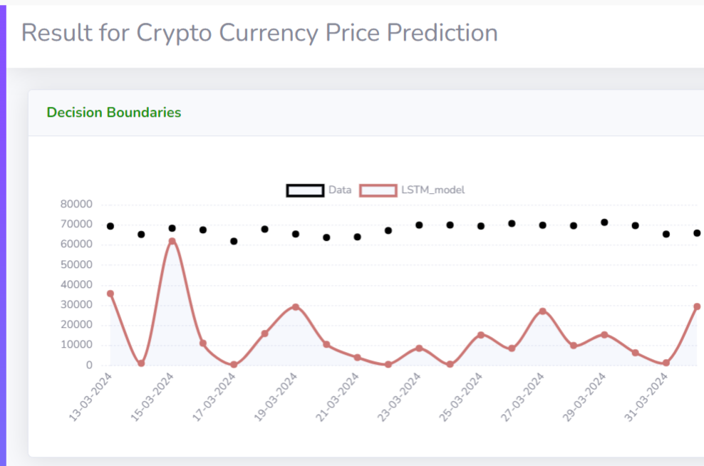

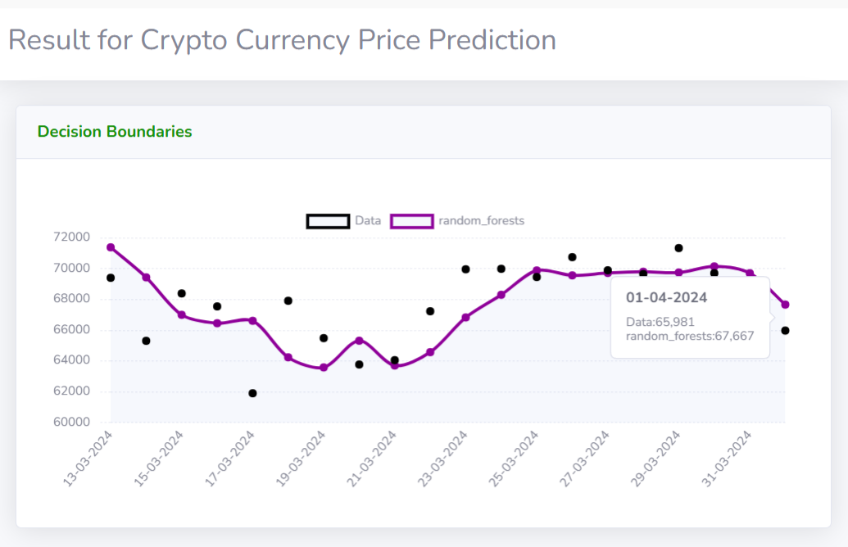

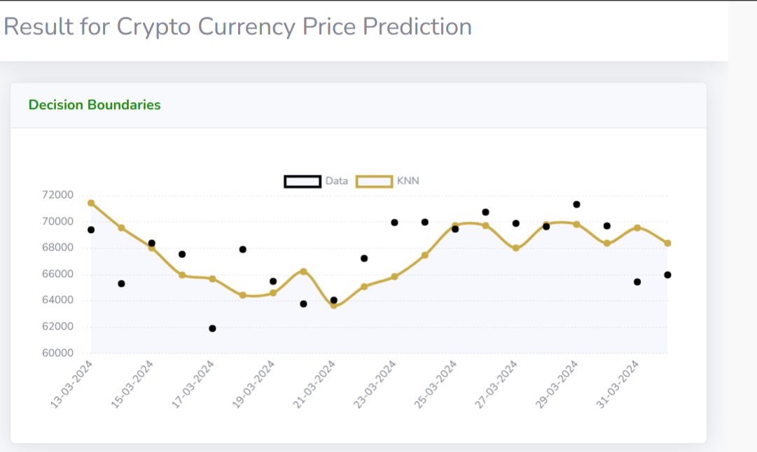

|  |  |  |  |  |  |
| --- | --- | --- | --- | --- | --- |
| **Tested** | **Test name** | **Inputs** | **Expected output** | **Actual Output** | **status** |
| 1 | Load Dataset | CSV file | Read dataset | Load dataset | success |
| 2 | Split dataset | Train80% and test20% | Divide the training set and Testing set | Split train and  Test | success |
|  | Train Model | Train dataset, random value, predicted class | Train with best accuracy | Train with best accuracy | success |
| 4 | Validate Model | No .of Epochs | Validate the Model with best fit | Model Generated | success |
| 5 | Predict accuracy and  Error Rate | Accuracy | Plot expected accuracy and  predicted accuracy | Plot expected predicted accuracy | success |
| 6 | Test Data | Test column | Predicted accuracy | Predicted accuracy | success |

# 

# **RESULT EVALUATION**

Table I shows that the RNN had the lowest RMSE and the LSTM had the best accuracy. In terms of accuracy and RMSE, the ARIMA prediction did not perform well. Based on the examination of the ARIMA projection, it was anticipated that the price would increase daily. The model produced no false positives. The class imbalance in the ARIMA forecast's predictive section (where prices always tend to rise) might be one cause of this. The great specificity and accuracy (specificity, precision = 100%) can be attributed to this. This indicates that it performs a respectable job of spotting price direction change(s), but it does not necessarily imply strong overall performance.

**CONCLUSION**

It is clear that deep learning models like the RNN and LSTM are useful for predicting Bitcoin, with the LSTM being better at identifying longer-term relationships. The sensitivity, specificity, and accuracy measures suggested strong performance, however the ARIMA forecast based on error performed far worse than the neural network models in real terms. While not considerably, the LSTM fared somewhat better than the RNN. But it takes a lot longer to train the LSTM.

**REFERENCES**

1. S. Nakamoto, “Bitcoin: A peer-to-peer electronic cash system,” 2008.
2. M. Briere, K. Oosterlinck, and A. Szafarz, “Virtual currency, tangible ` return: Portfolio diversification with bitcoins,” Tangible Return: Portfolio Diversification with Bitcoins (September 12, 2013), 2013.
3. I. Kaastra and M. Boyd, “Designing a neural network for forecasting financial and economic time series,” Neurocomputing, vol. 10, no. 3, pp. 215–236, 1996.
4. H. White, “Economic prediction using neural networks: The case of ibm daily stock returns,” in Neural Networks, 1988., IEEE International Conference on. IEEE, 1988, pp. 451–458.
5. C. Chatfield and M. Yar, “Holt-winters forecasting: some practical issues,” The Statistician, pp. 129–140, 1988.
6. B. Scott, “Bitcoin academic paper database,” suitpossum blog, 2016.