Ignite Guard: Innovating LPG gas Detection & Accident Avoidance Using IOT

# Aayush Shinde, Saurabh Sonawane, Pranav Salunke

1,2,3Student, Department of E&TC, MVP’s KBT College of Engineering, Nashik, Maharashtra, India.

# ABSTRACT

The "LPG Gas Leakage Detection and Accident Prevention System" presents a comprehensive solution utilizing the Micro controller ESP32 as its core component to address the risks associated with LPG gas leakage. This system integrates strategically placed gas sensors to continuously monitor ambient air for LPG gas presence, promptly detecting leaks and minimizing response time. The ESP32 serves as the central processing unit, analyzing sensor data in real-time to assess gas leak severity and trigger appropriate preventive actions, including activating alarms, shutting off gas valves, and notifying authorized personnel or emergency services. A user-friendly interface, typically an LCD display, enhances user awareness by providing real-time information on gas levels, leak detection, and preventive actions. Implementation of this system significantly reduces the potential risks of accidents, fires, or explosions in residential, commercial, and industrial settings, offering a reliable and efficient solution to enhance safety standards.

***Key Words*: LPG, Sensor technology,IOT**

# INTRODUCTION

In an era where Liquefied Petroleum Gas (LPG) serves as a cornerstone energy source for both residential and industrial sectors, the imperative for safety measures against potential gas leaks looms large. The volatile nature of LPG demands proactive solutions, and with recent strides in micro controller technology, the stage is set for a paradigm shift. Enter the ESP32 micro controller – renowned for its adaptability and reliability – poised to revolutionize gas detection and prevention systems. This project embarks on the development of an innovative LPG gas leakage detection and prevention system, harnessing the power of the ESP32 micro controller to deliver early warnings and deploy effective countermeasures. By strategically positioning sensors and employing sophisticated processing capabilities, the system not only detects gas presence but also interprets concentration levels, swiftly triggering alarms and safety protocols in the event of anomalies. With user-friendly interfaces and seamless integration with external devices, such as smartphones and computers, this system transcends conventional safety measures, promising unparalleled defense against potential disasters. From kitchens to industrial settings, the ESP32-based solution emerges as a beacon of reliability, efficiency, and versatility, safeguarding lives and properties with unwavering vigilance."

# .

# RELATED WORK

The development of effective LPG gas leakage detection and accident prevention systems has been an active area of research. Numerous studies have focused on exploring different types of gas sensors, such as semiconductor-based, electro chemical, and optical sensors, to reliably detect the presence of LPG and other combustible gases. The integration of these sensors into wireless sensor networks (WSNs) has gained significant attention, enabling the deployment of multiple sensors across an area and transmitting their data wirelessly to a central monitoring station.

Advanced signal processing techniques and machine learning algorithms have been employed to improve the accuracy and reliability of gas leak detection systems. These methods aim to differentiate between actual leaks and false positives, as well as estimate the leak location and concentration. With the advent of the Internet of Things (IOT) and cloud computing technologies, gas leak detection systems have been integrated with these platforms for remote monitoring, data storage, and analysis, facilitating real-time alerts and effective response measures.

Once a gas leak is detected, various mitigation strategies can be implemented, such as automatic shutoff valves, ventilation systems, and evacuation protocols. Research efforts have focused on developing integrated systems that can not only detect leaks but also automatically trigger appropriate mitigation measures. Ensuring regulatory compliance and adherence to relevant safety standards has been another area of focus, considering factors like installation requirements, maintenance, and testing protocols.

Gas sensor development: Researchers have explored various types of gas sensors, such as semiconductor-based sensors, electro chemical sensors, and optical sensors, to detect LPG and other combustible gases. These sensors rely on principles like changes in electrical resistance, electro chemical reactions, or optical absorption/emission to detect the presence of gas molecules.

Wireless sensor networks: Several studies have proposed the use of wireless sensor networks (WSNs) for gas leak detection and monitoring. In these systems, multiple gas sensors are deployed in an area, and their data is transmitted wirelessly to a central monitoring station for analysis and decision-making.

Machine learning and signal processing: Advanced signal processing techniques and machine learning algorithms have been employed to improve the accuracy and reliability of gas leak detection systems. These methods can help differentiate between actual leaks and false positives, as well as estimate the leak location and concentration.

Overall, the related work in this field encompasses a wide range of aspects, including sensor technology development, wireless communication networks, data processing and analysis techniques, IOT and cloud integration, mitigation strategies, and regulatory compliance, all aimed at enhancing the effectiveness and reliability of LPG gas leakage detection and accident prevention systems.

# METHODOLOGY

The project mainly consists of major components:

1. ESP 32 IOT Module
2. MQ6 Gas Sensor
3. PCB
4. LCD 16×2
5. Isolated Relay
6. DC Motor
7. Exhaust Fan
8. I2C LCD Module
9. Buzzer

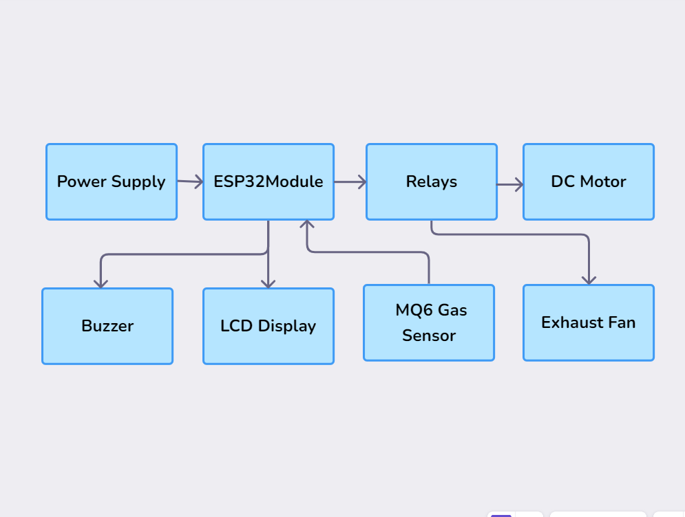

**Figure 1:** Block diagram of LPG Gas Leakage Detection & Accident Prevention System



A methodology for an LPG gas leakage detection and accident prevention system could involve a multi-layered approach:

1. Sensor Network: Deploy a network of gas sensors strategically throughout the area to detect leaks promptly. Utilize different types of sensors for redundancy and accuracy.

2. Data Fusion: Implement a data fusion technique to integrate information from multiple sensors. This can improve the reliability of leak detection and reduce false alarms.

3. Machine Learning Algorithms: Train machine learning models to analyse sensor data patterns and predict potential leaks before they occur. These algorithms can continuously learn and adapt to different environmental conditions.

4. Real-time Monitoring: Develop a central monitoring system that receives data from sensors in real-time. This system should provide instant alerts to relevant stakeholders, such as homeowners or emergency services, in case of a detected leak.

5. Automated Shut-off Valve: Integrate an automated shut-off valve into the gas supply line. This valve can be triggered automatically upon detection of a leak, preventing further gas flow and mitigating the risk of an accident.

6. Remote Control and Notification: Enable remote control of the system through a mobile app or web interface. Users should be able to monitor gas levels, receive notifications, and manually trigger the shut-off valve if necessary.

7. Emergency Response Integration: Connect the system to local emergency services to facilitate quick response in case of a severe leak or accident. This integration can include automatic alerts to fire departments or gas utility companies.

8.Regular Maintenance and Calibration: Implement a schedule for regular maintenance and calibration of sensors to ensure optimal performance and reliability of the system over time.

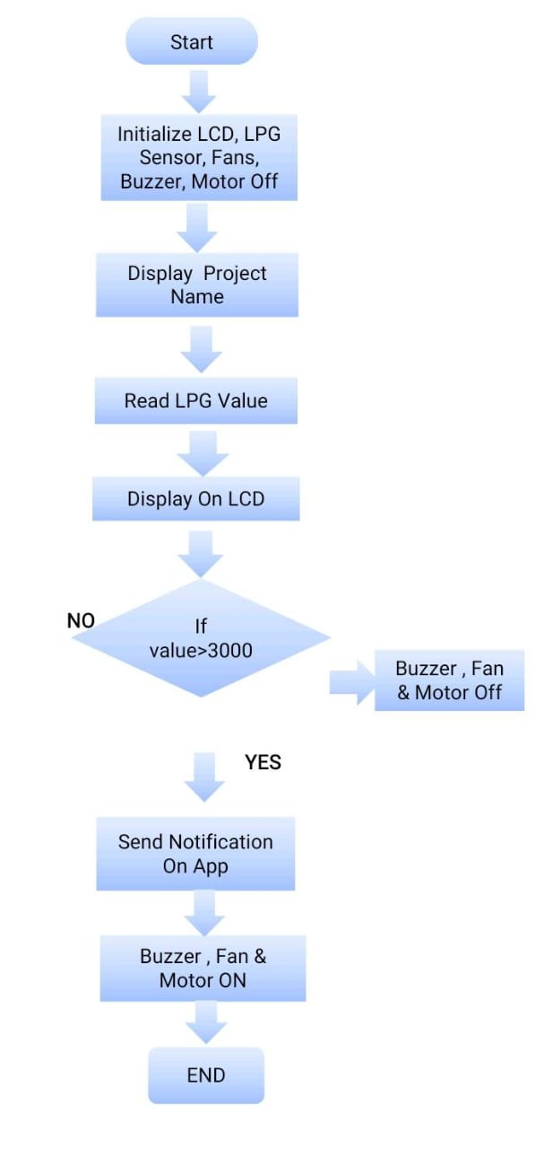

**Figure 2:** Flowchart of LPG Gas Leakage Detection & Accident Prevention System

# RESULTS AND DISCUSSION

After completing and testing the project we have observed these following results. As shown below

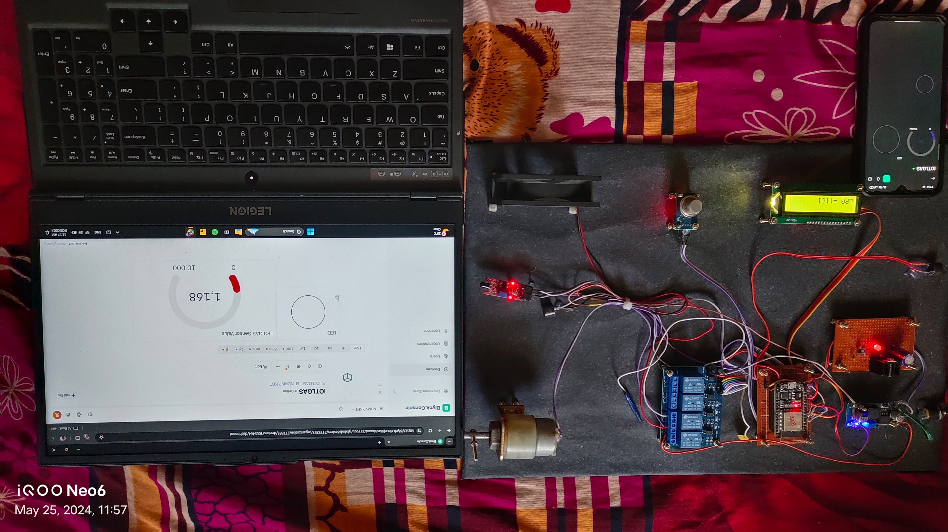

**Figure3:** Image of LPG Gas Leakage Detection & Accident Prevention Systems

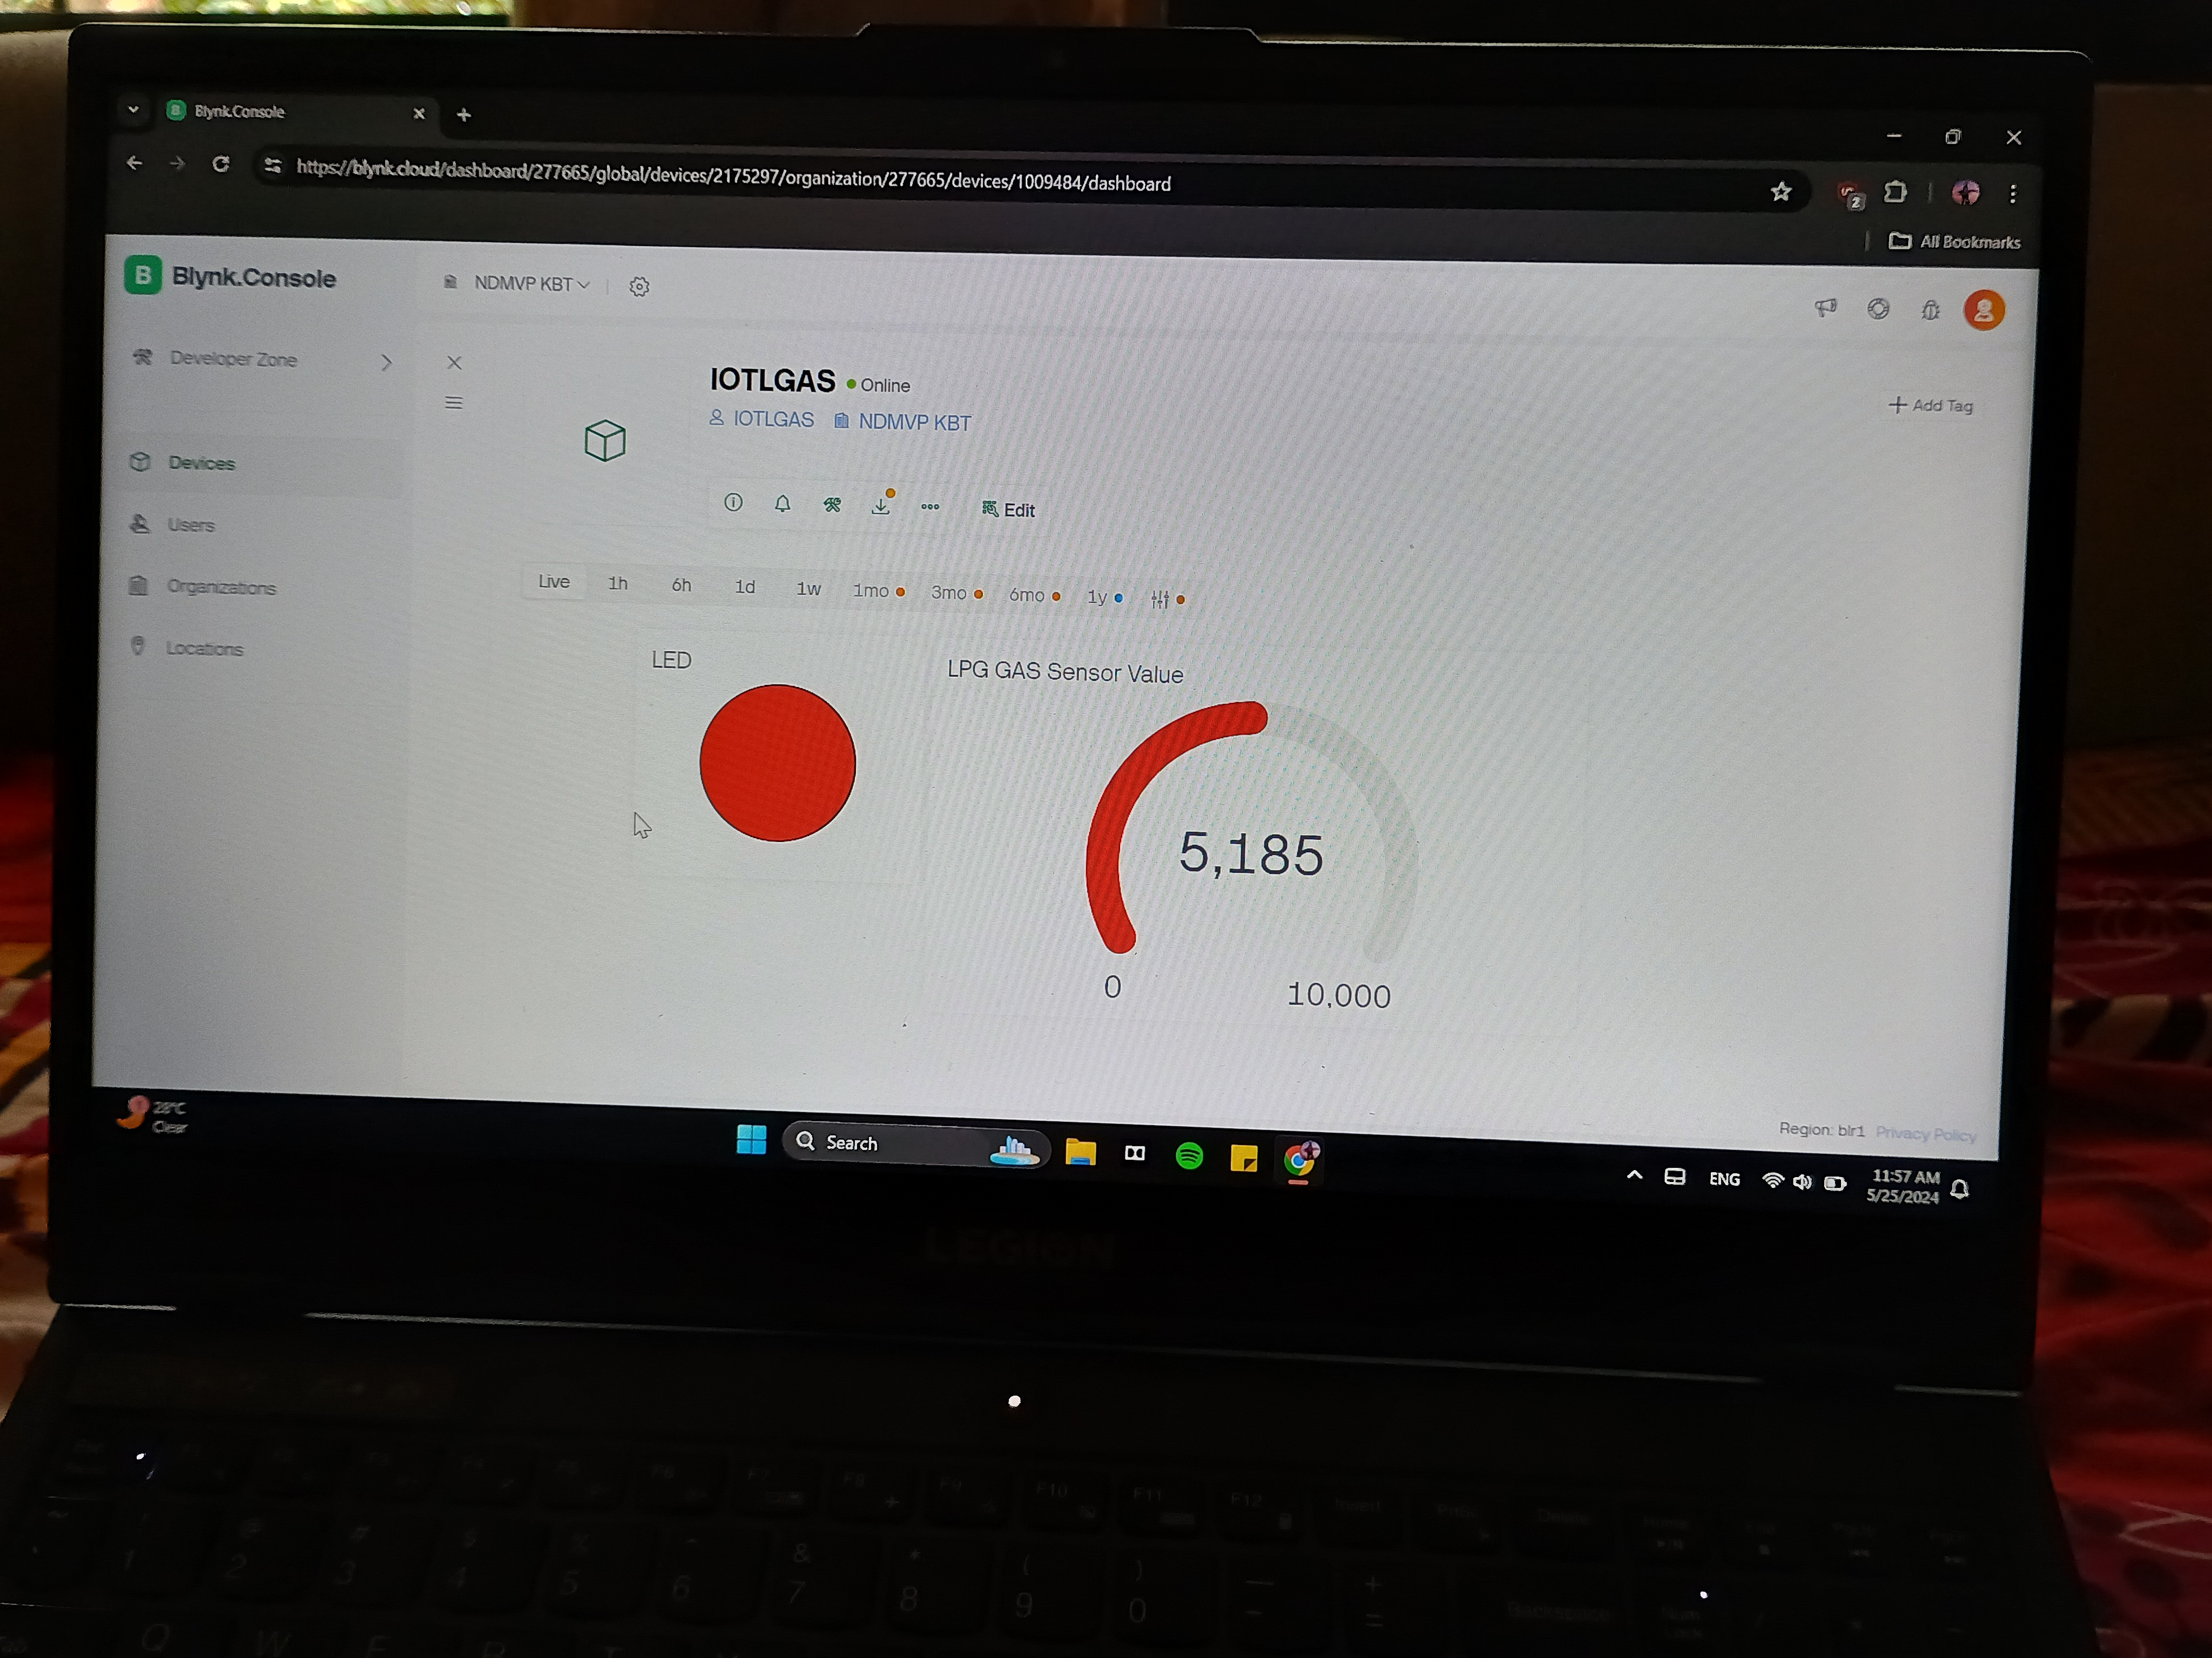

**Figure4:** image ofLPG Gas Measuring Value

# CONCLUSION

# Conclusion and future enhancement The LPG gas detection using ESP32 was successfully developed with working condition. The design of LPG gas sensor detection using LPG has been discussed in this paper to achieved all the objective. This is low cost with multi function, user friendly and portable product. It is not built for keep our safety in health but it is our responsibility to maintain safe and healthy environments. This system also gives an advantage to the user that can easily get alert of alarm by using buzzer. The distance to detect the gas is not easy to determine but using MQ6 gas sensor it can detect range of 200 to 10000 ppm. It depends on a few variables such as gas source leakage rate, room size, air currents and sensor placement. Thus, this product is designed in portable and easier to be placed near the gas pipeline especially in the house. Even though this product can prevent accidental of gas leakage that will explosion and poisoning but this is only a small part of prevented. All components and bodies should notice that hazardous facilities, maximum emphasis must be placed for properly equipping the facilities, installing early warning systems, training operators, informing public and agencies about the hazards involved, assessing, and reviewing hazards, carrying out rehearsals of emergencies to identify safety inadequacies, institutionalizing safety practices, preparing an emergency plan, and complying with all safety standards and regulations. In future, LPG gas leakage detection using ESP32 will give notification to the smartphone users using ESP32 motion sensor for IOS and android. Besides that, it can be using as extra function to any cooking stove for detecting any gas leakage in the kitchen. Besides that, other than using IOT module which is Wi-Fi module used to connecting with micro controller (ESP32) for sending and receiving data. It suggested using a load cell censor which converts a load into electrical signal that can be current, voltage or frequency change depending on circuit use in a project. By using load cell censor, it can measure the weight of gas cylinder over it and gives an analog form of output. The load cell is calibrated and will display the reading o LCD screen of weight and also added with GSM Module, by which an SMS is triggered.

# .

# REFERENCES

# Gabriel V. da Silva Medeiros, Matheus Ricardo dos Santos, Alba Sandyra Bezerra Lopes, Edmilson C. Barbalho Neto "Smart Gas: A smart platform for cooking gas monitoring". 2017 IEEE First Summer School on Smart Cities, Natal, Brazil, August 6-11, 2017, pp. 97-102.

# Shraddha Suresh Tanksale, Prof. A.S. Mali and Dr. B.T. Salokhe, "Automated Unified Trolley System for LPG Leakage Detection with Safety Measures and Refill Booking". International Journal of Engineering and Management Research, Volume-8, Issue-3, June 2018, pp: 224-228.

# S. Sivajothi Kavitha, S. Senthilkumar, "A Wireless Gas Leakage & Level Detection with Auto Renewal System". International Journal of Advanced Research in Electrical, Electronics and Instrumentation Engineering, Vol. 4, Issue 4, April 2015, pp: 2095-2100.

# 4. R. Naresh Naik, P. Siva Nagendra Reddy, S. Nanda Kishore, K. Tharun Kumar Reddy, "Micro controller Based LPG gas Monitoring & Automatic Cylinder booking with Alert System". IOSR Journal of Electronics and Communication Engineering (IOSR-JECE), Volume 11, Issue 4, Ver. I (Jul.-Aug .2016), PP 06-12.

# 5. A. H. D. Jebamalar Leavline, D. Asir Antony Gnana Singh, “LPG Gas Leakage Detection and Alert System,” Int. J. Electron. Eng. Res., vol. 9, no. 7, pp. 975–6450, 2017

# 6. D. M. Monirujjaman, “Sensor Based Gas Leakage Detector System,” in Engineering proceeding, 7th Electronic Conference on Sensors and Applications, 2020