# Elimination of Additional Charges due to Vehicle Halting at Customer’s Place and Transportation

**DINESH H, MBA Shipping and logistics management, Vels Institute of Science and Technology and Advanced Studies (VISTAS), Pallavaram, Chennai,** [**dineshkohli5601@gmail.com**](mailto:dineshkohli5601@gmail.com)

# *Corresponding Author: Anitha Kumari D, Professor, School Management studies, Vels Institute of Science and Technology and Advanced Studies (VISTAS), Pallavaram, Chennai, [anitha.sms@velsuniv.ac.in](mailto:anitha.sms@velsuniv.ac.in)

1. **Abstract:**

This abstract discusses the elimination of additional charges incurred from vehicle halting at a customer’s location and during transportation. Traditionally, logistics companies impose extra fees when vehicles are delayed at a customer’s site or during transit. These charges can arise due to unforeseen delays, extended loading or unloading times, and other interruptions. To improve customer satisfaction and streamline operations, companies are now exploring strategies to remove these additional costs. This involves optimizing scheduling, employing advanced tracking systems, and enhancing communication between drivers and customers. By adopting these measures, logistics providers can minimize idle times, reduce operational costs, and provide more transparent pricing. The elimination of such charges not only fosters better customer relationships but also enhances overall efficiency and competitiveness in the market. This shift represents a significant step towards a more customer-centric approach in the logistics industry.

# Introduction:

Transport and logistics is a collection of processes involved in the production, storage, inventory, delivery, and distribution of specific goods or services. Sometimes referred to as transportation and logistics, it is an integral element of the whole supply chain and it involves proactive procedures to move products safely and efficiently from the manufacturers to the sellers, and up to the end users or the consumers.

The primary goal of managing transport and logistics—especially for businesses and those in cargo consolidation—is to properly oversee the flow of supply from point A to point B, and for customers to receive products on time, damage-free, and according to expectations.

The logistics industry is responsible for moving products domestically and internationally and is therefore a huge contributor to economic development. According to a report released by Allied Market Research, the transport and logistics market is projected to grow to

$12,975.64 billion by the year 2027.

# Objectives

**Primary Objective**

To understand the process to make the driver or the transportation company to be available at the gate and clear the process on time.

# Secondary Objective

* to analyse the problems in unloading location is material requirements, space to unload the materials and unloading handlers’ availability.
* To reduce the delays in transportation drivers.
* to analyse the dissatisfaction of transporter and driver, because of the customer warehouse space optimization issues.
* To understand the problems in loading location is material readiness, invoice & e-way bill preparation and loading handlers’ availability.

# NEED FOR STUDY

Need for the study of eliminating additional charges due to vehicle halting in a customer's place and transportation at DSV Global Logistics, it is essential to consider various aspects such as customs clearance, tariffs, and value-added services offered by DSV.

DSV Global Logistics provides services like customs clearance, which involves handling duty and tax documents directly to streamline the process and potentially reduce additional charges. Additionally, understanding DSV's tariffs can help in managing costs associated with transportation.

Moreover, DSV offers buyer's consolidation services, which optimize container utilization and reduce costs by turning multiple less-than-container-load (LCL) shipments into full- container-load (FCL) shipments. This service can lead to fewer charges related to handling and transportation.

Studying these aspects within the context of DSV Global Logistics can provide insights into strategies for minimizing additional charges due to vehicle halting at a customer's place and during transportation.

# SCOPE FOR THE STUDY

Scope for the Study: "Elimination of Additional Charges due to Vehicle Halting in Customer's Place and Transportation at DSV Global Logistics".

To delve into the study focused on eliminating additional charges related to vehicle halting at a customer's place and during transportation at DSV Global Logistics, several key areas can be explored:

Customs Clearance Efficiency:

1, Investigate how streamlining customs clearance processes can reduce delays and associated charges.

2, Understanding DSV's Tariffs:

Analyze DSV's tariff structures to identify opportunities for cost optimization during transportation.

3, Buyer's Consolidation Services:

Explore how DSV's buyer's consolidation services can help optimize container utilization and reduce handling charges.

4, Market Dynamics and Trends:

Consider how market trends, such as geopolitical instability and protectionism, impact transportation costs, and potential additional charges.

5, Supply Chain Optimization:

Evaluate strategies for optimizing supply chains to minimize halting-related charges, including dual sourcing, buffer inventory management, and supply chain visibility.

By examining these aspects within the context of DSV Global Logistics, the study can provide valuable insights into effective strategies for eliminating additional charges associated with vehicle halting at customer locations and during transportation processes.

# REVIEW OF LITERATURE

Lumir peceny, Pavol Mesko, Jozef Gasparik 2020 Enhances the quality of business processes and makes it possible for businesses to respond to customer and market demands more quickly. The article discusses the optimisation of transport processes within a logistic chain. Generally speaking, optimisation methods are used more and more frequently to manage logistic chains because their outcomes bring suggestions to improve business processes. Benefits of optimisation methods include the reduction of costs associated with transport charges, storage, or production processes. In addition to the optimisation process's financial merit, it also increases the efficiency of the time required for logistics. The article's objective is to develop a proposal of measures within transport processes using the information gathered from an analysis of the current status of a chosen portion of a chosen business's logistic chain, and then to evaluate those measures from an economic perspective. To accomplish the purpose, the job needs to be separated into a the application portion and the theoretical-methodological portion. The optimisation process focuses on making better use of human resources, technology, and modes of transportation. The application section includes a transport route analysis and optimisation utilising operational research techniques. Vogel's Approximation Method and the Nearest Neighbour Methods are used in the work.

Anna Borucka 2020 Transport businesses compete in a market that is always evolving. Sustaining the current position and growing further necessitates tailoring the quality of services to meet consumer demands and requirements in addition to regularly monitoring, surveying, and fine-tuning the strategy in place. There are various approaches to this kind of examination. Logistic regression is suggested in this article. The study was carried out on the cornerstone of a trading and distribution business that supplies vehicle spare parts. Local auto repair shops are the most profitable group of consumers; hence this group was the focus of investigation.

Delivery time was taken into account when evaluating the quality of the service. It was established that the predictor's dichotomous form had two values: late delivery and on-time delivery. Regressors with statistically significant influence among the potential candidates and whose alteration was feasible were chosen. By identifying which of them—and to what extent—have an impact on the dependent variable, the research made it possible to adjust the plan of action and introduce fresh ideas that will increase the proportion of happy clients.

Somuya, Oyesiku , augest 2011 The report used a descriptive analysis to describe the reasons for the necessity for logistics and transportation research as well as its problems and advantages. This is based on the idea that local solutions that are fundamentally distinct are

needed to address transport and logistics issues in emerging nations. The current road environment varies frequently, and weather conditions have a big impact on both performance and design. The most vulnerable road users are frequently put in danger when motorcycles, pedal cycles, and other non-motorized transportation compete with cars, trucks, and pedestrians for the utilisation of the limited road space. But research has been successful in coming up with creative and affordable ways to provide access and facilitate transport services that satisfy the impoverished’ s desire for more mobility and safe, sustainable access. Even after more than 50 years of independence, Nigeria continues to depend on industrialised countries for the research needed to address its transportation-related issues. It would seem that the country would be better off making the relatively little expenditure of cash required for solution research.

In light of this, the paper aims to provide instances of the advantages of funding research in the transport industry and outlines initiatives intended to support innovation and research in the field in developing countries, determines the need for research, and makes recommendations about how organisations in recipient and donor countries can help set up a framework for doing research.

Liudmyla Boldyrieva, Halyna Zelinska, Valentyna Krapkina, Anna Komelina january 2019 There are several generalised methods for defining "transport logistics." The claim that one of the primary expenses of the logistics system is transportation has been supported. The Presented is the category apparatus of transport logistics, which reveals the fundamentals of these categories: general function, purpose, task (building transport systems, coordinating transportation and production processes, planning transportation processes jointly, guaranteeing technological unity of the transport-warehouse process, selecting a vehicle guaranteeing technological unity of the transport process, choosing a reasonable delivery route, resolving conflicts between purposes, cutting transportation costs, and objectives of raising warehouse costs)Specifically, the following roles in transport logistics have been proposed: system-forming, integrating, regulating, resulting, and reproducing. The elements that contributed to the allocation of transport into a distinct logistics functional area has been described. These include the fact that transportation accounts for a sizable amount of all logistical expenses, the necessity of transportation for material flow, and the inability of organisation. The three categories of transport-logistic systems are delivery, service, and transport. It has been established that components like warehouses and inventories connect transport logistics to other logistics systems. There are nine categories of worldwide issues related to Ukraine's transport logistics, including financial, technical, technological, informational, economic, international, customs, environmental, and labour issues.

The primary strategies for resolving issues with money, technology, information, trade, international relations, customs, the environment, and labour have been developed. The idea is to calculate a region's transport service market capacity by adding up all the volumes of transport services that are offered by local transport companies, transport companies operating in other regions, non-transport enterprises' own vehicles, the population, etc., and transport services that carriers are unable to provide because of insufficient transportation capacity.

Darja TOPOLSEK, kristina CIZIUNIENE, Tina CVAHTE OJSTERSEK dec 2018 The transportation and logistics industry encompasses a wide range of ideas, including forwarding, transportation, logistics, and transport. Additionally, there are other academic programmes

and fields to choose from, including logistics management, transport economics, and logistics logistics. The substance of plans, planning, organisation, management, and control over the flow of people, things, information, and money are frequently linked to all of these titles. But in actuality, they are frequently abused and connected. It is crucial to appropriately characterise these ideas as a result. This article addresses the idea of transport logistics in a variety of disciplines and research areas and is based on a variety of scientific publications. It was determined by the analysis's findings that there isn't a single logistic term.

In the transportation and logistics industry, there are numerous concepts: transportation, logistics, term. This study aims to define the notion of logistics and transport firms as it is applied in business in the Baltic States. The study's findings have demonstrated that various people have differing understandings of the idea of transport logistics. Thus, the goal of this essay is to define transport logistics using the findings of qualitative research and the examination of scientific literature.

# STATEMENT OF THE PROBLEM

Shipping from: Mannur Shipping to: Chettipet Seller: DB Sankar Buyer: DB Sankar

Starting Date: 25 February

Ending Date: 27 February (not reached) Reached Time: 28 February

Reason: Customer fault

Need to reach Timing: 27 February, before 6pm need to reach. Vehicle: Multi XL Lorry (32 feet)

Material: Bearing Material Condition: Good

Abstract: Shipping date started in 25 February and the ending date in 27 February, before 6pm need to reached. But unfortunately, the transport reached the destination in 28 February because of the customer fault. The fault is the customer don’t have enough space for loading the product. Main reason is customer need to aware about the Warehouse space and cargo loading area. The customer needs to pay halting charges Rs: 2500.

Finally, customer fault needs to know about the quantity they order the product and their warehouse space. This is why happening there in the warehouse.

Table:

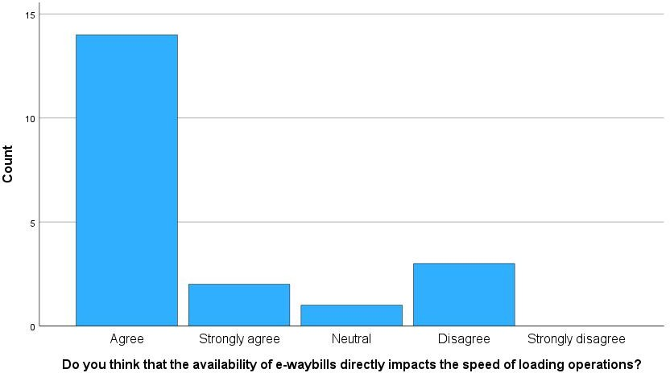

# Do you think that the availability of e-waybills directly impacts the speed of loading operations?

|  |  |  |  |  |  |
| --- | --- | --- | --- | --- | --- |
| Frequency | | | Percent | Valid Percent | Cumulative Percent |
| Valid | Agree | 14 | 70.0 | 70.0 | 70.0 |
| Strongly agree | 2 | 10.0 | 10.0 | 80.0 |
| Neutral | 1 | 5.0 | 5.0 | 85.0 |
| Disagree | 3 | 15.0 | 15.0 | 100.0 |
| Total | 20 | 100.0 | 100.0 |  |

INTERPRETATION: the above mentioned table, 70% responses agree, 15% responses disagree, 10% strongly agree and 5% responses neutral for the statement is the availability of e-waybills directly impacts the speed of loading operations.

Table:

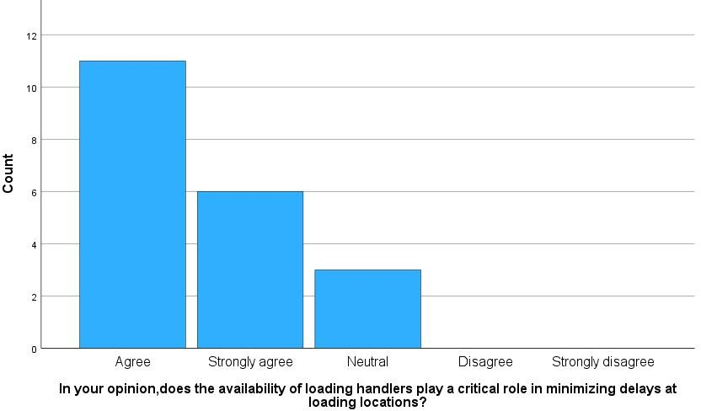

# In your opinion ,does the availability of loading handlers play a critical role in minimizing delays at loading locations?

|  |  |  |  |  |  |
| --- | --- | --- | --- | --- | --- |
| Frequency | | | Percent | Valid Percent | Cumulative Percent |
| Valid | Agree | 11 | 55.0 | 55.0 | 55.0 |
| Strongly agree | 6 | 30.0 | 30.0 | 85.0 |
| Neutral | 3 | 15.0 | 15.0 | 100.0 |
| Total | 20 | 100.0 | 100.0 |  |

INTERPRETATION: the above mentioned table, 55% responses agree, 30% responses strongly agree and 15% responses neutral for the statement for the availability of loading handlers play a crucial role in minimizing delays at loading locations.

# FINDING OF STUDIES

* 70% agree for the availably of e way bill directly impacts the speed of loading operations.
* 55% agree for the availability of loading handlers play a critical role in minimizing delays at loading locations.
* 50% agree that a lack of material readiness is a primary cause of delays in loading operations.
* 35% agree and neutral for the investing in more loading handlers is a viable solution to overcome issues at loading locations.
* 55% agree that improvements in material readiness can significantly reduce problems associated with loading locations.

# CHI SQUARE

* Comparing the two variables is Do you think that the availability of e-waybills directly impacts the speed of loading operations. And do you believe that reducing delays for drivers is crucial for transportation optimization
* comparing the two variables is Do you believe that having drivers available at the gate improves transportation efficiency? And Can you illustrate situations where minimizing waiting time in transportation led to tangible benefits

# WEIGHT AVERAGE:

Here, the weighted average for the statement is agree, most of the members agree for the availability of sufficient space to unload materials critical for avoiding delays and complications.

# CONCLUSION:

The study concluded with the identification of important goals intended to address the issues related to extra fees resulting from vehicles stopping at the customer's location and transportation. Understanding the procedure to guarantee drivers' or transportation companies' availability at the gate and enabling prompt clearance processes were the main goals. Analysing problems at unloading and loading locations, such as material requirements, space availability, handler availability, material readiness, and paperwork preparation, was the focus of secondary objectives.

By achieving these goals, the study hoped to lessen transportation delays, handle driver and transporter discontent due to problems with warehouse space optimization, and identify the root causes of delays and extra fees. Streamlining communication channels, implementing technological solutions for tracking and monitoring, offering opportunities for training and

development, optimizing warehouse space, negotiating contracts with clear clauses, and establishing proactive problem resolution mechanisms were among the recommendations made in order to achieve the desired outcome of eliminating additional charges.

# SUGGESTION:

**Simplify Communication Channels:** To guarantee efficient coordination and prompt updates on material readiness, space availability, and other requirements, establish clear channels of communication between the Transportation Company, drivers, loading/unloading handlers, and customers.

**Employ Technology Solutions:** To track the progress of shipments, optimize routes, and give drivers and customer’s real-time updates, make use of technology like GPS tracking, real-time monitoring systems, and mobile applications.

**Optimize Warehouse Space:** To reduce wait times and increase productivity during loading and unloading operations, work with clients to optimize warehouse space, storage facilities, and material handling procedures.