**Solar based Smart Dustbin using Arduino and GSM module**

Pooja Apte, Aashish Rohankar, Pallavi Tajane,Supriya Thool, Prof S.P.Lodey

Department of Electronics and Communication Engineering,

Shri Sai College of Engineering and Technology Bhadrawati , Maharashtra, India

# 

# Abstract

In the recent decades, urbanization has increased tremendously. At the same phase there is an increase in waste production. Waste management has been a crucial issue to be considered. This proposal is a way to achieve this good cause. In this project smart dustbin is built on a microcontroller-based platform Arduino Nano board which is interfaced with the Servo motor and ultrasonic sensor. Ultrasonic sensor is placed at the top of the dustbin which will measure the stature of the dustbin.

The threshold stature is set at a particular level. Arduino will be programmed in such a way that when someone comes in front of dustbin the servo motor will come in action and open the lid for the person to put the waste material into the dustbin. Once these smart bins are implemented on a large scale, by replacing our traditional bins present today, waste can be managed efficiently as it avoids unnecessary lumping of wastes on roadside. Foul smell from these rotten wastes that remain untreated for a long time, due to negligence of authorities and carelessness of public may lead to long term problems. Breeding of insects and mosquitoes can create nuisance around promoting unclean environment. This may even cause dreadful diseases.

***Keywords****: GSM, Arduino, Arduino IDE, Ultrasonic Sensor*

# Introduction

Dustbins (or Garbage bins, Trash Cans, whatever you call them) are small plastic (or metal) containers that are used to store trash (or waste) on a temporary basis. They are often used in homes, offices, streets, parks etc. to collect the waste. In some places, littering is a serious offence and hence public waste containers are the only way to dispose small waste. Usually, it is a common practice to use separate bins for collecting wet or dry, recyclable, or non-recyclable waste.

Nowadays there are tons of flats and apartments which have been built in the rapid urbanization area. There are several issues faced by the inhabitants of the flats. One of them is the issue of the domestic solid waste disposal, which cause pollutions. Thus, an unsystematic and inefficient disposal waste management may cause the bins to be always full of garbage, and further littering from the residents will cause the garbage piles to be scattered outside the bins. Therefore, there will be a question of sanitary as those garbage piles may become the root cause of illness and diseases like dengue, diarrhoea, and cholera. There are cases where some irresponsible residents, who normally live at the higher levels of the building, and simply threw their domestic waste directly from the floor which they live into the bins. This may cause injuries to people downstairs if they fell onto them. The waste disposal can be managed more properly and efficiently by constantly monitoring the bin status and the garbage level. In addition, the municipality can be alerted when the bin is full or almost full, thus promoting dynamic scheduling and routing of the garbage collection. By comparing to the conventional scheduling and routing.

This dynamic scheduling and routing are said to allow operational cost reduction, by reducing the number of trucks, the manual labour cost and the transport mileage savings. This paper presents an alternative in managing domestic waste especially in flat areas via a smart garbage monitoring system. This system will automatically monitor the garbage level at each bin and will alert the municipality or garbage van driver in the case where the bins are almost full. It is a decent gadget to make your home clean, due to practically all offspring of home consistently make it grimy and spread litter to a great extent by electronics, rappers, and various other things. Since the smart dustbin is additionally intriguing and children make fun with it so it will help to maintain cleanliness in home. Dustbin will open its lid when someone/object is near at some range then it will wait for given time than it will close automatically. Here lid will close when you don’t want to use, and it will only open when it required.

In this project, I have designed a simple system called Smart Dustbin using Arduino, Ultrasonic Sensor, and Servo Motor, where the lid of the dustbin will automatically open itself upon detection of human hand. The smart dustbin is a carefully designed solution that solves the social issue of waste disposal; the smart dustbin identifies the kind of material being thrown inside it and segregates it into bio or non-biodegradable.

This project combines knowledge in the field of telecommunications and computing. Sending short messages via a modem that is GSM (Global System for Mobile Communications) mobile phones to be used and studied and practiced to this project.

## Objectives

The purpose of this project is to provide some project that can monitor the dustbin using the new technology.

1. To develop a prototype of the smart dustbin monitoring system when the trash inside the dustbin is full it will automatically detect by the sensor system.
2. Design and build a prototype for an automatic open dustbin that can automatically open the lid when it detects the people who want to throw out their trash. It also can detect the level of the trash that inside the dustbin.
3. To get familiar with the Arduino and the respective sensors how to use them for a cause.
4. To analysis the dustbin program and set it up according to the physical distance for best Working.
5. To develop a system that can send information from one place to another place without any limitation
6. To integrate the project of dustbin that uses the communication system for sending information data and it also can provide the user-friendly system.

**Circuit Diagram**

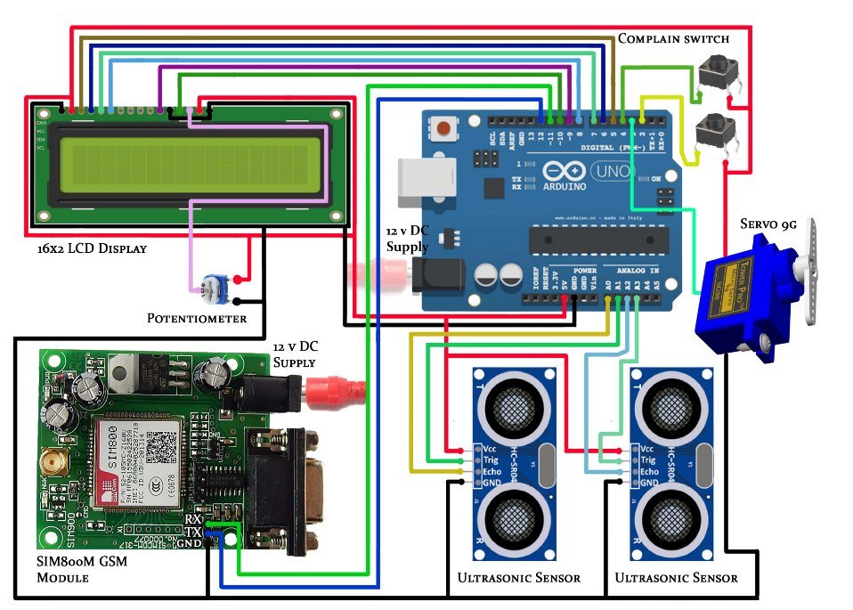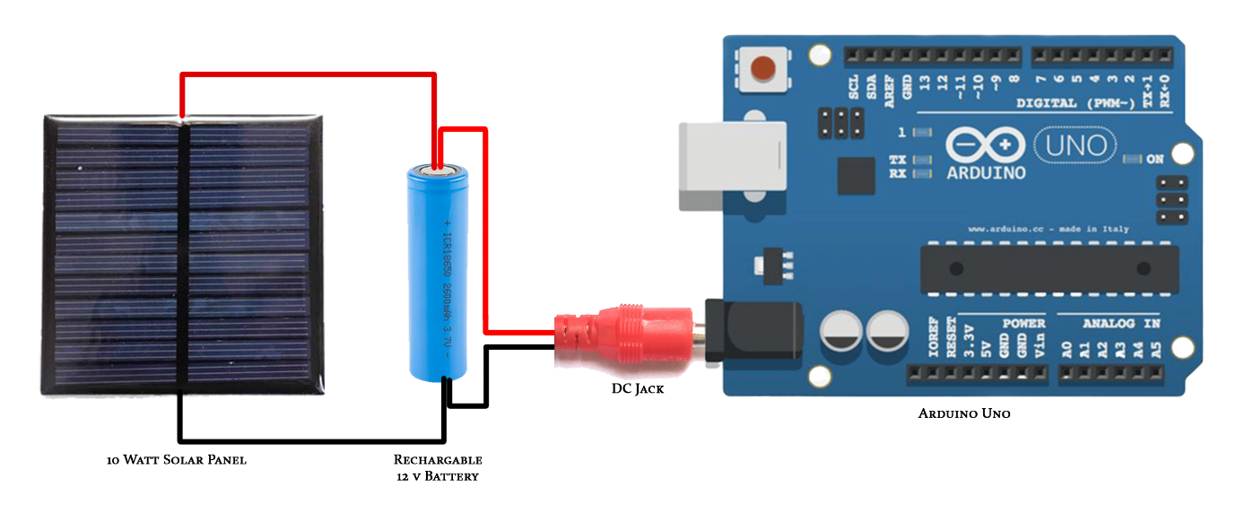

# Working

* After wiring and attaching all the devices and setting up to the Smart Dustbin, now observe all the important setup whether they are well connected, or something missed.
* After connection set up now next step is to submit/upload code in Arduino and supply power to the circuit.
* When system is powered ON, Arduino keeps monitoring for any things that come near the sensor at give range.
* When Ultrasonic sensor detect any object for example like hand or others, here Arduino calculates its distance and if it less than a certain predefines value than servo motor gets activate first and with the support of the extended arm of the lid.
* Lid will open for a given time than it will automatically close.

# Advantages

Following are the advantages of using Smart dustbin:

* A reduction in the number of waste collections needed by up to 80%, resulting in less manpower, emissions, fuel use and traffic congestion.
* A reduction in the number of waste bins needed.
* Maintain environment hygiene (i.e., no overflowing of waste and less unpleasant odour).

It will help in bringing evolution by technology in term of cleanliness.

Conclusion

Here we are going to make an evolution change toward cleanliness. The combination of intelligent waste monitoring and trash compaction technologies, smart dustbins are better and shoulders above traditional garbage dustbin. It is equipped with smart devices like sensor Arduino etc. Lid of the dustbin will automatically open when an object comes near to the dustbin and after certain time it will close the lid.

Automatic Garbage Fill Alerting system helps us to reduce the pollution. Many times, garbage dustbin is overflow and many animals like dog or cow enters inside or near the dustbin. Also, some birds are also trying to take out garbage from dustbin. This project can avoid such situations. And the message can be sent directly to the cleaning vehicle instead of the contractor’s office. Apart from this, differentiation can be made between dry trash bin and wet trash bin collecting plastic dry waste and biodegradable waste respectively. To implement this methane and smell sensors can be used. This helps in distinguishing the waste at the source and hence reducing the requirement of manpower. To enhance it further, an automated system can be developed which is able to pick up waste in and around the bin, segregate them and put them in respective bins.

**References**

1. S.S. Navghane, M.S. Killedar, Dr.V.M. Rohokale, IoT Based Garbage and Waste Collection Bin, May 2016.
2. Ghose, M.K., Dikshit, A.K., Sharma, S.K. A GIS based transportation model for solid waste disposal – A case study on Asansol municipality. Journal of Waste Management.
3. Guerrero, L.A., Maas, G., Hogland, W.: Solid waste management challenges for cities in developing countries. Journal of Waste Management.
4. Alexey Medvedev, Petr Fedchenkov, ArkadyZaslavsky, Theodoros, Anagnostopoulos Sergey Khoruzhnikov, Waste Management as an IoT-Enabled Service in Smart Cities.
5. Meghana K C, Dr. K R Nataraj, IOT Based Intelligent Bin for Smart Cities.
6. KasliwalManasi H., SuryawanshiSmitkumar B, A Novel Approach to Garbage Management Using Internet of Things for Smart Cities.
7. Vishesh Kumar Kurrel, Smart Garbage Collection Bin Overflows Indicator using Internet of Things
8. Monika K A, Nikitha Rao, Prapulla S B, Shobha G, Smart Dustbin-An Efficient Garbage Monitoring System.