**IMPROVING SOIL PROPERTIES BY USING WASTE OIL**

***Mohit Bhardwaj1*, Shivani2***

*1Student, 2Assistant Professor*

*Sat Priya Group of Institutions, Rohtak*

***\*Corresponding Author***

***E-mail Id:-msmahis500@gmail.com***

***ABSTRACT***

Transportation is the means to carry people and goods from one place to another place. It is very important in every stage of human civilization. The most widely used modes of transportation are roads and rails in India. So there is a need of development of these modes. Out of these modes, road transportation provides maximum flexibility to the passengers and it serves door to door connection. A proper network of roadways will help in development of economic, social, political and cultural fields of the country as a whole. Based on function, the roads are classified as National Highways (NH), State Highways (SH). Major District Roads (MDR), Other District Roads (ODR) and Village Roads (VR). Pavements are classified as Flexible and Rigid pavements depending upon their structural behaviour. The roads are generally constructed in different layers. The various layers of a flexible pavement are subgrade, sub base, base and surface course, whereas the rigid pavement consists of subgrade, base course and cement concrete slab.

The soil subgrade is prepared from natural soil to support the layers of pavement materials laid over it. The various loads on the pavement are ultimately received by the soil subgrade and then dispersed to the earth mass. The soil subgrade provides support and stability to the pavement and also helps in good drainage for rain water percolating through pavement. So it is desirable to well compact the top 50 cm layer of subgrade soil under controlled conditions of maximum dry density and optimum moisture content. The defects such as ruts, corrugations and cracks are caused mainly due to poor subgrade construction. So the subgrade should be constructed with good quality soil to avoid above mentioned problems.

***Keywords:-*** *soil subgrade, percoalating, major district road, state highways, village road*

**INTRODUCTION**

Many a times, required amount of good quality soil may not be available in nearby areas. The cost of transportation may increase for importing a large quantity of soil from distant borrow pits for the construction of soil subgrade. It is necessary to evaluate the strength properties of soil subgrade like CBR, density and shear strength etc. In case the subgrade layer does not come up to the expectations, the same is treated or stabilized to suit the requirements ie, to alter the properties of soil to improve strength and durability.

In India, researchers have worked on soil stabilization by using cement, lime. bitumen, fly ash and geosynthetics etc. in the past few decades. These additive materials have their own limitations like non-renewable sources, environmental issues, cost and availability and also the manufacturing of these materials being

destructive to the natural habitats. So soil properties may be improved by using new materials. The over increasing demand for cost effective, environmentally friendly construction practices and, perhaps the most of all, the reduced availability of suitable materials lead to use "waste" materials in the construction. In many cases the use of waste materials may undergo some form of stabilization or improvement. Many of the activities such as food preparation, use of automobiles and the industries producing by-products such as used engine oil, fly ash and steel slag ete are not eco-friendly. The hazards caused by disposing waste oils mainly cause bad impact on water bodies and may also cause problems in road drainage. It also affects aesthetic qualities of shore lines in case of areas near the sea. So use of these waste oils will not only address the problem of their disposal but may also prove to be economical.

THESIS TOPIC AND ITS IMPORTANCE

The research topic "Improving Soil properties by Using Waste Oil" focuses on the utilization of waste engine oil for improving the soil strength properties. Engine oil is mainly used in automobile industries for the functioning of machines. There is lots of wastage produced by industries in the form of waste engine oil.

Currently disposal of these waste oils is creating so much problems to the environment. Because of these environmental issues, industries producing waste oil are trying to make use of recycled oil. Now-a-days, recycled oils are processed as lubricants and manufactured into biodiesel. Even though only 10 to 20 percent of the total oils are recycled remaining percentage of waste oils is simply disposed to the nearby water bodies causing pollution. So utilization of the waste oil for construction of subgrade or embankment will decrease the environmental pollution.

In this research an attempt has been made to test the feasibility of waste engine oil for improving properties of subgrade soil. Waste engine oil is mixed with clayey soil in different proportions to test various properties. In order to evaluate the suitability of mix proportions, waste oil is added by varying its proportion from 0% to 5% by the weight of soil. It is expected that the outcome will be favourable for the construction of subgrade or embankment.

OBJECTIVES OF THE STUDY

In the present research work, an attempt has been made to test the suitability of waste oil for improving soil properties for the construction of soil subgrade or embankment. The aim of the research work is to improve the strength characteristics of clayey soil by adding waste engine oil in different mix proportions. The objectives of the research work are outlined as below.

1. To determine index properties of two types of soils used in the study, that is. CL type (clays of low plasticity) and SC type (clayey sand) soils.

2. To determine the maximum dry density (MDD) and optimum moisture content (OMC) of the soils with different mix proportions of waste engine oil.

3. To determine the California Bearing Ratio (CBR) value of the two soils with different mix proportions of waste engine oil.

4. To study the effect of addition of waste engine oil on compaction and strength characteristics of the soil.

5. To develop relationships between compaction and strength characteristics of the soils used in the study with the proportion of waste engine oil.

SCOPE OF THE STUDY

Use of waste engine oil for the road construction is one of the solutions for disposal problem of waste engine oils and reduces the dependency on conventional materials. The study has been taken up mainly to understand the feasibility of use of waste engine oil for construction of subgrade or embankment. The study has been conducted on two types of soils collected from Samna village near Kurukshetra (Soil-1) and NIT Kurukshetra (Soil-II). Soil-l is found to be CL type, i.e., inorganic clays of low plasticity and Soil-II is of SC type, i.e., clayey sands. For this study the waste engine oil was collected from a local automobile shop.

In this study, waste engine oil is mixed with soil in various proportions from 0% to 5% by weight of soil for testing the compaction characteristics and California Bearing Ratio (CBR) value. The results of the study are applicable only to the materials used in this study. However, the methodology can be applied to the other similar materials as well and expected results may also be similar and compatible.

In the construction of subgrade or embankment large amount of soil is required and also it is not always possible to obtain the soil of requisite strength characteristics. This leads to digging of good soil that causes wastage of agricultural land. deforestation and landslides in hilly areas. The cost and effort involved in this process is quite expensive. So the strength characteristics of available soil should be improved by adding some available waste materials.  
  
Now a day there is so much development in industries especially in automobile sector. The wastage caused by these automobile industries is more which results in disposal problem. They are mainly disposing the wastage in water bodies and it causes disturbance to natural habitat. Central pollution control board (CPCD) has taken action against these automobile industries for disposing waste oils in water bodies. So as a remedy these waste oils are used for the improvement of soil properties for construction of subgrade or embankment. This one is not only solves the disposal problem of industries and also preserves the natural soil.  
  
So many researchers have worked on waste oils for improving soil properties of subgrade. Some of the literatures related to use of waste oils for improving the soil properties are described below.

LITERATURE REVIEW

John P. Turner (1994) has done research on soil stabilization by using oil shale solid waste. In this research three soils were tested and the soils classified according to AASTHO classification. Soil 1 is classified as A-2-4 and soil Il is also A-2-4 but it contains higher percentage of fines than soil 1. Soil III classified as A-7-6, highly plastic clay. The use of 20% of oil shale solid waste, by weight increased the unconfined compressive strength of soil I from 517 to 3,290 kpa. The addition of 25% of oil shale solid waste, by weight to soil II yielded a resilient modulus of 1,300 to 2,700 kpa and exhibited acceptable durability against wet-dry conditions and marginal durability under freeze-thaw conditions. Treatment of soil III with oil shale solid waste resulted in little or no increase in unconfined compressive strength but resilient modulus of the stabilized clay was increased 20% over that of unstabilized clay. Oil shale solid waste has the potential to be used as a low cost construction material. From this research observed that oil shale solid waste more suitable for granular soils than fine soils.

R. M. Cruse et al (2000) have done research on water drop impact angle and soybean protein amendment effects on soil detachment. This laboratory study investigated on effect of soil shear strength and rain drop impact angle on soil detachment. The research conducted on loess and glacial till soils. In this research soybean protein material was added to each soil material at concentrations of 0.0, 0.5, and 1% by weight. Shear strength of loess increased from 0.61 to 1.85 Mg m² and for glacial till shear strength increased from 0.57 to 0.98 Mg m³. From this research the soybean protein material is suitable for increasing shear strength of the soil.

Lutfi Raad (2001) has done research on soil stabilization by using vegetable oil. In this research the materials used are processed vegetable oil and sand. For this research the vegetable oil is used 5% by weight of sand. The stabilization done by mixing vegetable oil for sand and simultaneously heating the mixture in between 50° C to 200° C then the mixture is spread over the area in which stabilized soil is compacted by a compaction roller. The compacted mixture is allowed to cure. The results shown that there is a considerable improvement in strength by increasing curing time. From this research the vegetable oil is suitable for stabilization of sand.

P. A. K. Greening and P. Page Green (2003) have done project on evaluation of sulphonated petroleum products as soil stabilizers and compaction aids. The materials used are seven types of sulphonated petroleum products (SPPs) and five types of soil. The mix is done by adding 0.015-0.12 mP/kg for the soil. The results shown that there is a considerable improvement in CBR value of clayey soil. From this project the increase in strength is particularly pronounced in materials with high clay content, which are the materials most susceptible to improve by adding sulphonated petroleum products.

Sanjay J. Shah et al (2003) conducted a case study on stabilization of fuel oil contaminated soil. The weight percentage of oil was found vary between 7 to 10% Both contaminated and uncontaminated soil analyzed for index properties and strength parameters. Contaminated soil was treated with lime, fly ash and cement. In the process of stabilization fuel oil formed a stable complex with metals.  
  
Fahad A. Al Otaibi (2006) has done project on assessment of the possibility of stabilizing sabkha soils using oil lake residue. Sabkha is a problematic salt-encrusted soil deposited under arid conditions which cannot be used for construction in its natural condition. For this project sabkha soils are collected from four locations for the detailed experimental testing. Oil residue was added to the sabkha soils at different percentages ranging from 0%-10%. The experimental programme included laboratory and field testing of physical properties and strength, consolidation and leaching aspects of the natural and oil mixed sabkha soils. Results shown that the addition of oil residue reduced the friction between the soil particles in the range of 5% to 28% and the facilitated sliding over each other resulted in an increase in the density of the compacted Sabkha soils of between 2% to 8.5%. The UCS increased in the range of 34% to 504% of the natural values. The shear strength slightly increased with oil addition, since the internal friction decreased and the cohesion intercept values increased in the range of 45% to 150%. The adsorbed oil residue on the cemented soil lumps acted as a waterproofing agent that reduced both salt dissolution by 56% of the natural soil and the long term coefficient of permeability in the range of 73% to 88 %. Under soaked conditions, the improvement in strength properties were pronounced. The natural Sabkha soil disintegrated upon soaking, while oil mixed Sabkha maintained its integrity. Yield stress increased in the range of 25% to 60% from the values of natural soils decreased in the stabilised Sabkha. From this research oil Lake Residue is suitable for stabilizing sabkha soils.  
  
Giovanna Cucci, et al (2008) have done research on improvement of soil properties by application of olive oil waste. Wet olive pomace is an organic material, a by- product of the olive milling process. The research done on silty-clay soil. The wet olive pomace applied at amounts ranging from 0 to 210 Mg/ha for soil. The results shown that it allows an overall fertility improvement and nutrient content increased without altering pH and salinity. Moreover, the application of wet pomace to the soil increased the structural stability index of the aggregates, favouring soil particle aggregation, which is very important for these soils. From this research olive oil waste is suitable for fertilizing soil for agriculture.  
  
Praveen Kumar and Gaurav Pandey (2009) have done research on use of oils and phosphates in soil stabilization. The research is done on locally available Roorkee soil. It is a cohesion less soil which is classified as SP as per IS classification. The materials used for stabilization are used Engine oil, soybean oil and enzyme solution Each admixture namely soybean oil, used Engine oil and enzyme solution was mixed with soil in different percentages 2% 3%, 4% by volume and the mixture was heated at 200°C and the mixture was kept in oven for 1 hour. In this research the laboratory study conducted on unconfined compressive strength test, CBR test and Tri axial test. The results shown that CBR values are increasing from 4% for Roorkee soil to 14.7%,17.1% and 11.4% with engine oil, soybean oil and enzyme solution respectively. The shear strength also increased from 1.6 kg/cm² for Roorkee soil to 2.51. 3.52 and 3.97 kg/cm² with engine oil, soybean oil and enzyme solution respectively. The optimum percentages of engine oil, soybean oil and enzyme solution are 4%, 2% and 2% respectively. From this research observed that the waste oils are also useful for soil stabilization.  
  
Hussein Yousif Aziz and Jianlin Ma (2011) have done research on gypseous soil improvement using fuel oil. A detailed laboratory tests were carried out on two soils. Soil I is sandy soil with gypsum content of 51.6% and soil II is clayey soil with gypsum content of 26.55%. The fuel oil is collected from Al-Dura refinery throughout the research. The fuel oils are brownish black petroleum fractions consisting largely distillation residues, with a relative density of about 0.95. The research included testing the shear strength, permeability, compressibility and also Atterberg limits for clayey soil. The permeability and leaching properties of soils are decreased by adding fuel oil. The durability of soils increased by adding 2% of fuel oil as compared to untreated soil. The collapsibility and compressibility are reduced for soils by adding fuel oil. The shrinkage limit of the soil is decreased and also gives more flexibility to the soil by adding fuel oil. The optimum percentage of fuel oil is 4% for sandy soils and 3% for clayey soils. From this research, it is indicated that fuel oil is suitable material for improving gypseous soil.

Nazir and Ashraf K (2012) have done research on stabilization of collapsible soil with engine oil. The collapsible soils are moisture sensitive and susceptible to large reduction in volume when subjected to wetting. In this research a laboratory study has done to find the effect of Engine oil to stabilize the collapsible soil. The laboratory study involves mainly basic properties of collapse potential. Atterberg limits. compaction and direct shear tests on collapsible soil stabilized with oil in the amount of 0%, 4%, 8%, and 12% by dry weight of soil. The results indicated that decrease in collapse potential, maximum dry density, frictional angle, moisture content and Atterberg limits, while the cohesion of soil is increased significantly. The overall shear strength is slightly increased. From this research concluded that Engine oil is suitable for stabilizing collapsible soil.

MATERIALS

The materials used for the research work are locally available waste engine oil and two type of soilsl namely clayey soil and clayey sand. The waste engine oil is collected from a local automobile shop in Kurukshetra. Two soils that is CL type SC type are collected respectively from Samna village near NH-1 in Kurukshetra district.

MATERIALS USED

Clayey soil (CL type)

The soil is extracted from a depth of 1 to 1.5 m below the ground surface. Pictorial views of the soil before drying and after drying are shown in Figs. below.

Fig. :Pictorial View of Soil (CL type) before Drying

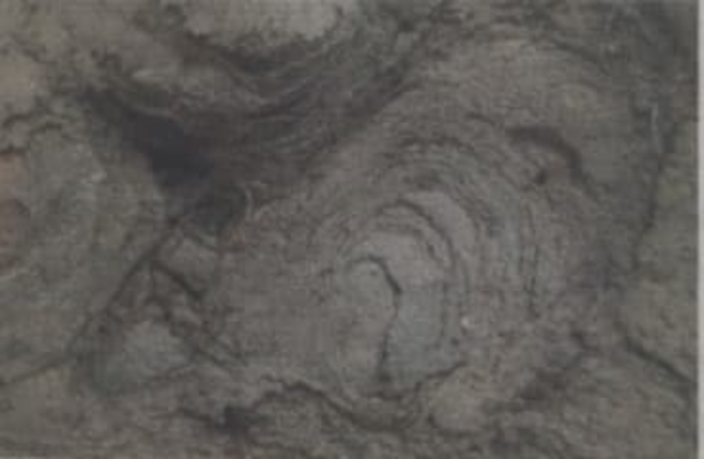

Fig. :Pictorial View of Soil (CL type) after Drying

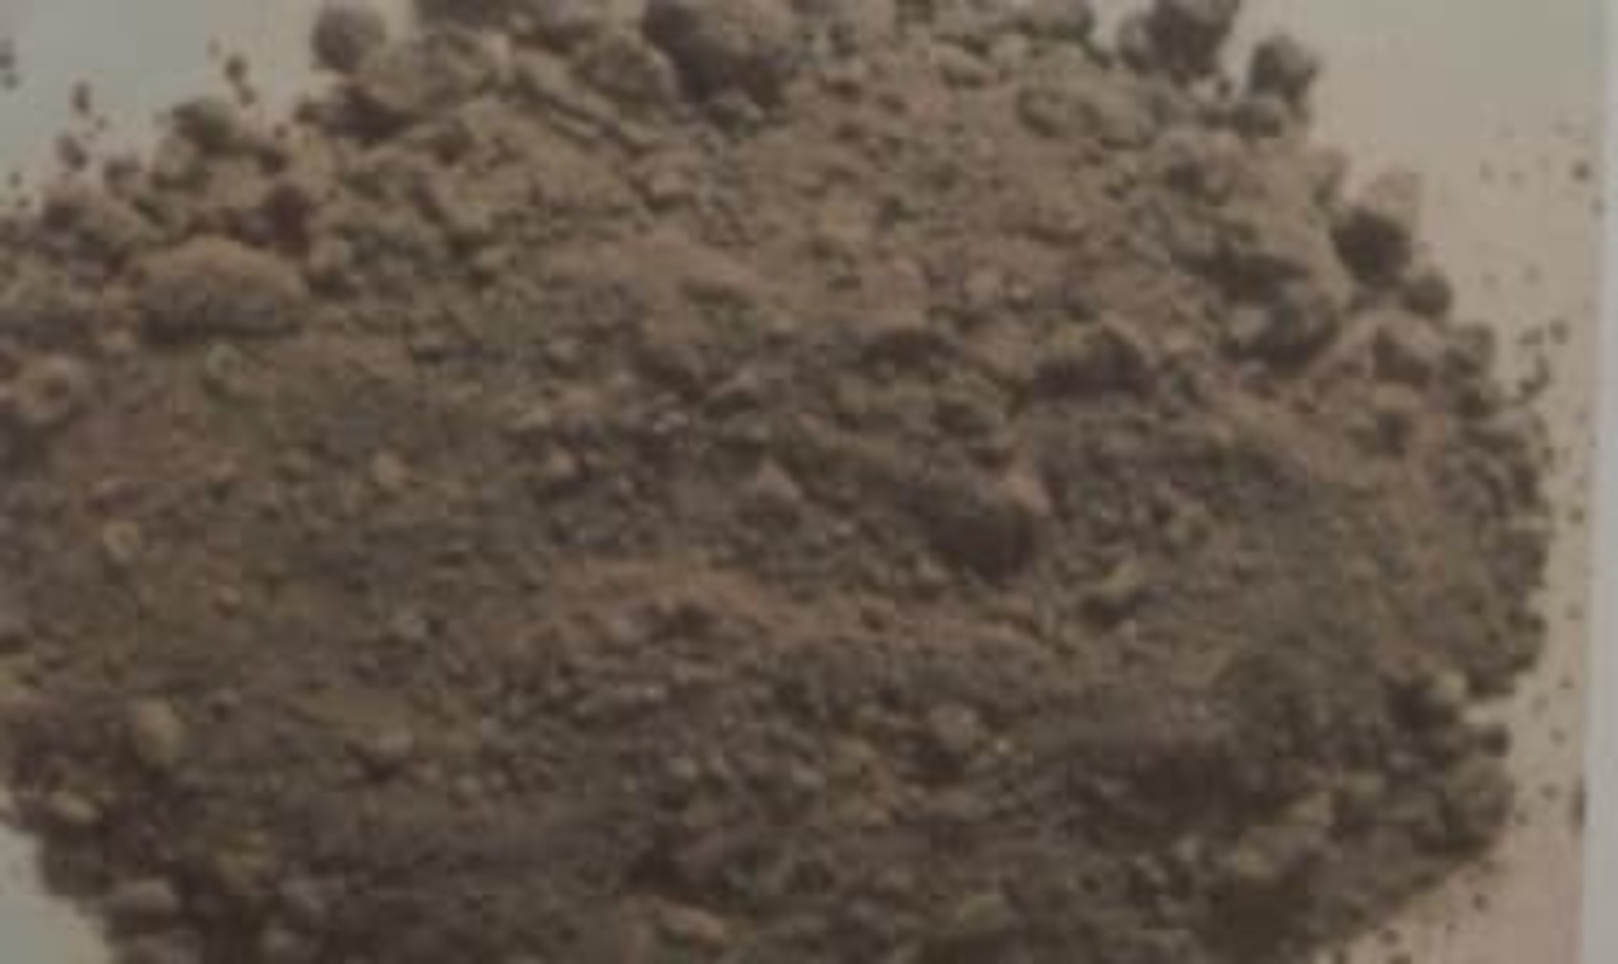

The soil sample collected from the site was wet for which it was dried in open air for two days and then lumps are broken using hammer in laboratory.

Clayey sand (SC type)

Clayey sand is collected from nearby Fanibhushan Bhawan in NIT Kurukshetra. The soil is extracted from a depth of one meter from the surface. The pictorial view of the soil is shown in Fig below.

Fig. :Pictorial View of Soil (SC type)

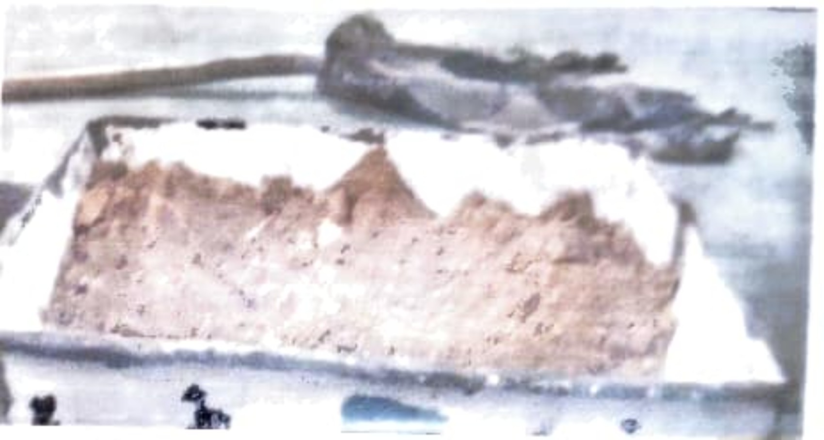

Waste Engine oil

Waste engine oil is collected from an automobile shop near Kessel mall in Kurukshetra. The waste engine oil though was obtained free of cost for this study, it may actually cost about Rs. Ten per litre. The colour of waste engine oil is observed as thick black. The pictorial view of waste engine oil is shown in Fig. below.

Fig.: Pictorial View of Container with Spilled Waste Engine Oil

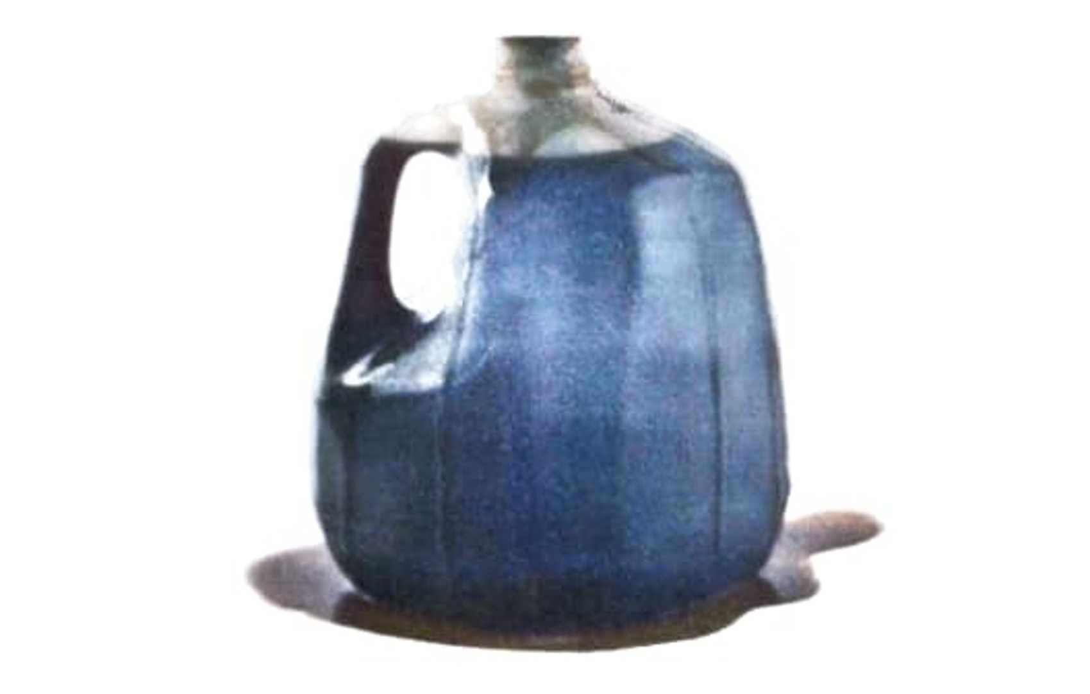

METHODOLOGY OF STUDY

GENERAL

In this study, various experiments have been carried out on the selected soils and their mix proportions with waste engine oil to understand the feasibility of using waste oil in the road construction. The experimental investigations have been carried out in Transportation Lab in Delhi.

The experiments have been carried out as per relevant Indian Standard (IS) codes. Laboratory investigations like Grain size distribution. Atterberg limits and Specific gravity of the soils were conducted to determine the Index properties of the materials. Strength parameters are evaluated using Standard Proctor test and California Bearing Ratio (CBR) test. Based on the requirements, suitability of the mixes is decided for subgrade construction. Fig. below shows the methodology of the study.

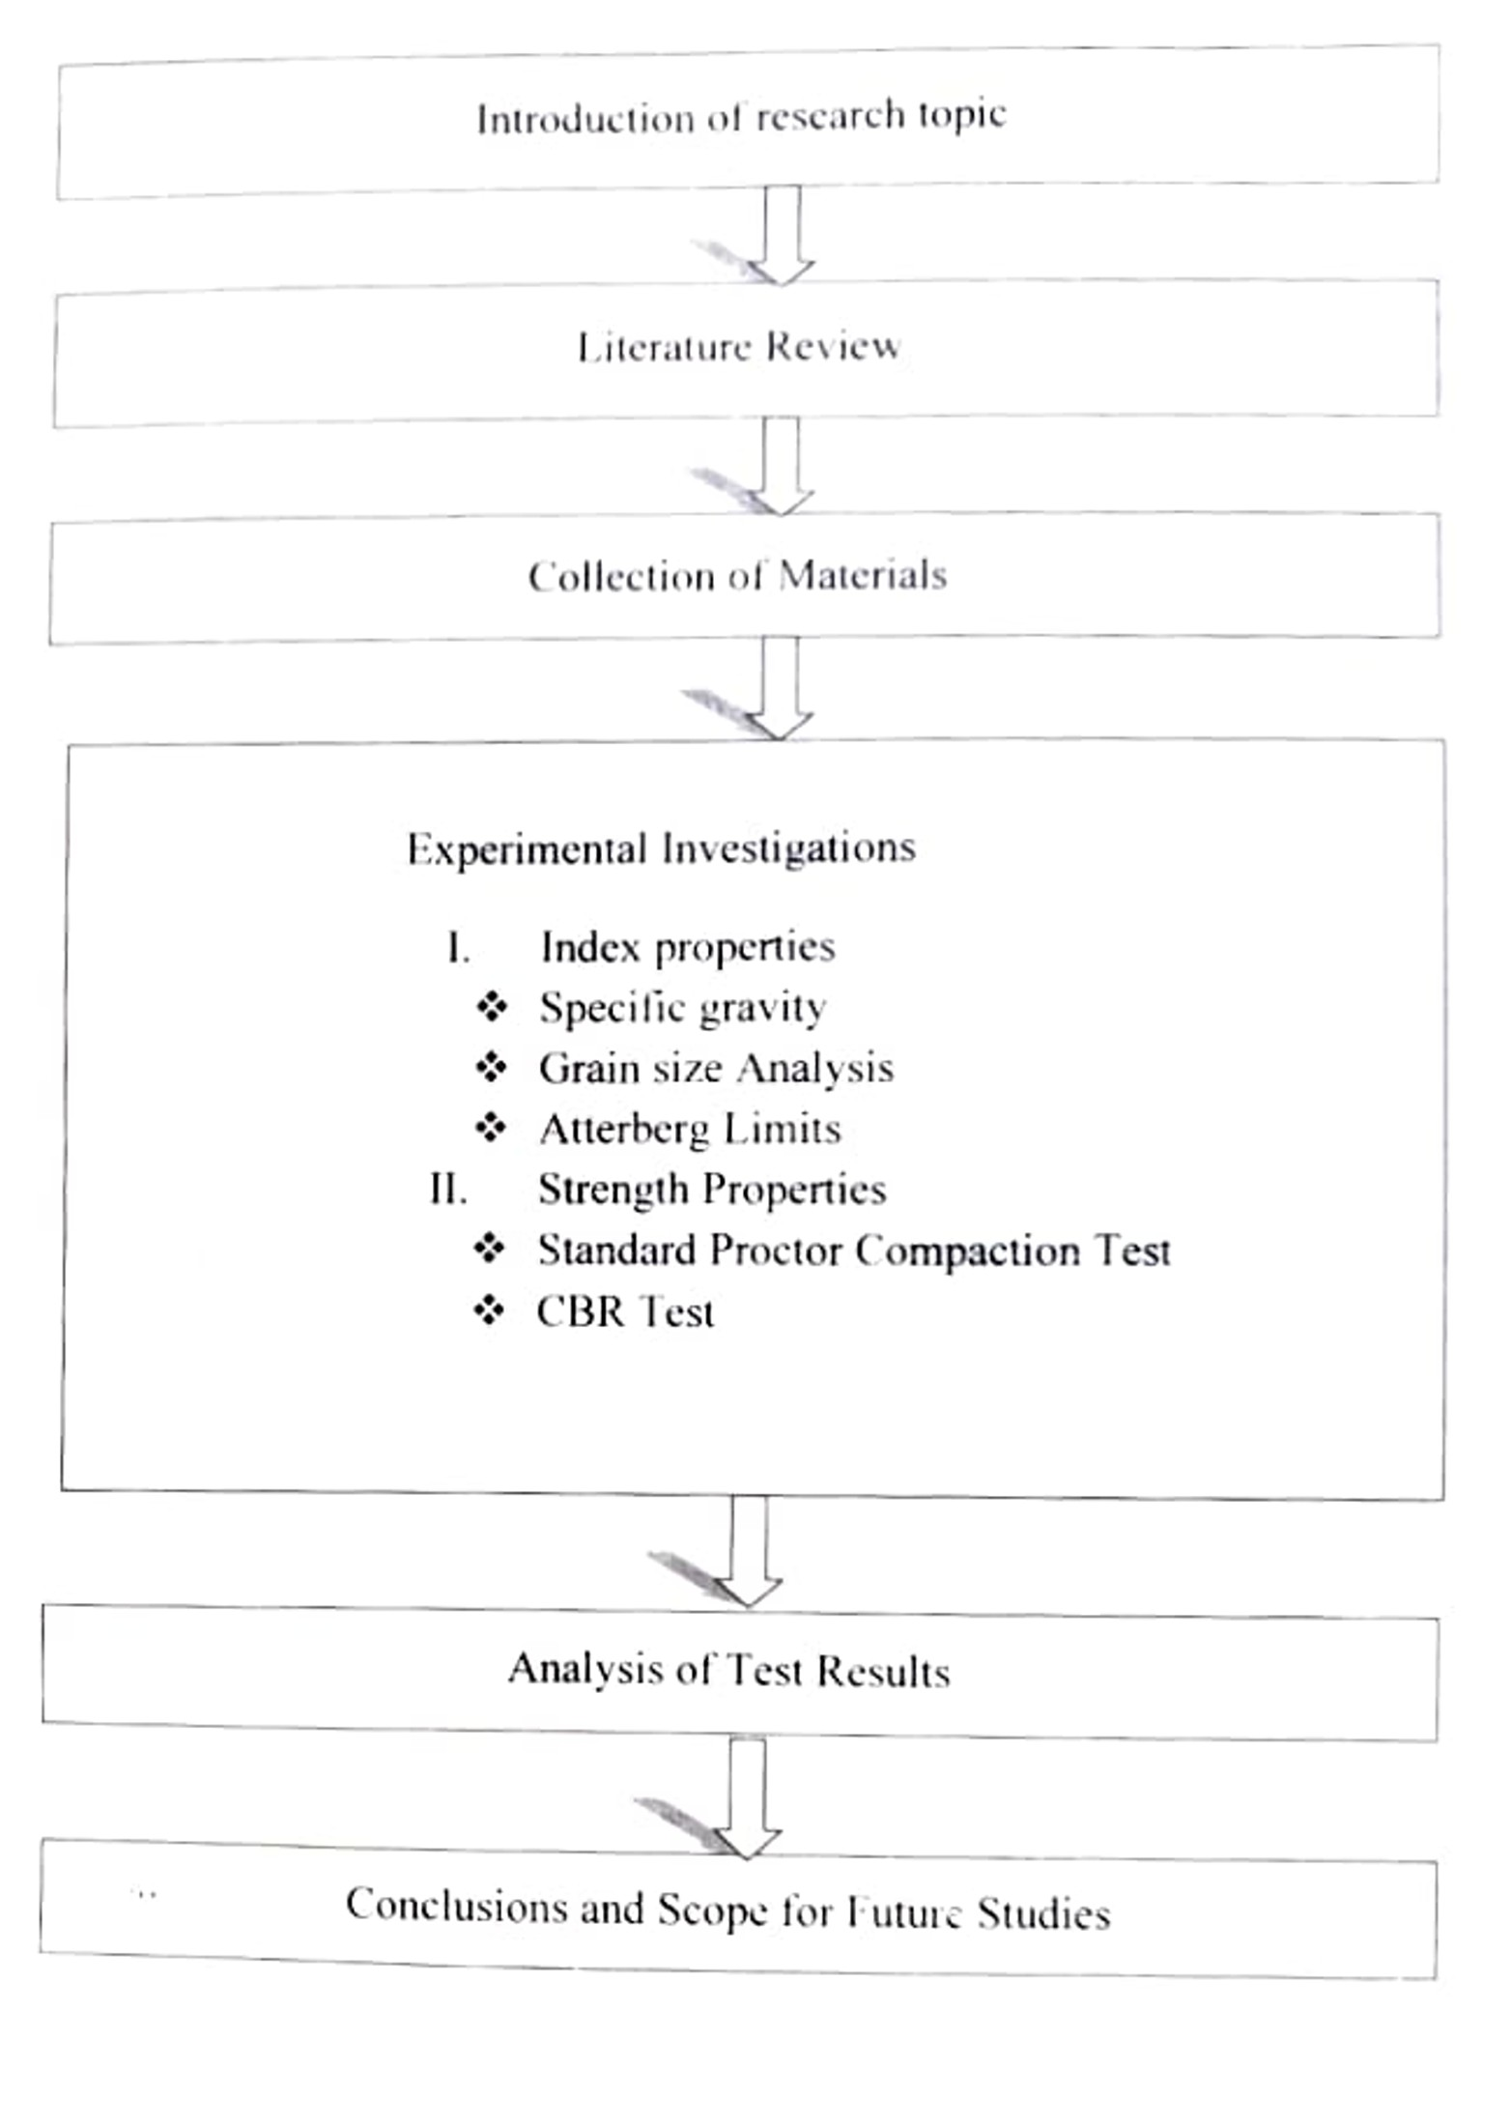

Fig. Methodology of the study

DESCRIPTION OF EXPERIMENTAL METHODS

Laboratory experiments like, Specific gravity. Atterberg limits and Particle size analysis have been carried out to determine the index properties of soil. Standard Proctor Test and CBR Test have been carried out to understand the strength parameters of the soil and mix proportions of soil and waste engine oil. All the experiments are carried out as per relevant Indian Standard (IS) codes.

Index Properties

Index properties like Atterberg limits, Specific gravity and Particle size analysis have been carried out to understand the soil and also help to identification and classification of soil. The Index properties are tested for inorganic clays of low plasticity (CL. type) and clayey sand (SC type).

Specific Gravity

It has been carried out based on IS 2720- Part 3-1980. The specific gravity of soil is defined as the ratio of the weight in air of given volume of soil solids at a stated temperature, to the weight ir air of an equal volume of distilled water at the stated temperature. For the soils, the specific gravity is measured by pycnometer apparatus.

Procedure of Experiment

Clean and dry the Pycnometer. Tightly screw its cap. Take its mass (M1) to the nearest of 0.1 gm.

Mark the cap and Pycnometer with a vertical line parallel to the axis of the Pycnometer to ensure that the cap is screwed to the same mark each time.

Unscrew the cap and place about 200g of oven dried soil in the Pycnometer. Screw the cap. Determine the mass (M2).

Unscrew the cap and add sufficient amount of de-aired water to the Pycnometer so as to cover the soil. Screw on the cap.

Shake well the contents. Connect the Pycnometer to a vacuum pump to remove the entrapped air, for about 20 minutes for fine-grained soils and about 10 minutes for coarse-grained soils.  
Disconnect the vacuum pump. Fill the Pycnometer with water, about three-

fourths full. Reapply the vacuum for about 5min till air bubbles stop appearing on the surface of the water.

Fill the Pycnometer with water completely up to the mark. Dry it from outside. Take its mass (M3).

Empty the Pycnometer. Clean tit and wipe it dry.

Fill the Pycnometer with water only. Screw on the cap up to the mark. Wipe it dry. Take its mass (M4).

Calculation  
The Specific gravity of the soil (G) is calculated by using the following formula. M2-M1 Specific Gravity (G) = M2 -M1 / ((M2 -M1)-(M3 -M4))

Here,  
M1= weight of empty pycnometer  
M2= weight of pycnometer + oven dried soil  
M3 = weight of pycnometer + oven dried soil + water M4 = weight of pycnometer + full water.

Particle Size Analysis (IS: 2720, Part 4-1985)

Particle size analysis is also known as mechanical analysis. It is a method of separation of soils into different fractions based on the particle size. It expresses quantitatively the proportions, by mass, of various sizes of particles present in a soil. It is generally shown graphically on a particle size distribution curve.

The mechanical analysis is done in two stages. The two stages of analysis are sieve analysis and sedimentation analysis. Sieve analysis is meant for coarse grained soils (particle size greater than 75 micron) which can easily pass through the set of sieves. Sedimentation analysis or wet sieve analysis is used for fine grained soils (particle size smaller than 75 microns). If soil mass contain the particles of both types of soils, a combined analysis comprising both sieve analysis and sedimentation analysis is required. In the present study two types of soils that is clayey sand and inorganic clays of low plasticity are used for experimental analysis.

Procedure for dry sieve analysis

The pan and the test sieve of sizes 0,075, 0.15, 0.3, 0.6, 1.18, 2.36 and 4.75 mm are placed one above the other in the increasing order of their sieve size. The soil taken for sieve analysis should be oven dry. The sample is sieved through 4.75 mm IS sieve. The portion retained on the 4.75 mm sieve is the gravel fraction. The remaining soil is sieved through the set of fine sieves. The sample is placed on the top sieve and the set of above mentioned sieves is kept in a mechanical shaker. Normally, 10 minutes shaking is sufficient for most soils. The mass of soil retained on each sieve and on pan is obtained to the nearest 0.1 gm. After that determine the percentage retained. cumulative percentage retained and the percentage finer based on the total mass taken. Based on these values plot the particle size distribution curve with particle size as abscissa on log scale and the percentage finer as ordinate. By using this curve calculate uniformity coefficient (C) and coefficient of curvature (C.). Uniformity coefficient, coefficient of curvature and percentage of fines are useful for classification and identification of soil.

Procedure for wet sieve analysis

If the soil contains a substantial quantity (say more than 5%) of fine particles, a wet sieve analysis is required. All lumps are broken into individual particles. A representative soil sample in the required quantity is taken and dried in oven. The pan and the test sieve of sizes 0.075, 0.15, 0.3, 0.6, 1.18, 2.36 and 4.75mm are placed one above the in the increasing order of sieve size selected. Additional test sieves of intermediate size may also be introduced as required depending up on the additional information necessary. The prepared soil specimen soaked in water is placed over the set of sieves and washed through the sieves with additional quantity of water as required. Washing is continued till the water passing each sieve is substantially clean. The fraction of sieve retained on each sieve is emptied carefully without loss of material in separate trays, oven dried at 105° to 110° C

and each fraction weighed separately. The total weight of dry soil sample taken for the sieve analysis could also be checked with the total weight of the dry soil fractions retained on each sieve and the pan at the bottom. Fig. below shows the dry sieve analysis performed in the laboratory.

Fig. : Pictorial View of Dry Sieve Analysis

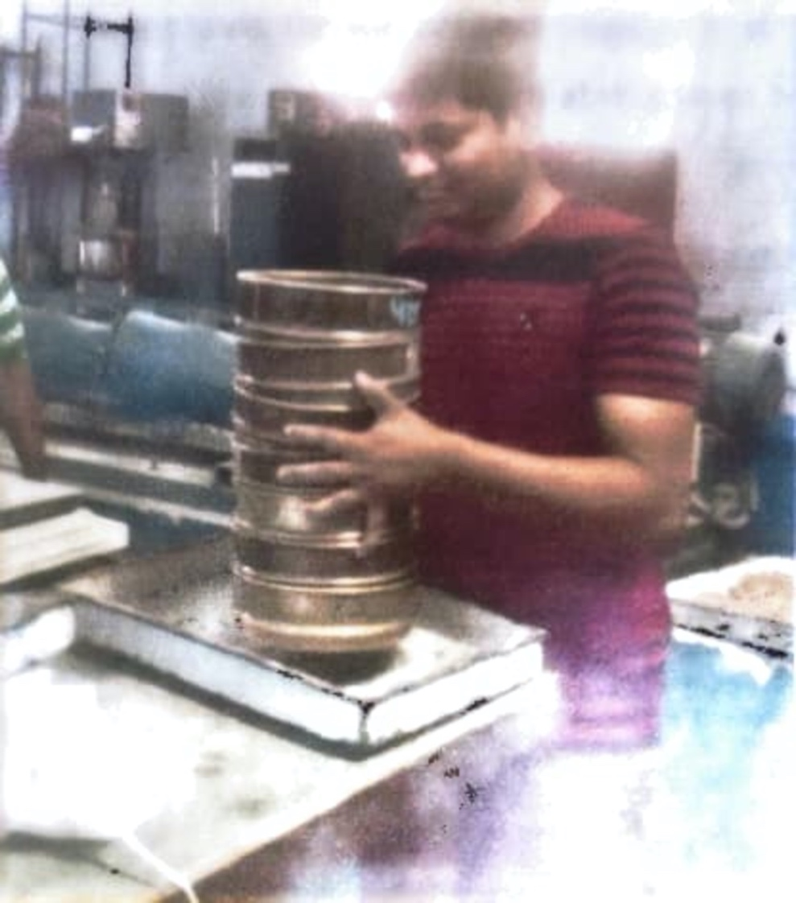

**CONCLUSIONS**

In this research work, the use of waste engine oil to improve the subgrade soil has been identified, discussed and analyzed. Waste engine oil is obtained from automobile industries. It has been collected from an automobile shop in Kurukshetra. The study mainly focused on the utilization of waste engine oil for improving the soil properties to achieve the end goal to obtain the minimum strength characteristics for the construction of soil subgrade. The study includes various laboratory investigations on Soil-I (CL type of soil) and Soil-II (SC type of soil) and their mixes with waste engine oil. The waste engine oil has been added to the soil from 0% to 5% by weight of soil to evaluate various properties of the soil waste engine oil mixes. The laboratory experiments consisted of determination of Atterberg limits. Specific gravity and particle size analysis to understand the Index properties of soils. The strength parameters have been evaluated by Standard proctor test and California bearing ratio (CBR) tests on soil waste engine oil mixes. The main conclusions drawn from the study are:

Properties of Soils

The Soil-I used in the study is CL. type, that is, Inorganic clays of low plasticity. The soil sample comprises 74.5% of silt and clay. Liquid limit of soil-1 is 29.24% with Plasticity index as 12.33%

The Soil-II used in the study is SC type, that is, Clayey Sands. The soil sample comprises 84,6% of sand and 13.4% of silt and clay. Liquid limit of soil-ll is 24.7% with Plasticity index as 9.3%

Compaction Characteristics

The Soil-1 has a Maximum Dry Density of 1.983 g/cc at an Optimum Moisture Content of 12.2%. The Waste Engine Oil is added with soil-1 from 0% to 5% by weight of soil-1. It is observed that MDD value increased from 1.983 g/cc to 2.096 g/ce and the OMC decreased from 12.2% to 11.6% as the proportion of Waste Engine Oil increased from 0% to 4% by weight of soil is due to WEO filling the voids of soil and causing cohesion between soil particles. Beyond 4% of WEO, the value of MDD is decreased and the value of OMC is increased which may be attributed to loss of cohesion due to excess filling of voids.

The Soil-II has a Maximum Dry Density of 1.994 g/ce at an Optimum Moisture Content of 11.4%. The Waste Engine Oil is added for the soil-Il from 0% to 5% by weight of soil- II. MDD values for Soil-II (SC type of soil) increased from 1.994 g/ce to 2.048 gice and the OMC decreased from 11.4% to 9.76% as the proportion of WEO increased from 0% to 3% by weight of soil. The increase in MDD and decrease in OMC of the mixture with increase in WEO content is due to WEO filling the voids of soil and causing cohesion between soil particles. Beyond 3 % of WEO, the value of MDD is decreased and the value of OMC is increased which may be attributed to loss of cohesion due to excess filling of voids.

**REFERENCES**

1. IS: 2720-1973: Specification for the determination of water content, Bureau of Indian Standards, New Delhi, India.

2. IS: 2720-1980: Specification for the determination of Specific gravity, Bureau of Indian Standards, New Delhi, India.

3. Fahad A. Al Otaibi (2006). An Assessment of the possibility of stabilizing Sabkha soils using oil lake residue reuse of waste materials, Geoenvironmental Research Centre, Cardiff University, August 2006.

4. Giovanna Cucci, Giovanni Lacolla, Leonardo Caranfa (2008), Improvement of soil properties by application of olive oil waste. Agronomy Journals for Sustainable Development.28 (2008) 521-526.

5. Hussein Yousif Aziz, Jianlin Ma (2011), Gypseous Soil Improvement using Fuel Oil, Journal of World Academy of Science. Engineering and Technology. Vol: 5 2011-03-29.

6. I.N.Obeta, J.Ohwoganohwov (2015), Application of Used Engine Oil in Soil- Cement stabilization, Nigerian Journal of Technology (NJOTECH), Vol. 34 No. 1. January 2015, pp. 104-108.

7. IS: 2720-1973: Specification for the determination of water content, Bureau of Indian Standards, New Delhi, India.

8. IS: 2720-1980: Specification for the determination of Specific gravity, Bureau of Indian Standards, New Delhi, India.