**Tailoring Agile: A Framework for Customizing and Deploying Project Management Methodologies**

Dr. Priyanka Bhandari and Monali Kirange

Assistant Professor, R. C. Patel Educational Trust’s Institute of Management Research and Development, Shirpur

monalikirange@gmail.com Priyanka.vbhandari30@gmail.com

**Abstract**

Agile methodologies have gained widespread adoption globally, offering a diverse range of over 20 methodologies tailored to different project types and organizational contexts. The selection and customization of these methodologies hinge on factors such as the nature of the project, the organization, and its workforce. Notably, the characteristics of employees, their interpersonal dynamics, and levels of motivation significantly influence the success of methodology implementation. Thus, it is imperative to assess and account for these factors when adapting a methodology. This paper aims to present a structured approach for customizing and integrating agile project management methodologies to suit the specific needs of project teams. The proposed method draws upon insights from change management, methodology customization, and implementation best practices, incorporating sociometric and motivational research techniques to inform the adaptation process.

1. **Introduction**

Many projects fail due to low project maturity levels, underscoring the necessity for a well-defined and customized project management (PM) methodology within the enterprise [1-2]. The implementation of agile project management methodologies stands out as a leading trend in the restructuring of software development processes. Since the publication of the Agile Manifesto, various applications of agile PM methodologies have been explored, alongside research endeavors examining both successful and unsuccessful implementation efforts [3-5]. The success factors of implementing the agile PM methodology have been linked to various elements including personnel considerations, training, customer engagement, team dynamics (size, proficiency, motivation), corporate culture, and planning and scheduling practices, among others. There exists a wide array of agile methodologies, each with its unique characteristics. Some commonly discussed ones in literature include Scrum, Extreme Programming, Kanban, Lean Software Development, Feature-Driven Development, Agile Unified Process, and Dynamic Systems Development Method (DSDM), among others [6-9]. These methodologies aim to address several disciplines such as project management, project life cycle, team management, engineering, and delivery. However, not all methodologies cover all these disciplines comprehensively. For instance, while DSDM encompasses all disciplines, Scrum predominantly focuses on team management and project life cycle [10-11, 27]. Emphasizing the significance of team management is a common thread across all agile methodologies. Without an effective and self-organized project team comprising empowered and motivated individuals, the implementation of agile methodologies can be challenging. Additionally, other success factors in agile software development are associated with organizational, personnel, process, technical, and project-related factors [12].

The methodology implementation involves several steps: identifying the suitable methodology, recognizing enterprise-specific needs, and adjusting and executing the chosen methodology [13]. The adaptation of agile project management (PM) methodologies has been extensively examined from various perspectives. Different approaches, ranging from agile-specific to more general engineering methods, can be employed for this adaptation [14-15]. It typically involves identifying roles, practices, artifacts, and processes that align with the current circumstances. These circumstances encompass factors related to the team, internal and external environments, objectives, maturity levels, and past experiences. When analyzing team factors, considerations include team size, distribution, turnover rates, prior collaborations, domain/tool/technology/process knowledge, among others. However, existing adaptation methods for agile PM methodologies often overlook aspects such as internal relationships and motivation within the project team [16]. Therefore, it is suggested that processes be tailored to each project team, emphasizing the importance of internal dynamics and motivation [17]. Thus, the aim of this paper is to introduce a method for adapting and implementing agile PM methodologies tailored to the specifics of the project team [18-19]. This proposed method integrates best practices from change management, methodology adaptation, and implementation, utilizing sociometric and motivational research methods to analyze the project team's employees. The primary contribution of this method lies in its incorporation of internal relationships and team motivation into the adaptation process of agile PM methodologies, with the objective of enhancing team effectiveness and self-organization [20]. The proposed method's efficacy was evaluated through a case study conducted in an IT company.

1. **Method**

The proposed method for adapting and implementing the agile PM methodology draws on best practices from change management, methodology adaptation, and implementation. It incorporates sociometric and motivation research methods. The development process of this method follows the principles of design science research, encompassing problem identification, design of the proposed method, and evaluation through case studies [21,23]. Figure 1 provides an overview of the method, while detailed descriptions of each phase are presented in the subsequent sections.

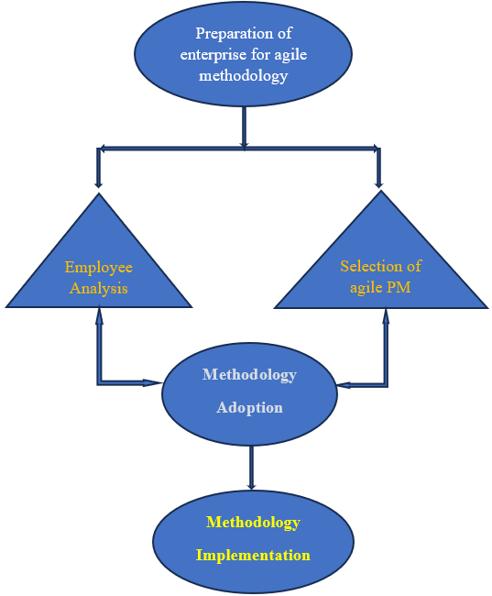

Fig. 1. Overview of Phases involved in Agile PM.

**Phase I: Preparation phase**

The preparation phase assists the enterprise or project team in readying themselves for a methodology change. Implementing the agile PM methodology entails alterations not only in physical processes but also in the mindset of employees. Each employee engaged in the change process must be convinced of the capabilities and benefits of the agile PM methodology in attaining project goals [22]. One recommended restructuring method for preparing for the implementation of the agile PM methodology is Adapting [24], which involves the following steps: Awareness, Desire, Ability, Promotion, and Transfer [25].

**Phase II: Employees’ analysis**

The employee analysis phase provides insights into employees' motivation, interpersonal dynamics, micro-groups, formal and informal leadership, and potential roles within the agile methodology [26]. This analysis utilizes two methods: sociometric and motivation research. The sociometric method employs a survey focused on quantitatively measuring interpersonal relationships and assessing small social groups. Participants are asked to allocate advantages to team members in various scenarios, distinguishing between formal and informal relationships. The motivation research method also employs a survey to examine motivational factors and challenges, referencing Maslow's hierarchy of needs [27]. Both methods follow a standard survey process, including preparation, data collection, and analysis, as illustrated in Figure 2 and further detailed in Reference [31]. Question tailoring and survey design are conducted during the preparation phase to suit the current context. Data collection can be executed through various survey types, with recommendations to provide clarity on survey location and circumstances for participants. Sociometric data analysis involves creating sociomatrices and sociograms, calculating sociometric indexes, and analyzing internal relationship groups and their structures using social network analysis techniques [28-31]. A summary of methods used for sociometric data analysis is provided in Figure 3. Meanwhile, motivation data analysis categorizes motives into groups such as transformation, communication, utility-pragmatic, cooperation, competition, and achievement, derived from respondents' answers, and delves into the underlying reasons behind these motivations.

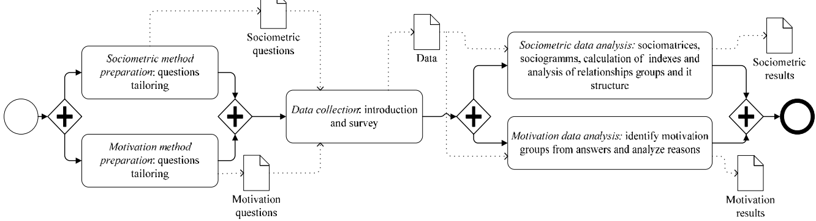

Fig. 2. Overview of the employees’ analysis phase

**Phase III: Selection Phase of Agile PM methodology**

Absolutely, selecting the right Agile project management methodology is crucial for the success of any enterprise project. Adapting an existing methodology often proves to be more efficient than creating a new one from scratch because established methodologies have been tested and refined over time, offering a wealth of experience and best practices to draw from.

McConnell's approach is indeed one of the methodologies that can be considered during this phase. Choosing a Custom Software Development Methodology" provides valuable insights into selecting the right methodology based on project characteristics, team composition, and organizational culture [36].

Other methodologies and guidelines that can be useful in this phase include:

1. Scrum: A widely-used Agile framework characterized by its iterative and incremental approach to project management. Scrum is particularly effective for projects with rapidly changing requirements and high levels of uncertainty [24].
2. Kanban: Another popular Agile framework focused on visualizing work, limiting work in progress, and maximizing flow. Kanban is suitable for projects with a continuous flow of work and emphasizes efficiency and flexibility [10, 19].
3. Lean: Originating from manufacturing, Lean principles emphasize maximizing customer value while minimizing waste. Lean Agile methodologies like Lean Startup can be valuable for projects focused on innovation and rapid experimentation.
4. SAFe (Scaled Agile Framework): Designed for large-scale Agile enterprises, SAFe provides guidance on scaling Agile practices across multiple teams and complex projects. It offers various configurations tailored to different organizational needs.
5. DSDM (Dynamic Systems Development Method): An Agile framework specifically designed for rapid application development, DSDM focuses on delivering functionality incrementally while maintaining a focus on business goals.
6. Crystal: Developed by Alistair Cockburn, Crystal methodologies prioritize team collaboration and communication. Crystal methodologies come in different flavors (e.g., Crystal Clear, Crystal Orange) tailored to different project sizes and complexities.
7. Feature-Driven Development (FDD): FDD is an Agile approach that emphasizes building features incrementally based on domain modeling. It is suitable for projects with well-defined requirements and a focus on delivering tangible results quickly.

When selecting the most suitable Agile methodology, it's essential to consider factors such as the project's size, complexity, industry, team dynamics, and organizational culture. Conducting thorough assessments and possibly even pilot projects can help determine which methodology aligns best with the enterprise's needs and objectives

**Phase IV: Methodology adaptation**

Adapting the methodology to fit the specific requirements of the project and the team can lead to improved outcomes in its implementation (Refer. Fig. 3). In the methodology adaptation phase, conflicts between the selected methodology and enterprise principles or employees' characteristics are analyzed, and necessary adjustments are made. This phase involves examining various elements of the Agile project management methodology, including roles, artifacts, processes, and practices, and making modifications as needed to ensure alignment with the project's needs and the capabilities of the team [32-35].

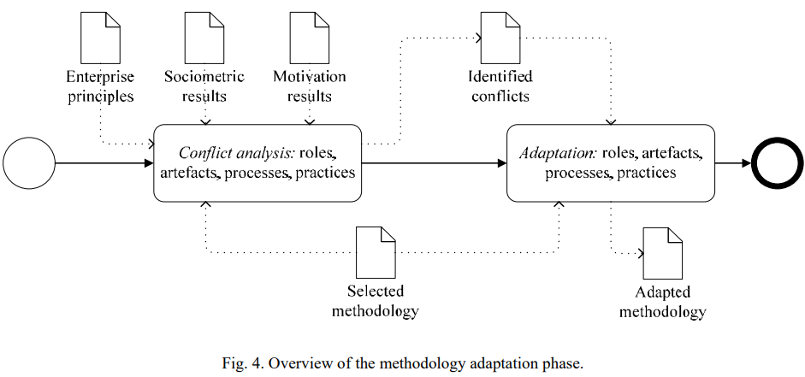

Fig. 3 Methodology adaptation phase

**Phase V: Methodology Implementation**

The methodology implementation phase ensures the methodology is implemented in line with the chosen implementation model, which could be either starting small or going all in, and with either public display or stealth. To achieve successful implementation, it's advisable to adhere to either the Deming cycle or the ShuHaRi principles, which aid in improving the quality of the implementation process.

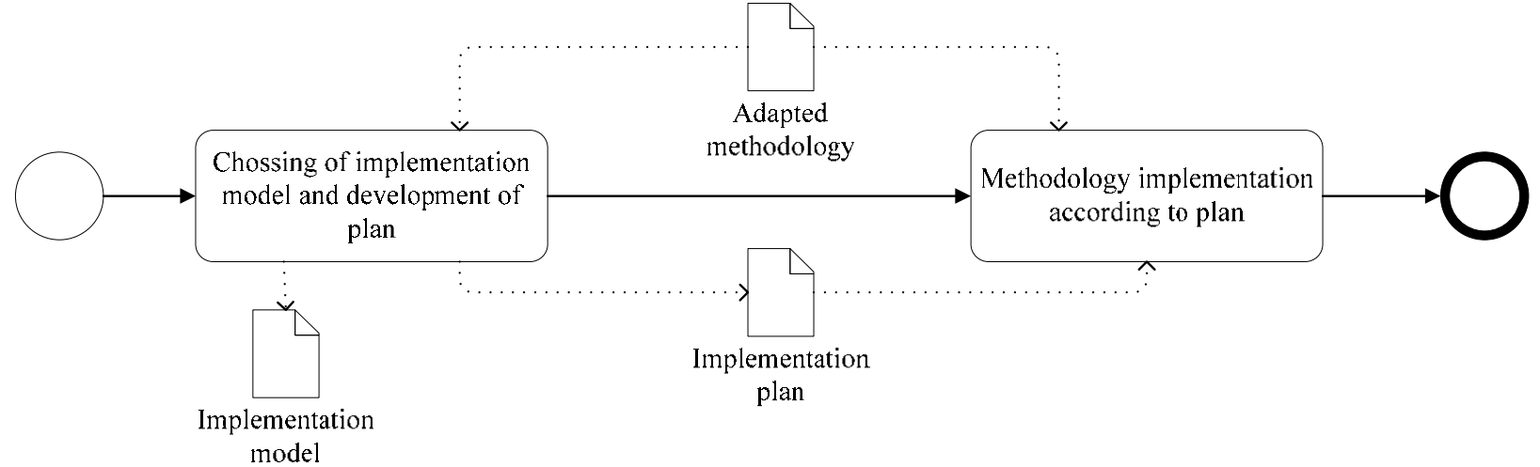

Fig. 4 Methodology Implementation Phase

1. **Case Study**

The proposed method has been put into practice and initially assessed through a single industry case study. This case study was conducted within an IT company characterized by an average team size of 10-15 employees. Prior to the case study, the company had been employing Agile development concepts along with certain elements of the Scrum project management methodology, albeit without a well-defined methodology in place. Further elaboration on the process and outcomes of the case study is provided in the subsequent section.

The adaptation and implementation of the Agile project management methodology have been structured according to the proposed method. The Scrum methodology has been selected as the foundational project management methodology. Prior to the results depicted in Figure 5, an analysis of the employees was conducted. Subsequently, several adaptations were integrated into the Scrum methodology:

* Guided by enterprise principles: Three new artifacts (tender, business requirement, test scenarios), three roles (business owner, stakeholder, analyst), two processes (requirements analysis, risk management), and two practices (planning poker, Kanban board) were introduced.
* Informed by the findings of the employees' analysis: One role (project manager), two processes (personal retrospection, motivation events), and one practice (pair analysis/programming/testing) were incorporated.

The detailed description of the employees' analysis and the methodology adaptation conducted in the case study exceeds the scope of this paper; additional details can be found in Rasnacis [31]. The chosen implementation model involved going all in with public display, with the implementation duration set at 8 weeks or 3 sprints.

Evaluation of the benefits derived from the adopted Agile project management methodology was performed six months post-implementation, relying on two types of data:

* Changes in the results of the employees' analysis aimed to assess improvements in team member relations, self-organization, and motivation resulting from the adaptation of the Agile PM methodology based on the employees' analysis. A second round of analysis was conducted on the same core team, and the results were compared with those of the initial analysis.
* Changes in project performance statistics aimed to evaluate the benefits of a well-defined and project team-tailored Agile PM methodology. Project performance statistics were gathered and assessed across four projects (three prior to the methodology adoption and one after). These projects, all related to software development for a single client, were similar in nature. Metrics included the number of development tasks versus bugs, risk analysis, and number of meetings. Notably, only one project had been completed for the designated client within the six-month period following the implementation of the adapted Agile PM methodology. The core project team remained consistent across all four projects, and the workload was measured by task count (refer to Fig. 6).

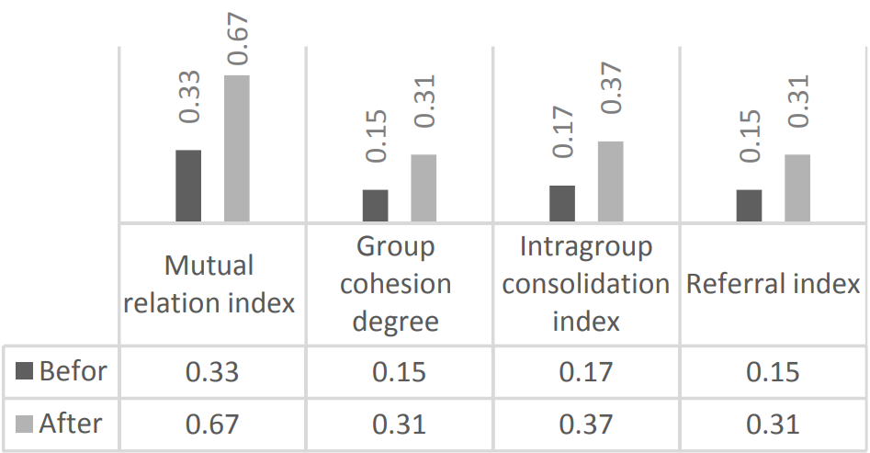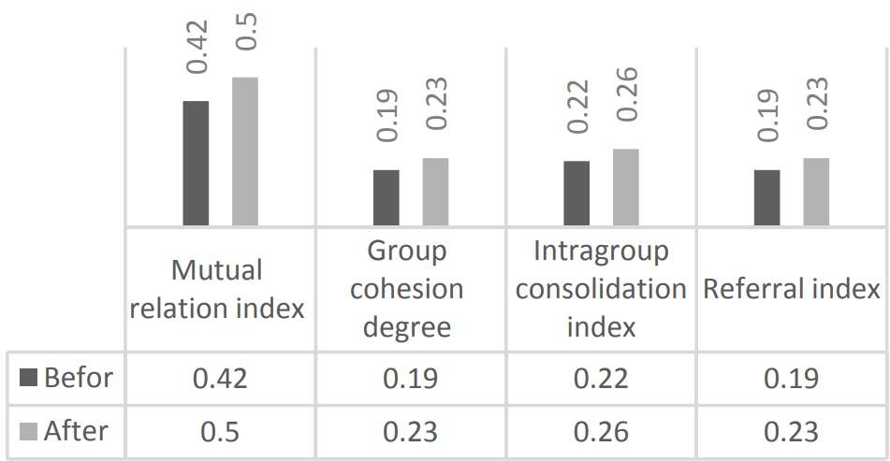

1. Formal Relationship (b) Informal Relationship

Fig. 5 Sociometric Indexes Summary

The analysis of the number of development tasks and bugs aimed to determine the percentage of bugs in the projects. The results, illustrated in Fig. 6, indicate a decrease in the bug percentage following the implementation of the Agile PM methodology. This decline is considered a positive outcome.

Improving risk management and communication, both internally and externally, was a prerequisite set by the company owner for the PM methodology change. Fig. 7a presents the results of the risk statistics, showcasing an increase in the extent of risk management. This increase is reflected in the detailed risk analysis, which encompasses more defined risks and corresponding risk responses. Naturally, the more comprehensive analysis also led to the identification of additional known risks.

Similarly, the analysis of communication volume, depicted in Fig. 7b, highlights an increase in both internal and external communication, approximately doubling in volume. The augmented internal communication, coupled with enhancements in sociometric indexes—particularly the mutual relation index of formal relationships—suggests an improvement in team communication.

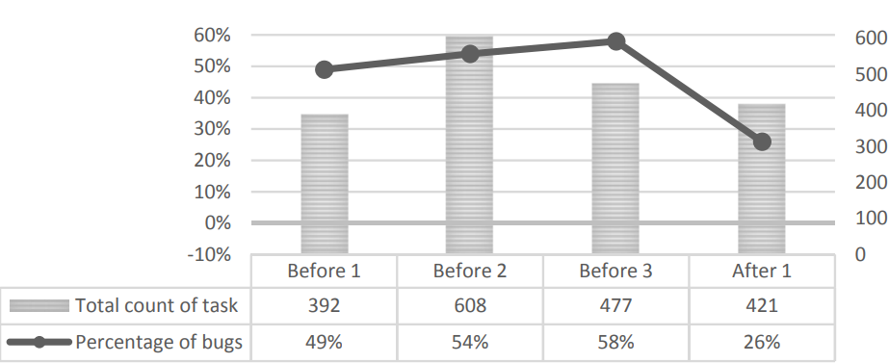

Fig. 6. Results of Development tasks count and bugs change.

Top of Form

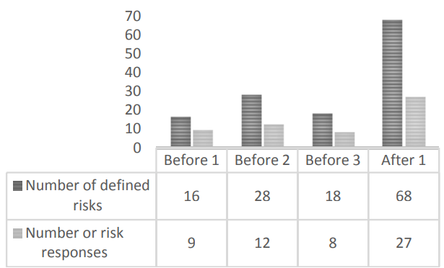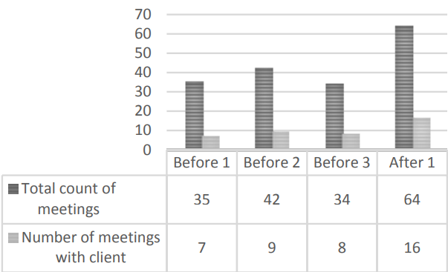

(a)Risk Management (b) Communication amount

Fig.7 Outcomes regarding improvements in risk management effectiveness and communication

1. **Conclusion**

The application of Agile project management methodologies is aimed at improving the development process, striving for fewer errors, faster delivery, streamlined communication, enhanced quality, more effective risk analysis, and reduced overhead costs. Nonetheless, research indicates that project teams often encounter challenges that could impede the successful implementation of Agile PM methodologies and consequently affect project outcomes. Therefore, thorough preparation of the team is crucial before introducing a new Agile PM methodology.

The proposed approach facilitates an assessment of team structure and motivation, enabling the customization of Agile roles, artifacts, processes, and practices to suit the specific needs of the project team. This tailored adaptation aims to enhance team self-organization, motivation, and overall effectiveness. The case study discussed in this paper serves as an initial evaluation of this proposed approach.

It's worth noting that the proposed method has its limitations. It is specifically designed for small teams comprising 10-16 individuals with prior collaborative experience, and it requires the selection of a foundational Agile PM methodology. Moreover, the method lacks explicit instructions on how to choose and adapt a methodology for the project team, relying instead on the application of existing solutions for these tasks. Consequently, users of this approach must possess expert knowledge of Agile roles, artifacts, processes, and practices to navigate these activities effectively.

**Reference**

1. L. Mayo-Alvarez et al. Luis Mayo-Alvarez, Shyla Del-Aguila-Arcentale, Aldo Alvarez-Risco, M. Chandra Sekar, Neal M. Davies, Jaime A. Ya´nez, Innovation by integration of Drum-Buffer-Rope (DBR) method with Scrum-Kanban and use of Monte Carlo simulation for maximizing throughput in agile project management, Journal of Open Innovation: Technology, Market, and Complexity 10 (2024) 100228.
2. Alaidaros, H., Omar, M., Romli, R., 2019. A Theoretical Framework for Improving Software Project Monitoring Task of Agile Kanban Method. Vol. 843. In: Saeed, F., Gazem, N., Mohammed, F., Busalim, A. (Eds.), Recent Trends in Data Science and Soft Computing. Springer International Publishing, Vo.843, pp. 1091–1099.
3. Dingsoyr T, Nerur S, Balijepally V, Moe NB. A decade of agile methodologies: Towards explaining agile software development. J Syst Soft. 85(6); 2012. p. 1213–1221.
4. Dyba T, Dingsoyr T. Empirical studies of agile software development: A systematic review. Inf Softw Technol. 50(9–10); 2008. p. 833–859.
5. Ahmed, J., Mrugalska, B., Akkaya, B., 2022. Agile management and VUCA 2.0 (VUCARR) during industry 4.0. In: Akkaya, B., Guah, M.W., Jermsittiparsert, K., BulinskaStangrecka, H., Kaya, Y. (Eds.), Agile Management and VUCA-RR: Opportunities and Threats in Industry 4.0 towards Society 5.0. Emerald Publishing Limited, pp. 13–26.
6. Livermore JA. Factors that Significantly Impact the Implementation of an Agile Software Development Methodology. J Softw. 3(4); 2008. p. 31–36.
7. Agile Methodology and PMBOK - PMP Mastery. Available: http://www.pm-primer.com/agile-methodology-and-pmbok/.
8. Hoda R, Noble J, Marshall S. Developing a grounded theory to explain the practices of self-organizing Agile teams. Empir Softw En. 17(6); 2011. p. 609–639.
9. Moe NB, Dings T, Dyb T. Understanding Self-Organizing Teams in Agile Software Development. In: 19th Australian Conference on Software Engineering. IEEE; 2008. p. 76–85.
10. Cocco, L., Mannaro, K., Concas, G., & Marchesi, M. (2011). Simulating Kanban and Scrum vs. Waterfall with System Dynamics. Agile Processes in Software Engineering and Extreme Programming, Berlin, Heidelberg.
11. Chow T, Cao D-B. A survey study of critical success factors in agile software projects. J Syst Softw. 81(6); 2008. p. 961–971.
12. Serrador P, Pinto JK. Does Agile work? Int J Proj Manag. 33(5); 2015. p. 1040–1051.
13. Campanelli AS, Parreiras FS. Agile methods tailoring – A systematic literature review. J Syst Softw.110; 2015. p. 85–100
14. El-Said SM, Hana M, Eldin AS. Agile Tailoring Tool (ATT): A Project Specific Agile Method. In: 2009 IEEE International Advance Computing Conference. IEEE; 2009. p. 1659–63.
15. Mikulenas G, Kapocius K. A Framework for Decomposition and Analysis of Agile Methodologies During Their Adaptation. In: Information Systems Development. NY: Springer New York; 2011. p. 547–560.
16. Qumer A, Henderson-Sellers B. A framework to support the evaluation, adoption and improvement of agile methods in practice. J. Syst Softw. 81(11); 2008. p. 1899–1919.
17. Hosseini, S.M., Sheikhi, N., 2012. An empirical examination of competitive capability’s contribution toward firm performance: moderating role of perceived environmental uncertainty. Int. Bus. Res. 5 (5), 116–131
18. Sidky A. A Structured Approach to Adopting Agile Practices: The Agile Adoption Framework. Available: https://theses.lib.vt.edu/theses/available/etd-05252007-110748/unrestricted/asidky_Dissertation.pdf.
19. Hofmann, C., Lauber, S., Haefner, B., Lanza, G., 2018. Development of an agile development method based on Kanban for distributed part-time teams and an introduction framework. Procedia Manuf. 23, 45–50
20. Duka D. Adoption of agile methodology in software development. In: 36th International Convention on Information & Communication Technology Electronics & Microelectronics (MIPRO); 2013. p. 426–430.
21. Bajec M, Vavpotic D, Krisper M. Practice-driven approach for creating project-specific software development methods. Inf Softw Technol. 49(4); 2007. p. 345-365.
22. Henderson-Sellers B, Ralyte J. Situational Method Engineering. Jour Univ Comp Sci. 16(3); 2016. p. 424-478.
23. Ismail, M.F. b, Mansor, Z., 2018. Agile Project Management: Review, Challenges and Open Issues. Adv. Sci. Lett. 24 (7), 5216–5219. https://doi.org/10.1166/ asl.2018.11705.
24. Lee, W.-T., Chen, C.-H., 2023. Agile Software Development and Reuse Approach with Scrum and Software Product Line Engineering. Electronics 12 (15), 3291.
25. Kalus G, Kuhrmann M. Criteria for software process tailoring: a systematic review. In: Proceedings of the 2013 International Conference on Software and System Process. New York: ACM Press; p. 171-180.
26. Gandomani TJ, Zulzalil H, Abd Ghani AA, Md. Sultan AB. Towards comprehensive and disciplined change management strategy in agile transformation process. Research Journal of Applied Sciences, Engineering and Technology. 6(13); 2013. p. 2345-2351.
27. Cohn M. Succeeding with Agile: Software Development Using Scrum. Addison-Wesley Professional; 2009. 504.
28. Kerr NL, Tindale RS. Methods of small group research. In: Handbook of Research Methods in Social and Personality Psychology. Cambridge university press; 2014. p. 188–219.
29. Maslow AH. A theory of human motivation. Psychol Rev. 50(4); 1943. p. 370–396.
30. A Guide to the Business Analysis Body of Knowledge (Babok Guide) 2nd Edition. IIBA; 2009. 272.
31. Rasnacis A, Berzisa S. Adaptation of Agile Project Management Methodology for Project Team. Inf Technol Manag Sci. 18(1); 2015.p. 122–128.
32. Kurzman C. Sociometry. In: International Encyclopedia of the social sciences. Stanford University Press; p. 390–392.
33. Scott WA, Cohen RD. Sociometric indices of group structure. Aust J Psychol. 30(1); 1978. p. 41–57.
34. Borgatti SP, Mehra A, Brass DJ, Labianca G. Network Analysis in the Social Sciences. Science. 323(5916); 2009. p. 892-895.
35. Vavpotic D, Vasilecas O. Selecting a methodology for business information systems development: Decision model and tool support. Comput Sci Inf Syst. 9(1); 2012. p. 135–164.
36. McConnell S. Rapid Development: Taming Wild Software Schedules. Microsoft Press; 1996. 680.
37. Linkevics G. Adopting to Agile Software Development. Appl Comput Syst. 16(1); 2014. p. 64–70.