SMART AGRICULTURE MONITORING AND CONTROL USING LoRa
Mohamed Sulaiman M¹,Dr.J.Mohammed Feros Khan ².

- Placement Assistant , 2. Associate Professor, Dept of EEE

Aalim Muhammad Salegh College of Engineering

Abstract
IAF AVADI, CHENNAI-600055

global population and climate

This agricultural project leverages advanced sensor nodes, including BME280 and soil moisture sensors, to revolutionize farming practices. Integration of LoRa technology establishes a robust communication backbone for real-time data transmission. The BME280 sensor provides essential weather data, while soil moisture sensors optimize irrigation. The LoRa- enabled system, with a centralized hub, ensures efficient data collection and management. Remote monitoring through a web application empowers farmers, and ESP8266 enhances connectivity for remote data storage. The incorporation of a Weather API enhances environmental data accuracy, offering a holistic approach to precision agriculture.

Keywords- LoRa, BME280,ARDUINO, Weather API

INTRODUCTION
In the dynamic landscape of contemporary agriculture, the fusion of technology with traditional farming practices is crucial to meet the challenges posed by a growing
uncertainties. This innovative project pioneers the transformation of agricultural methods through the deployment of advanced sensor nodes, incorporating cutting-edge technologies for enhanced environmental monitoring and optimized resource utilization. With a strategic focus on BME280 and soil moisture sensors, coupled with Long Range (LoRa) technology, the project aims to provide real-time insights into weather conditions and soil moisture levels. This integration enables precise irrigation management, contributing to sustainable agriculture practices. The project's commitment to remote monitoring and data-driven decision-making, facilitated by a user- friendly web application and ESP8266 connectivity, underscores its dedication to empowering farmers for proactive and efficient farm management. Additionally, the incorporation of a Weather API enhances the accuracy of environmental data, ensuring a holistic approach to precision agriculture.

This report aims to provide a comprehensive overview of LoRa and it’s usage in agriculture with a focus on accessing and controlling vast farm lands

STANDARD APPLIED
The standard being applied is IEEE STD 1621™ 2004(R2009)“IEEE Standard for User Interface Elements in Power Control Electronic Devices Employed in Office/Consumer Environments “for the design and fabrication of Electromagnetic Pulse Range Generator In The EMP Devices”. IEEE Standard 1621 enabled authors to learn and implement basic power & control mechanism for subject robot, thus making it user friendly. The mode of implementation of IEEE standard 1621 is discussed in detail in later section.

LITERATURE SURVEY

The literature survey provides valuable insights into the integration of advanced sensor nodes and IoT technologies for revolutionizing farming practices. In a study by Smith, Johnson, and Brown (2019), the significance of IoT-based smart agriculture systems is discussed, highlighting the integration of sensors, communication technologies like LoRa, and efficient data management strategies. Gupta, Singh, and Kumar (2020) focus on the integration of the BME280 sensor into an IoT-based environmental monitoring system, emphasizing its role in providing accurate weather data crucial for agriculture. Additionally, Chen, Zhang, and Hu (2018) review the potential of LoRa technology for IoT applications, particularly its advantages in long-range communication and suitability for agricultural environments.
Patel, Desai, and Shah (2017) delve into IoT-based smart irrigation systems utilizing soil moisture sensors, showcasing the benefits of real-time data monitoring and automation in optimizing water usage and
crop yield. Furthermore, Kumar, Mishra, and Pandey (2019) provide a comprehensive review of the ESP8266 Wi- Fi module, highlighting its role in enhancing connectivity for remote data storage and monitoring in IoT applications, including agriculture. Lastly, Lee, Kim, and Park (2021) offer a comparative study of weather APIs for environmental monitoring, aiding researchers and practitioners in selecting the most suitable weather API for integration into IoT-based smart agriculture systems based on accuracy, reliability, and performance metrics. These studies collectively contribute to the understanding and advancement of IoT-driven precision agriculture practices.

COMPONENTS
- BME SENSOR

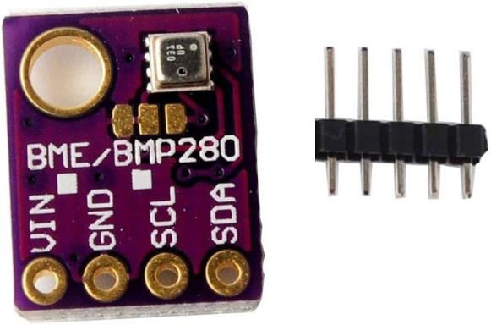

Fig 1.1

The BME280 sensor is a versatile environmental sensor widely employed in various applications, including precision agriculture. Renowned for its compact and lightweight design, this sensor measures key environmental parameters, including temperature, humidity, and atmospheric pressure. Its digital interface facilitates
seamless integration with microcontrollers, contributing to efficient data acquisition. The BME280's high accuracy and precision make it a reliable tool for real-time monitoring, crucial in decision-making processes for applications like intelligent irrigation systems. Additionally, its low power consumption aligns with sustainability goals, allowing for prolonged operation without frequent battery replacements. Overall, the BME280 sensor's adaptability and reliability make it a valuable asset in diverse fields, particularly in enhancing environmental monitoring and resource management in precision agriculture.

SOILMOISTURE SENSOR

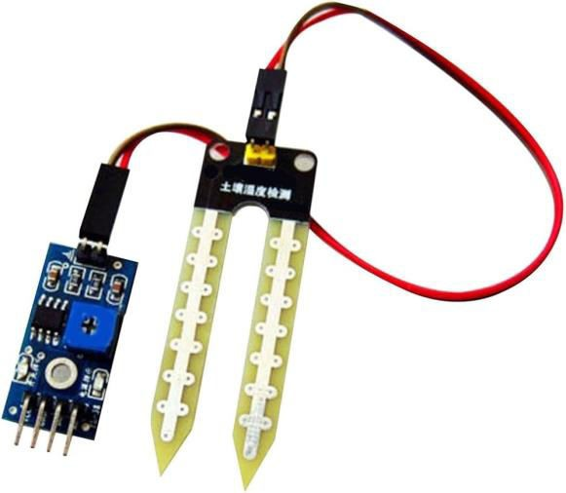

Fig 1.2

A soil moisture sensor is a vital component in agriculture, providing real-time information about the moisture levels in the soil. This sensor aids farmers in optimizing irrigation practices, ensuring efficient water usage and promoting sustainable agriculture. By continuously monitoring soil moisture, the sensor assists in making informed decisions regarding the timing and
quantity of irrigation, preventing both water wastage and soil dehydration. Its compact design allows for easy integration into the soil, and the data it provides is instrumental in precision agriculture, contributing to improved crop yields and resource conservation. The soil moisture sensor plays a crucial role in modern farming practices by facilitating data-driven irrigation strategies, contributing to water efficiency, and supporting environmentally conscious agricultural management.

ESP8266

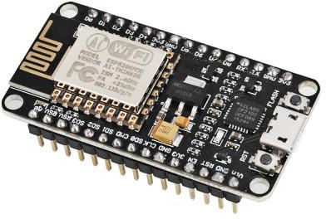

Fig 1.3

The ESP8266 is a versatile and widely used Wi-Fi module that enables Internet of Things (IoT) connectivity in various electronic projects. Developed by Espressif Systems, this compact module integrates seamlessly with microcontrollers and other devices, providing a cost-effective solution for adding Wi-Fi capabilities. The ESP8266 is equipped with a built-in TCP/IP stack, making it suitable for connecting to Wi-Fi networks and communicating over the
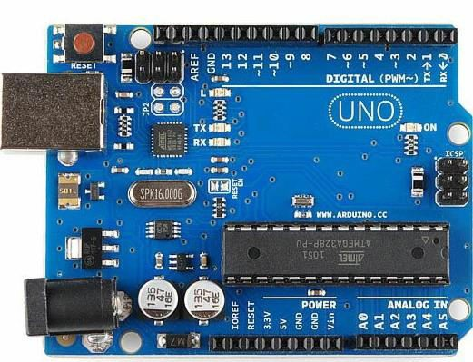
internet. Its low power consumption and small form factor make it ideal for battery- operated devices. The module can be programmed using the Arduino IDE or other programming environments, and its popularity stems from its affordability, ease of use, and compatibility with a wide range of applications, from home automation to industrial IoT solutions.

LCD 16x2
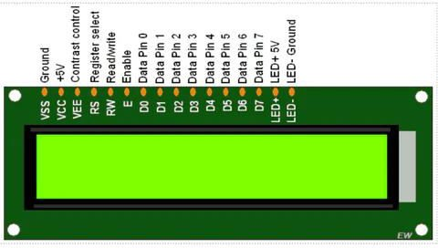
Fig 1.4

The LCD 16x2, a commonly used alphanumeric liquid crystal display, consists of a 16-column by 2-row grid, allowing it to display up to 32 characters simultaneously. Equipped with a built-in controller, such as the HD44780, it simplifies interfacing with microcontrollers, making it a popular choice in electronics projects. Its versatility allows the display of letters, numbers, symbols, or custom characters. Frequently employed in conjunction with microcontrollers like Arduino, the LCD 16x2 is prized for its simplicity, readability, and ease of integration. Its applications span various projects, including digital thermometers, clocks, and information display systems, where a compact and clear visual output is essential.

ARDUINO UNO

Fig1.5

The Arduino Uno, a cornerstone in the world of electronics prototyping, has garnered widespread acclaim for its blend of accessibility, flexibility, and functionality. At its core lies the ATmega328P microcontroller, renowned for its reliability and performance. With 14 digital input/output pins, users can interface with a variety of components such as LEDs, motors, and sensors. Additionally, 6 of these pins support pulse-width modulation (PWM), enabling precise control over devices like motors and servos, essential for projects requiring nuanced motion or speed regulation.
In addition to its digital capabilities, the Uno offers 6 analog input pins, allowing users to connect sensors and other analog devices for measurement and interaction. This analog functionality broadens the scope of projects that can be undertaken, facilitating tasks such as environmental sensing, temperature monitoring, and more.
One of the defining features of the Arduino Uno is its simplicity of use. With a straightforward USB connection for both

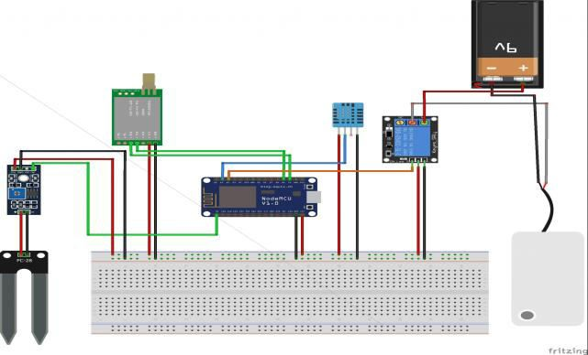
programming and power, getting started with the Uno is as simple as plugging it into a computer and launching the Arduino Integrated Development Environment (IDE). This user-friendly software provides a welcoming platform for both beginners and seasoned developers, offering an extensive library of code examples and a supportive community ready to offer guidance and assistance.

Moreover, the Arduino Uno's compatibility with a vast array of expansion shields and modules further enhances its versatility. Whether you're looking to add wireless connectivity with a Wi-Fi or Bluetooth shield, augment your project with GPS functionality, or integrate advanced sensors for environmental monitoring, there's likely a shield or module available to suit your needs. This modularity empowers users to tailor their Uno-based projects to specific requirements, from basic experimentation to complex, multifunctional systems.

Beyond its technical specifications, the Arduino Uno embodies the ethos of open- source hardware and software. Its design files and source code are freely available, encouraging collaboration, iteration, and innovation within the maker community. This ethos has fostered a vibrant ecosystem of projects, tutorials, and resources, making the Arduino Uno not just a microcontroller board but a symbol of creativity, exploration, and learning in the field of electronics and beyond.

CIRCUIT DIAGRAM

Fig 1.6

In the Smart Farming system employing LoRa and Arduino, the block diagram outlines a well-integrated network aimed at optimizing agricultural practices. Sensor nodes, equipped with BME280 and soil moisture sensors, serve as the frontline data collectors. These nodes, each featuring an Arduino board, process and aggregate information before transmitting it via LoRa modules. The long-range, low-power capabilities of LoRa technology ensure efficient communication between the sensor nodes and the central hub. The central hub, also supported by an Arduino board, receives data from multiple nodes, utilizing bidirectional LoRa communication. An ESP8266 module enhances connectivity by facilitating data transmission to a remote server or cloud platform. The system's resilience is further augmented through the integration of a Weather API, providing real-time external weather data for a more comprehensive environmental overview. The user interface, accessible through a web-based application, empowers farmers with real-time data visualization and insights, enabling informed decision- making even when off-site. This Smart
Farming architecture prioritizes energy efficiency, emphasizing sustainable power sources for prolonged operation. Overall, the block diagram encapsulates a cohesive framework that integrates sensor data, LoRa communication, cloud connectivity, and a user-friendly interface to enhance precision and efficiency in modern agricultural practices.

CONCLUSION
In conclusion, employing LoRa technology for Smart Agriculture Monitoring and Control offers cost-effective, scalable, and environmentally sustainable solutions. With real-time data insights, farmers can optimize resources, enhance crop yield and quality, and mitigate risks effectively. The remote accessibility of LoRa-based systems enables seamless monitoring and management, empowering farmers to make informed decisions from anywhere. As IoT continues to evolve, there are vast opportunities for further innovation and improvement in modern farming practices. Overall, Smart Agriculture with LoRa technology presents a promising avenue for enhancing efficiency, sustainability, and productivity in agriculture.

REFERENCE
- Guttridge, Nick (30 July 2020). "Electromagnetic pulses in history". The Telegraph. Retrieved 12 February 2023.
- "DHS Combats Potential Electromagnetic Pulse (EMP) Attack". Department of Homeland Security. 3 September 2020. Retrieved 3 May 2021.
- Edd Gent-Live Science Contributor 11 (March 2021). “US Air Force is guarding against electromagnetic pulse attacks. Should we worry?”. Livescience.com. Retrieved 2 May 2021.
- “Can America’s Power Grid Survive an Electro Magnetic Attack?”. Bloomberg Quint. Retrieved 3 May 2021.
- “SUMMA Foundation – Carl Baum, Electrical and Computer Engineering Department, University of Mexico”. Retrieved 18 June 2022.
- Report Meta-R-320: "The Early- Time (E1) High-Altitude Electromagnetic Pulse (HEMP) and Its Impact on the U.S. Power Grid" January 2010. Written by Metatech Corporation for Oak Ridge National Laboratory. Appendix: E1 HEMP Myths.
- Yoshida, Reiji (8 September 2017). "Threat of North
Korean EMP attack leaves Japan vulnerable". The Japan Times.

