**Tutorial on Utilisation of Point Poisson Process (PPP) Function in Matlab® for Simulation and Generation of Spatial Location Points**

Suraju A. Fadare 1 and Ibrahim G. AbdulHamid2

1,2 Department of Electrical and Electronic Engineering, Federal Polytechnic, Ilaro

1 [suraju.fadare@federapolyilaro.edu.ng](mailto:suraju.fadare@federapolyilaro.edu.ng) (Correspondent author)

[ibrahim.abdulhamid@federapolyilaro.edu.ng](mailto:ibrahim.abdulhamid@federapolyilaro.edu.ng)

**ABSTRACT**

Simulations of the positions or spatial distributions of electronic communication devices such as base stations (BS), electronic communication equipment, and electronic communication-enabled smart devices could be related to a stochastic process. Erudite scholars are fantastic at reporting their research works using numerous stochastic tools to model or simulate the spatial distributions of devices at various nodes of a communication network. Point-poisson processes (PPP) are of great interest, as observed in most available literature relating to electronic communication networks. In addition, those scholars utilised it to enhance the achievement of their respective objectives and results. However, utilising such a stochastic tool is a hindrance for some researchers to achieve similar objectives and results. Hence, the main aim of this tutorial is to impart knowledge of harnessing PPP in Matlab® as a research tool to generate random positions of nodes. The objective of this tutorial is to simplify the usage of PPP in generating random locations and enhance its further applications. This paper discussed its variants (posscdf, poisspdf, and poissrnd) and parameters (lambda and target values) relative to the simulation of the spatial distribution of electronic communication users or nodes. Values obtained from relevant examples were used to develop Matlab functions to generate Poisson random location points for communication users on rectangular and circular planes. The examples were explicit enough to simplify and impart knowledge of the applications of PPP distribution functions in solving Poisson-related problems in modelling and simulations.

**Keywords**:**Point Poisson Process PPP, Matlab, Simulation, poisscdf, poisspdf and poissrnd**

# **INTRODUCTION**

The unpredictable nature of positions of devices in networks of electronic communication systems calls for stochastic process in addressing generations of the spatial locations (Galkin et al., 2017; Hmamouche et al., 2021; Romero and Leus, 2019; Xu et al., 2022; Zhang et al., 2015). Cellular networks have made it possible for communication network nodes to avail themselves at any locations within the network coverage regions (Erunkulu et al., 2020; Mozaffari et al., 2019; Sabzehali et al., 2022; Wang et al., 2019). Hence, the usual restriction of fixed wired network is not applicable to prevalent wireless cellular network (Okpeki et al., 2019; Zeng et al., 2019). In addition, the advance in wireless technology is increasing the densities of network devices because of continuous increment in electronic communication enabled devices and heterogeneous nature of the advanced modern network (Azari et al., 2019; Hmamouche et al., 2021; Y. Li and Cai, 2017; Xiang et al., 2016). Furthermore, the trends in automation of remote electronic devices and interactions of sensors predispose the existence of network nodes in any random locations within the network coverage (Del Peral-Rosado et al., 2018; Jondhale et al., 2022; Shakhatreh et al., 2019; Xiang et al., 2016). Moreover, the innate stochastic nature of wireless propagation produces multipath channels for devices in random locations (Chetlur and Dhillon, 2017; Cui et al., 2020; J. Li et al., 2007; Samimi and Rappaport, 2016; Ur-Rehman and Zivic, 2018). Therefore, modelling and simulation of locations of nodes or devices in wireless network (WN) involves the usage appropriate stochastic tools (M et al., 2019; Qamar et al., 2019; Romero and Leus, 2019).

Matlab® simulation software proffer statistical tools to enhance the simulation tasks (Bavarva et al., 2015; Garg, 2020; Golam Sadeque, 2015; Marani et al., 2023; Omariba and Masese, 2019; Shebani et al., 2013). One of such statistical tools is Point Poisson (PPP) statistical distribution tools (Allen, 2019; Galkin et al., 2017; Glynn, 2004; Ju et al., 2021; Pandey, Perumalla, et al., 2023; Qamar et al., 2019; Weber et al., 2005; Xu et al., 2022; Yao et al., 2022; Zhang et al., 2015). The locations or positions of the network nodes are independent and relate to finite elements. These features enhances the applications of PPP (Alzenad and Yanikomeroglu, 2018; Pandey, Gupta, et al., 2023; Parshin, 2012; Zhang et al., 2015). The lambda parameter ($λ$) equates to the average or mean number of number of nodes per target area (Blaszczyszyn et al., 2013; Cholaquidis et al., 2017; *Poisson Cumulative Distribution Function - MATLAB Poisscdf - MathWorks United Kingdom*, n.d.). This is a very germane point for readers who are interested in applying PPP. Despite the randomness of the positions of network elements, $λ$ must be determined to generate the random positions of the nodes (Alzenad and Yanikomeroglu, 2018; Chetlur and Dhillon, 2020; P. Keeler, n.d.; Zhang et al., 2015). Consequently, predetermined values of $λ$ were used in many literatures. Hence, it is an essential parameter that researchers must consider and satisfy for the PPP model.

# **LITERATURE REVIEW**

PPP distribution is used for occurrence of events in continuous space or time interval ($δ$), which might be homogenous or heterogeneous in nature (H. P. Keeler et al., 2018; P. Keeler, 2018; Parshin, 2012). However, scope of the tutorial will be on homogenous space interval for apt understanding of basic applications of PPP in generation of user in random spaces. The two properties of PPP inferred from literature that enhance its application for simulation of random generation of location in given space are:

1. The occurrence of a point location in a defined space interval is independence of occurrence of another point in another space interval within the given observation space. The distribution of each location point in a given space is on disjoint space interval independent of one another.
2. The probability of *u* number of users in a space interval $δ$ is equal to probability of having the same *u* number of users in the total space. Therefore, the probability of locating u number of users depends on the number and the defined space interval per user ($δ$) as expressed in equation (1).

|  |  |  |  |
| --- | --- | --- | --- |
|  | $p\left( u,δ\right)=$ $λδ$ | $$λ ≥0$$ | (1) |

1. Lastly, for the PPP distribution, two users or more cannot occupy the same space interval. It means PPP distribution could generate a location point for one user only. Therefore, equation (2) expresses the model this property as required for our proposed applications.

|  |  |  |  |  |
| --- | --- | --- | --- | --- |
|  | $p\left( u,δ\right)=$ $\left\{\begin{aligned}λδ \\ 1-λδ \\ 0\end{aligned}\right.$ | $$u=1$$ $$u=0$$ $$u>1$$ | $$λ ≥0$$ | (2) |

The equation (2) ascertain the facts that PPP can simulate allocation of users per location points on a given space. Two users cannot occupy one space interval or location point. Some of its applications are stated below.:

1. number of emergency calls expected per hour at call center of emergency unit of a teaching hospital.
2. number of fault reports received per hours by the Works Unit of a higher institution.
3. locations of mobile users accessing a base station.
4. number of locations of sensors accessing an aerial base stations
5. Number of call drops per hour

The main important parameters for Poisson distribution is lambda ($λ$) (H. P. Keeler et al., 2018; P. Keeler, n.d.; Parshin, 2012). It is equal to the mean ($μ$) and variance $\left(σ^{2}\right)$ of the Poisson distribution as shown in equation (3). Equation (4) express the probability of having *u* number of users in a sample space with a given space or time interval (or unit space) for each user ($δ$) and average number of user per unit space ($λ$) (Pandey, Gupta, et al., 2023; *Poisson Cumulative Distribution Function - MATLAB Poisscdf - MathWorks United Kingdom*, n.d.). As stated be for the space or time interval is homogenous.

|  |  |  |  |
| --- | --- | --- | --- |
|  | $μ= λ$; $σ^{2}=$ $λ$ ` | $$λ ≥0$$ | (3) |
|  | $$ρ(u,λδ)=\frac{e^{-λδ}{\left(λδ\right)}^{u}}{u!}$$ | $u=1, 2, 3, …$; $λ ≥0$ | (4) |

Considering the equation (4) as PPP distribution function, its modification could lead to generation of different values of the random variable space location points. Matlab® has different command functions for PPP distribution. Researchers in the field of Engineering and Science utilised the functions researches related to modelling, optimization and simulation (Alzenad and Yanikomeroglu, 2018; Pandey, Perumalla, et al., 2023; Parida and Dhillon, 2023; Qamar et al., 2019; Zhang et al., 2015). However, the scope of the work is to explore in generation of points within a sample space.

# **METHODOLOGY**

The tutorial was focused on using Matlab® for generating spatial location points on rectangular or circular space using PPP distribution. Matlab® 2024a version '24.1.0.2578822 Update 2'. The first part of the tutorial contains discussion on the three basic PPP distribution functions. Last part of the tutorial is discussion on generation of user locations in rectangular and circular border region. Detail explanation of the two samples of simulations were done to create a fundamental knowledge for interested researchers.

# **TUTORIAL ON UTILIZATION OF PPP FOR GENERATION AND SIMULATION OF SPATIAL LOCATION POINTS USING MATLAB®**

The three basic Matlab® functions for PPP distribution are

1. *poisscdf*
2. *poissspmf*
3. *poissrnd*

## **Poisson Cumulative Distribution Function *poisscdf***

*poisscdf* is a Poisson cumulative distribution function (CDF) in Matlab for determination of the probability that a Poisson variable u is less than or equal to a specific value, *U,* given the average spatial rate , $λ$ (Pandey, Gupta, et al., 2023; *Poisson Cumulative Distribution Function - MATLAB Poisscdf - MathWorks United Kingdom*, n.d.; Qamar et al., 2019; Serfozo, 2009)

|  |  |  |  |
| --- | --- | --- | --- |
|  | $$ρ(u≤U, λ)=\sum_{u=0}^{U}{\left(\frac{e^{-λ}λ^{u}}{u!}\right)}$$ | $u=1, 2, 3, …U$; $λ≥0$ | (5) |

### **Example 1(a) on *poisscdf***

An average number of sensors that would access an ABS communication network covering ${1km}^{2}$ is forty (40). Use Matlab to determine the probability of having less than or equal to ten (10) sensors accessing the network.

This example illustrates how to determine Poisson CDF for the probability of having the Poisson variable having values less than or equal to the given variable. The given variable in this example is 10. The average or mean of the distribution is ${40 sensors per km}^{2}$. Considering equation (5), can modified to equation (6) to obtain the values of the Poisson CDF. Figure 1 shows the Matlab® script file and the obtained answer for the CDF.

|  |  |  |  |
| --- | --- | --- | --- |
|  | $$ρ\left(u≤10, 40\right)=\sum_{u=0}^{40}{\left(\frac{e^{-40}.{40}^{10}}{10!}\right)}=1.62019527×{10}^{-8}$$ | $u=1, 2, .., 10$; $$λ=40$$ | (6) |

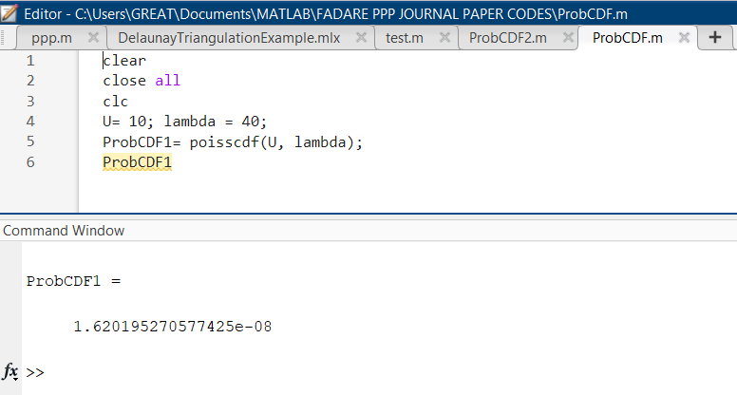**Example 1(b) on *poisscdf***

**Figure 1:poisscdf for Example 1(a) using Matlab®**

An average number of sensors that would access an ABS communication network covering ${1km}^{2}$ is forty (40). Use Matlab to determine the probability of having more than ten (10) sensors accessing the network.

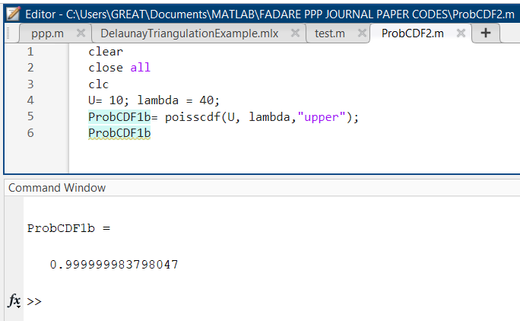Similarly, this example illustrates how to determine Poisson CDF for the probability of having the Poisson variable having values more than the given variable. The given variable in this example is 10. The average or mean of the distribution is ${40 sensors per km}^{2}$. The solution is jus a complementary form of the solution in Example 1(a). Equations display the answer to be the complementary form of the obtained Poisson CDF in equation (6). Figure 2 displays the Matlab® script file and the obtained answer for the solution of this example.

**Figure 2:poisscdf for Example 1(b) using Matlab®**

|  |  |  |  |
| --- | --- | --- | --- |
|  | $$ρ\left(u≥10, 40\right)=1-ρ\left(u≤10, 40\right)=1-\sum_{u=0}^{40}{\left(\frac{e^{-40}.{40}^{10}}{10!}\right)}=1.62019527×{10}^{-8}$$ | $u=1, 2, .., 10$; $$λ=40$$ | (7) |

## **Poisson Probability Density Function *poisspdf***

*poisspdf* is a Poisson Probability Density Function(PDF) in Matlab for specific determination of the probability of a Poisson variable u*,* given the average spatial or time rate , $λ$.

|  |  |  |  |
| --- | --- | --- | --- |
|  | $$ρ(u=U, λ)=\frac{e^{-λ}λ^{u}}{u!}$$ | $u=1, 2, 3, …U$; $λ≥0$ | (8) |

**Example 3 on *poisspdf***

An average number of sensors that would access an ABS communication network covering ${1km}^{2}$ is forty (40). Use Matlab to determine the probability of having ten (10) sensors accessing the network.

This example illustrates how to determine Poisson PDF for the probability of having the Poisson variable having values less than or equal to the given variable. The given variable in this example is 10. The average or mean of the distribution is ${40 sensors per km}^{2}$. Considering equation (5), can modified to equation (6) to obtain the values of the Poisson CDF. Figure 3 diplays the Matlab® script file and the obtained answer for the PDF.

|  |  |  |
| --- | --- | --- |
| $$ρ\left(u=10, 40\right)=\frac{e^{-λ}λ^{u}}{u!}=\frac{e^{-40}.{40}^{10}}{10!}=1.2278020×{10}^{-8}$$ | $u=10$; $λ=40$ | (7) |

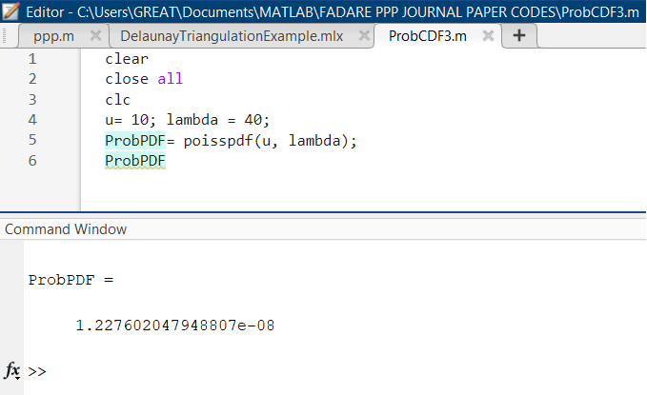

**Figure 3:poisspdf for Example 2 using Matlab®**

## **Poisson Random Variable Generator *poisspdf***

*poissrnd* is a Poisson random variable generator in Matlab for generating random variables using PPP stochastic distribution of Poisson variables u*,* given the average spatial or time rate , $λ$. This is the main tool required for the tutorial. The generated Poisson random variables, u, are equivalent to the stochastic distributed locations of users or any PPP stochastic process distributed variables on the given spatial or time space. The Poisson spatial or time rate, lambda or $λ$ are predetermined as the main variable for the *poissrnd* Matlab® function command. These are the three major syntaxes of the *poissrnd* command.

1. *u = poissrnd(lambda)*

This is to generate Poisson random numbers with mean value given as *lambda*. So, to generate random location points for communication users, the expected mean, $λ$, must be known. $λ$ is the only variable in this syntax. The expected average numbers of users to located on the given space is $λ$. So, the researchers that wants to carried out the modelling or simulation of users on given spatial plane must supply the specific values of the $λ$.

1. *u = poissrnd(lambda, a)*

Similarly, this syntax generates Poisson random numbers with mean value given as *lambda*. However, the second variable, *a*, indicates the size of the random Poisson variaables to be generated must be a 1 by *a* vector. This is applicable in generating spatial points along *x* or *y* coordinate.

1. *u = poissrnd(lambda,a,b)*

Similarly, this syntax generates Poisson random numbers with mean value given as *lambda*. However, both variables, *a* and *b* indicates the size of the random Poisson variaables to be generated must be *a* by *b* array. The generated array will have *a* rows and *b* columns.

## **Generating Matlab® PPP Functions for Random Point Generations in Rectangular Border Space**

The section is to exemplify the use of PPP distribution in generating random points to simulate locations of communication users. Figure 4 shows the Matlab® script code for simulating with explicit comments to explain every steps. The function developed to give example of how to use the PPP distribution to simulating the positions sensors within the within the ${1km}^{2}$ rectangular sample space at a given user density of ${40 users/km}^{2}$ 40. The Matlab function requires input parameters that defined the *x* and *y* axes as (minX, maxX, minY, maxY). In addition, the mean user density is another required parameter. Figure 5 illustrates the simulated user locations within the defined rectangular border using the PPP based user distribution Matlab® function. Both figures are suffice for interested readers to start generating stochastiv variable based on PPP distributions.

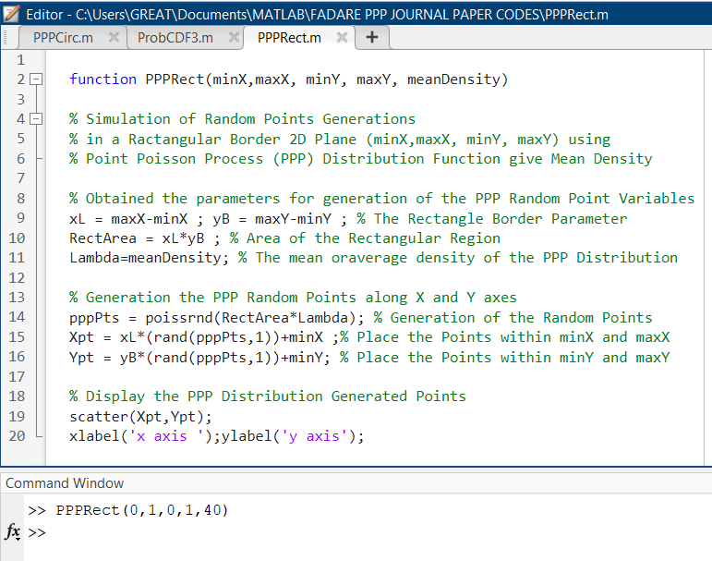

**Figure 4:Matlab® Function for Simulation of PPP Distributed User Location Points in a Rectangular Border Sample Plane**

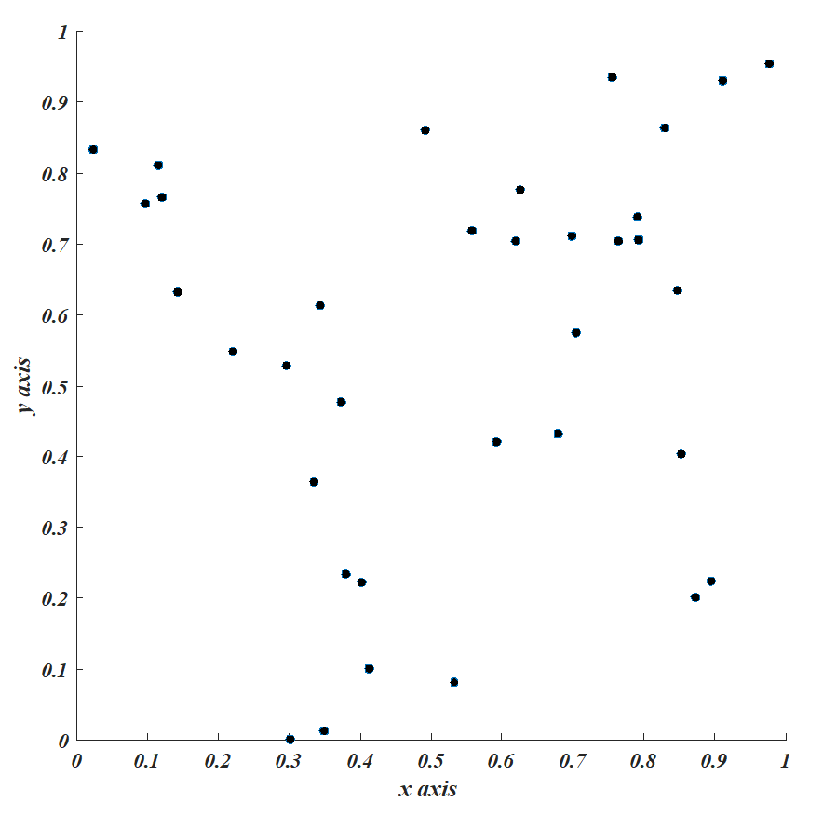

**Figure 5: Simulation of PPP Distributed User Location Points in a Rectangular Border Sample Plane**

## **Matlab® PPP Functions for Random Point Generations in Circular Border Space**

The sample plane for the PPP random distribution of users can be on a circular plane. Therefore, Figure 6 was presented as another explicit example of Matlab® function for the PPP point distribution for the knowledge of interested reader. Instead of having *x* and y axes defined, the radius of the circular sample plane and central points of the plane are required as input circular border parameter. In order to maintain our parameter for the ABS, the radius was set to *0.5 km* assuming that the circular plane will have diameter of *1 km* relative to the consider *1km* by 1*km* rectangular region as illustrated in Figure 7. Figure 7 presented the PPP distributed the output of the simulation function 7 when run with mean of *40 users per km2*, the circular horizontal plane radius of *0.5 km* and the plane center at (0,0) coordinate.

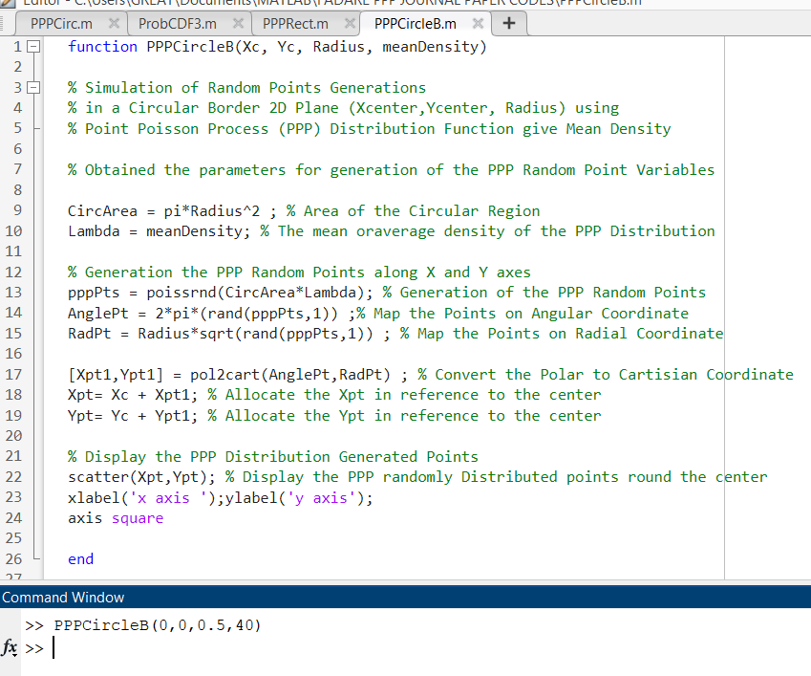

**Figure 6:Matlab® Function for Simulation of PPP Distributed User Location Points in a Circular Border Sample Plane**

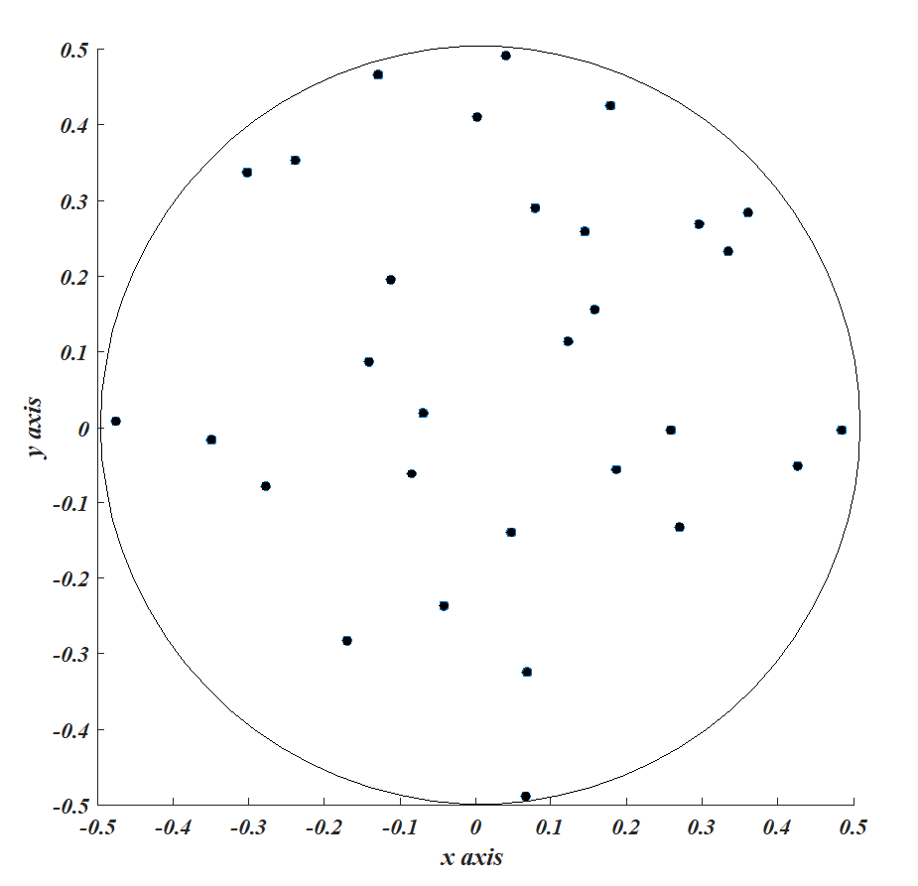

**Figure 7:Matlab® Function for Simulation of PPP Distributed User Location Points in a Rectangular Border Sample Plane**

# **Conclusion**

The nature of natural event are stochastic. In many research work, PPP distribution function was a tool used to generate data with independent occurrence and homogeneity in occurrence interval rate. Different examples of data that are simulated by applying Poisson probability distribution function were mentioned. The tutorial was developed with the objective of imparting the knowledge of using Matlab® PPP function to simulate engineering and scientific activities relative Poisson random variable. The tutorial discussed basic properties and fundamental of the PPP stochastic function. The paper concluding parts were presented with the objective of demystifying the simulation and generation of data like electronic communication user locations within a target ABS service region with rectangular or circular borders.

**REFERENCE**

Allen, T. T. (2019). *Introduction to Engineering Statistics and Lean Six Sigma* (3rd Edition). Springer.

Alzenad, M., and Yanikomeroglu, H. (2018). Coverage and Rate Analysis for Unmanned Aerial Vehicle Base Stations with LoS/NLoS Propagation. *2018 IEEE Globecom Workshops, GC Wkshps 2018 - Proceedings*. https://doi.org/10.1109/GLOCOMW.2018.8644511

Azari, M. M., Rosas, F., and Pollin, S. (2019). Cellular connectivity for UAVs: Network modeling, performance analysis, and design guidelines. *IEEE Transactions on Wireless Communications*, *18*(7), 3366–3381. https://doi.org/10.1109/TWC.2019.2910112

Bavarva, A., Dave, P. A., Soni, P. H., and Singh, P. A. (2015). *MATLAB Simulation Based Various Path Loss Prediction Model*. 1157–1160.

Blaszczyszyn, B., Karray, M. K., and Keeler, H. P. (2013). Using Poisson processes to model lattice cellular networks. *Proceedings - IEEE INFOCOM*. https://doi.org/10.1109/INFCOM.2013.6566864

Chetlur, V. V., and Dhillon, H. S. (2017). Downlink Coverage Analysis for a Finite 3-D Wireless Network of Unmanned Aerial Vehicles. *IEEE Transactions on Communications*, *65*(10), 4543–4558. https://doi.org/10.1109/TCOMM.2017.2722500

Chetlur, V. V., and Dhillon, H. S. (2020). Coverage and rate analysis of downlink cellular vehicle-to-everything (C-V2X) communication. *IEEE Transactions on Wireless Communications*, *19*(3), 1738–1753. https://doi.org/10.1109/TWC.2019.2957222

Cholaquidis, A., Forzani, L., Llop, P., and Moreno, L. (2017). On the classification problem for Poisson point processes. *Journal of Multivariate Analysis*, *153*. https://doi.org/10.1016/j.jmva.2016.09.002

Cui, Z., Briso-Rodriguez, C., Guan, K., Guvenc, I., and Zhong, Z. (2020). Wideband air-to-ground channel characterization for multiple propagation environments. *IEEE Antennas and Wireless Propagation Letters*, *19*(9), 1634–1638. https://doi.org/10.1109/LAWP.2020.3012889

Del Peral-Rosado, J. A., Raulefs, R., López-Salcedo, J. A., and Seco-Granados, G. (2018). Survey of Cellular Mobile Radio Localization Methods: From 1G to 5G. *IEEE Communications Surveys and Tutorials*, *20*(2), 1124–1148. https://doi.org/10.1109/COMST.2017.2785181

Erunkulu, O. O., Zungeru, A. M., Lebekwe, C. K., and Chuma, J. M. (2020). Cellular Communications Coverage Prediction Techniques: A Survey and Comparison. *IEEE Access*, *8*, 113052–113077. https://doi.org/10.1109/ACCESS.2020.3003247

Galkin, B., Kibilda, J., and Dasilva, L. A. (2017). Coverage Analysis for Low-Altitude UAV Networks in Urban Environments. *2017 IEEE Global Communications Conference, GLOBECOM 2017 - Proceedings*, *2018*-*Janua*(10), 1–6. https://doi.org/10.1109/GLOCOM.2017.8254658

Garg, A. (2020). *Machine Learning Coupled Trajectory and Communication Design for UAV-Facilitated Wireless Networks*. 1–16. http://arxiv.org/abs/2101.10454

Glynn, P. W. (2004). Stochastic Optimization. *Encyclopedia of Actuarial Science*, 1–20. https://doi.org/10.1002/9780470012505.tas034

Golam Sadeque, M. (2015). Bit Error Rate (BER) Comparison of AWGN Channels for Different Type’s Digital Modulation Using MATLAB Simulink. *American Scientific Research Journal for Engineering, Technology, and Sciences (ASRJETS) ISSN (Print)*, *13*(1), 61–71. http://asrjetsjournal.org/

Hmamouche, Y., Benjillali, M., Saoudi, S., Yanikomeroglu, H., and Renzo, M. Di. (2021). New Trends in Stochastic Geometry for Wireless Networks: A Tutorial and Survey. *Proceedings of the IEEE*, *109*(7), 1200–1252. https://doi.org/10.1109/JPROC.2021.3061778

Jondhale, S. R., Maheswar, R., and Lloret, J. (2022). Fundamentals of Wireless Sensor Networks. *EAI/Springer Innovations in Communication and Computing*, *66*(1997), 1–19. https://doi.org/10.1007/978-3-030-74061-0_1

Ju, S., Xing, Y., Kanhere, O., and Rappaport, T. S. (2021). Millimeter Wave and Sub-Terahertz Spatial Statistical Channel Model for an Indoor Office Building. *IEEE Journal on Selected Areas in Communications*, *39*(6), 1561–1575. https://doi.org/10.1109/JSAC.2021.3071844

Keeler, H. P., Ross, N., and Xia, A. (2018). When do wireless network signals appear Poisson? *Bernoulli*, *24*(3), 1973–1994. https://doi.org/10.3150/16-BEJ917

Keeler, P. (n.d.). *Simulating a homogeneous Poisson point process on a rectangle – H. Paul Keeler*. Retrieved July 4, 2024, from https://hpaulkeeler.com/poisson-point-process-simulation/

Keeler, P. (2018). Notes on Stochastic Processes. *Systems and Control in the Twenty-First Century*, 1–34.

Li, J., Conan, J., and Pierre, S. (2007). Position location of mobile terminal in wireless MIMO communication systems. *Journal of Communications and Networks*, *9*(3), 254–264. https://doi.org/10.1109/JCN.2007.6182853

Li, Y., and Cai, L. (2017). UAV-Assisted Dynamic Coverage in a Heterogeneous Cellular System. *IEEE Network*, *31*(4). https://doi.org/10.1109/MNET.2017.1600280

M, K. A., Hu, F., and Kumar, S. (2019). Deep Q-Learning Based Node Positioning for Throughput-Optimal Communications in Dynamic UAV Swarm Network. *IEEE Transactions on Cognitive Communications and Networking*, *1*(c), 1–12. https://doi.org/10.1109/TCCN.2019.2907520

Marani, M. R., Mirrezaei, S. M., and Mirzavand, R. (2023). Joint throughput and coverage maximization for moving users by optimum UAV positioning in the presence of underlaid D2D communications. *AEU - International Journal of Electronics and Communications*, *161*. https://doi.org/10.1016/j.aeue.2023.154541

Mozaffari, M., Saad, W., Bennis, M., Nam, Y. H., and Debbah, M. (2019). A Tutorial on UAVs for Wireless Networks: Applications, Challenges, and Open Problems. *IEEE Communications Surveys and Tutorials*, *21*(3), 2334–2360. https://doi.org/10.1109/COMST.2019.2902862

Okpeki, U. ., Egwaile, J. ., and Edeko, F. (2019). Performance and Comparative Analysis of Wired and Wireless Communication Systems using Local Area Network Based on IEEE 802.3 And IEEE 802.11. *Journal of Applied Sciences and Environmental Management*, *22*(11), 1727. https://doi.org/10.4314/jasem.v22i11.3

Omariba, Z. B., and Masese, N. B. (2019). A Study on Path Loss and Shadowing for Wireless Communication Channels. *International Journal of Advanced Research in Computer Science and Electronics Engineering (IJARCSEE)*, *8*(5), 2277–9043.

Pandey, K., Gupta, A. K., Dhillon, H. S., and Perumalla, K. R. (2023). Properties of a Random Bipartite Geometric Associator Graph Inspired by Vehicular Networks. *Entropy*, *25*(12). https://doi.org/10.3390/E25121619

Pandey, K., Perumalla, K. R., Gupta, A. K., and Dhillon, H. S. (2023). Fundamentals of Vehicular Communication Networks With Vehicle Platoons. *IEEE Transactions on Wireless Communications*, *22*(12), 8634–8649. https://doi.org/10.1109/TWC.2023.3264662

Parida, P., and Dhillon, H. S. (2023). Cell-Free Massive MIMO With Finite Fronthaul Capacity: A Stochastic Geometry Perspective. *IEEE Transactions on Wireless Communications*, *22*(3), 1555–1572. https://doi.org/10.1109/TWC.2022.3205349

Parshin, A. N. (2012). Notes on the Poisson formula. *St. Petersburg Mathematical Journal*, *23*(5), 781–818. https://doi.org/10.1090/s1061-0022-2012-01218-5

*Poisson cumulative distribution function - MATLAB poisscdf - MathWorks United Kingdom*. (n.d.). Retrieved July 4, 2024, from https://uk.mathworks.com/help/stats/poisscdf.html

Qamar, F., Dimyati, K., Hindia, M. N., Noordin, K. A., and Amiri, I. S. (2019). A Stochastically Geometrical Poisson Point Process Approach for the Future 5G D2D Enabled Cooperative Cellular Network. *IEEE Access*, *7*, 60465–60485. https://doi.org/10.1109/ACCESS.2019.2915395

Romero, D., and Leus, G. (2019). Non-cooperative aerial base station placement via stochastic optimization. *Proceedings - 2019 15th International Conference on Mobile Ad-Hoc and Sensor Networks, MSN 2019*, 131–136. https://doi.org/10.1109/MSN48538.2019.00036

Sabzehali, J., Shah, V. K., Fan, Q., Choudhury, B., Liu, L., and Reed, J. H. (2022). Optimizing Number, Placement, and Backhaul Connectivity of Multi-UAV Networks. *IEEE Internet of Things Journal*, *9*(21), 21548–21560. https://doi.org/10.1109/JIOT.2022.3184323

Samimi, M. K., and Rappaport, T. S. (2016). 3-D Millimeter-Wave Statistical Channel Model for 5G Wireless System Design. *IEEE Transactions on Microwave Theory and Techniques*, *64*(7), 2207–2225. https://doi.org/10.1109/TMTT.2016.2574851

Serfozo, R. (2009). Basics of Applied Stochastic Processes. *Basics of Applied Stochastic Processes*, 443.

Shakhatreh, H., Sawalmeh, A. H., Al-Fuqaha, A., Dou, Z., Almaita, E., Khalil, I., Othman, N. S., Khreishah, A., and Guizani, M. (2019). Unmanned Aerial Vehicles (UAVs): A Survey on Civil Applications and Key Research Challenges. *IEEE Access*, *7*, 48572–48634. https://doi.org/10.1109/ACCESS.2019.2909530

Shebani, N. M., Mohammed, A. E., Mosbah, M. A., and Hassan, Y. A. (2013). Simulation and analysis of path loss models for wimax communication system. *3rd International Conference on Digital Information Processing and Communications, ICDIPC 2013*, *December*, 692–703.

Ur-Rehman, O., and Zivic, N. (2018). Wireless communications. *Signals and Communication Technology*, 7–21. https://doi.org/10.1007/978-3-319-78942-2_2

Wang, H., Zhao, H., Wu, W., Xiong, J., Ma, D., and Wei, J. (2019). Deployment Algorithms of Flying Base Stations: 5G and Beyond With UAVs. *IEEE Internet of Things Journal*, *6*(6), 10009–10027. https://doi.org/10.1109/JIOT.2019.2935105

Weber, S. P., Yang, X., Andrews, J. G., and de Veciana, G. (2005). Transmission capacity of wireless ad hoc networks with outage constraints. *IEEE Transactions on Information Theory*, *51*(12), 4091–4102. https://doi.org/10.1109/TIT.2005.858939

Xiang, W., Zheng, K., and Shen, X. S. (2016). 5G mobile communications. In *5G Mobile Communications*. https://doi.org/10.1007/978-3-319-34208-5

Xu, F., Hu, Y., Hu, Z., and Cao, H. (2022). Coverage Probability Analysis for Device-to-Device Communication Underlaying Cellular Networks. *Electronics (Switzerland)*, *11*(3), 1–12. https://doi.org/10.3390/electronics11030464

Yao, Y., Wu, Y., Zhu, Z., Qin, X., and Yue, X. (2022). Modeling and Performance Analysis in UAV-Assisted Cellular Networks with Clustered Edge Users. *Electronics (Switzerland)*, *11*(5), 1–20. https://doi.org/10.3390/electronics11050828

Zeng, Y., Wu, Q., and Zhang, R. (2019). Accessing from the Sky: A Tutorial on UAV Communications for 5G and beyond. *Proceedings of the IEEE*, *107*(12), 2327–2375. https://doi.org/10.1109/JPROC.2019.2952892

Zhang, H., Chen, S., Feng, L., Xie, Y., and Hanzo, L. (2015). A Universal Approach to Coverage Probability and Throughput Analysis for Cellular Networks. *IEEE Transactions on Vehicular Technology*, *64*(9), 4245–4256. https://doi.org/10.1109/TVT.2014.2366597