**OPTIMAL DESIGN AND SENSITIVITY ANALYSIS OF HYBRID RENEWABLE ENERGY SYSTEMS FOR REMOTE LOCATIONS**

**Neha 1, Vivek Kumar2**

1M.Tech Student, Department of Electrical Engineering, BRCM College of Engineering and Technology

2 Professor and Head, Department of Electrical Engineering, BRCM College of Engineering and Technology

**ABSTRACT**

This paper presents an in-depth study on the optimal design and sensitivity analysis of hybrid renewable energy systems (HRES) tailored for remote locations. With the increasing demand for sustainable energy solutions, hybrid systems integrating various renewable energy sources such as solar, wind, and biomass have emerged as a promising alternative to conventional fossil fuels. The study begins with a comprehensive resource assessment to identify the potential of renewable resources in a selected remote area. Following this, an optimization framework is developed to determine the most efficient configuration of the HRES, aiming to minimize costs while maximizing energy reliability and sustainability. Sensitivity analysis is conducted to evaluate the impact of key parameters, such as resource availability, technological efficiency, and economic factors, on the system's performance. The results underscore the significance of tailored HRES designs for remote locations, demonstrating substantial benefits in terms of energy independence and environmental sustainability.

**Keywords:** Hybrid renewable energy system (HRES), storage system, renewable fraction.

1. **INTRODUCTION**

The increasing global demand for energy, coupled with the pressing need to reduce carbon emissions, has driven significant interest in renewable energy sources. Hybrid Renewable Energy Systems (HRES) have emerged as a promising solution to meet the energy requirements of remote and off-grid locations [1-3]. These systems integrate multiple renewable energy sources, such as solar, wind, and biomass, often complemented by energy storage systems, to provide a reliable and sustainable energy supply. Remote locations, such as rural communities, islands, and isolated industrial sites, face unique challenges in energy access. These areas are often far from central power grids, making traditional grid extension economically unfeasible and environmentally taxing. Consequently, HRES offer an attractive alternative by harnessing locally available renewable resources to create self-sustaining energy systems [4]. The optimal design of HRES involves determining the best configuration and sizing of the various system components to ensure cost-effectiveness, reliability, and environmental sustainability. This process requires careful consideration of several factors, including the variability of renewable energy sources, load demand profiles, system costs, and technological advancements. Additionally, sensitivity analysis plays a crucial role in assessing the robustness of the optimal design against uncertainties in key parameters such as resource availability, cost fluctuations, and technological changes [5]. This paper aims to present a comprehensive study on the optimal design and sensitivity analysis of HRES for remote locations. By employing advanced optimization techniques and robust sensitivity analysis methods, the study seeks to identify the most effective strategies for designing HRES that can adapt to varying conditions and uncertainties. The findings of this research will contribute to the broader understanding of how to implement and manage HRES in remote settings, ultimately promoting sustainable energy access and enhancing the resilience of these communities. Lack of access to reliable and sustainable electricity remains a significant challenge for remote communities worldwide [6-9]. Extending the national grid to these locations is often impractical due to high infrastructure costs and geographical limitations. Hybrid renewable energy systems (HRES) offer a promising alternative, utilizing a combination of renewable energy sources like solar photovoltaic (PV), wind, and biomass, coupled with energy storage and conventional generation (e.g., diesel generators) to meet electricity demands. This research paper investigates the optimal design and sensitivity analysis of HRES for remote locations. We aim to develop a methodology for selecting the most cost-effective and reliable system configuration considering the specific renewable energy resource availability, load profile, and economic factors.

The methodology will involve:

• Resource assessment: Evaluating the potential of various renewable energy sources (solar, wind, etc.) at the target location [10].

• Load forecasting: Analyzing the electricity consumption patterns of the remote community [11].

• System modeling: Developing a simulation model to assess the performance of different HRES configurations [12].

• Optimization: Employing optimization techniques to determine the optimal size and combination of renewable energy sources, energy storage, and conventional generation for minimizing costs or maximizing renewable energy penetration [13].

• Sensitivity analysis: Studying how the optimal design and performance of the HRES are affected by variations in critical parameters like load demand, fuel prices, and renewable resource availability [14].

Through this comprehensive approach, we aim to provide valuable insights for designing and implementing cost-effective, reliable, and sustainable HRES solutions for remote communities, promoting energy security and environmental benefits.

1. **RESOURCE ASSESSMENT**

The location selected for the work is Industrial area in Ludhiana District of State Punjab, India. Figure 1 shows the physical view of the selected location. Figure 2 displays the load profile for the chosen location.

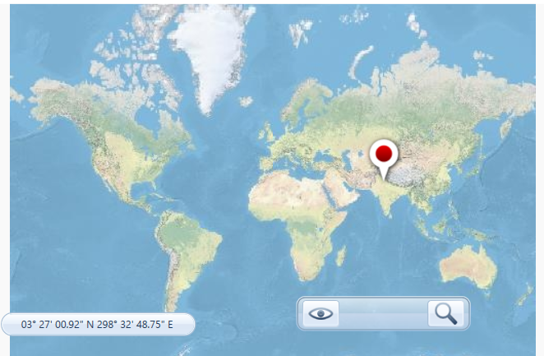

Figure 1: Representation of physical view of the chosen location

The load profile and all the parameters for the study is given in the below figure 3. All the matrices around chosen location based on NASA predefined values.

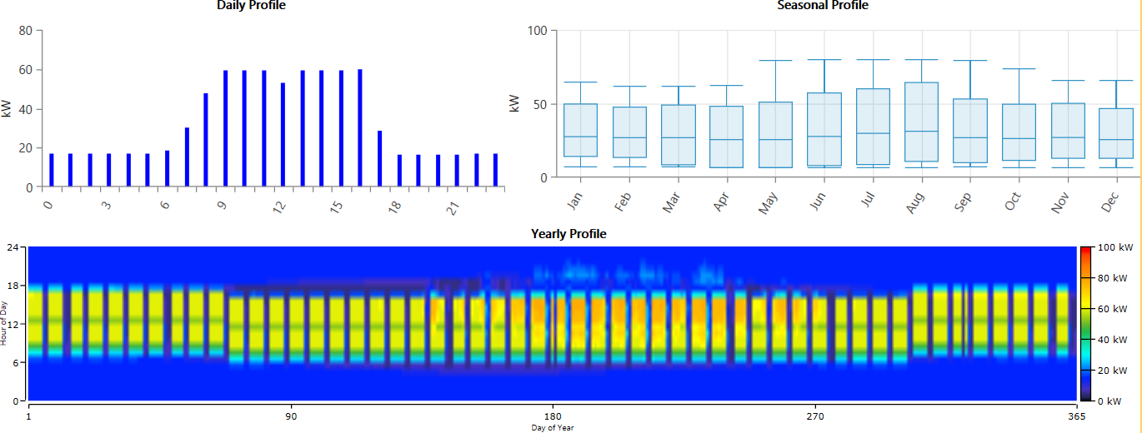

Figure 2: Load profile for the selected location of Punjab, India

Table 1: Average solar radiations for the selected location of Punjab, India

|  |  |  |
| --- | --- | --- |
| Month | Clearness Index | Daily Radiation (kWh/m2/day) |
| January | 0.607 | 3.500 |
| February | 0.627 | 4.420 |
| March | 0.643 | 5.610 |
| April | 0.646 | 6.600 |
| May | 0.582 | 6.480 |
| June | 0.556 | 6.360 |
| July | 0.530 | 5.950 |
| August | 0.548 | 5.730 |
| September | 0.623 | 5.670 |
| October | 0.662 | 4.920 |
| November | 0.697 | 4.180 |
| December | 0.630 | 3.380 |

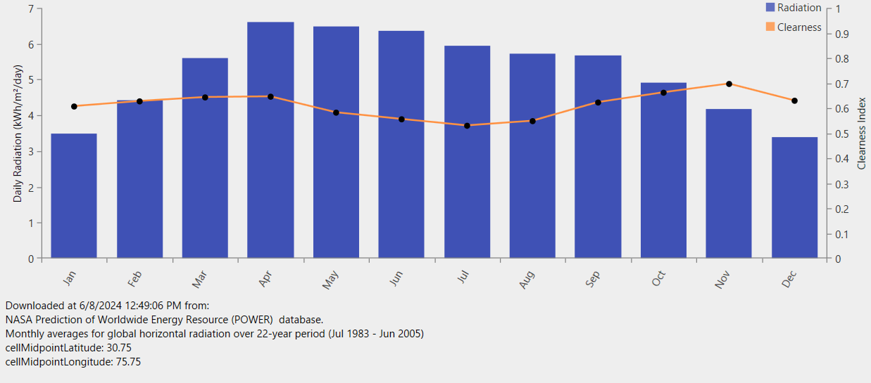

Figure 2: The average solar radiation for the chosen location is represented

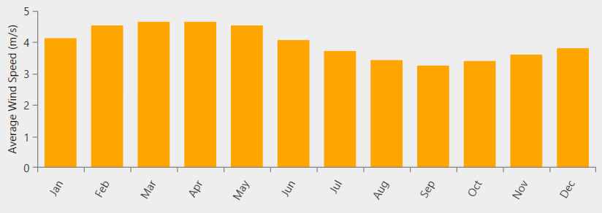

Figure 3: Representation of average speed of wind for the selected site of Punjab

For the hybrid microgrid, or HES, to be optimized and subject to sensitivity analysis, resource parameters are crucial. There are a few important elements that highlight the necessity of resource assessment in HES planning.

1. **OPTIMIZATION AND SENSITIVITY ANALYSIS**

Hybrid energy system optimization and sensitivity analysis include assessing the systems' performance in a range of technological, financial, and environmental scenarios. This study aids in determining the most dependable and affordable solutions for rural electricity. Hybrid energy systems, which usually combine renewable energy sources like solar, wind, and hydro power with energy storage devices like batteries and backup power sources like diesel generators, are best configured using optimization approaches. The goal is to minimize costs, reduce emissions, and ensure a reliable power supply.

**Sensitivity Analysis**

An essential first step in hybrid energy system optimization is sensitivity analysis. It entails assessing the effects of changes in important characteristics such as:

**Techno-economic factors:**

Energy cost (COE): the price of the energy that the system generates.

Net present cost (NPC): The entire cost of the system for its whole life.

Total capital cost (TCC): The initial investment required for the system.

Renewable penetration fraction (RPF): the percentage of renewable energy in the energy mix as a whole.

**Environmental factors:**

CO2 emissions: The amount of carbon dioxide released by the system.

Water pipe losses: The energy lost due to water flow in the system.

Generator minimum load: The minimum power required by the generator.

Battery roundtrip efficiency: The efficiency of the battery in charging and discharging.

Battery setpoint state of charge: The desired state of charge for the battery.

Capacity shortage: The difference between the required and available power.

PV capital cost multiplier: The cost of installing photovoltaic panels.

Multi-year module: The optimization module used for multi-year analysis.

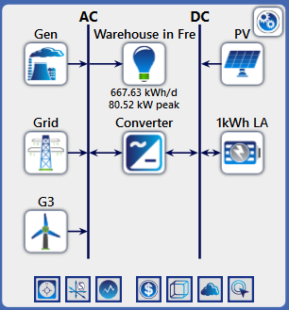

Figure 5: Representation of the Proposed HES

Table 2: Optimal sizing and cost assessment of HES for the chosen location

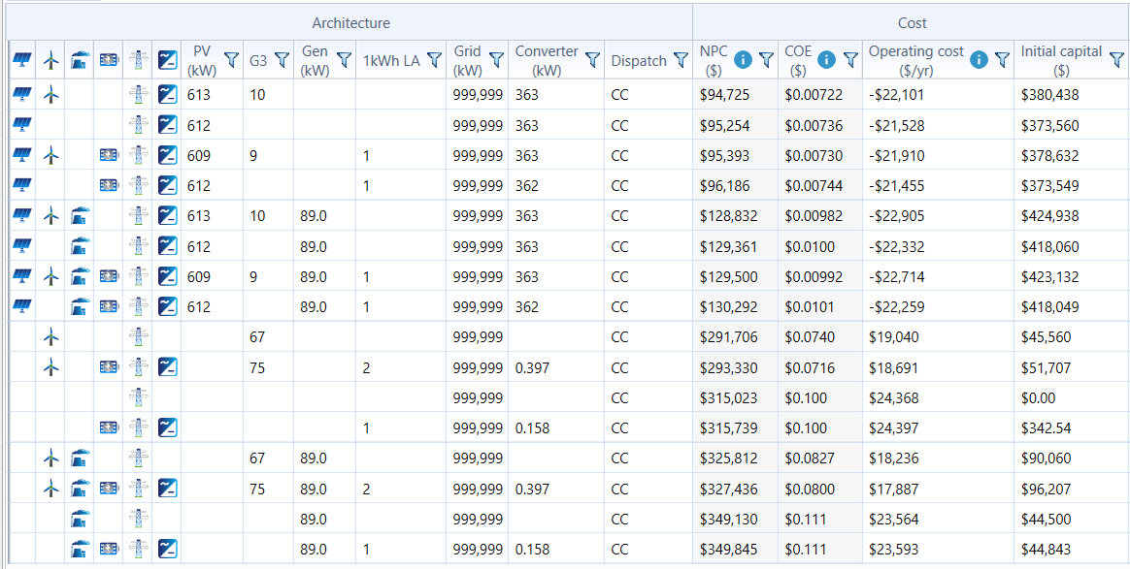

The table displays a comparison of different energy system configurations based on their architecture and cost metrics. Here’s a detailed explanation of each column and row in the table:

1. **Architecture:**
   * **Icons:** Each row starts with icons representing the components included in that configuration. The icons might depict different types of energy sources like solar PV, wind turbines, generators, grids, converters, etc.
   * **PV (kW):** Represents the capacity of the photovoltaic (solar) system in kilowatts.
   * **G3:** Likely represents a generator type or a specific component, with numbers indicating the quantity or capacity.
   * **Gen (kW):** Indicates the capacity of the generator in kilowatts.
   * **1kWh LA:** This could be a parameter or component related to energy storage or load adjustment.
   * **Grid (kW):** Represents the grid capacity in kilowatts.
   * **Converter (kW):** Indicates the capacity of the converter in kilowatts.
   * **Dispatch:** Specifies the dispatch strategy or type, here it is consistently listed as "CC" which might refer to a specific control or operation strategy.
2. **Cost:**
   * **NPC ($):** Net Present Cost, which represents the total cost of the system over its lifetime, discounted to present value.
   * **COE ($):** Cost of Energy, which indicates the cost per unit of energy generated by the system.
   * **Operating cost ($/yr):** Annual operating costs for the system.
   * **Initial capital ($):** The upfront cost required to set up the system.

#### Architecture Section:

1. **PV (kW):** This column shows the capacity of photovoltaic solar panels in kilowatts. The values range from 609 kW to 613 kW and up to 89 kW in some configurations.
2. **G3:** This column likely represents the number of generators used in the configuration. Values here range from 0 to 10.
3. **Gen (kW):** The generator capacity in kilowatts. It shows 1 kW, 89 kW, and some other configurations with different values.
4. **1kWh LA:** This column might represent the capacity of the 1 kWh lithium-ion battery system used in the configuration.
5. **Grid (kW):** This shows the grid capacity in kilowatts, which is consistently 999,999 kW, indicating a grid-connected system.
6. **Converter (kW):** The capacity of the power converter in kilowatts, which ranges from 0.158 kW to 363 kW.
7. **Dispatch:** The dispatch strategy used, which is consistently "CC" (Cycle Charging) across all configurations.

#### Cost Section:

1. **NPC ($):** Net Present Cost in dollars. This is the total lifetime cost of the system discounted back to present value. It ranges from $94,725 to $349,845.
2. **COE ($):** Cost of Energy in dollars per kilowatt-hour. This is the average cost to produce electricity, ranging from $0.00722 to $0.111.
3. **Operating cost ($/yr):** Annual operating cost in dollars, ranging from -$22,101 to $23,593.
4. **Initial capital ($):** The upfront cost to install the system, ranging from $0 to $424,938.
5. **Sensitivity Analysis.**

Sensitivity analysis is a crucial aspect of optimizing hybrid energy systems, as it helps evaluate the impacts of various techno-economic factors on system performance. Here are some key points related to sensitivity analysis in hybrid energy systems:

**Impact on System Performance:**

Cost of Energy (COE): Changes in the above factors can significantly affect the COE, which is a key metric for evaluating the economic viability of hybrid energy systems.

Total Net Present Cost (TNPC): TNPC is another important metric that is influenced by changes in the above factors.

Renewable Penetration Fraction (RPF): The RPF, which measures the proportion of renewable energy in the system, is also affected by changes in the above factors.

CO2 Emissions: The environmental impact of hybrid energy systems, measured by CO2 emissions, is influenced by the system's configuration and the factors mentioned above.

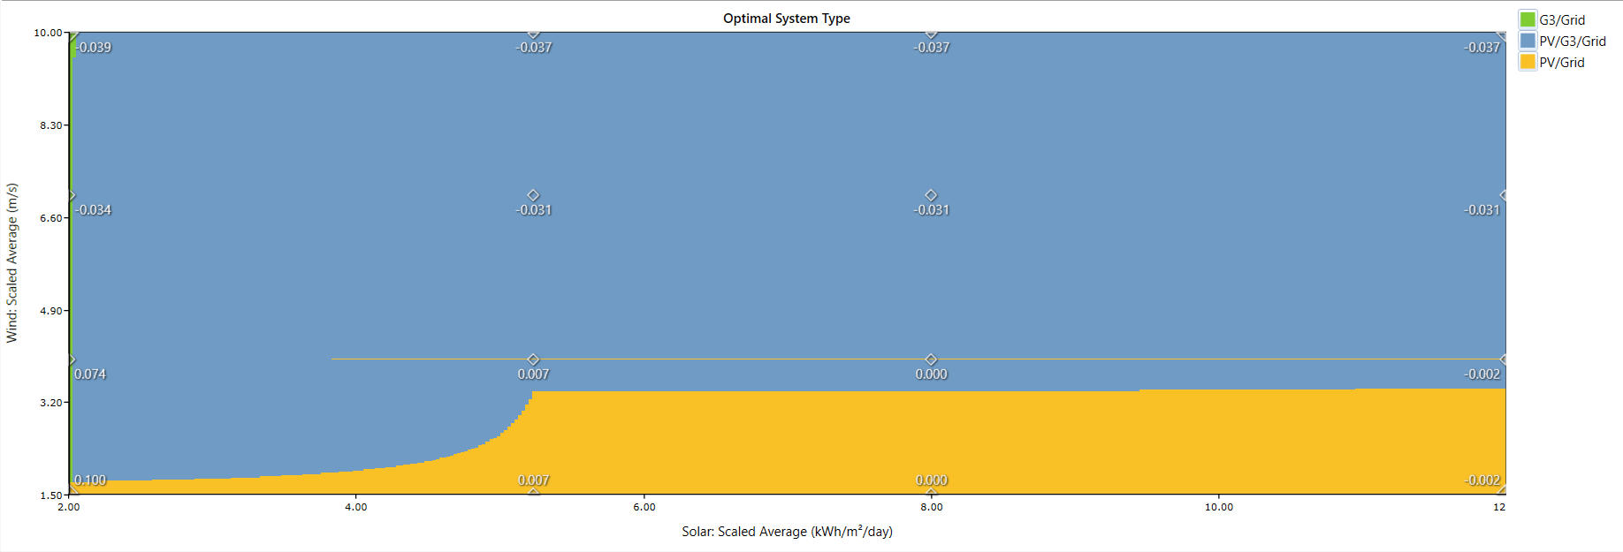

Figure 6: Plotting the ideal system type for the proposed HES's sensitivity analysis

Figure 6's sensitivity analysis plot illustrates the ideal system configuration for different mixes of solar and wind energy. The Solar Scaled Average is shown on the x-axis in kWh/m²/day, while the Wind Scaled Average is shown on the y-axis in m/s. The plot illustrates the regions where different system configurations are most cost-effective or efficient, as determined by the HOMER software.

**Key:**

* **G3/Grid (Green)**: This area represents the optimal use of a system combining a G3 generator and grid electricity.
* **PV/G3/Grid (Blue)**: This area represents the optimal use of a system combining photovoltaic (solar PV), a G3 generator, and grid electricity.
* **PV/Grid (Yellow)**: This area shows how to best utilize a system that combines grid electricity with photovoltaic (solar PV) power.

1. **EXPLANATION OF THE RESULTS**

**Low Solar and Low Wind Region**:

* + In the lower-left corner of the plot, where both solar and wind resources are minimal (solar < 4 kWh/m²/day and wind < 2.5 m/s), the **PV/Grid** system (yellow) is the optimal configuration. This indicates that in areas with low renewable resources, relying on solar PV combined with grid electricity is more cost-effective.

1. **High Solar and Low Wind Region**:
   * As the solar resource increases (solar > 4 kWh/m²/day) while the wind resource remains low, the **PV/Grid** system (yellow) continues to be optimal. This suggests that high solar availability significantly enhances the feasibility and cost-effectiveness of using solar PV and grid electricity.
2. **Moderate Solar and High Wind Region**:
   * In the region where wind resources are moderate to high (wind > 2.5 m/s) and solar resources are still moderate (solar < 7 kWh/m²/day), the **PV/G3/Grid** system (blue) becomes optimal. This indicates that the addition of wind resources makes the integration of a G3 generator with solar PV and grid electricity more viable.
3. **High Solar and High Wind Region**:
   * In the top-right corner of the plot, where both solar and wind resources are high, the **PV/G3/Grid** system (blue) dominates. This suggests that the combined use of solar PV, wind, a G3 generator, and grid electricity is the most efficient and cost-effective solution in regions with abundant renewable resources.
4. **Transition Regions**:
   * The transitions between different colors represent the boundaries where the optimal system type changes. These boundaries are influenced by the relative costs, efficiencies, and availability of the solar and wind resources.

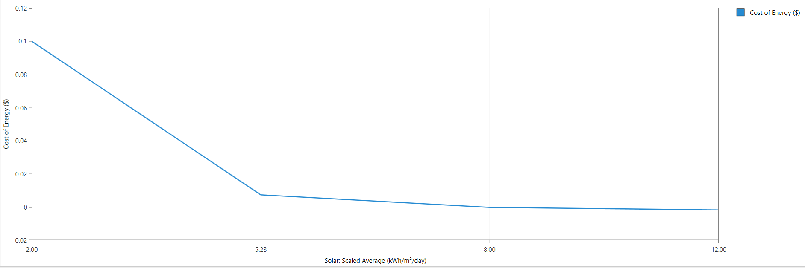

Figure 7: Line plot of the sensitivity analysis of HES

The sensitivity analysis plot in Figure 7 shows the relationship between the solar scaled average (in kWh/m²/day) and the cost of energy (in $).

**Explanation of the Results:**

1. **Low Solar Resource Region (2.00 to 5.23 kWh/m²/day)**:
   * At the lower end of the solar resource spectrum (2.00 to approximately 5.23 kWh/m²/day), there is a significant decrease in the cost of energy. Initially, at 2.00 kWh/m²/day, the cost of energy is relatively high, around $0.10. This indicates that with very low solar resources, generating energy is expensive, likely due to the increased reliance on more costly or less efficient energy sources.
   * As the solar resource increases, the cost of energy drops steeply. By the time the solar scaled average reaches 5.23 kWh/m²/day, the cost of energy decreases to approximately $0.02. This suggests that moderate increases in solar availability significantly reduce the cost of energy, likely due to the improved efficiency and greater contribution of solar PV systems.
2. **Moderate to High Solar Resource Region (5.23 to 12.00 kWh/m²/day)**:
   * Beyond 5.23 kWh/m²/day, the cost of energy plateaus and shows only a slight further decrease as solar resources continue to increase up to 12.00 kWh/m²/day. The cost stabilizes around $0.02, indicating that once a certain threshold of solar availability is reached, additional increases in solar resource have a diminishing impact on reducing the cost of energy.
   * This plateau suggests that the energy system has optimized its use of solar resources, and further improvements in solar availability yield marginal cost benefits. The energy system is likely already taking full advantage of the available solar resources to minimize costs.
3. **CONCLUSION**

This research highlights the viability and advantages of hybrid renewable energy systems for remote locations. The optimal design process, grounded in thorough resource assessment and robust optimization techniques, ensures the development of cost-effective and reliable energy solutions. The sensitivity analysis reveals the critical factors influencing the performance of HRES, providing valuable insights for policymakers and engineers in designing resilient energy systems. The findings emphasize that customized HRES configurations, adapted to the specific characteristics of remote areas, can significantly enhance energy security and promote sustainable development. Future research should focus on integrating advanced technologies and exploring the socio-economic impacts of HRES implementation in various remote settings.

1. **REFERENCES:**
2. Nallolla, C.A.; Perumal, V. Optimal Design of a Hybrid Off-Grid Renewable Energy System Using Techno-Economic and Sensitivity Analysis for a Rural Remote Location. Sustainability **2022**, 14, 15393. <https://doi.org/10.3390/su142215393>
3. Ashok, S. (2007). Optimised model for community-based hybrid energy system. Renewable Energy, 32, 1155-1164. <https://doi.org/10.1016/J.RENENE.2006.04.008>.
4. Lian, J., Zhang, Y., Ma, C., Yang, Y., & Chaima, E. (2019). A review on recent sizing methodologies of hybrid renewable energy systems. Energy Conversion and Management. <https://doi.org/10.1016/j.enconman.2019.112027>.
5. Guo, S., Liu, Q., Sun, J., & Jin, H. (2018). A review on the utilization of hybrid renewable energy. Renewable and Sustainable Energy Reviews. <https://doi.org/10.1016/J.RSER.2018.04.105>.
6. Wang, X., Palazoglu, A., & El‐Farra, N. (2015). Operational optimization and demand response of hybrid renewable energy systems. Applied Energy, 143, 324-335. <https://doi.org/10.1016/J.APENERGY.2015.01.004>.
7. Dagdougui, H., Minciardi, R., Ouammi, A., Robba, M., & Sacile, R. (2012). Modeling and optimization of a hybrid system for the energy supply of a “Green” building. Energy Conversion and Management, 64, 351-363. <https://doi.org/10.1016/J.ENCONMAN.2012.05.017>.
8. Pérez-Navarro, Á., Alfonso, D., Ariza, H., Cárcel, J., Correcher, A., Escrivá-Escrivá, G., Hurtado, E., Ibáñez, F., Peñalvo, E., Roig, R., Roldán, C., Sánchez, C., Segura, I., & Vargas, C. (2016). Experimental verification of hybrid renewable systems as feasible energy sources. Renewable Energy, 86, 384-391. <https://doi.org/10.1016/J.RENENE.2015.08.030>.
9. Li, L., & Wang, X. (2021). Design and operation of hybrid renewable energy systems: current status and future perspectives. Current opinion in chemical engineering, 31, 100669. <https://doi.org/10.1016/J.COCHE.2021.100669>.
10. Afgan, N., & Carvalho, M. (2008). Sustainability assessment of a hybrid energy system. Energy Policy, 36, 2903-2910. <https://doi.org/10.1016/J.ENPOL.2008.03.040>.
11. Deshmukh, M., & Deshmukh, S. (2008). Modeling of hybrid renewable energy systems. Renewable & Sustainable Energy Reviews, 12, 235-249. <https://doi.org/10.1016/J.RSER.2006.07.011>.
12. Sinha, S., & Chandel, S. (2014). Review of software tools for hybrid renewable energy systems. Renewable & Sustainable Energy Reviews, 32, 192-205. <https://doi.org/10.1016/J.RSER.2014.01.035>.
13. Eze, F.; Ogola, J.; Kivindu, R.; Egbo, M.; Obi, C. Technical and economic feasibility assessment of hybrid renewable energy system at Kenyan institutional building: A case study. Sustain. Energy Technol. Assess. 2022, 51, 101939.
14. Kreishan, M.Z.; Fotis, G.; Vita, V.; Ekonomou, L. Distributed Generation Islanding Effect on Distribution Networks and End User Loads Using the Load Sharing Islanding Method. Energies 2016, 9, 956.
15. Pepermans, G.; Driesen, J.; Haeseldonckx, D.; Belmans, R.; D’haeseleer, W. Distributed generation: Definition, benefits and issues. Energy Policy 2005, 33, 787–798.