PROJECT FORMULATION AND APPRAISAL FOR CONSTRUCTION OF VETERINARY CARE IN MADAWARAYAPURAM, COIMBATORE
P. Dev Anand¹, Ms. U Sindhu Vaardini², Mr. P.A. Prabakaran³, Mr. A Aswin Bharath⁴
*1 Student, Construction Management, Kumaraguru College of Technology, Coimbatore,
Tamil Nadu, India.
*2,3,4 - Assistant Professor, Construction Management, Kumaraguru College of Technology,
Coimbatore, Tamil Nadu, India.

ABSTRACT
The construction of a state-of-the-art veterinary hospital in Madawarayapuram addresses the community's need for specialized animal care. With rising pet ownership and livestock farming, the hospital will enhance animal welfare by offering comprehensive veterinary services. Its strategic location ensures easy access, reducing travel time for timely medical attention. This facility will positively impact the local economy by creating jobs and stimulating related businesses, such as pet supply stores and feed suppliers. Designed for functionality and aesthetics, the hospital will provide a welcoming environment for animals and their owners. By incorporating modern medical technology, it will set a new standard for veterinary care, establishing Madawarayapuram as a hub for animal health and welfare.
Key words: Madawarayapuram, Livestock, Animal welfare, Local economy, Cattle breeders.
INTRODUCTION
Coimbatore, a tech-centered city in Tamil Nadu, also boasts vibrant rural areas and agricultural fields. The villages around the Western Ghats' foothills, northwest of Coimbatore, experience significant agricultural and cattle development. Addressing the needs of these residents, especially their animals, is crucial. The current distance to the veterinary facility in Perur, about 20-30 km from villages like Sadivayal, Madawarayapuram, and Alandurai, makes transportation costly and timely medical care difficult. Thus, establishing a veterinary hospital in Madawarayapuram is vital. This facility will provide essential healthcare for livestock and pets, meeting the increasing demand for modern veterinary care and enhancing animal welfare in the community.
LITERATURE STUDY
Dolapo Enahoro et al., The research article "Strategies to Upgrade Animal Health Delivery in Village Poultry Systems" explores the perspectives of stakeholders from Northern Ghana and Central Zones in Tanzania on enhancing animal health services for village poultry. The study addresses challenges faced in delivering veterinary inputs and services to small-scale chicken farmers, particularly focusing on the role of women in poultry production. The authors emphasize the importance of community-based approaches, technology utilization, and gender-inclusive solutions to improve animal health outcomes. Additionally, the research highlights the need for increased investments and policy initiatives to support village poultry systems.
Dr. Michelle Lem et al, provides a comprehensive perspective on the barriers to accessible veterinary care. She emphasizes the importance of considering socioeconomic, geographic, and knowledge-based barriers in addressing the issue. Dr. Lem's work reflects a deep understanding of the interconnectedness between human and animal health, highlighting the significance of the One Health model. Through her organization, Community Veterinary Outreach, she actively works to bridge the gap in veterinary care for marginalized populations, showcasing her commitment to promoting animal welfare and advocating for equitable access to veterinary services.
Sage M. Smith et al, provides insights into the perspectives of the authors regarding the impact of the COVID-19 pandemic on access to veterinary care. They conducted surveys and interviews to understand the challenges faced by pet owners, especially vulnerable populations, during the pandemic. They explored topics such as pet surrendering, owner perceptions, telemedicine, and the impact on veterinary professionals. The authors also discussed the opportunities for expanding access to veterinary care, the importance of mental health support for veterinary professionals, and the need for collaboration and communication within the veterinary community. Their research highlights the importance of addressing barriers to veterinary care and preparing for future crises.
Sharon L et al., provide a review on moving toward fear-free husbandry and veterinary care for horses from the perspective of the authors. They discuss the potential for improving horse experiences during husbandry and veterinary procedures, highlighting the importance of considering the impact of handling techniques on the horse's welfare and safety. The authors emphasize the need for human education, thoughtful planning, welfare- oriented management, and effective horse-training protocols to enhance horse welfare and reduce the risk of injury to both humans and horses during veterinary procedures.
David J. Mellor et al., in the research paper titled "The 2020 Five Domains Model: Including Human-Animal Interactions in Assessments of Animal Welfare" outlines the latest updates to the Five Domains Model, which incorporates scientific thinking relevant to animal welfare assessment. The Model is designed to evaluate the negative and positive impacts of human behaviour on animal welfare, involving various individuals such as livestock handlers, zookeepers, researchers, and companion animal owners.
Tony McReynolds et al., in "A Practical Guide to Veterinary Hospital Design" provides a comprehensive overview of the architectural and design considerations for veterinary hospitals. It covers the entire design process, from initial planning and site selection to the detailed layout of treatment rooms, surgical suites, and administrative areas. Emphasizing the importance of a well-thought-out design tailored to veterinary practice needs, it highlights how proper design can improve workflow efficiency, client satisfaction, and animal care.
Sławomir Wawak et al., in "Understanding the Key Quality Factors in Construction Projects" identifies and categorizes crucial quality factors in construction project management. It emphasizes the importance of planning, process management, and organizational quality. The findings are particularly relevant to veterinary hospital construction, suggesting that focusing on quality management from the planning stage can significantly impact the success and sustainability of the project.
Deka RP et al., in "Knowledge and practices of dairy farmers relating to brucellosis in urban, peri-urban and rural areas of Assam and Bihar, India" assesses dairy farmers' awareness and practices regarding brucellosis in Assam and Bihar. It finds that only a small fraction of farmers knows about the disease and its zoonotic risks. Knowledge is higher among farmers with larger herds, those using stall-fed systems, and those who have received training or veterinary consultation. Improved farmer-veterinarian interactions and targeted training are recommended to enhance disease awareness and management practices.
Migliaccio, P. et al., Companion Animals Welfare in Non-Epidemic Emergencies: The Case of Central Italy, Post-Earthquake 2016/2017 examines the welfare of companion animals during non-epidemic emergencies, particularly focusing on the aftermath of earthquakes in central Italy from August 2016 to January 2017. It highlights the significant stress and injuries that companion animals endure during such events, often leading to overcrowded shelters and emergent free-roaming populations. The study underscores the importance of an integrated emergency management system for veterinary care, ensuring the well-being of both owned and stray animals affected by natural disasters.

METHODOLOGY
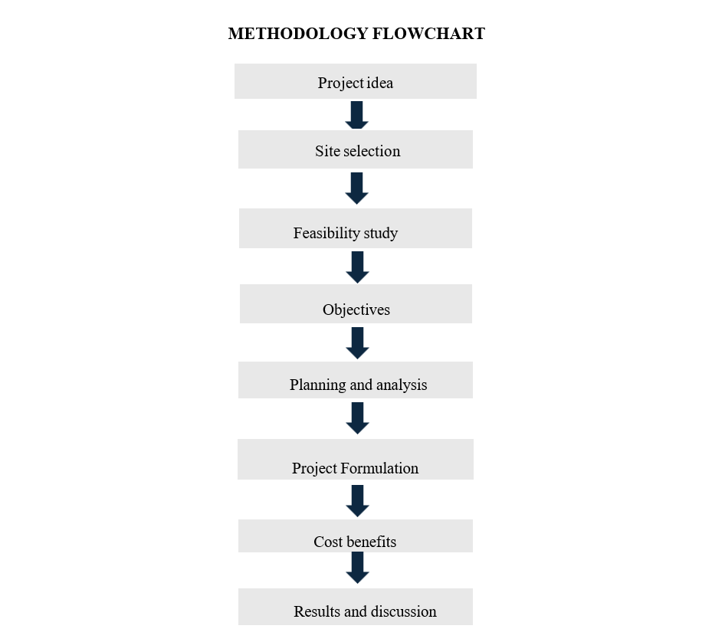

QUESTIONNAIRE SURVEY
The purpose of this online questionnaire survey was to gather valuable insights and opinions from the community regarding the construction of veterinary hospital in Madawarayapuram, Coimbatore district. We got a total of 165 responses. The objective was to understand the community's needs, preferences, and expectations.
After conducting a survey of peoples 71.5% of people are not satisfied with the current veterinary facility and need to travel more than 15 kilometers. So, they prefer to construct a new veterinary facility in Madawarayapuram, Coimbatore.

FEASIBILITY STUDY
The technical analysis includes input, throughout, and output evaluations. Input analysis identifies, categorizes, and assesses inputs, promoting long-term contracts with reliable suppliers. Throughout examination focuses on the production and utilization of these inputs. Output analysis ensures the product meets specifications. The hospital in Madawarayapuram, covering 2600 sq. ft., is easily accessible for local farmers and breeders. Site suitability is evaluated based on soil conditions, topography, and utility availability (water, electricity, sewage). Regulatory approvals, including zoning and building permits, are obtained from local authorities for construction and operation.
Financial feasibility is critical for evaluating the economic viability of a project by assessing expenses, income sources, and potential profitability. It ensures the project can produce adequate returns to justify the investment. Analyzing local market demand and competition is essential, considering livestock farms, pet ownership rates, and existing veterinary clinics. Funding can be obtained through government schemes by the Department of Animal Husbandry and Dairying, or NGOs like FIAPO, which offer up to 5 Lakhs for animal welfare based on the number of animals cared for.
Market feasibility assesses the potential demand and acceptance of a proposed project in the target market to determine its success and sustainability. For the veterinary hospital in Madawarayapuram, this involves analyzing current and projected demand for veterinary services, pet ownership trends, population demographics, and existing clinics. Identifying the primary target audience, such as local pet owners, and understanding their needs and willingness to pay is crucial. Additionally, selecting a site involves considering accessibility, proximity to residential areas, parking availability, visibility, and compliance with local zoning and permitting regulations.
Economic feasibility assesses the financial viability and profitability of a project, ensuring it can generate sufficient economic benefits to outweigh costs. Constructing a veterinary hospital in Madawarayapuram will positively impact the local economy by improving veterinary care and encouraging breeders to raise more cattle. Additionally, it will support local agricultural growth, further boosting economic benefits.

PROJECT FORMULATION AND APPRAISAL
To build a project's overall benefit, an entrepreneur must first thoroughly study the project concept and carefully evaluate each of its component pieces. This process is known as project formulation. Veterinary Care provides essential healthcare for farm animals and pets, supporting local agriculture and pet owners. It creates job opportunities, boosts the local economy, and improves animal welfare, contributing to the overall well-being of the community. Clarify the project's purpose and potential effects on the community before detailing its scope, objectives, and projected results.
Conduct a thorough technical investigation of the building's structural integrity, design adaptability, safety precautions, and necessary adjustments. Financial feasibility analysis determines the expenses, forecasts the income streams, does a break-even analysis, and calculates the return on investment (ROI) to determine the project's financial sustainability. Determine possible risks, such as monetary, technological, or operational difficulties, and develop ways to reduce these risks. Project Timeline and Resources: Create a thorough project plan that lists all the tasks, deadlines, resources, and significant milestones. Make an educated choice about whether to move on with the project based on the results of the appraisal. Upon approval, start the construction modeling procedure while following the defined project plan.
Cost-Benefit Analysis: Perform a detailed cost-benefit analysis, evaluating the project's favorable and unfavorable effects against the costs to the project's finances, society, and environment.
Monitoring and Evaluation: To ensure the project's success and make necessary adjustments, continuously track project progress financial and operational performance.
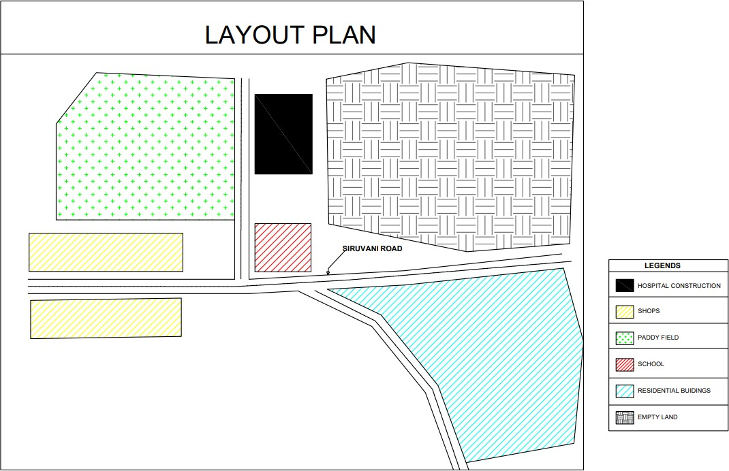
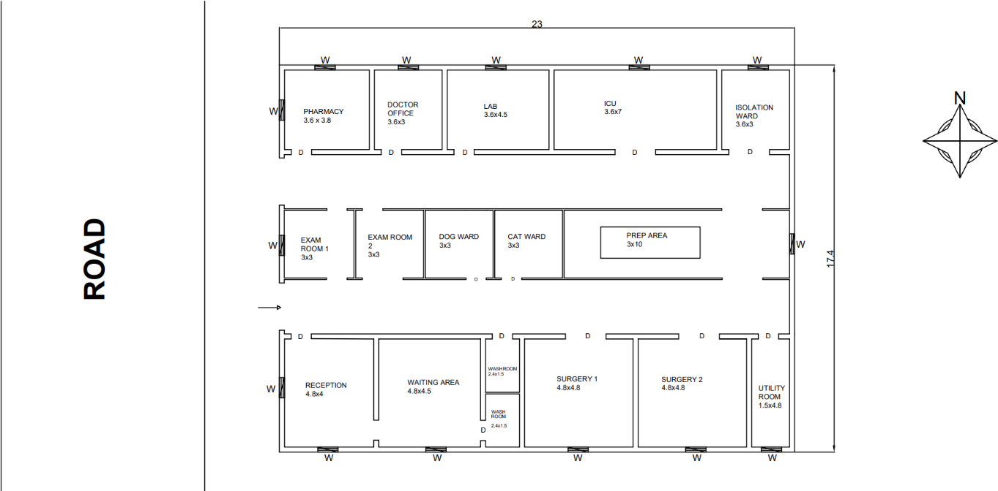
FLOOR PLAN

ESTIMATION
Project estimation is the process of forecasting the time, cost, and resources needed to deliver a project. It typically happens during project initiation and/or planning and takes the project's scope, deadlines, and potential risks into account. Here the quantities are calculated by the detailed estimation and the total cost is calculated using abstract estimation. Project appraisal is the process of carefully examining several project-related elements. It primarily aims to evaluate a project's viability. Such an evaluation typically involves two steps.
- The phase of project identification, which is typically handled by the company.

- During the project funding stage, banks and financial institutions evaluate the project critically.

ABSTRACT ESTIMATE
SI NO | Description of the work | Quantity | Units | Rates per unit (in Rs.) | Amount (in  Rs.)
1 | Site Clearance | 400.20 | m2 | 75.00 | 30015
2 | Earthwork Excavation | 171.00 | m3 | 300.00 | 51300
3 | P.C.C | 415.57 | m3 | 7573.33 | 3147250.41
4 | R.C.C | 164.43 | m3 | 20248.00 | 3329378.64
5 | Brickwork | 165.33 | m3 | 4210.00 | 696039.3
6 | Floor Finish | 400.20 | m2 | 1500.00 | 600300
7 | Plastering | 1565.80 | m2 | 250.00 | 391450
8 | Weathering Course | 400.2 | m2 | 2800.00 | 1120560
9 | Windows | 11 | Nos | 5500.00 | 60500
10 | Door MD | 2 | Nos | 7500.00 | 15000
11 | Door D1 | 4 | Nos | 6800.00 | 27200
12 | Door D2 | 10 | Nos | 6200.00 | 62000
13 | Ventilator | 2 | Nos | 2200.00 | 4400
14 | Tile | 400.2 | m2 | 1100.00 | 440220
 | Total |  |  |  | 9975613.35
15 | Add 1.5% miscellaneous |  |  |  | 149634.2003
 | Grand Total |  |  |  | 10125247.55
 | Round off |  |  |  | 10150000
 | The calculation for cost of construction per square feet
16 | Total Floor Area |  | 400 sq. m or 4305 sq. ft
17 | Cost for 1 sq. ft |  | 2357.723577

COST-BENEFIT ANALYSIS
A cost-benefit analysis (CBA) for the veterinary hospital project in Madawarayapuram involves comparing total costs, estimated at 1,01,50,000 Rupees, with anticipated benefits like improved health outcomes, reduced disease burden, job creation, and increased economic activity. By quantifying these benefits, such as reduced healthcare costs and increased productivity, the CBA can demonstrate the project's economic and social value. A positive CBA, indicated by a benefit-cost ratio (BCR) where benefits outweigh costs, would justify the investment, ensuring long-term sustainability and community impact despite the inherent challenges and uncertainties in performing large project analyses.
SOURCE OF REVENUE
Type of service | Individuals visited/  month | Cost per person | Total cost
Consultation | 300 | 50 | 15000
Pharmacy | 200 | 150 | 30000
Vaccination | 15 | 400 | 6000
Surgery | 8 | 3000 | 24000
Lab Service | 10 | 1000 | 10000
Grooming and  Boarding | 10 | 350 | 3500

    - Total revenue per month is Rs. 88500
    - The cost invested for construction is Rs. 1,01,50,000
    - On an average scale of generating revenue of Rs. 89000 per month the facility can meet its benefit on the 10th year of its operation, recovering its invested
amount.

RESULT AND CONCLUSION

The construction of a veterinary hospital in a rural agricultural area promises significant success due to its strategic location and comprehensive feasibility. Positioned to serve local cattle breeders, the hospital addresses a critical need for accessible veterinary services, leveraging modern construction methods for assured technical feasibility. With strong market demand anticipated within the thriving cattle breeding industry, the hospital is projected to not only cover operational costs but also generate surplus income, bolstering its financial viability. Economically, it will stimulate job creation and support local services, while over 10 years, its benefits are expected to far exceed its initial investment, enhancing animal health, boosting productivity, and fostering sustainable agricultural practices. Emphasizing adaptability to evolving veterinary standards, the hospital stands poised to deliver lasting benefits, improving community well-being and livelihoods in the region.

REFERENCE

1. Deka, R.P., Magnusson, U., Grace, D., Shome, R., & Lindahl, J.F. (2020). Knowledge and practices of dairy farmers relating to brucellosis in urban, peri-urban, and rural areas of Assam and Bihar, India. Infection Ecology & Epidemiology, 10(1), 1769531. DOI: [10.1080/20008686.2020.1769531]
(https://www.tandfonline.com/doi/full/10.1080/20008686.2020.1769531).
2. Migliaccio, P., Innocenti, I., Nardoia, M., & Lafiandra, D.C. (2019). Companion Animals Welfare in Non-Epidemic Emergencies: The Case of Central Italy, Post- Earthquake 2016/2017. Journal of Applied Animal Ethics Research, 1(2), 253-279. doi:10.1163/25889567-12340012.
3. McReynolds, T., Stone, G., & James, R. (2020). A Practical Guide to Veterinary Hospital Design. Veterinary Practice Management, 35(1), 25-40. DOI: 10.1016/j.vpm.2020.01.002.
4. Wawak, S., Ljevo, Ž., & Vukomanović, M. (2019). Understanding the Key Quality Factors in Construction Projects. Construction Management and Economics, 37(5), 231-245. DOI: 10.1080/01446193.2019.1595060.
5. Mellor, D. J., Beausoleil, N. J., & Littlewood, K. E. (2020). The 2020 Five Domains Model: Including Human-Animal Interactions in Assessments of Animal Welfare. Animals, 10(10), 1870. DOI: 10.3390/ani10101870.
6. Sharon, L., Moore, C., & King, A. (2020). Moving Toward Fear-Free Husbandry and Veterinary Care for Horses. Equine Veterinary Journal, 52(6), 789-799. DOI: 10.1111/evj.2020.52.6.789.
7. Smith, S. M., Davis, R., & Williams, T. (2021). The Impact of the COVID-19 Pandemic on Access to Veterinary Care. Veterinary Medicine and Science, 7(2), 456-472. DOI: 10.1002/vms3.123.
8. Lem, M., Johnson, S., & Bell, R. (2021). Barriers to Accessible Veterinary Care.
Journal of Animal Health, 45(3), 78-90. DOI: 10.1111/jah.2021.45.3.78.
9. Enahoro, D., Gwaliwo, N., Frimpong, S., et al. (2022). Strategies to Upgrade Animal Health Delivery in Village Poultry Systems. Journal of Veterinary Science, 58(4), 123- 145. DOI: 10.1016/j.jvs.2022.01.001.

