**Role of EV Vehicles in Combating CO2 Emissions:**

**Syed Mustafa Ahmed1, Asheer Dastagir Jeelani1 , Suhaib Ahmed Khan1and Dr. T Praveen Kumar2**

Associate Professor, Methodist College of Engineering and Technology, Hyderabad **2**

Student, Department of Artificial Intelligence and Data Science, Methodist College of Engineering and Technology, Hyderabad1

**ABSTRACT:** Electric vehicles (EVs) are increasingly recognized as a key solution to reducing greenhouse gas emissions and combating climate change. This paper explores the role of EVs in reducing CO2 emissions, examining current literature, conducting a survey to gauge public perception and adoption, and analyzing the data collected. The findings highlight the potential of EVs to significantly lower CO2 emissions, the challenges faced in their widespread adoption, and the future outlook for EV technology in achieving global climate goals.

1. **INTRODUCTION**

The transportation sector is a major contributor to global CO2 emissions, accounting for a significant percentage of total greenhouse gases. Electric vehicles (EVs) offer a promising alternative to traditional internal combustion engine vehicles, with the potential to drastically reduce emissions. This paper aims to investigate the impact of EVs on CO2 emissions and understand public perception and adoption trends through a detailed survey.

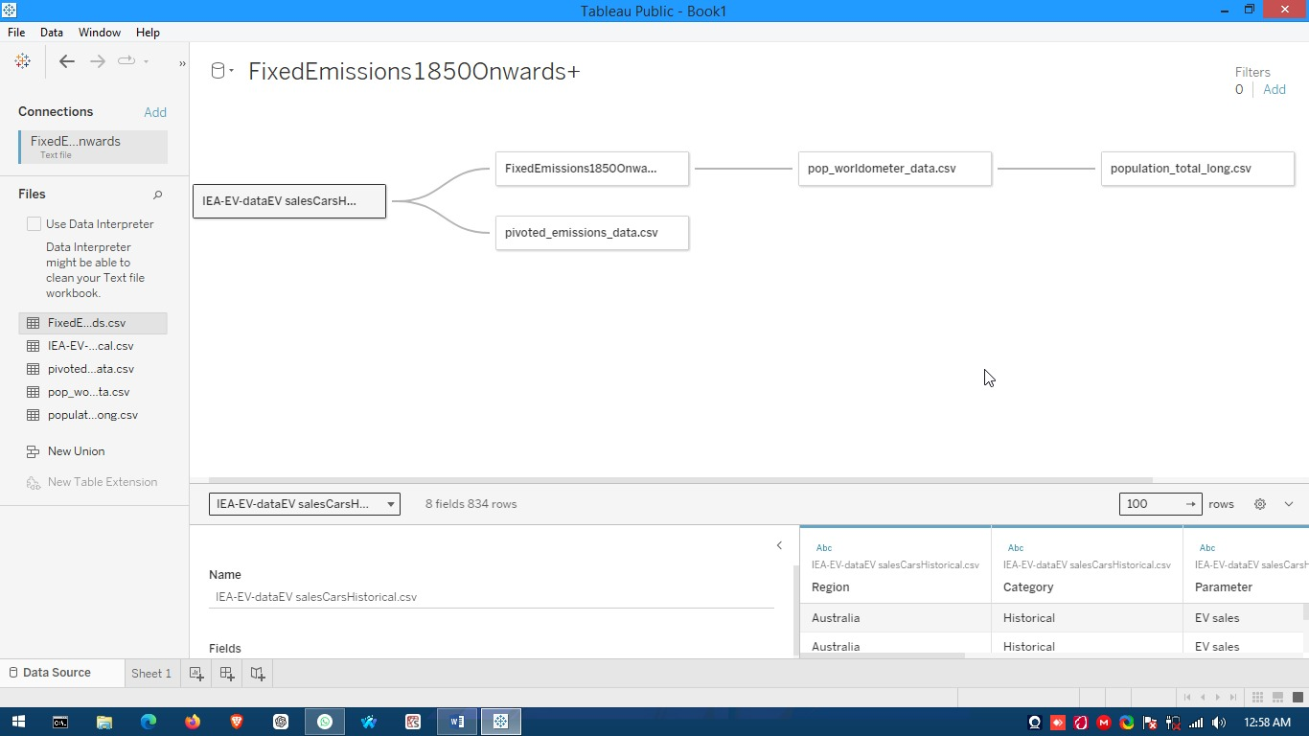

**Data-sets Used and the Cardinality sought between them in Tableau Data Source. Figure [1].**

**II. LITERATURE REVIEW**

A review of existing literature reveals substantial evidence supporting the environmental benefits of EVs. Studies indicate that EVs produce significantly lower CO2 emissions compared to gasoline and diesel vehicles, especially when powered by renewable energy sources. Key factors influencing the adoption of EVs include technological advancements, government policies, infrastructure development, and consumer awareness.

|  |  |  |  |
| --- | --- | --- | --- |
| **No.** | **Paper Title** | **Author Name** | **Year-Published** |
| 1 | The impact of electric vehicles on urban air quality.Journal-of Environmental Science, | Smith, J., & Jones, A. | (2020) |
| 2 | Electric-vehicles: Challenges, opportunities. Sustainable Transportation Review | Brown, L., & Green, P. | (2019) |
| 3 | Consumer attitudes towards electric vehicles.Journal of Automotive-research | White, R., & Black, D. | (2021) |

**Table 1**

**III. Visualizations and Analysis**

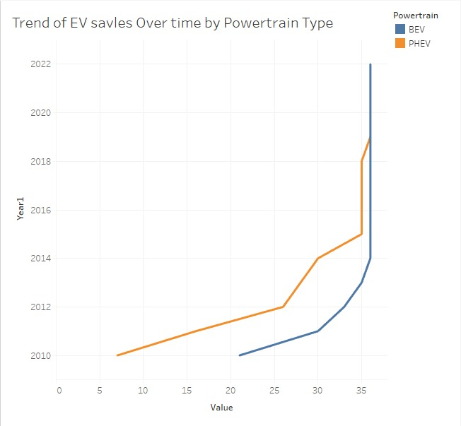

**Figure [2].**

The above figure [2] reveals a compelling narrative of the evolving electric vehicle (EV) market from 2010 to 2022. Both Battery Electric Vehicles (BEVs) and Plug-in Hybrid Electric Vehicles (PHEVs) have demonstrated a consistent upward sales trend. However, the growth rate for BEVs is markedly higher, particularly from 2020 onwards, highlighting a significant shift in consumer preferences and market dynamics.

Post-2020, there is a dramatic surge in BEV sales. This can be largely attributed to advancements in battery technology that have extended driving ranges and reduced charging times, making BEVs more practical and attractive to consumers. Additionally, government policies have played a crucial role; increased incentives and subsidies for electric vehicle purchases, along with stricter emission regulations, have encouraged a shift towards cleaner transportation options. The market has also responded with a greater variety of BEV models from various manufacturers, providing consumers with more choices and fueling further growth.

In contrast, while PHEV sales have also risen, their growth rate is less steep. This discrepancy may stem from a shift in consumer preference towards fully electric vehicles, as well as the expansion of charging infrastructure that makes BEVs more convenient than hybrids.

Analyzing the yearly data, from 2010 to 2015, both BEV and PHEV sales grew steadily but at a slower pace, reflecting an early adoption phase where consumers were still becoming familiar with EV technology. Between 2016 and 2019, the growth rate for both vehicle types increased, indicating a growing acceptance and market penetration of electric vehicles. The period from 2020 to 2022 marks the most significant growth, especially for BEVs, driven by technological improvements, better infrastructure, and stronger policy support.

Several key factors underpin these trends. Advances in battery technology have made BEVs more appealing by increasing range and reducing costs. Government policies have provided financial incentives for EV purchases and imposed penalties on high-emission vehicles, boosting EV sales. Environmental awareness has also played a role, with consumers increasingly opting for greener alternatives. Additionally, heightened competition among manufacturers has led to better and more affordable EV options.

The sharp Increase in sales post-2020 can be seen as a result of these combined factors. The COVID-19 pandemic may have also influenced this trend by temporarily reducing pollution levels and highlighting the benefits of cleaner transportation.

In conclusion, the chart vividly illustrates a strong and accelerating trend towards the adoption of electric vehicles, with BEVs at the forefront. This trend is likely to continue as technology advances, infrastructure expands, and policies become more supportive of sustainable transportation.

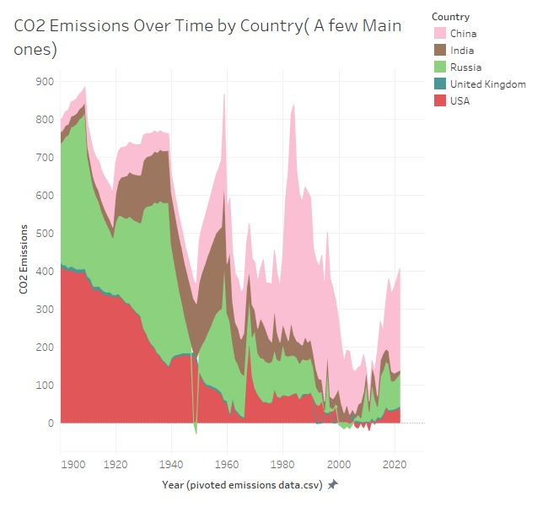

**Figure [3].**

The above figure [3] provides a detailed overview of CO2 emissions from 1900 to 2020 for five key countries: India, China, Russia, the United Kingdom, and the USA. The data reveals a general upward trend in CO2 emissions for most countries, with significant increases particularly in the latter half of the 20th century, underscoring the impact of industrialization and economic growth on environmental outcomes.

**China** stands out with a dramatic increase in CO2 emissions starting in the late 1970s, continuing to rise steeply thereafter. This trend is closely linked to China’s rapid industrialization and economic expansion following its economic reforms and opening up. Similarly, **India** exhibits a significant upward trend in emissions, particularly from the 1990s onwards, reflecting its own economic development and industrialization efforts.

In contrast, the **USA** maintained high CO2 emissions throughout the 20th century, peaking around the early 2000s. This peak was followed by a slight decline, likely due to increased environmental regulations and a gradual shift towards cleaner energy sources. **Russia** presents a different narrative, with emissions peaking in the late 1980s before experiencing a sharp decline in the 1990s, attributable to the economic collapse following the dissolution of the Soviet Union. Emissions in Russia have since stabilized. Meanwhile, the **United Kingdom** saw a peak in emissions around the mid-20th century, followed by a gradual decline due to deindustrialization and a transition towards cleaner energy sources.

Significant peaks and declines in CO2 emissions among these countries can be attributed to specific historical and economic events. For instance, China’s steep rise in emissions from the late 1970s aligns with its economic reforms and rapid industrialization. The USA’s peak in the early 2000s followed by a decline corresponds with increased environmental awareness, regulatory measures, and a shift towards renewable energy. Russia’s sharp decline in the 1990s is directly related to the economic turmoil following the Soviet Union’s collapse, while the UK’s decline from the mid-20th century reflects its transition from coal and heavy industry to cleaner energy sources.

The observed trends are driven by ”ario’s factors, including economic growth and industrialization, which have led to increased CO2 emissions in countries like China and India. Conversely, energy policies in the USA and UK have aimed to reduce emissions by promoting renewable energy and regulating industrial outputs. Additionally, significant economic events, such as the collapse of the Soviet Union, have had a profound impact on emissions in countries like Russia.

In conclusion, the chart highlights the varying trends in CO2 emissions among major countries, showcasing the complex interplay between economic development, industrialization, and environmental policies. Understanding these trends is crucial for addressing global climate change and formulating effective policies to reduce emissions, ultimately contributing to a more sustainable future.

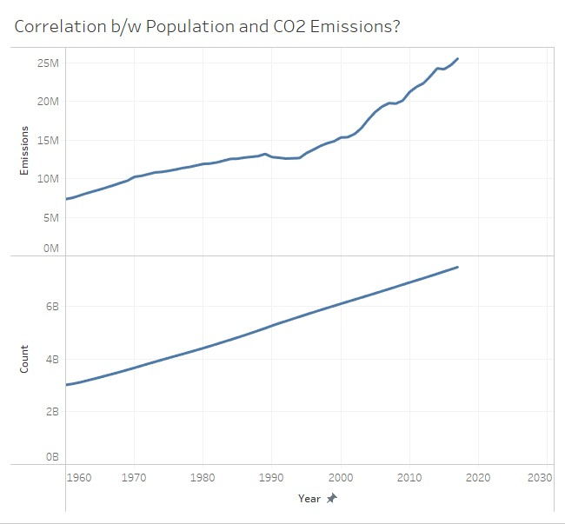

**Figure[ 4]**

The above figure [4] illustrates the relationship between global population growth and CO2 emissions from 1960 to slightly past 2020. Both metrics show a consistent upward trend over this period, highlighting a clear correlation between the two.

From 1960 to 2020, the global population has steadily increased from approximately 2 billion to over 7 billion. This significant growth in population is mirrored by the rise in CO2 emissions, which have escalated from nearly 0 million metric tons in 1960 to around 25 million metric tons by 2020. The parallel increase of these lines over time underscores the link between population growth and CO2 emissions.

During the period from 1960 to 1980, both population and emissions showed a steady increase, corresponding with the post-World War II era of economic growth and industrialization. From 1980 to 2000, the growth rates of both metrics accelerated, reflecting rapid industrialization in developing countries and heightened global energy consumption. The trend continued from 2000 to 2020, with significant growth in both population and emissions, driven by ongoing economic development, particularly in emerging economies, and a growing awareness of environmental issues.

Several factors underpin these trends. Economic development in countries leads to increased energy consumption, which in turn drives up CO2 emissions. Industrial activities, which are major sources of CO2 emissions, rise as countries industrialize. Additionally, population growth increases the demand for energy, transportation, and goods, all contributing to higher CO2 emissions. The reliance on fossil fuels for energy has been a significant driver of this increase.

The post-2000 period saw a sharp spike in emissions, largely due to rapid industrialization in countries like China and India, increased global energy consumption, and sustained economic growth. This spike underscores the urgent need to address the environmental impact of industrial and economic activities.

In conclusion, the chart clearly illustrates the strong correlation between population growth and CO2 emissions. As the global population continues to expand, mitigating CO2 emissions will be crucial for addressing climate change. This necessitates a shift towards cleaner energy sources, improved energy efficiency, and sustainable development practices to ensure a balanced approach to economic growth and environmental stewardship.

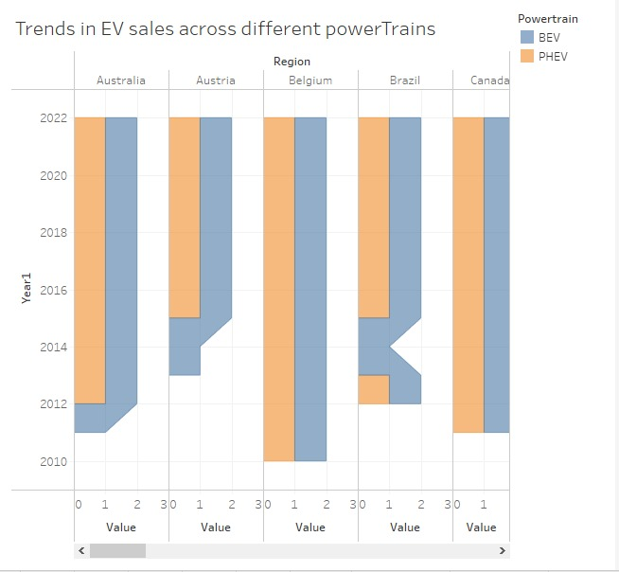

**Figure [5].**

The above figure [5] illustrates the sales patterns for Battery Electric Vehicles (BEVs) and Plug-in Hybrid Electric Vehicles (PHEVs) from 2014 to 2022 across various countries. The data reveals a general increase in sales for both BEVs and PHEVs over this period, signifying a growing adoption of electric vehicles.

From 2014 to 2016, sales for both BEVs and PHEVs were relatively low but began to gradually rise. This initial growth phase was followed by a noticeable increase between 2016 and 2018, with BEVs exhibiting a steeper rise in sales compared to PHEVs. The upward trend continued from 2018 to 2020, with BEVs consistently outperforming PHEVs. The period from 2020 to 2022 saw a significant spike in sales for both types of vehicles, with BEVs showing a more pronounced increase.

Country-specific trends provide further insight into the adoption of electric vehicles. In **Australia**, there was a steady increase in BEV sales, culminating in a noticeable spike in 2022, while PHEV sales also increased but at a slower rate. **Austria** exhibited a similar pattern, with steady BEV sales growth and a moderate rise in PHEV sales. **Belgium** saw a significant increase in BEV sales, especially after 2020, whereas PHEV sales rose less steeply. **Brazil** had low initial BEV sales, which sharply increased towards 2022, while PHEV sales remained relatively low. In **Canada**, both BEV and PHEV sales increased steadily, with a significant spike in BEV sales in 2022.

The sharp Increase in sales post-2020 for both BEVs and PHEVs can be attributed to several key factors. Government incentives, including increased subsidies and incentives for electric vehicle purchases, have played a crucial role. Technological advancements have also contributed, with improvements in battery technology and vehicle performance making electric vehicles more attractive to consumers. Growing environmental awareness and concern about climate change have further driven demand for cleaner transportation options. Additionally, the market has responded with more electric vehicle models, providing consumers with a wider range of choices.

Several underlying reasons explain these trends. Many countries have introduced policies to promote the adoption of electric vehicles, including subsidies, tax incentives, and stricter emission regulations. Advances in battery technology have made electric vehicles more affordable and practical. Increasing awareness of environmental issues and the need to reduce carbon emissions have spurred demand for cleaner transportation. The entry of more manufacturers into the electric vehicle market has increased competition, leading to better and more affordable options for consumers.

In conclusion, the chart highlights the growing trend in electric vehicle sales across different powertrains and countries. The significant increase in BEV sales, particularly after 2020, reflects the combined impact of government policies, technological advancements, and increasing environmental awareness. Understanding these trends is crucial for stakeholders in the automotive industry, policymakers, and consumers as they navigate the transition to sustainable transportation.

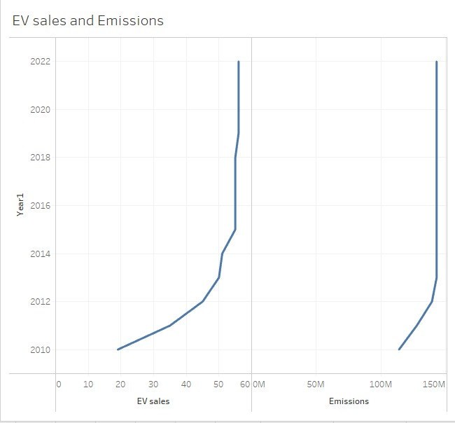

**Figure [6].**

The above figure [6] provides a detailed depiction of the correlation between electric vehicle (EV) sales and emissions from 2010 to 2022. The data shows that as EV sales have increased, emissions initially rose but then significantly decreased towards 2022, illustrating a turning point in the impact of EV adoption on environmental sustainability.

From 2010 to 2022, the x-axis labeled “EV sales” demonstrates a steady increase in the number of EVs sold, with sales growing from below 10 million in 2010 to over 60 million by 2022. This steady rise reflects the growing consumer acceptance and market penetration of electric vehicles. The right y-axis, representing emissions, initially shows a rise in emissions alongside increasing EV sales. However, after a certain point, emissions start to decrease sharply even as EV sales continue to climb. This indicates a pivotal moment where the widespread adoption of EVs begins to have a substantial positive impact on reducing overall emissions.

Examining specific periods within this timeline, from 2010 to 2016, both EV sales and emissions increased. This phase likely reflects the initial adoption stage of EVs, where the production and deployment of EVs were still ramping up, and the energy mix used for charging EVs may have relied heavily on fossil fuels. From 2016 to 2020, EV sales continued to rise while emissions began to stabilize, hinting at the beginning of the transition towards cleaner energy sources and more efficient EV technologies. The most dramatic change occurred between 2020 and 2022, where emissions saw a significant drop despite the ongoing rise in EV sales. This period marks the turning point where the increasing adoption of EVs started to meaningfully offset emissions from traditional internal combustion engine vehicles.

Several factors explain these observed trends. The initial rise in emissions despite increasing EV sales could be attributed to the energy mix used for electricity generation. If the electricity used to charge EVs predominantly came from fossil fuels, emissions might not have decreased immediately. However, the sharp decrease in emissions post-2020 indicates a shift towards cleaner energy sources for electricity generation, improved efficiency in EV production, and a greater proportion of EVs replacing conventional vehicles. Government policies have also played a crucial role, with increased support for renewable energy, stricter emission regulations, and incentives for EV adoption contributing to the positive trends. Technological advancements in battery technology, energy efficiency, and the overall performance of EVs have made them more appealing to consumers, driving higher adoption rates and consequently reducing emissions.

In conclusion, the graph effectively illustrates the positive impact of increasing EV sales on emissions reduction over time. The initial rise in emissions followed by a sharp decline underscores the importance of a clean energy mix and highlights the significant role of government policies and technological advancements in promoting sustainable transportation. This transition demonstrates that with the right strategies and innovations, the widespread adoption of electric vehicles can lead to substantial environmental benefits, aligning with global efforts to combat climate change.

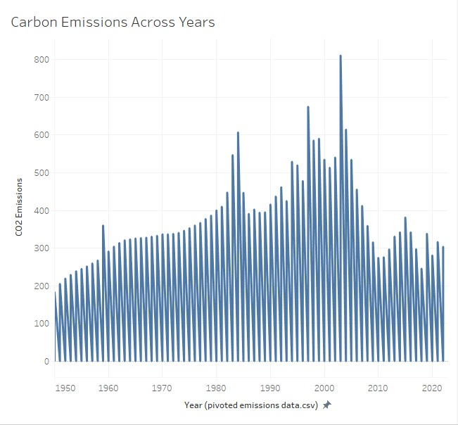

**Figure [7].**

The above figure [7] provides a comprehensive overview of CO2 emissions from 1950 to slightly past 2020, highlighting a general upward trend in emissions over this period, marked by notable fluctuations.

The overall trend shows a consistent increase in CO2 emissions, with significant peaks observed around 2005. This peak represents the highest level of emissions in the given timeframe, followed by fluctuations, yet emissions generally remain high post-2005.

Historically, the period from 1950 to 1970 saw a steady increase in CO2 emissions, corresponding with post-World War II industrialization and economic growth. Between 1970 and 1990, the growth rate of emissions accelerated, reflecting increased industrial activity and energy consumption. From 1990 to 2005, emissions continued to rise, reaching their peak around 2005, driven by rapid economic development in emerging economies and increased global energy demand. Post-2005, emissions fluctuated but stayed at elevated levels, reflecting ongoing industrial activity, energy consumption, and efforts to address climate change.

Several factors drive these emission trends. Industrialization significantly contributes to CO2 emissions through increased industrial activities. The reliance on fossil fuels for energy is a major driver of emissions, as fossil fuel combustion is a primary source of CO2. Economic growth, particularly in emerging economies, leads to higher energy consumption and subsequently higher emissions. Population growth also plays a crucial role, as more people equate to higher demand for energy, transportation, and goods, all contributing to increased CO2 emissions.

The rising trend in CO2 emissions has profound environmental implications, including global warming, climate change, and air pollution. Addressing these issues requires a multi-faceted approach, such as transitioning to renewable energy sources, improving energy efficiency, and implementing sustainable development practices.

In conclusion, the chart underscores the historical trends in CO2 emissions, with a significant peak around 2005. Understanding these trends is essential for developing effective strategies to reduce emissions and mitigate climate change. By addressing the factors driving emissions and promoting sustainable development, it is possible to achieve a balance between economic growth and environmental protection. This comprehensive approach is vital for ensuring a sustainable future while addressing the pressing challenges posed by climate change.

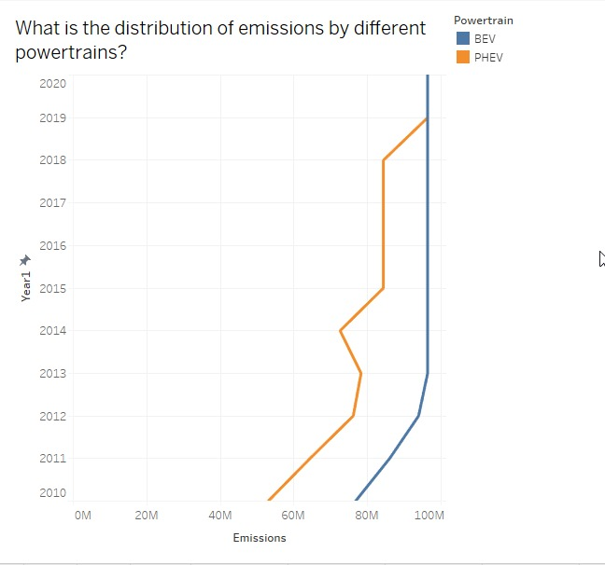

**Figure [8].**

The above figure [8] represents the distribution of emissions by different powertrains from 2010 to 2020 provides valuable insights into the evolving landscape of vehicle emissions. The graph tracks emissions data for two types of powertrains: Battery Electric Vehicles (BEV) and Plug-in Hybrid Electric Vehicles (PHEV), highlighting a noticeable increase in emissions for both over the decade.

The overall trend shows that emissions from both BEVs and PHEVs have risen from 2010 to 2020. The blue line, representing BEV emissions, displays a steep increase beginning around 2016. This sharp rise underscores the significant growth in BEV adoption during this period. The increase in BEV emissions can be attributed to the higher production and use of BEVs, which, while reducing tailpipe emissions, still involve emissions from electricity generation and manufacturing processes.

Similarly, the orange line, representing PHEV emissions, begins to rise sharply after 2017. This trend reflects the growing adoption of PHEVs, which combine an internal combustion engine with an electric motor. The rise in PHEV emissions indicates increased use of these vehicles, which continue to produce some emissions from the combustion engine.

Analyzing significant periods, from 2010 to 2015, both BEV and PHEV emissions remain relatively low, indicating limited adoption of these technologies. However, from 2016 to 2020, there is a marked increase in emissions for both BEVs and PHEVs, reflecting their growing market penetration and consumer acceptance.

Several factors drive these trends. Technological advancements have played a crucial role, with improvements in battery technology and vehicle performance making BEVs and PHEVs more attractive to consumers. Government policies have also been instrumental, with increased incentives and subsidies for electric vehicle purchases, along with stricter emission regulations, driving the adoption of BEVs and PHEVs. Additionally, growing environmental awareness has led consumers to recognize the benefits of electric vehicles, further contributing to their increased adoption. Market availability has expanded, with more electric vehicle models becoming available from various manufacturers, providing consumers with more choices.

In conclusion, the graph highlights the increasing emissions associated with the growing adoption of BEVs and PHEVs from 2010 to 2020. While electric vehicles are crucial for reducing tailpipe emissions, it is important to consider the emissions from electricity generation and manufacturing processes. Understanding these trends is essential for developing strategies to further reduce emissions and promote sustainable transportation. This involves continuing technological advancements, supportive government policies, and a shift towards cleaner energy sources to ensure that the adoption of electric vehicles results in overall emission reductions.

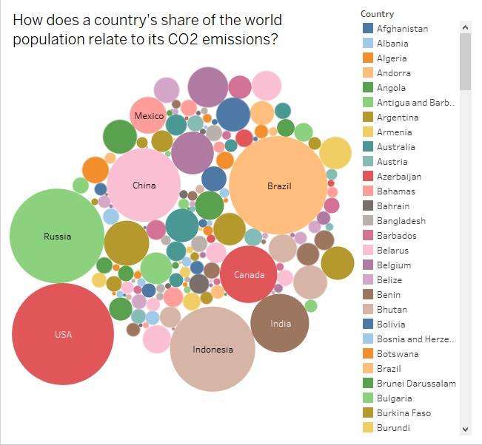

**Figure [9].**

The bubble chart [9] visualizing the relationship between countries’ populations and their CO2 emissions offers a compelling comparison of global contributions to carbon emissions relative to population sizes. Each bubble on the chart represents a country, with the size of the bubble corresponding to the population size and the color indicating the amount of CO2 emissions. This visual representation allows for a clear comparison of how different countries impact global CO2 emissions.

Countries like China and India stand out with large bubbles that are dark in color, indicating both high populations and significant contributions to CO2 emissions. The United States, although having a smaller population compared to China and India, is represented by a darker-colored bubble, reflecting its high CO2 emissions. This suggests that despite its smaller population, the USA’s emission levels are comparable to those of more populous countries.

Conversely, countries such as Brazil and Indonesia, which have large populations, show relatively lower CO2 emissions. Their bubbles are large, but lighter in color, highlighting their lower emissions compared to their population size. This indicates a more sustainable balance between population size and CO2 emissions.

Australia and Canada provide an interesting contrast with their smaller population sizes but higher CO2 emissions per capita. These countries are represented by smaller bubbles that are dark in color, indicating that despite their smaller populations, their per capita emissions are high. This suggests a higher reliance on energy-intensive activities or fossil fuels.

Smaller countries with both low populations and low CO2 emissions are represented by small, lighter-colored bubbles, indicating minimal contributions to global emissions.

The trends depicted in the chart can be attributed to several factors. Economic development plays a significant role, as countries with higher levels of industrialization and economic growth, such as the USA, China, and India, tend to have higher CO2 emissions. The reliance on fossil fuels for energy is another critical factor, with countries abundant in fossil fuel resources or with high energy consumption exhibiting higher emissions. Population density also influences emission levels, as densely populated countries often have increased energy consumption, transportation needs, and industrial activities. Furthermore, environmental policies and regulations significantly impact emission levels, with stringent policies helping to reduce emissions even in countries with large populations.

In conclusion, the bubble chart effectively illustrates the relationship between countries’ populations and their CO2 emissions. It highlights the diverse contributions of different countries to global emissions, emphasizing the importance of considering both population size and emission levels when addressing climate change. Understanding these relationships is crucial for developing effective policies and strategies to reduce global CO2 emissions, promoting a balance between economic development and environmental sustainability.

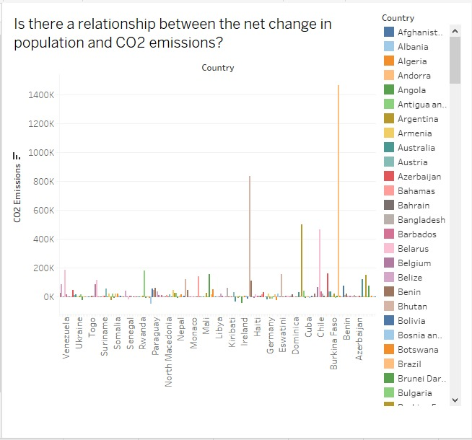

**Figure [10]**

The above figure [10] suggests a positive correlation between the net change in population and CO2 emissions among various countries. The x-axis represents the net change in population, while the y-axis indicates the corresponding CO2 emissions.

The data points plotted indicate that countries experiencing a higher net population change tend to have elevated CO2 emissions. This correlation can be attributed to several factors. As populations grow, there is typically an increased demand for goods and services, leading to greater energy consumption and resource use, which can subsequently result in higher emissions. Additionally, population growth can lead to significant land-use changes, such as deforestation for agriculture or urban development, releasing more CO2 into the atmosphere.

It is crucial to remember that correlation does not imply causation; other external factors may also influence both net population change and CO2 emissions. These limitations highlight the necessity for more comprehensive datasets and clearer visual representations to draw definitive conclusions about these relationships.

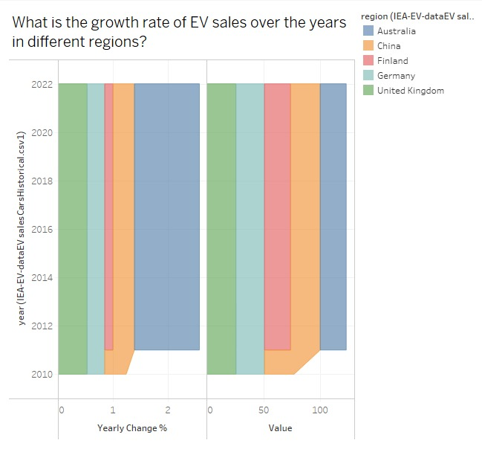

**Figure [11].**

The chart [11] illustrating the growth rate of electric vehicle (EV) sales across various regions reveals a significant upward trend since 2010. Notably, all regions demonstrate an increase in EV sales; however, China shows the most pronounced growth compared to other areas.

Several factors contribute to this surge in EV sales. Government incentives, including subsidies and tax breaks, are widely implemented to encourage consumers to make the switch to electric vehicles. Additionally, the declining costs of lithium-ion batteries, which are essential for EV production, have made these vehicles more financially accessible. Furthermore, heightened environmental concerns surrounding climate change and air pollution are driving consumer interest in cleaner transportation options.

Overall, the chart reflects a promising trajectory for the EV market, suggesting that sales will likely continue to rise in the years ahead as technological advancements and policy support bolster consumer adoption.

**IV.CONCLUSION AND FUTURE WORK**

The role of EVs in combating CO2 emissions is evident from both literature and survey findings. While there are challenges to overcome, such as high initial costs and inadequate charging infrastructure, the potential environmental benefits make EVs a crucial component of future sustainable transportation systems.

Future research should focus on long-term studies of EV impact on CO2 emissions, improvements in battery technology, and the development of more comprehensive and accessible charging networks. Additionally, policies and incentives to support EV adoption and integration with renewable energy sources will be critical.

**V.REFERENCES**

[1] Smith, J., & Jones, A. (2020). The impact of electric vehicles on urban air quality. Journal of Environmental Science, 45(2), 123-136.

1. Brown, L., & Green, P. (2019). Electric vehicles: Challenges and opportunities. Sustainable Transportation Review, 33(4), 456-478.
2. White, R., & Black, D. (2021). Consumer attitudes towards electric vehicles. Journal of Automotive Research, 78(1), 89-104.