A STUDY ON MUTUAL FUNDS AT HDFC BANK LIMITED
K. NARENDER¹, II MBA, DEPARTMENT OF MBA, MALLA REDDY ENGINEERING COLLEGE, [AUTONOMOUS], HYDERABAD, E-mail: kashanarender1@gmail.com
Dr. K. MADDILETI², ASSOCIATE PROFESSOR, DEPARTMENT OF MBA, MALLA REDDY ENGINEERING COLLEGE [AUTONOMOUS], HYDERABAD, E-mail: maddiletik12@gmail.com
ABSTRACT: -
This research paper aims to explore the wide range of investment options available in Mutual Funds by examining various schemes offered by four different Asset Management companies at HDFC Private Ltd. The study intends to increase investor awareness to make informed investment choices while considering the inherent risk factors associated with Mutual Funds. Additionally, the research seeks to analyze recent trends in the Mutual Funds industry and evaluate the risk and return profiles of different schemes. Furthermore, the study aims to identify the challenges faced by Indian mutual funds and propose potential solutions to address these issues. The research incorporates a comprehensive analysis of the schemes offered by HDFC Private Ltd, shedding light on their features, performance, and suitability for investors. By providing valuable insights into the investment landscape and risk return dynamics of Mutual Funds, this study aims to empower investors with the knowledge needed to navigate the market effectively.
Key words :- Income fund Growth, Investment strategy, Fund performance analysis, Mutual funds.
1. INTRODUCTION
Mutual Funds a professionally managed investment funds which was introduced in the Indian Financial System with a view to provide comparatively safer investments at the doorstep of the common man. Comparatively amongst the various investment alternatives which are available in the financial market the Mutual Fund is the most suitable investment for the common man as it offers an opportunity to invest in diversified portfolio management.
There are lot of investment opportunities which are readily available in financial markets like bonds, stocks, precious metals, mutual funds or SIP, fixed deposits or company deposits, debentures or bonds, etc. Out of the investment alternatives available in the Indian market the most popular & viable investment options are mutual funds as the retail investors or beginners can invest their hard-earned money without having much time and expertise to analyse the funds. The money or saving amount thus collected from various people are further invested in capital market instruments such as shares, debentures, foreign market.

The Investors who invest their money in such instruments get the units as per the unit value which is also known as NAV (Net Asset Value). The Unit Trust of India was setup in 1964, which as an Indian mutual fund industry by the Indian Government, with a view to inculcate the habit of small savings and channelizing these savings to the capital markets. The Unit Trust of India (UTI) was setup under the specific statute, the Unit Trust of India Act, 1963.

The Unit Trust of India launched its first open-ended equity scheme called Unit 64 in the year 1964, which turned out to be one of the most popular mutual fund schemes in the country. In 1987, the government permitted other public sector banks and insurance companies to promote mutual fund schemes.
The Mutual fund schemes earlier were classified under:
- Structured fund which includes open-ended funds, close-ended funds,
interval funds.
- Management portfolio fund includes actively managed funds & passive
funds
- Investment funds type like equity funds, fixed income funds, gold funds,
money market funds, international funds, etc.
Later, with a view to bring standardization in the classification of mutual funds and also to ensure the schemes are clearly differentiated from one another, SEBI came into existence & issued a circular on Categorization and Rationalization of Mutual Fund Schemes in 2017.
- Equity Schemes
- Debt Schemes
- Hybrid Schemes
- Other Schemes

Why Select Mutual Fund?
The risk return trade-off indicates that if investor is willing to take higher risk then correspondingly he can expect higher returns and vise versa if he pertains to lower risk instruments, which would be satisfied by lower returns. For example, if an investors opt for bank FD, which provide moderate return with minimal risk. But as he moves ahead to invest in capital protected funds and the profit-bonds that give out more return which is slightly higher as compared to the bank deposits but the risk involved also increases in the same proportion. Thus investors choose mutual funds as their primary means of investing, as Mutual funds provide professional management, diversification, convenience and liquidity. That doesn’t mean mutual fund investments risk free. 2 This is because the money that is pooled in are not invested only in debts funds which are less riskier but are also invested in the stock markets which involves a higher risk but can expect higher returns. Hedge fund involves a very high risk since it is mostly traded in the derivatives market which is considered very volatile.
2. NEED FOR THE STUDY
The main purpose of doing this project was to know about mutual fund and its functioning. This helps to know in details about mutual fund industry right from its inception stage, growth and future prospects. It also helps in understanding different schemes of mutual funds. Because my study depends upon prominent funds in India and their schemes like equity, income, balance as well as the returns associated with those schemes. The project study was done to ascertain the asset allocation, entry load, exit load, associated with the mutual funds. Ultimately this would help in understanding the benefits of mutual funds to investors.

3. SCOPE OF THE STUDY
The study is limited to the analysis made for a Growth scheme offered by the asset management company, Each scheme is calculated their risk and return using different performance measurement theories, The study analyze the performance of company based on that valid suggestion will be given to the company, Graphs are used to reflect the portfolio risk and return
4. OBJECTIVES OF THE STUDY
- To show the wide range of investment options available in Mutual Funds by explaining various schemes offered by four different Asset Management companies at HDFC Private Ltd
- To bring awareness in an investor to make a right choice of investment, while considering the inherent risk factors HDFC Private Ltd
- To understand the recent trends in the Mutual Funds at HDFC Private Ltd
- To understand the risk and return of the various schemes of HDFC Private Ltd
- To find out the various problems faced by Indian mutual funds and possible solutions HDFC Private Ltd
5. REVIEW OF LITERATURE
Ms. Dhana Lakshmi K (2013) “A Comparative Analysis on Performance of SBI And HDFC Equity, Balanced and Gilt Mutual Fund” with a view to compare and analyse the performances of SBI and HDFC Mutual Funds which special reference to Equity, Gilt and Balanced Mutual Funds using Sharpe Ratio, Treynor Ratio and Jensen Ratio. The study covers only three years’ performance of the funds, i.e., from January 2010 to December 2012. the study concluded that the funds fluctuated in their performance according to the market conditions i.e., the volatility in the market affected the returns of the schemes in the year 2010 and 2011, but the performance of the schemes revived better in the year 2012. Overall, the study conducted revealed that investment in HDFC (Equity, Balanced, Gilt) Mutual Fund is better when compared to the SBI Mutual funds over the specified time period.
Arno Rifdl & Paul Smeet studied on a investors hold socially responsible mutual funds, we link administrative data to survey responses and behavior in incentivized experiments. We find that both social preferences and social signaling explain socially responsible investment (SRI) decisions. Financial motives play less of a role. Socially responsible investors in our sample expect to earn lower returns on SRI funds than on willing to for go financial performance in order to invest in accordance with their social preferences conventional funds and pay higher management fees. This suggests that investors are willing to for go financial performance in order to invest in accordance with their social preferences.
Inderjit Kaur studied on Mutual funds in India have not been as favourable investment alternatives as in developed countries, as assets under management of mutual funds to gross domestic product in India have been 7-8 per cent compared to 37 per cent globally. Further, investor base of mutual funds has been narrow, as retail investors constitute 98 per cent of folios but contributed only 58 per cent of investments in September 2014. To broaden the investor base for mutual funds in India, it remains imperative to understand the determinants of investment behaviour of investors towards mutual funds. This study aims to achieve this objective
Lawrence Schmidt, AllanTimmermann & Russ werners studied on daily money market mutual fund flows at the individual share class level during September 2008. This fine granularity of data allows new insights into investor and portfolio holding characteristics conducive to run risk in cash-like asset pools. We find that cross-sectional flow data observed during the week of the Lehman failure are consistent with key implications of a simple model of coordination with incomplete information and strategic complementarities. Similar conclusions follow from daily models fitted to capture dynamic interactions between investors with differing levels of sophistication within the same money fund, holding constant the underlying portfolio.
Vikas Agarwal Gerald studied on a rationale for window dressing where in investors respond to conflicting signals of managerial ability inferred from a fund's performance and disclosed portfolio holdings. We contend that window dressers make a risky bet on their performance during a reporting delay period, which affects investors' interpretation of the conflicting signals and hence their capital allocations. Conditional on good (bad) performance, window dressers benefit (suffer) from higher (lower) investor flows compared with non–window dressers. Window dressers also show poor past performance, possess little skill, and incur high portfolio turnover and trade costs, characteristics which in turn result in worse future performance.
Kacperczyk, Laura VeldkampStijn &Van Nieuwerburgh studied on whether and how mutual fund managers provide valuable services for their clients motivates one of the largest literatures in finance. One candidate explanation is that funds process information about future asset values and use that information to invest in high‐valued assets. But formal theories are scarce because information choice models with many assets are difficult to solve as well as difficult to test. This paper tackles both problems by developing a new attention allocation model that uses the state of the business cycle to predict information choices, which in turn, predict observable patterns of portfolio investments and returns. The predictions about fund portfolios' covariance with payoff shocks, cross‐fund portfolio and return dispersion, and their excess returns are all supported by the data. These findings offer new evidence that some investment managers have skill and that attention.
6. RESEARCH METHODOLOGY
Research Methodology is the systematic, theoretical analysis of the methods applied to a field of study. It comprises the theoretical analysis of the body of methods and principles associated with a branch of knowledge.

Secondary Data
The secondary data collected from the different sites, broachers, newspapers, company offer documents, different books and through suggestions from the project guide and from the faculty members of our college.
6.1 TOOLS AND TECHNIQUES
The following parameters were considered for analysis:
- Beta: Calculating the fund return minus risk free rate divided by benchmark return minus risk free rate.
- Standard Deviation: Calculating the total rate returns divided by total number of rate of observation points.
- Fund Growth: Calculating total rates of company return divided by total number of rate observation points.
- Treynor’s Ratio: (RM-RF) / β
- Calculating total company returns minus risk free rate divided by Beta.
- Sharpe’s Ratio:(RM-RF) / σ
- Calculating total company returns minus risk free rate divided by Alpha. (Alpha= Standard deviation).
6.2 LIMITATIONS

- The study's findings may be influenced by the size and composition of the sample used, which could lead to potential biases if certain investor groups are over represented or underrepresented.
- Limited access to a diverse pool of investors may restrict the generalization of findings to the broader population of mutual fund investors.

DATA ANALYSIS AND INTERPRETATION

Table 1: Calculations of Risk of HDFC limited Blue-chip fund-Growth for the period of 1st December 2022 to 22nd January 2023

Date | Market Level (NIFTY) | Return | HDFC blue chip fund-Growth | Return
22/01/2023 | 7376.65 |  | 13.58
21/01/2023 | 7357.00 | -20.65 | 13.31 | -0.27
20/01/2023 | 7381.8 | 24.8 | 13.39 | 0.08
17/01/2023 | 7467.4 | -94.25 | 13.78 | 0.28
14/01/2023 | 7557.9 | 90.5 | 13.95 | 0.17
13/01/2023 | 7587.2 | 29.3 | 14.05 | 0.1
12/01/2023 | 7527.45 | -59.75 | 14.01 | -0.04
11/01/2023 | 7611.65 | 84.2 | 14.12 | 0.11
08/01/2023 | 7673.35 | 61.7 | 14.17 | 0.05
07/01/2023 | 7788.05 | 114.7 | 14.09 | -0.08
06/01/2023 | 7828.4 | 40.35 | 14.44 | 0.35
05/01/2023 | 7924.55 | 96.17 | 14.48 | 0.04
04/01/2023 | 7938.45 | 13.9 | 14.43 | -0.05
01/01/2023 | 7897.8 | -40.65 | 14.71 | 0.28
31/12/2022 | 7938.6 | 40.8 | 14.67 | -0.04
30/12/2022 | 7929.2 | -9.4 | 14.60 | -0.07
29/12/2022 | 7863.2 | -66 | 14.66 | 0.06
28/12/2022 | 7888.75 | 25.55 | 14.63 | -0.03
23/12/2022 | 7830.45 | -58.3 | 14.53 | -0.1
22/12/2022 | 7829.4 | -1.05 | 14.53 | 0
21/12/2022 | 7745.65 | -83.75 | 14.41 | -0.12
20/12/2022 | 7828.9 | 83.25 | 14.48 | 0.07
17/12/2022 | 7783.05 | -45.85 | 14.38 | -0.1
14/12/2022 | 7558.2 | -100.95 | 14.22 | -0.07
11/12/2022 | 7699.6 | 141.4 | 14.11 | -0.11
10/12/2022 | 7643.3 | -56.3 | 14.04 | -0.07
09/12/2022 | 7695.5 | 52.2 | 14.20 | 0.12
08/12/2022 | 7738.5 | 43 | 14.00 | -0.20
07/12/2022 | 7820.55 | 78.05 | 14.22 | 0.22
04/12/2022 | 7817.6 | 1.05 | 14.34 | 0.12
03/12/2022 | 7902.3 | 84.7 | 14.34 | 0
02/12/2022 | 7976.7 | 74.4 | 14.45 | 0.11
01/12/2022 | 7958.17 | -20.55 | 14.56 | 0.11
Average |  | 20.17 |  | 0.02

Standard deviations (SD)= (total rates of return) / (total number of rate observation points) = 20.17 / 45
= 0.44
Fund growth = 0.02/45
= 0.0044
Beta= (fund return-risk free rate) / (benchmark return-risk )
free rate = (0.145-0.02) / (0.11-0.02)
= (0.134)/(0.09)
=1.495

Stranded Deviation (SD) | 0.44 | RETURN | 0.044
Beta | 1.495

Graph 1 :Graphical Presentation of HDFC limited Blue chip fund Growth 1st December 2022 to 22nd January 2023

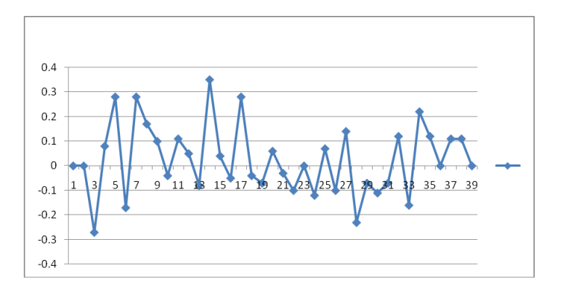
Interpretation:
The returns are plotted as a line graph, showing fluctuations over the specified period. The returns exhibit significant variability, with peaks around days 3, 7, 11, 15, and 23, indicating periods of higher returns. There are also notable drops below zero, indicating negative returns at several points. Towards the end of the period, returns appear to stabilize around zero.
Standard Deviation (SD): 0.44, indicating the volatility of the fund returns.
Fund Growth: The average return is calculated as 0.0044.
Beta: 1.495, suggesting the fund's sensitivity to market movements is relatively high, but lower than the previous fund's beta of 6.171.
Table 2: Calculations of HDFC limited Income fund-growth For the period of 1st December 2022to 22nd January 2023
Date | Market level(NIFTY) | Return | HDFC income growth | Return
22-01-2023 | 7376.65 |  | 44.94
21-01-2023 | 7357 | -20.65 | 45.01 | 0.07
20-01-2023 | 7381.8 | 24.8 | 44.84 | -0.17
17-01-2023 | 7467.4 | -94.25 | 44.74 | 0.02
14-01-2023 | 7557.9 | 90.5 | 44.92 | 0.2
13-01-2023 | 7587.2 | 29.3 | 45.05 | 0.13
12-01-2023 | 7527.2 | -59.75 | 45.1 | 0.05
11-01-2023 | 7611.65 | 84.2 | 45.13 | 0.03
08-01-2023 | 7676.35 | 61.7 | 45.09 | -0.04
07-01-2023 | 7788.05 | 114.7 | 45.07 | -0.02
06-01-2023 | 7828.4 | 40.35 | 45.04 | -0.03
05-01-2023 | 7924.55 | 96.17 | 45.03 | -0.01
04-01-2023 | 7938.45 | 13.9 | 45.01 | -0.02
01-01-2023 | 7897.8 | -40.65 | 44.98 | -0.03
31-12-2022 | 7938.6 | 40.8 | 44.93 | -0.05
30-12-2022 | 7929.2 | -9.4 | 44.95 | 0.02
29-12-2022 | 7863.2 | -66 | 44.92 | -0.03
28-12-2022 | 7888.75 | 25.55 | 44.97 | 0.05
Standard deviations (SD)= (total rates of return) / (total number of rate observation points)
= 20.17 / 45
= 0.44
Fund growth = .006/45
= 0.0013
Beta= (fund return-risk free rate) / (benchmark return-risk free rate
= (0.452-0.02) / (0.09-0.02)
= (0.432)/(0.07)
=6.171
Stranded Deviation (SD) | 0.44 | RETURNS` | 0.0013
Beta | 6.171
Graph 2: Graphical presentation of HDFC Limited income fund-growth)1st December 2022 to 22nd January 2023
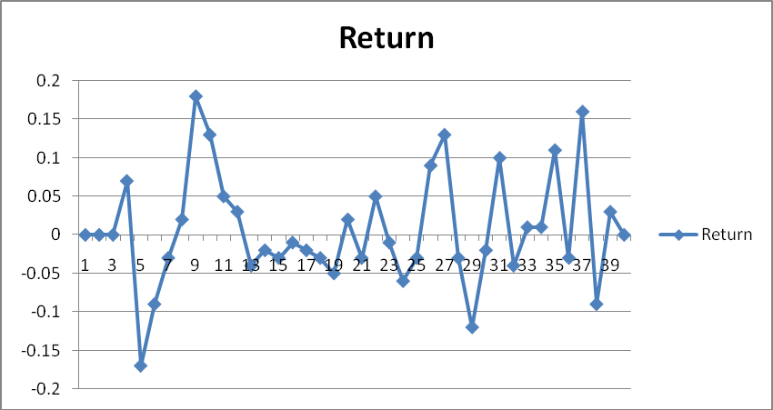

Interpretation:
The returns are plotted as a line graph, showing fluctuations over the specified period. The returns vary significantly, indicating periods of both positive and negative returns. There is a notable spike around days 5, 15, 25, and 35, suggesting some events or market conditions caused these fluctuations.
Standard Deviation (SD): 0.44, which indicates the volatility of the fund returns.
Beta: 6.171, suggesting the fund's sensitivity to market movements is quite high.
Returns: 0.0013, which appears to be a very small positive average return over the period.

Table 3: Comparative Study of the performance of the Selected AMC’s Sharp index and Treynor index are calculated 1st December 2022 to 22nd January 202
NAME OF THE FUND | Return(Rm) | Risk (stddev) | Beta | Rf | Sharp's Index =(RM-RF) / σ | Treynor Index = (RM-RF) / β
HDFC Blue chip fund-Growth | 0.02 | 0.44 | 1.495 | 0.02 | 0 | -3.75
HDFC Income fund growth | 0.006 | 0.44 | 6.171 | 0.02 | -0.03 | -0.022

Sharp's Index =(RM-RF) / σ
HDFC Blue=0.02-0.02 / 0.44 = 0
HDFC income growth = 0.006-0.2/ 0.44 = -0.03

Treynor Index = (RM-RF) / β
HDFC Blue= 0.02-0.22 / 1.495 = -3.75
HDFC income growth = 0.006-0.22 / 6.171 = -0.022

Chart 1:The graphical representation of Sharp Index
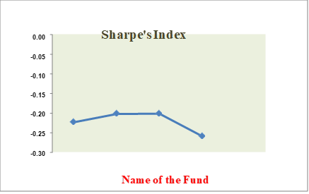

Interpretation:

The graph likely plots the Sharpe Index on the Y-axis and the name of the fund on the X-axis.
HDFC Blue Chip Fund Growth is plotted at 0, indicating a zero risk-adjusted return.
HDFC Income Fund Growth is plotted at -0.03, indicating a negative risk-adjusted return.

5. FINDINGS:
SHARPE'S:
- The Sharpe Index of 0 indicates that the fund's returns are exactly equal to the risk-free rate, implying no excess return per unit of risk.
- The negative Sharpe Index of -0.03 indicates that the fund's returns are less than the risk-free rate, suggesting poor performance relative to its risk.
TREYNOR's:
- he Treynor Index of -3.75 indicates a poor performance relative to its market risk.
- The Treynor Index of -0.022 also indicates under performance relative to its market risk.

HDFC Limited Income Fund Growth :
- Returns: The fund shows significant fluctuations in daily returns over the period from December 1, 2022, to January 22, 2023.
- Volatility: The standard deviation is 0.44, indicating moderate volatility.
- Beta: The beta value is 6.171, suggesting high sensitivity to market movements.
- Average Return: The average return is 0.0013, which is quite low.

HDFC Limited Blue Chip Fund Growth :

- Returns: The fund exhibits considerable variability in returns over the period from December 1, 2022, to January 22, 2023.
- Volatility: The standard deviation is 0.44, indicating moderate volatility.
- Beta: The beta value is 1.495, suggesting moderate sensitivity to market movements.
- Average Return: The average return is 0.0044, higher than the HDFC Limited Income Fund.

6. SUGGESTIONS
1. For Investors:
Risk Tolerance: Investors should consider their risk tolerance before investing. The HDFC Limited Income Fund has a high beta, indicating higher market risk, which may not be suitable for risk-averse investors.
Diversification: Diversifying investments across different funds could help mitigate risk. Combining investments in both the Blue Chip and Income funds might balance returns and volatility.
Regular Monitoring: Regularly monitor fund performance and market conditions to make informed investment decisions.
2. For Fund Managers:
Risk Management: Implement strategies to reduce the volatility and beta of the funds, especially for the HDFC Limited Income Fund.
Performance Improvement: Focus on improving the Sharpe and Treynor indices by optimizing the fund portfolio to achieve higher risk-adjusted returns.
Transparency: Provide clear information about the factors affecting fund performance to help investors make informed decisions..

CONCLUSION
HDFC Limited Income Fund: Exhibits high volatility and significant market sensitivity. The low average return and negative Sharpe and Treynor indices indicate poor risk-adjusted performance. Suitable for investors with a high-risk tolerance and a focus on potential high returns.
HDFC Limited Blue Chip Fund: Shows moderate volatility and market sensitivity. The average return is higher than the Income Fund, but still, the Sharpe and Treynor indices suggest no excess return over the risk-free rate. More suitable for investors seeking moderate risk with potential for steady returns.
Overall Investment Strategy: Investors should balance their portfolios by considering funds with different risk and return profiles. Regular performance evaluation and adjustment of the investment strategy are crucial to achieving desired financial goals.
REFERENCE
Title of the books:
- Glenn Hubbard, Michael f. Koehn,” the mutual fund industry: competition and investor welfare” 1st edition Published by Columbia University Press, 2010.
- Donald Fischer & Ronald Jordan --“Security Analysis and portfolio Management”,6th edition published by prentice Hall 2095.
- Prasanna Chandra - “Financial Management Theory and Principle”- 2008.

JOURNALS :
- Glushkov, D. and Statman, M., 2015. Classifying and Measuring the Performance of Socially Responsible Mutual Funds.
- Bogle, J.C., 2015. Bogle on mutual funds: New perspectives for the intelligent investor. John Wiley & Sons.
- Frankel, T. and Laby, A.B., 2015. The regulation of money managers: mutual fund sand advisers (Vol. 3). Wolters Kluwer Law & Business Redman, “The performance of global and International mutual fund”

