CONSTRUCTION TECHNIQUE OF RAILWAY UNDER BRIDGE BY BOX PUSHING METHOD AT KATNI – SINGRAULI SECTION LC-1 KM 1089 (MADHYA PRADESH): A CASE STUDY
MAYANK RASHMI KANT GAUR¹, Prof. HIRENDRA PRATAP SINGH², Prof. RAKESH SAKALE³
PG Student1, Prof.2, Prof.3
School of Research & Technology, People’s University Bhopal (M.P.)

ABSTRACT
Bhopal-Vidisha road is a segment of SH-18 situated on northern part of Madhya Pradesh State having existing total length of 36.15 km and proposed length is 36.15. The Project Road for maintenance, widening and upgrading of existing road starts from Bhanpura Junction at Km 3+400 near Bhopal and terminates at Km 39+600 at Sanchi-Salamatpur junction. The Project road passes through two district of Madhya Pradesh namely, Bhopal and Raisen. The end point of project road is at existing km. 39+600 near Sanchi town with three arm junction on SH-18.

CHAPTER-I
INTRODUCTION

Introduction

The Site of the project comprises the section of PWD road commencing from Katni-Padariya in the State of Madhya Pradesh.
It Includes:- Construction of Proposed 5m RUB and its two lane approaches in Lieu of Existing Level crossing No.1 at Railway chainage 1089 by box pushing method.

Index Map and Location plan of the Project

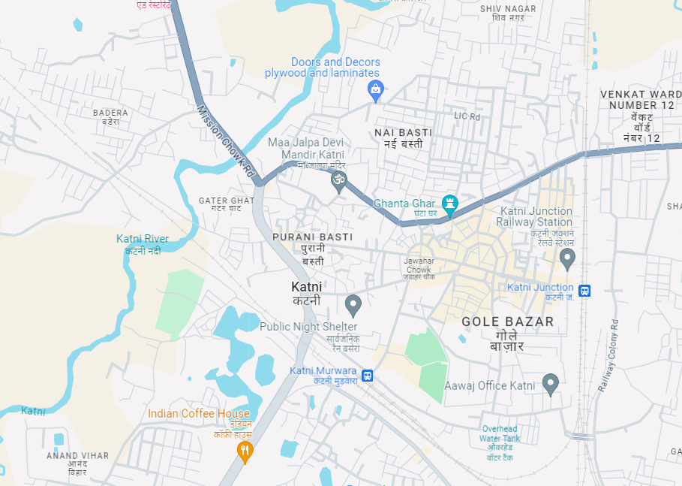

Salient Feature Of Project:-

Project | Construction Technique Of Railway Under Bridge By Box Pushing Method At Katni Singrouli Section Lc1 Km1089 (Madhya Pradesh) : A Case Study.
Authority Engineer | Sr. DEN/Co/JBP
Employer | Western Central Railway, Jabalpur
EPC Contractor | N S Manwani-Bhusawal ,Sai Plaza Behind Icici Bank , Bhusawal, Maharashtra-425201 India.
Section | Section LC1 Km1089
Length of the Project | 250 m
Date of signing of Agreement | 13/12/2022
Appointed Date | 13/12/2022
Construction Period | 12 Months (till 13-12-2023)
Original Contract Amount | 5.91 Crores

CHAPTER-II
LITERATURE REVIEW
2.1 OVERVIEW – GLOBAL RECESSION IMPACTS CONSTRUCTION GROWTH

“The global crisis has impacted the construction industry in many ways. Infrastructure projects are slowing down and the real estate sector is in the slums”.

- The construction industry has achieved annual growth of about 12% over the past 5 years. It contributed Rs 3.8 trillion to India's GDP during 2007-08, compared to Rs 3.46 trillion in 2006-07.
- Employing a total of about 32 million people, the sector is the second largest employer after agriculture. It has a multiplier impact on basic industries such as steel, cement, aluminum and oil and gas.
- More than half (about 54%) of construction activity is generated by the infrastructure sector. Of this total, public sector activities account for 70% and the private sector accounts for about 30%. Besides infrastructure, industrial activities account for the second highest proportion, about 36%. The remainder is made up of residential and commercial activities.

The Construction Industry Development Council (CIDC) is the highest representative body for the construction industry. The membership list includes four ministries, major public sector companies, leading private companies, financial institutions, universities, research organizations and rating agencies.

The construction sector is largely dominated by small companies, accounting for 96% of all contractors. Medium-sized companies account for about 3%, the rest are large companies. Some of the major companies include Larsen and Toubro, Jaiprakash Industries Limited, Hindustan Construction Company Limited, Simplex Concrete Piles (India) Limited, Unitech Limited, Gammon India Limited, Punj Lloyd and Nagarjuna Construction.

• In the past 5 years, the industry has had many new trends. Project sizes increased, equipment and manpower increased, and better technology was deployed. Until the global crisis, the growth rate of the construction industry was always higher than the GDP growth rate.

• However, the situation has changed significantly in the past six months. While the sector grew strongly in the first half of 2008, growth slowed in the second half.
Although official figures have not been released, experts estimate that in the 2008-09 financial year, the growth rate of the construction industry will match the GDP growth rate, which will decrease from 7 to 8%.

• The global crisis has impacted the construction industry in many ways. Infrastructure projects are slowing down and the real estate sector is in crisis. Most construction and engineering companies have postponed some previously planned major projects, either due to lack of capital or because they are no longer economically viable. On the one hand, donors are waiting to see how the economic and financial situation develops, on the other hand, donors are waiting for interest rates to return to previous levels.
• In the past 5 years, the industry has had many new trends. Project sizes increased, equipment and manpower increased, and better technology was deployed. Until the global crisis, the growth rate of the construction industry was always higher than the GDP growth rate.
• However, the situation has changed significantly in the past six months. While the sector grew strongly in the first half of 2008, growth slowed in the second half. Although official figures have not been released, experts estimate that in the 2008-09 financial year, the growth rate of the construction industry will match the GDP growth rate, which will decrease from 7 to 8%.
• The global crisis has impacted the construction industry in many ways. Infrastructure projects are slowing down and the real estate sector is in crisis. Most construction and engineering companies have postponed some previously planned major projects, either due to lack of capital or because they are no longer economically viable. On the one hand, donors are waiting to see how the economic and financial situation develops, on the other hand, donors are waiting for interest rates to return to previous levels.
• Real estate is the sector most affected by the decline in demand for residential and commercial real estate. The artificial demand for housing created during the boom no longer exists. Combined with the steady increase in capital values, higher interest rates have actually more than doubled real estate borrowers' interest costs. Demand for commercial real estate has also decreased, causing many companies to pause expansion plans. However, the recent Delhi lottery. The Development Authority suggests that if affordable housing becomes available, demand will increase.
- The highway sector also shows signs of slowing down. About 60% of awarded national road projects have not yet been financially settled. Additionally, the National Highways Authority of India has recorded a significant decrease in the number of bids received for national highway projects. In fact, withdrawals have been made on various sections of Phase III of the National Road Development Programme.
- Indian ports witnessed a decline in cargo traffic due to reduced global trade. Private port projects announced at major ports under the National Maritime Development Program will face difficulty in raising capital. Even the major Greenfield airport projects currently underway will almost certainly be delayed.
- The pace of activity in the power sector, especially manufacturing, also slowed down. Private manufacturing projects awarded through international competitive bidding are delayed due to lack of funds. The production target of 78,700 MW of Plan 11 seems unattainable. There has not been much impact on the distribution and transmission segment because most of these projects arefunded from capital received from the Electricity Finance Corporation or the Rural Electrification Corporation.
- Sectors such as railways and urban infrastructure remained more or less the same. This is mainly because funding for these sectors comes mainly from public sources with minimal private participation. There may be a slowdown in urban transport projects. For example, the developers of the Rs 120 billion Hyderabad Metro Rail project are finding it difficult to raise capital.
- According to the report, the growth rate of orders of most construction and engineering companies decreased. The cumulative order backlog of engineering and construction companies grew just 10 percent in the final quarter of calendar year 2008, the slowest growth rate in the past eight quarters. While there was a slight growth in orders from the Centre, states and local companies, orders from foreign companies fell significantly (nearly 25 per cent during the quarter).
- The crisis has affected supporting industries, especially the construction equipment industry, worth 139.5 billion rupees. Before the crisis, the Indian appliance market had been growing at about 35% in almost seven years. However, from October to December 2008, the growth rate decreased by 30%. Many companies have reduced production at their manufacturing units and are therefore turning to the government to supply stores. However, over the years, the level of mechanization has improved and new business activities have emerged among domestic and global enterprises.
- Prices of key raw materials such as steel and cement have fallen. Steel prices fell from Rs 54,000 per tonne in January 2008 to Rs 29,250 per tonne in December 2008. Cement prices also fell. Currently, a bag of cement costs an average of Rs 215 to Rs 235 and could go down further.
- The construction industry faces a number of challenges, including shortages of skilled and unskilled labor, reliable institutional dispute resolution mechanisms, and lack of contractual procedures and records reasonable. Although ICDT has taken a number of initiatives to address these issues, more remains to be done.
- The global crisis has slowed down construction activity and it looks like the situation will only start to improve in early 2010. The Planning Commission has estimated an investment of around Rs 22,140 crore will be required demand for infrastructure sectors in the May 11 period Year plan.
- Hopefully the Government's stimulus package and recent measures by the RBI will help stabilize the current situation. The Indian Infrastructure Finance Corporation was allowed to raise Rs 100 billion through issuance of tax-free bonds in March 2009. This will fund road and port projects totaling Rs 250 crore billion Rs. Additionally, to fund additional projects worth Rs 750 crore in the next 18 months, IIFCL has been given access to another Rs 300 crore once the amount raised during the current year will be put to productive use.
- Some other important measures include liberalization of external commercial borrowing policy, revision of real estate loan ceiling to Rs 2 million from Rs 0.5 million, increase in risk limit of investors Foreign institutional investors for corporate bonds in Rupees from Rs 270 billion to Rs 675 billion, exemption from anti-subsidy duty on cement, bars and TMT structures, strict monitoring of public expenditure to speed up spending on all projects and programmers.

2.2 WINNERS IN DOWNTURN (BUSINESS TODAY-22ND MARCH 2009)
2.2.1 No Bridge Too Far
The robustness of Larsen & Toubro's core business of engineering & construction helps it counter the tough times. Plus, it has newer growth engines that are reviving up. Virendra verma
- Y. M. Deosthalee, Chief Financial Officer (CFO) of Larsen & Toubro (L&T), was burning the midnight oil over a strategic decision to acquire a business that isn‘t quite core to the engineering and construction giant. L&T is one amongst the several companies in the fray to acquire scandal struck Satyam Computers. True L&T has an IT services arm (L&T Infotech), and a buyout of Satyam would help it to scale that business up considerably. However, investors don’t appear to be convinced about L&T’s software ambitions - the stock had tanked to a 52 week low at the time of writing - and would rather see those funds being pumped into the flagship operations. The L&T top brass, for its part, is clear about its long term vision for the group (and its shareholders), market don’t faze its Chairman & Managing Director A.M. Naik. “Our diversity in different core sectors of the economy helps us to maintain growth even in some parts of our business portfolio is adversely affected by the market”, says the 66-year-old engineer, who has risen to the top from the ranks.
- For a company that has built a reputation by constructing bridges, roads and world class plants on time challenges and obstacles aren’t exactly uncommon. Yet, after going through several economic cycles, the company appears to be coming close to perfecting the art of winning in the slowdown. The past two quarters have been a period of its peers has lost direction. The 25 percent growth (excluding extraordinary income of Rs. 916.3 crore) in net profit for the December- ended quarter was much better than what most analysts tracking the company were expiring. The management is upbeat about closing the year with a revenue growth of 25 - 30 percent; and the bottom line also grow at the same rate for the financial year ending March 2009. L&Ts confidence stems from the Rs. 68,800 crore order books on hand and more importantly; none of these orders have been cancelled or delayed.
- Double digit growth on such a large base in such trying conditions is creditable. Anand Rathi Securities expects the company‘s net profit at a rate of 18.8 percent in the current financial year. There will be a lag effect of 1-2 quarters for engineering companies, says Ajay Parmar, Head of Research, Embay Global Financial Services. He says the company is feeling some impact of the slowdown as growth in order inflow has been 11 percent in December quarter compared to 30 percent for first nine Months.
- So, how is L&T blazing the trail in the midst of an economy slowdown? - A rigorous risk management policy, increasing operational efficiency, a strong order book and a Diversified portfolio - including new business like railways and power - have all Contributed to the growth”, says Deosthalee.
- What also helps is that even though L&T competes with global players when bidding for international projects, its main focus is on the Indian market where there's plenty of action. Some 85 per cent of its revenues come from domestic projects.
- Still, there's no denying that the ongoing slowdown will catch up with L&T, sooner or later. Project delays and cancellations will be inevitable as the downturn intensifies, and that may impact the order flow in the days ahead. Deosthalee, for his part, hardly sees any dark clouds ahead - not for another year, at least. "L&T is confident that it will be able to sustain a robust growth trend in 2009-2010," He reckons. Deosthalee, of course, has a few aces up his sleeve. Engineering & construction will continue to be the company's biggest growth engines. But new businesses, like the railways division, will also start kicking in. Within six months of starting this arm, it has already got orders worth around Rs 5,000 crore. This includes Rs. 2,900-crore order for a mono-rail project in Mumbai and another Rs 1,600-crore order from the Indian Railways.
- L&T's biggest strength, though, is its sheer depth of experience in project execution. This helps it too often complete projects ahead of schedule, which, in turn, results in Savings in costs and working capital. A decision taken a few years ago to shift back to a variable input cost structure has also helped it maintain profit margins. "Close to 70 Percent of our contracts are on a cost - plus basis, and we also have a very structured Payment schedule," reveals Deosthalee.
2.3. GLOBAL CRISIS AND ITS IMPACT ON INDIA

A. Prasad and C. Panduranga Reddy, 2009 “While western world and the U.S have plunged into recession, But Indian Economy is being affected by the spill-over effects of the crisis (Chidambaram 2008) due to great savings habit among people. The most important lesson that we must learn from the crisis is that we must be self-reliant. Though World Trade Organization (WTO) propagates free trade, we must adopt protectionist measures so that recession does not affect our country.”

Jayamani, M. And Dr. Asima Nusrath, 2011 “In the present situation, apartment system is appropriate in terms of accommodating more houses and people within reasonable costs. Land market situation, especially in the high income residential areas are already undergoing transition in architectural design. It is most likely that this change in the construction design may pass into the moderate income areas in the second stage and lastly, it may appear even in the low income residential areas. Traditional single housing system will eventually become costlier for construction and maintenance for a single owner.”

Aviral Kumar Tiwari, et. al 2011 & 2013 “This study had examined the direction of causality between economic growth and construction flows both in static and dynamic framework. Subsequently, we incorporated those breaks dates in co integration analysis. Co integration analysis revealed that there was strong evidence of long-run relationship between economic growth and construction flows.

The results suggest that for the short-run, Indian government can focus on the development of construction sector as it increases GDP. However, in the long-run Indian government should gradually cut down her budget expenditure on construction sector. The work can be extended further by analyzing the issue under a multivariate framework”

Robin et al., 2009 T. Robin, G. Antonini, M. Bierlaire, et al. “The need of today is not just the pumping of liquidity in to the Indian economy but also in addition the injection of demand. The biggest challenges before India are to ensure monetary and fiscal stimuli work. Over the next year, source of growth should shift to manufacturing and possibly are covering agriculture.”

The project entitled analysis and design and execution of cross traffic works in railways using box pushing technique (RUB), illustrates about the work to be carried out for the widening of existing roads using box pushing techniques for rail under bridges. It also explains about the methodology involved in execution of box pushing technique. The de sign will be carried out as per Indian standards, particularly Indian railways standards, IRC, IRS, and IS CODES. In which the design of major components thrust bed, precast box used for the widening are done as per IRS codes. The design of pre-cast box is done using STAAD pro, it also includes the layout of reinforcement details of two important structures used in this method apart from conventional method i.e., thrust bed (main bed and auxiliary bed), pre cast box (A. L. M. Kamakshi & A. Gayathri Devi, 2016).
The topic entitled about issues involved during exaction of Railway under bridge using box pushing technique and its remedies, illustrate about the method of execution of rail way under bridge and issues involved during execution by box pushing technique for widening of existing roads and its remedies. It also explains about the methodology involved in application of box pushing technique for construction of RUB (Railway under bridge). This topic primarily gives attention towards problems that arises during execution and its resolution (K. ASUDULLAH KHAN, 2016).

The project entitled analysis and design and execution of cross traffic works in railways using box pushing technique (RUB), illustrates about the work to be carried out for the widening of existing roads using box pushing techniques for rail under bridges. It also explains about the methodology involved in execution of box pushing technique. The design will be carried out as per Indian standards, particularly Indian railways standards, IRC, IRS, and IS CODES. In which the design of major components thrust bed, precast box used for the widening are done as per IRS codes. The design of pre cast box is done using STAAD pro, it also includes the layout of reinforcement details of two important structures used in this method apart from conventional method i.e., thrust bed (main bed and auxiliary bed), pre cast box. In railways whenever there is a need to make a underpass ,either for canal crossing, RUB’S(Rail under bridges), programme of widening existing railway culverts etc. BOX PUSHING TECHNIQUE is used. Since the work has to be done without interruption to rail traffic, box pushing technique is largely favoured in comparison to conventional methods. Present day Intensity of Traffic, both Rail & Road due to the fast development, is very heavy it cannot the disturbed, for construction of under bridges or Canal Crossings, drainage etc. by conventional i.e. open cut system. Box Pushing Technique is developed where in R.C.C. Boxes in segments are cast outside and pushed through the heavy embankments of Rail or Road by Jacking. Keywords: Cross Traffic Works, Box Pushing Technique, Rail Under Bridge (RUB), IRC, IRS, I.S Codes (M.A.Rahman1, G. Raju, 2018).

The intersection of railway track and the road at the same level is referred to a level crossing. In the urban areas the level crossing are generally monitored by qualified railway personnel who monitor the train movement and close the level crossing gate to stop the interfering road traffic but such closing of gates leads to congestion in road traffic and also causes loss of time to road users. Road under bridge and road over bridge are considered as solutions for avoiding level crossings of roads and railway track. There are 3 main methods in construction of road under bridge. Box pushing method, Cut and cover method, Rolling technique using RH girder. In this we discuss about the implements, soil friction, effects required, capacity of jacks and there uses, skew angles and at square angles (Ranjeet. P , D.V.S. Narshima Rao, Mohd Akram Ullah Khan, K. Hanuman, 2016).
The project entitled analysis and design and execution of cross traffic works in railways using box pushing technique (RUB) ,illustrate about the work to be carried out for the widening of existing roads using box pushing techniques for rail under bridges . it also explains about the methodology involved in execution of box pushing technique .The de sign will be carried out as per Indian Standards ,particularly Indian railway standards, IRC, IRS, IS CODES .In which design of major components thrust bed, precast box used for the widening are done as per IRS codes. The design of precast box is dome using STADD PRO, it also includes the layout of reinforcement details of two important structures used in method apart from conventional methods i.e. thrust bed (main bed and auxiliary bed), pre cast box (Priyanka M. Rajput et. al 2019).

CHAPTER-III
METHODOLOGY ADOPTED
3.1 Understanding of the Project:

The bidder's comprehension of the project based on the Project Profile, which also outlines the different work tasks that are expected to be completed.

  - Mobilisation:

3.2.1 Soon after the designated day, the mobilisation of staff and equipment to complete the initially planned operations will begin. As soon as we are selected as the winning binder, we must make all necessary preparations. We will further step up our efforts after receiving Lol to ensure that the job is completed on the "appointed date”.
3.2.1 In order to start the project on time, workers will be deployed to handle the early contractual obligations, which include setting up a temporary camp, providing plant and equipment, micro-level planning, identifying material sources and quarries, making procurement arrangements, etc.

3.3 Work Plan:

The work plan is enclosed here with:

The effort will begin concurrently on many fronts.
This is how the work will go on, and it will happen at least four times: at the culverts, VUP, RUB and retaining wall.
Wherever necessary, the contractor will communicate with local traffic authorities throughout the process to coordinate traffic control throughout the construction period.

3.4 Earthwork:

Any vegetation on the ground should be highlighted with the intended formation's toe line. After that, the earth must be rolled and compacted according to the guidelines. Benches at varying levels will be used to construct the embankment in tiers. Until the bottom of the subgrade is reached, the procedure must be repeated.
The embankment fill material will come from appropriate highway excavated material that has been approved for borrowing, in accordance with the requirements. By sleeping into piles, the authorised borrow areas will be free of vegetation. A hydraulic excavator will dig up the fill material, load it into tippers and carry it in layers for the purpose of building an embankment.

To make spreading easier, tippers will be instructed to systematically discharge embankment fill material. Vibratory tollers will be used to compress the fill material once it has been moistened to the ideal moisture content to get the required density. The fill material will be laid down in layers that make sense and compacted to the specifications specified level of tightness.
If the earth meets all the requirements for the requisite gradation, L.I. P.I., and CBR value, it will also be used as embankment material to the greatest degree feasible once side slopes are cut down and excavations made for cross drainage work are completed.
The site will conduct an in-situ density test to ensure that the compaction parameters are met in accordance with the specifications. Furthermore, the embankment's profile has to be examined for longitudinal and cross slopes.
Similar preparation must be done for the sub-grade as well, but using soil with a greater CBR value in accordance with the design requirements and standards.
3.5 Structural Concrete Works:

The suggested methodology for executing the construction of bridges, CD works, retaining walls, and other structures is provided below as (a) General Methodology and (b) Special works. This is because there are bridges to be built and several Cross Drainage Works in addition to concrete drains along the alignment:

  - Miscellaneous Items:

It is suggested that examples of various things, such road sign boards, be submitted for the client's approval. Long before the products are executed, shop drawings will be created and sent to the client for approval.
The customer has approved a reputable manufacturer from whom the thermoplastic paint material will be sourced. A appropriate road marking equipment will be used, and skilled labourers with extensive expertise will do the paint application task.
It is suggested that the project's drams be built in accordance with the plans and specifications, in tandem with the advancement of the main works.
Kerbs at intersection and median openings will be painted. There must be delineators at both these sites and the toll plazas.
Fast-growing shrubs and tree seedlings must be planted in the median, which should be filled with agricultural soil, and along the sides of the roadways in accordance with an authorised arboricultural work plan.
An authorised safety plan will guide the implementation of safety measures throughout construction.

    - MAINTENANCE

To ensure safe operation, all vehicles utilised for the transportation of people and materials must go through regular periodic inspections. These checks need to be done, especially for the doors, horn, lights, and brakes. The driver is required to document any defects or malfunctions that arise in the vehicle while it is being transported in a logbook that is kept inside. The site management is responsible for making sure that the work equipment is kept in excellent operating condition, with regular inspections and servicing performed every time a certain amount of time or distance.

    - DAILY CHECK BY DRIVER

Before using the car, the driver should do daily safety inspections that include the criteria listed below.
Tyres
Brakes
Steering
Mirrors
Windscreen Cleaners
Cleaners alerts for danger
Particular safety mechanism, such as control interlocks
Drivers should do these inspections, according to management.

    - POTENTIALLLY HAZARDOUS OPERATIONS

The following activities operations are potentially hazardous in connection with the vehicles.

  - REVERSING

About 25% of workplace fatalities are related to reversing automobiles. When practicable, traffic solutions that remove the need for reversing should be incorporated into workplace architecture to prevent negligent reversing from causing costly damage to products, plans, and premises. Reversing areas should be clearly identified and marked with non-essential people in the absence of an integrated traffic system. Bank employees will be there to direct traffic and ensure that pedestrians and non-essential staff stay away from the reversing area. They will be dressed in high visibility apparel. Real view mirrors and externally placed minors are required on vehicles.

CHAPTER-IV
PROCEDURE ADOPTED

PROCEDURE

Site Photos:-
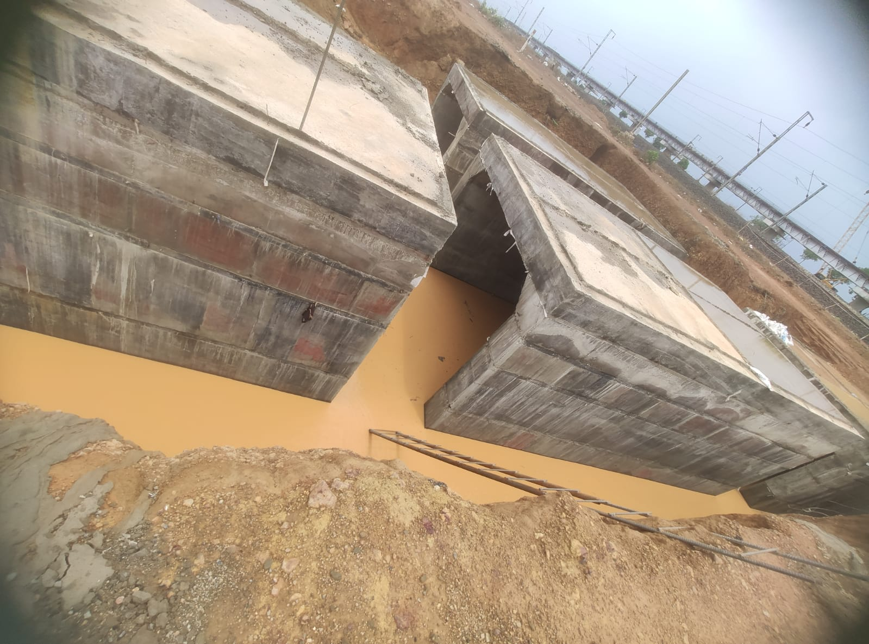
Figure 1 : RUB Construction

4.1 Equipment List:-

Sl No | Description | Mobilization Status | Remarks
1 | Capacity Weigh Bridge (100T) | 1
2 | Transite Mixer | 2
3 | Concrete Pump | 1
4 | Batching Plant -Schwing Stelter (CP 30) | 1
5 | Diesel Generator (125 KVA) | 1
6 | Diesel Generator (63 KVA) | 1
7 | Crane – Escorts (15 T) | 1
8 | JCB Backhoe Loader | 2
9 | Tractor | 3
10 | Hyundai Verra | 1
11 | Hero Splendor Plus | 1
12 | Concrete Mixer (0.25 Cum) | 1
13 | Bolero Camper | 1
14 | Toyota Innova Car | 1
15 | Excavator 320 | 1
16 | Generator 10 kva | 2
17 | Tower light | 2
18 | Bajaj Discover 125 | 1
Lab Mobilization
1 | Hot air oven | 1
2 | Flexure cube testing machine | 1
3 | 10 % Fine value Testing Machine | 1
4 | Compression Testing Machine | 1
5 | Concrete Mixer (0.15Cum) | 1
6 | Los Angeles Abrasion Testing Machine | 1
7 | Aggregate Impact Value Testing machine | 1
8 | CBR testing Machine | 1

  - QUALITY CONTROL SYSTEM:-

Purpose of Quality Assurance /Quality Control (QA/QC):
An diagram of the association and operational structure of the development extend, as well as common strategies and rules to be taken after by this association and operation structure in carrying out all perspectives of the Development errands related to usage of the contract works, are given within the Quality Assurance/Quality Control (QA/QC) manual. QAS may be a collection of archived strategies outlined to deliver affirmation that the project's yield fulfills the useful necessities. The project's association, obligations, staff, supplies, apparatus, methods, testing, reviews, and other perspectives ought to all be secured by the quality framework.

This handbook has been carefully created to guarantee that taking after its proposals will lead to compelling, secure, and dependable work supervision that entirely complies with the contract's criteria and determinations. As a result, the basic structure of this manual is based on development administrator strategies that are in line with acknowledged universal hone for this kind of interstate broadening development venture. Particular rules and shapes are, where appropriate, produced based on acknowledged Indian hone that complies with MORT&H and IRC. All perusers of this handbook ought to be mindful, in any case, that the contract reports counting the specifications—are the ones that administer the development supervision prepare in all circumstances.

In order to meet with established quality systems, rules, SOPs, and record keeping standards, this system must be applied by the project team's personnel.

Objective of the System

The reason of the QA/QC manual is to form it simpler for the different workplaces, extend locales, and the extend coordination office to facilitate with one another. To get a comprehensive understanding of the project's execution, the fabric build can make a MIS report based on the information examined by the extend coordination office and give it to the location workplaces. This will make it conceivable for location workplaces to collaborate with one another and effectively deliver high-quality work.

This document is an effort in this direction and shall enable day-to-day codified information exchange across project office. This will help in:

• Efficient coordination among offices;
• Prompt compilation of project activities;
• Instantaneous information available for report generation;
• Activity analysis concerning wish quality;
• Validation of CPM/ME's contribution to the site engineers, to guarantee quality compliance.

Quality Policy

- Quality policy initiated by the management, aimed at ensuring achievement of the goal of quantity along with quality towards complete satisfaction of the customers. The management's motto is "Customer satisfaction is our goal. " We, the management, believe and are determined that the right choice at the right time is the best. The management is result oriented and focused on achieving the highest level of customer satisfaction. Avoid cost increase or mitigate its impact if increase is unavoidable. Reduce construction time. If not, stick to the schedule. If deviations continue to occur, reduce the scope. Raise quality to global standards without increasing price. Errors must wait until the final check.

Necessity of quality system

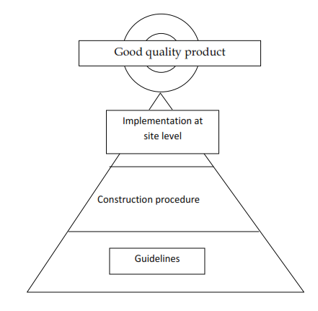

System Flow – Directions

- The system must follow the process outlined in the following operation flowchart, which explains at a glance how the system works. It can be done in the following ways:
  - The system may be triggered by scheduled or unexpected site visits by dedicated team members/employees. In this case, it can only be performed as part of the contractor's team members/employees' duties and responsibilities. All interactions between the field office (involved in any of the project activities) and the head office (Nulliplex) should be documented through this structured system. The number of required and mandatory visits for validation will be specified as the scope of the validation repeat list and/or validation test plan.
And
- Request from Contractor/Concessionaire to Independent Construction Company for approval of drawings/documents (documents are plans, formwork plan calculations etc.) or RFA/RFI for site verification and approval of construction work, which will be done later. There has been some progress in terms of construction management.
For example, if site clearing or fixing of foundations and pouring of concrete is to commence, the IC team must visit the site area as per the inspection request information provided by the temporary labour/concession company.Once the drawings are submitted by the concessionaire, they must again be reviewed and approved by the authorized IE officer.

- At every site visit or interaction with the field office, the expert team/personnel must understand the legally binding requirements, extend the quality assurance system and be aware of the legal provisions regarding environmental impact. IE site personnel can continue with the important checklists at the beginning of each checklist and MIS passage area. The valid coding as stated in this document and/or established from time to time must be carried out after the full completion of the plans and checklists, especially the data area of ​​the MIS passage. The transmission of sensitive information to the computer and the achievement of the overall system objectives must comply with the specified codes.

- In case of violation of the confirmed methods and measures, the Group Leader must issue a Non-Conformity Report (NCR). The Concessionaire must discuss the issue with the affected employees and rectify the issues raised by the Concessionaire. After making appropriate adjustments as recommended in the NCR, the Temporary Worker/Concessionaire must submit a Corrective Action Report (CAR) along with an RFI for IE site visit and review.

- The completed information should be sent to the group pioneer members, who will review the content, make comments and forward it to the administrators daily.

- Remotely assigned employees may present the completed checklist to their supervisor and have their supervisor provide comments at their convenience or after a delay selected by the CPM based on area and availability.

- The Computer Administrator/IT Personnel may enter MIS data from completed Checklists, Non-Conformance Reports (if issued), and Corrective Action Reports in areas stamped "For MIS Entry" daily into the designated entry fields labeled "MIS -LOG" into the computer.

Notes:
  - Under normal circumstances, edits in MIS section should be received by HO latest on the 2nd day from the date of assessment, 1st day-site visit, 2nd day-CPM approval.
  - However, transmission of information to head office happens every working day and data is handed over to IT admin on the previous working day.
Notes : observations if any by the field Staff can be written on the backside of the checklists

CHAPTER-V

RESULT & CONCLUSION

- Quantities of items of works is prepared by using MX-Road estimator software.
- Construction Schedule is prepared by using mx project software.
- Railway under Bridge estimate is prepared by taking the rates from schedule of rates issued by the Central Public Works Department.
- By analysis it is found that the time required for the construction of Railway Under Bridge is very less as compared to the time required for the construction of Railway Over Bridge.
- It has also observed that the cost of construction for the Railway Under Bridge is economical than Railway Over Bridge.
- Finally it has been concluded that the viability of Railway under bridge by box pushing method is adopted for construction of railway bridge.

REFERENCES

- A. Prasad and C. Panduranga Reddy, 2009 “Global Financial crisis and Its Impact on India ”J Soc Sci 21(1): 1-5 (2009).
- International Journal Of Engineering Research online – vol.4, issue.6, 2016 – design of road crossing under the railway line using box pushing method(rub).
- International Journal Of Research In Engineering & Technology – vol.5, issue – 03, mar 2016 – procedure and construction of road under bridge by box pushing method.
- International Journal For Technological Research In Engineering – vol.5, issue – 10, june 2018 – design & analysis of railway under bridge (rub) by using box pushing method.
- Research Designs & Standards Organisation Journals.
- Indian Road Congress Journals.
- Aviral Kumar Tiwari et. al 2013 “The environmental of financial development, economic growth, coal consumption and trade openness on CO2 emmision in south africa”, Elsevier page 1452-1459 Vol. 6, 2013.
- Aviral Kumar Tiwari et. al 2011, “Economic growth and FDI in Asia: A panel-data approach” Elsevier page 173-187, Vol.41 Issue 2, 2011.
- A. L. M. Kamakshi, A. Gayathri Devi, 2016 “Design Of Road Crossing Under The Railway Line Using Box Pushing Method (Rub)” International Journal of Engineering Research Vol. I, Issue 6 Nov-Dec 2016.
- Jayamani, M. And Dr. Asima Nusrath, 2011 “Booming Real Estate Markets, Changing Urban Design and Endangered Heritage Status: A Case Study of Mysore Urban Area” ITP, India Journal 8-2, 59-73, April-June 2011.
- K. ASUDULLAH KHAN, 2016 “The Study Of Problems Involved During Execution Of Railway Under Bridge Using Box Pushing Technique And Its Remedies” International Journal of Civil Engineering (IJCE) ISSN(P): 2278-9987; ISSN(E): 2278-9995 Vol. 5, Issue 2, Feb – Mar 2016, 31-38.

- M. A. Rahman, G. Raju, 2018 “ Design And Analysis Of Railway Under Bridge (Rub) By Using Box Pushing Method” International Journal For Technological Research In Engineering Volume 5, Issue 10, June-2018.
- Design of steel structures P.Dayaratnam, Publishers S.Chand Edition 2011-2012.
- Ranjeet. P1, D.V.S. Narshima Rao2, Mohd Akram Ullah Khan3, K. Hanumanthu, 2016 “ Procedure and construction of road under bridge by box pushing method” IJRET: International Journal of Research in Engineering and Technology eISSN: 2319-1163 | pISSN: 2321-7308 2016.
- Robin et al., 2009 T. Robin, G. Antonini, M. Bierlaire, et al. Specification, estimation and validation of a pedestrian walking behavior model Transportation Research Part B: Methodological, 43 (1) (2009), pp. 36–56.
- Railway engineering, B.L.Gupta & Amit Gupta 3rd edition, Reprint 2012.
- Bridge Tunnel and Railway Engineering, S.P.Bindra, Latest.
- Railway Works Engineering, M.M.Agarwal, 4th revised edition, Reprint 2014.
- Priyanka M. Rajput, Omkar A. Phatak, Devendra J. Sawant, Jay P. Digaskar, Omkar C. Shinde, Yashraj B. Mahind Volume: 06 Issue: 05 May 2019 IRJET.
- TRB, 2010 Transportation Research Board (TRB) Highway Capacity Manual 2010 (fifth edition) TRB, Washington DC (2010).
- Railway Works Engineering, M.M.Agarwal, 4th revised edition, Reprint 2014.

