**A NEW ANALYTICAL RP-HPLC METHOD FOR THE ESTIMATION OF LAMIVUDINE IN PURE FORM AND MARKETED PHARMACEUTICAL DOSAGE FORM**

B. Vasanth Kumar1, Rizwana Begum2, Sowmya3, A.Yasodha4

1Department of Pharmaceutical Analysis, Dhanvanthri College of Pharmaceutical Sciences, Thirumala Hills, Centre City, Appannapally, Mahabubnagar, Telangana 509001

2Assistant Professor, Department of Pharmaceutical Analysis, Dhanvanthri College of Pharmaceutical Sciences, Thirumala Hills, Centre City, Appannapally, Mahabubnagar, Telangana 509001

3Assistant Professor, Department of Pharmaceutical Analysis, Dhanvanthri College of Pharmaceutical Sciences, Thirumala Hills, Centre City, Appannapally, Mahabubnagar, Telangana 509001

4Professor & Principal, Department of Pharmaceutical Analysis, Dhanvanthri College of Pharmaceutical Sciences, Thirumala Hills, Centre City, Appannapally, Mahabubnagar, Telangana 509001

**Corresponding Author:**

**Name:** B. Vasanth Kumar

**Department:** Department of Pharmaceutical Analysis

**Mail id:** nayakvasanth947@gmial.com

**Phone:** 9121761243

**ABSTRACT**

**Objective:** A rapid, sensitive, selective, and reproducible reversed-phase high-performance liquid chromatographic method has been developed and validated for the determination of Lamivudine in bulk and marketed pharmaceutical dosage forms.

**Methods:** The chromatographic separation was carried out in an isocratic mode on a Symmetry C18 (250mm x 4.6mm, 5µm particle size) column with a mobile phase consisting of Methanol and Phosphate Buffer (0.05M) pH-3.8 with Ortho Phosphoric Acid in the ratio of 55:45% v/v at a flow rate of 1.0 ml/min. The run time was maintained for 7.0 min and detection was monitored at 232nm.

**Results:** The retention time of Lamivudine was found to be 3.075 min. Calibration curve were linear over a concentration range of 6–16 µg/ml with correlation coefficient 0.9998. The limit of detection and limit of quantification for Lamivudine was found to be 0.85µg/ml and 2.55µg/ml respectively. The intra- and inter-day precision was 9.0% and the accuracy ranged from 98% to 102% over the linear range. The performance of the method was validated according to the present ICH guidelines for specificity, limit of detection, limit of quantification, linearity, accuracy, precision, and ruggedness.

**Conclusion:** This method was found to be simple, selective, precise, accurate, and cost-effective. Hence, the method can be successfully applied to analyze the Lamivudine concentration in bulk and marketed pharmaceutical dosage forms.

**Key Words:** Lamivudine, RP-HPLC, Method Development, Validation, Accuracy, Precision.

**INTRODUCTION**

Lamivudine is a monothioacetal that consists of cytosine having a (2R, 5S)-2-(hydroxy methyl)-1, 3-oxathiolan-5-yl moiety attached at position 1. An inhibitor of HIV-1 reverse transcriptase, it is used as an antiviral in the treatment of AIDS and hepatitis B. It has a role as a HIV-1 reverse transcriptase inhibitor, an antiviral drug, an anti-HBV agent, an allergen, a prodrug and an EC 2.7.7.49 (RNA-directed DNA polymerase) inhibitor [1]. It is a monothioacetal, a primary alcohol, an oxacycle and a nucleoside analogue. It is functionally related to a cytosine. Lamivudine (brand name: Epivir) is a prescription medicine approved by the U.S. Food and Drug Administration (FDA) for the treatment of HIV infection in adults and children. Lamivudine is always used in combination with other HIV medicines [2]. A reverse transcriptase inhibitor and Zalcitabine analog in which a sulfur atom replaces the 3' carbon of the pentose ring. It is used to treat Human Immunodeficiency Virus Type 1 (HIV-1) and hepatitis B (HBV). Lamivudine is a nucleoside reverse transcriptase inhibitor (NRTI) with activity against Human Immunodeficiency Virus Type 1 (HIV-1) and hepatitis B (HBV) to disrupt viral DNA synthesis [3]. When phosphorylated, lamivudine can form active metabolites that compete for incorporation into viral DNA. Via DNA incorporation, lamivudine metabolites competitively inhibit the activity of the HIV reverse transcriptase enzyme and act as a chain terminator of DNA synthesis. Due to the lack of a 3'-OH group, incorporated nucleoside analogues prevent the formation of a 5' to 3' phosphodiester linkage that is essential for DNA chain elongation. Lamivudine is a synthetic nucleoside analogue and is phosphorylated intracellularly to its active 5'-triphosphate metabolite, lamivudine triphosphate (L-TP). This nucleoside analogue is incorporated into viral DNA by HIV reverse transcriptase and HBV polymerase, resulting in DNA chain termination [4]. The IUPAC Name of Lamivudine is 4-amino-1-[(2R, 5S)-2-(hydroxy methyl)-1, 3-oxathiolan-5-yl] pyrimidin-2-one. The Chemical Structure of Lamivudine is shown in follows

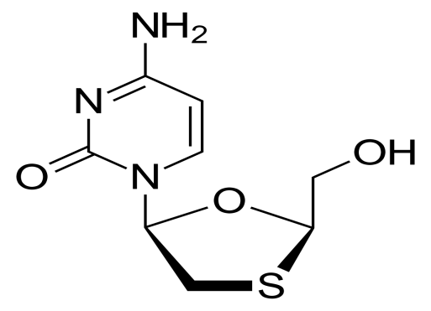

**Fig-1: Chemical Structure of Lamivudine**

A literature survey reveals the report of a few analytical methods for the determination of these drugs individually in bulk samples and in their dosage forms [34-38]. Methods for the determination of Lamivudine in bulk and biological samples and in pharmaceutical preparations were also reported. A reported method for the determination of the Lamivudine in bulk and tablets studies employs a good symmetry, retention time and good separation. The authors now propose for stability indicating RP-HPLC method for simple, precise and accurate method for Lamivudine in bulk and pharmaceutical dosage forms.

**MATERIALS AND METHODS**

**Instruments:**

The chromatographic separation was performed on Waters HPLC compact liquid chromatographic system integrated with a variable wavelength programmable UV detector and an automatic injector equipped with Empower2 Software with Isocratic. A reverse phase Symmetry C18 (250mm x 4.6mm, 5µm particle size) Column [5] was used. ELICO SL-159 UV – Vis spectrophotometer double beam UV visible spectrophotometer and Wenser High Precision Balance Model: PGB 100 electronic balance was used for Spectrophotometric determinations and weighing purposes respectively.

**Reagents and Chemicals**

Pharmaceutical grade pure Lamivudine sample was procured from Local Market. HPLC grade Methanol and HPLC grade Water were used of Merck Specialities Private Limited, Mumbai. Potassium dihydrogen ortho phosphate, Acetonitrile, Hydrochloric acid, Sodium Hydroxide and 3% Hydrogen Peroxide were procured from A.R Chemicals Pvt.Ltd.

**UV Analysis for Development of Method and Validation of Developed Method for determination of Lamivudine**

**Preparation of Standard Stock Solution of Lamivudine**

Accurately weighed 10mg of Lamivudine and it was transferred to clean and dry 100 ml of volumetric flask and dissolved in methanol and made-up the volume to 100 ml with same solvent system. The final solution obtained 100μg per ml of Lamivudine solution.

**Determination of Wavelength of Maximum Absorbance for Lamivudine**

Standard Lamivudine solution (1ml) was transferred to separate 10 ml volumetric flask. The final volume was adjusted to 10 ml with the same mobile phase [6]. The absorbance of the final resulted solution was scanned in the range 400 to 220 nm against mobile phase as blank.

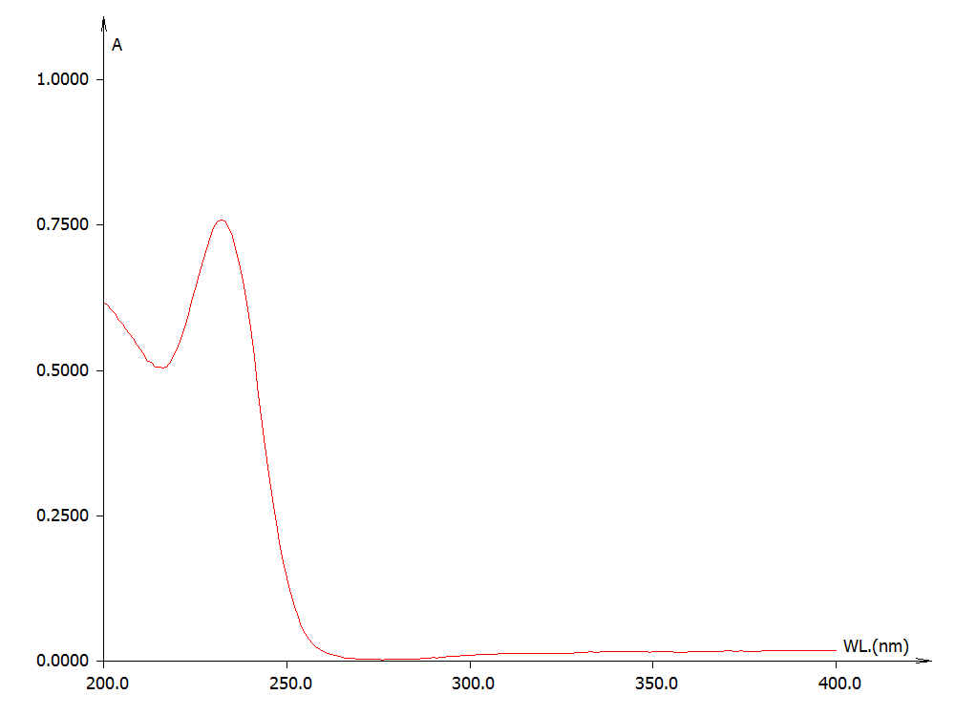

**Fig-2: UV Spectrum of Lamivudine (232 nm)**

**Development and Validation of a Method for the Simultaneous Estimation of Lamivudine by RP-HPLC in Bulk and Pharmaceutical Dosage Form**

**Selection of Wavelength**

The λmax of the ingredient i.e. Lamivudine, were found to be 232 nm in methanol as solvent system. As the drug having almost near absorption max & at 232 nm Lamivudine shows more intense at 232 nm has been chosen as common absorption maximum for HPLC analysis [7].

**Preparation of Standard Solution of Lamivudine**

Weighed accurately 10mg of standard Lamivudine and transferred into clean & dry 100 ml volumetric flask. Then 20 ml of mobile phase was added and sonicated to dissolve in 100ml of volumetric flask. The final volume was made up to the mark with same solvent. The final solution contained about 100μg/ml of Lamivudine.

**Initialization of the Instrument**

The HPLC instrument was switched on. First the column was washed with the HPLC grade water for 45 minutes. After washing the column that the column is saturated with the mobile phase in 45 minutes. The mobile phase was run to find the peaks or identification of peaks [8]. After 20 minutes the standard drug solution was prepared and injected in HPLC system.

**Preparation of Phosphate buffer pH 3.8:**

Dissolve 6.8g of Potassium dihydrogen orthophosphate in 1000ml of HPLC water, adjust the pH to 3.8 with orthophosphoric acid and add sufficient HPLC water to produce 1000ml. The mobile phase was sonicated for 15 min and filtered through a 0.45 µm membrane filter paper.

**Preparation of Mobile phase**

Accurately measured 550 ml (55%) of Methanol, 450 ml of Phosphate buffer (45%) were mixed and degassed in digital ultra sonicater for 15 minutes and then filtered through 0.45 µ filter under vacuum filtration [9].

**Preparation of Standard Solutions**

10mg Lamivudine was accurately weighed and transferred into 10 ml volumetric flasks, dissolved using mobile phase and the volume was made up with the same solvent to obtain primary stock solution of concentration 1000µg/ml of the drug. (Working stock solution).

**Preparation of Sample Solution**

20 tablets of Lamivudine were initially weighed and powdered and an amount equivalent to 10mg was accurately weighed into a 10ml volumetric flask, mixed with 10ml of mobile phase. The solution was made up to the volume with mobile phase and sonicated for 5 minutes. The solution was then filtered through 0.45µm Millipore membrane filter. The solution contains 1000µg/ml of Lamivudine. From the above stock solution 0.1ml aliquot was transferred in to a 10 ml volumetric flask, volume was made up to the mark with mobile phase to obtain a final concentration of 10 µg/ml of Lamivudine.

**RESULTS AND DISCUSSION**

**Method Development:**

**Optimization of Method:**

The chromatographic conditions (composition of the mobile phase, its pH) were optimized through several trials to achieve the better sensitivity and good symmetric peak shape for Lamivudine [10]. Different combination ratios of Methanol and acetonitrile with different phosphate buffers were tested. The best chromatographic separation was achieved with a Symmetry C18 (250mm x 4.6mm, 5µm particle size) Column, and Methanol and Phosphate Buffer (0.05M) pH-3.8 with Ortho Phosphoric Acid were taken in proportion of 55:45% v/v as mobile phase at a flow rate of 1.0 ml/min, and the Column temperature was maintained at Ambient. UV detection was performed at 232 nm and sample temperature was maintained at room temperature with a run time of 7.0min. Under the above described chromatographic conditions, Lamivudine was detected at retention time of 3.075 min. The representative optimized chromatogram of Lamivudine is shown in the figure 3.



**Fig-3: Optimized Chromatographic Condition for Lamivudine (3.075 min)**

**Method of Validation**

The proposed method was validated for various parameters such as linearity and range, accuracy, precision, robustness, ruggedness, sensitivity and specificity according to ICH Q2 (R1) guideline and USP guidelines [28,33].

**System Suitability Parameter**

This includes the type of equipment, electronics, analytical operations and samples to be analyzed constitute an integral system that can be examined. The following system suitability test parameters were determined [11-12]. The obtained data are shown in Table-1.

**Table-1:**  **Data** **of System Suitability Parameter**

|  |  |  |  |
| --- | --- | --- | --- |
| **S.No.** | **Parameter** | **Limit** | **Result** |
| 1 | Resolution | Rs > 2 | 3.72 |
| 2 | Asymmetry | T ≤ 2 | Lamivudine =0.19 |
| 3 | Theoretical plate | N > 2000 | Lamivudine =4569 |
| 4 | Tailing Factor | T<2 | Lamivudine=1.36 |

**Linearity and Range**

Standard solutions ofLamivudine in the concentration range of 0 μg/ml to 16 μg/ml were obtained by transferring (0.6, 0.8, 1.0, 1.2, 1.4, 1.6ml) of Lamivudine stock solution (1000ppm) to the series of 10 ml volumetric flasks to the separate series of 10ml volumetric flasks. The volumetric flasks were made up to the mark with mobile phase. The solutions were filtered through a 0.45 μm membrane filter and degassed under ultrasonic bath. The final resulted solutions were injected into HPLC the system. The run time/stop time maintained was 7 min and the various types of peak areas were measured [13-14]. The calibration data are shown in Table 2 and calibration curve data are shown in figure 4.

**Table-2: Calibration Data for Lamivudine**

|  |  |  |
| --- | --- | --- |
| **S. No.** | **Conc. (µg/ml)** | **Mean Peak Area** |
| 1 | 0 | 0 |
| 2 | 6 | 641233 |
| 3 | 8 | 844610 |
| 4 | 10 | 1052647 |
| 5 | 12 | 1250435 |
| 6 | 14 | 1465354 |
| 7 | 16 | 1662043 |

**\*** Mean of three triplicate determinations

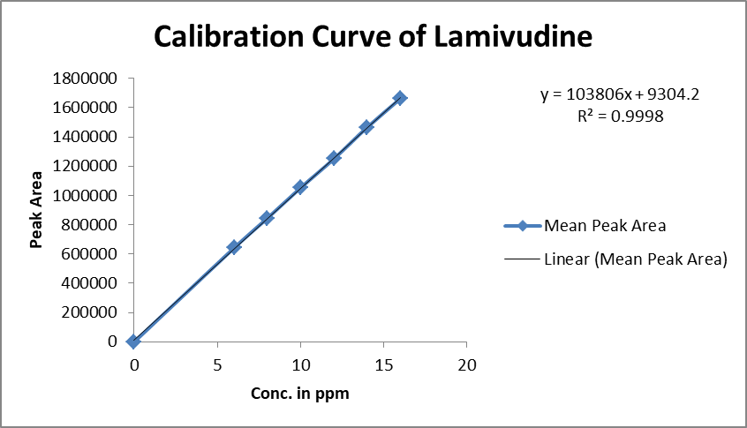

**Fig-4: Calibration** **Curve for Lamivudine**

**Accuracy**

**Recovery Study of Lamivudine**

The accuracy of the proposed developed method the % recovery studies were carried out by adding different quantities (80%, 100%, and 120%) of pure drug of Lamivudine was taken and added to the prepared pre-analyzed formulation of concentration 10μg/ml. From that % recovery values were measured [15-17]. The results were shown in Table-3.

**Table-3: Data of Recovery Studies for Lamivudine**

|  |  |  |  |  |  |
| --- | --- | --- | --- | --- | --- |
| **Sample ID** | **Concentration (μg/ml)** | | **Peak Area** | **% Recovery of**  **Pure drug** | **Statistical Analysis** |
| **Amount Added** | **Amount Found** |
| S1 : 80 % | 8 | 8.105 | 93435 | 101.312 | Mean= 100.0163%  S.D. = 1.293505  % R.S.D.= 1.293294 |
| S2 : 80 % | 8 | 7.898 | 91287 | 98.725 |
| S3 : 80 % | 8 | 8.001 | 92356 | 100.012 |
| S4 : 100 % | 10 | 10.195 | 115135 | 101.95 | Mean= 101.4033%  S.D. = 0.613379  % R.S.D.= 0.60489 |
| S5 : 100 % | 10 | 10.152 | 114687 | 101.52 |
| S6 : 100 % | 10 | 10.074 | 113879 | 100.74 |
| S7 : 120 % | 12 | 12.171 | 135647 | 101.425 | Mean= 100.6053%  S.D. = 0.730041  % R.S.D. = 0.725649 |
| S8 : 120 % | 12 | 12.044 | 134324 | 100.366 |
| S9 : 120 % | 12 | 12.003 | 133897 | 100.025 |

**Precision**

**Repeatability**

The precision of each method was ascertained separately from the peak areas & retention times obtained by actual determination of six replicates of a fixed amount of drug Lamivudine (API). The percent relative standard deviation was calculated for Lamivudine are presented in the table [18-19].

Repeatability was assessed using six time repetition of working concentration.

The results are shown in Table 4.

**Table-4**: **Data Showing Repeatability Analysis for Lamivudine**

|  |  |
| --- | --- |
| **HPLC Injection**  **Replicates of Lamivudine** | **Area Under the Curve** |
| Replicate – 1 | 1013546 |
| Replicate – 2 | 1025824 |
| Replicate – 3 | 1012351 |
| Replicate – 4 | 1036584 |
| Replicate – 5 | 1015419 |
| Replicate – 6 | 1028572 |
| **Average** | **1022049** |
| **Standard Deviation** | **9781.365** |
| **% RSD** | **0.957035** |

**Result & Discussion:** The repeatability study which was conducted on the solution having the concentration of about 10 μg/ml for Lamivudine (n =6) showed a RSD of 0.957035% for Lamivudine. It was concluded that the analytical technique showed good repeatability.

**Intermediate Precision:**

**Intra-Assay & Inter-Assay:**

The intra & inter day variation of the method was carried out & the high values of mean assay & low values of standard deviation & % RSD (% RSD < 2%) within a day & day to day variations for Lamivudine revealed that the proposed method is precise [20].

**Table-5: Results of Intra-Assay & Inter-Assay for Lamivudine**

|  |  |  |  |  |
| --- | --- | --- | --- | --- |
| **Conc. of Lamivudine (API) (µg/ml)** | **Observed Conc. of Lamivudine (µg/ml) by the Proposed Method** | | | |
| **Intra-Day** | | **Inter-Day** | |
| **Mean (n=6)** | **% RSD** | **Mean (n=6)** | **% RSD** |
| 8 | 7.96 | 0.86 | 8.07 | 0.93 |
| 10 | 10.08 | 0.76 | 10.03 | 0.47 |
| 12 | 12.06 | 0.57 | 12.03 | 0.83 |

**Result and Discussion:**

The intraday and interday studies results show that the mean % RSD was found to be within acceptance limit i.e. (≤2%). Hence it was concluded that there was no significant difference for the assay, which was tested within the day and between the days. So, we concluded that the proposed method at selected wavelength was found to be precise.

**Specificity:**

Specificity can be determined by comparing the chromatograms obtained from the drugs with the chromatogram obtained from the blank solution. Blank solution was prepared by mixing the excipients in the mobile phase without drug. Drug solutions were prepared individually and the sample containing one drug was also prepared. Now these mixtures were filtered by passing through 0.45 μ membrane filters before the analysis [21-22]. In this observation no excipient peaks were obtained near the drug in the study run time. This indicates that the proposed method was specific.

The chromatograms representing the peaks of blank, Lamivudine and the sample containing the one drug was shown in following figures respectively.

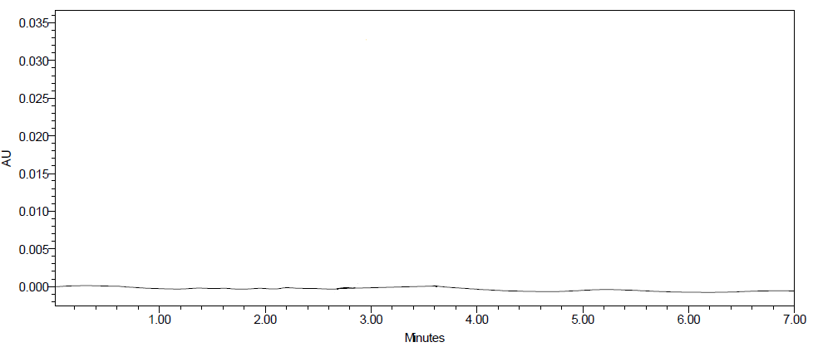

**Fig-5: Chromatogram for Blank Solution**



**Fig-6: Chromatogram for Standard Solution**

**Observation:** In this test method blank, standard solutions were analyzed individually to examine the interference. The above chromatograms show that the active ingredient was well separated from blank and their excipients and there was no interference of blank with the principal peak. Hence the method is specific.

**Method Robustness:**

The influence of small changes in optimized chromatographic conditions such as changes in flow rate (± 0.1ml/min), Temperature (±20C), Wavelength of detection (±2nm) & Methanol content in mobile phase (±2%) studied to determine the robustness of the method are also in favour of (Table-6, RSD (%) < 2%) the proposed RP-HPLC method was used for the analysis of Lamivudine (API) [23-25].

**Table-6: Result of Method Robustness Test**

|  |  |
| --- | --- |
| **Change in Parameter** | **% RSD** |
| Flow (1.1 ml/min) | 1.02 |
| Flow (0.9 ml/min) | 0.84 |
| Temperature (270C) | 0.94 |
| Temperature (230C) | 0.43 |
| Wavelength of Detection (234 nm) | 0.76 |
| Wavelength of detection (230 nm) | 0.61 |

**Limit of Detection and Limit of Quantification**

The limit of detection and limit of quantization (LOD and LOQ) can be determined by the following equations [26-28]. These equations are based on the signal to noise ratio. These two equations are useful for the determination of LOD and LOQ.

**L.O.D. = 3.3 (SD/S).**

**L.O.Q. = 10 (SD/S)**

Where,

SD = Standard deviation Response

S = Slope of the Calibration curve

The slope S and standard deviation response values are obtained from the calibration curve of the analyte (Drug).

**Result & Discussion**

The LOD was found to be 0.85 μg/ml and LOQ was found to be 2.55 μg/ml for Lamivudine and which represents that sensitivity of the method is high.

**Determination of Lamivudine in Pharmaceutical Dosage form**

20 tablets were taken and the I.P. method was followed to measure the average weight. Above weighed tablets were finally powdered and triturated well by using mortar and pestle. A quantity of powder equivalent to 100 mg of drug were calculated and transferred to clean & dry 100ml volumetric flask, and add 70 ml of HPLC grade methanol and solution was sonicated for 15 minutes by using Sonicator [29]. Then after volume was made up to 100 ml with same solvent. Then finally 10ml of the above solution was diluted up to 100ml with HPLC grade methanol or same solvent. The solution was filtered through a membrane filter (0.45 µm) and sonicated to degas. From this stock solution (0.1 ml) was transferred to five different 10 ml volumetric flasks and volume was made up to 10 ml with same solvent system [30].

The solution prepared was injected in five replicates into the HPLC system and the observations were recorded.

A duplicate injection of the standard solution (without drug) was injected into the HPLC system and the peak areas were recorded. The data are shown in Table-7.

**ASSAY:**

% Assay=AT/AS×WS/DS×DT/WT×P/100×AW/LC×100

Where:

AT = Peak Area of sample obtained with sample preparation

WS = Weight of working standard taken in mg

AS = Peak Area of standard obtained with standard preparation

WT = Weight of sample taken in mg

DS = Dilution of Standard solution

P = Percentage purity of working standard

DT = Dilution of sample solution

The assay was performed explained in above chapter [31]. Results obtained are tabulated in below:

**Table-7: Recovery Data for Estimation Lamivudine in Pharmaceutical Dosage form**

|  |  |  |  |
| --- | --- | --- | --- |
| **Brand Name of Tablets** | **Labelled Amount of Drug (mg)** | **Mean (±SD) Amount (mg) found by the Proposed Method (n=6)** | **Assay + % RSD** |
| Lamivir HBV Tablet (Cipla Ltd) | 100mg | 99.92 (± 0.269) | 99.489 (± 0.479) |

**Result & Discussion**: The assay of Lamivir HBV Tablets containing Lamivudine was found to be 99.489% respectively.

**Stability Studies**

The API (Lamivudine) was subjected to kept in some stress conditions in various ways to observe the rate and extent of degradation that is likely to occur in the course of storage and/or after administration to body. The different types of forced degradation pathways/studies are studied here are acid hydrolysis, basic hydrolysis, thermal degradation and oxidative degradation.

**Results of Degradation Studies:**

The results of the forced degradation studies indicated the **specificity** of the developed method that has been developed [32-33]. Lamivudine were stable in thermal and acidic stress conditions. The results of stability studies are given in the following Table-8.

**Table-8:** **Results of Stress Studies of Lamivudine API**

|  |  |  |  |  |
| --- | --- | --- | --- | --- |
| **Stress Conditions** | **Time**  **(hours)** | **Assay of Active Substance** | **Assay of Degraded Products** | **Mass Balance (%)** |
| Acid Hydrolysis (0.1N HCl) | 24Hrs. | 95.32 | 4.68 | 100.00 |
| Basic Hydrolysis (0.IN NaOH) | 24Hrs. | 90.13 | 9.87 | 100.00 |
| Thermal Degradation (50 0C) | 24Hrs. | 94.32 | 5.68 | 100.00 |
| UV (254nm) | 24Hrs. | 84.71 | 15.29 | 100.00 |
| 3% Hydrogen peroxide | 24Hrs. | 73.16 | 26.84 | 100.00 |

**SUMMARY AND CONCLUSION**

A simple reverse phase HPLC method was developed for the estimation of Lamivudine in bulk and pharmaceutical dosage form. A Symmetry C18 (250 x 4.6mm, 5µm particle size) column from Waters in isocratic mode, with Methanol: Phosphate Buffer (0.05M) pH-3.8 with OPA (55:45% v/v).The flow rate was 1.0ml/min and effluent was monitored at UV wavelength of 232nm. The retention times were 3.075 min. The linearity and range was found to be in the range of 0-16 µg/ml for Lamivudine. The correlation coefficient of Lamivudine was found to be 0.999, which indicates a perfect correlation. As per ICH guide lines the method was validated over the range of 0–16 μg/mL for the analyte, and is accurate accuracies of three concentrations ranged from 98-102% for Lamivudine. Accuracy, precision, system suitability, LOD & LOQ were determined. Degradation studies were done to find the loss of drug by acid, alkali, oxidation, thermal, photo & neutral all are found within the limit so it was concluded that the developed method was precise, accurate and robust for determination of % purity in formulation of tablet dosage form.

In the present investigation, a simple, sensitive, precise and accurate RP-HPLC method was developed for the quantitative estimation of Lamivudine in bulk drug and pharmaceutical dosage forms. The results expressed in Tables for RP-HPLC method was promising. The RP-HPLC method is more sensitive, accurate and precise compared to the Spectrophotometric methods. This method can be used for the routine determination of Lamivudine in bulk drug and in Pharmaceutical dosage forms.

**BIBLIOGRAPHY**

1. https://go.drugbank.com/drugs/DB00709
2. https://pubchem.ncbi.nlm.nih.gov/compound/Lamivudine
3. https://en.wikipedia.org/wiki/Lamivudine
4. https://www.1mg.com/drugs/lamivir-hbv-tablet-33877
5. "Principles of Instrumental Analysis", 5th edition, Harcourt Publishes Int Company, Skoog, Holler and Nieman, Chapter 28, p.726-766.
6. "HPLC Columns" Theory, Technology and Practice. Uwe D. Neue, Wiley-VC
7. Handbook of HPLC, Vol.78, by Elena Katz et al. Marcel Dekker Inc.
8. "Instrumental Methods of Chemical Analysis", 5th Edition, Galen W. Ewing, McGraw Hill Book Company 1988.
9. "HPLC in Pharmaceutical Industry", Fong and Long, Marcel Dekker Series
10. "Instrumental Method of Chemical Analysis" by Chatwal Anand, Himalaya Publishing House, p.no.615-623.
11. Dr. Kealey and P.J Haines, Analytical Chemistry, 1stedition, Bios Publisher, (2002), P1-7.
12. "Practical Pharmaceutical Chemistry", 4th edition, Part 2, by Beckett and Stenlake, CBS Publishers and Distributors, P.No.157-174.
13. Govt. of India, Ministry of Health and Family Welfare.Vol. 2. Delhi: Publication by Controller of Publication; 2007. Indian Pharmacopoeia; pp. 484–554.
14. British Pharmacopoeia.(International ed.) 1993; Vol. 1:429, 483. Published on the Recommendation of the Medicines Commissions Pursuant to Medicines Act 1968, 1993.
15. United States Pharmacopoeia 29 NF 24, Published on the Recommendation of the Medicines Commissions Pursuant to Medicines, page no. 587.
16. Skoog, West, Holler, Crouch, “Fundamentals of analytical chemistry”, eighth edition, 2009 (Indian edition), Cengage learning India Pvt ltd, New Delhi, Page no. 271-280.
17. A.V Kasture, K.R Mahadik, S.G Wadodkar, H.N. More, “A textbook of pharmaceutical analysis, Instrumental methods”, Nirali Prakashan, vol.2, 9th edition, page no. 5-7, 28-30.
18. Settle FA, In: Handbook of Instrumental Techniques for Analytical Chemistry. 1st ed, Singapore, Pearson Education Inc.2004.
19. Willard HH and Dean AJ. Instrumental Methods of Analysis. CBS Publishers and distributors, 7th ed, 1986, 513-515.
20. Connors AK. In: A Text Book of Pharmaceutical Analysis. A Wiley Interscience Publication, 3rd ed, 2005, 373-400.
21. Ahuja S. In: High Pressure Liquid Chromatography of Comprehensive Analytical Chemistry. Elsevier Publications. 2006.
22. Principles and Methods. In: Amesham Biosciences of Reversed Phase Chromatography. 6-8.
23. Synder LR, Kirkland JJ and Glajch JL. In: Practical HPLC Method Development, 2nd ed, John Wiley and Sons Inc. Canada. 1997.
24. Mohammad T et al., HPLC Method Development and Validation for Pharmaceutical Analysis- A Review. International Pharmaceutica Sciencia. 2012, 2(3), 14.
25. Snyder LR, Kirkland JJ and Glajch JL. In: Practical HPLC Method Development. 2nd ed, 2001.
26. Vibha G et al., Development and validation of HPLC method - a review. International Research Journal of Pharmaceutical and Applied Sciences. 2012, 2(4), 22-23.
27. Bliesner DM. In: Validating Chromatographic Methods. John Wiley & sons Inc. 2006, 88-92.
28. Validation of Analytical Procedures: Methodology. ICH-Guidelines Q2B, Geneva. 1996, 11. (CPMP/ICH/281/95).
29. Development and validation of HPLC method - A Review, Vibha Gupta et al, International Research Journal of Pharmaceutical and Applied Sciences, 2012; 2(4):17-25.
30. A Review: HPLC Method Development and Validation, Santosh Kumar Bhardwaj *et al. International Journal of Analytical and Bioanalytical Chemistry, accepted 20 November 2015.
31. Method Development: A Guide to Basics Quantitative & Qualitative HPLC, LC, GC Chromacademy.
32. Lalit V Sonawane* Bioanalytical Method Validation and Its Pharmaceutical Application- A Review Pharmaceutica Analytica Acta 2014, 5:3Center for Drug Evaluation and Research (CDER) Reviewer Guidance.
33. ICH Topic Q 2 (R1) Validation of Analytical Procedures: Text and Methodology.
34. Gavhane Mayuri1st*, Dr. Patil Ravindra2nd, Veer Vikram3rd, Kalamkar Tanmayi4th, Patil Dipti5th, Analytical Method Development and Validation of Lamivudine by RP-HPLC Method, International Journal of Creative Research Thoughts (IJCRT), © 2023 IJCRT | Volume 11, Issue 7, July 2023, Pages: b610-b617.
35. Akhilesh Vikram Singh,* Lila K. Nath, and Nihar R. Pani, Development and Validation of Analytical Method for the Estimation of Lamivudine in Rabbit Plasma, Journal of Pharmaceutical Analysis, 2011 Nov; 1(4): 251–257.
36. Manikanta Kumar A, B. Naga Sandhya*, Mahesh Nasare, V. V. L. N Prasad, Prakash V Diwan, Development and Validation of RP-HPLC method for simultaneous estimation of Lamivudine and Efavirenz in the Pharmaceutical Dosage Form, Journal of Advanced Pharmacy Education & Research, Oct-Dec 2012, Vol 2, Issue 4, Pages: 232-238.
37. S. K. Patro*, S. R. Swain, V. J. Patro and N. S. K. Choudhury, Development and Validation of High Performance Liquid Chromatographic Method for Determination of Lamivudine from Pharmaceutical Preparation, E-Journal of Chemistry, 2010, 7(1), 117-122.
38. S. Jayaseelan, *S. Suresh, G. Sathish Kumar, V. Sekar, P. Perumal, Bioanalytical Method Development and Validation of Lamivudine By Rp-Hplc Method, International Journal of ChemTech Research, Vol.2, No.1, pp 163-167, Jan-Mar 2010.