**Revolutionising Radiology: Integrating Artificial Intelligence for Enhanced Diagnostic Accuracy and Efficiency**

**Tamanna Chidanand1-**

1Student, Computer Science, PES Institute of Technology,Bangalore,Karnataka, India

**ABSTRACT**

**This review addresses the growing demand for radiological imaging amidst a shortage of skilled radiologists and declining imaging reimbursements. It focuses on how Artificial Intelligence (AI), alongside Machine Learning (ML) and Deep Learning (DL), has transformed the field of radiology. Tracing the evolution of AI from its inception in the 1950s to the present, we highlight key milestones such as the development of basic machine learning, natural language processing, and the rise of deep learning and neural networks.**

**We provide a comprehensive overview of the AI workflow in radiology, covering stages from data acquisition to treatment planning and follow-up care, and demonstrate how AI optimises each stage for improved patient outcomes. Through a series of case studies, we substantiate the pivotal role of AI in increasing workflow efficiency and diagnostic accuracy.**

**Challenges such as patient confidentiality, regulatory compliance, algorithmic bias, and the enigmatic 'black box' nature of AI models are acknowledged, presenting opportunities for further growth and improvement. The conclusion emphasises AI's transformative impact on radiology, underscoring its potential as a driving force for innovation and enhanced patient care.**

**Keywords:Artificial Intelligence, Machine Learning, Deep Learning, Radiological Imaging, Neural Networks,AI Workflow.**

1. **INTRODUCTION**

The main rationale behind the integration of AI in medical imaging was to introduce efficacy and efficiency in clinical care. The need for Radiological Imaging is growing at a disproportionate rate as compared to the number of workers available, the decline in imaging reimbursements which in turn elevates the radiologists’ workload. A study revealed that on average, a radiologist has to interpret over 150 images per day, on a normal 8 hour shift.

This highlights the empirical need for AI integration.

A perfectly assimilated AI unit would increase efficiency, reduce errors and reduce radiologists’ workload by presenting them with pre-screened images and identified features.

1. **The evolution of Artificial Intelligence**

The evolution of AI began in the 1950s when acclaimed scientist Alan Turing proposed the Turing machine in support of theoretical work and simple algorithms. AI as we now know it, has its origins in philosophical portrayals of human cognition as a mechanical process.

In the 1960s and 70s, research expanded leading to the development of Basic Machine Learning and Natural Language Processing techniques.

The inception of Modern AI Concepts is largely attributed to the development of the first AI chatbot, MIT’s Eliza in the 1960’s. Eliza was purported to mimic human responses in every situation.

The 1970’s saw a significant leap forward with the emergence of rule based expert systems like MYCIN, which laid the foundation for the use of AI in healthcare.

The 1980’s and 90's saw a rise of expert systems and neural networks , though progress was slow due to limited computational power.

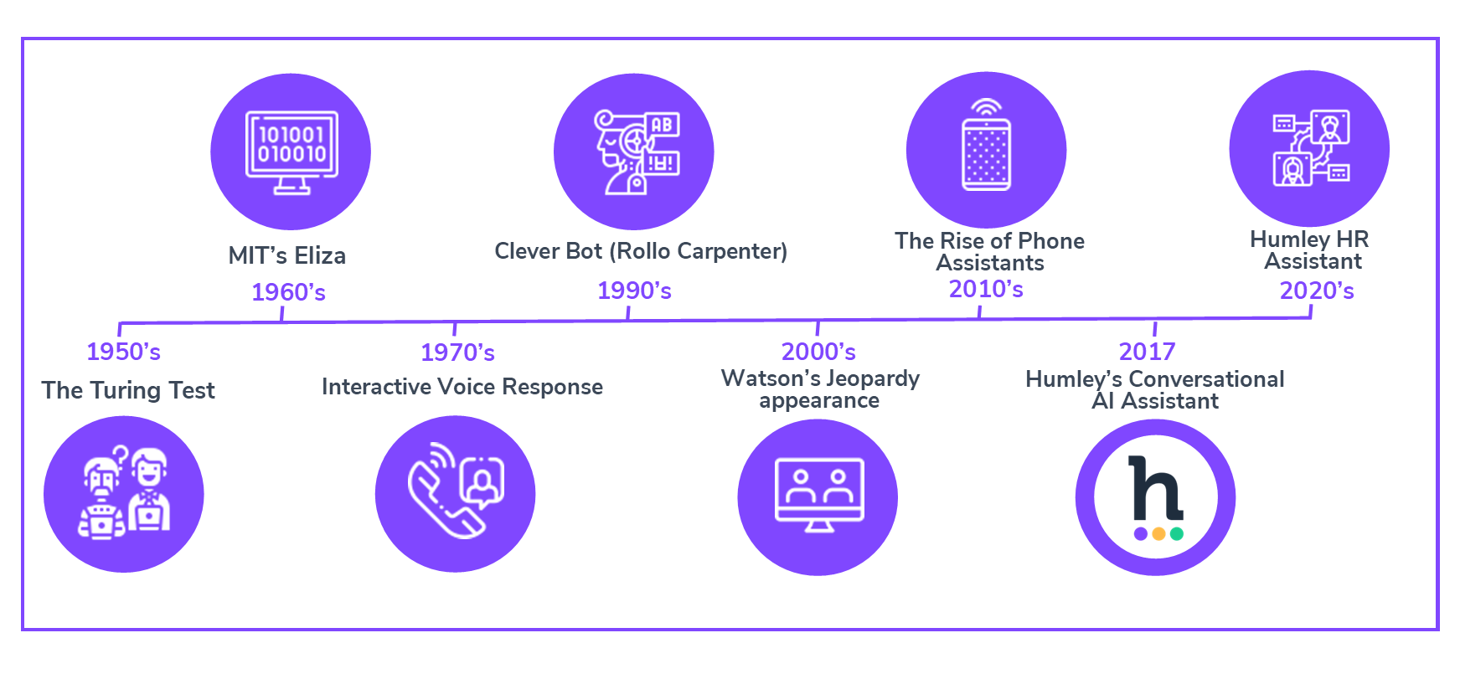

The 2000’s brought in a significant turning point with the advent of big data , advancements in computing and machine learning algorithms .

The 2010’s marked a breakthrough in image and speech recognition, pattern recognition and natural language processing models using deep learning and neural network concepts.

These concepts were engineered in a way that mimics the human brain, this precipitated major advancements in medical image classification, diagnosis and detection, due to their capacity to learn hierarchical representations from large data sets.

While researchers have expressed their reservation about using AI due to healthcare disparities, adversarial attacks and responsibility issues, this highlights the need to develop robust strategies to manage these risks responsibly.

These milestones have established the groundwork for the current state-of-the-art applications of AI in medical imaging systems.

1. **Algorithms Used**

**3.1 *Machine Learning Algorithms based on predefined features:***

Historically, AI methods primarily relied on training with a defined set of features and specific parameters derived from expert knowledge. These handcrafted features were tailored to measurable aspects of imaging, such as shape, size, and intensity. These algorithms were seamlessly integrated into imaging systems, enabling automatic extraction and analysis of these predefined features. For instance, in chest X-rays, AI might detect nodules or lesions indicative of lung disease, while in mammography, it would focus on identifying masses or calcifications that suggest breast cancer.

However, this dependence on predefined features restricted the flexibility and adaptability of these algorithms. Consequently, they often faced challenges with variations in image quality, differences in patient anatomy, and the subtlety of certain pathological signs, which limited their diagnostic accuracy and robustness.

**3.2 *Convolutional Neural Networks (CNN) Algorithms:***

This class of deep learning algorithms are specially designed to process structured grid data, such as images by imitating the function of the visual cortex of an animal brain.

Convolutional layers, activation functions, pooling and fully-connected layers are the core building blocks of CNNs.

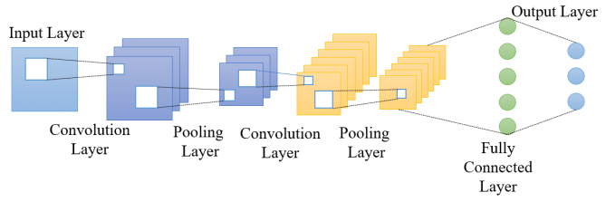

1. ***Convolution Layer:***

The visual cortex of an animal brain comprises mainly neurons. Convolutional layers are designed to automatically and adaptively learn spatial hierarchies of features from input images. They help in detecting patterns such as edges, textures, and shapes.The layer applies a set of filters (or kernels) across the input image to produce feature maps. Each filter slides over the input (performing a convolution operation) to detect specific features at different spatial locations.

The output of the convolutional layer is then passed through an activation function layer.

The Activation Function Layer uses activation functions to ensure that the representation in the input space is mapped to a different output space as per the requirements.

The different Activation Functions are:

1. ***Tan hyperbolic function:***

It takes a real valued number x and squashes it between -1 to 1, providing a smooth, non-linear transformation of the input. This function is particularly useful in situations where the output needs to be centred around zero, which can help with the convergence of learning algorithms.

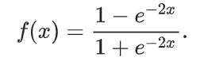

However, it suffers from the vanishing gradient problem in a similar manner to the sigmoid function. For very large or very small input values, the tanh function saturates and its gradients approach zero, which can slow down learning or even halt it in deep neural networks.

Despite these challenges, the tanh function's benefits, such as its zero-centred output, often make it a valuable choice for certain applications, though careful consideration of its limitations is essential.

1. ***Sigmoid function:***

It takes a real valued number x and squashes it between 0 to 1, which is useful for modelling probabilities and binary classification tasks. These are widely used in the hidden layers of neural networks and in the output layers.

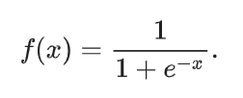

However, it suffers from the vanishing gradient problem, where gradients become very small for extreme input values, leading to slow or stalled learning in deep networks. Furthermore, the sigmoid function involves exponential calculations, which can be computationally expensive compared to simpler functions.

These limitations make the sigmoid function less favourable in some modern deep learning architectures, where alternatives like ReLU or tanh are often preferred for their improved performance and efficiency.

1. ***Rectified Linear Unit (ReLU) function:***

It takes a real valued number x and converts x to 0 if x is negative and returns x as is if x is positive. It has become one of the most widely used activation functions in neural networks, particularly in deep learning models. It has become popular due to its simplicity, efficiency, and ability to help with the vanishing gradient problem.

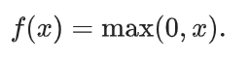

One of the primary concerns is the "dying ReLU" problem, where neurons can become inactive if they only output zeros due to negative inputs or improper weight initialization.Moreover, ReLU is not zero-centred, meaning that it can cause inefficient learning dynamics due to gradients being consistently of the same sign. While variants such as Leaky ReLU and ELU have been developed to address some of these issues, ReLU's limitations still pose challenges, particularly in ensuring stable and effective training in complex neural network architectures.

***B. Pooling Layer:***

The pooling layer performs nonlinear downsampling of the convolved features. Usually, a pooling layer (like max pooling) follows the convolutional layer to reduce the spatial dimensions of the feature maps, thereby reducing the computational load and helping in generalisation.

The main types of pooling are maximum pooling and average pooling.

***C. Fully Connected Layer:***

A fully connected layer, also known as a dense layer, is a fundamental component in neural networks, particularly in feedforward neural networks.Fully connected layers are used to learn high-level, abstract representations of the input data. They are typically found towards the end of neural network architectures.Every neuron in a fully connected layer is connected to every neuron in the previous layer. This means each output neuron has a weighted sum of all input neurons followed by an activation function.

They are historically suited for tasks involving image analysis and are known to have revolutionised the field of medical imaging. CNN mainly focuses on image classification, object detection, image segmentation and enhancing.

Some of the applications of CNN include High resolution computed tomography (HRCT), Ensemble CNN, Small-kernel CNN, etc.

**4. Radiology Reimagined**

AI has brought a paradigm shift in Radiology by redefining traditional workflows and introducing automations of many clinical tasks. In the realm of Image Scanning, AI tools can quickly identify abnormalities, such as tumours or fractures, and provide quantitative assessments, reducing the workload on radiologists and minimising human error. Additionally, AI facilitates personalised treatment planning by integrating imaging data with patient history and other clinical information.

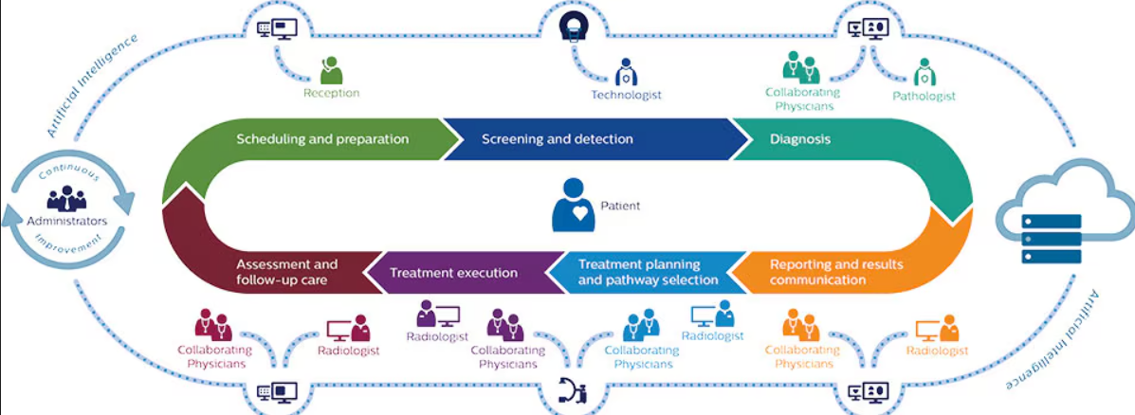

The integration of AI in radiology represents a significant transformation in clinical workflows, enhancing various stages from data handling to patient care.

1. **Optimised Scheduling and Preparation**: AI leverages historical data to refine scheduling and scanner management, effectively reducing patient wait times and optimising resource allocation.
2. **Enhanced Screening and Detection**: AI algorithms select the most appropriate imaging techniques and settings, minimising radiation exposure while maintaining high image quality. This process also accelerates scanning times and ensures accurate image capture.
3. **AI-Enhanced Diagnosis**: By assisting radiologists in image interpretation, AI helps identify critical cases that require urgent attention. This support improves diagnostic accuracy and efficiency.
4. **Streamlined Reporting and Communication**: AI automates the generation of standardised reports based on image analysis, facilitating faster and more accurate communication of results. Integration with electronic health records (EHRs) ensures timely delivery of results to patients.
5. **Informed Treatment Planning and Pathway Selection**: AI correlates imaging data with patient history to provide actionable insights for treatment planning. By analysing past cases, AI predicts patient responses to various treatments, helping to tailor the most effective care plans.
6. **Predictive Treatment Execution**: During treatment, AI continuously monitors patient data to anticipate potential complications, ensuring proactive management and enhancing treatment safety.
7. **Comprehensive Assessment and Follow-Up Care**: AI manages follow-up appointments and tracks disease progression by comparing current images with historical data, maintaining high standards of patient care.

By incorporating AI throughout these stages, radiology departments can achieve faster, more accurate, and insightful medical services, leading to enhanced patient outcomes and overall satisfaction. This integration of advanced technology with clinical expertise sets a new benchmark for excellence in healthcare.

**5. Case Study**

**5.1 *Cardiovascular Imaging***

In recent years, AI has played a pivotal role in the enhancement of detection and quantification of heart diseases, detection of vascular anomalies, etc. AI algorithms integrate multi-modality imaging data to ensure efficient interpretation of images, recognising initial stages of coronary diseases such as heart failure and Myocardial Infarction through modalities like Echocardiogram, CT, MRI, etc.

Researchers at John Hopkins University have developed an AI integrated system to help assess the echocardiograms. The AI model analyses images to identify structural abnormalities, measure heart function and ejection fraction and detect conditions such as cardiomyopathy or arrhythmias. The AI system proved to improve diagnostic accuracy, decreased the time for evaluation and hence decreased the workload of echocardiographic physicians.

Google Health partnered with University College London Hospitals(UCLH) to develop an AI model that pre-determines patient deterioration as the cardiovascular disease progresses. The system did so by analysing patient data, vital signs, lab results and clinical notes to identify patients at risk. The model demonstrated the ability to predict adverse cardiovascular events hours before they actually occurred. This enabled healthcare providers to intervene and take appropriate measures before the patient deteriorated.

**5.2 Pulmonary Imaging**

In recent years, AI has played a pivotal role in transforming pulmonary imaging by significantly enhancing the detection and quantification of lung diseases. AI algorithms integrate multi-modality imaging data, including chest CT scans and X-rays, to ensure efficient and accurate interpretation of pulmonary images. These advanced AI systems leverage deep learning techniques to identify and characterise lung nodules, assess their potential malignancy, and detect subtle abnormalities that might be missed by traditional methods. By automating the analysis of imaging data, AI tools not only improve the accuracy of early-stage lung cancer detection but also streamline the workflow for radiologists. This integration reduces diagnostic errors, minimises false positives, and accelerates the overall diagnostic process.

Collaborative efforts between radiologists and AI developers have led to continuous improvements in these systems, ensuring that they remain effective and adaptable to evolving clinical needs. Consequently, the use of AI in pulmonary imaging at institutions like MD Anderson Cancer Center represents a significant advancement in improving diagnostic precision and patient outcomes.

At MD Anderson Cancer Center, AI has been instrumental in advancing the diagnosis and management of lung cancer through enhanced pulmonary imaging. Utilising deep learning algorithms, the AI system meticulously analyses chest CT scans to identify and characterise lung nodules and other abnormalities with remarkable precision. his technological advancement not only improves the accuracy of early-stage lung cancer detection but also reduces the incidence of false positives, leading to more reliable diagnoses. Furthermore, the integration of AI into the imaging workflow streamlines the review process, allowing radiologists to focus on complex cases and make more informed decisions. Through interdisciplinary collaboration between radiologists, oncologists, and AI researchers, the system continuously evolves to maintain high performance and adapt to new data.

**5.3 NeuroradiologyImaging**

Within the realm of neuroradiology, AI coupled with specific supervised techniques and Deep Learning algorithms has proven to be indispensable in managing high-dimensional data to facilitate the early detection of strokes, haemorrhages and detection of large vessel occlusion.

AI also plays a critical role in the detection of neurodegenerative disorders like Parkinson’s and Alzheimer’s. AI algorithms are coupled with CNNs to analyse MR images and detect the presence of certain biomarkers associated with these diseases. AI displays the ability to detect refined voxel-level patterns which aids in discerning subtle changes in brain function or brain structure, which is imperative for the identification of these neurodegenerative disorders.

Mount Sinai Health System, a leading healthcare provider in New York,employed an AI platform developed by a company called Aidoc, which specialises in AI solutions for radiology. Aidoc’s AI algorithms are designed to detect and prioritise acute abnormalities in medical imaging, specifically in CT scans and MRIs. The AI system was trained to analyse the image in real-time and highlight potential abnormalities, such as intracranial haemorrhages, strokes, and brain tumours. The flagged images are then prioritised for review by radiologists, ensuring that urgent cases receive immediate attention.

**6. Challenges and Limitations**

***Data Quantity and Quality :***AI algorithms require large amounts of high-quality, annotated data to train efficiently. Inconsistent or poor quality data can lead to inaccurate models bearing inaccurate results.

Additionally, a well trained AI model requires to be trained on sufficient volumes of annotated images. This has proven to be challenging due to privacy concerns and the proprietary nature of medical data.

***Black Box Nature :*** Many AI models, particularly ones using Deep Learning algorithms, operate as “black boxes”. This makes it hard to understand how the model reached its conclusion. Healthcare workers need to be able to trust the AI model , which requires the model to be transparent and interpretable to explain its reasoning.

***Algorithmic Bias and Fairness :***Some AI models that are not trained on diverse datasets may prove to produce biassed results. This can lead to disparities in healthcare.

**7. CONCLUSION**

AI has the potential to revolutionise radiology, driving significant advancements in diagnostic accuracy, efficiency, and patient care. While challenges remain, the continuous evolution of AI technology and collaborative efforts to address these issues will undoubtedly pave the way for a future where AI plays an integral role in radiology. As we move forward, embracing AI’s capabilities while maintaining rigorous standards and ethical considerations will ensure that this technology fulfils its promise of transforming radiological practice and improving healthcare outcomes.

1. **REFERENCES**
2. Hosny A., Parmar C., Quackenbush J., Schwartz L.H., Aerts H.J. Artificial intelligence in radiology. *Nat. Rev. Cancer. [*[*PubMed*](https://pubmed.ncbi.nlm.nih.gov/28131497)*] [*[*CrossRef*](https://doi.org/10.1016%2Fj.acra.2016.11.021)*] [*[*Google Scholar*](https://scholar.google.com/scholar_lookup?journal=Acad.+Radiol.&title=Role+of+Imaging+in+the+Era+of+Precision+Medicine&author=A.+Giardino&author=S.+Gupta&author=E.+Olson&author=K.+Sepulveda&author=L.+Lenchik&volume=24&publication_year=2017&pages=639-649&pmid=28131497&doi=10.1016/j.acra.2016.11.021&)*]*
3. Mnih V et al. Human-level control through deep reinforcement learning. *Nature* 518, 529–533 (2015). [[PubMed](https://pubmed.ncbi.nlm.nih.gov/28131497)] [[CrossRef](https://doi.org/10.1016%2Fj.acra.2016.11.021)] [[Google Scholar](https://scholar.google.com/scholar_lookup?journal=Acad.+Radiol.&title=Role+of+Imaging+in+the+Era+of+Precision+Medicine&author=A.+Giardino&author=S.+Gupta&author=E.+Olson&author=K.+Sepulveda&author=L.+Lenchik&volume=24&publication_year=2017&pages=639-649&pmid=28131497&doi=10.1016/j.acra.2016.11.021&)]
4. [Reabal Najjar](https://pubmed.ncbi.nlm.nih.gov/?term=Najjar%20R%5BAuthor%5D). Redefining Radiology.  *[*[*PubMed*](https://pubmed.ncbi.nlm.nih.gov/28131497)*] [*[*Google Scholar*](https://scholar.google.com/scholar_lookup?journal=Acad.+Radiol.&title=Role+of+Imaging+in+the+Era+of+Precision+Medicine&author=A.+Giardino&author=S.+Gupta&author=E.+Olson&author=K.+Sepulveda&author=L.+Lenchik&volume=24&publication_year=2017&pages=639-649&pmid=28131497&doi=10.1016/j.acra.2016.11.021&)*]*
5. Editors, N. Auspicious machine learning. *Nat. Biomed. Engineer* 1, 0036 (2017). [[Google Scholar](https://scholar.google.com/scholar_lookup?journal=Nat.+Biomed.+Engineer&title=Auspicious+machine+learning&author=+N.&volume=1&publication_year=2017&pages=0036&)]
6. [Ahmed Hosny](https://pubmed.ncbi.nlm.nih.gov/?term=Hosny%20A%5BAuthor%5D), [Chintan Parmar](https://pubmed.ncbi.nlm.nih.gov/?term=Parmar%20C%5BAuthor%5D), [John Quackenbush](https://pubmed.ncbi.nlm.nih.gov/?term=Quackenbush%20J%5BAuthor%5D), [Lawrence H. Schwartz](https://pubmed.ncbi.nlm.nih.gov/?term=Schwartz%20LH%5BAuthor%5D),and [Hugo J. W. L. Aerts](https://pubmed.ncbi.nlm.nih.gov/?term=Aerts%20HJ%5BAuthor%5D). Artificial intelligence in radiology. *[*[*PubMed*](https://pubmed.ncbi.nlm.nih.gov/28131497)*] [*[*Google Scholar*](https://scholar.google.com/scholar_lookup?journal=Acad.+Radiol.&title=Role+of+Imaging+in+the+Era+of+Precision+Medicine&author=A.+Giardino&author=S.+Gupta&author=E.+Olson&author=K.+Sepulveda&author=L.+Lenchik&volume=24&publication_year=2017&pages=639-649&pmid=28131497&doi=10.1016/j.acra.2016.11.021&)*]*
7. Yala A., Lehman C., Schuster T., Portnoi T., Barzilay R. A Deep Learning Mammography-based Model for Improved Breast Cancer Risk Prediction. *Radiology. [*[*PubMed*](https://pubmed.ncbi.nlm.nih.gov/31063083)*] [*[*CrossRef*](https://doi.org/10.1148%2Fradiol.2019182716)*] [*[*Google Scholar*](https://scholar.google.com/scholar_lookup?journal=Radiology&title=A+Deep+Learning+Mammography-based+Model+for+Improved+Breast+Cancer+Risk+Prediction&author=A.+Yala&author=C.+Lehman&author=T.+Schuster&author=T.+Portnoi&author=R.+Barzilay&volume=292&publication_year=2019&pages=60-66&pmid=31063083&doi=10.1148/radiol.2019182716&)*]*
8. Walter F. Wiggins et al., Radiology: Artificial Intelligence, 2021.  *[RSNA] [*[*Google Scholar*](https://scholar.google.com/scholar_lookup?journal=Acad.+Radiol.&title=Role+of+Imaging+in+the+Era+of+Precision+Medicine&author=A.+Giardino&author=S.+Gupta&author=E.+Olson&author=K.+Sepulveda&author=L.+Lenchik&volume=24&publication_year=2017&pages=639-649&pmid=28131497&doi=10.1016/j.acra.2016.11.021&)*]*
9. Laurent Dercle et al., Jitc, 2022.[Artificial intelligence and radiomics: fundamentals, applications, and challenges in immunotherapy.](https://jitc.bmj.com/content/10/9/e005292?utm_source=trendmd&utm_medium=paid&utm_campaign=usage&utm_content=bau_trendmd&utm_id=BMJ074)*[RSNA]*
10. Peter Steiger, Radiology, 2022.[Radiomics and Artificial Intelligence](https://pubs.rsna.org/doi/10.1148/radiol.220081?utm_source=TrendMD&utm_medium=cpc&utm_campaign=Radiology_TrendMD_0).*[RSNA] [*[*Google Scholar*](https://scholar.google.com/scholar_lookup?journal=Acad.+Radiol.&title=Role+of+Imaging+in+the+Era+of+Precision+Medicine&author=A.+Giardino&author=S.+Gupta&author=E.+Olson&author=K.+Sepulveda&author=L.+Lenchik&volume=24&publication_year=2017&pages=639-649&pmid=28131497&doi=10.1016/j.acra.2016.11.021&)*]*
11. Makeeva V. An Essential Roadmap for AI in Radiology.2023.*[*[*Google Scholar*](https://scholar.google.com/scholar_lookup?journal=Acad.+Radiol.&title=Role+of+Imaging+in+the+Era+of+Precision+Medicine&author=A.+Giardino&author=S.+Gupta&author=E.+Olson&author=K.+Sepulveda&author=L.+Lenchik&volume=24&publication_year=2017&pages=639-649&pmid=28131497&doi=10.1016/j.acra.2016.11.021&)*]*
12. Wang H., Zhu H., Ding L. Accurate classification of lung nodules on CT images using the TransUnet. [[PMC free article](https://www.ncbi.nlm.nih.gov/pmc/articles/PMC9760709/)] [[PubMed](https://pubmed.ncbi.nlm.nih.gov/36544802)] [[CrossRef](https://doi.org/10.3389%2Ffpubh.2022.1060798)] [[Google Scholar](https://scholar.google.com/scholar_lookup?journal=Front.+Public+Health&title=Accurate+classification+of+lung+nodules+on+CT+images+using+the+TransUnet&author=H.+Wang&author=H.+Zhu&author=L.+Ding&volume=10&publication_year=2022&pages=1060798&pmid=36544802&doi=10.3389/fpubh.2022.1060798&)]
13. Bhandari A., Koppen J., Agzarian M. Convolutional neural networks for brain tumour segmentation.2020.[[PMC free article](https://www.ncbi.nlm.nih.gov/pmc/articles/PMC9760709/)] [[PubMed](https://pubmed.ncbi.nlm.nih.gov/36544802)] [[CrossRef](https://doi.org/10.3389%2Ffpubh.2022.1060798)] [[Google Scholar](https://scholar.google.com/scholar_lookup?journal=Front.+Public+Health&title=Accurate+classification+of+lung+nodules+on+CT+images+using+the+TransUnet&author=H.+Wang&author=H.+Zhu&author=L.+Ding&volume=10&publication_year=2022&pages=1060798&pmid=36544802&doi=10.3389/fpubh.2022.1060798&)]
14. UMass Chan Medical School Department of Radiology Artificial Intelligence in MRI. 2020. <https://www.umassmed.edu/radiology/radnews/2020/10/ai-mri/>
15. Kooi T et al. Large scale deep learning for computer aided detection of mammographic lesions. *Med. Image Anal* 35, 303–312 (2017). [[PubMed](https://pubmed.ncbi.nlm.nih.gov/27497072)] [[Google Scholar](https://scholar.google.com/scholar_lookup?journal=Med.+Image+Anal&title=Large+scale+deep+learning+for+computer+aided+detection+of+mammographic+lesions&author=T+Kooi&volume=35&publication_year=2017&pages=303-312&pmid=27497072&)]
16. Van Booven DJ, Kuchakulla M, Pai R, Frech FS, Ramasahayam R, Reddy P, Parmar M, Ramasamy R, Arora H. A Systematic Review of Artificial Intelligence in Prostate Cancer. Res Rep Urol. 2021 Jan 22;13:31-39. doi: 10.2147/RRU.S268596. PMID: 33520879; PMCID: PMC7837533.[[PMC free article](https://www.ncbi.nlm.nih.gov/pmc/articles/PMC9760709/)] [[PubMed](https://pubmed.ncbi.nlm.nih.gov/36544802)] [[CrossRef](https://doi.org/10.3389%2Ffpubh.2022.1060798)] [[Google Scholar](https://scholar.google.com/scholar_lookup?journal=Front.+Public+Health&title=Accurate+classification+of+lung+nodules+on+CT+images+using+the+TransUnet&author=H.+Wang&author=H.+Zhu&author=L.+Ding&volume=10&publication_year=2022&pages=1060798&pmid=36544802&doi=10.3389/fpubh.2022.1060798&)]
17. Lakhani P., Sundaram B. Deep Learning at Chest Radiography: Automated Classification of Pulmonary Tuberculosis by Using Convolutional Neural Networks. *Radiology.* 2017;284:574–582. doi: 10.1148/radiol.2017162326. [[PubMed](https://pubmed.ncbi.nlm.nih.gov/28436741)] [[CrossRef](https://doi.org/10.1148%2Fradiol.2017162326)] [[Google Scholar](https://scholar.google.com/scholar_lookup?journal=Radiology&title=Deep+Learning+at+Chest+Radiography:+Automated+Classification+of+Pulmonary+Tuberculosis+by+Using+Convolutional+Neural+Networks&author=P.+Lakhani&author=B.+Sundaram&volume=284&publication_year=2017&pages=574-582&pmid=28436741&doi=10.1148/radiol.2017162326&)]
18. Allen B., Agarwal S., Coombs L., Wald C., Dreyer K. 2020 ACR Data Science Institute Artificial Intelligence Survey. *J. Am. Coll. Radiol.* 2021;18:1153–1159. doi: 10.1016/j.jacr.2021.04.002. [[PubMed](https://pubmed.ncbi.nlm.nih.gov/33891859)] [[CrossRef](https://doi.org/10.1016%2Fj.jacr.2021.04.002)] [[Google Scholar](https://scholar.google.com/scholar_lookup?journal=J.+Am.+Coll.+Radiol.&title=2020+ACR+Data+Science+Institute+Artificial+Intelligence+Survey&author=B.+Allen&author=S.+Agarwal&author=L.+Coombs&author=C.+Wald&author=K.+Dreyer&volume=18&publication_year=2021&pages=1153-1159&pmid=33891859&doi=10.1016/j.jacr.2021.04.002&)]
19. Huang X, Shan J & Vaidya V in *2017 IEEE 14th International Symposium on Biomedical Imaging (ISBI 2017)* 379–383 (Melbourne, Australia, 2017). [[Google Scholar](https://scholar.google.com/scholar_lookup?title=2017+IEEE+14th+International+Symposium+on+Biomedical+Imaging+(ISBI+2017)&author=X+Huang&author=J+Shan&author=V+Vaidya&publication_year=2017&)]
20. Shortliffe E., editor. *Computer-Based Medical Consultations: MYCIN.* 1st ed. Elsevier; Amsterdam, The Netherlands: 1976. [[Google Scholar](https://scholar.google.com/scholar_lookup?title=Computer-Based+Medical+Consultations:+MYCIN&publication_year=1976&)]
21. Krizhevsky A., Sutskever I., Hinton G.E. ImageNet classification with deep convolutional neural networks. *Commun. ACM.* 2017;60:84–90. doi: 10.1145/3065386. [[CrossRef](https://doi.org/10.1145%2F3065386)] [[Google Scholar](https://scholar.google.com/scholar_lookup?journal=Commun.+ACM&title=ImageNet+classification+with+deep+convolutional+neural+networks&author=A.+Krizhevsky&author=I.+Sutskever&author=G.E.+Hinton&volume=60&publication_year=2017&pages=84-90&doi=10.1145/3065386&)]
22. Shariat SF, Karam JA, Roehrborn CG. Blood biomarkers for prostate cancer detection and prognosis. *Future Oncol*. 2007;3:449–461. doi: 10.2217/14796694.3.4.449 [[PubMed](https://pubmed.ncbi.nlm.nih.gov/17661720)] [[CrossRef](https://doi.org/10.2217%2F14796694.3.4.449)] [[Google Scholar](https://scholar.google.com/scholar_lookup?journal=Future+Oncol&title=Blood+biomarkers+for+prostate+cancer+detection+and+prognosis&volume=3&publication_year=2007&pages=449-461&pmid=17661720&doi=10.2217/14796694.3.4.449&)]
23. <https://heart.bmj.com/content/heartjnl/106/5/399/F2.large.jpg?width=800&height=600&carousel=1>
24. <https://pubs.rsna.org/cms/10.1148/rg.2021210020/asset/images/medium/rg.2021210020.va.gif>
25. <https://ai2-s2-public.s3.amazonaws.com/figures/2017-08-08/a086868cbdebafbe2cdc7052465337dda53ed8c7/4-Figure2-1.png>
26. <https://tse4.mm.bing.net/th?id=OIP.qaCLF3-HaxqGYsIM6mncMAHaCe&pid=Api&P=0&h=180>
27. <https://tse3.mm.bing.net/th?id=OIP.UXfKbr2OhGc2kPkJS9SRvQHaCw&pid=Api&P=0&h=180>
28. Baxi, V., Edwards, R., Montalto, M. *et al.* Digital pathology and artificial intelligence in translational medicine and clinical practice. *Mod Pathol* 35, 23–32 (2022). <https://doi.org/10.1038/s41379-021-00919-2>